Chicago Transit Authority

Number SB20-0029
Effective January 18, 2020
Copies to Bus Distribution List
Supersedes
Activity Code 10971

Scheduling & Service Planning
Bus Schedule Bulletin

Randolph Williams, Senior Manager January 14, 2020
Forest Glen Garage

Due to construction, Red Line rail service will run express between Loyola and Berwyn from 2200 hours Friday, January 17, 2020 until 0400 hours on Monday, January 20, 2020. To accommodate Red Line customers between the Loyola and Berwyn stations, operate thirteen (13) extras on a special “Red Line Shuttle” on Saturday, January 18, 2020.

All times shown in the schedule are considered estimates and may vary per Supervisor’s instruction by approximately +\- 5 minutes depending on actual ridership or train arrivals in the field.

Operators must enter “1001” as the route number into the farebox.

Operators must operate the bus annunciator system in “manual override mode” for all extras, and must select route #999 in order to select the appropriate shuttle trip destination sign.

*Shuttle bus Operators must register each free ride by pressing the #8 key on the bus farebox. No fares will be collected on the shuttle buses. Operators should board customers using front and rear doors, upon the discretion and on-site assistance of the Bus Service Supervisor. The Bus Service Supervisor must count customers boarding at the rear door and inform the Bus Operator of the count.*

RE: Red Line Shuttle – Red Line Loyola to Berwyn Shuttle – Saturday

Operate the following 13 extras on Saturday, January 18, 2020 ONLY:

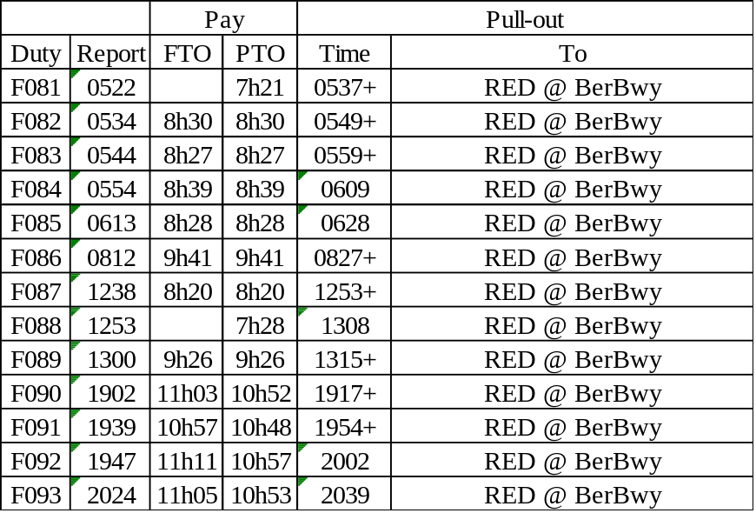

Assign Standard 40 foot buses with working automated passenger counts.
A training map is attached.
A Supervisor’s Guide is attached.
Duty paddles are attached.
-continued-

Please contact Theodore Coulson, Senior Manager, Bus Scheduling, at 312-681-4186 with any immediate concerns regarding the implementation of this bulletin.

Please forward comments, including ridership and cost analysis data to:
Jacob Connor, Coordinator, Special Event Planning
Scheduling & Service Planning Dept., 10th Floor / 567 W. Lake Street / Chicago, IL 60661-1465

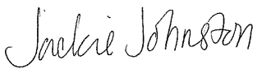
Jacqueline Johnson
Director Scheduling

