ACTIVITY-BASED LEARNING LAB REPORT
Department of Computer Science & Engineering | Web Development Project Suite
Student Name: Abhinav Nair
Roll Number: 26000001
Academic Year: 2026-2027

1. EXECUTIVE OVERVIEW
This report documents the design, implementation and visual verification of three web applications developed as part of Web Development Activity Based Learning coursework. The projects demonstrate HTML5 semantic structure, CSS3 styling, responsive layouts and user friendly interface design.

2. CASE STUDY 1: PERSONAL PORTFOLIO WEBSITE
A personal portfolio webpage presenting student information, technical skills, project highlights and contact details. The website uses structured sections, navigation links and responsive cards.
Figure 1.1: Web Preview Output for Portfolio Website
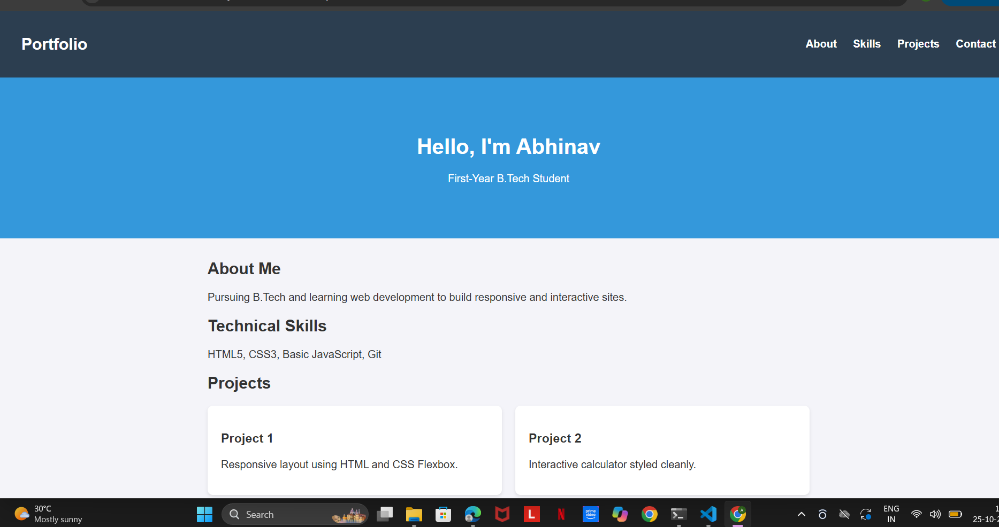

3. CASE STUDY 2: SWEET DELIGHTS BAKERY WEBSITE
A bakery storefront website featuring product showcases, pricing cards, promotional offers and contact information. The layout focuses on clean presentation and responsive design.
Figure 2.1: Web Preview Output for Sweet Delights Bakery Website
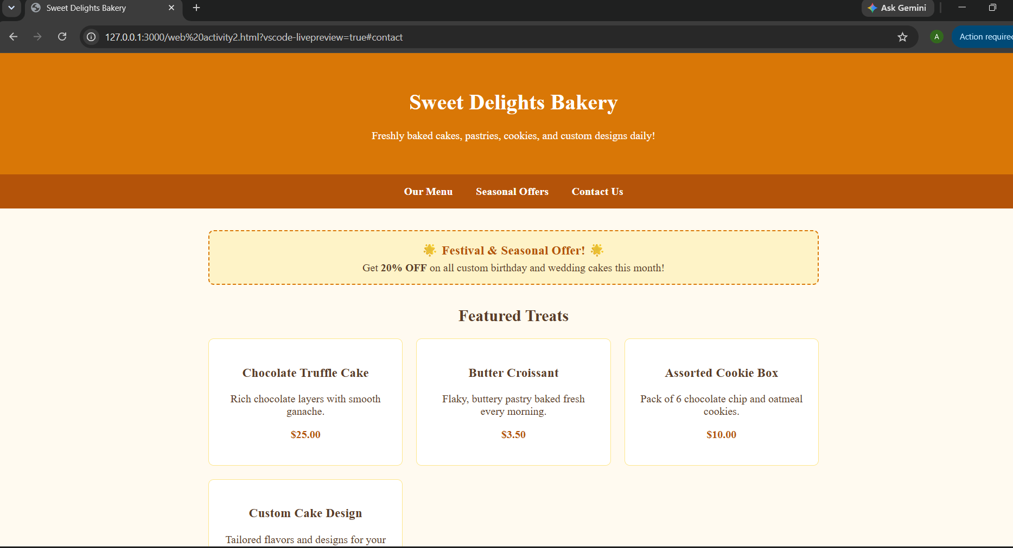

4. CASE STUDY 3: NUTRILIFE & HEALTHY FOOD WEBSITE
A nutrition themed website featuring healthy food categories, recipe cards, meal planning information and health tips using a green wellness focused theme.
Figure 3.1: Web Preview Output for NutriLife & Healthy Food Website
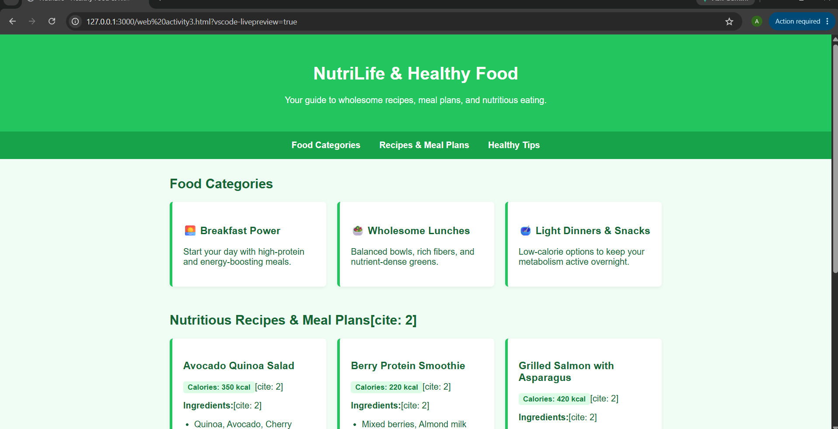

5. TECHNICAL IMPLEMENTATION SNAPSHOT
HTML5 semantic elements, navigation menus, CSS flexbox layouts, responsive containers, card based interfaces and modern typography were used throughout the projects.

6. COMPARATIVE PROJECT MATRIX
Project 1: Portfolio Website - Professional profile presentation.
Project 2: Sweet Delights Bakery - Product and business showcase.
Project 3: NutriLife - Nutrition and recipe information portal.

7. CONCLUSION
The three projects strengthened practical front end web development skills and provided experience in creating responsive and visually appealing websites using HTML5 and CSS.

