TECHNICAL DESIGN PAPER

SpillFlow
  - Fast, bounded-memory data operations for .NET
A simple explanation of the flow, design, algorithms, safety controls, and measured results
Main idea Use RAM for a small piece. Use disk for the rest. Never load the whole data set at one time.

Author: Abhishek Kore
Residence: Miami, Florida, USA
Version: 0.1.0-alpha.1
Date: August 23, 2026

Abstract
Many data operations keep all data in RAM. This is fast when the data is small. It can fail when the data is very large. SpillFlow is a .NET library that keeps memory use under control. It saves temporary pieces on disk, works on one safe piece at a time, and streams results back to the caller.
The design uses stable hash partitioning for sets and joins. It uses sorted runs and a bounded merge for ordering. It also uses memory leases, pooled asynchronous block I/O, a disk quota, checksums, optional AES-GCM encryption, generated binary codecs, cleanup, and recovery checkpoints.
In a measured test with 100 million records and a 1 GiB managed-memory limit, SpillFlow was faster than ExternalSort in four matching operations. This paper explains why in simple language. It also states the limits that still remain.
Reading note A technical word is explained the first time it appears. The diagrams show the same ideas in picture form.

Paper map
- The problem and the main idea
- The full system flow and component design
- The algorithms used by each operation
- How memory, disk, I/O, security, codecs, and recovery work
- Measured CPU, RAM, speed, and disk results
- Known limits and the next engineering work

1. The problem
A normal LINQ operation often builds a large set, list, lookup table, or sort buffer in RAM. RAM is the fast working memory in a computer. If the data is larger than available RAM, the program may slow down, cause heavy garbage collection, or stop with an out-of-memory error.
This problem is common in banking, logging, analytics, claims, and batch processing. A file may hold millions or billions of rows. The program must finish the work even when the machine has little RAM.
Design goal Keep the result correct. Keep memory bounded. Use disk in a controlled way. Fail safely when a hard limit cannot be met.

2. The main idea
Spill means moving temporary working data from RAM to disk. SpillFlow does not put the whole input on disk without a plan. It divides data by key or creates sorted runs. It then reads only the pieces needed for the next step.
- Small data stays in RAM when it fits.
- Large data is written as small framed blocks.
- Equal keys are sent to the same partition.
- An unsafe partition is split again.
- A sort opens only a limited number of files at one time.
- Results are yielded one at a time instead of being stored in a final list.
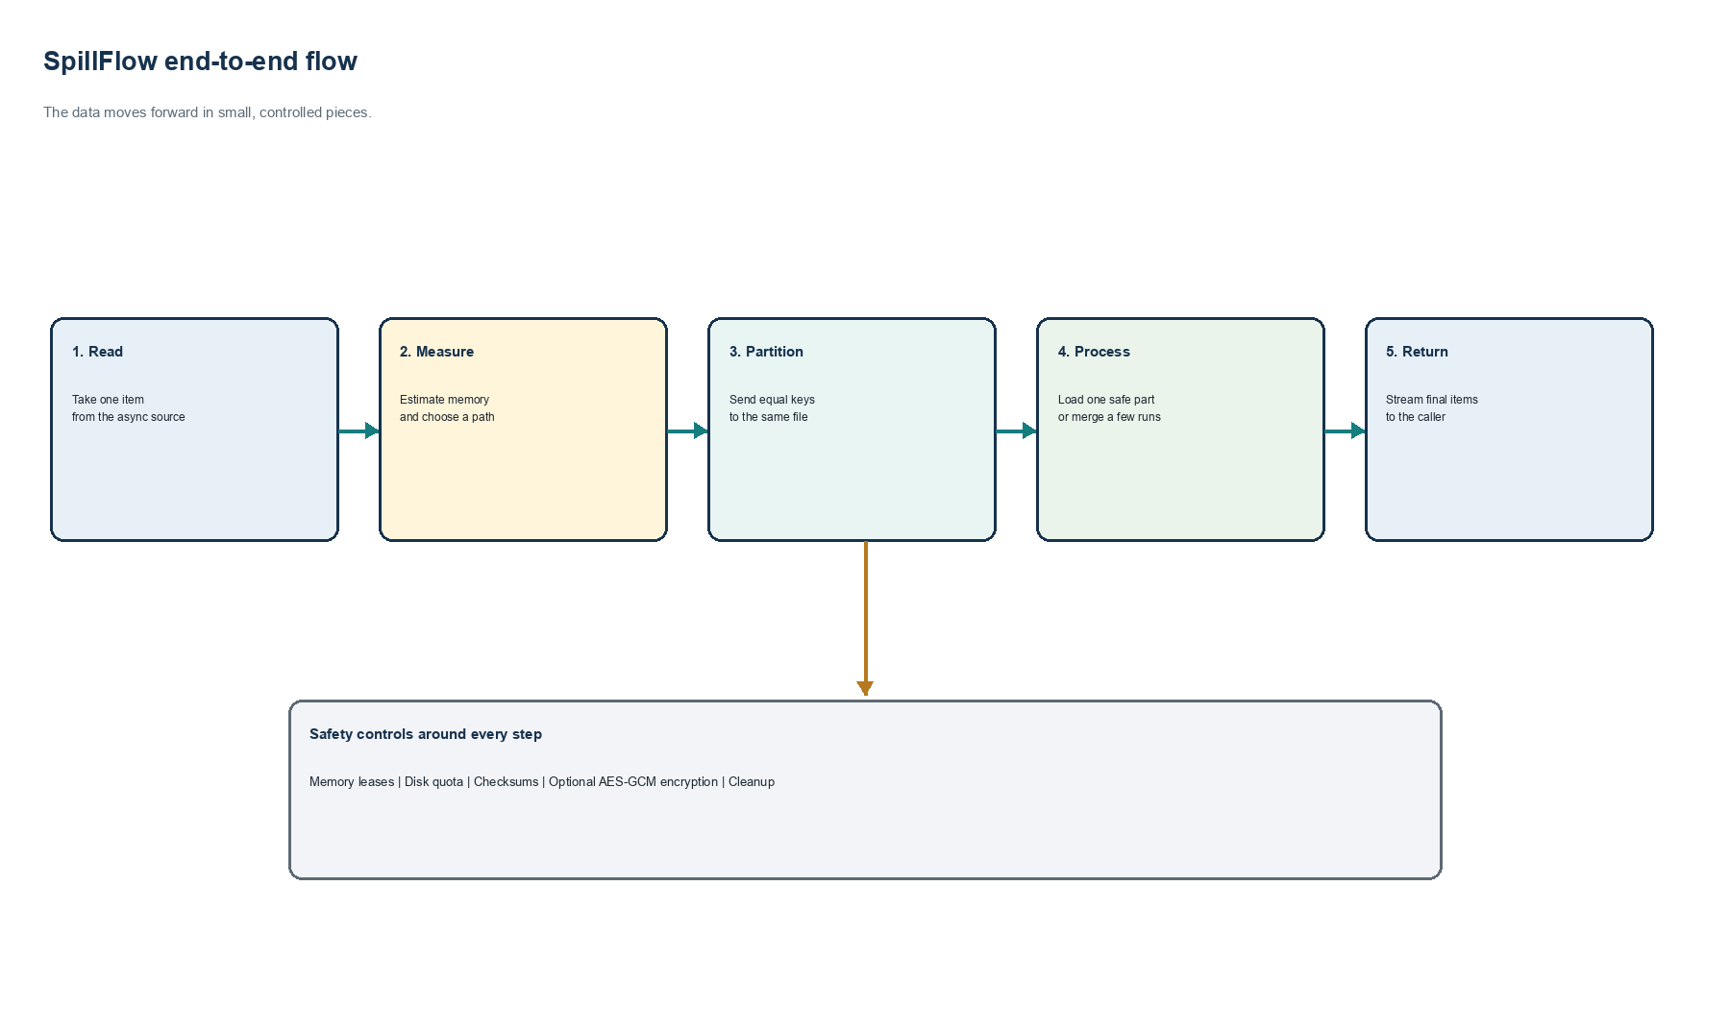
Figure 1. SpillFlow end-to-end flow.

3. System design
The public entry point is a SpillSession. One session owns the memory budget, disk budget, temporary directory, codecs, encryption key, statistics, and recovery manifest. All operations use the same session rules. This keeps resource decisions in one place.
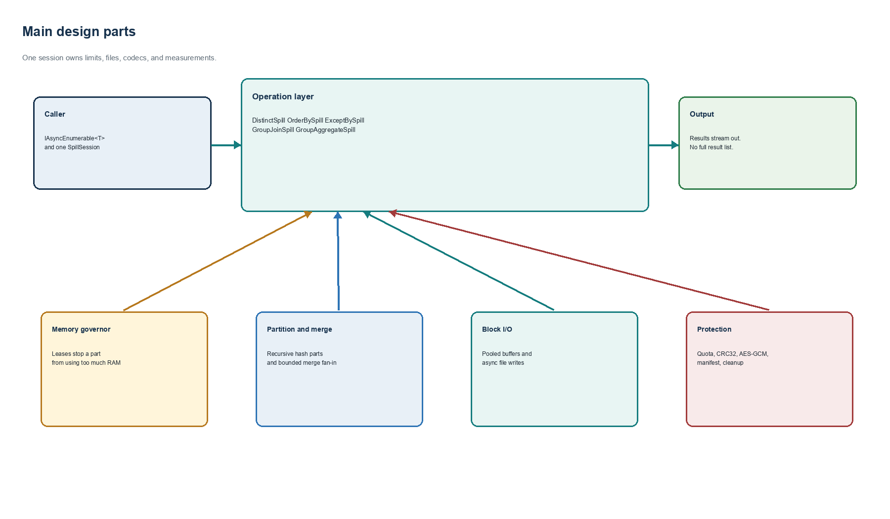
Figure 2. Main SpillFlow components.

3.1 Main components
Part | Simple job
SpillSession | Owns limits, temporary files, codecs, statistics, cleanup, and recovery.
Memory governor | Gives a lease before a large partition or I/O buffer may use RAM.
Partition writer | Writes equal keys to the same temporary partition.
Partition refiner | Splits a partition again when it is too large for a safe lease.
Pooled record writer | Reuses byte arrays and writes full blocks with async I/O.
Block reader | Checks the header, decrypts if needed, checks CRC32, and decodes records.
Codec generator | Creates fast binary encode and decode code during compilation.
Recovery manifest | Stores the session version, file names, and caller checkpoints.

4. Memory design

4.1 Fast path for small work
Disk is slower than RAM. SpillFlow first tries an in-memory path when this is safe. Distinct and grouped aggregation can finish without a temporary file when their state remains below the threshold. The normal threshold is 75 percent of the session memory setting. The remaining space is kept for buffers and runtime overhead.

4.2 Memory leases
A memory lease is permission to use a known number of bytes. The session keeps one atomic count of leased bytes. Atomic means two threads cannot update the count incorrectly at the same time. If a request is larger than the remaining budget, SpillFlow throws SpillResourceLimitException before loading the partition.
available = lease_capacity - bytes_already_leased
if requested_bytes > available:
fail with SpillResourceLimitException
else:
reserve requested_bytes
do the work
release the lease
The lease budget controls memory owned directly by SpillFlow. It cannot count every object created by the .NET runtime or by user code. For this reason, MemoryLimitBytes is a library budget, not a promise about total process RAM.

4.3 Recursive partitioning
A partition file may still be too large. SpillFlow estimates the RAM needed after decoding. The default estimate multiplies file bytes by 2.0 because objects in RAM are often larger than encoded bytes. If the estimate will not fit, the refiner uses a deeper hash and writes 16 child partitions by default. It repeats this check up to the configured depth.
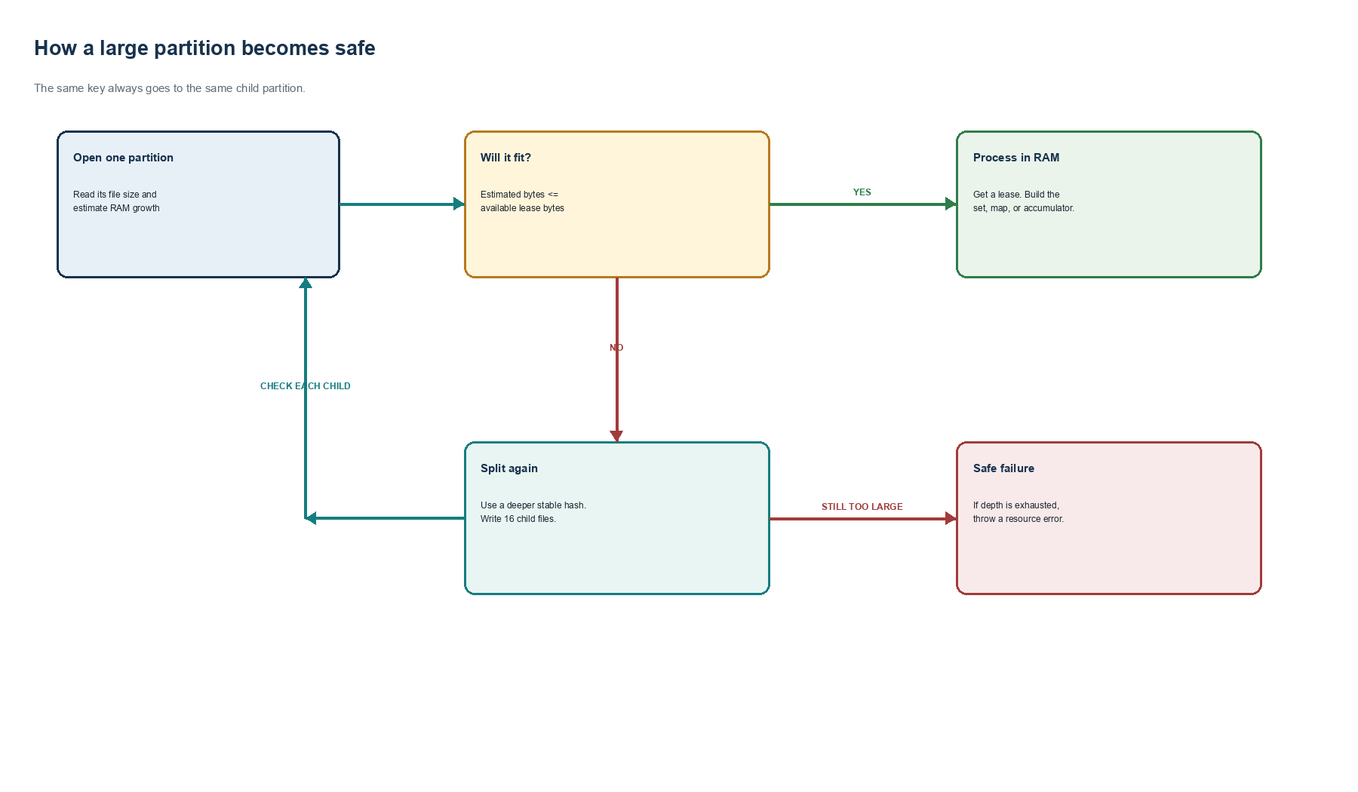
Figure 3. Recursive partition safety decision.
Why this matters A bad data shape cannot quietly force the library to load a huge partition. The library either makes smaller parts or gives a clear resource error.

5. Algorithms used by each operation

5.1 DistinctSpill
- Read each source item and get its key.
- Use the equality comparer to get the hash. This is important because equal keys must have equal hashes.
- Write the item to its partition.
- Refine any partition that is too large.
- Load one safe partition under a lease and keep the first item for each key.
- Yield those items and delete the finished file.

5.2 ExceptBySpill
ExceptBy has a source side and an exclusion-key side. Both sides must use the same partition rule. SpillFlow refines the pair together. It loads exclusion keys for one leaf partition, then yields only the first source item whose key is not excluded.

5.3 GroupJoinSpill
GroupJoin also partitions two inputs together. For one safe leaf, SpillFlow builds a lookup from each right key to its right-side records. It then reads left records and sends the matching list to the result function. The lookup is released before the next leaf.

5.4 GroupAggregateSpill
Grouped aggregation stores one accumulator per key. An accumulator is a small running value, such as count and total amount. The operation starts in RAM. If the estimated state crosses the threshold, it writes the buffered prefix to partitions and continues in spill mode. The source is not read a second time.

5.5 OrderBySpill
Ordering uses external merge sort. External means the algorithm can use disk. The source is read into a bounded list. The list is sorted and written as one sorted run. After all runs exist, SpillFlow merges them with a priority queue. The queue holds only the next item from each open run.
while source has items:
fill one bounded list
sort the list
write one sorted run
while run_count > merge_fan_in:
merge small groups into new runs
merge the final runs and stream the result
MergeFanIn limits how many readers are open in one merge. The default is 16. If there are more runs, SpillFlow makes more merge passes. This uses more disk I/O, but it avoids thousands of open files.
Operation | Disk plan | RAM state | Output
Distinct | Stable hash partitions | One set of seen keys | One item per key
ExceptBy | Paired hash partitions | Exclusion set and seen set | Keys not excluded
GroupJoin | Paired hash partitions | Right-side lookup | One result per left item
GroupAggregate | Fast path, then hash parts | One accumulator per key | One result per key
OrderBy | Sorted runs | One run buffer and merge queue | All items in key order

6. Fast block I/O
Writing one record with one system call is slow. SpillFlow rents a byte array from ArrayPool. Renting lets later writers reuse the same array instead of asking the garbage collector for a new one. Records are copied into this array. When it is full, one asynchronous write sends the block to the file.
The I/O buffer also needs a memory lease. When many partition writers may be open, GetIoBlockSize gives each writer a smaller fair share. This prevents the buffers themselves from breaking the memory plan.
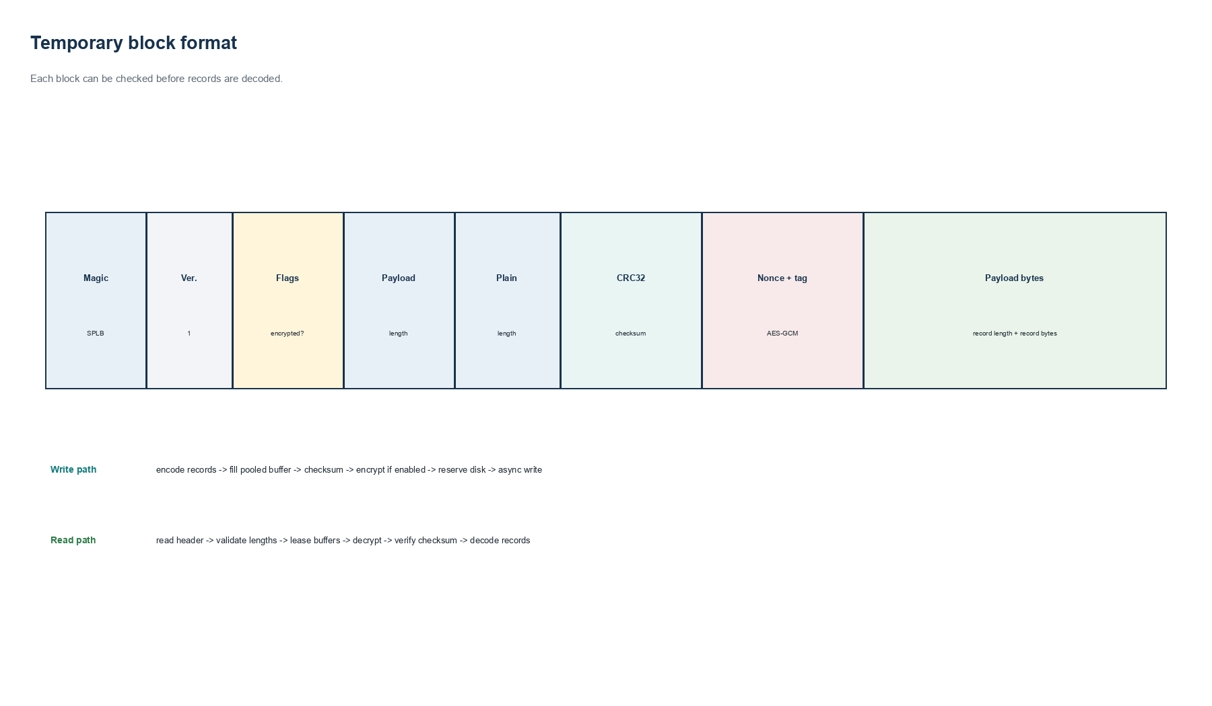
Figure 4. Version 1 temporary block format.

6.1 Record framing
Each record starts with a four-byte length. The reader uses the length to find the next record. Each block starts with a 48-byte header. The header includes the format magic SPLB, version, flags, payload length, plain length, CRC32 checksum, nonce, and authentication tag.

7. Disk safety and cleanup
Before a physical block is written, the session reserves its header and payload bytes against MaxDiskUsageBytes. The default quota is 10 GiB. If the block would cross the quota, the write fails before the file grows without control. When a file is deleted, its real length is removed from the current disk count.
- Every session gets its own spillflow-ID directory.
- Normal disposal deletes the whole session directory.
- A new session may remove abandoned directories older than the configured age.
- Consumed merge runs and processed partitions are deleted as early as possible.
- Peak and current disk bytes are available in SpillStatistics.

8. Data protection

8.1 Checksums
CRC32 detects accidental block damage. The writer computes CRC32 from plain bytes. The reader computes it again after reading or decrypting. If the values differ, the reader rejects the block. CRC32 is an error check. It is not encryption.

8.2 Optional AES-GCM
A caller may give a 16, 24, or 32-byte key. SpillFlow then encrypts each block with AES-GCM. Each block gets a random 12-byte nonce and a 16-byte authentication tag. The tag detects a changed ciphertext, nonce, or tag. The key is copied into the session but is never written to disk.
Key rule The application must protect and provide the key again during recovery. SpillFlow is not a key vault.

9. Generated binary codecs
A codec changes an object into bytes and changes the bytes back into an object. JSON can do this, but JSON is larger and creates more work. SpillFlow includes a source generator. The C# compiler runs the generator when it sees GenerateSpillCodec on a type.
[GenerateSpillCodec]
public sealed class Transaction
{
public Guid Id { get; set; }
public long AmountInCents { get; set; }
public string Currency { get; set; } = "";
}
session.RegisterCodec(new TransactionSpillCodec());
Generated fields are ordered by property name. Integers and long values use explicit little-endian bytes. Strings use UTF-8 and a length. A length of -1 means a nullable string is null. The decoder checks every length and rejects trailing bytes. Unsupported, read-only, generic, abstract, or nonconstructible models produce a compile error instead of silently losing data.

10. Recovery design
A normal session deletes files when it is disposed. A caller can instead call PreserveForRecovery. The session writes a JSON manifest with the manifest version, block version, session ID, creation time, next file number, and file names. The caller can also save a typed checkpoint, such as a source position or source token.
- SaveCheckpointAsync writes a temporary JSON file first.
- The temporary file is flushed and moved over the checkpoint name.
- Checkpoint names allow only ASCII letters, numbers, dash, and underscore.
- Recover validates the manifest version and safe file names.
- Recovered file sizes are counted against the new disk quota.
Important limit Recovery restores files and caller state. It does not yet restart the middle of every operation automatically.

11. Why the design can be efficient
Design choice | Why it helps
Small fast path | Avoids disk when state fits.
Stable binary codec | Creates fewer and smaller temporary bytes than JSON.
Pooled blocks | Cuts array allocation and reduces write calls.
Async I/O | Lets file waits complete without a blocking write call.
Early file deletion | Keeps peak temporary disk below cumulative bytes written.
Bounded merge fan-in | Stops open-reader count from growing with the number of runs.
Recursive partitioning | Keeps one working partition within the lease budget.
Streaming output | Does not build a second full result collection.

12. Measured results
Each 100-million-record case ran in a fresh Release process. DOTNET_GCHeapHardLimit was set to 1 GiB. SpillFlow used a 64 MiB session memory setting. Inputs were generated as they were read. Output counts and deterministic checksums matched ExternalSort. This is a constrained-process test, not a physical laptop with only 1 GB of total system RAM.
Operation | Spill time | External time | Speedup | Spill RAM | External RAM
Distinct | 56.4 s | 262.7 s | 4.66x | 123 MB | 144 MB
OrderBy | 133.8 s | 348.4 s | 2.60x | 70 MB | 142 MB
ExceptBy | 251.5 s | 379.6 s | 1.51x | 125 MB | 127 MB
GroupJoin | 132.3 s | 359.9 s | 2.72x | 153 MB | 153 MB

12.1 CPU use
Operation | Spill CPU time | External CPU time | Spill average | External average
Distinct | 78.6 s | 349.5 s | 1.39 cores | 1.33 cores
OrderBy | 183.1 s | 477.7 s | 1.37 cores | 1.37 cores
ExceptBy | 337.3 s | 524.6 s | 1.34 cores | 1.38 cores
GroupJoin | 184.0 s | 484.9 s | 1.39 cores | 1.35 cores

One full logical CPU is shown as 1.00 core. Both libraries used about 1.3 to 1.4 logical cores on average. SpillFlow finished sooner because it needed less total CPU work, not because it used many more cores.

12.2 Disk and allocation
Operation | Spill peak disk | Peak leases | Spill allocations | External allocations
Distinct | 0.80 GB | 25.1 MB | 0.14 GB | 23.59 GB
OrderBy | 0.96 GB | 2.23 MB | 0.08 GB | 23.86 GB
ExceptBy | 1.65 GB | 16.8 MB | 19.43 GB | 50.76 GB
GroupJoin | 1.76 GB | 16.8 MB | 15.35 GB | 56.33 GB

ExternalSort does not expose matching temporary-disk counters. ExceptBy and GroupJoin still allocate many managed bytes over the full run. Peak RAM stayed bounded, but lowering these cumulative allocations is an important next optimization.

13. Correctness and release evidence
Check | Result
Automated tests | 25 passed
Line coverage | 88.7 percent
Branch coverage | 81.8 percent
Release build | Zero compiler warnings
NuGet audit | No known vulnerable direct or transitive packages
Package consumer | Generated codec and DistinctSpill passed from the packed NuGet
Benchmark correctness | Counts and checksums matched in all compared operations

14. Known limits
- The session memory setting does not measure every .NET or user-created object.
- One extremely frequent key cannot be made smaller by hashing. GroupJoin may fail safely for this hot-key case.
- Recovery does not yet restart every internal operation phase by itself.
- Block headers do not yet include codec and schema fingerprints.
- Temporary-directory permissions and secure deletion need more platform hardening.
- Hash operations do not keep source order. OrderBy is not stable for equal keys unless a sequence tie-breaker is added.
- The measured results are single runs on one machine and storage system. They are not universal promises.

15. Recommended next work
Order | Work | Simple goal
1 | Heavy-key path | Stream or chunk one very large key group without building one huge list.
2 | Schema identity | Put codec ID and version in each block and recovery manifest.
3 | Automatic restart | Checkpoint operation phases and completed partitions.
4 | Allocation reduction | Avoid repeated object and byte-array creation in ExceptBy and GroupJoin.
5 | File hardening | Apply restricted permissions and document secure key handling.
6 | Broader tests | Repeat benchmarks on Linux, Windows, SSD, HDD, and skewed banking data.

16. Conclusion
SpillFlow uses a simple rule: keep only a safe piece in RAM and move controlled working data to disk. The hard part is making every piece obey the same limits. Memory leases, recursive partitions, bounded merge fan-in, pooled async blocks, quotas, checksums, encryption, codecs, cleanup, and recovery work together to do this.
The measured results show that the design can use less work and finish faster than the tested ExternalSort version for the selected workloads. The project is ready for an alpha open-source release. It should not yet be called a complete production banking platform. The known limits give a clear path for the next version.
Short answer SpillFlow is efficient because it controls the size, number, format, and lifetime of every temporary piece.

Appendix A. Default settings
Setting | Default | Meaning
MemoryLimitBytes | 256 MiB | Main library memory setting
PartitionCount | 64 | First hash split
MergeFanIn | 16 | Maximum readers in one merge group
PartitionMemoryExpansionFactor | 2.0 | Encoded bytes to estimated RAM
MaxPartitionDepth | 4 | Maximum recursive split depth
RecursivePartitionCount | 16 | Children made by a deeper split
IoBlockSizeBytes | 128 KiB | Preferred pooled block size
MaxDiskUsageBytes | 10 GiB | Maximum physical temporary data
AbandonedSessionAge | 24 hours | Age used by stale-session cleanup

Appendix B. Implementation basis
This paper describes the SpillFlow source tree and test evidence available on August 23, 2026. The main implementation modules are listed below.
- SpillExtensions.cs - operation algorithms
- SpillSession.cs and SpillOptions.cs - resource ownership, quota, cleanup, statistics, and recovery
- SpillMemoryPool.cs - memory leases
- PartitionRefiner.cs and PartitionPairRefiner.cs - recursive partitioning
- PooledRecordWriter.cs and RecordFile.cs - block I/O
- SpillBlockFormat.cs - header, checksum, and encryption fields
- SpillCodecGenerator.cs - generated binary codecs
- SpillExtensionsTests.cs, GeneratedCodecTests.cs, and RecoveryTests.cs - automated evidence
- BENCHMARK_RESULTS.md - measured performance evidence
- DRAWBACKS.md - remaining limits

