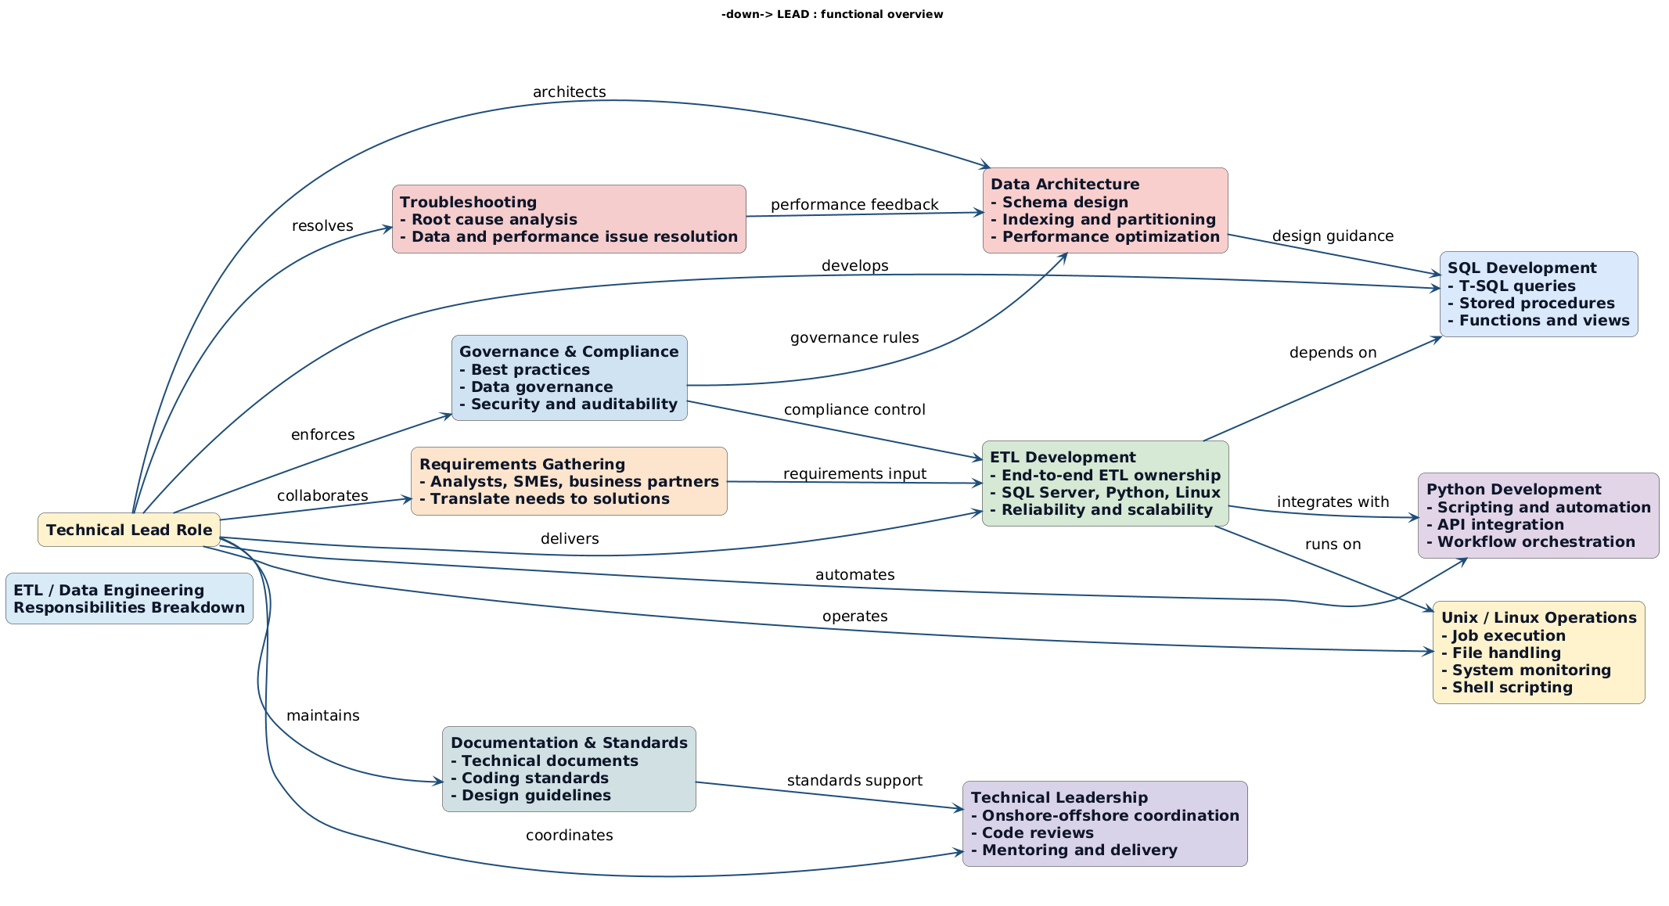
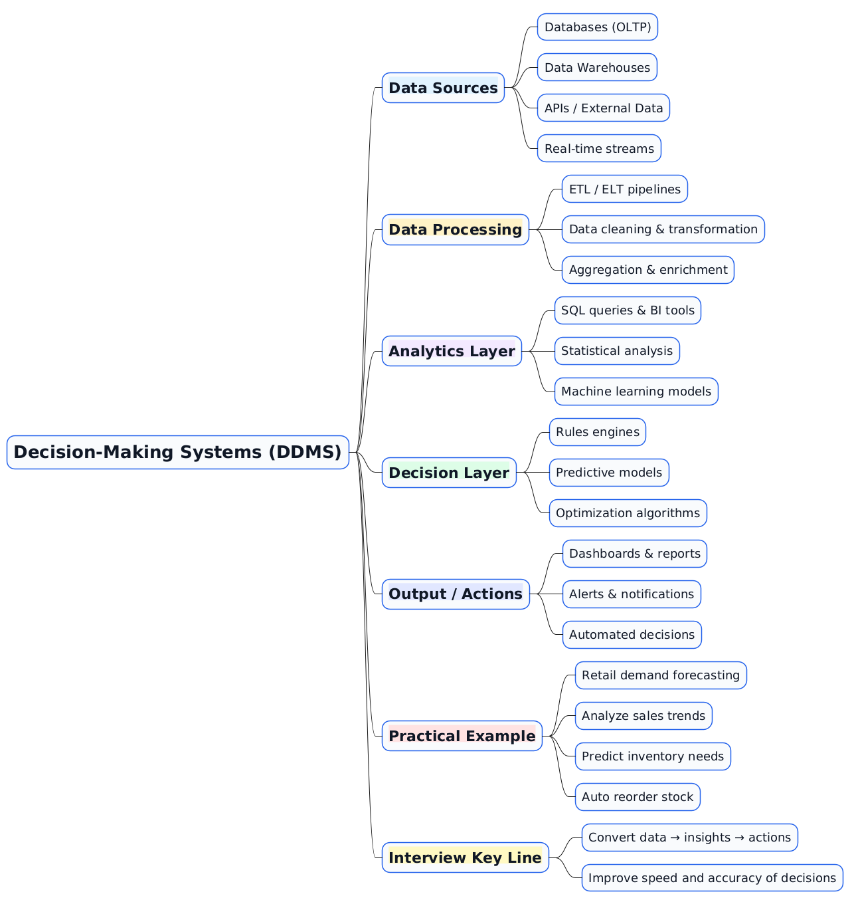
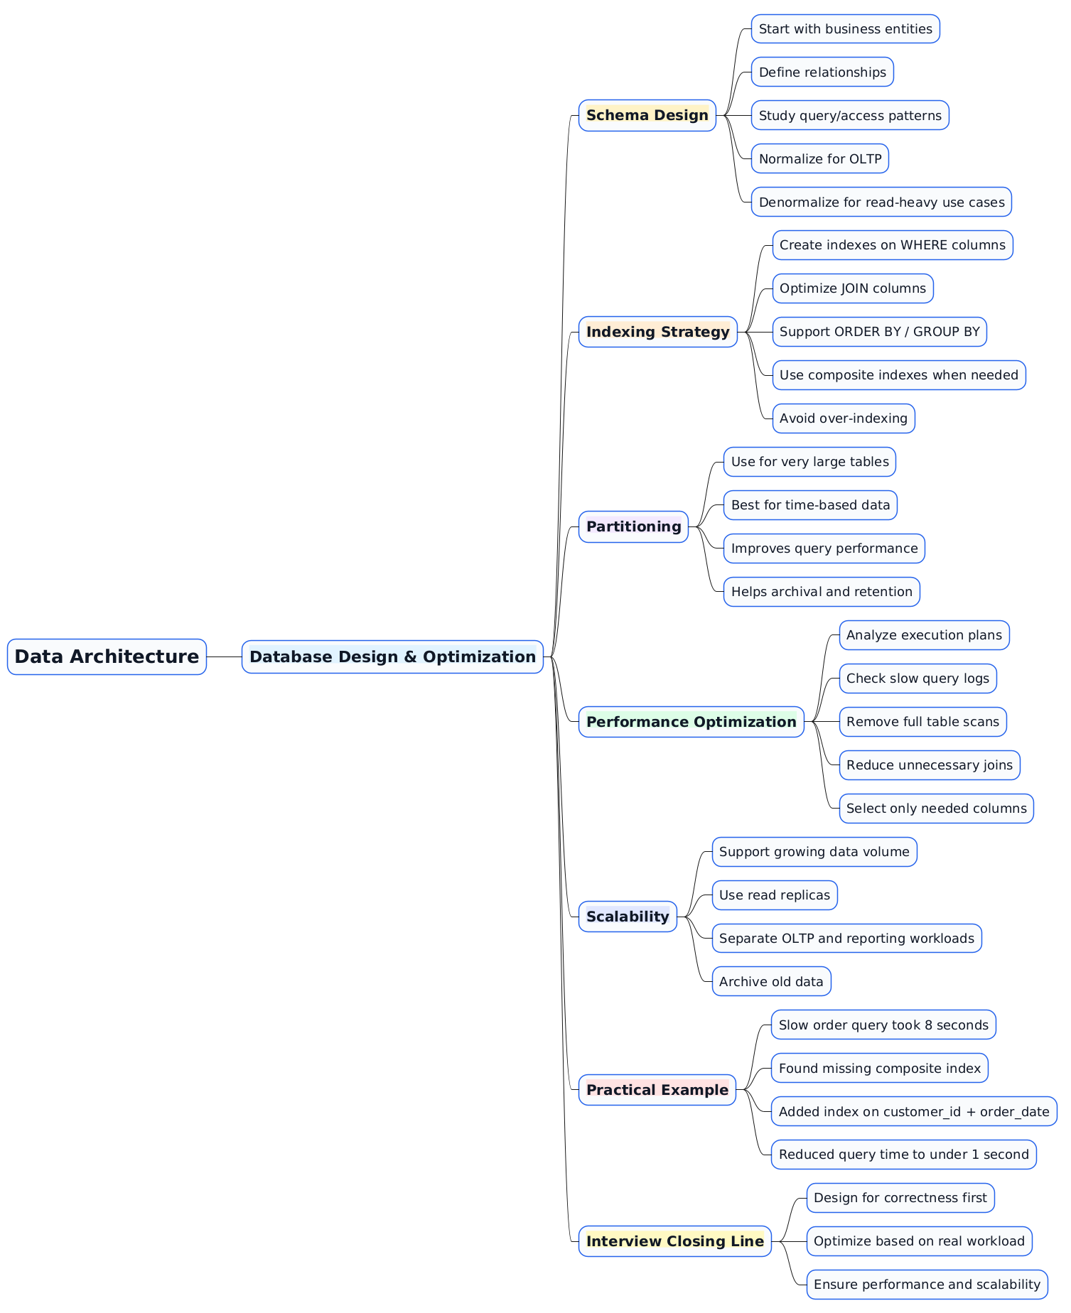

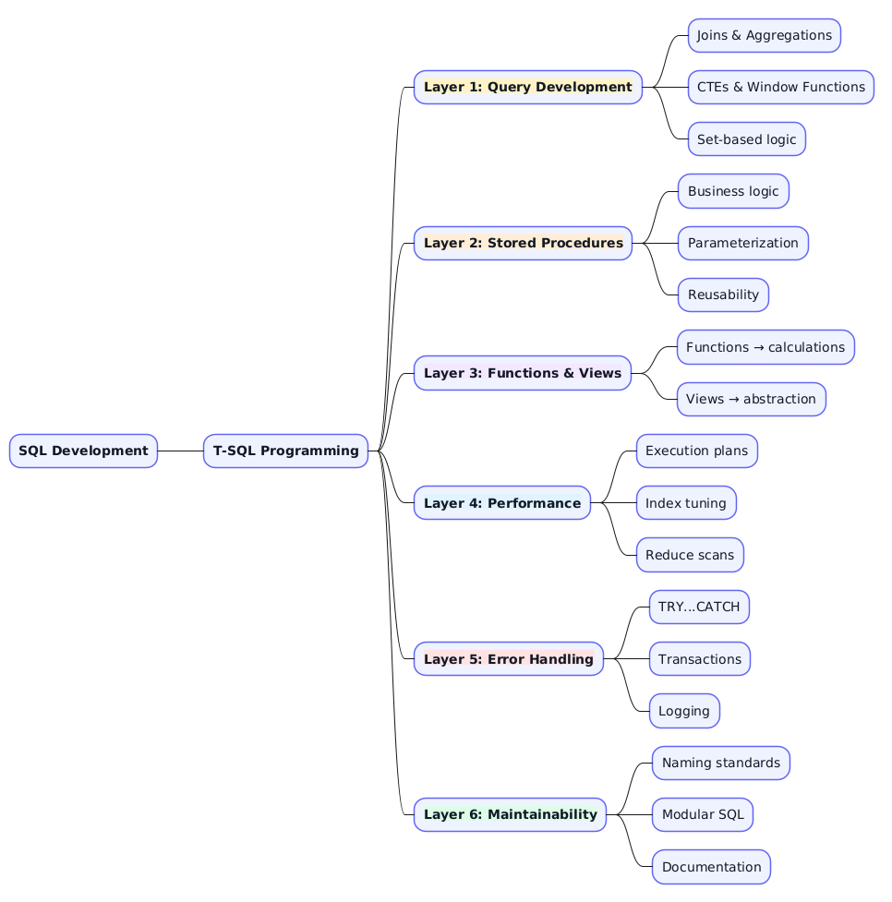


@startmindmap
skinparam backgroundColor #FFFFFF

skinparam node {
BackgroundColor #F8FAFC
BorderColor #2563EB
FontColor #111827
FontSize 19
FontName Arial
}

skinparam rootNode {
BackgroundColor #DBEAFE
BorderColor #1D4ED8
FontColor #1E3A8A
FontSize 26
FontStyle bold
}

* <b><size:26>Decision-Making Systems (DDMS)</size></b>

** <b><size:22><back:#E0F2FE>Data Sources</back></size></b>
*** <size:18>Databases (OLTP)</size>
*** <size:18>Data Warehouses</size>
*** <size:18>APIs / External Data</size>
*** <size:18>Real-time streams</size>

** <b><size:22><back:#FEF3C7>Data Processing</back></size></b>
*** <size:18>ETL / ELT pipelines</size>
*** <size:18>Data cleaning & transformation</size>
*** <size:18>Aggregation & enrichment</size>

** <b><size:22><back:#F3E8FF>Analytics Layer</back></size></b>
*** <size:18>SQL queries & BI tools</size>
*** <size:18>Statistical analysis</size>
*** <size:18>Machine learning models</size>

** <b><size:22><back:#DCFCE7>Decision Layer</back></size></b>
*** <size:18>Rules engines</size>
*** <size:18>Predictive models</size>
*** <size:18>Optimization algorithms</size>

** <b><size:22><back:#E0E7FF>Output / Actions</back></size></b>
*** <size:18>Dashboards & reports</size>
*** <size:18>Alerts & notifications</size>
*** <size:18>Automated decisions</size>

** <b><size:22><back:#FEE2E2>Practical Example</back></size></b>
*** <size:18>Retail demand forecasting</size>
*** <size:18>Analyze sales trends</size>
*** <size:18>Predict inventory needs</size>
*** <size:18>Auto reorder stock</size>

** <b><size:22><back:#FEF9C3>Interview Key Line</back></size></b>
*** <size:18>Convert data → insights → actions</size>
*** <size:18>Improve speed and accuracy of decisions</size>

@endmindmap

