TIS_GapAnalysis_Ref_RobastDB Architecture

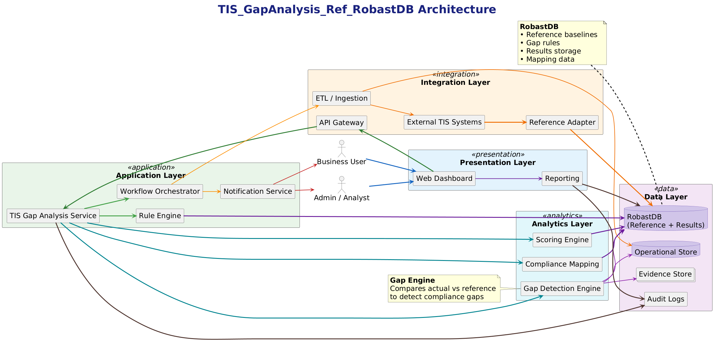

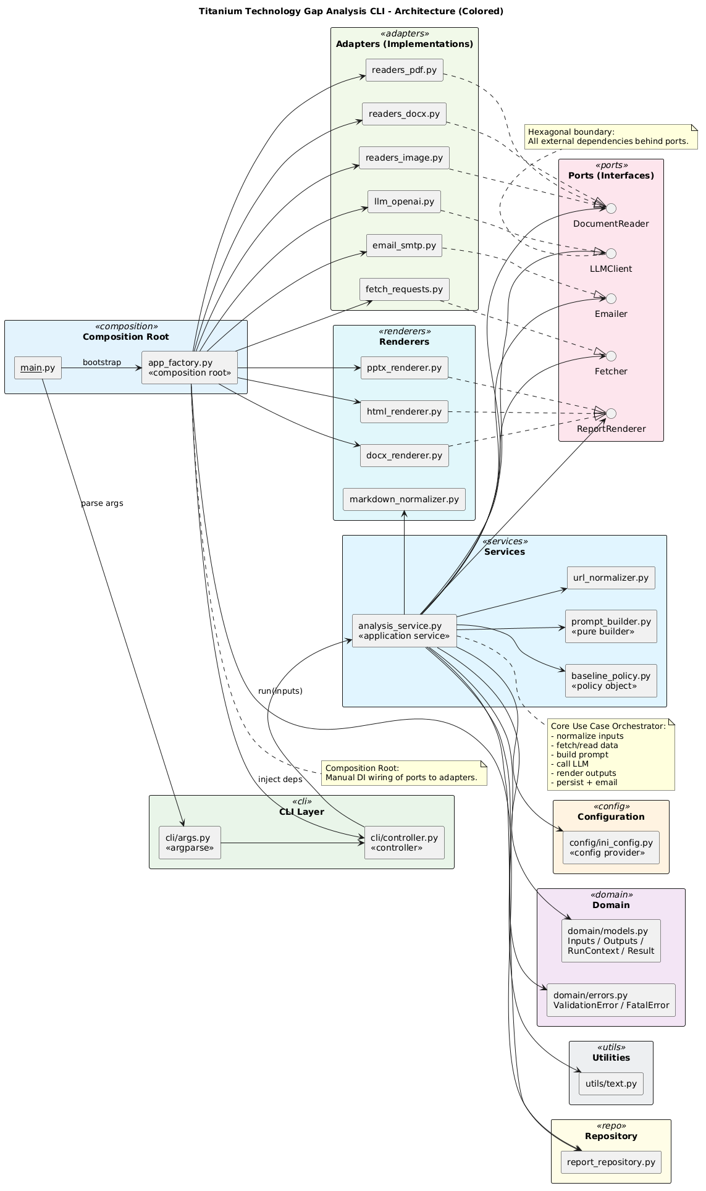

========== script ==============

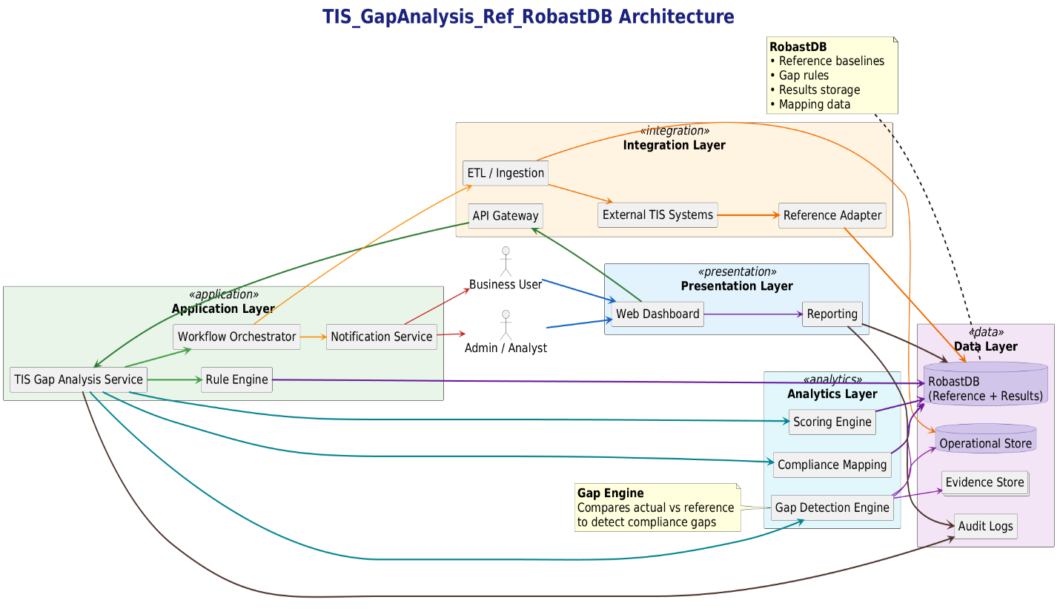

@startuml
title <size:38><b><color:#1A237E>TIS_GapAnalysis_Ref_RobastDB Architecture</color></b></size>

' Global styling
skinparam shadowing false
skinparam componentStyle rectangle
skinparam packageStyle rectangle
left to right direction

' Further increased font sizes (~35% more)
skinparam defaultFontSize 24
skinparam titleFontSize 38
skinparam packageFontSize 24
skinparam componentFontSize 24
skinparam databaseFontSize 24
skinparam arrowFontSize 20

' Color palette
skinparam package {
BackgroundColor<<presentation>> #E3F2FD
BackgroundColor<<application>> #E8F5E9
BackgroundColor<<integration>> #FFF3E0
BackgroundColor<<data>> #F3E5F5
BackgroundColor<<analytics>> #E0F7FA
BorderColor #424242
}

skinparam rectangle {
BackgroundColor #FFFFFF
BorderColor #616161
FontSize 24
}

skinparam database {
BackgroundColor #D1C4E9
BorderColor #4527A0
}

skinparam arrow {
Thickness 3
FontSize 20
}

actor "Business User" as User
actor "Admin / Analyst" as Admin

' LEFT SIDE (Analytics + Data)
package "Analytics Layer" <<analytics>> {
[Gap Detection Engine] as GapEngine
[Scoring Engine] as ScoreEngine
[Compliance Mapping] as Compliance
}

package "Data Layer" <<data>> {
database "RobastDB\n(Reference + Results)" as RobastDB
database "Operational Store" as ODS
collections "Evidence Store" as DocStore
[Audit Logs] as AuditRepo
}

' CENTER
package "Application Layer" <<application>> {
[TIS Gap Analysis Service] as GapService
[Rule Engine] as RuleEngine
[Workflow Orchestrator] as Orchestrator
[Notification Service] as Notify
}

' RIGHT SIDE
package "Integration Layer" <<integration>> {
[API Gateway] as APIGW
[ETL / Ingestion] as ETL
[Reference Adapter] as RefAdapter
[External TIS Systems] as SourceSystems
}

package "Presentation Layer" <<presentation>> {
[Web Dashboard] as UI
[Reporting] as Reporting
}

' Relationships (colored)
User -[#1565C0,thickness=3]-> UI
Admin -[#1565C0,thickness=3]-> UI

UI -[#2E7D32,thickness=3]-> APIGW
UI -[#6A1B9A,thickness=2]-> Reporting

APIGW -[#2E7D32,thickness=3]-> GapService

GapService -[#00838F,thickness=3]-> GapEngine
GapService -[#00838F,thickness=3]-> ScoreEngine
GapService -[#00838F,thickness=3]-> Compliance

GapService -[#43A047]-> RuleEngine
GapService -[#43A047]-> Orchestrator

Orchestrator -[#FB8C00,thickness=2]-> ETL
Orchestrator -[#FB8C00,thickness=2]-> Notify

ETL -[#EF6C00,thickness=2]-> SourceSystems
ETL -[#EF6C00,thickness=2]-> ODS

RefAdapter -[#EF6C00]-> RobastDB
SourceSystems -[#EF6C00]-> RefAdapter

GapEngine -[#8E24AA,thickness=2]-> ODS
GapEngine -[#8E24AA,thickness=2]-> RobastDB
GapEngine -[#8E24AA,thickness=2]-> DocStore

RuleEngine -[#6A1B9A]-> RobastDB
ScoreEngine -[#6A1B9A]-> RobastDB
Compliance -[#6A1B9A]-> RobastDB

GapService -[#4E342E]-> AuditRepo
Reporting -[#4E342E]-> AuditRepo
Reporting -[#4E342E]-> RobastDB

Notify -[#C62828,thickness=2]-> User
Notify -[#C62828,thickness=2]-> Admin

' Notes
note left of RobastDB
<b>RobastDB</b>
• Reference baselines
• Gap rules
• Results storage
• Mapping data
end note

note left of GapEngine
<b>Gap Engine</b>
Compares actual vs reference
to detect compliance gaps
end note

@enduml



@startuml
title Titanium Technology Gap Analysis CLI - Architecture (Colored)

skinparam componentStyle rectangle
skinparam packageStyle rectangle
skinparam shadowing false
left to right direction

' ===== COLOR DEFINITIONS =====
skinparam package {
BackgroundColor<<composition>> #E3F2FD
BackgroundColor<<cli>> #E8F5E9
BackgroundColor<<config>> #FFF3E0
BackgroundColor<<domain>> #F3E5F5
BackgroundColor<<services>> #E1F5FE
BackgroundColor<<ports>> #FCE4EC
BackgroundColor<<adapters>> #F1F8E9
BackgroundColor<<renderers>> #E0F7FA
BackgroundColor<<repo>> #FFFDE7
BackgroundColor<<utils>> #ECEFF1
}

skinparam component {
BackgroundColor<<core>> #FFFFFF
BackgroundColor<<external>> #FAFAFA
}

' ===== PACKAGES =====

package "Composition Root" <<composition>> {
component "__main__.py" as main
component "app_factory.py\n<<composition root>>" as app_factory
}

package "CLI Layer" <<cli>> {
component "cli/args.py\n<<argparse>>" as cli_args
component "cli/controller.py\n<<controller>>" as cli_controller
}

package "Configuration" <<config>> {
component "config/ini_config.py\n<<config provider>>" as ini_config
}

package "Domain" <<domain>> {
component "domain/models.py\nInputs / Outputs /\nRunContext / Result" as domain_models
component "domain/errors.py\nValidationError / FatalError" as domain_errors
}

package "Services" <<services>> {
component "analysis_service.py\n<<application service>>" as analysis_service
component "baseline_policy.py\n<<policy object>>" as baseline_policy
component "prompt_builder.py\n<<pure builder>>" as prompt_builder
component "url_normalizer.py" as url_normalizer
}

package "Ports (Interfaces)" <<ports>> {
interface "LLMClient" as port_llm
interface "Fetcher" as port_fetcher
interface "DocumentReader" as port_readers
interface "ReportRenderer" as port_renderers
interface "Emailer" as port_emailer
}

package "Adapters (Implementations)" <<adapters>> {
component "llm_openai.py" as adapter_llm
component "fetch_requests.py" as adapter_fetcher
component "readers_pdf.py" as adapter_pdf
component "readers_docx.py" as adapter_docx
component "readers_image.py" as adapter_image
component "email_smtp.py" as adapter_email
}

package "Renderers" <<renderers>> {
component "markdown_normalizer.py" as markdown_normalizer
component "html_renderer.py" as html_renderer
component "docx_renderer.py" as docx_renderer
component "pptx_renderer.py" as pptx_renderer
}

package "Repository" <<repo>> {
component "report_repository.py" as report_repository
}

package "Utilities" <<utils>> {
component "utils/text.py" as utils_text
}

' ===== FLOW =====

main --> app_factory : bootstrap
main --> cli_args : parse args
cli_args --> cli_controller
app_factory --> cli_controller : inject deps

cli_controller --> analysis_service : run(inputs)

analysis_service --> ini_config
analysis_service --> url_normalizer
analysis_service --> baseline_policy
analysis_service --> prompt_builder
analysis_service --> markdown_normalizer
analysis_service --> report_repository
analysis_service --> domain_models
analysis_service --> domain_errors
analysis_service --> utils_text

analysis_service --> port_fetcher
analysis_service --> port_readers
analysis_service --> port_llm
analysis_service --> port_renderers
analysis_service --> port_emailer

' ===== ADAPTER BINDINGS =====

adapter_llm ..|> port_llm
adapter_fetcher ..|> port_fetcher
adapter_pdf ..|> port_readers
adapter_docx ..|> port_readers
adapter_image ..|> port_readers
adapter_email ..|> port_emailer

html_renderer ..|> port_renderers
docx_renderer ..|> port_renderers
pptx_renderer ..|> port_renderers

' ===== COMPOSITION ROOT WIRING =====

app_factory --> adapter_llm
app_factory --> adapter_fetcher
app_factory --> adapter_pdf
app_factory --> adapter_docx
app_factory --> adapter_image
app_factory --> html_renderer
app_factory --> docx_renderer
app_factory --> pptx_renderer
app_factory --> adapter_email
app_factory --> report_repository

' ===== NOTES =====

note right of app_factory
Composition Root:
Manual DI wiring of ports to adapters.
end note

note right of analysis_service
Core Use Case Orchestrator:
- normalize inputs
- fetch/read data
- build prompt
- call LLM
- render outputs
- persist + email
end note

note bottom of port_llm
Hexagonal boundary:
All external dependencies behind ports.
end note

@enduml

