Sales Analytics ETL — Project Workflow Chart
End-to-end pipeline: loading Schwab trade history via the Trader API (schwab_market_data) through FIFO realized-gain analytics computed with Polars (Sales Analytics ETL using Polars).
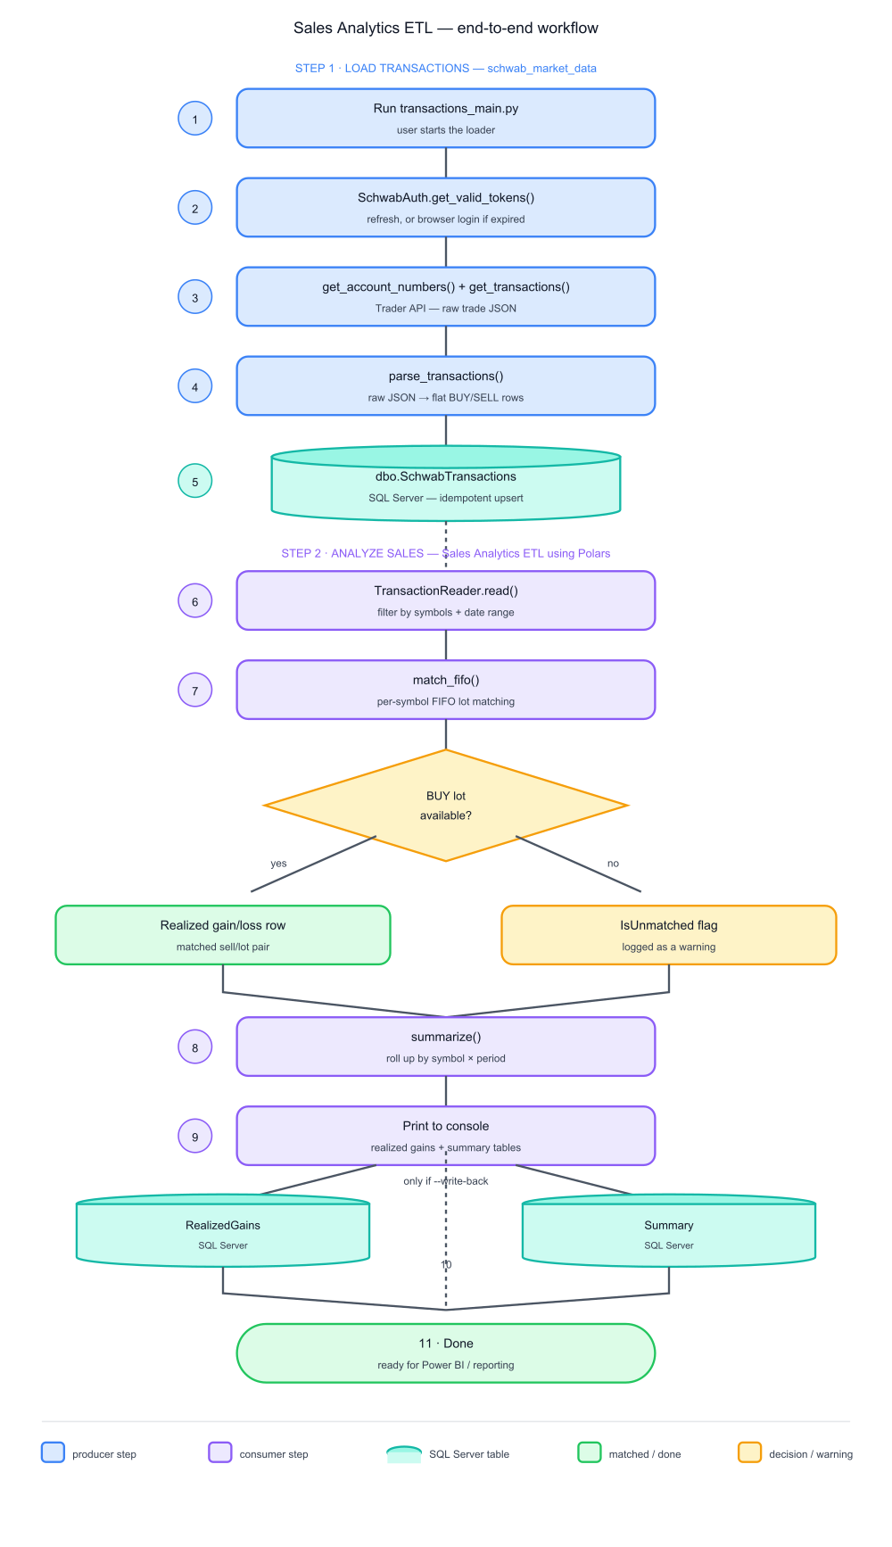

Step reference
- 1. Run transactions_main.py — User starts the loader.
- 2. SchwabAuth.get_valid_tokens() — Refreshes the token, or falls through to an interactive browser login if the refresh token has expired.
- 3. get_account_numbers() + get_transactions() — Calls the Schwab Trader API for the linked account and its raw trade history.
- 4. parse_transactions() — Flattens raw Schwab JSON into flat BUY/SELL rows.
- 5. dbo.SchwabTransactions — Idempotent delete+insert into SQL Server — the handoff point between the two projects.
- 6. TransactionReader.read() — Sales Analytics ETL reads the table, filtered by symbols and trade-date range.
- 7. match_fifo() — Per-symbol FIFO lot matching of each SELL against prior BUY lots.
- 7a. BUY lot available? — Decision point: matched rows get a realized gain/loss; unmatched shortfalls are flagged (IsUnmatched) and logged as a warning, not dropped.
- 8. summarize() — Rolls matched rows up by symbol × period (month or year).
- 9. Print to console — Realized gains and summary tables are always printed.
- 10. RealizedGains / Summary tables — Written to SQL Server only when --write-back is passed.
- 11. Done — Data is ready for reporting (e.g. Power BI) against PBI_Projects.
Generated by Claude Code — reflects the pipeline as built through 2026-07-17.

