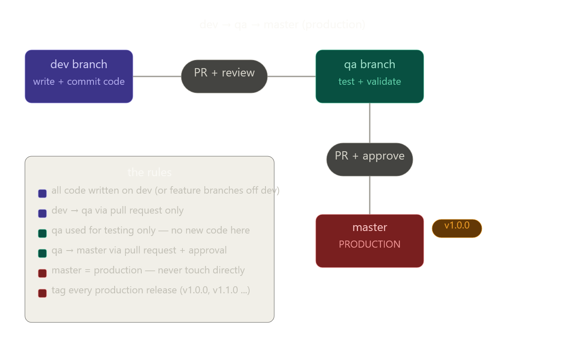

Exactly — that's the complete workflow in one sentence:
dev → qa → master → production
In practice for your Schwab project the daily git commands look like this:
powershell
# 1. Always start work on dev
git checkout dev
git pull origin dev

# 2. Make changes, commit
git diff origin/dev

file names that changed:

git diff origin/dev
git diff origin/dev --name-only
git diff origin/dev --stat

CommandShowsgit diff origin/devfull line-by-line changesgit diff origin/dev --name-onlyjust file namesgit diff origin/dev --statfiles + lines added/removedgit log origin/dev..HEAD --onelinecommits not yet pushed

git add .
git commit -m "add price history loader"
git push origin dev

# 3. When ready — open a PR: dev → qa (on GitHub/Azure DevOps)
# After review and tests pass, merge it

# 4. When qa is validated — open a PR: qa → master
# After approval, merge it and tag the release
git checkout master
git pull origin master
git tag -a v1.0.0 -m "first production release"
git push origin v1.0.0
qa never gets code written directly on it — it only receives merges from dev. master never gets touched directly — it only receives merges from qa.

lets create master
3:21 PM
Run these commands inside your schwab_loader project folder:
bash
cd C:\Ara\Python\Api\Schwab\Working\schwab_market_data

git init
git add .
git commit -m "initial commit - modular schwab market data loader"
git branch -M master

git checkout -b dev
git push -u origin dev

git checkout master
git checkout -b qa
git push -u origin qa

git checkout master
If you already have a remote (GitHub/GitLab/Azure DevOps), add it first:
bash
git remote add origin https://github.com/YOUR_USERNAME/schwab_market_data.git
git push -u origin master
git push -u origin dev
git push -u origin qa
Verify:
bash
git branch -a
Expected output:
dev
* master
qa
remotes/origin/dev
remotes/origin/master
remotes/origin/qa

Do you have an existing remote repo (GitHub, Azure DevOps, etc.) or is this a brand new local repo? That'll determine whether you need the remote add step.
(use "git push" to publish your local commits) (.venv) PS C:\Ara\Python\Api\Schwab\Working\schwab_market_data> dev dev : The term 'dev' is not recognized as the name of a cmdlet, function, script file, or operable program. Check the spelling of the name, or if a path was included, verify that the path is correct and try again. At line:1 char:2 + dev + ~~~ + CategoryInfo : ObjectNotFound: (dev:String) [], CommandNotFoundException + FullyQualifiedErrorId : CommandNotFoundException
(.venv) PS C:\Ara\Python\Api\Schwab\Working\schwab_market_data> * master * : The term '*' is not recognized as the name of a cmdlet, function, script file, or operable program. Check the spelling of the name, or if a path was included, verify that the path is correct and try again. At line:1 char:1 + * master + ~ + CategoryInfo : ObjectNotFound: (*:String) [], CommandNotFoundException + FullyQualifiedErrorId : CommandNotFoundException
(.venv) PS C:\Ara\Python\Api\Schwab\Working\schwab_market_data> qa qa : The term 'qa' is not recognized as the name of a cmdlet, function, script file, or operable program. Check the spelling of the name, or if a path was included, verify that the path is correct and try again. At line:1 char:3 + qa + ~~ + CategoryInfo : ObjectNotFound: (qa:String) [], CommandNotFoundException + FullyQualifiedErrorId : CommandNotFoundException
(.venv) PS C:\Ara\Python\Api\Schwab\Working\schwab_market_data> remotes/origin/dev remotes/origin/dev : The term 'remotes/origin/dev' is not recognized as the name of a cmdlet, function, script file, or operable program. Check the spelling of the name, or if a path was included, verify that the path is correct and try again. At line:1 char:3 + remotes/origin/dev + ~~~~~~~~~~~~~~~~~~ + CategoryInfo : ObjectNotFound: (remotes/origin/dev:String) [], CommandNotFoundException + FullyQualifiedErrorId : CommandNotFoundException
(.venv) PS C:\Ara\Python\Api\Schwab\Working\schwab_market_data> remotes/origin/master remotes/origin/master : The term 'remotes/origin/master' is not recognized as the name of a cmdlet, function, script file, or operable program. Check the spelling of the name, or if a path was included, verify that the path is correct and try again. At line:1 char:3 + remotes/origin/master + ~~~~~~~~~~~~~~~~~~~~~ + CategoryInfo : ObjectNotFound: (remotes/origin/master:String) [], CommandNotFoundException + FullyQualifiedErrorId : CommandNotFoundException
Show more
3:22 PM
You accidentally pasted the output of git branch -a directly into PowerShell instead of just reading it. Those lines (dev, * master, qa, remotes/...) are not commands — they were just showing you what the branches look like.
Your branches are already created correctly! Just run these one at a time to confirm:
powershell
git branch -a
That will show you the list without trying to execute it. Then verify with:
powershell
git status
And to see just local branches:
powershell
git branch
You should see:
dev
* master
qa
The * just means you're currently on master — everything looks like it worked fine. Do you have a remote repo set up (GitHub, Azure DevOps, etc.) to push these branches to?
(.venv) PS C:\Ara\Python\Api\Schwab\Working\schwab_market_data> dev dev : The term 'dev' is not recognized as the name of a cmdlet, function, script file, or operable program. Check the spelling of the name, or if a path was included, verify that the path is correct and try again. At line:1 char:2 + dev + ~~~ + CategoryInfo : ObjectNotFound: (dev:String) [], CommandNotFoundException + FullyQualifiedErrorId : CommandNotFoundException
(.venv) PS C:\Ara\Python\Api\Schwab\Working\schwab_market_data> * master * : The term '*' is not recognized as the name of a cmdlet, function, script file, or operable program. Check the spelling of the name, or if a path was included, verify that the path is correct and try again. At line:1 char:1 + * master + ~ + CategoryInfo : ObjectNotFound: (*:String) [], CommandNotFoundException + FullyQualifiedErrorId : CommandNotFoundException
(.venv) PS C:\Ara\Python\Api\Schwab\Working\schwab_market_data> qa qa : The term 'qa' is not recognized as the name of a cmdlet, function, script file, or operable program. Check the spelling of the name, or if a path was included, verify that the path is correct and try again. At line:1 char:3 + qa + ~~ + CategoryInfo : ObjectNotFound: (qa:String) [], CommandNotFoundException + FullyQualifiedErrorId : CommandNotFoundException
(.venv) PS C:\Ara\Python\Api\Schwab\Working\schwab_market_data> remotes/origin/dev remotes/origin/dev : The term 'remotes/origin/dev' is not recognized as the name of a cmdlet, function, script file, or operable program. Check the spelling of the name, or if a path was included, verify that the path is correct and try again. At line:1 char:3 + remotes/origin/dev + ~~~~~~~~~~~~~~~~~~ + CategoryInfo : ObjectNotFound: (remotes/origin/dev:String) [], CommandNotFoundException + FullyQualifiedErrorId : CommandNotFoundException
(.venv) PS C:\Ara\Python\Api\Schwab\Working\schwab_market_data> remotes/origin/master remotes/origin/master : The term 'remotes/origin/master' is not recognized as the name of a cmdlet, function, script file, or operable program. Check the spelling of the name, or if a path was included, verify that the path is correct and try again. At line:1 char:3 + remotes/origin/master + ~~~~~~~~~~~~~~~~~~~~~ + CategoryInfo : ObjectNotFound: (remotes/origin/master:String) [], CommandNotFoundException + FullyQualifiedErrorId : CommandNotFoundException
Show more
4:03 PM
You are still pasting the output into PowerShell. Those lines are not commands — they are just text to read.
Please type these commands one at a time, pressing Enter after each:
Step 1 — check your branches:
powershell
git branch
Step 2 — if dev and qa are missing, create them:
powershell
git checkout -b dev
git checkout master
git checkout -b qa
git checkout master
Step 3 — confirm all three exist:
powershell
git branch
You should see:
dev
* master
qa
Just read that output — do not paste it back in. Do you see all three branches listed?
(.venv) PS C:\Ara\Python\Api\Schwab\Working\schwab_market_data> git branch dev * master qa (.venv) PS C:\Ara\Python\Api\Schwab\Working\schwab_market_data> git checkout -b dev fatal: a branch named 'dev' already exists (.venv) PS C:\Ara\Python\Api\Schwab\Working\schwab_market_data> git checkout master Already on 'master' Your branch is ahead of 'origin/main' by 1 commit. (use "git push" to publish your local commits) (.venv) PS C:\Ara\Python\Api\Schwab\Working\schwab_market_data> git checkout -b qa fatal: a branch named 'qa' already exists (.venv) PS C:\Ara\Python\Api\Schwab\Working\schwab_market_data> git checkout master Already on 'master' Your branch is ahead of 'origin/main' by 1 commit. (use "git push" to publish your local commits) (.venv) PS C:\Ara\Python\Api\Schwab\Working\schwab_market_data>
Show more
4:08 PM
All three branches already exist and everything is good. Here's the current state:
dev — exists
master — current branch (marked with *)
qa — exists
The only remaining thing is this warning:
Your branch is ahead of 'origin/main' by 1 commit.
Your remote is called origin/main but your local default is master. Fix that by pushing master to the remote:
powershell
git push origin master
Then push dev and qa to the remote too:
powershell
git push origin dev
git push origin qa
After that run:
powershell
git branch -a
And you should see all three on both local and remote:
dev
* master
qa
remotes/origin/dev
remotes/origin/master
remotes/origin/qa

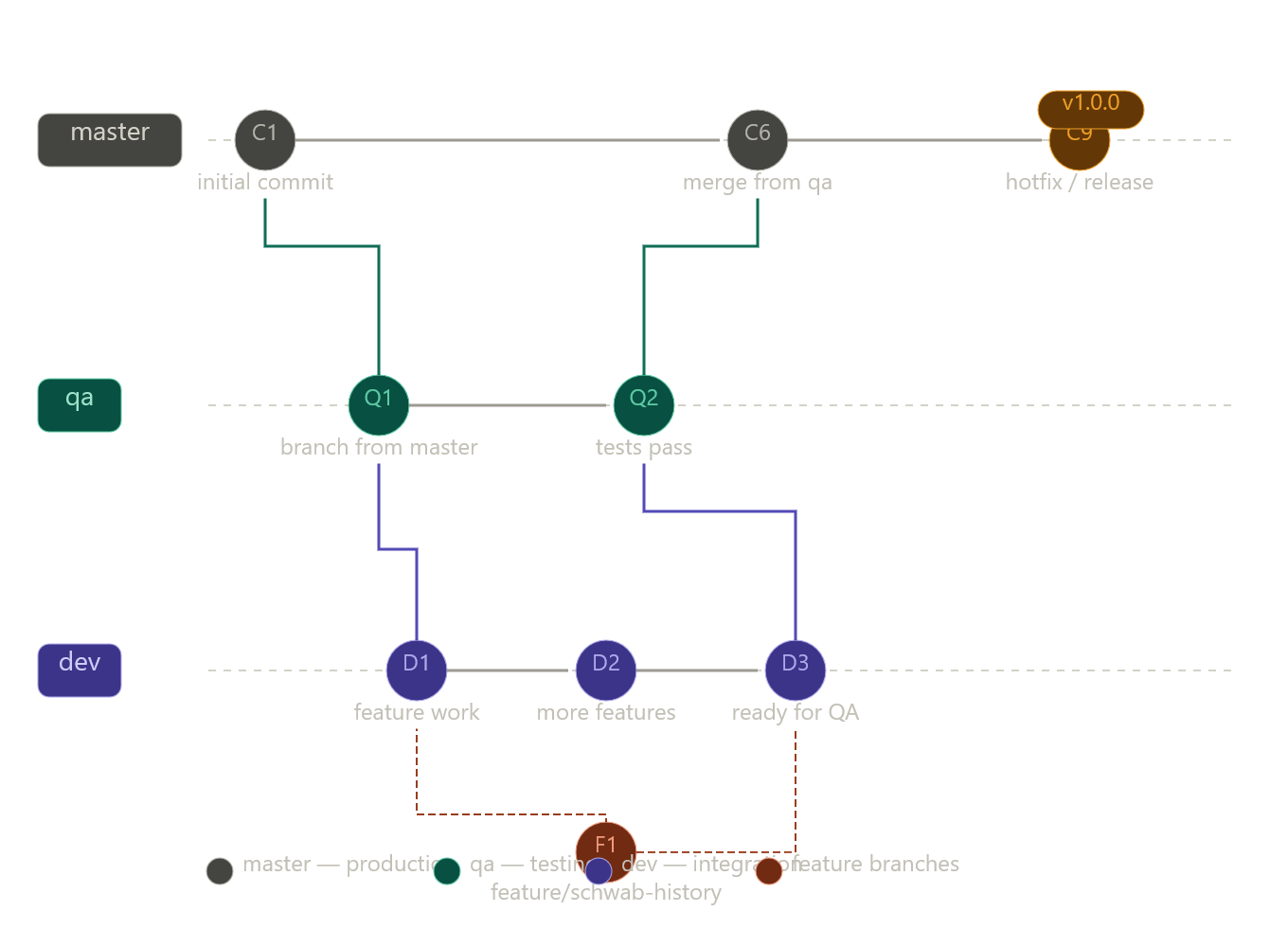

Click any node to ask about that part of the workflow. Here's what each branch is for in your project:
- master — production only. Only receives merges from qa after testing passes, or emergency hotfixes tagged as releases (v1.0.0)
- qa — staging/testing. Receives merges from dev when features are ready to test
- dev — daily integration. All feature branches merge back here first
- feature/* — short-lived branches off dev for individual pieces of work (e.g. feature/schwab-history, feature/price-history-loader)
The dashed lines show feature branch creation and merge — always branching from dev and merging back to dev, never directly to qa or master.

You're right — the golden rule is nobody touches master directly. The only path in is a Pull Request from qa, after tests pass and at least one reviewer approves.
To enforce this in GitHub, go to Settings → Branches → Add rule and check:
- Require pull request reviews before merging
- Require status checks to pass
- Restrict who can push
- Block force pushes
- Block deletions
In Azure DevOps it's under Repos → Branches → Branch Policies on master.
The flow is always: feature/* → dev → qa → master (PR only). Master only ever moves forward, never backward.

Sonnet 4.6

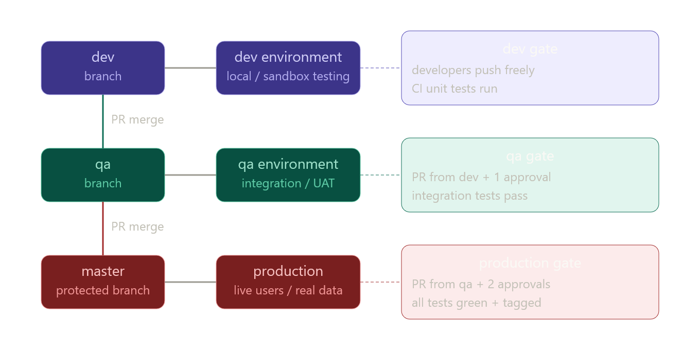

The rule is simple — one branch, one environment:
Branch | Deploys to | Who can push
dev | dev / sandbox | developers freely
qa | qa / staging | PR from dev only
master | production | PR from qa only, protected
So the full journey for your Schwab code is:
feature/price-history → dev → qa → master → PRODUCTION
master is the production branch. When you tag a release (v1.0.0) on master, that is exactly what goes live. dev and qa never touch production directly.



Exactly — that's the complete workflow in one sentence:
dev → qa → master → production
In practice for your Schwab project the daily git commands look like this:
powershell
# 1. Always start work on dev
git checkout dev
git pull origin dev

# 2. Make changes, commit
git add .
git commit -m "add price history loader"
git push origin dev

# 3. When ready — open a PR: dev → qa (on GitHub/Azure DevOps)
# After review and tests pass, merge it

# 4. When qa is validated — open a PR: qa → master
# After approval, merge it and tag the release
git checkout master
git pull origin master
git tag -a v1.0.0 -m "first production release"
git push origin v1.0.0
qa never gets code written directly on it — it only receives merges from dev. master never gets touched directly — it only receives merges from qa.

