Github branch management

List branches
current branch
git branch
git branch -vv

git branch -a
* dev ← local current branch
main ← local branch
qa ← local branch
remotes/origin/dev ← remote branch
remotes/origin/main ← remote branch
remotes/origin/qa ← remote branch

git branch local
git branch -r remote

remote current branch as well
git branch -avv
* dev abc1234 [origin/dev] your last commit message ← local current + tracking remote
main def5678 [origin/main] initial commit
qa ghi9012 [origin/qa] test pass
remotes/origin/dev abc1234 your last commit message
remotes/origin/main def5678 initial commit
remotes/origin/qa ghi9012 test pass

git branch -list branches
git config --global init.defaultBranch main
rename branch If your repo currently says master and you want to rename it to main:
git branch -m master main
git push -u origin main

git branch -vv

Create dev branch from main:
- git checkout main
- git checkout -b dev
- git push -u origin dev
Create qa branch from main:
- git checkout main
- git checkout -b qa
- git push -u origin qa
Verify all 3 branches exist:
* qa
dev
main
remotes/origin/dev
remotes/origin/main
remotes/origin/qa
Yes, that's exactly the standard Git branching workflow:
dev → qa → main

# always work in dev
git checkout dev

# make changes, then commit
git add .
git commit -m "your message"
git push origin dev

When ready to test — merge dev into qa:
git checkout qa
git merge dev
git push origin qa

When qa is approved — merge qa into main:
git checkout main
git merge qa
git push origin main

Go back to dev to continue working:
git checkout dev

git branch

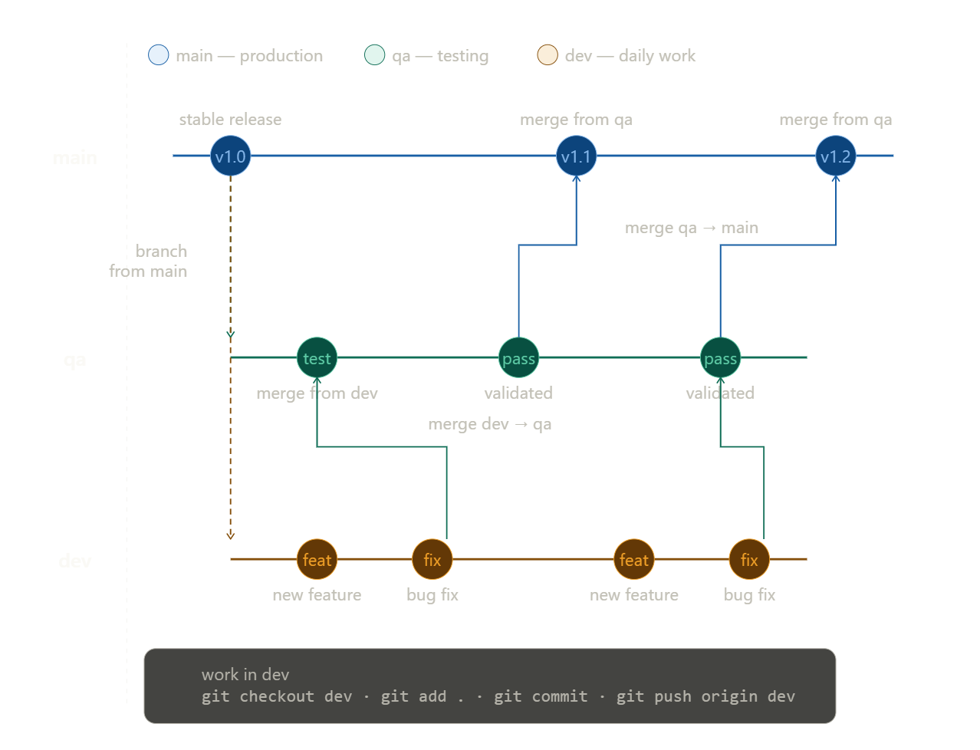

The flow reads left to right — time moves forward. Both qa and dev branch off main at the start. Work happens in dev (commits: feat, fix), gets merged up to qa for testing, then once validated merges up to main as a new release. The cycle repeats for every feature batch.

Run this in your project folder:
powershell
git push -u origin dev
That pushes your local dev branch to the remote and sets it as the tracking branch. From now on git push and git pull will sync with origin/dev.
Verify it worked:
powershell
git branch -vv
You should see:
* dev abc1234 [origin/dev] your last commit message

