Titanium Analytics
Results Analysis and Recommendations
Jensen Beach AHU1 temperature, AHU 1 (channel 0) - main building north wing (°F) | 2025-08-01 to 2025-08-14

Summary
This report reviews an exported results file from the Extreme & Change Analytics Lab using three methods: Extremes, Changes and Volatility. Each real abnormality is reported as location, condition, normal range, observed value, magnitude, duration and status.
- Data gap: no readings from 2025-08-06 09:45 to 2025-08-06 22:00 (12 h 15 min).
- Below typical from 2025-08-09 22:00 to 2025-08-10 06:45 (9 h), up to 7.56°F from typical.
- The engine flagged 47 events with a 5.0-hour baseline; with a 24.0-hour baseline the same data gives 6.
Source file | res.csv
Period | 2025-08-01 00:00 to 2025-08-14 23:45
Readings | 1,296, about one every 15.0 minutes (660 Night, 636 Day)
Analysis settings in the file | Window 20 (about 5.0 h), K_E 2.0
Reference | No reference document configured

1. How this sensor normally behaves
The typical daily swing is 5.6-7.84°F; schedule transitions happen around hours 7, 8, 9, 10, 18, 19, 20, 21, 22.
Hours | Typical value (°F)
00:00-03:59 | 80.08
04:00-07:59 | 80.08
08:00-11:59 | 74.76-78.96
12:00-15:59 | 74.76-75.04
16:00-19:59 | 74.76-75.6
20:00-23:59 | 77.28-80.08

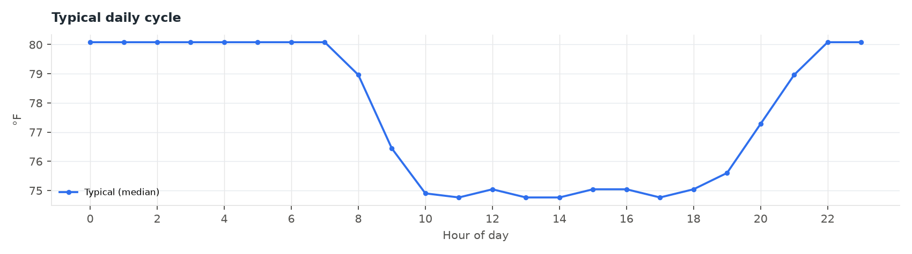
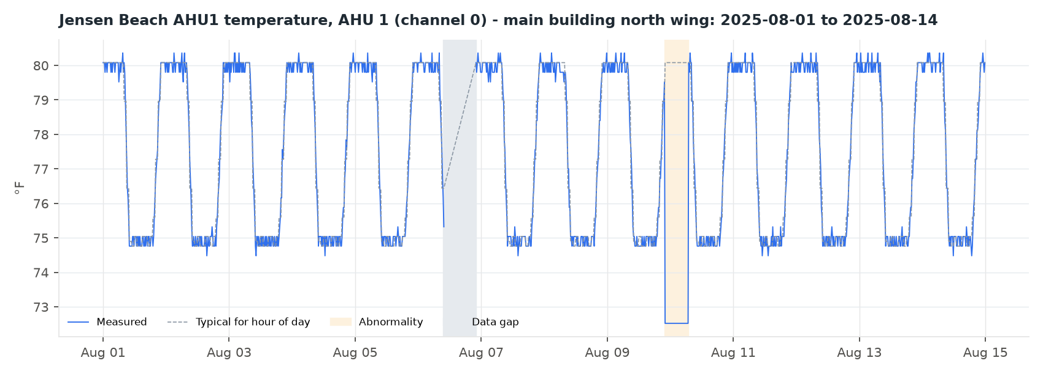
Shaded: abnormalities (orange) and data gaps (grey). Dashed line: typical value for each hour of the day.

2. Extremes: abnormalities found
Each reading was compared with the typical value for the same hour of the day. Deviations larger than 1.25°F lasting at least an hour are reported.

Abnormality 1: Data gap
Location | Jensen Beach AHU1 temperature, AHU 1 (channel 0) - main building north wing
Condition | No readings received
Normal | A reading about every 15.0 minutes
Observed | Last reading 2025-08-06 09:45, next reading 2025-08-06 22:00
Magnitude | About 48 readings missing
Duration | 12 h 15 min
Status | Resolved, readings resumed

Readings resumed after the gap.

Abnormality 2: Below typical for this time of day
Location | Jensen Beach AHU1 temperature, AHU 1 (channel 0) - main building north wing
Condition | Unusually low for the time of day
Normal range | 80.08-80.08°F
Observed | 72.52-72.52°F; 72.52°F at 2025-08-09 22:00
Magnitude | Up to 7.56°F below typical
Duration | 9 h (2025-08-09 22:00 to 2025-08-10 06:45, Saturday)
Status | Resolved

- Observed 72.52-72.52°F where 80.08-80.08°F is typical.
Hypothesis to investigate (not a conclusion): Check schedules, overrides and equipment logs for this period - a hypothesis to check, not a conclusion.

3. Changes
- Typical fastest change: -0.84°F down, 0.84°F up per reading.
- 70.0% of abnormal-change flags fall in schedule transition hours.

4. Volatility
- Daily variability of changes stays between 0.32 and 0.83°F.

5. Why the engine flagged what it did
 | Window 20 (about 5.0 h) - in file | Window 96 (about 24.0 h)
Extreme readings | 246 | 46
Non-normal readings | 485 | 170
Separate events | 47 | 6

93.0% of extreme flags (228 of 246) fall in schedule transition hours, and 50 came from periods with almost no variability.

6. Recommendations

Building operations
- Review the abnormal periods. Check schedules, overrides and equipment logs for the periods listed.
- Check the data gap. Find the cause and alert on missing data.

Analytics engine and app
- Use a daily baseline. A window covering one day avoids flagging the normal cycle.
- Add a variability floor. At least one sensor step, so a single tick cannot trigger an extreme.

Limitations
- Causes are hypotheses for investigation.
- The typical baseline uses only the period in this file.

About this report
Generated 2026-10-09 16:09 by the Extreme & Change Analytics Lab.
All tables and numbers were computed by the app from the results data.
AI wording not used: no OpenAI API key is set ([openai] api_key in config.local.ini).

