Titanium Analytics
Results Analysis and Recommendations
Jensen Beach, AHU 1 (channel 0), temperature (°F) | Aug 1 to Aug 21, 2025

Summary
This report reviews one exported results file from the Extreme & Change Analytics Lab using the three methods described in the Titanium Analytics document: Extremes, Changes and Volatility. Each real abnormality is reported in the document's format: location, condition, normal range, observed value, magnitude, duration and status.
- Two real abnormalities: a 12-hour data outage on Sunday Aug 10, and an unoccupied setback that was not followed over the Aug 9-11 weekend (up to 7.3°F below typical).
- Most app flags were the normal daily cycle: with a 5-hour baseline (Window 20), 73 events were flagged in 3 weeks; with a daily baseline (Window 96) the same data gives 5.
- The system is otherwise stable: consistent schedule, consistent pull-down rate, no worsening volatility trend.

Source file | extreme_data_AHU_1_channel_0_Fahrenheit_20250801-1129_to_20250821-1158_p1.csv
Period | Aug 1, 2025 11:29 to Aug 21, 2025 11:58 (page 1 of the export)
Readings | 2,000, one every 15 minutes (1,137 Day, 863 Night)
Analysis settings in the file | Bollinger / Z-score baseline, Window 20, K_E 2.0
Reference | Titanium_analytics.docx (Extremes, Changes, Volatility; abnormality report format)

1. How this building normally behaves
The data shows a very regular daily cycle, repeated almost every day of the week. The daily swing is 6.2 to 7.6°F and the weekly pattern is stable.
Time | Typical temperature | Interpretation
10:00-18:00 | 74.6-74.9°F | Occupied, cooling holding setpoint
19:00-23:00 | Rising to about 80°F | Cooling setback starts
00:00-08:00 | 79.7-80.3°F | Unoccupied, held at setback
08:00-10:00 | Falling about 1.4°F per 15 min | Morning pull-down

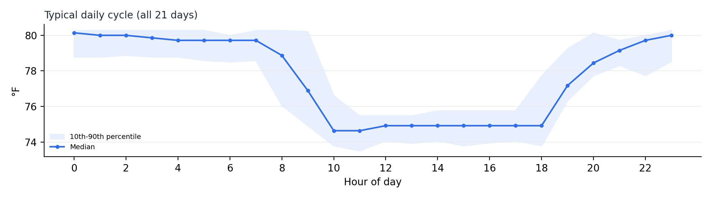
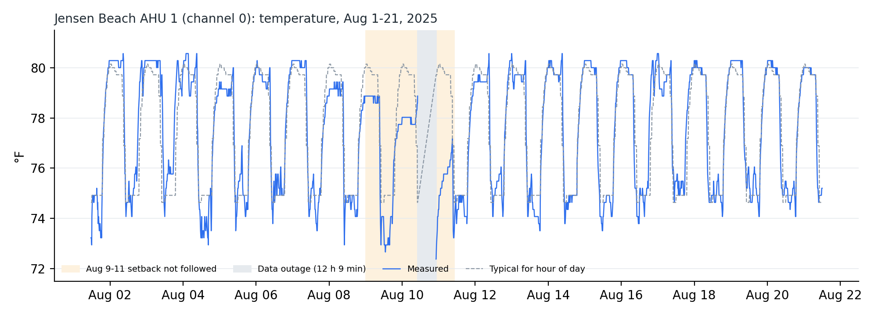
Shaded: the Aug 9-11 abnormality (orange) and the data outage (grey). Dashed line: typical temperature for each hour of the day.

2. Extremes: abnormalities found
Each reading was compared with the typical temperature for the same hour of the day across all 21 days. Two conditions stand out.

Abnormality 1: Data outage
Location | Jensen Beach, AHU 1 (channel 0)
Condition | No readings received
Normal | A reading every 15 minutes
Observed | Last reading Aug 10 10:08, next reading Aug 10 22:17
Magnitude | About 48 readings missing
Duration | 12 hours 9 minutes (Sunday)
Status | Resolved, readings resumed

Abnormality 2: Unoccupied setback not followed (Aug 9-11)
Location | Jensen Beach, AHU 1 (channel 0)
Condition | Unusually low temperature during unoccupied hours
Normal range (22:00-08:00) | 79.7-80.3°F
Observed | 72.38°F at Aug 10 22:17; 74.8-76.7°F through Monday morning
Magnitude | Up to 7.3°F below typical; 3.5-5.4°F below typical until 08:00 Monday
Duration | About 10 hours after the outage, with a weaker build-up from Saturday Aug 9
Status | Resolved, normal behavior from Aug 11 10:00

- Saturday Aug 9 already ran 1-2°F cooler than typical all day (about 72.9-73.2°F at midday against a typical 74.9°F).
- The Saturday and Sunday night setbacks plateaued at 78.9°F and 78.0°F instead of about 80.3°F.
- After the outage the space was cooled overnight as if occupied.
Hypothesis to investigate (not a conclusion): a schedule override, manual mode, or a controller restart after the outage that defaulted to occupied cooling.

Minor observations
- Sunday Aug 3: at 10:00 the temperature was still 78.5°F (typical 74.6°F, +3.8°F), so the pull-down started about an hour late; the afternoon ran 0.7-1.1°F warm.
- Weekend evenings (Aug 2, 3, 16, 17) start warming at about 18:15 instead of about 19:00 on weekdays, suggesting a slightly different weekend schedule.

3. Changes
- The morning pull-down rate is very consistent: the fastest normal drop is 1.41°F per 15 minutes, every weekday around 09:00. 124 of the 170 abnormal-change flags are daytime, mostly 08:00-09:00, so they reflect the schedule, not abnormal behavior.
- Aug 13 09:26 had a slightly steeper drop (-1.69°F). Minor; worth watching only if it repeats.
- The largest jump (-6.49°F) is not a real change: it spans the 12-hour data gap.

4. Volatility
- Overall the system is stable: the daily variability of 15-minute changes stays between 0.29 and 0.41°F, with no worsening trend over the 3 weeks.
- Daytime is naturally more variable than night (0.43°F against 0.28°F), as expected with cooling cycling.
- Aug 8 and Aug 14 had more up-and-down reversals (19.6 and 17.5 per 100 readings, against about 11 typically). Mild; watch for valve or damper hunting if this increases.
- The sensor reports in 0.28°F steps (72.38, 72.66, 72.94 and so on), so overnight values often sit perfectly flat.

5. Why the app flagged so much
 | Current export (Window 20) | Same data, Window 96
Extreme readings | 335 | 49
Non-normal readings | 883 (44%) | 195
Separate events | 73 | 5

Window 20 is a 5-hour baseline, so every evening warm-up and morning pull-down looks "extreme". 75% of the extreme flags (251 of 335) fall in transition hours. Another 62 flags came from overnight periods with almost no variability, where a single 0.28°F sensor step produced Z-scores up to 4.25; the typical deviation behind those flags was only 0.27°F.

6. Recommendations

Building operations
- Investigate the Aug 10 outage (sensor, gateway, network or power) and alert on missing data longer than 1 hour.
- Check the BMS logs for Aug 9-11: overrides, manual mode, schedule edits and controller restarts. Confirm the controller resumes its schedule after a power or communication loss.
- Confirm the intended setpoints (occupied about 74.9°F, unoccupied about 80.3°F) and record them as official normal ranges.
- Review the weekend schedule. Weekends are cooled to the same 74.9°F as weekdays; if the building is lightly occupied, a weekend setback could save energy.

Analytics engine and app
- Use a daily baseline (Window 96 for 15-minute data). This alone reduced 73 events to 5.
- Add an hour-of-day baseline that compares each reading with what is typical for that hour. It isolated the Aug 9-11 problem and ignored the normal cycle.
- Add a minimum variability floor of at least the 0.28°F sensor step, so one sensor tick cannot trigger an extreme.
- Add data-gap detection as its own abnormality type.
- Add a Volatility channel (variability against its own baseline, plus reversal counts). The Titanium document promises Volatility; the engine currently has Extremes and Changes only.
- Report events, not rows, in the document's table format.

7. Market review: output against the Titanium document
Promise in the document | Today | After the recommended fixes
Extremes, Changes, Volatility | Volatility not implemented | All three covered
Fewer unnecessary notifications | 73 events in 3 weeks, mostly the normal schedule | About 5 events, real ones on top
Concise report per abnormality | Row-level CSV | One table per event, as in section 2
Find problems before a tenant complains | Real issue buried among false flags | Aug 9-11 and the outage surface immediately

The Aug 9-11 weekend is a strong case study: a real, explainable abnormality (an outage followed by the setback not being restored) that conventional threshold alarms would likely miss, because 72-76°F is within normal comfort limits.

Limitations
- This covers page 1 of the export only: 3 weeks of the 13 months available (Aug 1, 2025 to Sep 25, 2026).
- Causes are hypotheses for investigation. The data shows statistical patterns; it does not record why they happened.
- The "typical" baseline uses these 21 days only; a longer history would give a stronger baseline.

