schwab_market_data_pyspark — Project Workflow Chart
Rolling moving averages, Bollinger Bands, and Z-Score anomaly flags computed with Spark window functions over dbo.SchwabQuotesHistory (populated by the sibling schwab_market_data project). No changes were made to the existing analytics or db logic — this documents the pipeline as already built.
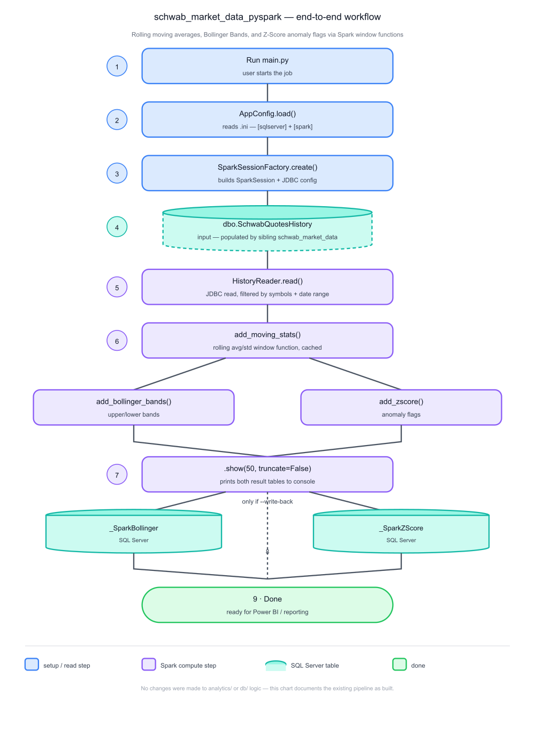

Step reference
- 1. Run main.py - Composition root — parses CLI args, sets up logging.
- 2. AppConfig.load() - Reads schwab_market_data_pyspark.ini — [sqlserver] and [spark] sections.
- 3. SparkSessionFactory.create() - Builds the SparkSession, including the mssql-jdbc Maven package config.
- 4. dbo.SchwabQuotesHistory - Input table — populated by the sibling schwab_market_data project, not this one.
- 5. HistoryReader.read() - JDBC read pushed down by symbols + date range subquery.
- 6. add_moving_stats() - Rolling average/stddev over a trailing window; result is cached since both downstream branches fork from it.
- 6a. add_bollinger_bands() - Upper/lower bands from the cached moving stats.
- 6b. add_zscore() - Anomaly flags from the cached moving stats.
- 7. .show(50, truncate=False) - Always prints both result tables to console.
- 8. Write-back tables - SchwabQuotesHistory_SparkBollinger / _SparkZScore — written only when --write-back is passed.
- 9. Done - Data is ready for reporting (e.g. Power BI) against PBI_Projects.
Generated by Claude Code - infrastructure replicated from the Sales Analytics ETL using Polars project, 2026-07-21.

