|  |  |  |
| --- | --- | --- |
| Bit3 bit2 bit1 bit0 | Theoretical DAC voltage | Measured DAC voltage |
| 0 | 0V | .5mV |
| 1 | .22V | 0.0548V |
| 2 | .44V | 109.1mV |
| 3 | .66V | 163.4mV |
| 4 | .88V | 216mV |
| 5 | 1.1V | 270.3mV |
| 6 | 1.32V | 324.6mV |
| 7 | 1.54V | 379mV |
| 8 | 1.76V | 429mV |
| 9 | 1.98V | 484mV |
| 10 | 2.2V | 538mV |
| 11 | 2.42V | 592mV |
| 12 | 2.64V | 645mV |
| 13 | 2.86V | 699mV |
| 14 | 3.08V | 753mV |
| 15 | 3.3V | 808mV |

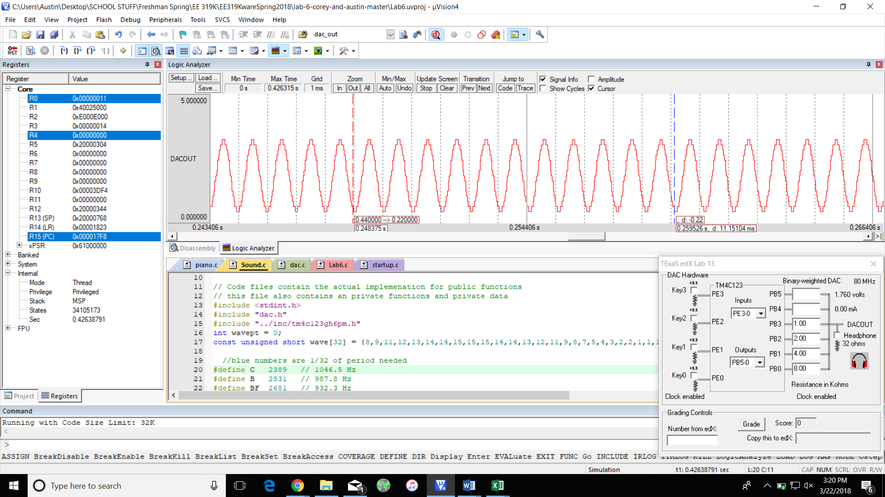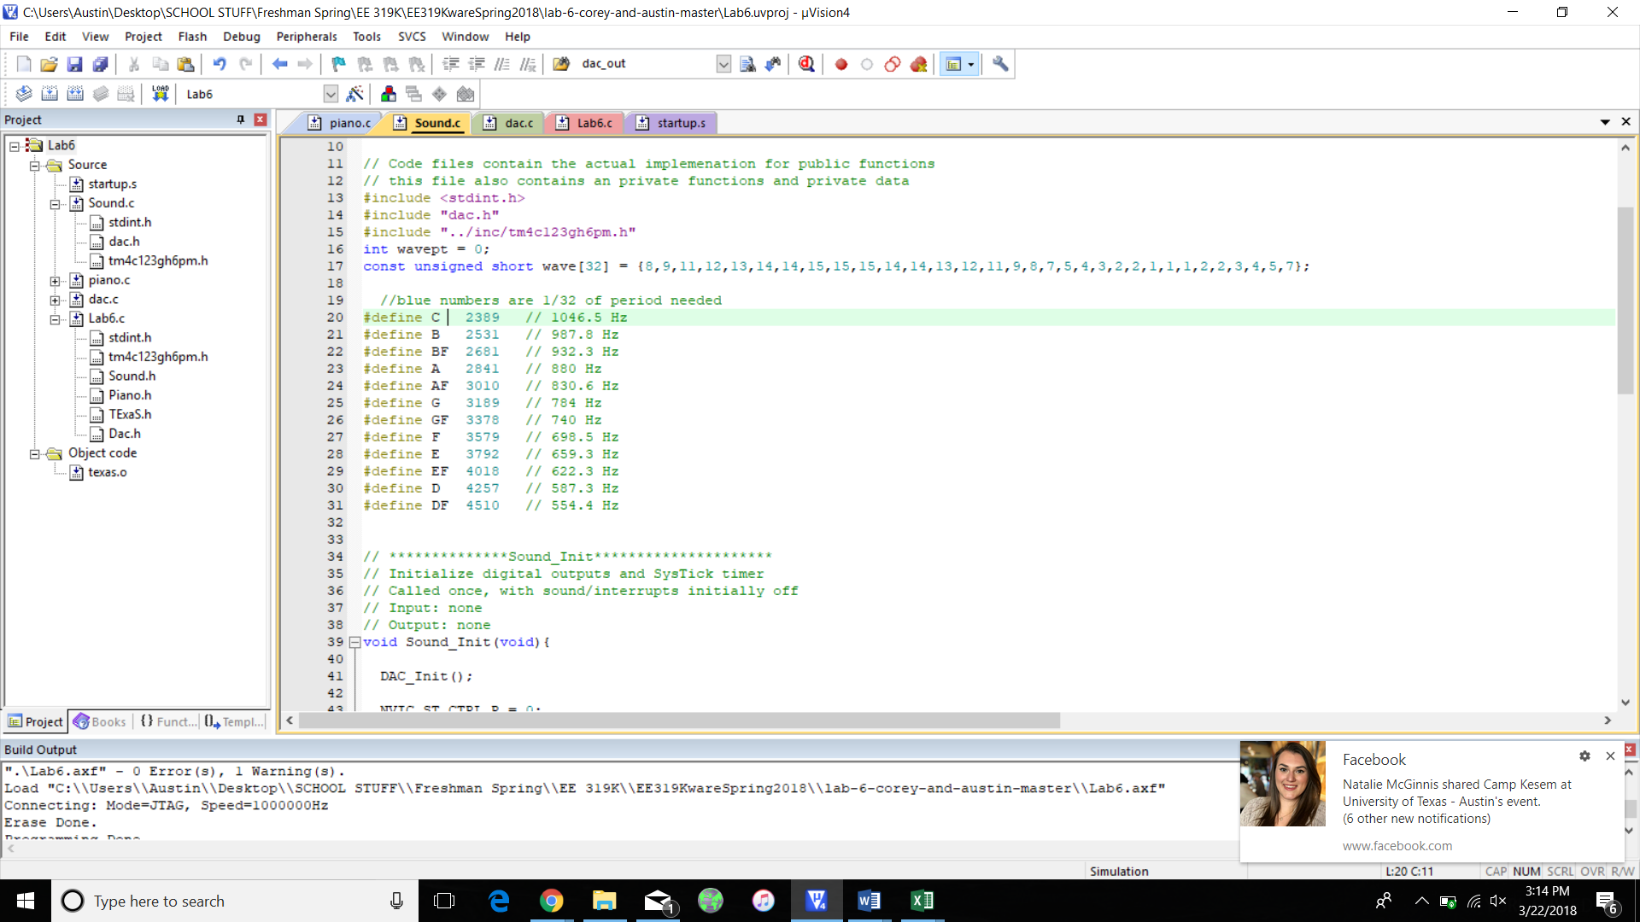

Range =3.08V

Precision=