PomoDojo - Source Code Overview
Project: PomoDojo - Cross-Platform Pomodoro Timer Application
Team: Ablasse Kingcaid-Ouedraogo, Sebastian Reyna, Praise Fisher-Afolabi
Course: COSC 4320 - Fall 2025
__________________________________________________

Source Code Summary
The PomoDojo application consists of 11 source files with 616 lines of code, organized across three layers: Frontend (C#), Interoperability (P/Invoke), and Backend (C++).

Program Units and Modules
File | Module | Lines | Purpose
`Program.cs` | Entry Point | 26 | Application bootstrap and profile loading
`UIController.cs` | UI Presentation | 166 | Console menu and user interaction
`SessionManager.cs` | Session Orchestration | 99 | Timer state management and session transitions
`Session.cs` | Session Model | 68 | Session data structure and state machine
`TimerEngine.cs` | Timer Execution | 40 | Asynchronous countdown loop
`Profile.cs` | Profile Management | 92 | User account creation and persistence
`UserSettings.cs` | Settings Model | 8 | Timer configuration data structure
`NotificationService.cs` | Notifications | 9 | Session completion alerts
`Interop/NativeApi.cs` | P/Invoke Bridge | 23 | C++/C# interoperability layer
`native/pomodojo.cpp` | Timer Core | 67 | Native timer implementation
`native/pomodojo.h` | API Header | 18 | Native function declarations

__________________________________________________

Layer Descriptions

Frontend Layer (C# - 9 Modules)
Program.cs - Application entry point that creates the data directory, loads existing user profiles from JSON storage, and initializes the UI controller.
UIController.cs - Primary user interface module implementing a console-based menu system. Handles user authentication (login/registration), displays session status with countdown timer, and provides settings management. Manages the main application loop with polling-based UI updates.
SessionManager.cs - Central orchestration module bridging the UI and native timer. Calls P/Invoke functions to control the C++ timer, tracks session transitions between work and break periods, maintains completed Pomodoro count, and triggers notifications. Loads and applies user settings from profiles.
Session.cs - Data model representing individual timer sessions. Defines SessionType enumeration (Focus, ShortBreak, LongBreak, None) and implements session state management (running, paused, finished) with a Tick() method for countdown operations.
TimerEngine.cs - Asynchronous timer execution module using CancellationTokenSource for graceful shutdown. Runs a loop that calls Session.Tick() every second when active.
Profile.cs - User profile management with JSON serialization. Provides static methods for profile creation (SetupProfile), loading (LoadProfile), and persistence (SaveAllProfiles). Tracks total Pomodoros completed per user.
UserSettings.cs - Configuration data model containing timer duration settings: FocusMinutes (default: 25), ShortBreakMinutes (default: 5), LongBreakMinutes (default: 15), PomodorosBeforeLongBreak (default: 4), and AutoStartNext flag.
NotificationService.cs - Simple notification module that outputs session completion alerts to the console with an audible bell character.

Interoperability Layer (P/Invoke - 1 Module)
Interop/NativeApi.cs - Platform Invocation Services bridge providing four static extern methods decorated with [DllImport] attributes:
- `StartPomodojo(int workMinutes, int breakMinutes)` - Initiates timer with specified durations
- `StopPomodojo()` - Terminates the running timer
- `GetRemainingSeconds()` - Returns current countdown value
- `IsWorkPeriod()` - Returns boolean indicating work vs. break period
Uses CallingConvention.Cdecl for C++ compatibility and MarshalAs(UnmanagedType.I1) for boolean marshaling.

Backend Layer (C++ - 2 Modules)
native/pomodojo.h - Header file defining cross-platform DLL export macros (POMODOJO_API) with Windows __declspec and Linux __attribute__ variants. Declares the four extern "C" functions for C-compatible ABI.
native/pomodojo.cpp - Core timer implementation using C++ standard library features:
- Atomic variables (`std::atomic<bool>`, `std::atomic<int>`) for thread-safe state sharing
- Dedicated timer thread (`std::thread`) spawned on `StartPomodojo()` call
- TimerLoop function implementing alternating work/break cycle with 1-second precision
- Thread-safe countdown without mutex locks using atomic operations
__________________________________________________

Data Storage
data/profiles.json - JSON file storing user profiles with settings and statistics. Uses System.Text.Json for serialization with indented formatting for readability.
__________________________________________________

Build Artifacts
File | Description
`build/PomoDojo` | Compiled executable
`build/PomoDojo.dll` | .NET assembly
`native/pomodojo.dll` | Windows native library
`native/pomodojo.so` | Linux native library
`native/libpomodojo.so` | Linux library (with lib prefix)

__________________________________________________

Architecture Diagram
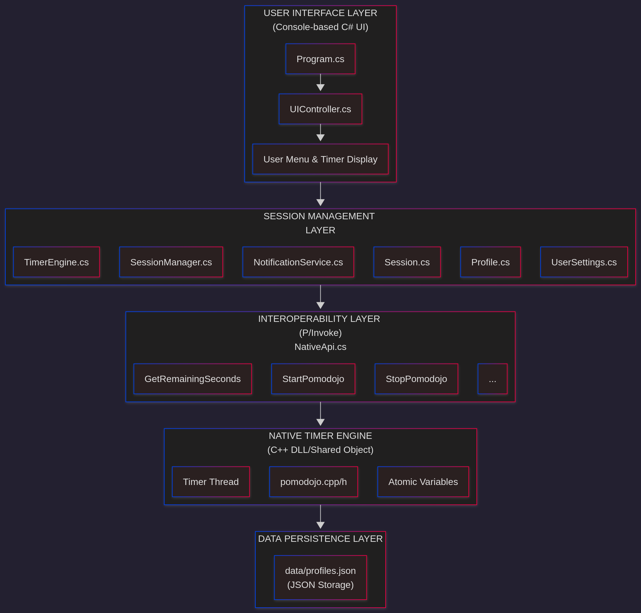
__________________________________________________

Dependency Chain
Program.cs
└── UIController.cs
└── SessionManager.cs
├── NativeApi.cs (P/Invoke)
│ └── pomodojo.dll/.so
├── Profile.cs
├── UserSettings.cs
└── NotificationService.cs

