**INCEPTION**

Team 7

**Project Vision**

Our objective is to develop a game to rekindle childhood memories of playing board games, but with a modern touch of strategic gameplay. It will a 2D board game with various characters, powerups, and interesting graphic design. The game will not be a multiplayer game. However, you can play against AI or with your friend using the same device.

**Features**

Our concept is to create a board game where players take turns to roll the dice for movement and choose one of three characters to move around the board in a predefined path, with the goal to have all 3 characters on the final space. Many spaces will affect the character in some way, ranging from damage, moving forward or backward along the board, or gaining a temporary benefit. If a character runs out of health they will respawn at the last checkpoint passed along the board. If a character lands on a space with an enemy character, they will inflict damage on each other. The target audience for our game is anyone who loves to play board games.

Features of a good board game:

* Rules that are easy to understand and remember
* Strategic decisions with an element of luck
* Fun playing pieces
* Can be played over and over again [1]

Our features:

* Game characteristics
  + 2D
  + Offline
  + Single device multiplayer mode
* Simple Objective - Get all three of your characters to the end tile to win the game.
* Components
  + Tiles - road from start to finish
  + Characters - each player will play with 3 characters
  + Dice - to determine character movement
* Engaging gameplay - When you land on a tile, an event will occur.
  + Forward or backward moves
  + Health damage and regeneration
  + Obtain event cards
  + Portals: Takes the character to another tile
  + Quicksand: Capture the character until a certain dice number is rolled
* Event cards - Event Cards will be a form of powerups and special events in our game. We plan to devise different types of wildcards to make the game full of fun. Powerups can affect any characters on the board.
  + Freeze one of the opponent's characters
  + Double your next move
  + Choose your steps
  + Deduct opponent’s next move
  + Inflict damage
  + Heal damage
* A mix of tactical play and luck - When a dice is rolled, the player can decide on which character to move. The strategy will be formed based on the location of the player’s characters, the location of the opponent’s characters, and the type of tiles nearby.
* Characters - We will include a wide variety of fictional characters to choose from.

**Hand-sketched main menu**

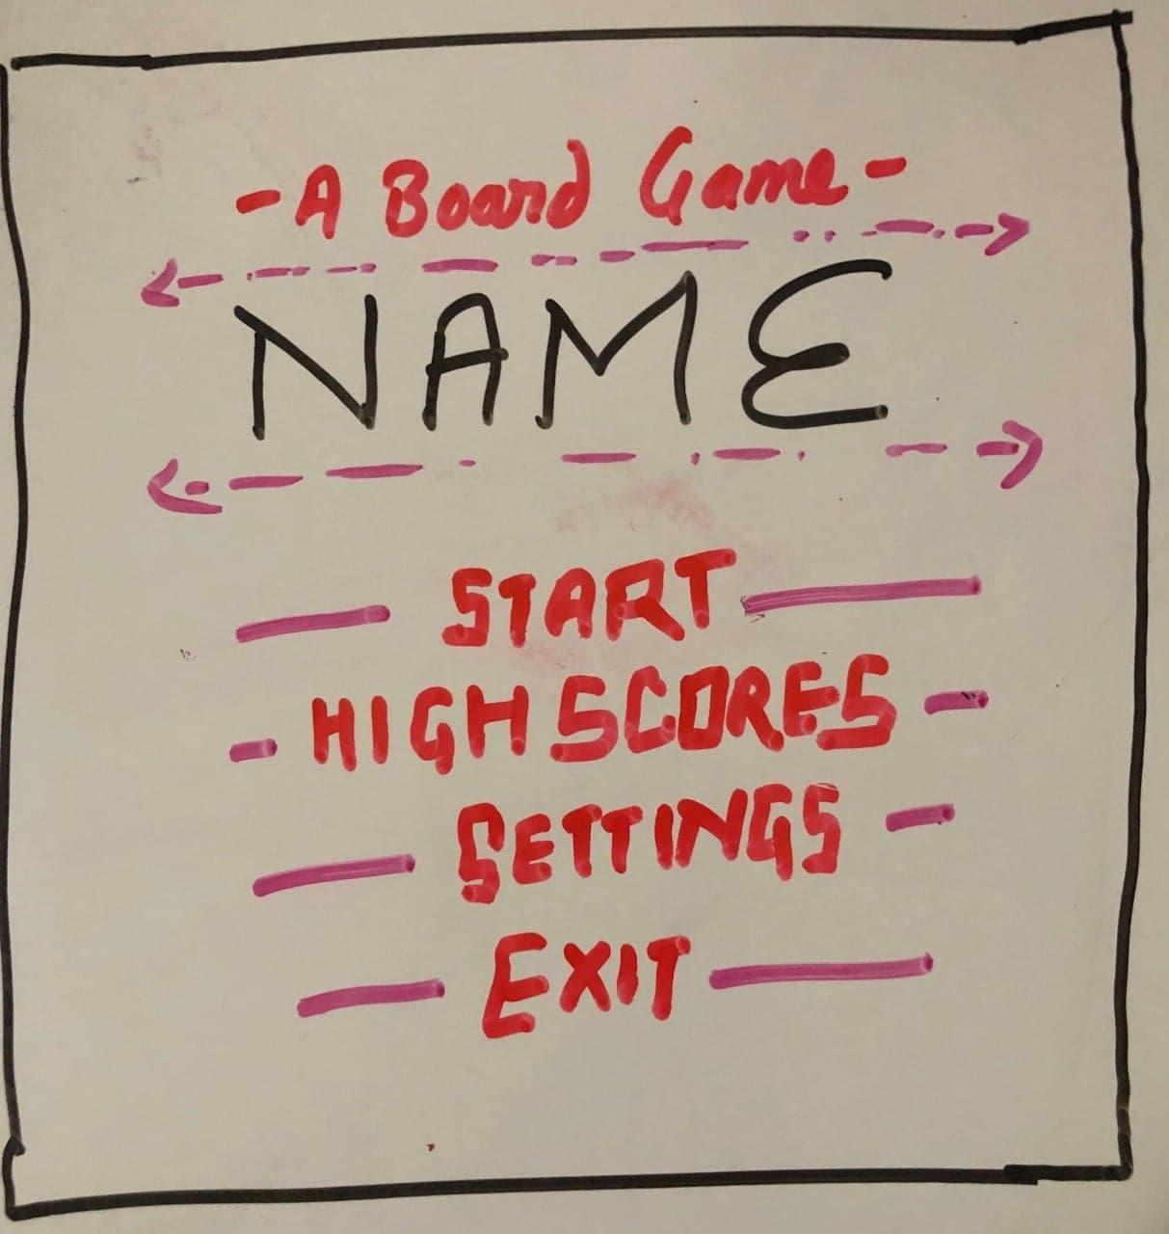

**Board Ideas (Simple layout)**

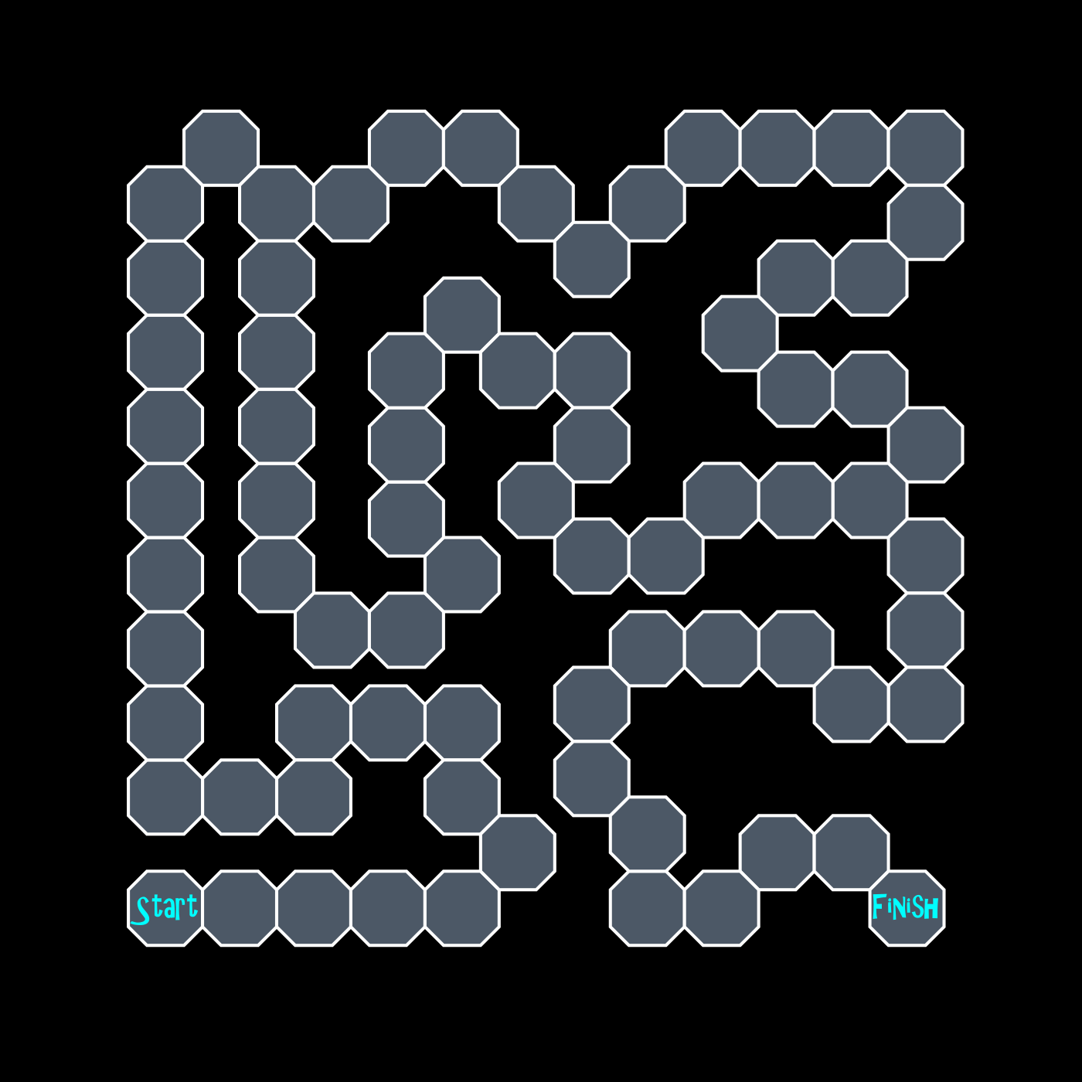

**Competitors**

Our game is not the first of its kind to be created, nor will it be the last. As such it will face competition in the marketplace; both to be noticed at all amidst the huge number of available games and to compete with similar games. Listed below are several competitors and how our game will stand out in comparison to them.

Snakes and Ladders is a simple game where players compete to be the first to the final space, moving up or down the board as they land on special spaces. This game utilizes a roll-to-move mechanic in which a player rolls a die and moves the indicated number of spaces. If you land on certain spaces, you also further up or down the board [2]. In contrast, in our game, each player is trying to get three characters to the end and can move anyone with a given die roll. This adds strategy to the game as the player decides which to move and avoid any hazards upon the board. This choice adds much-needed depth to the game and allows players more control over their chances of victory.

Another game that is competing with ours is the Game of Life. In the game, players move down a prebuilt track with various events happening to their characters depending on which space they land on. Players have a couple different choices of routes they can choose to follow to out-compete their foes [3]. Our game also has different routes and events that grant blessings or curses on various spaces. It is differentiated, again, by the choice of which character to move. This grants control to the player to strategically move to the greatest benefit. As characters reach the end of the board choices will become more and more difficult. In addition, our game features character death which will send the character back to the start or a checkpoint, adding an element of risk to greedier moves.

Our final competitor is the board game Trouble. Trouble has players moving a plastic peg around the board a number of spaces equal to the roll of a die. If the peg lands on another, that peg goes back to start and is replaced with the moving peg [4]. Our game has checkpoints that characters return to, and characters are only sent back when their health is depleted. Sharing a space with another enemy character only inflicts damage to both.

Finally, our game also allows you to hold event cards to play at any time, including on another player's turn. These events can range from inflicting damage to moving more or fewer spaces, allowing players to mess with the moves of their opponents and interrupt their plans. This combination of mechanics makes our game stand out against its competitors as a unique experience.

**Risks**

Risks are the potential problems that could arise during the conduction of any kind of project. Risks can be defined in various categories based on the type of project and it is very important that stakeholders identify, understand and deal with them properly. The Following are the risks that could arise during the development of our board game project:

1. Implementing functional and effective AI

Most of the time in game development consists of defining and designing interactive AI. The opponent AI should not be too hard nor too easy to make the game more interactive and challenging. So, AI design can make a simple game amazing or make the most creative game boring. Thus, it will be critical for us to devise a good AI for the game. The best approach to minimize this risk will be designing simple functional AI at first and slowly developing its effectiveness and interactions with other players as we go forward in the project.

Risk exposure RE: = pR * ER = 0.8 * 10 = 8 hours

1. Effective Graphic Design

There are several awesome games out there which are ruined by poor graphic design. It will be hard for any player to play a game if he/she cannot identify the bonus card or damage event lying in your way. Similarly, a very simple graphic also makes the game plan. Color, space, balance, alignment etc. are the main components of graphic design which make the game attractive as well as assist in understanding the theme of the game. Poor implementation of these things will result in the game being unproductive, unfun, or unintuitive. We plan to learn more on how we can amplify artistic appeal of our game. And we will create simple yet good graphics for the game.

Risk exposure RE: = pR * ER = 0.75 * 8 = 6 hours

1. Time management

Since we must complete the project within this semester, time management will play a very important role in obtaining the desired outcome. Ineffective time management can result in stress and frustration among team members, as well as heighten the risk of an incomplete project. Symptoms of poor time management include poor quality and missing requirements, which must be corrected before they hamper the project. We will follow the agile method and use scrum to schedule our tasks and track our progress. We plan to meet at least twice a week to plan, review and complete the tasks. The workload will be divided amongst the team members and a schedule set to review each other’s work throughout the semester.

Risk exposure RE: = pR * ER = 0.4 * 20 = 8 hours

**References**

[1] <https://www.theboardgamefamily.com/2015/04/great-family-game/>

[2] <https://www.thesprucecrafts.com/chutes-and-ladders-snakes-and-ladders-411609>

[3][https://web.archive.org/web/20120907013112/http://www.harrogate-scene.com/vintagegames/pdfs/game%20of%20life1.pdf](https://web.archive.org/web/20120907013112/http:/www.harrogate-scene.com/vintagegames/pdfs/game%20of%20life1.pdf)

[4] <https://howdoyouplayit.com/trouble-game-rules-play-trouble/>

**Github Link**

https://github.com/ablaze007/BoardGame