MongoDB入门操作手册（Shell版）

- mongodb介绍、层次结构、数据类型
1、概述
（1）特点
>面向集合（Collenction-Orented）
意思是数据被分组存储在数据集中，被称为一个集合（Collenction)。每个集合在数据库中都有一个唯一的标识名，并且可以包含无限数目的文档。集合的概念类似关系型数据库（RDBMS）里的表（table），不同的是它不需要定义任何模式（schema)。

>模式自由（schema-free)
意味着对于存储在 MongoDB数据库中的文件，我们不需要知道它的任何结构定义。提了这么多次"无模式"或"模式自由"，它到是个什么概念呢？例如，下面两个记录可以存在于同一个集合里面：
{"welcome" : "Beijing"}
{"age" : 25}

>文档型
意思是我们存储的数据是键 -值对的集合,键是字符串,值可以是数据类型集合里的任意类型 ,包括数组和文档 .我们把这个数据格式称作“BSON”即 “Binary Serialized document Notation.”

- 适用场合
>网站数据：MongoDB非常适合实时的插入，更新与查询，并具备网站实时数据存储所
需的复制及高度伸缩性。
>缓存：由于性能高，MongoDB也适合作为信息基础设施的缓存层。在系统重启之后，
由 MongoDB搭建的持久化缓存层可以避免下层的数据源过载。
>大尺寸，低价值的数据：使用传统的关系型数据库存储一些数据时可能会比较昂贵，在此之前，很多时候程序员往往会选择传统的文件进行存储。
>高伸缩性的场景：MongoDB非常适合由数十或数百台服务器组成的数据库。MongoDB
的路线图中已经包含对 MapReduce引擎的内置支持。
>用于对象及 JSON数据的存储：MongoDB的BSON数据格式非常适合文档化格式的存储及查询。

2、层次结构
（1）文档(document)、集合(collection)、数据库(database)的层次结构如下图:

（2）mongodb与关系型数据库的映射关系
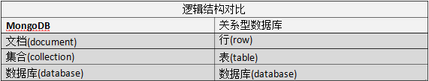

- mongodb的数据类型（page 194）
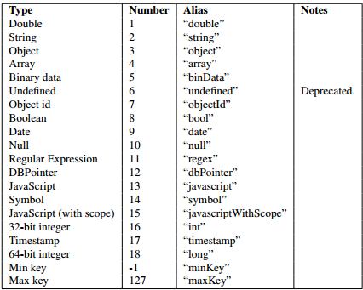

二、mongodb安装与登录
- 通过yum源安装mongodb （关闭selinux、配置yum源、启动mongod）
- 关闭selinux
[root@localhost bin]# cat /etc/sysconfig/selinux
# This file controls the state of SELinux on the system.
# SELINUX= can take one of these three values:
# enforcing - SELinux security policy is enforced.
# permissive - SELinux prints warnings instead of enforcing.
# disabled - No SELinux policy is loaded.
SELINUX=disabled
# SELINUXTYPE= can take one of these two values:
# targeted - Targeted processes are protected,
# mls - Multi Level Security protection.
SELINUXTYPE=targeted
（2）配置软件仓库
[root@localhost bin]# tail /etc/yum.repos.d/rhel-source.repo
[rhel-source]
name=Red Hat Enterprise Linux $releasever - $basearch - Source
baseurl=file:///mnt

[mongodb-org-3.2]
name=MongoDB Repository
baseurl=https://repo.mongodb.org/yum/redhat/$releasever/mongodb-org/3.2/x86_64/
gpgcheck=0
enabled=1
（3）安装mongodb并免验证启动
[root@localhost bin]# yum install -y mongodb-org
[root@localhost bin]# rpm -qa | grep mongodb
mongodb-org-server-3.2.1-1.el6.x86_64
mongodb-org-tools-3.2.1-1.el6.x86_64
mongodb-org-3.2.1-1.el6.x86_64
mongodb-org-shell-3.2.1-1.el6.x86_64
mongodb-org-mongos-3.2.1-1.el6.x86_64
[root@localhost bin]# service mongod start
Starting mongod: [ OK ]

[root@localhost ~]# ps -ef | grep mongo
root 5958 1112 3 Feb03 pts/0 01:27:05 mongod --auth --port 27017 --dbpath /var/lib/mongo
root 6004 1589 0 Feb03 pts/1 00:00:00 mongo
root 7282 7264 0 04:17 pts/2 00:00:00 grep mongo
[root@localhost bin]# chkconfig mongod on
[root@localhost bin]# chkconfig --list | grep mongod
mongod 0:off 1:off 2:on 3:on 4:on 5:on 6:off
[root@localhost bin]#

- 配置授权并使用授权用户登录
（1）mongo授权机制及角色介绍

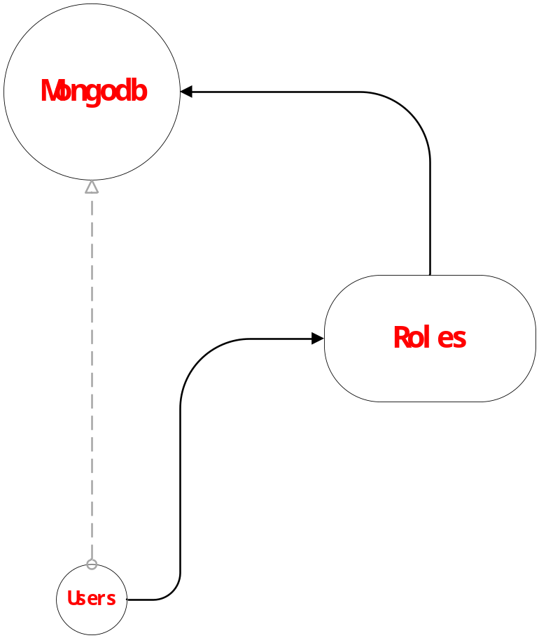

MongoDB提供了很多内建角色，用户通用的数据库管理。MongoDB提供了数据库管理权限和数据库用户权限两种类型，其他的权限只能作用于admin数据库上。要使用哪个数据库，就在哪个数据库上建用户。
角色具体参考：https://docs.mongodb.org/manual/core/security-built-in-roles/

（2）免授权验证登录mongodb并创建登录用户
[root@localhost mongo]# mongo
MongoDB shell version: 3.2.1
connecting to: test
Server has startup warnings:
2015-10-27T17:18:55.534+0800 I CONTROL [initandlisten]
>
>
> use test;
switched to db test
> db.createUser(
... {
... user: "developers2",
... pwd: "developers2",
... roles: [ { role: "dbOwner", db: "test" } ]
... }
... );
Successfully added user: {
"user" : "developers2",
"roles" : [
{
"role" : "dbOwner",
"db" : "test"
}
]
}
> show users;
{
"_id" : "test.developers2",
"user" : "developers2",
"db" : "test",
"roles" : [
{
"role" : "dbOwner",
"db" : "test"
}
]
}
>

（3）修改配置文件/etc/mongod.conf并重启mongodb
[root@localhost mongo]# cat /etc/mongod.conf
# mongod.conf
# for documentation of all options, see:
# http://docs.mongodb.org/manual/reference/configuration-options/
# where to write logging data.
systemLog:
destination: file
logAppend: true
path: /var/log/mongodb/mongod.log

# Where and how to store data.
storage:
dbPath: /var/lib/mongo
journal:
enabled: true
# engine:
# mmapv1:
# wiredTiger:
# how the process runs
processManagement:
fork: true # fork and run in background
pidFilePath: /var/run/mongodb/mongod.pid # location of pidfile

# network interfaces
net:
port: 27017
bindIp: 0.0.0.0 # Allow all ip access Mongodb
#security:
security:
authorization: enabled #enable authorization
#operationProfiling:
#replication:
#sharding:
## Enterprise-Only Options
#auditLog:
#snmp:
[root@localhost mongo]#
[root@localhost ~]# /etc/init.d/mongod restart
Stopping mongod: [ OK ]
Starting mongod: [ OK ]

（4）客户端登录验证授权情况
[root@localhost ~]# mongo
MongoDB shell version: 3.2.1
connecting to: test
> use test;
switched to db test
> show collections;
2015-10-28T16:50:15.701+0800 E QUERY [thread1] Error: listCollections failed: {
"ok" : 0,
"errmsg" : "not authorized on test to execute command { listCollections: 1.0, filter: {} }",
"code" : 13
} :
_getErrorWithCode@src/mongo/shell/utils.js:23:13
DB.prototype._getCollectionInfosCommand@src/mongo/shell/db.js:746:1
DB.prototype.getCollectionInfos@src/mongo/shell/db.js:758:15
DB.prototype.getCollectionNames@src/mongo/shell/db.js:769:12
shellHelper.show@src/mongo/shell/utils.js:695:9
shellHelper@src/mongo/shell/utils.js:594:15
@(shellhelp2):1:1

> db.auth("developers2","developers2"); #登录授权
1
> show collections;
sour_product_odcinfo
>
三、mongodb的CRUD操作（mongo Shell版本）
1、基础操作
（1）建库建表（建库->在库中建用户->授权登录->建表并插入数据->查看）
> use admin;
switched to db admin
> db.auth("root","dzkjdata");
1
> show dbs;
admin 0.000GB
local 0.000GB
test 7.196GB
testtwo 0.000GB
> show users;
{
"_id" : "admin.root",
"user" : "root",
"db" : "admin",
"roles" : [
{
"role" : "userAdminAnyDatabase",
"db" : "admin"
}
]
}
>
> use student;
switched to db student
> db.createUser(
... {
... user: "dev",
... pwd: "dev",
... roles: [ { role: "dbOwner", db: "student" } ]
... }
... );
Successfully added user: {
"user" : "dev",
"roles" : [
{
"role" : "dbOwner",
"db" : "student"
}
]
}
> show users;
{
"_id" : "student.dev",
"user" : "dev",
"db" : "student",
"roles" : [
{
"role" : "dbOwner",
"db" : "student"
}
]
}
> show dbs;
admin 0.000GB
local 0.000GB
test 7.196GB
testtwo 0.000GB
> db.auth("dev","dev");
1
> db.teacher.insert({"name":"zhangsan"});
WriteResult({ "nInserted" : 1 })
> show dbs;
admin 0.000GB
local 0.000GB
student 0.000GB
test 7.196GB
testtwo 0.000GB
> show collections;
teacher
>

- 删表删库
> db
student
> show dbs;
admin 0.000GB
local 0.000GB
student 0.000GB
test 7.196GB
testtwo 0.000GB
> db.dropDatabase();
{ "dropped" : "student", "ok" : 1 }
> show dbs;
admin 0.000GB
local 0.000GB
test 7.196GB
testtwo 0.000GB
> show collections;
>

（3）增删查改数据
#增加test集合的一条数据
> use test;
switched to db test
> db.test.insert(
... {
... item: "ABC1",
... details: {
... model: "14",
... manufacturer: "XYZ Company"
... },
... stock: [ { size: "S", qty: 25 }, { size: "M", qty: 50 } ],
... category: "clothing"
... }
... );
WriteResult({ "nInserted" : 1 })

#查询该条记录
> db.test.find({item: "ABC1"});
{ "_id" : ObjectId("56b3de0985d42849583da92c"), "item" : "ABC1", "details" : { "model" : "14", "manufacturer" : "XYZ Company" }, "stock" : [ { "size" : "S", "qty" : 25 }, { "size" : "M", "qty" : 50 } ], "category" : "clothing" }
>

#更新该条记录
> db.test.update(
... { item: "ABC1" },
... {
... $set: {
... category: "888666"
... }
... }
... );
WriteResult({ "nMatched" : 1, "nUpserted" : 0, "nModified" : 1 })
> db.test.find({item: "ABC1"});
{ "_id" : ObjectId("56c56597d6993d3fd7a049b4"), "item" : "ABC1", "details" : { "model" : "14Q3", "manufacturer" : "XYZ Company" }, "stock" : [ { "size" : "S", "qty" : 25 }, { "size" : "M", "qty" : 50 } ], "category" : "888666" }
>
#删除该条记录
> db.test.remove({category: "888666"});
WriteResult({ "nRemoved" : 1 })
> db.test.find({category: "888666"});
>

- 条件操作符使用

MongoDB中条件操作符有：
(>) 大于 - $gt
(<) 小于 - $lt
(>=) 大于等于 - $gte
(<= ) 小于等于 - $lte

> for(var i=1;i<101;i++) db.tools.save({"id":i,"name":"zhangsan"+i});
WriteResult({ "nInserted" : 1 })
> db.tools.count();
100
> db.tools.find({"id":{$gt:90}});
{ "_id" : ObjectId("5631fa565f1d006df6c50efe"), "id" : 91, "name" : "zhangsan91" }
{ "_id" : ObjectId("5631fa565f1d006df6c50eff"), "id" : 92, "name" : "zhangsan92" }
{ "_id" : ObjectId("5631fa565f1d006df6c50f00"), "id" : 93, "name" : "zhangsan93" }
{ "_id" : ObjectId("5631fa565f1d006df6c50f01"), "id" : 94, "name" : "zhangsan94" }
{ "_id" : ObjectId("5631fa565f1d006df6c50f02"), "id" : 95, "name" : "zhangsan95" }
{ "_id" : ObjectId("5631fa565f1d006df6c50f03"), "id" : 96, "name" : "zhangsan96" }
{ "_id" : ObjectId("5631fa565f1d006df6c50f04"), "id" : 97, "name" : "zhangsan97" }
{ "_id" : ObjectId("5631fa565f1d006df6c50f05"), "id" : 98, "name" : "zhangsan98" }
{ "_id" : ObjectId("5631fa565f1d006df6c50f06"), "id" : 99, "name" : "zhangsan99" }
{ "_id" : ObjectId("5631fa565f1d006df6c50f07"), "id" : 100, "name" : "zhangsan100" }
>
> db.tools.find({"id":{$gte:90}});
{ "_id" : ObjectId("5631fa565f1d006df6c50efd"), "id" : 90, "name" : "zhangsan90" }
{ "_id" : ObjectId("5631fa565f1d006df6c50efe"), "id" : 91, "name" : "zhangsan91" }
{ "_id" : ObjectId("5631fa565f1d006df6c50eff"), "id" : 92, "name" : "zhangsan92" }
{ "_id" : ObjectId("5631fa565f1d006df6c50f00"), "id" : 93, "name" : "zhangsan93" }
{ "_id" : ObjectId("5631fa565f1d006df6c50f01"), "id" : 94, "name" : "zhangsan94" }
{ "_id" : ObjectId("5631fa565f1d006df6c50f02"), "id" : 95, "name" : "zhangsan95" }
{ "_id" : ObjectId("5631fa565f1d006df6c50f03"), "id" : 96, "name" : "zhangsan96" }
{ "_id" : ObjectId("5631fa565f1d006df6c50f04"), "id" : 97, "name" : "zhangsan97" }
{ "_id" : ObjectId("5631fa565f1d006df6c50f05"), "id" : 98, "name" : "zhangsan98" }
{ "_id" : ObjectId("5631fa565f1d006df6c50f06"), "id" : 99, "name" : "zhangsan99" }
{ "_id" : ObjectId("5631fa565f1d006df6c50f07"), "id" : 100, "name" : "zhangsan100" }
>
> db.tools.find({"id":{$lt:10}});
{ "_id" : ObjectId("5631fa565f1d006df6c50ea4"), "id" : 1, "name" : "zhangsan1" }
{ "_id" : ObjectId("5631fa565f1d006df6c50ea5"), "id" : 2, "name" : "zhangsan2" }
{ "_id" : ObjectId("5631fa565f1d006df6c50ea6"), "id" : 3, "name" : "zhangsan3" }
{ "_id" : ObjectId("5631fa565f1d006df6c50ea7"), "id" : 4, "name" : "zhangsan4" }
{ "_id" : ObjectId("5631fa565f1d006df6c50ea8"), "id" : 5, "name" : "zhangsan5" }
{ "_id" : ObjectId("5631fa565f1d006df6c50ea9"), "id" : 6, "name" : "zhangsan6" }
{ "_id" : ObjectId("5631fa565f1d006df6c50eaa"), "id" : 7, "name" : "zhangsan7" }
{ "_id" : ObjectId("5631fa565f1d006df6c50eab"), "id" : 8, "name" : "zhangsan8" }
{ "_id" : ObjectId("5631fa565f1d006df6c50eac"), "id" : 9, "name" : "zhangsan9" }
> db.tools.find({"id":{$lte:10}});
{ "_id" : ObjectId("5631fa565f1d006df6c50ea4"), "id" : 1, "name" : "zhangsan1" }
{ "_id" : ObjectId("5631fa565f1d006df6c50ea5"), "id" : 2, "name" : "zhangsan2" }
{ "_id" : ObjectId("5631fa565f1d006df6c50ea6"), "id" : 3, "name" : "zhangsan3" }
{ "_id" : ObjectId("5631fa565f1d006df6c50ea7"), "id" : 4, "name" : "zhangsan4" }
{ "_id" : ObjectId("5631fa565f1d006df6c50ea8"), "id" : 5, "name" : "zhangsan5" }
{ "_id" : ObjectId("5631fa565f1d006df6c50ea9"), "id" : 6, "name" : "zhangsan6" }
{ "_id" : ObjectId("5631fa565f1d006df6c50eaa"), "id" : 7, "name" : "zhangsan7" }
{ "_id" : ObjectId("5631fa565f1d006df6c50eab"), "id" : 8, "name" : "zhangsan8" }
{ "_id" : ObjectId("5631fa565f1d006df6c50eac"), "id" : 9, "name" : "zhangsan9" }
{ "_id" : ObjectId("5631fa565f1d006df6c50ead"), "id" : 10, "name" : "zhangsan10" }

3、Limit,skip,$typ,sort等的用法
> db.tools.find({},{"_id":0}).limit(2);
{ "id" : 1, "name" : "zhangsan1" }
{ "id" : 2, "name" : "zhangsan2" }
> db.tools.find({},{"_id":0}).limit(3).skip(1);
{ "id" : 2, "name" : "zhangsan2" }
{ "id" : 3, "name" : "zhangsan3" }
{ "id" : 4, "name" : "zhangsan4" }
> db.tools.find({},{"_id":0}).limit(3).skip(4);
{ "id" : 5, "name" : "zhangsan5" }
{ "id" : 6, "name" : "zhangsan6" }
{ "id" : 7, "name" : "zhangsan7" }
>
> for(var i=101;i<200;i++) db.tools.save({"id":i,"name":i*2});
WriteResult({ "nInserted" : 1 })
> db.tools.count();
199
> db.tools.find({"name":{$type:2}}).count();
100
> db.tools.find({"name":{$type:2}}).limit(2);
{ "_id" : ObjectId("5631fa565f1d006df6c50ea4"), "id" : 1, "name" : "zhangsan1" }
{ "_id" : ObjectId("5631fa565f1d006df6c50ea5"), "id" : 2, "name" : "zhangsan2" }
> db.tools.find({},{"_id":0}).sort({"id":-1}).limit(5);
{ "id" : 199, "name" : 398 }
{ "id" : 198, "name" : 396 }
{ "id" : 197, "name" : 394 }
{ "id" : 196, "name" : 392 }
{ "id" : 195, "name" : 390 }
> db.tools.find({},{"_id":0}).sort({"id":1}).limit(5);
{ "id" : 1, "name" : "zhangsan1" }
{ "id" : 2, "name" : "zhangsan2" }
{ "id" : 3, "name" : "zhangsan3" }
{ "id" : 4, "name" : "zhangsan4" }
{ "id" : 5, "name" : "zhangsan5" }
>

