
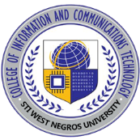
STI WEST NEGROS UNIVERSITY
Burgos St., Bacolod City 6100

COLLEGE OF INFORMATION and COMMUNICATIONS TECHNOLOGY

ICT Capstone Exhibit Activity Form

Date: ____________
Student Name |  | Group Code
Project Title
Project Manager |  | Section
Title of the System & Interviewee/Exhibitor

System Description/Key Features/Technologies Used

Student Insights/ Relevance/Identified Gaps (Based on Your Proposed Study)

Photo Documentation
.

Name | Signature and Date
(Interview/Exhibitor)
Ariel T. Sumagaysay
(Capstone Project 1 Coordinator)

