Agentic AI-Based Intelligent Travel Planning System
Software Design Description

Final-Year Project (BTech Information Technology)
Academic Prototype

Document Issue Status
Document ID: ATP/SDD |  | Document Issue Number: 1  Document Revision Number: 0
Prepared by | Ashfaque C, Muhammad Fawas K,  Abel Mathew, Afrah Shad EK | Prepared Date: | 27-10-2026
Reviewed by |  | Reviewed Date:
Approved by |  | Approved Date:
Distribution list | Project Guide; Project Team
Document Amendment Record
Sl. No. | Issue No | Revision No | Date | Pages Corrected | Remarks
1 | 1 | 0 | 27-10-2026 | - | Initial release



Contents

1 Introduction

1.1 Purpose
This Software Design Description (SDD) explains how the Agentic AI-Based Intelligent Travel Planning System will be built so that it meets the requirements in the Software Requirement Specification (SRS, Document ID ATP/SRS, Issue 1, Revision 0). It turns the functional requirements FR-01 to FR-55, the non-functional requirements NFR-01 to NFR-19 and the external interface requirements of the SRS into an architecture, an agent workflow, class, interaction and state models, and a database design that the team can implement and test.
Intended audience:
- Developers: to build the frontend, backend, agents and database as designed.
- Testers: to write test cases from the workflows, state models and data models, and trace them to the SRS.
- Project guide and reviewers: to review the design before implementation starts.
- Future teams: to add agents, data sources or destinations without redesigning the system.
Status note. This document describes a planned design. No component is claimed as implemented or tested. Appendix E lists every component as Planned, and the team should update it as work is verified.

1.2 Scope
The software product is the Agentic AI-Based Intelligent Travel Planning System. It is a web application that turns a natural-language travel request into a budget-aware, day-wise itinerary with an interactive map and a downloadable PDF. A Supervisor Agent, built with LangGraph and a local language model, coordinates four specialized agents: Transit, Lodging, Geospatial and Safety.
- Accepts a travel request (origin, destination, duration, optional start date, travelers, budget, preferences, interests).
- Suggests transport, accommodation, attractions and restaurants, and estimates routes, distances and costs.
- Checks weather and mapped emergency services near the stay.
- Checks the plan against budget, time and preferences, and replans a limited number of times when a check fails.
- Shows the itinerary, cost summary and map, and creates a PDF with images and credits.
The system does not book tickets or hotels, take payments, or guarantee exact fares, availability or safety. Every cost is an estimate unless a verified source supplies it, and the interface labels it that way.
Design additions beyond SRS Issue 1. The project brief contains items that the SRS does not yet state. This SDD designs them so that the team can add matching requirements to the SRS (Appendix C).
No. | Design addition | Where designed
P-01 | Downloadable PDF itinerary (ReportLab) | Sections 2, 3.1.4, 3.2.3(j)
P-02 | Attraction images with licence and attribution records | Sections 3.2.3(i), 4.2 (place_images)
P-03 | Replanning retry limit (no endless loops) | Sections 2, 3.2.3(a), (h)
P-04 | Administrator maintains hotel and transport data | Sections 3.1.5, 4.2
P-05 | Transport fallback order: feeds, curated data, road estimate | Section 3.2.3(c)
P-06 | Safety wording rule: advisory facts only, no "safe/unsafe" claims | Section 3.2.3(f)
P-07 | Optional travel start date as an input | Sections 3.2.3(b), 4.2 (trips)

1.3 Product / System Overview
The system has a React frontend, a FastAPI backend, a LangGraph agent layer that uses a local LLM through Ollama, and a PostgreSQL database with PostGIS. The agents get facts from tools and data sources (OpenStreetMap services, OSRM, Open-Meteo, transit feeds and curated datasets). The tools are not agents. Figure 1 is the block diagram from the SRS.
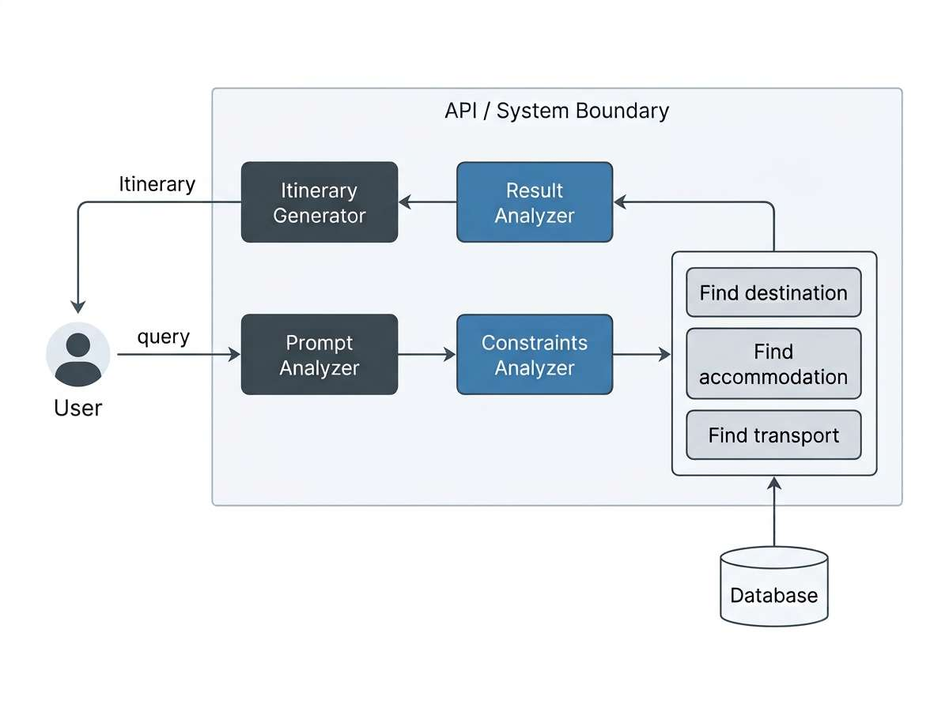
Figure 1: System block diagram (from the SRS)
General workflow: Travel request → Validation → Supervisor splits tasks → four agents fetch data → Supervisor validates budget, time and weather → (replan if needed) → day-wise itinerary → map, cost summary and PDF.
Module | Responsibility | SRS requirements
Travel Request | Collects the form and free-text request; validates mandatory fields. | FR-01 to FR-10
Supervisor | Reads the request, splits tasks, merges results, checks constraints, replans, builds the itinerary. | FR-11 to FR-22
Transit | Finds transport options, distance, time and estimated cost. | FR-23 to FR-27
Lodging | Finds and filters stays from the curated dataset. | FR-28 to FR-30
Geospatial | Geocodes places, finds attractions and food places, groups them by day, calculates routes. | FR-31 to FR-35
Safety | Weather forecast, weather warnings, mapped hospitals, police stations and pharmacies. | FR-36 to FR-39
Budget | Estimates costs by category and compares with the budget. | FR-40 to FR-43
Itinerary and Replanning | Day-wise plan, bounded replanning, new itinerary versions. | FR-44 to FR-50
Map and PDF | MapLibre map data; PDF with images and credits. | FR-51, FR-52, P-01, P-02
Data Storage and Admin | Trips, itineraries, places, hotel and transport data, caches. | FR-53 to FR-55, P-04

Example. A user enters: "5-day trip from Kochi to Hyderabad for 2 people, budget ₹6000, budget transport and stay, historical places and local food." The system extracts the parameters, finds transport and stay options, groups attractions near the stay into days, checks weather, and compares the total estimate with ₹6000. If the total is too high it tries a cheaper option (up to the retry limit). The ₹6000 is the user's limit, not a promise that the trip is feasible at that price.

1.4 User Characteristics
These characteristics explain design choices. They are not requirements in themselves.
User | Characteristics | Effect on the design
Traveler | Basic computer and internet skills; no knowledge of AI, APIs or databases. | One simple request page with a free-text box; plain-language results; labels such as "estimated" and "not available"; progress shown while planning runs.
Student / Researcher | Technical; studies agentic AI and geospatial planning. | Agents and tools are separate classes; each AgentResult is stored so a run can be inspected.
Administrator | Technical team member who maintains data and settings. | Protected /admin endpoints for hotel and transport data; configuration in environment files; changes written to an audit log.

The traveler uses a guest session (no sign-up) in this version, so the design does not collect an email or password from travelers. Saved trips are tied to the session token.

1.5 Definitions, Acronyms & Abbreviations
Term | Meaning
SRS / SDD | Software Requirement Specification / Software Design Description
Agent | A software component that does one job and returns a structured result
Supervisor | The agent that splits the request, checks results and decides on replanning
Tool | An external service or dataset used by an agent (not an agent)
LLM / Ollama | Large Language Model / program that runs an open-source LLM locally
LangGraph | Framework that runs the agent workflow as a graph with shared state
State | The shared data object passed between workflow steps
Replanning | Choosing a new option after a check fails or conditions change
AgentResult | The structured output of one agent run
Data quality | Label on a value: VERIFIED, ESTIMATED or UNAVAILABLE
POI | Point of Interest
OSM / OSRM / OTP | OpenStreetMap / Open Source Routing Machine / OpenTripPlanner
GTFS | General Transit Feed Specification (public transit data format)
PostGIS | Spatial extension for PostgreSQL
REST / JSON / HTTPS | Web API style / data format / secure HTTP
ER / PK / FK / UQ | Entity Relationship / primary key / foreign key / unique key
UML | Unified Modeling Language (class, sequence and state diagrams)
Boundary / control / entity | Screen or API / coordinating logic / stored data

1.6 Design and Implementation Constraints
The items below limit the design. Each one comes from the SRS (Section 1.6); the design consequence is given.
- a) Regulatory and usage policies: Nominatim, Overpass and image providers have usage rules and rate limits. Design: a CacheService, a request limiter and a User-Agent header; image licences are checked before use.
- b) Hardware: a local LLM needs RAM and preferably a GPU. Design: a small quantized model, a timeout on every LLM call, and a fallback that uses the form fields if extraction fails.
- c) Interfaces to other applications: free services may be slow, incomplete or unavailable. Design: every tool call is wrapped, returns a quality label, and a failure does not stop the workflow.
- d) Parallel operation: several users may plan at once. Design: stateless REST endpoints, one workflow run per trip, and background execution with status polling.
- e) Audit functions: admin changes and logins are logged. Design: audit_logs table.
- f) Control functions and g) signal protocols: not applicable.
- h) Languages: Python (backend and agents), JavaScript/React (frontend), SQL (PostgreSQL/PostGIS).
- i) Reliability: the LLM can make mistakes and free data can be missing. Design: the LLM only reads the request and writes text; prices, timings, ratings and coordinates come from data sources; every output is schema-checked.
- j) Criticality: low; the system gives planning help, not safety guarantees. Design: advisory wording and a visible disclaimer.
- k) Security: API keys must stay on the server and user input must be validated. Design: Section 2 (security by layers) and Section 3.2.4.

1.7 Assumptions and Dependencies
Assumptions
- Users give reasonably valid requests, and map data exists for the chosen destination.
- External services are reachable during planning; when they are not, the system degrades as described in Section 3.2.4.
- The accommodation and intercity transport datasets are prepared by the team for the demo routes.
- The chosen local LLM can extract parameters and write short itinerary text.
Dependencies
- Python, FastAPI, LangGraph, SQLAlchemy, ReportLab and an HTTP client library.
- React, Tailwind CSS and MapLibre GL JS.
- Ollama with an open-source model; PostgreSQL with PostGIS; Docker (optional) for development.
- Nominatim, Overpass API, OSRM, Open-Meteo, GTFS feeds where they exist, and the image sources Wikimedia Commons, Unsplash and Pexels.

1.8 References
No. | Document / reference | Organization | Availability
[1] | Software Requirement Specification, Agentic AI-Based Intelligent Travel Planning System (ATP/SRS) | Project team | Project repository
[2] | Project Summary and Project Brief: Agentic AI-Based Intelligent Travel Planning System | Project team | Project repository
[3] | Software Design Description template | Institution / course | From the project guide
[4] | LangGraph, FastAPI, Ollama documentation | Respective projects | Official websites
[5] | PostgreSQL and PostGIS documentation | PostgreSQL / PostGIS projects | Official websites
[6] | React, Tailwind CSS and MapLibre GL JS documentation | Respective projects | Official websites
[7] | ReportLab user guide | ReportLab | Official website
[8] | Nominatim usage policy; Overpass API; OSRM; Open-Meteo documentation | OpenStreetMap community, OSRM project, Open-Meteo | Official websites
[9] | GTFS specification | Public transit data community | Official website
[10] | Wikimedia Commons reuse guidelines; Unsplash API guidelines; Pexels API terms | Respective providers | Official websites

Add exact version numbers and access dates for each reference in the final report.

2 High Level Design (System Architecture)
The system has five tiers: client, application, intelligence, data and external services. The React app talks to the FastAPI backend over HTTPS. The backend starts a LangGraph workflow in which the Supervisor Agent calls four agents. The agents read the database and call external tools. Figure 2 shows the component view.
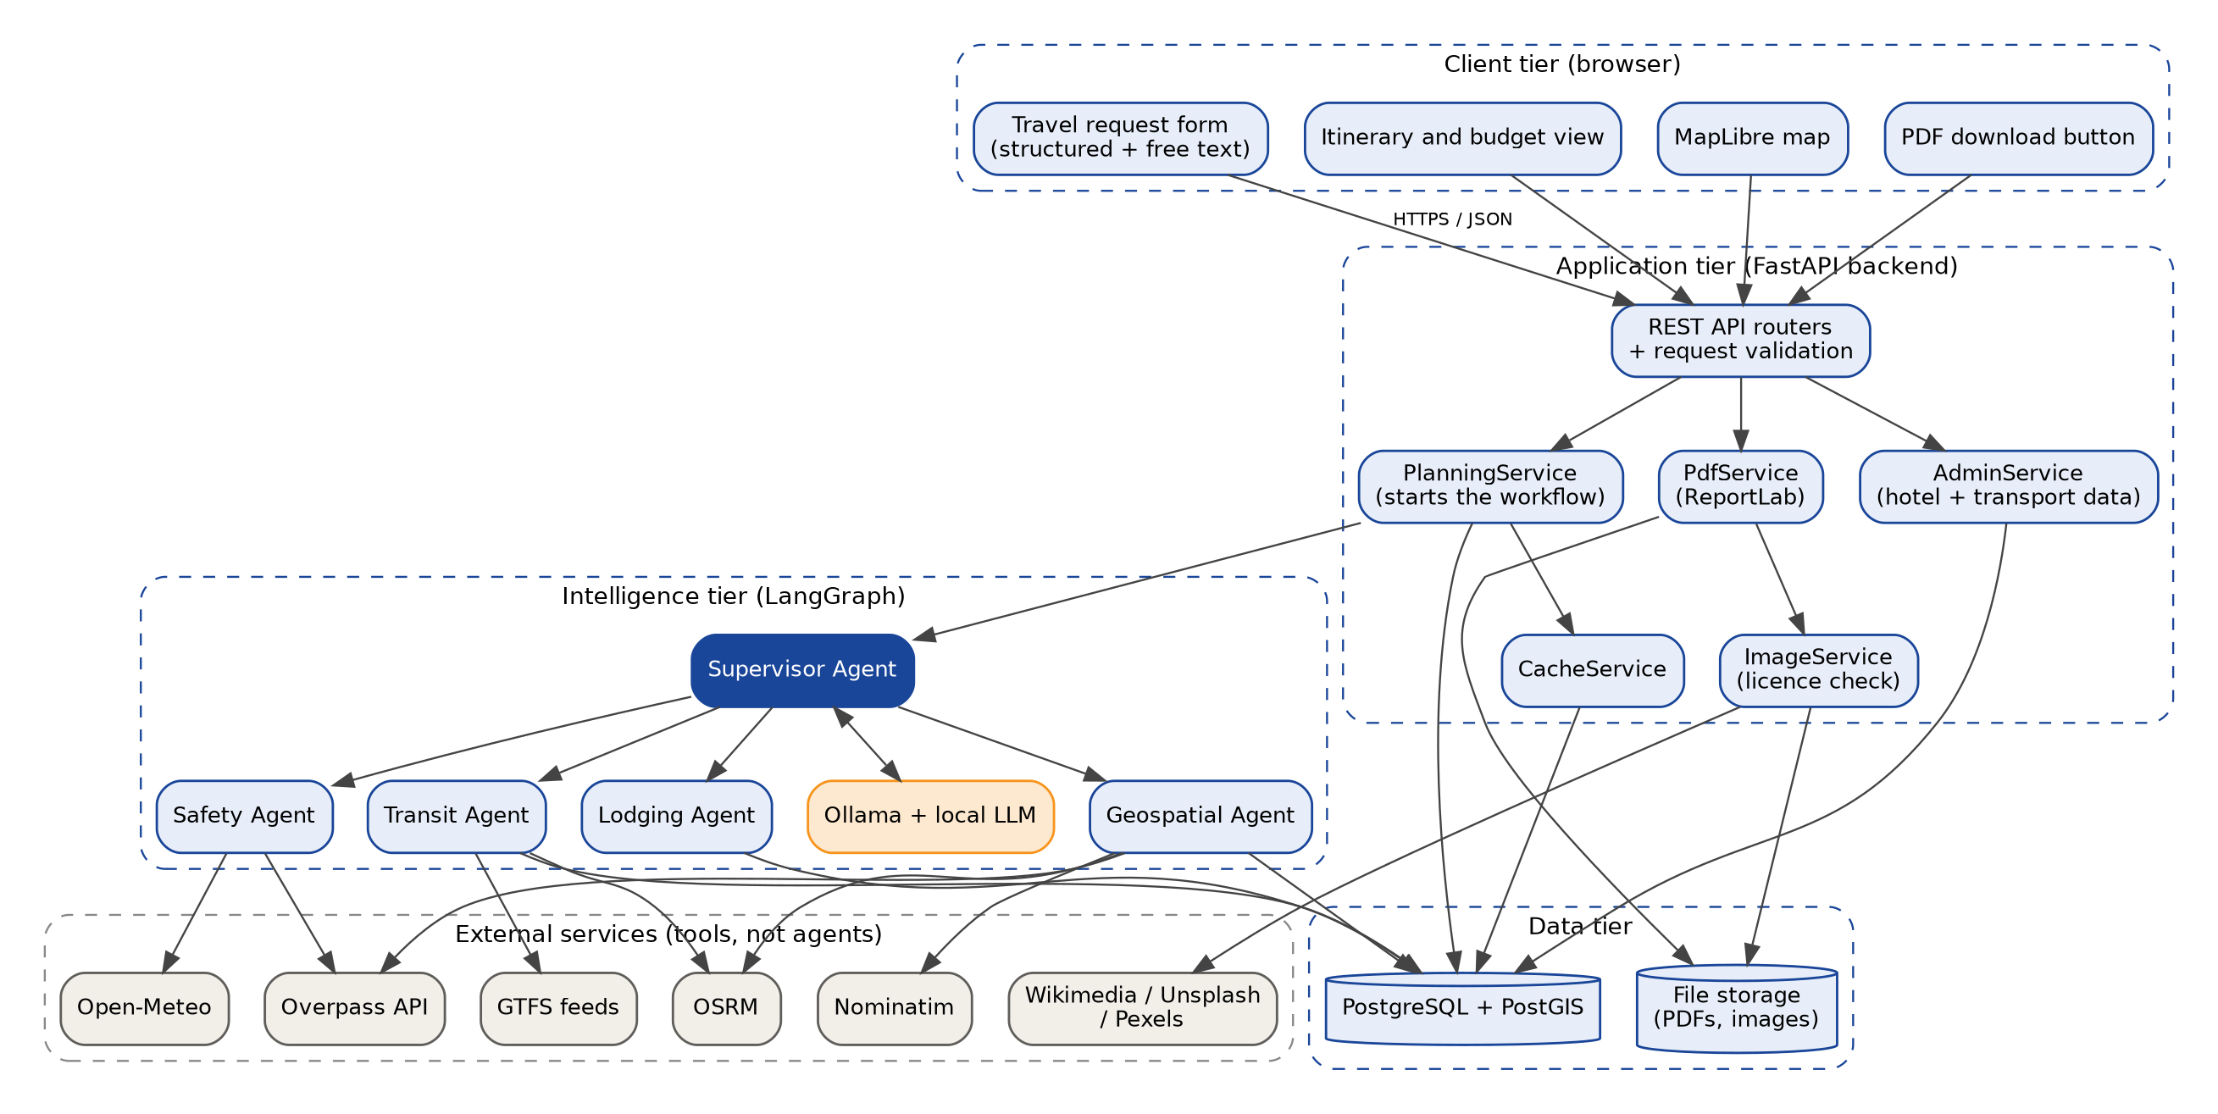
Figure 2: System architecture (component view)
Component descriptions
Component | Responsibility | Technology
Request form and result views | Collects the request, shows progress, itinerary, costs and data-quality labels, lets the user modify the plan. | React, Tailwind CSS
Map view | Shows stay, attractions, restaurants, services and routes from GeoJSON. | MapLibre GL JS
API routers and validation | REST endpoints, input validation, guest session, admin role check, rate limiting. | FastAPI, Pydantic
PlanningService | Creates the trip record and starts the workflow in the background; reports status. | Python
Supervisor Agent | Reads the request, splits tasks, merges and validates results, replans, builds the itinerary. | LangGraph, Ollama LLM
Transit Agent | Transport options, distance, time, estimated cost. | Python, GTFS, OSRM, curated table
Lodging Agent | Stays within budget, near the attractions. | Python, PostgreSQL
Geospatial Agent | Geocoding, attractions, restaurants, day grouping, routes. | Python, Nominatim, Overpass, OSRM, PostGIS
Safety Agent | Weather forecast, bad-weather flags, mapped emergency services. | Python, Open-Meteo, Overpass
BudgetValidator, ItineraryBuilder | Cost totals by category; schedule of items per day (plain code, no LLM). | Python
PdfService, ImageService | Builds the PDF; picks images only when the licence allows. | ReportLab, Wikimedia / Unsplash / Pexels APIs
AdminService | Create, edit, deactivate hotel and transport records; audit logging. | FastAPI, SQL
CacheService | Stores geocode, route and POI results with expiry. | PostgreSQL (geo_cache)
PostgreSQL + PostGIS | All stored data and spatial queries (Section 4). | PostgreSQL, PostGIS
File storage | PDF files and downloaded images. | Server file system / Docker volume

Figure 3 shows where the parts run. During development all parts can run on one machine. The Ollama service runs on the host so that it can use the GPU.
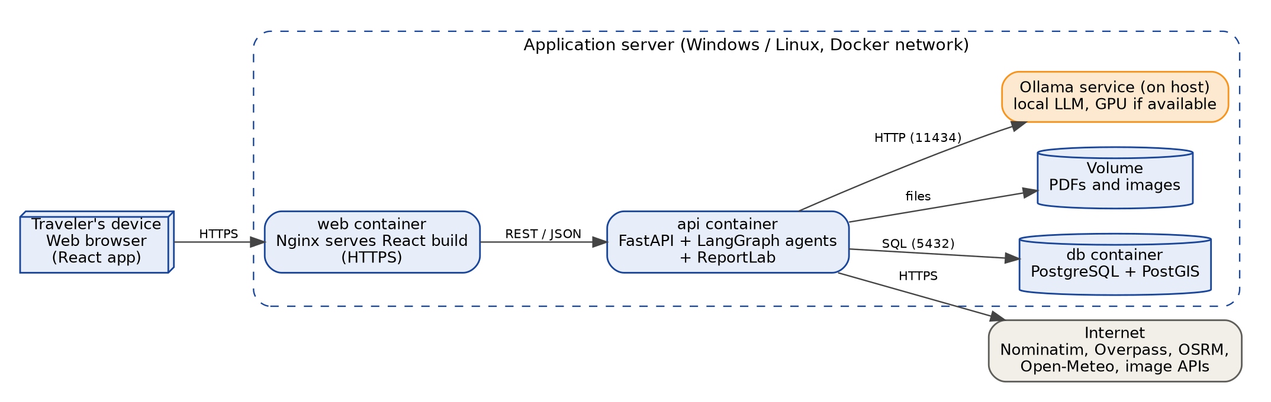
Figure 3: Deployment diagram

Agent workflow design
The Supervisor runs a fixed, controlled graph. Agents never call each other. They only receive a task from the Supervisor and return an AgentResult. Figure 4 shows the steps, including the bounded replanning loop.
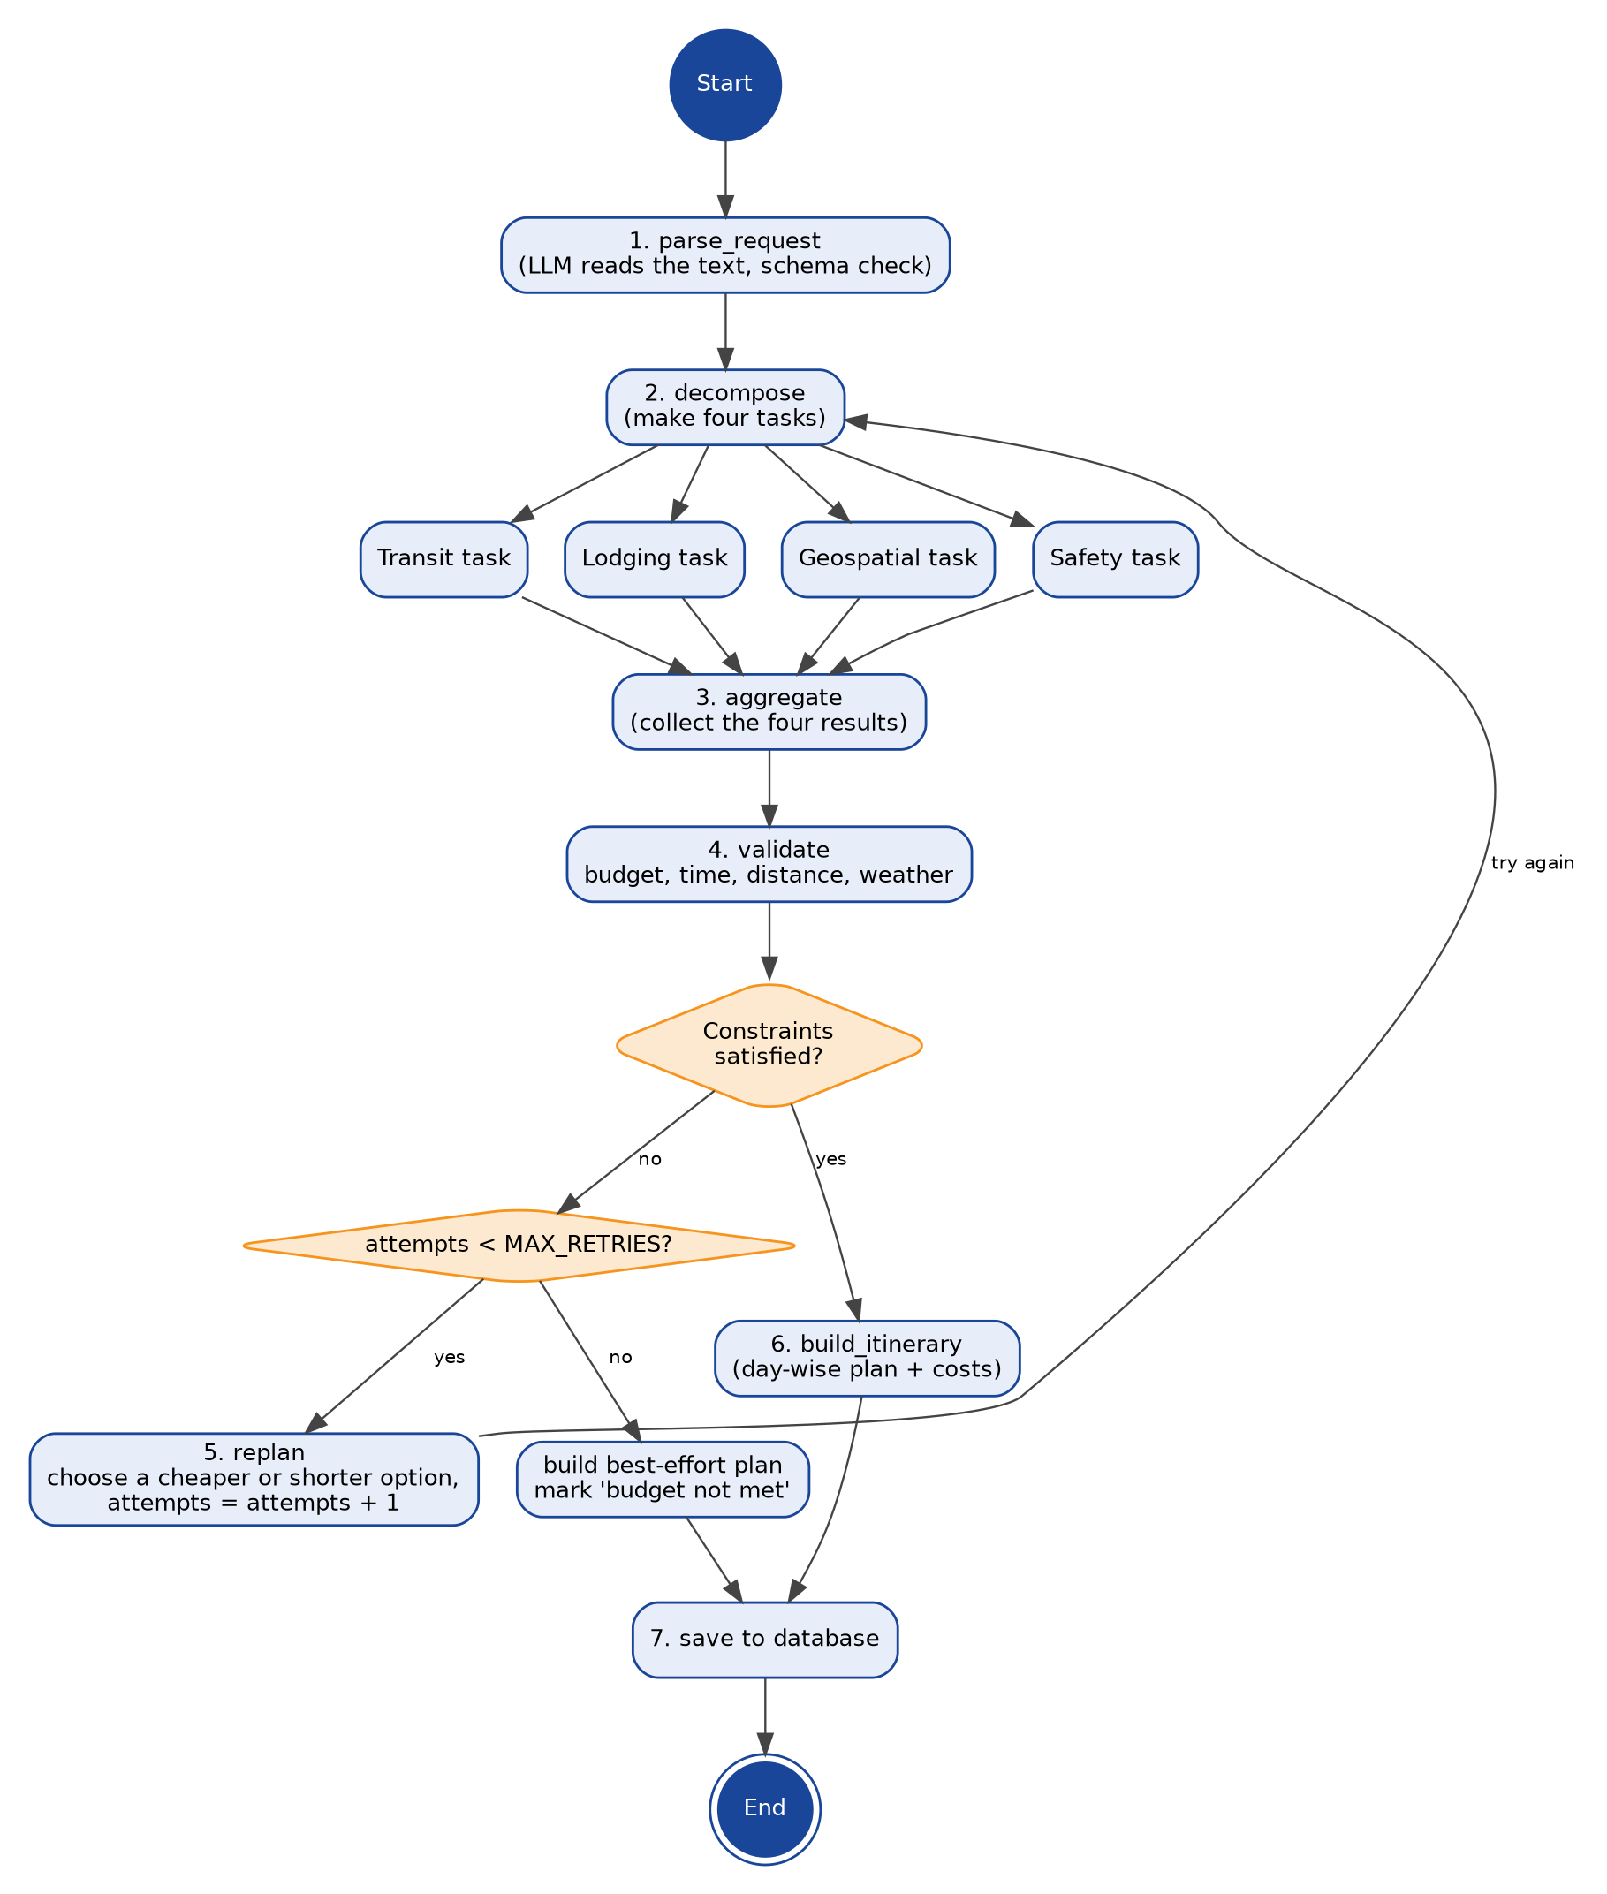
Figure 4: LangGraph workflow with bounded replanning
Replanning stops after MAX_RETRIES attempts (initial value 3). If the constraints still fail, the Supervisor builds the best available plan, marks it "budget not met" and shows the shortfall, so the system never loops forever.
Shared workflow state (TripState)
Field | Content
request | Validated travel request (origin, destination, days, start date, travelers, budget, preferences, interests).
tasks | The four task descriptions made by the Supervisor.
results | AgentResult for each agent: status, payload and data-quality labels.
budget_report | Costs by category, total, remaining budget, list of violations.
attempts | Number of replans so far (compared with MAX_RETRIES).
strategy | Current replanning step (cheaper transport, cheaper stay, fewer paid activities, or weather swap).
warnings | Messages for the user, such as missing data or weather alerts.
itinerary | The day-wise plan once built.

Structured agent outputs. Each agent returns JSON that follows a fixed schema, so the Supervisor can check and combine it. A value that cannot be found is returned as null with quality UNAVAILABLE. Agents never invent prices, ratings or timings.
Agent | Main fields returned | Quality labels used
Transit | options[mode, operator, departure, duration_min, distance_km, fare, source] | VERIFIED (curated or feed), ESTIMATED (road estimate)
Lodging | stays[name, price_per_night, rating, location, last_verified] | VERIFIED (from dataset), UNAVAILABLE
Geospatial | days[day_no, places[name, category, location, visit_min, fee], legs[from, to, km, min]] | VERIFIED (OSM data), ESTIMATED (fees, visit time)
Safety | forecast[day, rain_prob, rain_mm, flag], services[type, name, location, distance_km] | VERIFIED (forecast, OSM), UNAVAILABLE

Interfaces between components (REST API)
Planning can take up to about two minutes (NFR-01), so the create call returns at once and the app polls for progress. Traveler endpoints need a guest session token. Admin endpoints also need the ADMIN role.
Method | Endpoint | Purpose | Requirements
POST | /api/trips | Create a trip from the form or free text; returns 202 and trip_id; planning starts. | FR-01 to FR-22
GET | /api/trips/{id}/status | Current workflow step and attempt number. | NFR-01
GET | /api/trips/{id} | Itinerary, costs, warnings and data-quality labels. | FR-43 to FR-46
PUT | /api/trips/{id} | Change a requirement and replan (new itinerary version). | FR-47 to FR-50
POST | /api/trips/{id}/replan | Re-check with new weather or a user request. | FR-47 to FR-50
GET | /api/trips/{id}/map | GeoJSON of stay, places and routes for MapLibre. | FR-51, FR-52
GET | /api/trips/{id}/pdf | Generate and download the PDF itinerary. | P-01, P-02
GET, DELETE | /api/trips, /api/trips/{id} | List trips of this session; delete a trip. | FR-53, FR-54
POST | /auth/admin-login | Admin login; returns a short-lived token. | P-04
GET, POST, PUT | /admin/accommodations, /admin/transport-routes | Add, edit or deactivate hotel and transport records. | P-04, FR-28

Key design decisions
- Facts from data, words from the LLM. The LLM reads the request and writes itinerary text. Prices, timings, coordinates and weather always come from data sources (NFR-12).
- Controlled workflow. A fixed LangGraph graph with a retry limit gives repeatable behaviour and avoids endless loops.
- Agents and tools are separate. Each external service sits behind a client class, so a service can be replaced or mocked in tests (NFR-18, NFR-24).
- Honest data labels. Every cost, timing and rating carries VERIFIED, ESTIMATED or UNAVAILABLE, and the UI and PDF show it (NFR-11, NFR-13).
- Graceful failure. A failing tool gives a PARTIAL or UNAVAILABLE result and a warning, not a crash (NFR-10).
- Caching and rate limits. Geocoding, route and POI results are cached with an expiry date, which keeps the free services within their limits (NFR-03, NFR-04).
- Security by layers. HTTPS, validated input, keys kept in server environment variables, parameterized SQL, hashed admin passwords, and LLM output treated as untrusted data.

3 Low Level Design (Detail Design)

3.1 Analysis Model
Each use case is realised with boundary objects (screens and API endpoints), control objects (services and the Supervisor) and entity objects (stored data). Sequence diagrams are given for the use cases that carry the main logic. UC-01 to UC-03 come from the SRS; UC-04 and UC-05 are the use cases shown in the SRS use case diagram (Figure 2 of the SRS).
Use case | Name | Requirements | Sequence diagram
UC-01 | Create travel plan | FR-01 to FR-46 | Figure 5
UC-02 | Modify travel plan | FR-47 to FR-50 | Figure 6
UC-03 | Dynamic replanning | FR-47 to FR-50, FR-36 to FR-39 | Figure 7
UC-04 | View itinerary and map; download PDF | FR-43, FR-51, FR-52, P-01, P-02 | Figure 8
UC-05 | Maintain hotel and transport data (Administrator) | FR-28, FR-53, P-04 | Described below

3.1.1 UC-01 Create travel plan
The traveler submits the form or a free-text request. FastAPI checks the mandatory fields (origin, destination, duration, travelers, budget) and starts the workflow in the background. The Supervisor asks the LLM to extract the parameters as JSON and checks them against a schema. It then sends a task to each of the four agents at the same time. Each agent queries its tools and returns an AgentResult. The Supervisor checks budget, time and weather. If a check fails and the retry limit is not reached, it replans; otherwise it asks the LLM to write short descriptions, saves the itinerary and returns it.
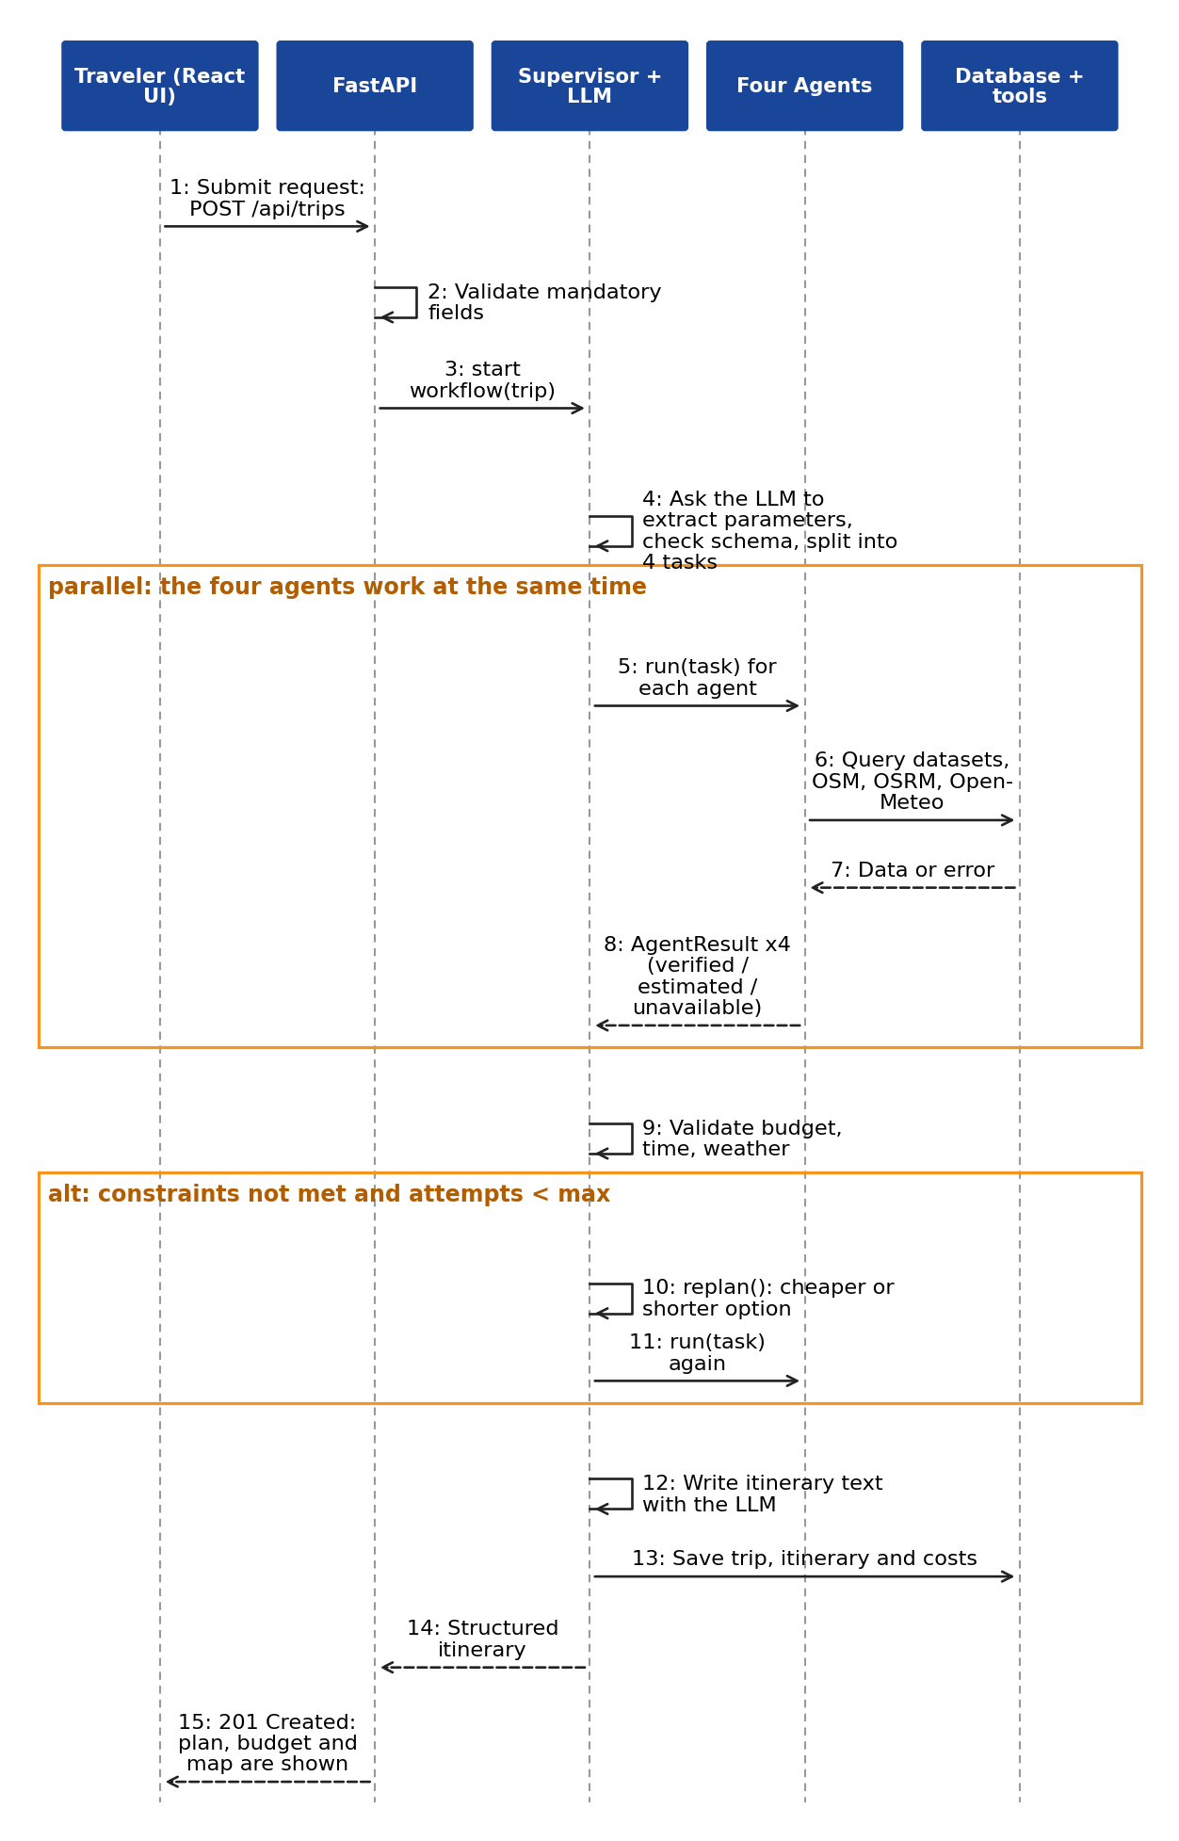
Figure 5: Sequence diagram: UC-01 Create travel plan

3.1.2 UC-02 Modify travel plan
When the traveler changes a requirement, the Supervisor does not start from zero. It loads the stored results, decides which agents are affected (for example, a lower budget affects Transit and Lodging, a new interest affects Geospatial), runs only those agents, rebuilds the affected days and saves a new itinerary version. The old version is marked SUPERSEDED and kept as history.
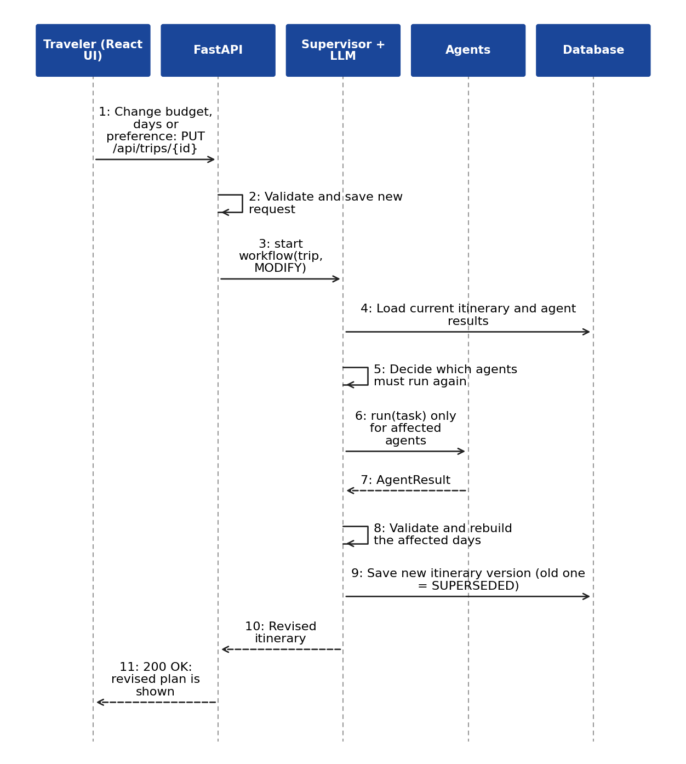
Figure 6: Sequence diagram: UC-02 Modify travel plan

3.1.3 UC-03 Dynamic replanning
The Safety Agent reads the forecast. If rain or storm limits are crossed on a day, it warns the Supervisor. The Supervisor saves a ReplanEvent, finds the outdoor items on that day and asks the Geospatial Agent for indoor alternatives near the stay (a PostGIS distance query). It checks route, time and cost of each alternative, picks the first that passes, saves a new itinerary version and tells the user which day changed and why.
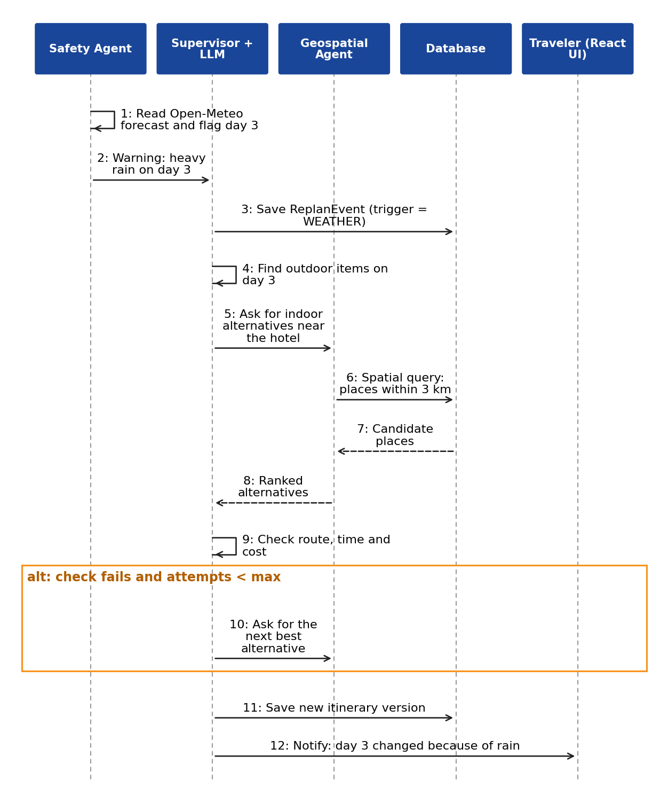
Figure 7: Sequence diagram: UC-03 Dynamic replanning (weather)

3.1.4 UC-04 View itinerary and map; download PDF
The itinerary page reads the stored itinerary and the GeoJSON map data; nothing is recalculated. For the PDF, PdfService loads the final itinerary and asks ImageService for one image per attraction. An image is used only if its licence is on the allowed list and its author and licence text are stored; otherwise the PDF shows a plain placeholder. The PDF contains the trip overview, day-wise plan, transport and stay details, cost breakdown with estimate labels, map links and an image credits section.
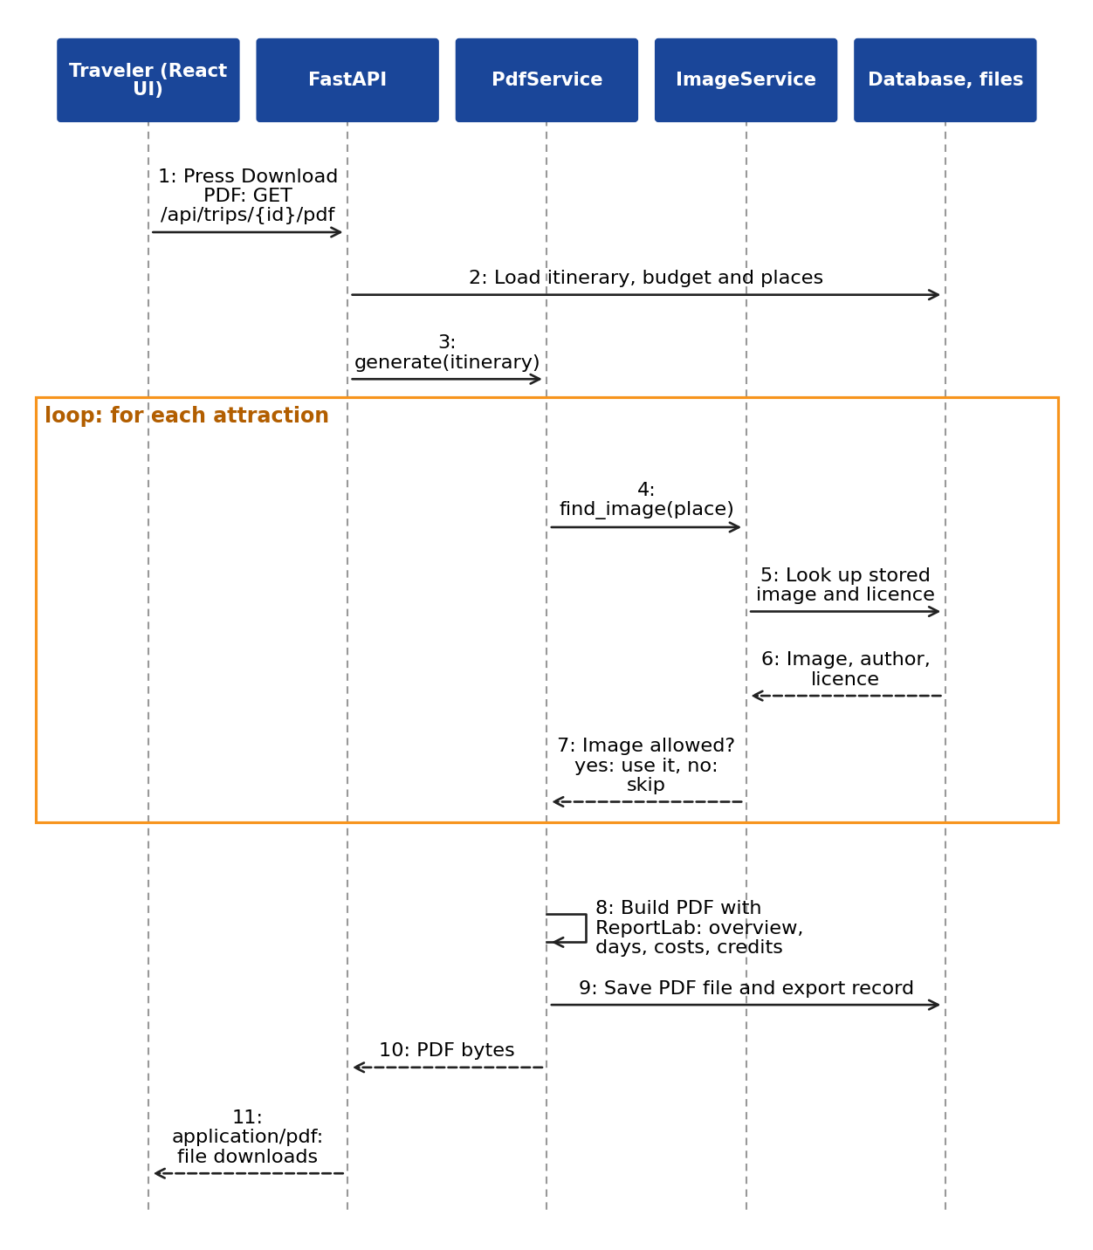
Figure 8: Sequence diagram: UC-04 Download PDF itinerary

3.1.5 UC-05 Maintain hotel and transport data
The administrator is a team member who logs in through /auth/admin-login and uses the /admin endpoints to add, edit or deactivate accommodation and transport records (bus, train and flight timings and fares collected from official sources). Each record stores its source and last_verified date. AdminController validates the input, writes through the Repository and records the change in audit_logs. Plans that already exist are not changed; the change applies to plans generated afterwards. Configuration values (API keys, model name, limits) are kept in server environment files, not in the database.

3.2 Design Model

3.2.1 Class diagrams
Controllers receive requests, services hold the business logic, agents do the planning work, and client classes hide each external tool. The Repository class hides database access so that agents can be tested with a stub. Figure 9 shows the stored (domain) classes and Figure 10 shows the controllers, agents, services and tool clients.
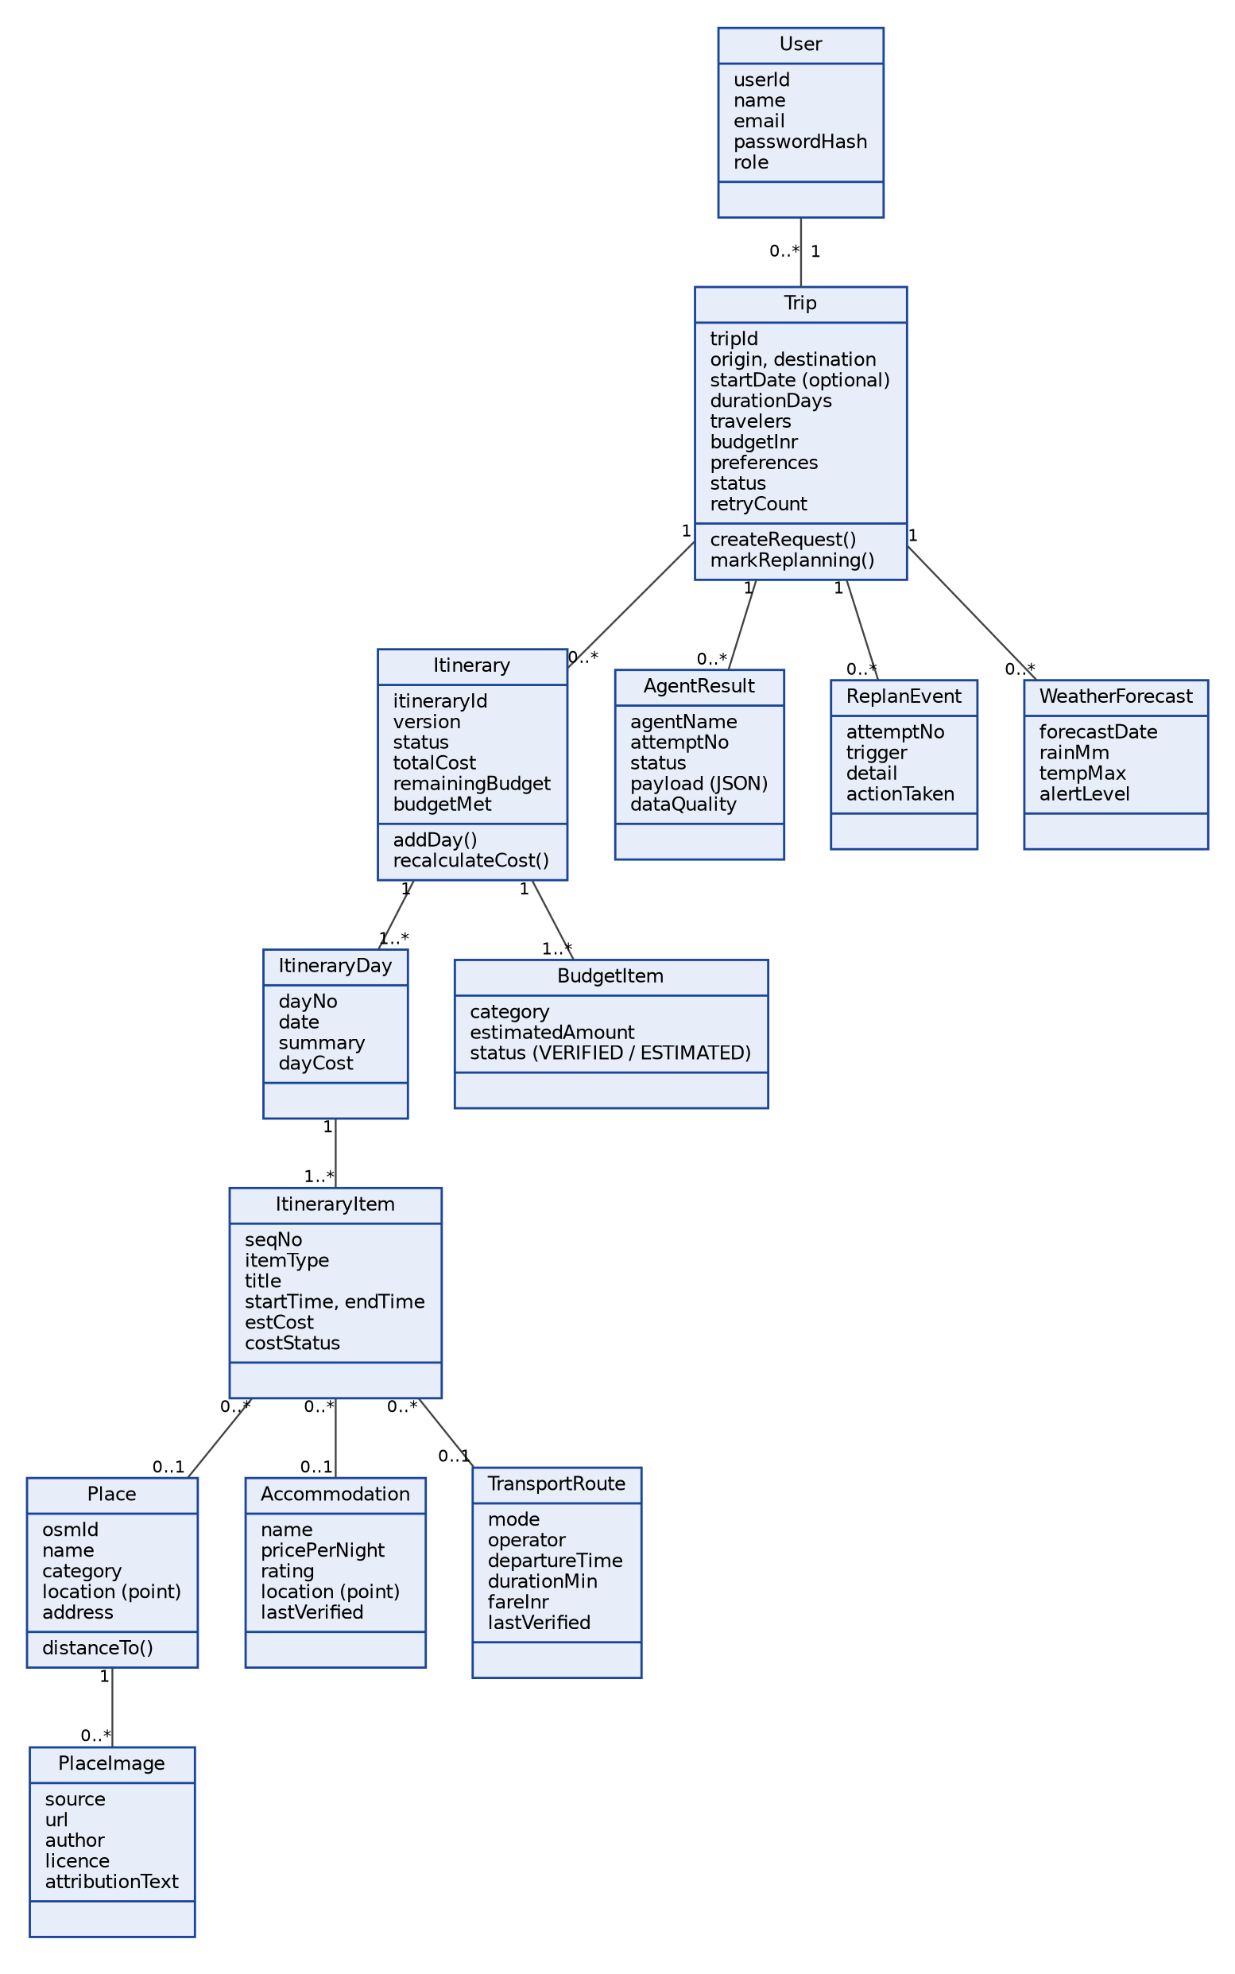
Figure 9: Class diagram: domain classes
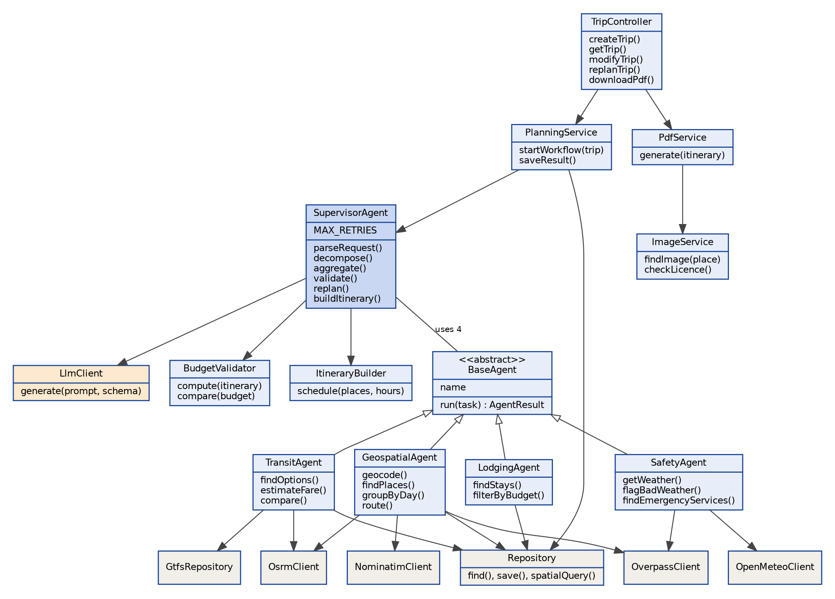
Figure 10: Class diagram: controllers, agents, services and tool clients

3.2.2 State transition diagrams
Two objects change state over time: the trip, and each agent task. Figure 11 shows the trip. Figure 12 shows one agent task; PARTIAL and UNAVAILABLE results can be retried during replanning, within the same retry limit.
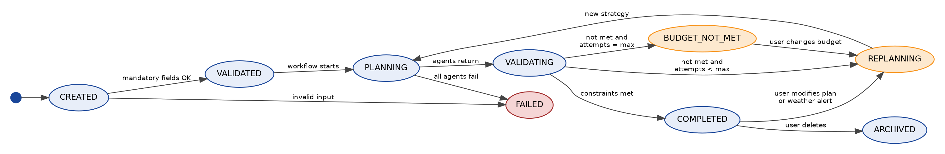
Figure 11: State diagram: trip
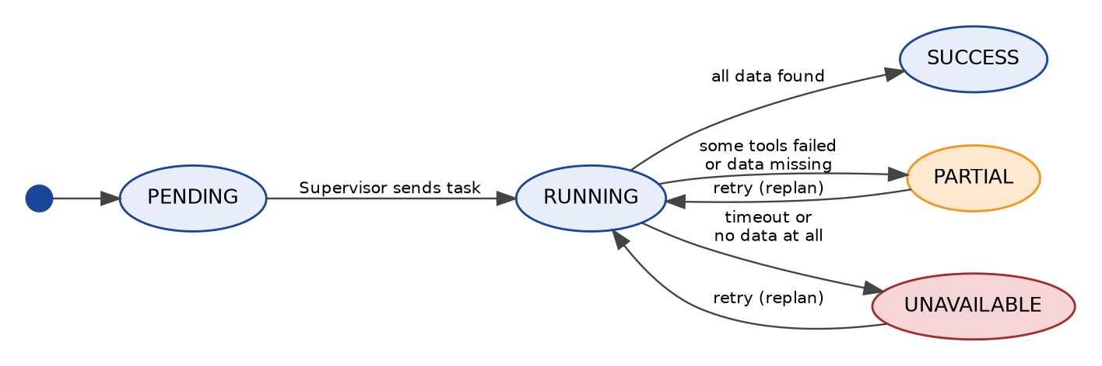
Figure 12: State diagram: agent task

3.2.3 Pseudo code for important methods
The numbers below are initial design values kept in a configuration file, so the team can tune them during testing. They are starting points, not measured results.
Setting | Initial value | Use
MAX_RETRIES | 3 | Replanning attempts before building a best-effort plan
AGENT_TIMEOUT / LLM_TIMEOUT | 20 s / 60 s | Stop waiting for a tool or the model
DAY_START, DAY_END | 09:00, 18:00 | Time window for activities
DEFAULT_VISIT_MIN | 90 min | Time at an attraction when no better value exists
MAX_LEG_MIN | 60 min | Longest allowed local trip between two stops
RAIN_PROB_LIMIT, RAIN_MM_LIMIT | 60 %, 10 mm | Day is flagged for outdoor items above these values
ALT_RADIUS_KM | 3 km | Search radius for replacement places
PEOPLE_PER_ROOM | 2 | Rooms needed = ceil(travelers / 2)
CACHE_TTL geocode / route / POI | 30 / 7 / 7 days | Expiry of cached tool results
Rates for food, local travel, fares | to be calibrated | Per-person-per-day food cost, local transport per day and road fare per km; measured from collected local prices, not guessed

(a) Supervisor.runWorkflow(trip): FR-11 to FR-22, P-03
FUNCTION runWorkflow(trip):
req = parseRequest(trip) # (b)
attempts = 0; strategy = INITIAL
LOOP:
tasks = decompose(req, strategy)
results = RUN_IN_PARALLEL(Transit.run, Lodging.run, Geo.run, Safety.run, tasks)
results = markFailedAsPartialOrUnavailable(results)
report = BudgetValidator.validate(req, results) # (g)
IF report.ok: BREAK
IF attempts >= MAX_RETRIES: report.budgetMet = FALSE; BREAK
attempts += 1; strategy = nextStrategy(report, attempts) # (h)
save ReplanEvent(trip, attempts, report.reason, strategy)
itinerary = ItineraryBuilder.schedule(req, results, report)
itinerary.text = Llm.describe(itinerary) # wording only, validated
save(itinerary, results, report); RETURN itinerary

(b) Supervisor.parseRequest(trip): FR-09 to FR-12, P-07
FUNCTION parseRequest(trip):
fields = trip.formFields # always trusted first
IF trip.freeText is not empty:
json = Llm.generate(EXTRACT_PROMPT, trip.freeText, schema = RequestSchema)
IF NOT validSchema(json): json = Llm.generate(...) once more
IF still invalid: warn("Could not read free text; using the form"); json = {}
fields = merge(fields, json) # form values win on conflict
REQUIRE origin, destination, durationDays, travelers, budget
IF any missing: RETURN error asking the user for the missing field
IF startDate given: derive each day's date, else use "Day 1..N" and skip forecasts
RETURN TravelRequest(fields)

(c) TransitAgent.run(task): FR-23 to FR-27, P-05
FUNCTION run(task):
options = []
options += Gtfs.find(origin, dest, date) # public transit feed, if one exists
options += SELECT * FROM transport_routes # curated bus, train, flight records
WHERE origin_city = o AND dest_city = d AND is_active # quality = VERIFIED
IF options is empty:
(km, min) = Osrm.route(origin, dest) # road distance and time
options = [RoadEstimate(km, min, fare = km * RATE_PER_KM)] # quality = ESTIMATED
options = filter by user transport preference
cost = option.fare * travelers (round trip if returning)
rank by (meets preference, cost, duration); RETURN top 3 with quality labels
# no tool failure stops the run: each failure adds a warning and the next source is tried

(d) LodgingAgent.run(task): FR-28 to FR-30
FUNCTION run(task):
rooms = ceil(travelers / PEOPLE_PER_ROOM); nights = durationDays - 1
stayBudget = (budget - transportEstimate) * STAY_SHARE # STAY_SHARE is configurable
perNight = stayBudget / nights / rooms
stays = SELECT * FROM accommodations
WHERE is_active AND city = destination AND price_per_night <= perNight
AND type matches preference
ORDER BY rating DESC NULLS LAST, price_per_night, distance to attractions
IF stays is empty: RETURN UNAVAILABLE("No stay in dataset within budget")
RETURN top 3 stays with last_verified date # never invent a hotel or price

(e) GeospatialAgent.planDays(task): FR-31 to FR-35, FR-72, FR-73
FUNCTION planDays(task, stay):
center = Nominatim.geocode(destination) # cached
pois = Overpass.query(categories for task.interests, around center) # cached
pois = rank by interest match, then by ST_Distance(poi, stay)
FOR day IN 1..N:
current = stay; used = 0; plan = []
WHILE pois not empty:
next = nearest poi to current (PostGIS)
leg = Osrm.route(current, next)
IF leg.min > MAX_LEG_MIN: SKIP next; CONTINUE
IF used + leg.min + visitMin(next) > (DAY_END - DAY_START): BREAK
plan.add(next, leg); used += leg.min + visitMin(next); current = next
add one food place near the last stop
RETURN days with legs, places, entry fee if known (else UNAVAILABLE)

(f) SafetyAgent.run(task): FR-36 to FR-39, P-06
FUNCTION run(task):
IF startDate is null: forecast = UNAVAILABLE("No dates given") ELSE
forecast = OpenMeteo.daily(destination, dates)
FOR day IN forecast:
day.flag = day.rainProb >= RAIN_PROB_LIMIT OR day.rainMm >= RAIN_MM_LIMIT OR day.storm
services = Overpass.query(hospital, pharmacy, police, around stay, radius 5 km)
RETURN forecast with flags, services with distances
# Wording rule: report only facts and sources. Never say an area is "safe" or "unsafe".
# Show: "Nearest mapped hospital: X, 2.1 km (OpenStreetMap data)".

(g) BudgetValidator.validate(req, results): FR-40 to FR-43
FUNCTION validate(req, results):
cost.transport = chosenTransport.cost
cost.stay = chosenStay.pricePerNight * nights * rooms
cost.food = FOOD_RATE * travelers * durationDays # ESTIMATED
cost.local = LOCAL_RATE * durationDays # ESTIMATED
cost.activities = SUM(entry fees that are known); count unknown fees as UNAVAILABLE
total = SUM(cost); remaining = req.budget - total
problems = []
IF total > req.budget: problems.add(BUDGET, shortfall = -remaining)
IF any day scheduled hours > DAY_END - DAY_START: problems.add(TIME)
IF any outdoor item on a flagged weather day: problems.add(WEATHER)
RETURN Report(ok = problems is empty, total, remaining, problems, labels per line)

(h) Supervisor.nextStrategy(report, attempts): FR-42, FR-47 to FR-50
FUNCTION nextStrategy(report, attempts):
IF BUDGET in report.problems:
attempts = 1: RETURN CHEAPER_TRANSPORT # next cheaper mode that still fits the time
attempts = 2: RETURN CHEAPER_STAY # lower price tier, or closer to attractions
attempts = 3: RETURN FEWER_PAID_ACTIVITIES # drop lowest-priority paid items
IF WEATHER in report.problems: RETURN SWAP_OUTDOOR_FOR_INDOOR(ALT_RADIUS_KM)
IF TIME in report.problems: RETURN FEWER_STOPS_PER_DAY
# each strategy changes the tasks sent to the agents; nothing is repeated unchanged

(i) ImageService.findImage(place): P-02
FUNCTION findImage(place):
stored = SELECT * FROM place_images WHERE place_id = place.id
IF stored exists: RETURN stored
FOR source IN [Wikimedia Commons, Unsplash, Pexels]: # in this order
candidate = source.search(place.name, place.city)
IF candidate is null: CONTINUE
IF candidate.licence NOT IN ALLOWED_LICENCES: CONTINUE # e.g. CC0, CC BY, CC BY-SA,
# Unsplash and Pexels licences
IF author or licence text missing: CONTINUE
download to storage; save(place_id, source, url, author, licence, attributionText)
RETURN saved
RETURN NONE # PDF shows a placeholder

(j) PdfService.generate(itinerary): P-01, P-02
FUNCTION generate(itinerary):
doc = ReportLab document with header, footer and page numbers
add title page: destination, days, travelers, budget, "Estimates only"
FOR day IN itinerary.days:
add heading; add table of items (time, place, transport, est. cost, quality label)
FOR place IN day.attractions: img = ImageService.findImage(place); add img if present
add cost table by category with total and remaining budget
add safety section: weather flags and nearest mapped services (facts only)
add map links; add "Image credits" listing author, licence and source for every image used
save file; insert pdf_exports record; RETURN file

(k) CacheService.getOrFetch(key, kind, fetchFn)
FUNCTION getOrFetch(key, kind, fetchFn):
row = SELECT payload FROM geo_cache WHERE cache_key = key AND expires_at > now()
IF row exists: RETURN row.payload
TRY: payload = rateLimited(fetchFn()) # respects provider limits
CATCH error: stale = latest expired row; RETURN stale (flagged "old data") OR error
INSERT payload with expires_at = now() + CACHE_TTL[kind]; RETURN payload

3.2.4 Error handling and security design
Situation | Design response
A tool (Nominatim, Overpass, OSRM, Open-Meteo) times out or returns an error | Retry once, then use cached data flagged "old", or return PARTIAL/UNAVAILABLE with a warning. The workflow continues (NFR-10).
No public transit feed for the route | Use the curated transport table; if that is empty, show a road-based estimate labeled ESTIMATED (P-05).
No hotel within budget | Return UNAVAILABLE and trigger replanning; never invent a hotel.
LLM output is invalid JSON or does not match the schema | Retry once; then use form fields only and warn the user.
LLM is slow or Ollama is not running | Time out after LLM_TIMEOUT; show a clear error for free-text requests and still accept the structured form.
Constraints cannot be met after MAX_RETRIES | Build the best-effort plan, mark it "budget not met" and show the shortfall.
No image with an allowed licence | The PDF uses a placeholder; no image is used without author and licence data.
Malicious or oversized input, including prompt injection text | Pydantic limits on length and type; the free text goes only into the extraction step; LLM output is schema-checked and cannot choose tools or run commands.
Secrets and access | API keys in server environment variables only; admin passwords hashed; admin endpoints need the ADMIN role; SQL is parameterized; HTTPS at the Nginx proxy; per-IP rate limits (NFR-05 to NFR-08).

4 Database Design

4.1 ER Model
The entities come from the SRS (Section 2.11 and FR-53 to FR-55), the class model and the design additions. The model has 16 tables. It is drawn in two parts that share the trips and itinerary_items tables. Part 1 covers users, trips, agent results, itineraries and costs. Part 2 covers places, images, hotels, transport, weather, cache and audit. The crow's-foot end marks the "many" side.
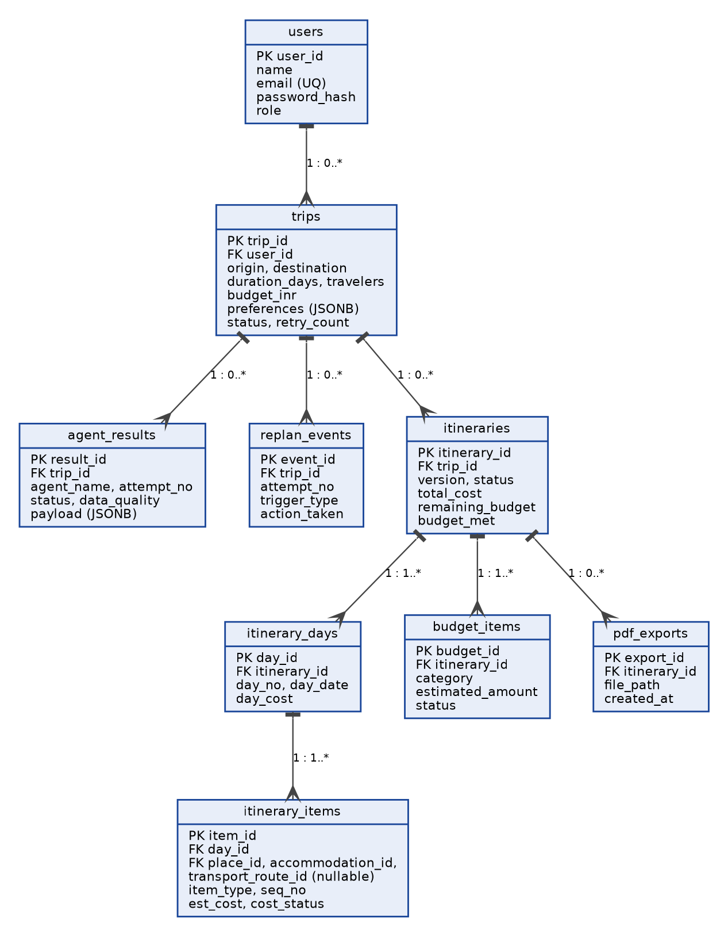
Figure 13: ER diagram: users, trips, agent results and itineraries
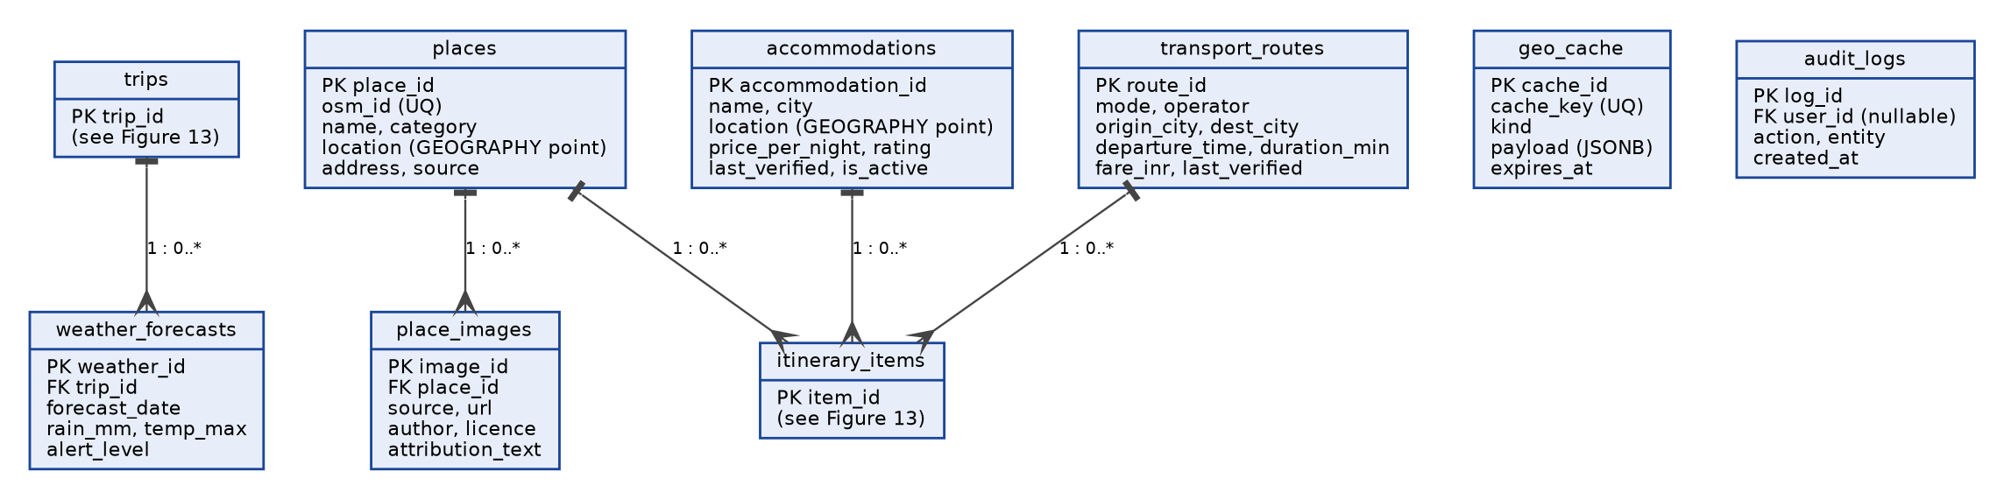
Figure 14: ER diagram: places, images, accommodation, transport, weather, cache and audit
Parent | Child | Cardinality | Meaning
users | trips | 1 : 0..* | A guest or admin user owns many trips.
trips | agent_results | 1 : 0..* | Each agent run (and rerun) for a trip is stored.
trips | replan_events | 1 : 0..* | Each replanning attempt and its reason.
trips | itineraries | 1 : 0..* | Versions of the plan; one is ACTIVE.
itineraries | itinerary_days | 1 : 1..* | A plan has one record per day.
itinerary_days | itinerary_items | 1 : 1..* | A day has ordered items (transport, stay, place, meal).
itineraries | budget_items | 1 : 1..* | Costs by category.
itineraries | pdf_exports | 1 : 0..* | PDF files generated for a version.
places, accommodations, transport_routes | itinerary_items | 1 : 0..* | An item may point to one place, stay or route.
places | place_images | 1 : 0..* | Licensed images with author and licence.
trips | weather_forecasts | 1 : 0..* | Forecast per day for the trip location.

4.2 Database Object Definitions
Database: PostgreSQL with the PostGIS extension. Primary keys are generated integers (BIGINT identity). "UQ" is a unique key. Child records of a trip use ON DELETE CASCADE, so deleting a trip removes its data. audit_logs uses ON DELETE SET NULL so the audit trail stays without the identity. Spatial columns use GEOGRAPHY(Point, 4326) with a GIST index.

Table: users
Guest travelers and administrators.
Column | Type | Constraints / notes
user_id | BIGINT | PK, identity
name | VARCHAR(100) | NULL for guests
email | VARCHAR(150) | UQ, NULL for guests
password_hash | VARCHAR(255) | NULL for guests; salted hash for admins, never the password
role | VARCHAR(10) | NOT NULL, 'TRAVELER' or 'ADMIN'
created_at | TIMESTAMPTZ | NOT NULL, default now()

Table: trips
The travel request and its status (FR-01 to FR-10, FR-53).
Column | Type | Constraints / notes
trip_id | UUID | PK
user_id | BIGINT | FK users, NOT NULL, ON DELETE CASCADE
origin_text, destination_text | VARCHAR(150) | NOT NULL, as typed by the user
origin_geo, destination_geo | GEOGRAPHY(Point) | NULL until geocoded
start_date | DATE | NULL if not given
duration_days | SMALLINT | NOT NULL, CHECK 1 to 30
travelers | SMALLINT | NOT NULL, CHECK 1 to 20
budget_inr | NUMERIC(10,2) | NOT NULL, CHECK > 0
preferences | JSONB | transport, stay, interests, food
raw_text | TEXT | free-text request, NULL if form only
status | VARCHAR(20) | CREATED, VALIDATED, PLANNING, VALIDATING, REPLANNING, COMPLETED, BUDGET_NOT_MET, FAILED, ARCHIVED
current_step, retry_count | VARCHAR(30), SMALLINT | workflow progress; retry_count default 0
created_at | TIMESTAMPTZ | NOT NULL, default now()
updated_at | TIMESTAMPTZ | NOT NULL

Table: agent_results
Output of each agent run, kept for inspection and reuse (FR-18, FR-54).
Column | Type | Constraints / notes
result_id | BIGINT | PK, identity
trip_id | UUID | FK trips, NOT NULL, CASCADE; INDEX (trip_id, agent_name)
agent_name | VARCHAR(15) | TRANSIT, LODGING, GEOSPATIAL, SAFETY
attempt_no | SMALLINT | NOT NULL, default 0
status | VARCHAR(15) | SUCCESS, PARTIAL, UNAVAILABLE
payload | JSONB | structured output of the agent
data_quality | VARCHAR(12) | VERIFIED, ESTIMATED, UNAVAILABLE
created_at | TIMESTAMPTZ | NOT NULL, default now()

Table: replan_events
Why and how each replanning happened (FR-47 to FR-50).
Column | Type | Constraints / notes
event_id | BIGINT | PK, identity
trip_id | UUID | FK trips, NOT NULL, CASCADE
attempt_no | SMALLINT | NOT NULL
trigger_type | VARCHAR(15) | BUDGET, TIME, WEATHER, USER_CHANGE, DATA_MISSING
detail | TEXT | reason text
action_taken | VARCHAR(40) | for example CHEAPER_TRANSPORT
created_at | TIMESTAMPTZ | NOT NULL, default now()

Table: itineraries
Versions of the plan (FR-44, FR-90).
Column | Type | Constraints / notes
itinerary_id | BIGINT | PK, identity
trip_id | UUID | FK trips, NOT NULL, CASCADE; INDEX (trip_id, status)
version | SMALLINT | NOT NULL, starts at 1
status | VARCHAR(12) | ACTIVE, SUPERSEDED
total_cost | NUMERIC(10,2) | NOT NULL
remaining_budget | NUMERIC(10,2) | may be negative
budget_met | BOOLEAN | NOT NULL
summary_text | TEXT | LLM-written overview, checked against data
created_at | TIMESTAMPTZ | NOT NULL, default now()

Table: itinerary_days
One row per day.
Column | Type | Constraints / notes
day_id | BIGINT | PK, identity
itinerary_id | BIGINT | FK itineraries, NOT NULL, CASCADE
day_no | SMALLINT | NOT NULL, UQ with itinerary_id
day_date | DATE | NULL if no start date
day_cost | NUMERIC(10,2) | NOT NULL
weather_flag | BOOLEAN | default false
summary | TEXT | NULL

Table: itinerary_items
Ordered items inside a day.
Column | Type | Constraints / notes
item_id | BIGINT | PK, identity
day_id | BIGINT | FK itinerary_days, NOT NULL, CASCADE
seq_no | SMALLINT | NOT NULL, order in the day
item_type | VARCHAR(12) | TRANSPORT, STAY, ATTRACTION, MEAL, OTHER
title | VARCHAR(150) | NOT NULL
start_time, end_time | TIME | NULL allowed
place_id | BIGINT | FK places, NULL
accommodation_id | BIGINT | FK accommodations, NULL
transport_route_id | BIGINT | FK transport_routes, NULL
leg_km, leg_min | NUMERIC(6,1), SMALLINT | travel from the previous item
est_cost | NUMERIC(10,2) | NOT NULL, default 0
cost_status | VARCHAR(12) | VERIFIED, ESTIMATED, UNAVAILABLE

Table: budget_items
Cost by category (FR-40 to FR-43).
Column | Type | Constraints / notes
budget_id | BIGINT | PK, identity
itinerary_id | BIGINT | FK itineraries, NOT NULL, CASCADE
category | VARCHAR(15) | TRANSPORT, STAY, FOOD, ACTIVITIES, OTHER
estimated_amount | NUMERIC(10,2) | NOT NULL
status | VARCHAR(12) | VERIFIED or ESTIMATED

Table: places
Attractions, restaurants and emergency services found by the Geospatial and Safety agents (FR-32, FR-38).
Column | Type | Constraints / notes
place_id | BIGINT | PK, identity
osm_id | BIGINT | UQ with osm_type
name | VARCHAR(200) | NOT NULL
category | VARCHAR(20) | ATTRACTION, RESTAURANT, HOSPITAL, PHARMACY, POLICE, OTHER
location | GEOGRAPHY(Point,4326) | NOT NULL; GIST index
address | VARCHAR(255) | NULL
entry_fee | NUMERIC(8,2) | NULL if unknown
source | VARCHAR(20) | OSM or other
fetched_at | TIMESTAMPTZ | NOT NULL

Table: place_images
Images and their licence records (P-02).
Column | Type | Constraints / notes
image_id | BIGINT | PK, identity
place_id | BIGINT | FK places, NOT NULL, CASCADE
source | VARCHAR(15) | WIKIMEDIA, UNSPLASH, PEXELS
url | VARCHAR(500) | NOT NULL
local_path | VARCHAR(255) | NULL until downloaded
author | VARCHAR(150) | NOT NULL
licence | VARCHAR(60) | NOT NULL, must be on the allowed list
attribution_text | VARCHAR(300) | NOT NULL

Table: accommodations
Curated hotel data maintained by the administrator (FR-28, P-04).
Column | Type | Constraints / notes
accommodation_id | BIGINT | PK, identity
name | VARCHAR(150) | NOT NULL
city | VARCHAR(80) | NOT NULL; INDEX
location | GEOGRAPHY(Point,4326) | NOT NULL; GIST index
type | VARCHAR(15) | BUDGET, MIDRANGE, PREMIUM, HOSTEL
price_per_night | NUMERIC(8,2) | NOT NULL, CHECK > 0
rating | NUMERIC(2,1) | NULL if unknown
source | VARCHAR(150) | NOT NULL, where the data came from
last_verified | DATE | NOT NULL
is_active | BOOLEAN | NOT NULL, default true

Table: transport_routes
Curated bus, train and flight records (P-04, P-05).
Column | Type | Constraints / notes
route_id | BIGINT | PK, identity
mode | VARCHAR(10) | BUS, TRAIN, FLIGHT
operator | VARCHAR(100) | NULL
origin_city, dest_city | VARCHAR(80) | NOT NULL; INDEX (origin_city, dest_city)
departure_time | TIME | NULL
duration_min | INTEGER | NOT NULL
fare_inr | NUMERIC(8,2) | NOT NULL
source | VARCHAR(150) | NOT NULL
last_verified | DATE | NOT NULL
is_active | BOOLEAN | NOT NULL, default true

Table: weather_forecasts
Forecast per day for a trip (FR-36, FR-37).
Column | Type | Constraints / notes
weather_id | BIGINT | PK, identity
trip_id | UUID | FK trips, NOT NULL, CASCADE
forecast_date | DATE | NOT NULL, UQ with trip_id
rain_prob_pct | SMALLINT | NULL
rain_mm | NUMERIC(5,1) | NULL
temp_max_c | NUMERIC(4,1) | NULL
alert_level | VARCHAR(10) | NONE, WATCH, WARNING
fetched_at | TIMESTAMPTZ | NOT NULL

Table: geo_cache
Cached tool results (NFR-03, NFR-04).
Column | Type | Constraints / notes
cache_id | BIGINT | PK, identity
cache_key | VARCHAR(300) | NOT NULL, UQ
kind | VARCHAR(10) | GEOCODE, ROUTE, POI
payload | JSONB | NOT NULL
expires_at | TIMESTAMPTZ | NOT NULL; INDEX

Table: pdf_exports
Generated PDF files (P-01).
Column | Type | Constraints / notes
export_id | BIGINT | PK, identity
itinerary_id | BIGINT | FK itineraries, NOT NULL, CASCADE
file_path | VARCHAR(255) | NOT NULL
created_at | TIMESTAMPTZ | NOT NULL, default now()

Table: audit_logs
Admin and login actions (constraint e).
Column | Type | Constraints / notes
log_id | BIGINT | PK, identity
user_id | BIGINT | FK users, NULL, ON DELETE SET NULL
action | VARCHAR(40) | LOGIN_OK, LOGIN_FAILED, HOTEL_ADDED, ...
entity | VARCHAR(40) | table and record id
detail | TEXT | NULL
created_at | TIMESTAMPTZ | NOT NULL, default now()

5 Appendices
As required by the SDD template, this section gives (a) the reference to the SRS and (b) the Requirement Traceability Matrix. Appendices C to F hold supporting material for the design.

Appendix A: Software Requirement Specification
Item | Detail
Title | Software Requirement Specification: Agentic AI-Based Intelligent Travel Planning System
Document ID | ATP/SRS, Issue 1, Revision 0
Prepared by | Ashfaque C, Muhammad Fawas K, Abel Mathew, Afrah Shad EK
Location | Project repository (same folder as this SDD)
Used in this SDD | FR-01 to FR-55, NFR-01 to NFR-19, UC-01 to UC-03, acceptance checks AC-01 to AC-09

Appendix B: Requirement Traceability Matrix (SRS to design)
SRS requirements | Design component | Tables | Figures
FR-01 to FR-10 Travel request | API routers, Supervisor.parseRequest | trips | 5
FR-11 to FR-22 Supervisor | SupervisorAgent, LangGraph workflow | trips, agent_results, replan_events | 4, 5
FR-23 to FR-27 Transit | TransitAgent, GtfsRepository, OsrmClient | transport_routes, geo_cache | 5
FR-28 to FR-30 Lodging | LodgingAgent | accommodations | 5
FR-31 to FR-35 Geospatial | GeospatialAgent, Nominatim / Overpass / OSRM clients | places, geo_cache | 5, 7
FR-36 to FR-39 Safety | SafetyAgent, OpenMeteoClient | weather_forecasts, places | 7
FR-40 to FR-43 Budget | BudgetValidator | budget_items, itineraries | 5
FR-44 to FR-46 Itinerary | ItineraryBuilder, LLM wording | itineraries, itinerary_days, itinerary_items | 5, 8
FR-47 to FR-50 Replanning | Supervisor.nextStrategy, ReplanEvent | replan_events, itineraries | 4, 6, 7
FR-51, FR-52 Map | /map endpoint, MapLibre | places, itinerary_items | 8
FR-53 to FR-55 Storage | Repository, PostGIS queries | all tables | 13, 14
NFR-01 to NFR-04 Performance | Background run, status polling, CacheService | geo_cache | 4
NFR-05 to NFR-09 Security | Validation, hashing, HTTPS, audit log | users, audit_logs | 3
NFR-10 to NFR-13 Reliability, accuracy | Quality labels, partial results, retries | agent_results | 12
NFR-14 to NFR-19 Usability, maintainability | React UI, separate agent and tool classes | - | 2, 10

Appendix C: Proposed additions to the SRS
The design adds the following requirements. Add them to the SRS in the next revision, keeping the same wording style.
ID | Proposed requirement
P-01 | The system shall generate a downloadable PDF itinerary containing the trip overview, day-wise plan, transport and stay details, cost breakdown and map links.
P-02 | The system shall include an attraction image in the PDF only when its source, author and licence are recorded and the licence allows reuse; the PDF shall list image credits.
P-03 | The Supervisor Agent shall limit replanning to a configured maximum number of attempts and then present the best available plan with the unmet constraint shown.
P-04 | An administrator shall be able to add, edit and deactivate accommodation and transport (bus, train, flight) records, each with a source and a last-verified date.
P-05 | The Transit Agent shall look for transport data in this order: public transit feed, curated transport records, road-based estimate, and shall label each result as verified or estimated.
P-06 | The Safety Agent shall report weather and mapped emergency services as sourced facts and shall not state that a place is safe or unsafe.
P-07 | The system shall accept an optional travel start date; when it is missing, the system shall plan by day number and shall not show dated forecasts.

Appendix D: Suggested build order
The brief asks for a small working prototype first. This order matches the phases in the project brief.
Phase | Build | Done when
1 | React form, FastAPI endpoint, curated dataset, fixed itinerary | A request returns a simple day-wise plan
2 | LangGraph workflow with Supervisor and four agents using stub data | All four results reach the Supervisor
3 | Ollama request extraction with schema check | Free text becomes valid parameters
4 | Real tools: Nominatim, Overpass, OSRM, Open-Meteo; PostgreSQL/PostGIS; cache | A real destination returns real places and routes
5 | Budget validation and bounded replanning | An over-budget request is replanned or reported
6 | MapLibre map, images with licences, ReportLab PDF | The PDF downloads with credits
7 | Testing (acceptance checks AC-01 to AC-09 of the SRS) | All checks pass or gaps are documented

Appendix E: Implementation status
Update this table only after a component has been built and tested. Nothing is claimed as done in this issue.
Component | Status | Notes
React UI and map | Planned
FastAPI backend and API | Planned
LangGraph workflow and Supervisor | Planned
Transit, Lodging, Geospatial, Safety agents | Planned
Ollama integration | Planned | Model choice depends on available hardware
PostgreSQL / PostGIS schema | Planned
Hotel and transport datasets | Planned | Demo routes to be collected by the team
PDF generation and images | Planned | Licence checks required
Admin data maintenance | Planned

Appendix F: Related documents
- Software Requirement Specification (ATP/SRS, Issue 1, Revision 0).
- Project Summary and Project Brief of the Agentic AI-Based Intelligent Travel Planning System.

