Softnerve Tech Assessment

**Submitted by: Ablokit Joshi  
Perusing BTech from IIT Kanpur  
Phone No. : +919315800879  
Email id:** [**joshiablokit2001@gmail.com /**](mailto:joshiablokit2001@gmail.com%20/)[**ablokitj20@iitk.ac.in**](mailto:ablokitj20@iitk.ac.in) **Linkedin:** [**https://www.linkedin.com/in/ablokit-joshi-28194822a/**](https://www.linkedin.com/in/ablokit-joshi-28194822a/) **Github:** [**https://github.com/ablokitj20**](https://github.com/ablokitj20) **Resume:** [**https://drive.google.com/file/d/187mVGJnCQuVd82yj_ioWeraZI-Ye_uf_/view?pli=1**](https://drive.google.com/file/d/187mVGJnCQuVd82yj_ioWeraZI-Ye_uf_/view?pli=1)

Ques 1:

vector<int> findLeaders(const vector<int>& v) {

    vector<int> leaders;

    int curr_leader = 0; // to store the maximum value till the ith iteration

    // loop to find the leaders

    for (int i = v.size() - 1; i >= 0; i--) {

        if (v[i] > curr_leader)

            leaders.push_back(v[i]);

        curr_leader = max(curr_leader, v[i]);

    }

    reverse(leaders.begin(), leaders.end()); // Reverse the order of leaders to get the chronological orer

    return leaders;

}

Test Case:  
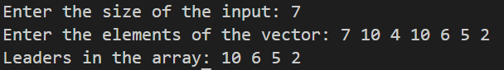

Time Complexity: O(N)  
Space Complexity: O(leaders.size()) or O(N) in worst case scenario.

Ques 2:

int Max_Profit(vector<int>&prices){

    int n = prices.size();//size of vector

    int min_so_far = prices[0]; // to store the minimum vale till the ith iteration

    int max_profit = 0; // to store the maximum profit till the ith iteration

    for(auto price : prices){

        if(price < min_so_far)

            min_so_far = price; //max_so_far updated as price is smaller

        max_profit = max(max_profit,price - min_so_far); //calculating the maximum profit till now

    }

    return max_profit;

}

Test Case:  
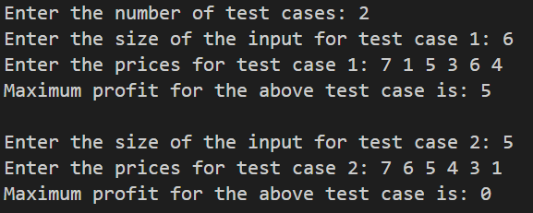

Time Complexity: O(N)  
Space Complexity: O(N)

Ques 3: Solving using recursion.

// Helper function to find XOR sum of all the subsets

void Subset_XORs(vector<int> &v, int curr_XOR, int &sum, int start)

{

    if (start == v.size()) //base condition

    {

        sum += curr_XOR; //adding the XOR sum of a subset to the sum

        return;

    }

    Subset_XORs(v, curr_XOR, sum, start + 1); // call the function excluding (start)th element

    Subset_XORs(v, (curr_XOR ^ v[start]), sum, start + 1); // call the function including XORed value of (start)th element and curr_XOR

}

// Main function

int XOR_Sum(vector<int> &nums)

{

    int ans = 0;

    Subset_XORs(nums, 0, ans, 0);// call the helper function and pass ans as reference

    return ans;

}

`

Test Case:  
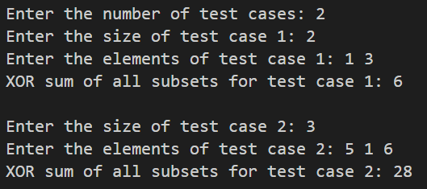

Time Complexity: O(2N)  
Space Complexity: O(N)

QnA:

1. Rating in scale of DSA (Please mention DSA topic or algorithm you are extremely good at)
2. I would give myself 7 out of 10. I am good at number theory, stacks, hashing, recursions, DP.
3. Leetcode / hacker rank. code chef ranking?
4. I don’t solve problems from these platforms, rather I spend most of the DSA time in Interviewbit.
5. Deep learning rating – (Mentioned if worked in GAN Related project)
6. I have a good in-depth knowledge of the neural networks theory and have worked on various projects using Python language and frameworks like Tensorflow and Keras. I would rate myself 7 out of 10 as there are several other aspects like the GAN of DL that haven’t explored due to time constraint. I particularly like ML/DL where we have to deal with image datas.
7. Appetite of research and putting thoughts in doc
8. Having done a research internship at IIT Kanpur on Computer Vision has fueled my appetite for research and the desire to dive deeper into this field. I have also done several other projects under the esteem professors of IITK, requiring a good amount of research and patience and I have excelled in each of them. I am forever keen to learn more and excel my Problem Solving skills.