

Functional Safety Concept Lane Assistance

**Document Version: 3.0**

**Template Version 1.0, Released on 2017-06-21**



# Document history

|  |  |  |  |
| --- | --- | --- | --- |
| Date | Version | Editor | Description |
| 2018-03-13 | 1.0 | Abhishek Mantha | Document initialization |
| 2018-03-13 | 2.0 | Abhishek Mantha | Revising for Final Submission |
| 2018-03-14 | 3.0 | Abhishek Mantha | Final Submission |
|  |  |  |  |
|  |  |  |  |

# Table of Contents

Document history

Table of Contents

Purpose of the Functional Safety Concept

Inputs to the Functional Safety Analysis

Safety goals from the Hazard Analysis and Risk Assessment

Preliminary Architecture

Description of architecture elements

Functional Safety Concept

Functional Safety Analysis

Functional Safety Requirements

Refinement of the System Architecture

Allocation of Functional Safety Requirements to Architecture Elements

Warning and Degradation Concept

# Purpose of the Functional Safety Concept

The functional safety concept allocates identified functional safety requirements to the relevant parts of the system diagram. Allocation means defining which part of the system architecture will implement each requirement. Functional safety requirements are specified with attributes such as: ASIL level; fault tolerant time interval, which measure how quickly a system needs to react to a hazardous situation; safe state, which discusses what a system looks like after it has avoided an accident. Finally, the functional safety concepts address verification and validation processes to prove the system actually meets requirements.

# Inputs to the Functional Safety Concept

## Safety goals from the Hazard Analysis and Risk Assessment

|  |  |
| --- | --- |
| **ID** | **Safety Goal** |
| Safety_Goal_01 | Oscillating steering torque from LDW function shall be limited. |
| Safety_Goal_02 | LKA function shall be time limited so that driver cannot misuse the system for autonomous driving. |

## Preliminary Architecture

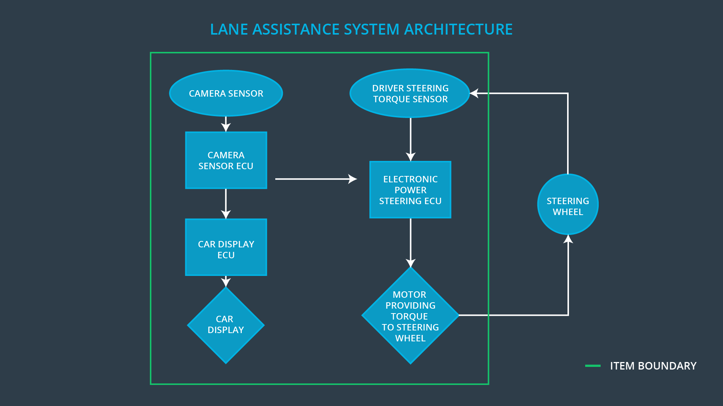

### Description of architecture elements

|  |  |
| --- | --- |
| **Element** | **Description** |
| Camera Sensor | The Camera Sensor reads in images from road. |
| Camera Sensor ECU | The Camera Sensor ECU identifies when the vehicle has accidentally departed its lane, and sends the appropriate messages to the Car Display ECU and the Electronic Power Steering ECU. |
| Car Display | The Car Display displays notifications on driver dashboard. |
| Car Display ECU | The Car Display ECU sends messages to be displayed by the Car Display, triggered by incoming input from the Camera Sensor ECU. |
| Driver Steering Torque Sensor | The Driving Steering Torque Sensor records current steering wheel torque. |
| Electronic Power Steering ECU | The Electronic Power Steering ECU combines data from Camera Sensor ECU and Driver Steering Torque Sensor to determine amount of oscillating torque to apply, depending on amount steering wheel is already turned and if unsafe lane departure has occurred. The Electronic Power Steering ECU sends a signal to motor controlling steering wheel torque to apply physical force. |
| Motor | The Motor applies the torque to steering wheel specified by the Electronic Power Steering ECU. |

# Functional Safety Concept

The functional safety concept consists of:

* Functional safety analysis
* Functional safety requirements
* Functional safety architecture
* Warning and degradation concept

## Functional Safety Analysis

|  |  |  |  |
| --- | --- | --- | --- |
| **Malfunction ID** | **Main Function of the Item Related to Safety Goal Violations** | **Guidewords (NO, WRONG, EARLY, LATE, MORE, LESS)** | **Resulting Malfunction** |
| Malfunction_01 | Lane Departure Warning (LDW) function shall apply an oscillating steering torque to provide the driver a haptic feedback | The LDW warning is giving **MORE** torque than what is safe. | The LDW function applies an oscillating torque with very high torque amplitude (above limit). |
| Malfunction_02 | Lane Departure Warning (LDW) function shall apply an oscillating steering torque to provide the driver a haptic feedback | The LDW warning is giving **MORE** torque than what is safe. | The LDW function applies an oscillating torque with very high torque frequency (above limit). |
| Malfunction_03 | Lane Keeping Assistance (LKA) function shall apply the steering torque when active in order to stay in ego lane | The LKA function has **NO** time limit. | The LKA function is not limited in time duration which leads to misuse as an autonomous driving function. |

## Functional Safety Requirements

Lane Departure Warning (LDW) Requirements:

|  |  |  |  |  |
| --- | --- | --- | --- | --- |
| **ID** | **Functional Safety Requirement** | **ASIL** | **Fault Tolerant Time Interval** | **Safe State** |
| Functional  Safety  Requirement  01-01 | The lane keeping item shall ensure that the lane departure oscillating torque amplitude is below Max_Torque_Amplitude. | C | 50 ms | LDW will set oscillating torque amplitude to 0 |
| Functional  Safety  Requirement  01-02 | The lane keeping item shall ensure that the lane departure oscillating torque frequency is below Max_Torque_Frequency. | C | 50 ms | LDW will set oscillating torque amplitude to 0 |

Lane Departure Warning (LDW) Verification and Validation Acceptance Criteria:

|  |  |  |
| --- | --- | --- |
| **ID** | **Validation Acceptance**  **Criteria and Method** | **Verification Acceptance**  **Criteria and Method** |
| Functional  Safety  Requirement  01-01 | **Criteria**: Test how drivers react to different torque amplitudes to prove selection of an appropriate Max_Torque_Amplitude  **Method**: Live driving simulations | **Criteria**: When torque amplitude crosses Max_Torque_Amplitude, lane assistance output is set to 0 within 50 ms fault tolerant time interval  **Method**: software test inserting fault into system to observe results |
| Functional  Safety  Requirement  01-02 | **Criteria**: Test how drivers react to different torque frequencies to prove selection of an appropriate Max_Torque_Frequency  **Method**: Live driving simulations | **Criteria**: When torque frequency crosses Max_Torque_Frequency, lane assistance output is set to 0 within 50 ms fault tolerant time interval  **Method**: Software test |

Lane Keeping Assistance (LKA) Requirements:

|  |  |  |  |  |
| --- | --- | --- | --- | --- |
| **ID** | **Functional Safety Requirement** | **ASIL** | **Fault Tolerant Time Interval** | **Safe State** |
| Functional  Safety  Requirement  02-01 | The Electronic Power Steering ECU shall ensure that the lane keeping assistance torque is applied for only Max_Duration | B | 500 ms | LKA will set oscillating torque amplitude to 0. |

Lane Keeping Assistance (LKA) Verification and Validation Acceptance Criteria:

|  |  |  |
| --- | --- | --- |
| **ID** | **Validation Acceptance**  **Criteria and Method** | **Verification Acceptance**  **Criteria and Method** |
| Functional  Safety  Requirement  02-01 | **Criteria**: Test if drivers are dissuaded from taking hands off wheel based on selected Max_Duration value  **Method**: Live driving simulations | **Criteria**: When max duration crosses Max_Duration, lane assistance output is set to 0 within 500 ms fault tolerant time interval  **Method**: Software test |

## Refinement of the System Architecture

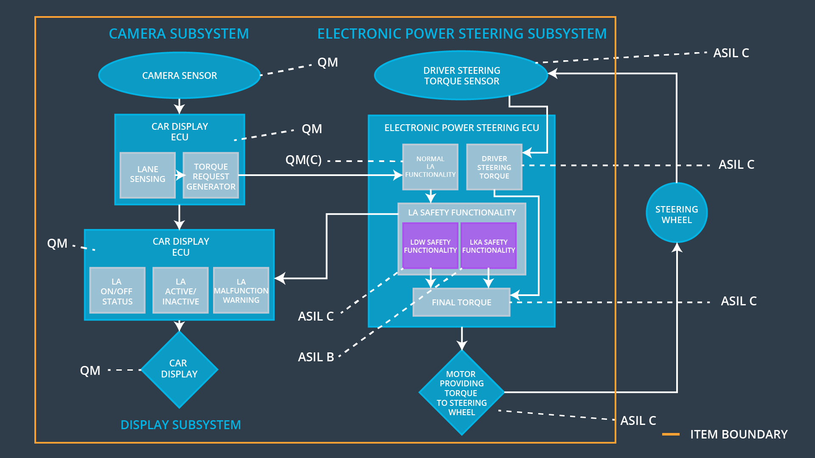

## Allocation of Functional Safety Requirements to Architecture Elements

|  |  |  |  |  |
| --- | --- | --- | --- | --- |
| **ID** | **Functional Safety Requirement** | **Electronic Power Steering ECU** | **Camera ECU** | **Car Display ECU** |
| Functional  Safety  Requirement  01-01 | Electronic Power Steering ECU shall ensure that oscillating torque amplitude requested by LDW function is below Max_Torque_Amplitude. | **x** | **--** | **--** |
| Functional  Safety  Requirement  01-02 | Electronic Power Steering ECU shall ensure that oscillating torque frequency requested by LDW function is below Max_Torque_Frequency. | **x** | **--** | **--** |
| Functional  Safety  Requirement  02-01 | Electronic Power Steering ECU shall ensure that lane keeping assistance torque requested by LKA function is applied for only Max_Duration. | **x** | **--** | **--** |

## Warning and Degradation Concept

|  |  |  |  |  |
| --- | --- | --- | --- | --- |
| **ID** | **Degradation Mode** | **Trigger for Degradation Mode** | **Safe State invoked?** | **Driver Warning** |
| WDC-01 | LDW disabled; torque request will be set to 0. | The LDW warning is giving **MORE** torque than what is safe. | Yes | Warning light appears on dashboard. |
| WDC-02 | LKA disabled; torque request will be set to 0. | The LKA function has **NO** time limit. | Yes | Warning light appears on dashboard |