

Technical Safety Concept Lane Assistance

**Document Version: 3.0**

**Template Version 1.0, Released on 2017-06-21**



# Document history

|  |  |  |  |
| --- | --- | --- | --- |
| Date | Version | Editor | Description |
| 2018-03-13 | 1.0 | Abhishek Mantha | Document initialization |
| 2018-03-13 | 2.0 | Abhishek Mantha | Revising for Final Submission |
| 2018-03-14 | 3.0 | Abhishek Mantha | Final Submission |
|  |  |  |  |
|  |  |  |  |

# Table of Contents

Document history

Table of Contents

Purpose of the Technical Safety Concept

Inputs to the Technical Safety Concept

Functional Safety Requirements

Refined System Architecture from Functional Safety Concept

Functional overview of architecture elements

Technical Safety Concept

Technical Safety Requirements

Refinement of the System Architecture

Allocation of Technical Safety Requirements to Architecture Elements

Warning and Degradation Concept

# Purpose of the Technical Safety Concept

The Technical Safety Concept defines how the subsystems interact at the message level and describes how subsystem ECUs communicate with each other.

# Inputs to the Technical Safety Concept

## Functional Safety Requirements

|  |  |  |  |  |
| --- | --- | --- | --- | --- |
| **ID** | **Functional Safety Requirement** | **ASIL** | **Fault Tolerant Time Interval** | **Safe State** |
| Functional  Safety  Requirement  01-01 | Electronic Power Steering ECU shall ensure that oscillating torque amplitude requested by the LDW function is below Max_Torque_Amplitude | C | 50 ms | LDW will set oscillating torque amplitude to 0 |
| Functional  Safety  Requirement  01-02 | Electronic Power Steering ECU shall ensure that oscillating torque frequency requested by LDW function is below Max_Torque_Frequency. | C | 50 ms | LDW will set oscillating torque amplitude to 0 |
| Functional  Safety  Requirement  02-01 | Electronic Power Steering ECU shall ensure that lane keeping assistance torque requested by LKA function is applied for only Max_Duration. | C | 500 ms | LKA will set oscillating torque amplitude to 0 |

## Refined System Architecture from Functional Safety Concept

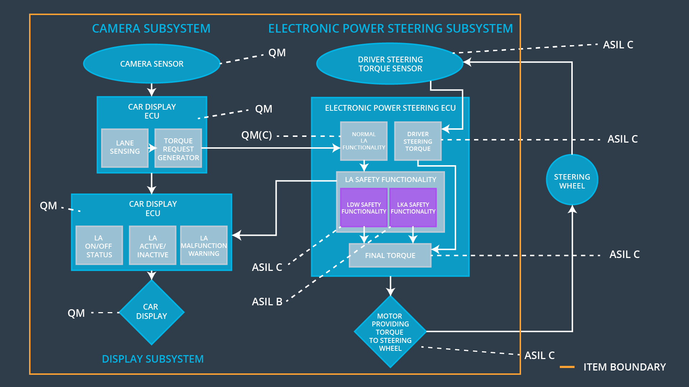

### Functional overview of architecture elements

|  |  |
| --- | --- |
| **Element** | **Description** |
| Camera Sensor | Collects and transmits current camera images to Car Display ECU |
| Camera Sensor ECU - Lane Sensing | Determines if vehicle is correctly within bounds of current lane or if lane change maneuver is being taken w/o turn signal |
| Camera Sensor ECU - Torque request generator | Generates oscillating torque request applied to steering wheel if Lane Sensing component identifies that additional torque must be applied |
| Car Display | Displays notifications/warnings to driver dashboard |
| Car Display ECU - Lane Assistance On/Off Status | Determines if Lane Assistance is currently turned on and transmits appropriate display notification to Car Display |
| Car Display ECU - Lane Assistant Active/Inactive | Transmits appropriate display notification to Car Display if LDW or LKA functions are executed only if Lane Assistant is Active |
| Car Display ECU - Lane Assistance malfunction warning | Transmits malfunction warning display notification to Car Display if LDW or LKA functions are executed and Lane Assistance is On and Lane Assistant is Active |
| Driver Steering Torque Sensor | Collects and transmits current steering wheel torque to EPS ECU |
| Electronic Power Steering (EPS) ECU - Driver Steering Torque | Determines how much oscillating torque to apply to steering wheel based on current vehicle maneuver and on Lane Assistance Status level |
| EPS ECU - Normal Lane Assistance Functionality | Executes normal lane assistance functionality if vehicle departs from lane without turn signal and lane keep assistance is activated |
| EPS ECU - Lane Departure Warning Safety Functionality | Executes lane departure warning safety functionality and transmits appropriate signal to Car Display ECU and appropriate torque amount to apply to Final Torque component |
| EPS ECU - Lane Keeping Assistant Safety Functionality | Executes lane keeping assistance safety functionality and transmits appropriate signal to Car Display ECU and appropriate torque amount to apply to Final Torque component |
| EPS ECU - Final Torque | Determines the appropriate amount of torque to apply to steering wheel |
| Motor | Apply final torque to steering wheel |

# Technical Safety Concept

## Technical Safety Requirements

**Lane Departure Warning (LDW) Requirements:**

Functional Safety Requirement 01-01 with its associated system elements

(derived in the functional safety concept)

|  |  |  |  |  |
| --- | --- | --- | --- | --- |
| **ID** | **Functional Safety Requirement** | **Electronic Power Steering ECU** | **Camera ECU** | **Car Display ECU** |
| Functional  Safety  Requirement  01-01 | The lane keeping item shall ensure that lane departure oscillating torque amplitude is below Max_Torque_Amplitude. | **X** |  |  |

Technical Safety Requirements related to Functional Safety Requirement 01-01 are:

|  |  |  |  |  |  |
| --- | --- | --- | --- | --- | --- |
| **ID** | **Technical Safety Requirement** | **ASIL** | **Fault Tolerant Time Interval** | **Architecture Allocation** | **Safe State** |
| Technical  Safety  Requirement  01 | LDW safety block shall ensure that amplitude of ‘LDW_Torque_Request’ sent to EPS ‘Final Torque’ component is below ‘Max_Torque_Amplitude’. | C | 50 ms | LDW Safety Functionality Block | ‘LDW_Torque_Request’ shall be set to 0. |
| Technical  Safety  Requirement  02 | As soon as LDW function deactivates LDW feature, the 'LDW Safety' software block shall send ‘LDW_Error_Status’ to car display ECU to turn on warning light. | C | 50 ms | LDW Safety Functionality Block | ‘LDW_Torque_Request’ shall be set to 0. |
| Technical  Safety  Requirement  03 | As soon as failure is detected by LDW function, it shall deactivate LDW feature and 'LDW_Torque_Request' shall be set to 0. | C | 50 ms | LDW Safety Functionality Block | ‘LDW_Torque_Request’ shall be set to 0. |
| Technical  Safety  Requirement  04 | Validity and integrity of data transmission for 'LDW_Torque_Request' signal shall be ensured. | C | 50 ms | Data Transmission Integrity Check Component | ‘LDW_Torque_Request’ shall be set to 0. |
| Technical  Safety  Requirement  05 | Memory test shall be conducted at start up of EPS ECU to check for any faults in memory. | A | Ignition cycle | Safety Startup Component | ‘LDW_Torque_Request’ shall be set to 0. |

Functional Safety Requirement 01-2 with its associated system elements

(derived in the functional safety concept)

|  |  |  |  |  |
| --- | --- | --- | --- | --- |
| **ID** | **Functional Safety Requirement** | **Electronic Power Steering ECU** | **Camera ECU** | **Car Display ECU** |
| Functional  Safety  Requirement  01-02 | The lane keeping item shall ensure that the lane departure oscillating torque frequency is below Max_Torque_Frequency. | **X** |  |  |

Technical Safety Requirements related to Functional Safety Requirement 01-02 are:

|  |  |  |  |  |  |
| --- | --- | --- | --- | --- | --- |
| **ID** | **Technical Safety Requirement** | **ASIL** | **Fault Tolerant Time Interval** | **Architecture Allocation** | **Safe State** |
| Technical  Safety  Requirement  01 | LDW safety component shall ensure that frequency of ‘LDW_Torque_Request’ sent to EPS ‘Final Torque’ component is below ‘Max_Torque_Frequency’. | C | 50 ms | LDW Safety Functionality Block | ‘LDW_Torque_Request’ shall be set to 0. |
| Technical  Safety  Requirement  02 | As soon as LDW function deactivates LDW feature, the 'LDW Safety' software block shall send ‘LDW_Error_Status’ to Car Display ECU to turn on warning light. | C | 50 ms | LDW Safety Functionality Block | ‘LDW_Torque_Request’ shall be set to 0. |
| Technical  Safety  Requirement  03 | As soon as failure is detected by LDW function, it shall deactivate LDW feature and 'LDW_Torque_Request' shall be set to 0. | C | 50 ms | LDW Safety Functionality Block | ‘LDW_Torque_Request’ shall be set to 0. |
| Technical  Safety  Requirement  04 | Validity and integrity of data transmission for 'LDW_Torque_Request' signal shall be ensured. | C | 50 ms | Data Transmission Integrity Check Component | ‘LDW_Torque_Request’ shall be set to 0. |
| Technical  Safety  Requirement  05 | Memory test shall be conducted at start up of EPS ECU to check for any faults in memory. | A | Ignition cycle | Safety Startup Component | ‘LDW_Torque_Request’ shall be set to 0. |

**Lane Keeping Assistance (LKA) Requirements:**

Functional Safety Requirement 02-1 with its associated system elements

(derived in the functional safety concept)

|  |  |  |  |  |
| --- | --- | --- | --- | --- |
| **ID** | **Functional Safety Requirement** | **Electronic Power Steering ECU** | **Camera ECU** | **Car Display ECU** |
| Functional  Safety  Requirement  02-01 | The lane keeping item shall ensure that the lane keeping assistance torque is applied for only Max_Duration | **X** |  |  |

Technical Safety Requirements related to Functional Safety Requirement 02-01 are:

|  |  |  |  |  |  |
| --- | --- | --- | --- | --- | --- |
| **ID** | **Technical Safety Requirement** | **ASIL** | **Fault Tolerant Time Interval** | **Architecture Allocation** | **Safe State** |
| Technical  Safety  Requirement  01 | LKA safety component shall ensure that amplitude of ‘LKA_Torque_Request’ sent to EPS Final Torque component is below ‘Max_Duration’. | B | 500 ms | LKA Safety Functionality Block | ‘LKA_Torque_Request’ shall be set to 0. |
| Technical  Safety  Requirement  02 | As soon as LKA function deactivates LKA feature, LKA Safety software block shall send ‘LKA_Error_Status’ to Car Display ECU to turn on warning light. | B | 500 ms | LKA Safety Functionality Block | ‘LKA_Torque_Request’ shall be set to 0. |
| Technical  Safety  Requirement  03 | As soon as failure is detected by LKA function, it shall deactivate LKA feature and LKA_Torque_Request' shall be set to 0. | B | 500 ms | LKA Safety Functionality Block | ‘LKA_Torque_Request’ shall be set to 0. |
| Technical  Safety  Requirement  04 | Validity and integrity of data transmission for LKA_Torque_Request' signal shall be ensured. | B | 500 ms | Data Transmission Integrity Check Component | ‘LKA_Torque_Request’ shall be set to 0. |
| Technical  Safety  Requirement  05 | Memory test shall be conducted at start up of EPS ECU to check for any faults in memory. | A | Ignition cycle | Safety Startup Component | ‘LKA_Torque_Request’ shall be set to 0. |

## Refinement of the System Architecture

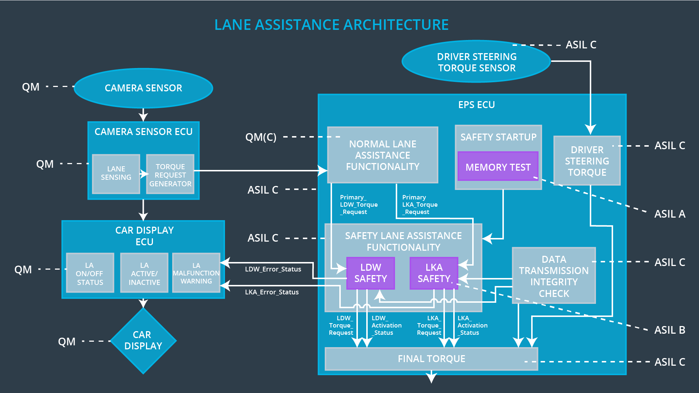

## Allocation of Technical Safety Requirements to Architecture Elements

All Technical Safety Requirements are allocated to the Electronic Power Steering ECU. Please refer to the above table under “Technical Safety Requirements” for a detailed specification of component architecture allocations.

## Warning and Degradation Concept

|  |  |  |  |  |
| --- | --- | --- | --- | --- |
| **ID** | **Degradation Mode** | **Trigger for Degradation Mode** | **Safe State invoked?** | **Driver Warning** |
| WDC-01 | LDW disabled; torque request will be set to 0. | The LDW warning is giving **MORE** torque than what is safe. | Yes | Warning light appears on dashboard. |
| WDC-02 | LKA disabled; torque request will be set to 0. | The LKA function has **NO** time limit. | Yes | Warning light appears on dashboard |