Leveraging LLMs and Glassbox models for explainable predictions app

# Introduction

This app is developed leveraging Streamlit, InterpretML, Guidance and OpenAI methodologies to demonstrate the power of LLMs in providing explainable predictions for end user.

The application is currently using [Space Titanic dataset](https://www.kaggle.com/competitions/spaceship-titanic) with the dataset description hard coded in the code, however this can be used for additional datasets by inputting data descriptions in the application interface. Please check your org policies before proceeding with your own dataset

# Methodology

Since LLMs are trained exclusively on text data, it is difficult for interactions without text. This is where the Talk2EBM library of Microsoft comes into play, Talk2EBM allows us to convert graphical analysis into text data.

This text data can be understood by the LLM including the graphical distributions and the working of the EBM algorithm. This description can be combined with a prompt, dataset description and individual prediction in an application for end users to have a higher insight into the application as well have more confidence on the prediction.

# Application flow

1. The application allows us to upload a csv file and displays the dataframe for visual inspection

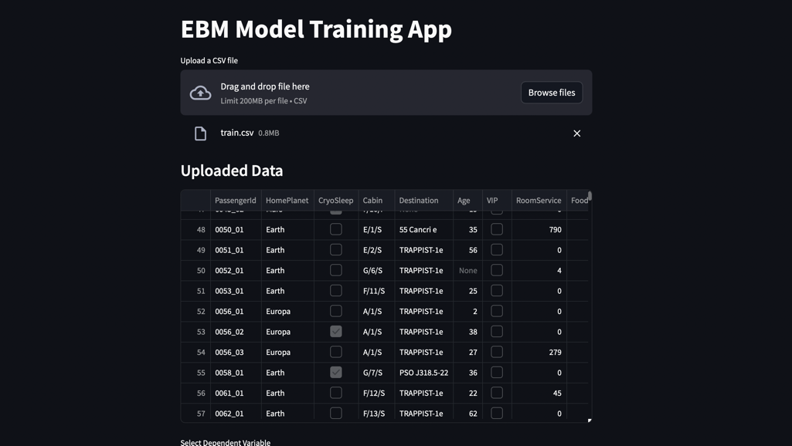

1. Once the data is inspected, the modelling variable or the outcome is chosen followed by the predictors and a submit button is clicked for the EBM model to be trained

1. Once a model is trained, the user can select a value for explanation, in the first example, we are selecting “Maham Ofracculy”. This passenger was not transported and the LLM interprets the prompt to provide a suitable explanation of the absence of cryo sleep as below

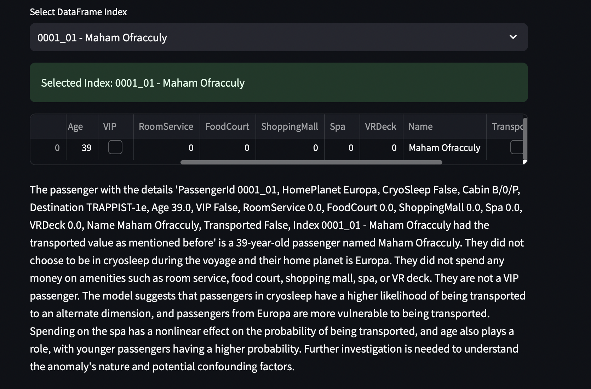

In the next example, we are choosing “Altark Susent”, the LLM provides a suitable explanation again.

