SQL ASSIGNMENT 1
Querying • Filtering • Sorting • Joins • Subqueries

Student Name | ALLAH BACHAIO MEMON
Roll No. | 916334
Class / Section | MCDE

Instructions
- Create the sample database by running the file ShopDB_setup.sql in SQL Server Management Studio. It creates the tables shown on the next pages.
- There are 9 parts with 5 questions each. Every question is worth 2 marks.
- Write your SQL query inside the answer box under each question. Test the query in SQL Server before you type it here.
- Use only the table and column names given in this document. Write keywords in CAPITAL letters and put every clause on a new line so your query is easy to read.
- Where a question asks for an explanation, write it as a comment after your query, starting with --.
- Do not copy from other students. Submit this same Word file (.docx) with your name and roll number filled in.

The ShopDB Database
All questions use one small shop database made of four tables. Orders is linked to the other tables. A value shown as NULL means the data is missing.

ShopDB reference data — original page 2
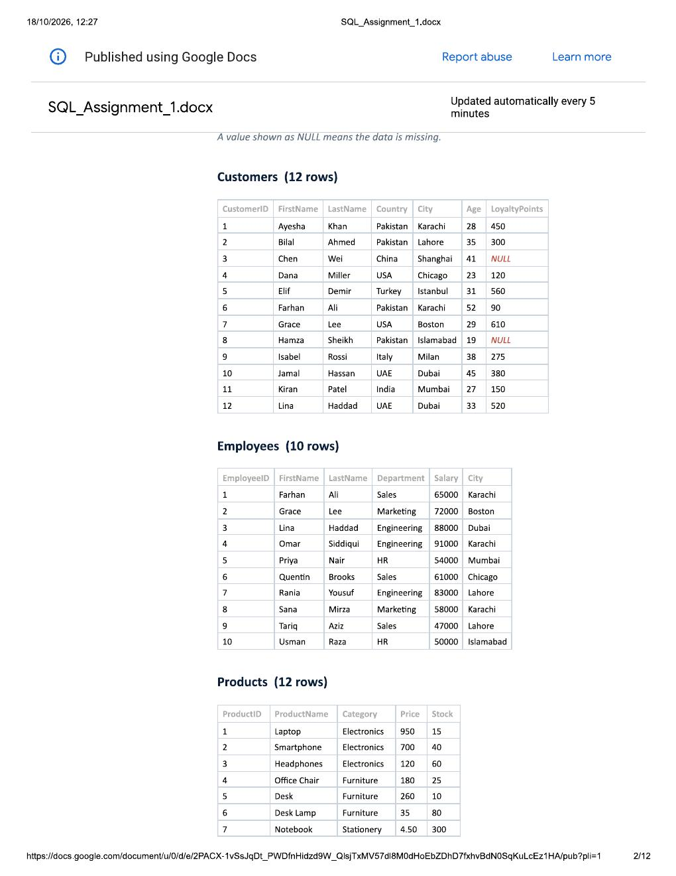

ShopDB reference data — original page 3
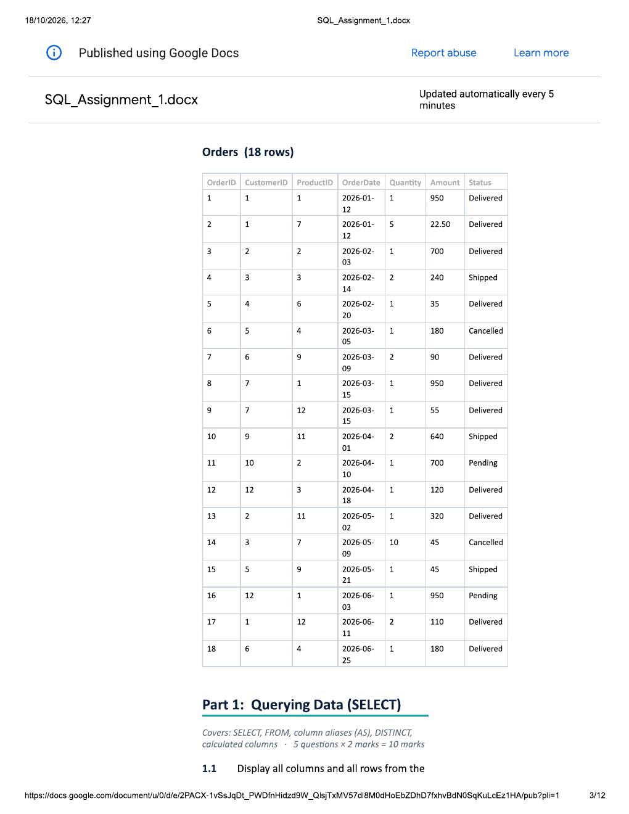

Part 1: Querying Data (SELECT)
Covers: SELECT, FROM, column aliases (AS), DISTINCT, calculated columns — 5 questions × 2 marks = 10 marks
1.1 Display all columns and all rows from the Customers table. [2 marks]
Your answer (SQL query):
SELECT *
FROM Sales.Customers;
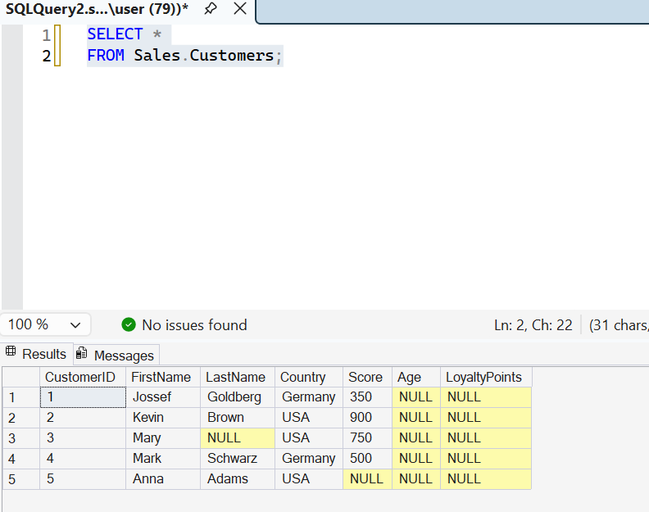

1.2 Display only the FirstName, LastName and Country of all customers. [2 marks]
Your answer (SQL query):
SELECT FirstName, LastName, Country
FROM Sales.Customers;
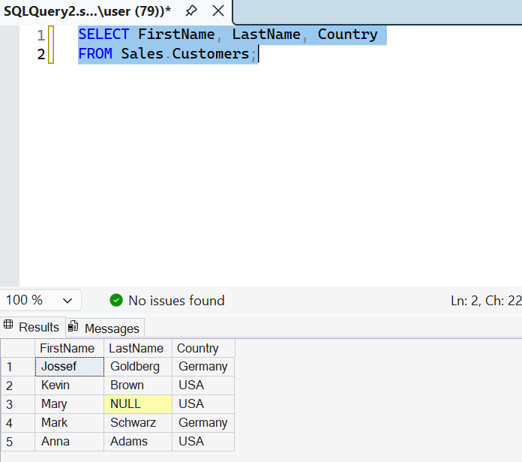

1.3 Display the ProductName and Price of all products. Rename the output columns as Product and UnitPrice. [2 marks]
Your answer (SQL query):
SELECT Product AS Product, Price AS UnitPrice
FROM Sales.Products;
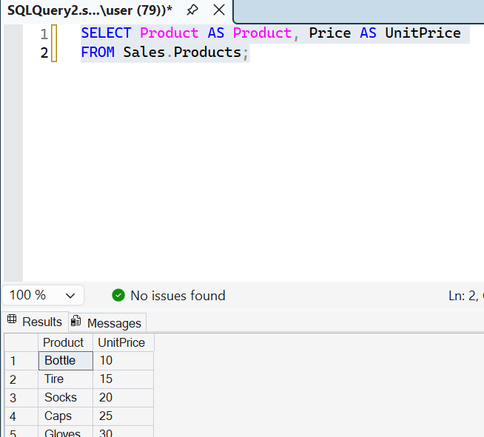

1.4 Display the list of countries where our customers live. Each country must appear only once. [2 marks]
Your answer (SQL query):
SELECT DISTINCT Country
FROM Sales.Customers;

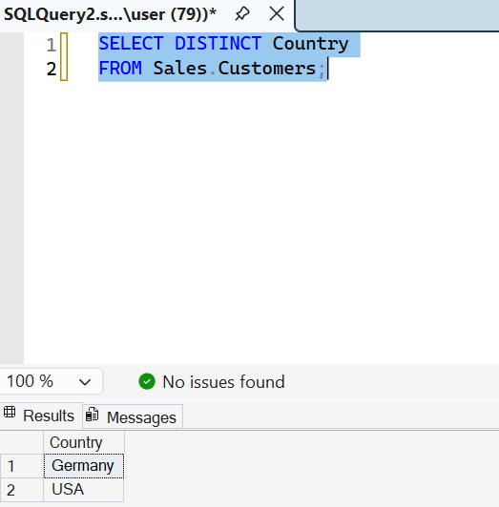

1.5 Display each employee's FirstName, Salary and a new column called SalaryAfterRaise that shows the salary increased by 10%. [2 marks]
Your answer (SQL query):
SELECT FirstName, Salary,
Salary * 1.10 AS SalaryAfterRaise
FROM Sales.Employees;

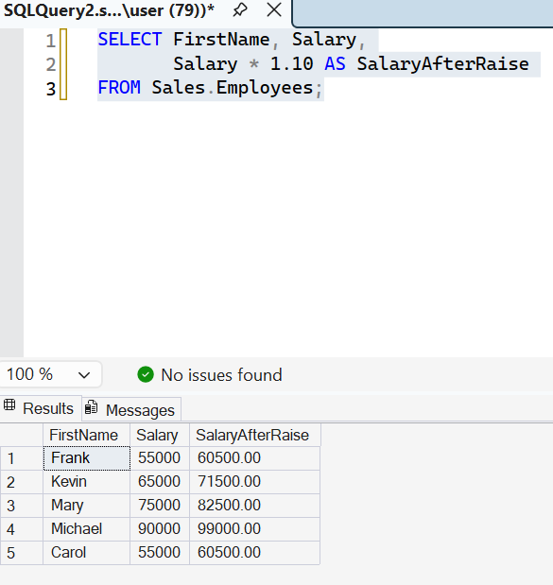

Part 2: Filtering Data (WHERE)
Covers: WHERE with =, <>, >, <, >=, <= and IS NULL — 5 questions × 2 marks = 10 marks

2.1 Display all customers who live in Pakistan. [2 marks]
Your answer (SQL query):
SELECT *
FROM Sales.Customers
WHERE Country = 'Pakistan';

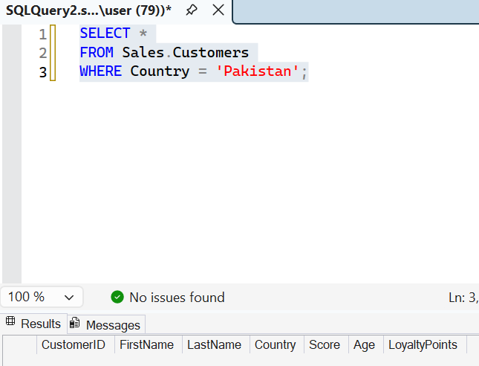

2.2 Display the ProductName and Price of all products that cost more than 100. [2 marks]
Your answer (SQL query):
SELECT Product AS ProductName, Price
FROM Sales.Products
WHERE Price > 100;

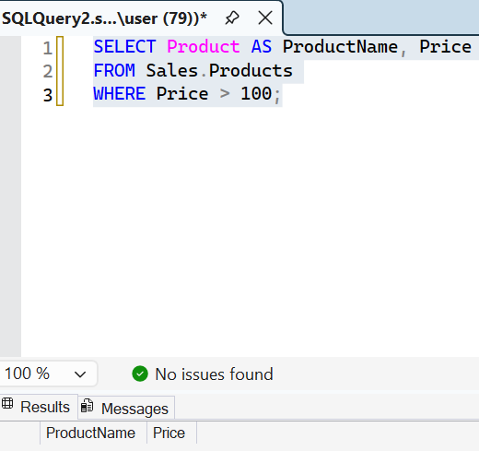

2.3 Display the FirstName, Department and Salary of employees who earn 60000 or less. [2 marks]
Your answer (SQL query):
SELECT FirstName, Department, Salary
FROM Sales.Employees
WHERE Salary <= 60000;
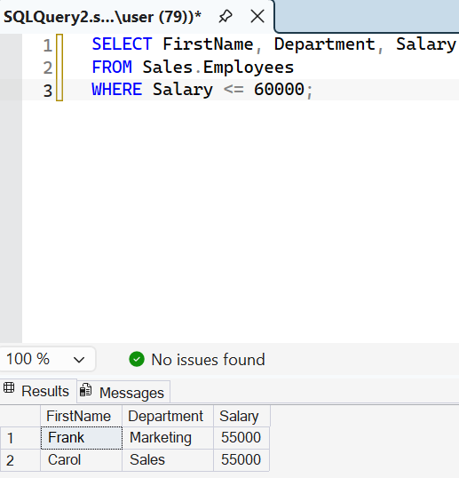

2.4 Display all orders whose Status is not 'Cancelled'. [2 marks]
Your answer (SQL query):
SELECT *
FROM Sales.Orders
WHERE OrderStatus <> 'Cancelled';
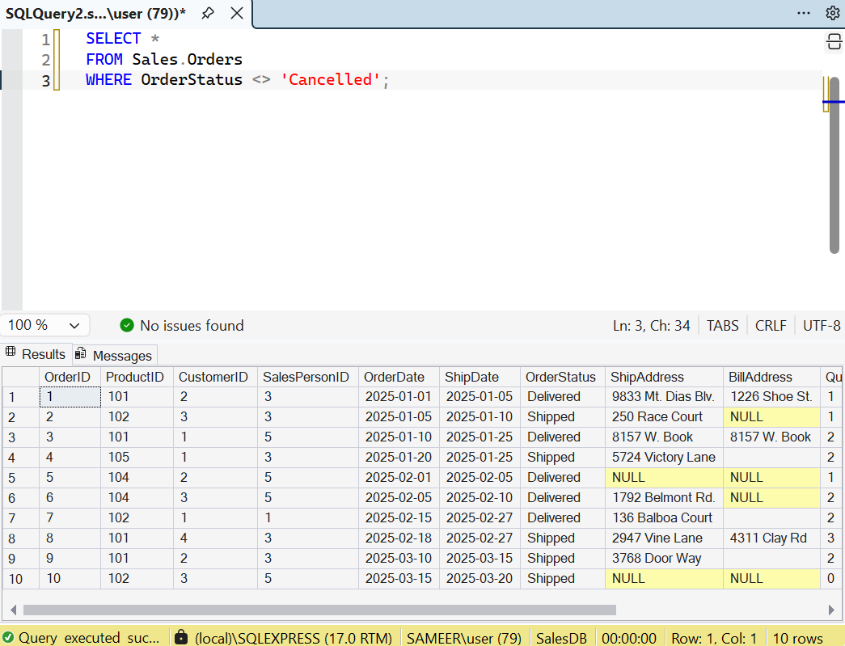

2.5 Display the FirstName and LastName of customers whose LoyaltyPoints value is missing (NULL). [2 marks]
Your answer (SQL query):
SELECT FirstName, LastName
FROM Sales.Customers
WHERE LoyaltyPoints IS NULL;

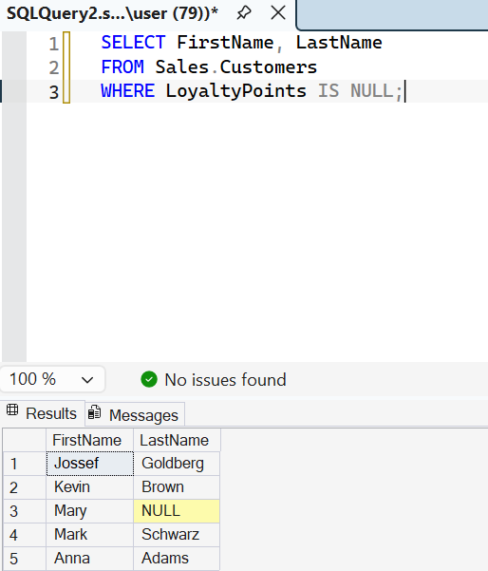

Part 3: Sorting Data (ORDER BY)
Covers: ORDER BY with ASC, DESC and more than one column — 5 questions × 2 marks = 10 marks

3.1 Display ProductName and Price of all products, sorted from the lowest price to the highest price. [2 marks]
Your answer (SQL query):
SELECT Product AS ProductName, Price
FROM Sales.Products
ORDER BY Price ASC;
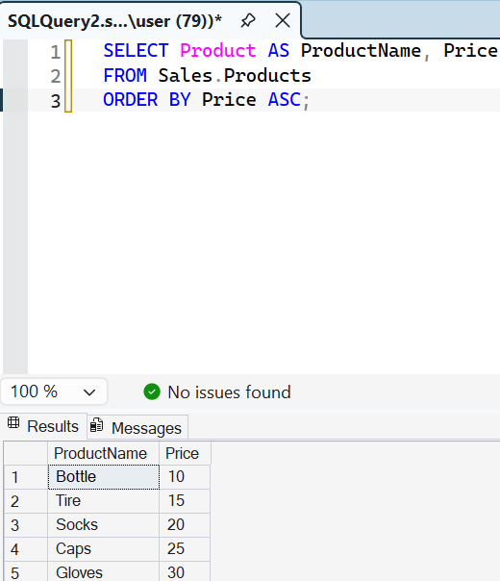

3.2 Display FirstName and Age of all customers, sorted from the oldest to the youngest. [2 marks]
Your answer (SQL query):
SELECT FirstName, Age
FROM Sales.Customers
ORDER BY Age DESC;
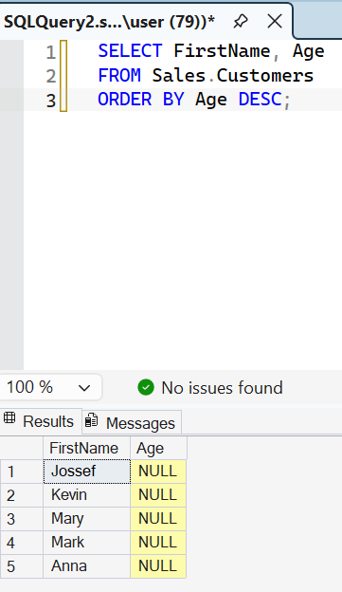

3.3 Display all employees sorted alphabetically by LastName (A to Z). [2 marks]
Your answer (SQL query):
SELECT *
FROM Sales.Employees
ORDER BY LastName ASC;

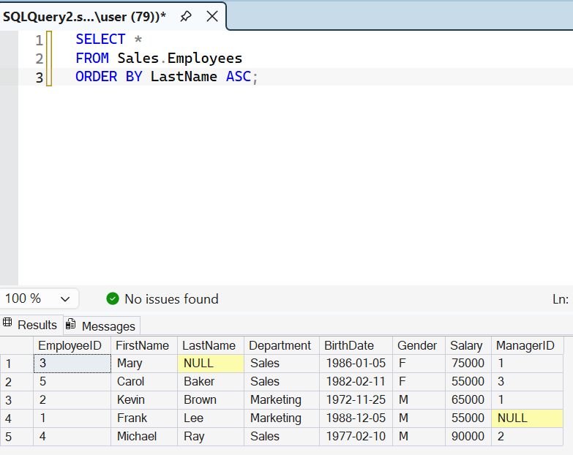

3.4 Display FirstName, Country and LoyaltyPoints of all customers. Sort them by Country (A to Z) and, within the same country, by LoyaltyPoints from highest to lowest. [2 marks]
Your answer (SQL query):
SELECT FirstName, Country, LoyaltyPoints
FROM Sales.Customers
ORDER BY Country ASC, LoyaltyPoints DESC;
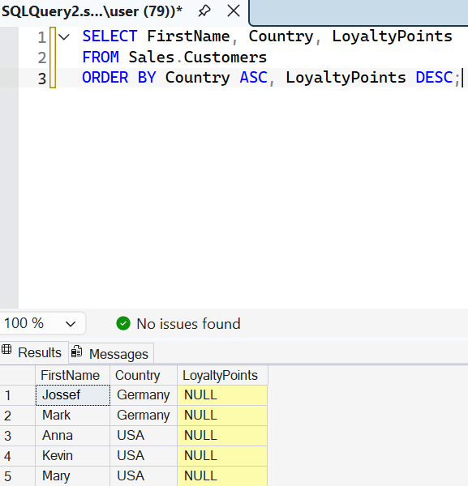

3.5 Display OrderID, OrderDate and Amount of all orders whose Status is 'Delivered', with the most recent order first. [2 marks]
Your answer (SQL query):
SELECT OrderID, OrderDate, Sales AS Amount
FROM Sales.Orders
WHERE OrderStatus = 'Delivered'
ORDER BY OrderDate DESC;
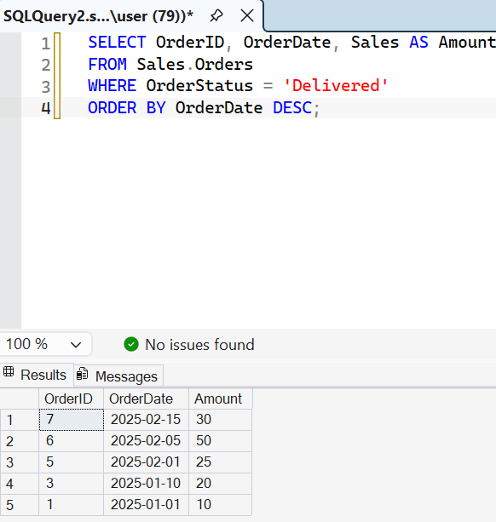

Part 4: AND, OR and NOT
Covers: Combining conditions with AND, OR, NOT and brackets — 5 questions × 2 marks = 10 marks
4.1 Display customers who live in Pakistan AND are older than 30. [2 marks]
Your answer (SQL query):
SELECT *
FROM Sales.Customers
WHERE Country = 'Pakistan'
AND Age > 30;
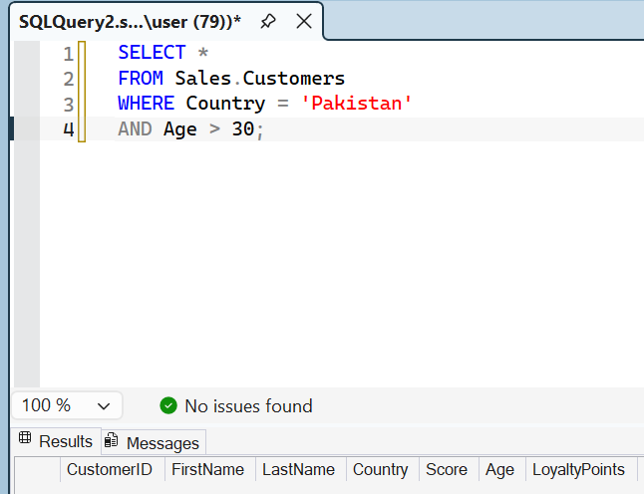

4.2 Display products that belong to the 'Furniture' category OR cost less than 10. [2 marks]
Your answer (SQL query):
SELECT *
FROM Sales.Products
WHERE Category = 'Furniture'
OR Price < 10;

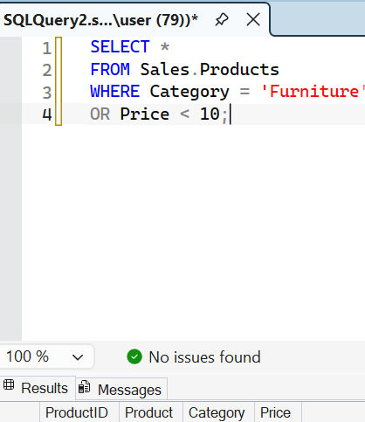

4.3 Display employees who work in the 'Sales' department AND earn more than 50000. [2 marks]
Your answer (SQL query):
SELECT *
FROM Sales.Employees
WHERE Department = 'Sales'
AND Salary > 50000;

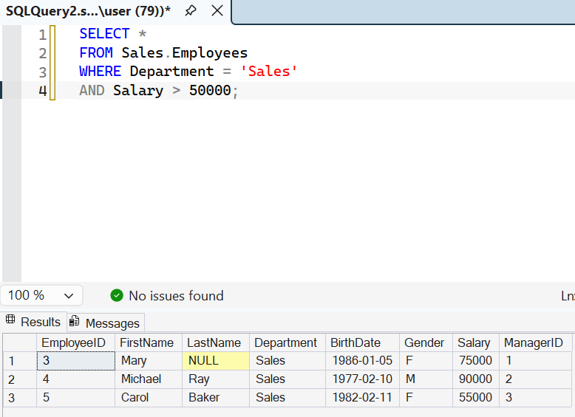
4.4 Display customers who do NOT live in Pakistan. Use the NOT operator. [2 marks]
Your answer (SQL query):
SELECT *
FROM Sales.Customers
WHERE NOT Country = 'Pakistan';
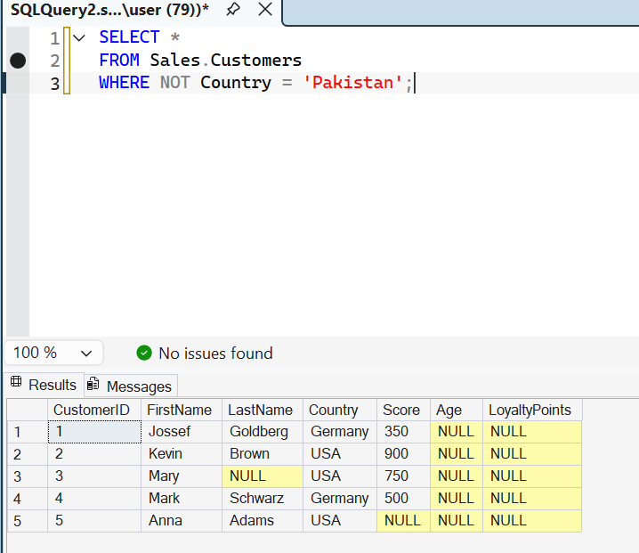

4.5 Display customers who live in the USA or the UAE and who have more than 400 LoyaltyPoints. (Hint: use brackets.) [2 marks]
Your answer (SQL query):
SELECT *
FROM Sales.Customers
WHERE Country IN ('USA', 'UAE')
AND LoyaltyPoints > 400;
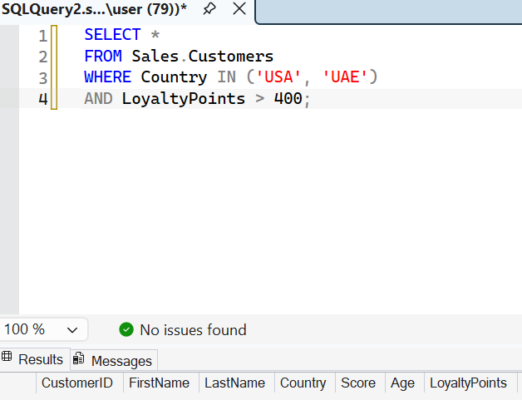

Part 5: TOP
Covers: SELECT TOP n, combined with ORDER BY and WHERE — 5 questions × 2 marks = 10 marks
5.1 Display the first 3 rows of the Customers table. [2 marks]
Your answer (SQL query):
SELECT TOP 3 *
FROM Sales.Customers;
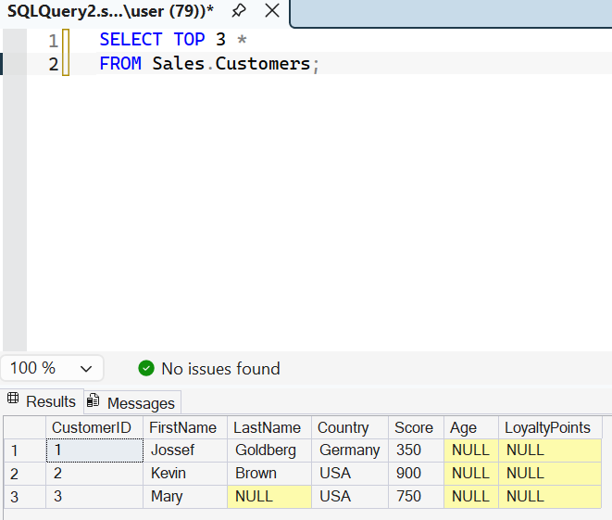

5.2 Display the ProductName and Price of the 5 most expensive products. [2 marks]
Your answer (SQL query):
SELECT TOP 5 Product AS ProductName, Price
FROM Sales.Products
ORDER BY Price DESC;
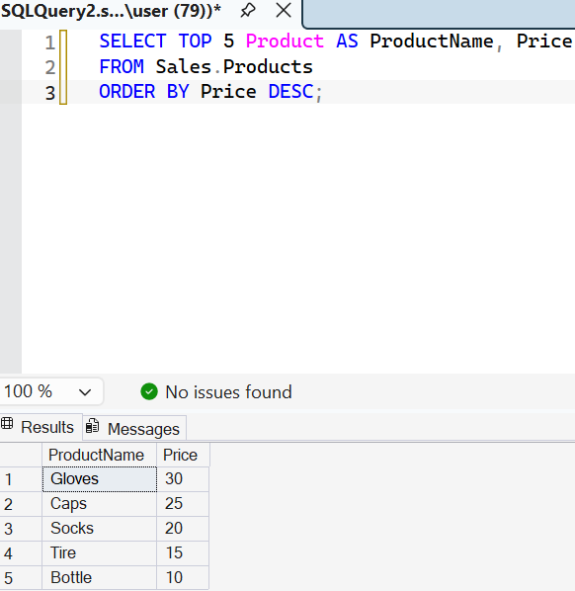

5.3 Display the FirstName and Age of the 3 youngest customers. [2 marks]
Your answer (SQL query):
SELECT TOP 3 FirstName, Age
FROM Sales.Customers
ORDER BY Age ASC;
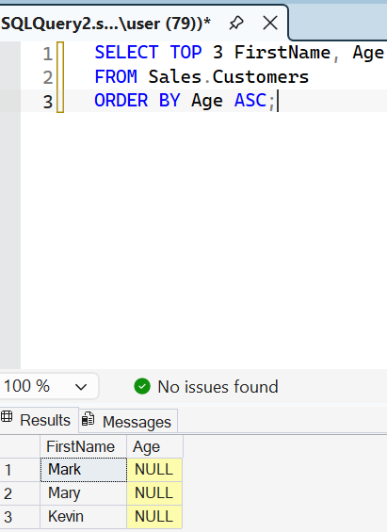

5.4 Display the FirstName, LastName and Salary of the highest-paid employee (only one row). [2 marks]
Your answer (SQL query):
SELECT TOP 1 FirstName, LastName, Salary
FROM Sales.Employees
ORDER BY Salary DESC;

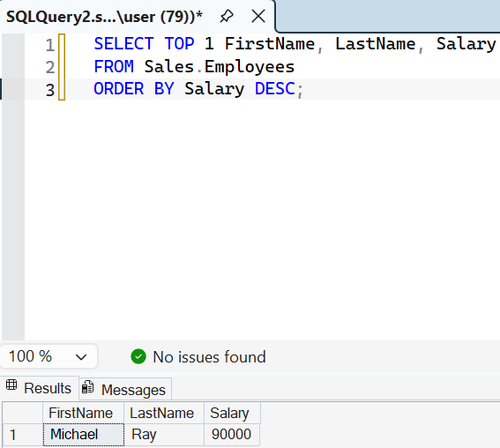

5.5 Display OrderID, OrderDate and Amount of the 2 most recent orders whose Status is 'Delivered'. [2 marks]
Your answer (SQL query):
SELECT TOP 2 OrderID, OrderDate, Sales AS Amount
FROM Sales.Orders
WHERE OrderStatus = 'Delivered'
ORDER BY OrderDate DESC;

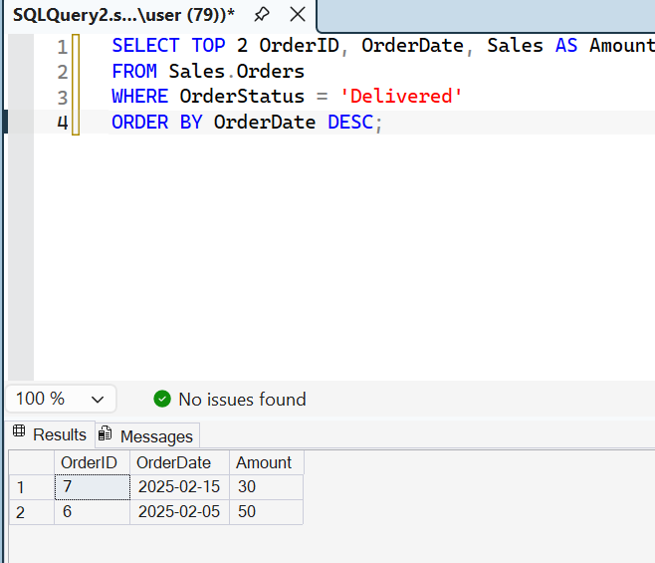

Part 6: SET Operators
Covers: UNION, UNION ALL, INTERSECT, EXCEPT. Both queries return FirstName and LastName — 5 questions × 2 marks = 10 marks
6.1 Using UNION, display one combined list of FirstName and LastName of all customers and all employees. A person who appears in both tables must be shown only once. [2 marks]
Your answer (SQL query):
SELECT FirstName, LastName
FROM Sales.Customers

UNION

SELECT FirstName, LastName
FROM Sales.Employees;
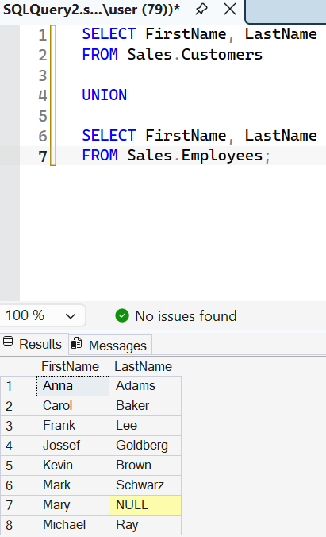

6.2 Write the same query using UNION ALL. How many more rows do you get compared with Question 6.1, and why? (Write your answer as a comment after the query.) [2 marks]
Your answer (SQL query):
SELECT FirstName, LastName
FROM Sales.Customers

UNION ALL

SELECT FirstName, LastName
FROM Sales.Employees;

-- UNION ALL keeps duplicate rows, unlike UNION.

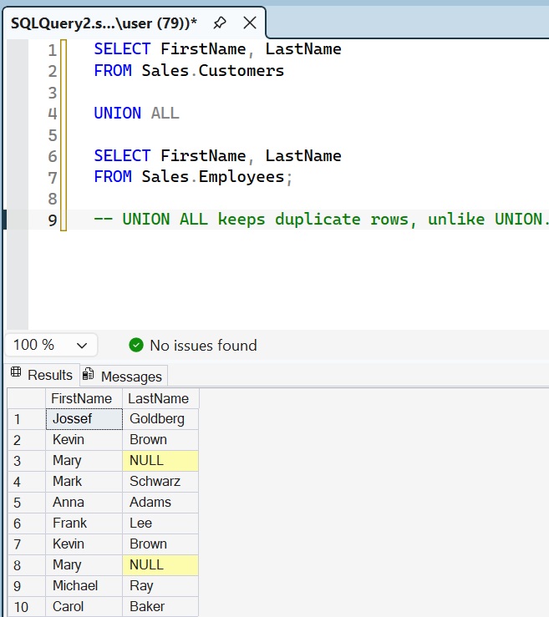

6.3 Using INTERSECT, display the FirstName and LastName of people who are both a customer and an employee. [2 marks]
Your answer (SQL query):
SELECT FirstName, LastName
FROM Sales.Customers

INTERSECT

SELECT FirstName, LastName
FROM Sales.Employees;

6.4 Using EXCEPT, display the FirstName and LastName of customers who are not employees. [2 marks]
Your answer (SQL query):
SELECT FirstName, LastName
FROM Sales.Customers

EXCEPT

SELECT FirstName, LastName
FROM Sales.Employees;
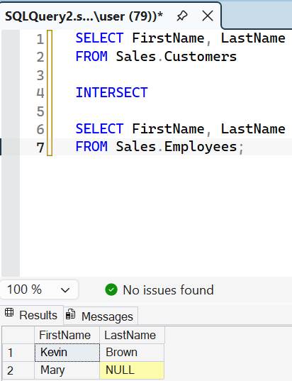
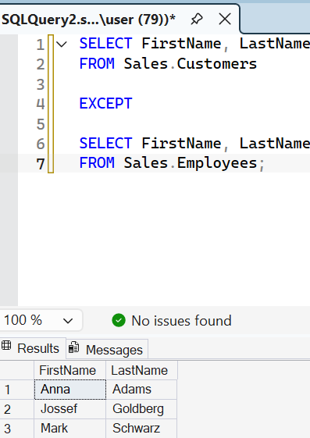

6.5 Using UNION ALL, display FirstName, LastName and an extra column called PersonType that shows 'Customer' for customers and 'Employee' for employees. Sort the final result by FirstName. [2 marks]
Your answer (SQL query):
SELECT FirstName, LastName, 'Customer' AS PersonType
FROM Sales.Customers

UNION ALL

SELECT FirstName, LastName, 'Employee' AS PersonType

FROM Sales.Employees

ORDER BY FirstName;
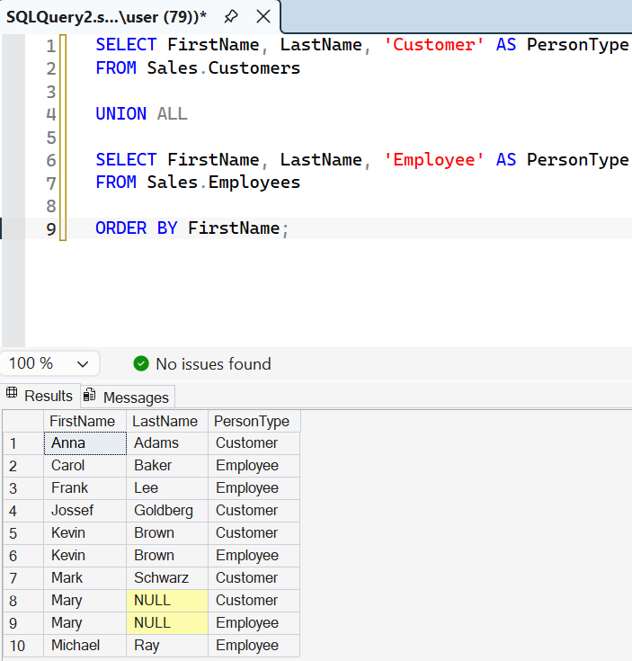

Part 7: IN and NOT IN
Covers: Matching a column against a list of values — 5 questions × 2 marks = 10 marks
7.1 Display customers who live in Pakistan, UAE or India. Use IN. [2 marks]
Your answer (SQL query):
SELECT *
FROM Sales.Customers
WHERE Country IN ('Pakistan', 'UAE', 'India');

7.2 Display ProductName and Category of products whose category is either 'Stationery' or 'Accessories'. Use IN. [2 marks]
Your answer (SQL query):
SELECT Product AS ProductName, Category
FROM Sales.Products
WHERE Category IN ('Stationery', 'Accessories');
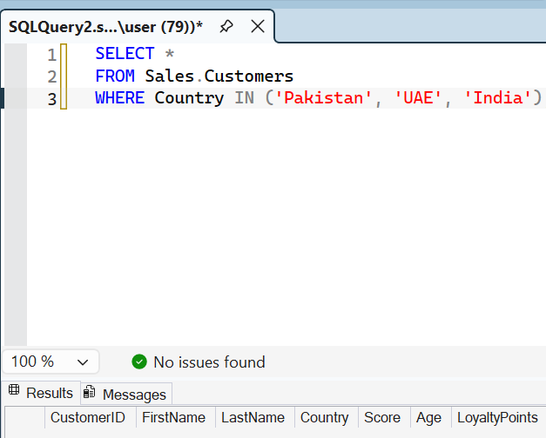
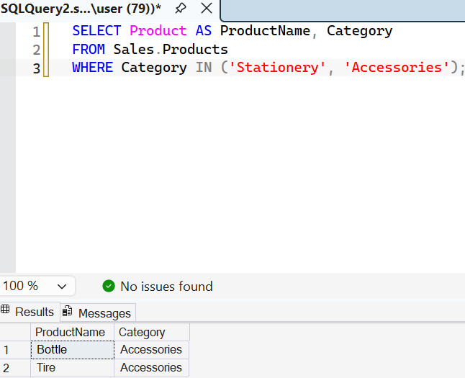

7.3 Display customers who do not live in the USA, China or Italy. Use NOT IN. [2 marks]
Your answer (SQL query):
SELECT *
FROM Sales.Customers
WHERE Country NOT IN ('USA', 'China', 'Italy');
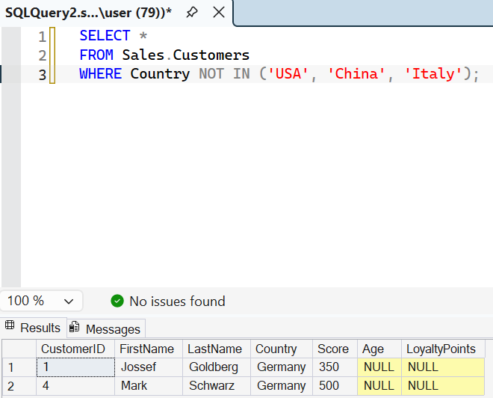

7.4 Display FirstName, Department and Salary of employees who work in 'HR' or 'Marketing', with the highest salary first. [2 marks]
Your answer (SQL query):
SELECT FirstName, Department, Salary
FROM Sales.Employees
WHERE Department IN ('HR', 'Marketing')
ORDER BY Salary DESC;
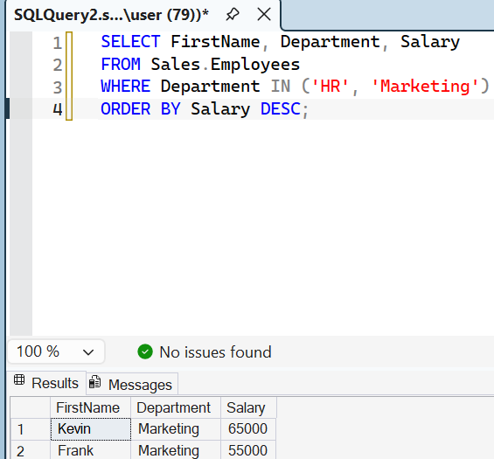

7.5 Display all orders whose Status is neither 'Cancelled' nor 'Pending'. Use NOT IN. [2 marks]
Your answer (SQL query):
SELECT *
FROM Sales.Orders
WHERE OrderStatus NOT IN ('Cancelled', 'Pending');

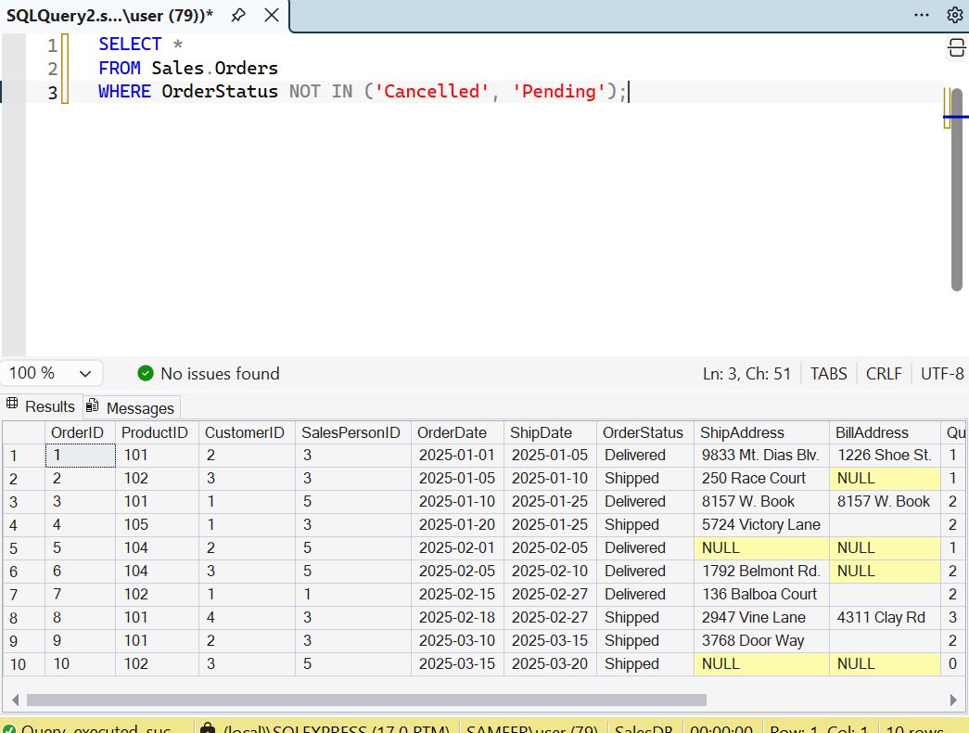

Part 8: JOINs
Covers: INNER JOIN, LEFT JOIN, RIGHT JOIN, finding unmatched rows, joining three tables — 5 questions × 2 marks = 10 marks
8.1 Display OrderID, the customer's FirstName and the OrderDate for every order. (Join Orders and Customers.) [2 marks]
Your answer (SQL query):
SELECT O.OrderID, C.FirstName, O.OrderDate
FROM Sales.Orders O
INNER JOIN Sales.Customers C
ON O.CustomerID = C.CustomerID;
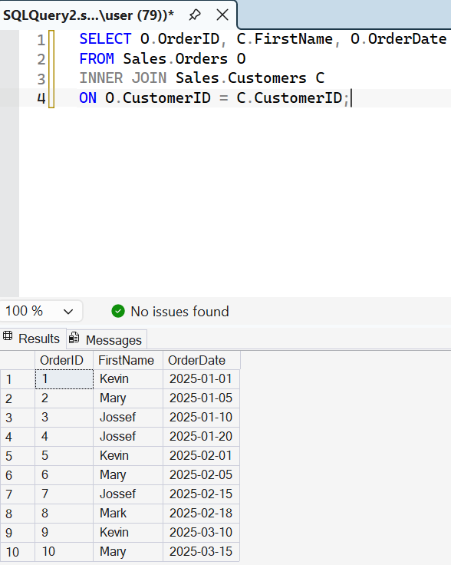

8.2 Display every customer's FirstName together with the OrderID of their orders. Customers who have never ordered must also appear (their OrderID will be NULL). [2 marks]
Your answer (SQL query):
SELECT C.FirstName, O.OrderID
FROM Sales.Customers C
LEFT JOIN Sales.Orders O
ON C.CustomerID = O.CustomerID;
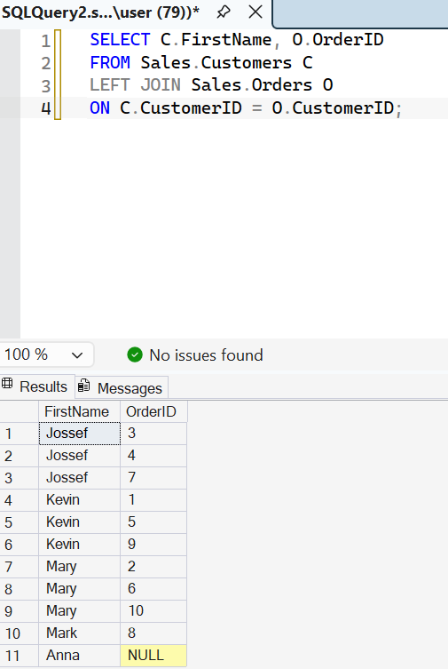

8.3 Display every product’s ProductName together with the OrderID in which it was sold. Products that were never ordered must also appear. Use a RIGHT JOIN and start from the Orders table. [2 marks]
Your answer (SQL query):
SELECT P.Product AS ProductName, O.OrderID
FROM Sales.Orders O
RIGHT JOIN Sales.Products P
ON O.ProductID = P.ProductID;

8.4 Display the FirstName and LastName of customers who have never placed any order. [2 marks]
Your answer (SQL query):
SELECT C.FirstName, C.LastName
FROM Sales.Customers C
LEFT JOIN Sales.Orders O
ON C.CustomerID = O.CustomerID
WHERE O.OrderID IS NULL;
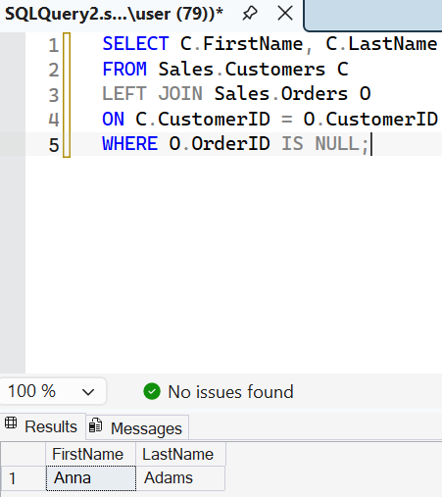

8.5 For all orders with Status 'Delivered', display the customer's FirstName, the ProductName, the OrderDate and the Quantity. (This needs three tables.) [2 marks]
Your answer (SQL query):
SELECT C.FirstName, P.Product AS ProductName,
O.OrderDate, O.Quantity
FROM Sales.Orders O
INNER JOIN Sales.Customers C
ON O.CustomerID = C.CustomerID
INNER JOIN Sales.Products P
ON O.ProductID = P.ProductID
WHERE O.OrderStatus = 'Delivered';

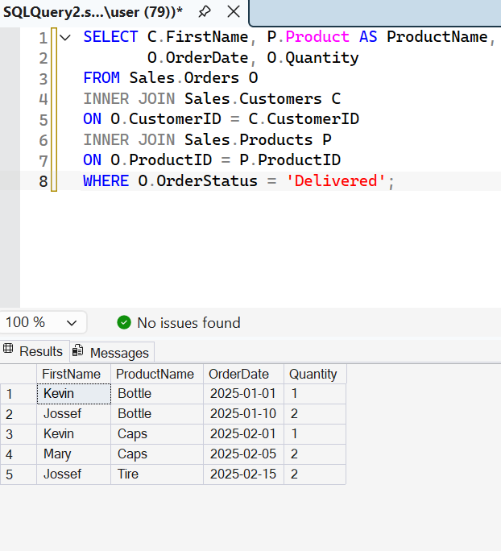

Part 9: Subqueries
Covers: Subqueries in WHERE: single value, IN and NOT IN — 5 questions × 2 marks = 10 marks
9.1 Display ProductName and Price of products that cost more than the product 'Desk Lamp'. Use a subquery to find the price of the Desk Lamp (do not type the number yourself). [2 marks]
Your answer (SQL query):
SELECT Product AS ProductName, Price
FROM Sales.Products
WHERE Price > (
SELECT Price
FROM Sales.Products
WHERE Product = 'Desk Lamp'
);

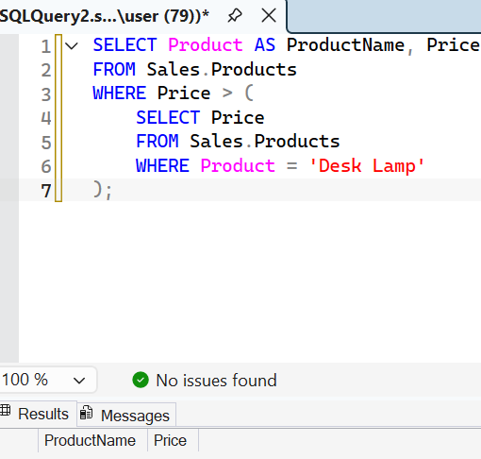

9.2 Display ProductName and Price of products that cost more than the average price of all products. (Hint: AVG(Price).) [2 marks]
Your answer (SQL query):
SELECT Product AS ProductName, Price
FROM Sales.Products
WHERE Price > (
SELECT AVG(Price)
FROM Sales.Products
);

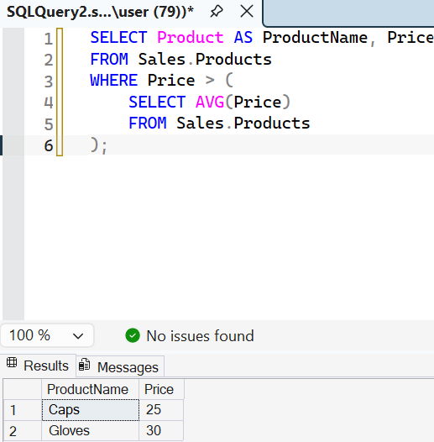

9.3 Display FirstName and LastName of customers who have placed at least one order. Use IN with a subquery on the Orders table. [2 marks]
Your answer (SQL query):
SELECT FirstName, LastName
FROM Sales.Customers
WHERE CustomerID IN (
SELECT CustomerID
FROM Sales.Orders
);
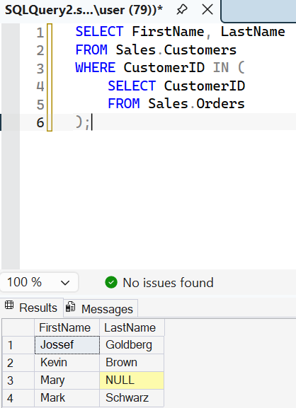

9.4 Display the ProductName of products that have never been ordered. Use NOT IN with a subquery. [2 marks]
Your answer (SQL query):
SELECT Product AS ProductName
FROM Sales.Products
WHERE ProductID NOT IN (
SELECT ProductID
FROM Sales.Orders
);

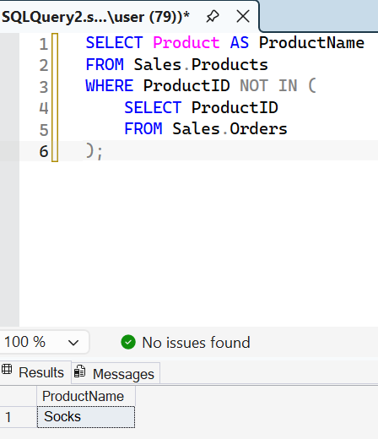

9.5 Challenge: Display FirstName and LastName of customers who have ordered at least one product from the 'Electronics' category. (Hint: a subquery inside a subquery.) [2 marks]
Your answer (SQL query):
SELECT FirstName, LastName
FROM Sales.Customers
WHERE CustomerID IN (
SELECT CustomerID
FROM Sales.Orders
WHERE ProductID IN (
SELECT ProductID
FROM Sales.Products
WHERE Category = 'Electronics'
)
);
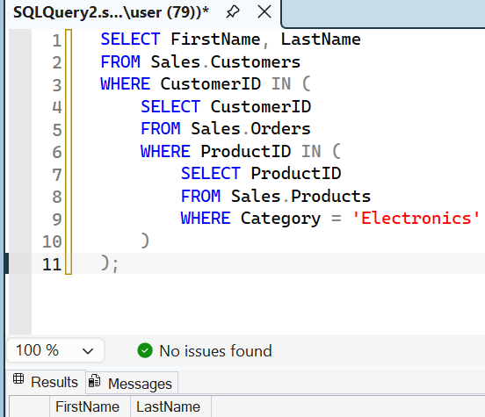

End of assignment. Please check that every answer box is filled before you submit.

