# VHDL Files (Code)

## LogicalStep_Lab3_top

library ieee;

use ieee.std_logic_1164.all;

use ieee.numeric_std.all;

entity LogicalStep_Lab3_top is port (

clkin_50 : in std_logic;

pb : in std_logic_vector(3 downto 0);

sw : in std_logic_vector(7 downto 0); -- The switch inputs

leds : out std_logic_vector(7 downto 0); -- for displaying the switch content

seg7_data : out std_logic_vector(6 downto 0); -- 7-bit outputs to a 7-segment

seg7_char1 : out std_logic; -- seg7 digit selectors

seg7_char2 : out std_logic -- seg7 digit selectors

);

end LogicalStep_Lab3_top;

architecture Energy_Monitor of LogicalStep_Lab3_top is

-- Components Used--

-------------------------------------------------------------------

component compx4 port(

Operand_A : in std_logic_vector(3 downto 0);

Operand_B : in std_logic_vector(3 downto 0);

A_greater_B : out std_logic;

A_equals_B : out std_logic;

A_lesser_B : out std_logic

);

end component;

component EMCL port (

--Inputs

greaterinput : in std_logic;

equalinput : in std_logic;

lesserinput : in std_logic;

FWBpb : in std_logic_vector (2 downto 0); --(pb2-Fdoor), (pb1-window), (pb0-bdoor)

led : out std_logic_vector(7 downto 0)

);

end component;

component SevenSegment port (

hex : in std_logic_vector(3 downto 0); -- The 4 bit data to be displayed

sevenseg : out std_logic_vector(6 downto 0) -- 7-bit outputs to a 7-segment

);

end component;

component segment7_mux port (

clk : in std_logic := '0';

DIN2 : in std_logic_vector(6 downto 0);

DIN1 : in std_logic_vector(6 downto 0);

DOUT : out std_logic_vector(6 downto 0);

DIG2 : out std_logic;

DIG1 : out std_logic

);

end component ;

-- Create any signals, or temporary variables to be used

signal Current_Temp : std_logic_vector(3 downto 0);

signal Desired_Temp : std_logic_vector(3 downto 0);

signal DoorsWindowsOpen : std_logic_vector(2 downto 0);

signal greater : std_logic;

signal equals : std_logic;

signal lesser : std_logic;

signal SystemLights : std_logic_vector(6 downto 0);

signal seg7_A : std_logic_vector(6 downto 0);

signal seg7_B : std_logic_vector(6 downto 0);

signal Temp_Display : std_logic_vector(6 downto 0);

-- Here the circuit begins--

begin

Desired_Temp <= sw(7 downto 4); -- A

Current_Temp <= sw(3 downto 0); -- B

DoorsWindowsOpen <= NOT(pb(2 downto 0));

--Component Hookup—

INST1: compx4 port map (Desired_Temp, Current_Temp, greater, equals, lesser);

INST2: EMCL port map (greater, equals, lesser, DoorsWindowsOpen, leds);

INST3: SevenSegment port map (Desired_Temp, seg7_A); --Digit 2

INST4: SevenSegment port map (Current_Temp, seg7_B); --Digit 1

INST5: segment7_mux port map (clkin_50, seg7_A, seg7_B, seg7_data, seg7_char1, seg7_char2);

end Energy_Monitor;

# Subordinate Files

## Compx4

library ieee;

use ieee.std_logic_1164.all;

use ieee.numeric_std.all;

entity compx4 is port(

Operand_A : in std_logic_vector(3 downto 0);

Operand_B : in std_logic_vector(3 downto 0);

A_greater_B : out std_logic;

A_equals_B : out std_logic;

A_lesser_B : out std_logic

);

end entity compx4;

architecture Comp4 of compx4 is

--COMPONENT USED--

component Compx1 port(

A : in std_logic;

B : in std_logic;

greater : out std_logic;

equals : out std_logic;

lesser : out std_logic

);

end component;

--SIGNAL CREATION—

signal greater3: std_logic;

signal equals3: std_logic;

signal lesser3 : std_logic;

signal greater2: std_logic;

signal equals2: std_logic;

signal lesser2 : std_logic;

signal greater1: std_logic;

signal equals1: std_logic;

signal lesser1: std_logic;

signal greater0: std_logic;

signal equals0: std_logic;

signal lesser0: std_logic;

begin

INST1: Compx1 port map (Operand_A(3), Operand_B(3),greater3,equals3,lesser3);

INST2: Compx1 port map (Operand_A(2), Operand_B(2),greater2,equals2,lesser2);

INST3: Compx1 port map (Operand_A(1), Operand_B(1),greater1,equals1,lesser1);

INST4: Compx1 port map (Operand_A(0), Operand_B(0),greater0,equals0,lesser0);

A_greater_B <= greater3 OR (equals3 AND greater2) OR (equals3 AND equals2 AND greater1) OR (equals3 AND equals2 AND equals1 AND greater0);

A_lesser_B <= lesser3 OR (equals3 AND lesser2) OR (equals3 AND equals2 AND lesser1) OR (equals3 AND equals2 AND equals1 AND lesser0);

A_equals_B <= equals3 AND equals2 AND equals1 AND equals0;

end Comp4;

## Compx1

library ieee;

use ieee.std_logic_1164.all;

use ieee.numeric_std.all;

entity Compx1 is port (

A : in std_logic;

B : in std_logic;

greater : out std_logic;

equals : out std_logic;

lesser : out std_logic

);

end entity Compx1;

architecture Comp of Compx1 is

begin

greater <= A AND NOT(B);

equals <= A XNOR B;

lesser <= NOT(A) AND B;

end Comp;

## EMCL

library ieee;

use ieee.std_logic_1164.all;

use ieee.numeric_std.all;

entity EMCL is port (

--Inputs--

greaterinput : in std_logic;

equalinput : in std_logic;

lesserinput : in std_logic;

FWBpb : in std_logic_vector(2 downto 0); --(pb2-Fdoor), (pb1-window), (pb0-bdoor)

led : out std_logic_vector(7 downto 0)

*--Independant Outputs (Comments for Understanding)*

*--FWBpb : std_logic_vector (2 downto 0);*

*--Furnace_ON : std_logic;*

*--At_Temp : std_logic;*

*--AC_ON : std_logic;*

*--Dependant Outputs*

*--Blower_ON : std_logic;*

*--FrontDoor_OPEN : std_logic;*

*--Windows_OPEN : std_logic;*

*--BackDoor_OPEN : std_logic*

);

end entity EMCL;

architecture EMCL of EMCL is

begin

led(4) <= FWBpb(0); --BackDoor_OPEN

led(5) <= FWBpb(1); --Windows_OPEN

led(6) <= FWBpb(2); --FrontDoor_OPEN

led(0) <= greaterinput AND (NOT(FWBpb(0)) AND NOT(FWBpb(1)) AND NOT(FWBpb(2))); --FURNACE_ON

led(1) <= equalinput; -- AT_TEMP

led(2) <= lesserinput AND (NOT(FWBpb(0)) AND NOT(FWBpb(1)) AND NOT(FWBpb(2)));

-- AC_ON

led(3) <= (lesserinput OR greaterinput) AND NOT(FWBpb(0)) AND NOT(FWBpb(1)) AND NOT(FWBpb(2)); --BLOWER_ON

end EMCL;

Truth Table

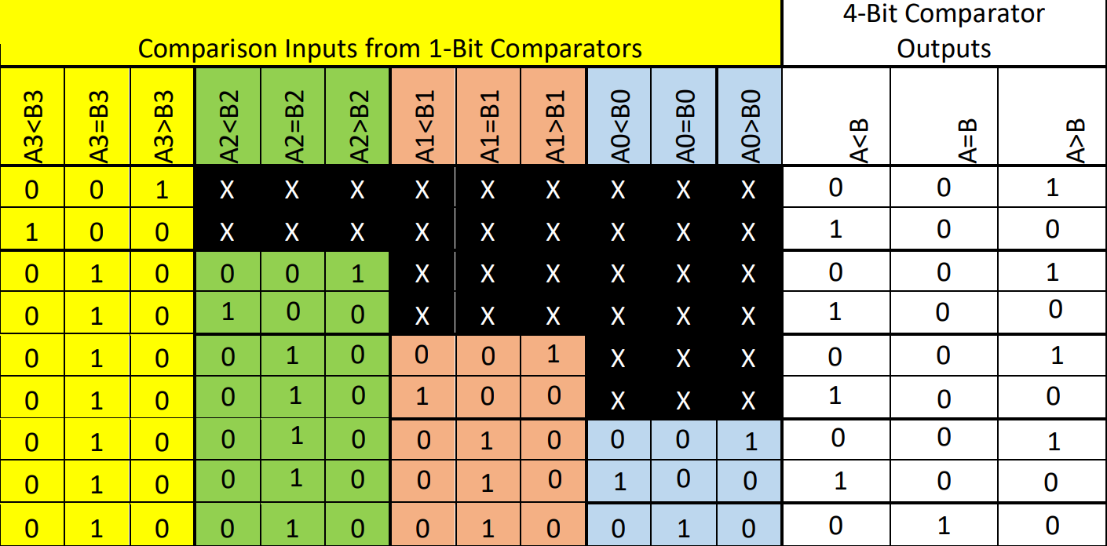

Simulations

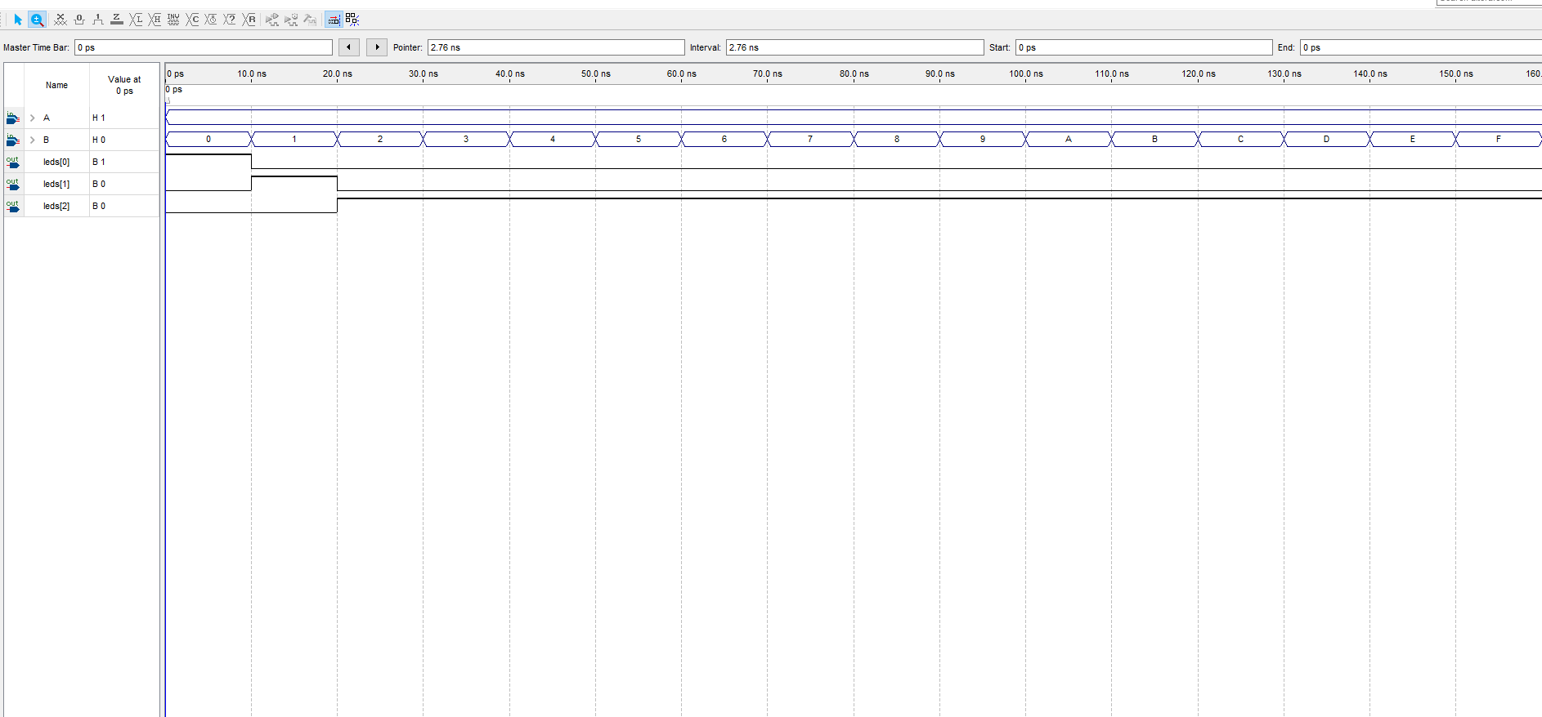Simulation 1:

Input_A set to a static value of hex 1. Input_B run through all hex values between hex 0 and hex F.

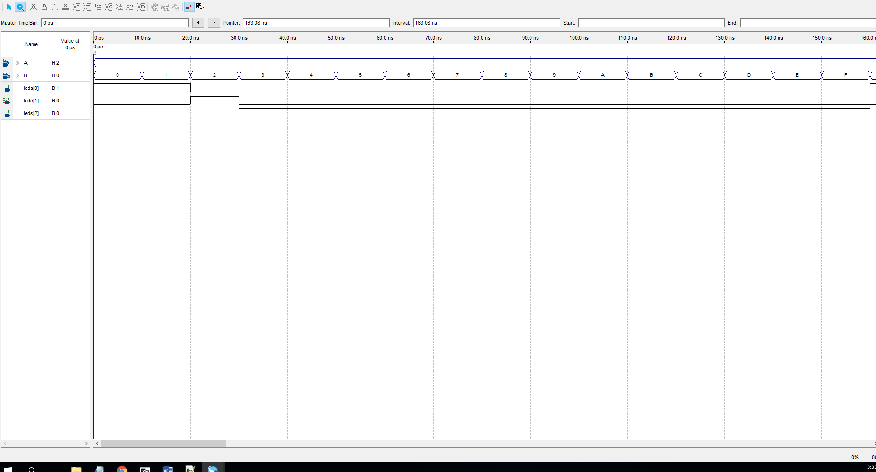Simulation 2:

Input_A set to a static value of hex 2. Input_B run through all hex values between hex 0 and hex F.

### Simulation 3:

Input_A set to a static value of hex 8. Input_B run through all hex values between hex 0 and hex F.

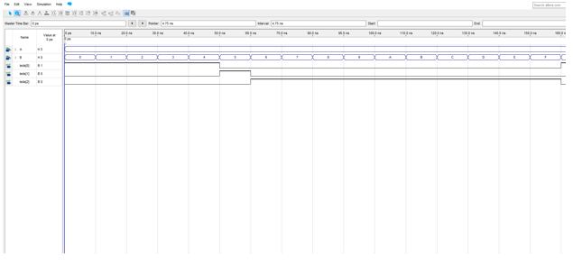Simulation 4:

Input_A set to a static value of hex 5. Input_B run through all hex values between hex 0 and hex F.

RTL View of Logic Design

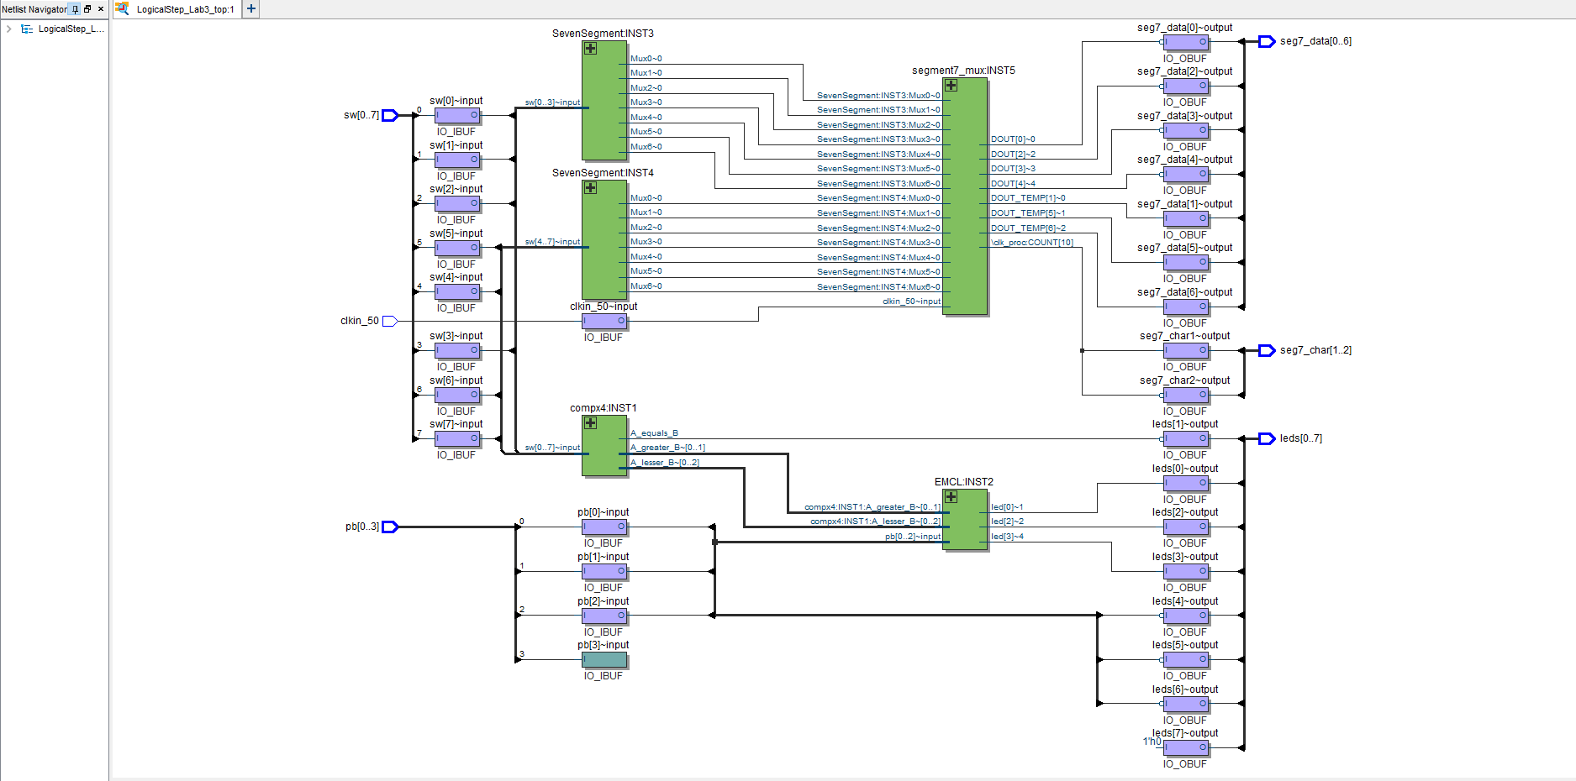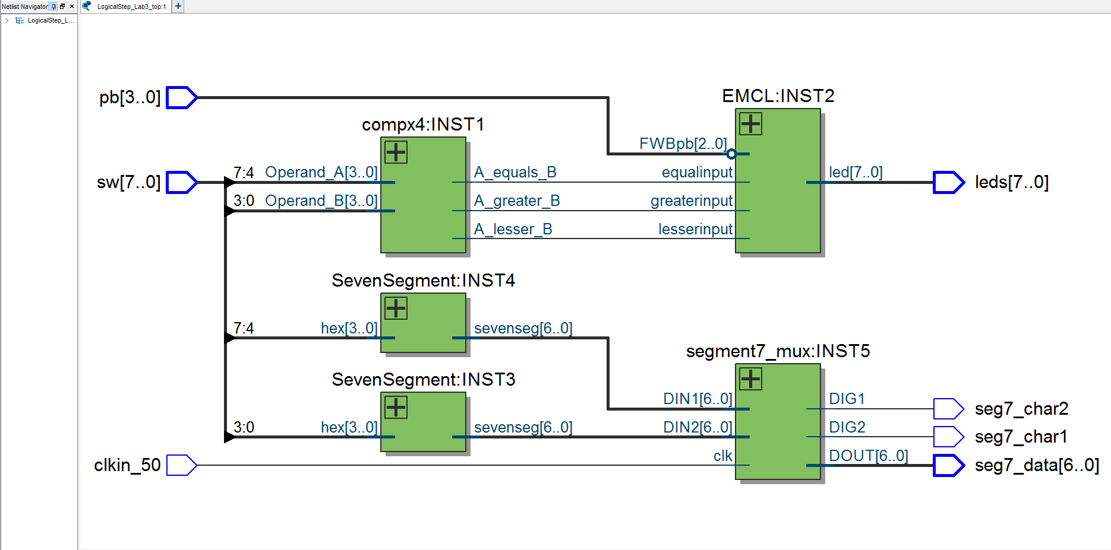Figure 1 RTL View ­­

Figure 2 Technology Mapping Post-Mapping

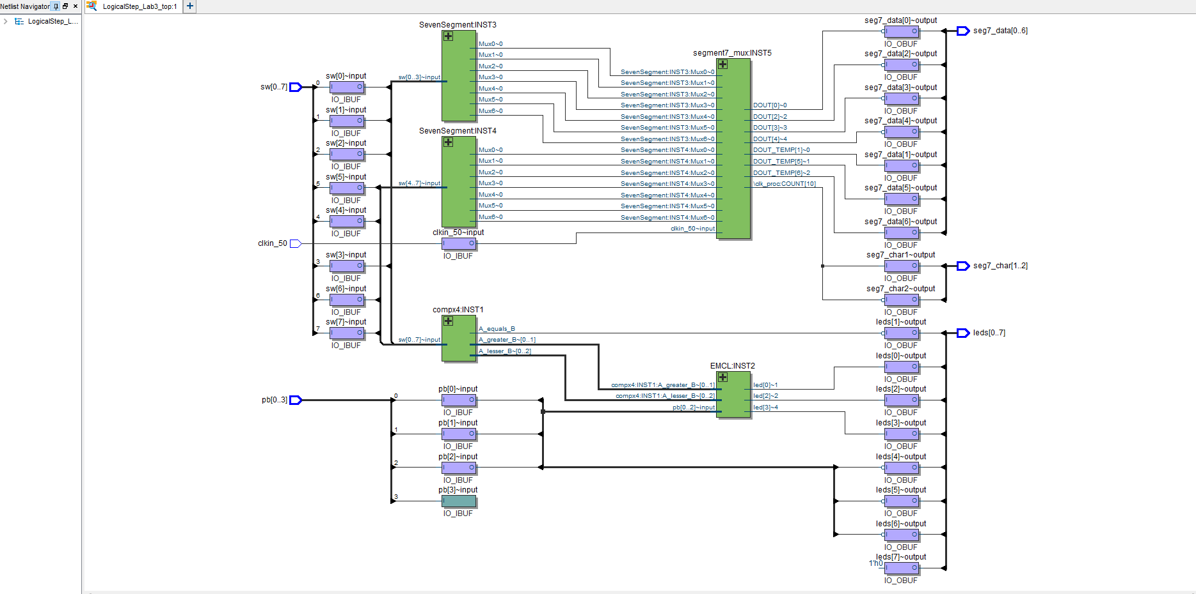

Figure 3 Technology Mapping Post-Fitting

Total Logical Elements

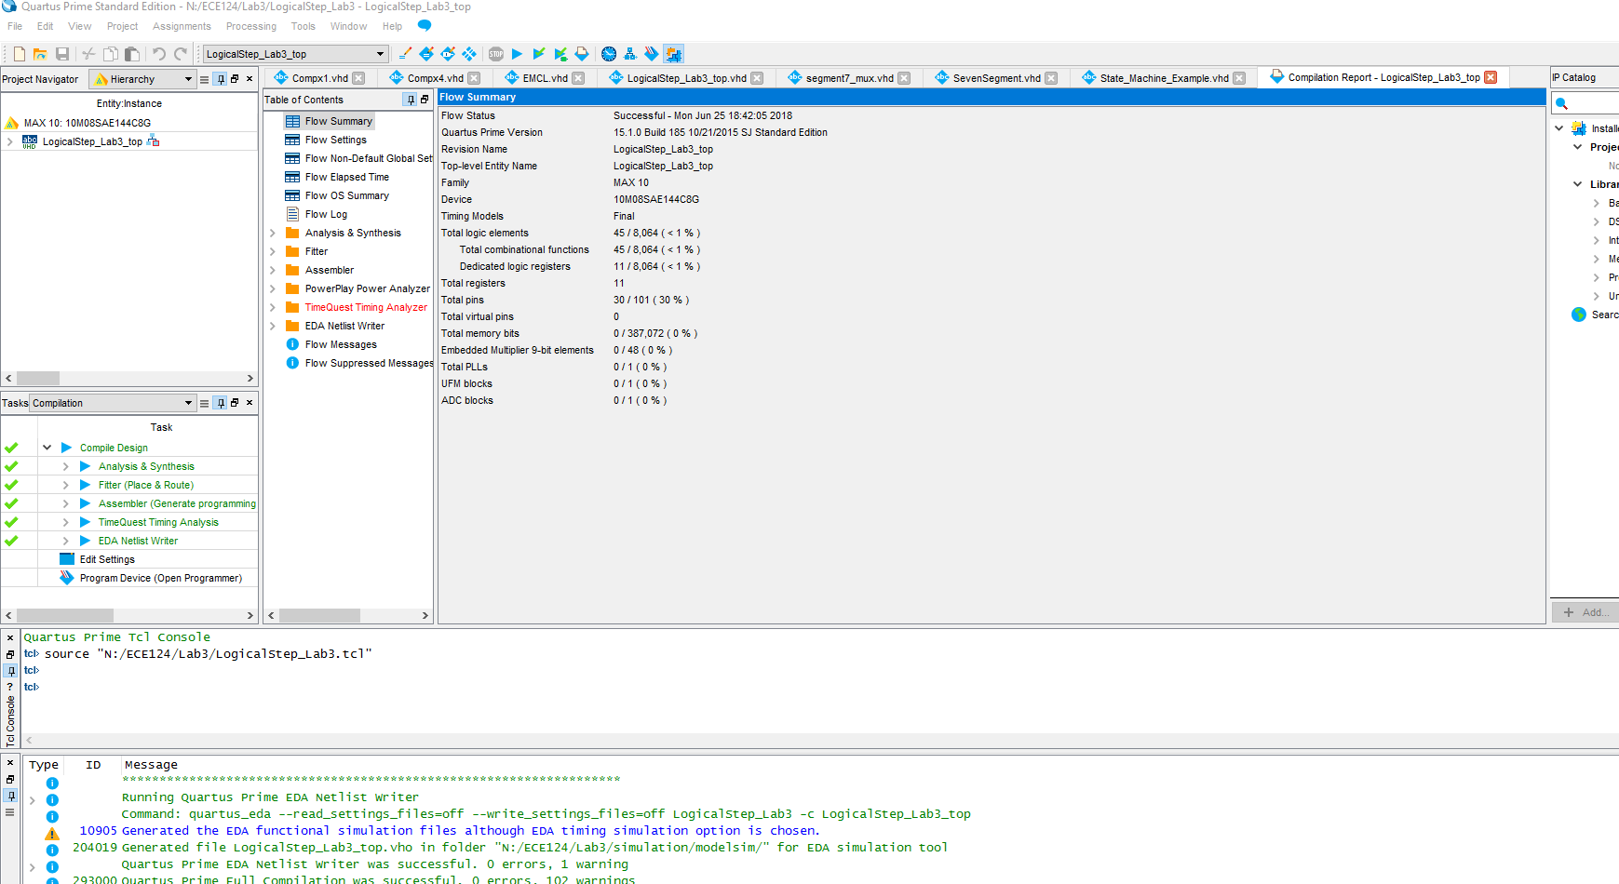The total number of design logic elements are **45**.