So how I can install Jenkin using Docker Desktop?

If you have Docker desktop than you can proceed otherwise you must follow first, how to install docker desktop on window?

For now, complete this Jenkin, assuming that you have Docker Desktop on you window PC Up and Running

1. Install Docker Desktop on your Windows PC. You can download it from the Docker website: https://www.docker.com/products/docker-desktop
2. Open Docker Desktop and make sure it's running.
3. Open a terminal window (e.g., Command Prompt, PowerShell, Git Bash) and enter the following command to pull the latest Jenkins image from Docker Hub:

docker pull jenkins/Jenkins

1. Once the image is downloaded, start a new Jenkins container by entering the following command:

docker run -p 8080:8080 -p 50000:50000 jenkins/jenkins

1. This will start a new Jenkins container and map ports 8080 and 50000 to the same ports on your local machine, allowing you to access the Jenkins web interface.
2. Wait for the container to start up and initialize. You can monitor its progress in the terminal window.
3. Once the container is running, open your web browser and navigate to http://localhost:8080 to access the Jenkins web interface. You should see the Jenkins setup page.

Follow the on-screen instructions to complete the Jenkins setup process, including creating an administrator account and installing any necessary plugins.

If you are getting any Error like below

docker: Error response from daemon: Ports are not available: exposing port TCP 0.0.0.0:8080 -> 0.0.0.0:0: listen tcp 0.0.0.0:8080: bind: Only one usage of each socket address (protocol/network address/port) is normally permitted.

To correct this issue follow the below steps,

docker stop $(docker ps -aq --filter name=jenkins)

docker rm $(docker ps -aq --filter name=jenkins)

docker run -p 8088:8080 -p 50000:50000 jenkins/jenkins

This will start a new Jenkins container and map ports 8088 and 50000 to the same ports on your local machine, allowing you to access the Jenkins web interface.

1. Wait for the container to start up and initialize. You can monitor its progress in the terminal window.
2. Once the container is running, open your web browser and navigate to http://localhost:8088 to access the Jenkins web interface. You should see the Jenkins setup page.
3. Follow the on-screen instructions to complete the Jenkins setup process, including creating an administrator account and installing any necessary plugins.

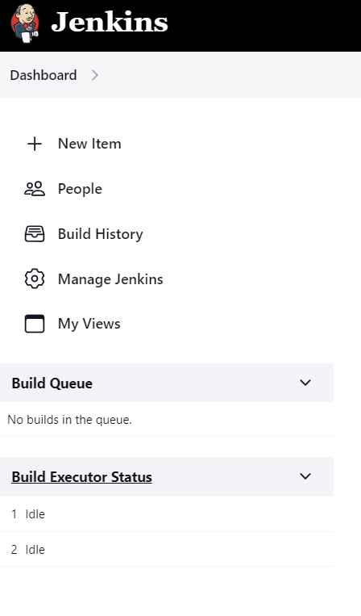

So, I am hoping that you will reach at this initial Dashboard.

Until this point if you have any error or difficulties, you can ask as a query.

So, you reached at the Dashboard with clean slate.

Let’s proceed further…