TEAM-AI FOUNDATION · PROJECT COUNTERSTRIKE · REQUIREMENTS UNDERSTANDING
Counterstrike Agents Fleet
A visual summary of my understanding of the problem, scope, deliverables and acceptance criteria — with open questions for mentor review.
Item | Detail
Project / team | Team-AI Foundation · Project Counterstrike
Focus areas · skills | Fulfilling the requirements with proper documentation · AI, Python, APIs, DevOps
Expected outcome | Process improvement proposal with a working prototype
Team size | 2 participants
Target date | 16 November 2026 (to be confirmed)
Prepared by | Abinash Kumar Mishra · Draft v0.1 for mentor review

Problem (from brief): Enterprises like Fidelity rely on internal apps, open-source software, cloud services, infrastructure platforms, AI solutions and third-party vendors. New vulnerabilities can emerge from many sources and hit critical services with little warning. A centralised capability is needed to proactively monitor, identify and analyse newly disclosed vulnerabilities across the technology landscape.
The solution should: Detect newly disclosed vulnerabilities in near real time · identify affected vendors, products, technologies and services · correlate with Fidelity's technology and vendor inventory · assess business, operational and security impact · prioritise by severity, exploitability, exposure and business criticality · recommend remediation · deliver actionable alerts.

1. The problem in one picture
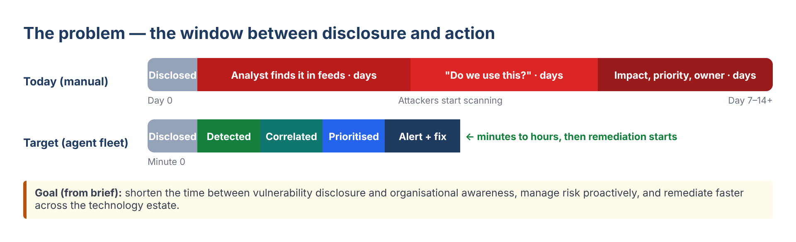
The brief says… | What it means for the build
"Near real time" | Scheduled polling of public feeds (e.g. every 15 min) with de-duplication
"Relevance to our technology stack" | An inventory to match against — the key input to confirm
"Correlate with inventory" | Product + version-range matching, with AI help for messy names
"Prioritise by severity, exploitability, exposure, criticality" | Explainable risk score using CVSS, EPSS, CISA KEV and asset context
"Actionable intelligence and alerts" | Routed alerts with owner, impact, fix and sources — low noise
"Agents fleet" | Several focused AI agents coordinated by an orchestrator

2. Proposed solution
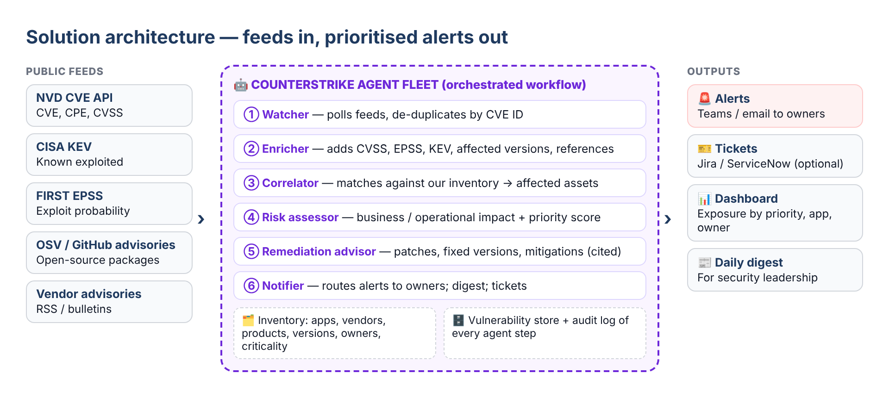
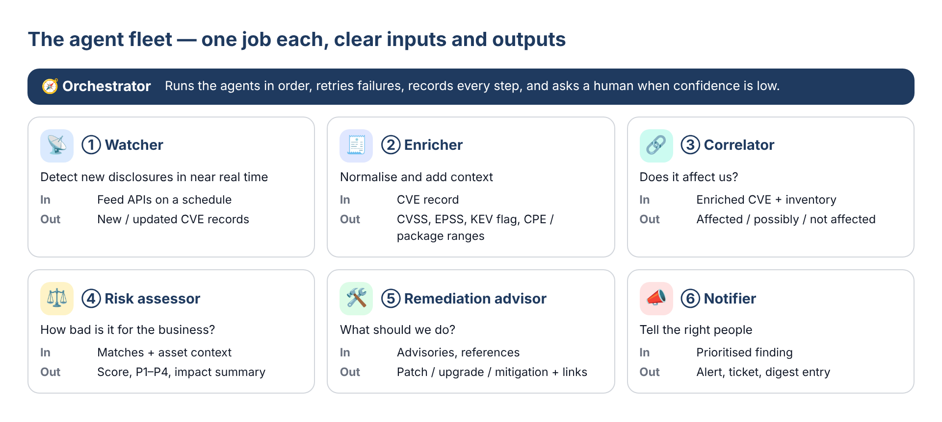

3. Correlation and prioritisation
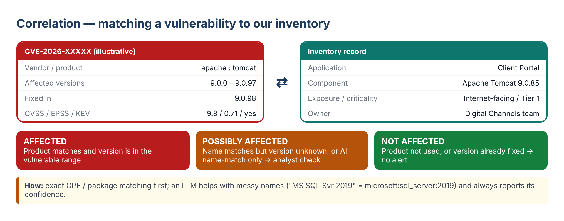
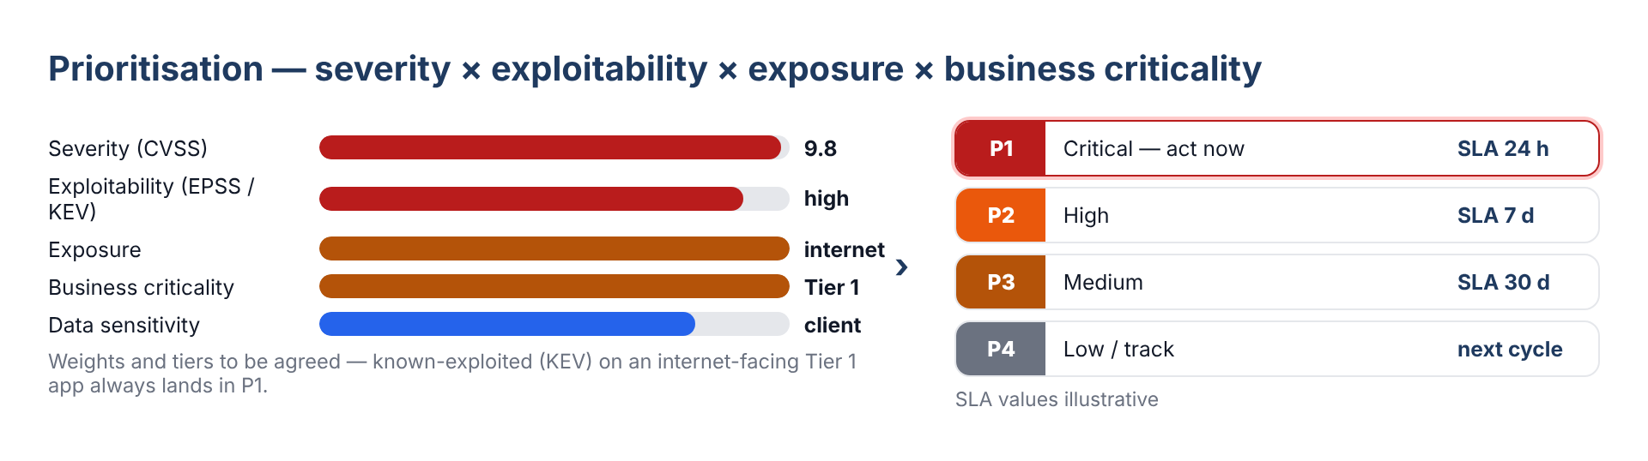

4. Outputs
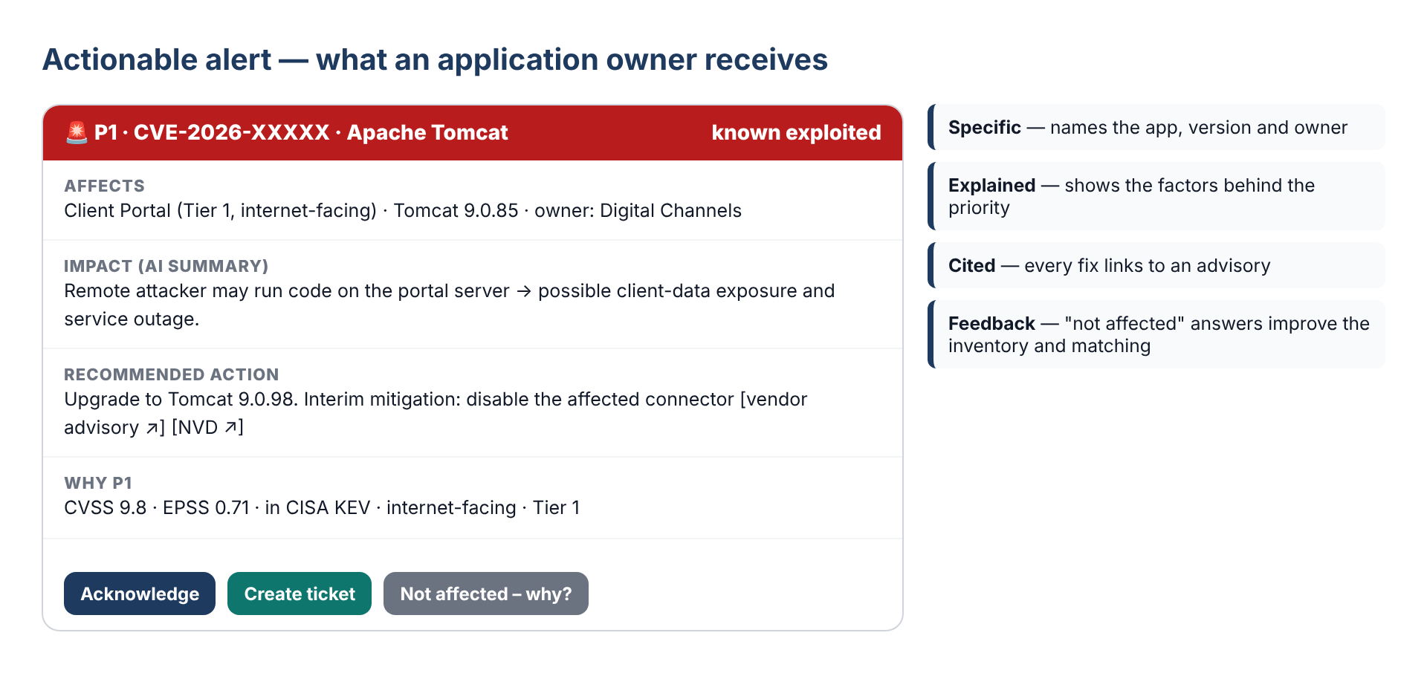
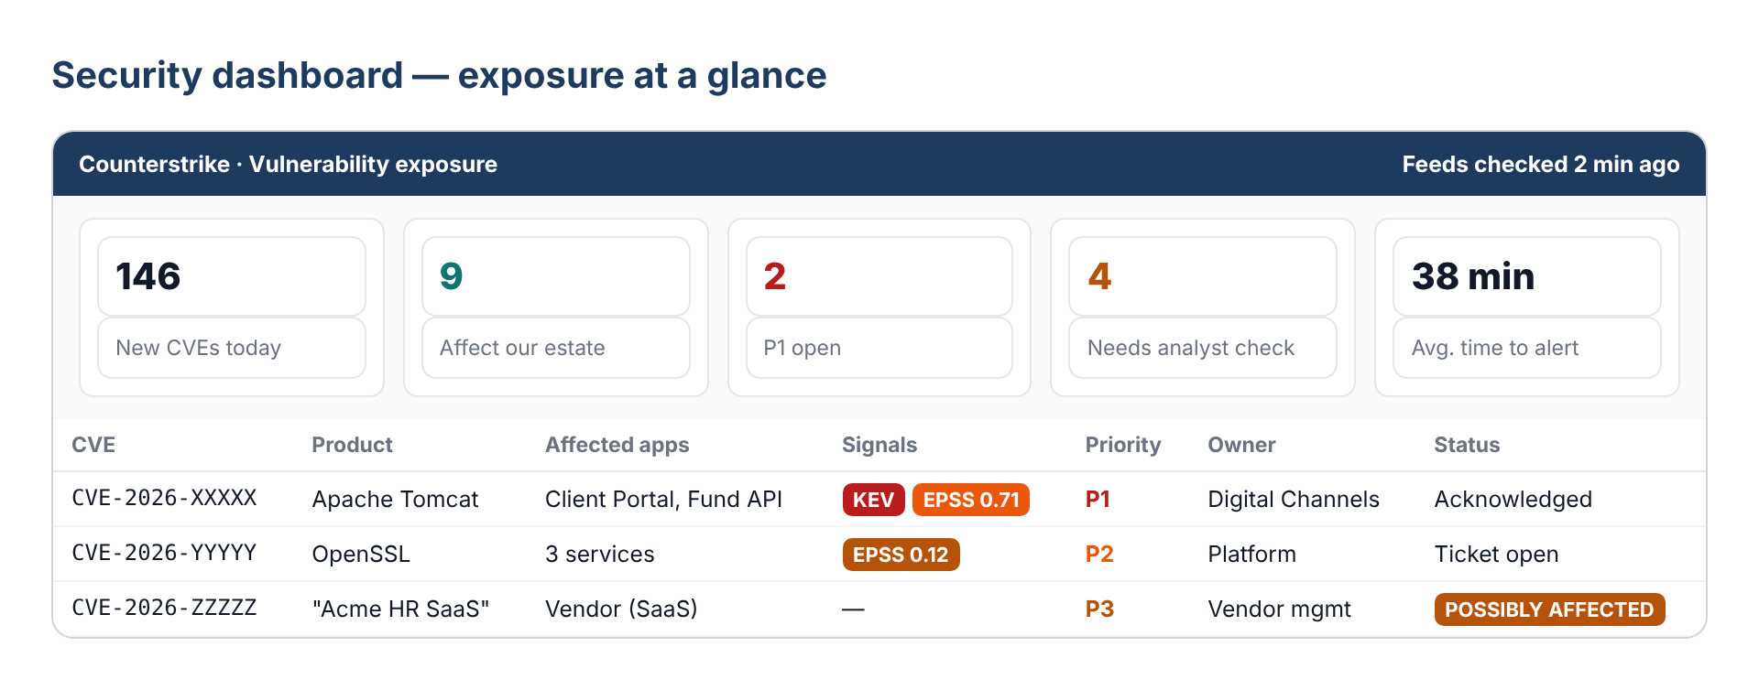

5. Guardrails and process improvement
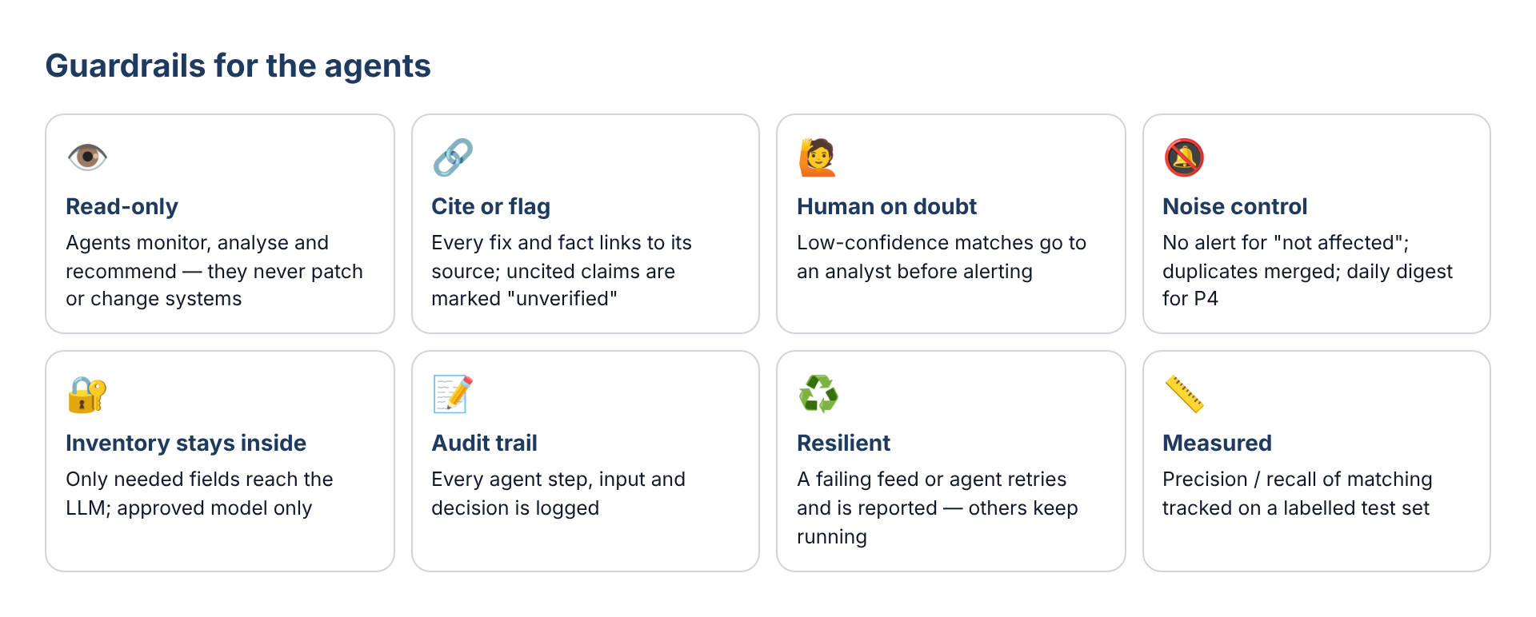
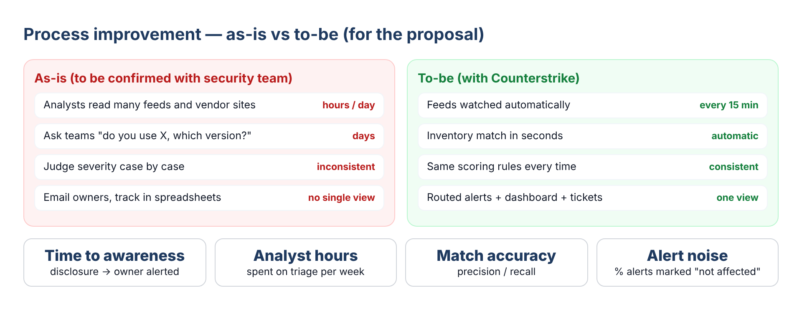

6. Requirement breakup
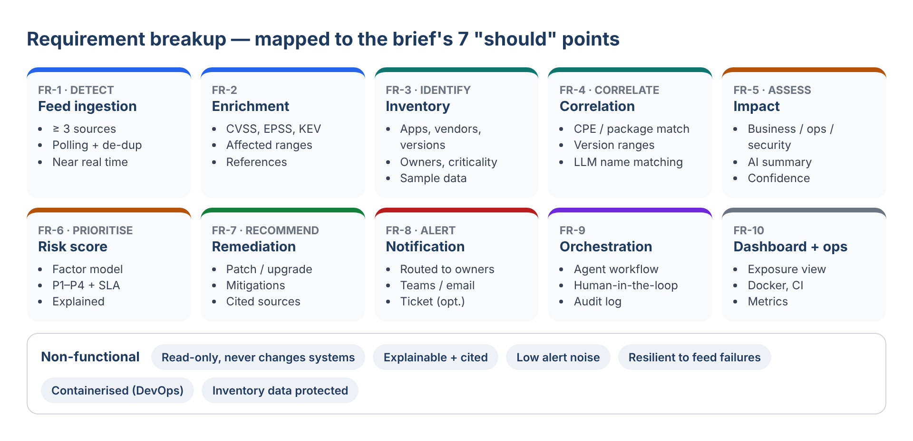
ID | Requirement | Priority
FR-1 | Ingest ≥ 3 public feeds (NVD, CISA KEV, OSV / GitHub advisories) on a schedule; de-duplicate by CVE ID | Must
FR-2 | Enrich with CVSS, EPSS, KEV flag, affected products / version ranges, references | Must
FR-3 | Maintain an inventory of apps, vendors, products, versions, owners, criticality, exposure | Must
FR-4 | Correlate CVEs to inventory: affected / possibly affected / not affected, with confidence | Must
FR-5 | Assess business, operational and security impact (AI summary) | Must
FR-6 | Explainable risk score → P1–P4 with SLA | Must
FR-7 | Recommend patches, fixed versions and mitigations, always citing sources | Must
FR-8 | Route alerts to owners (Teams / email); daily digest; tickets optional | Must
FR-9 | Orchestrate agents with retries, human review for low confidence, audit log | Must
FR-10 | Exposure dashboard; containerised deployment with CI | Should
Stretch | Vendor advisory scraping, ticket integration, feedback learning, threat-intel feeds | Could

7. Deliverables
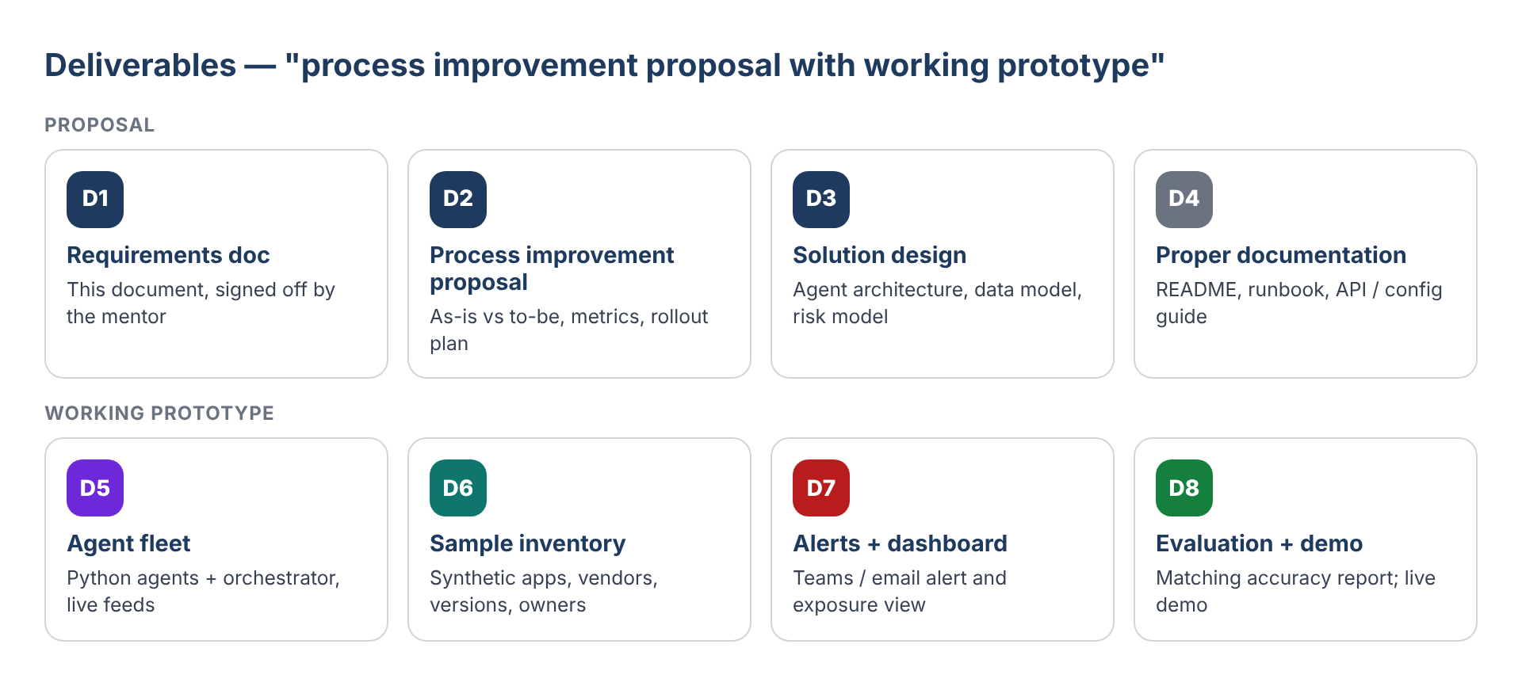

8. Acceptance criteria
ID | Criterion | How it is verified
AC-1 | New CVEs from ≥ 3 sources are ingested within one polling cycle and de-duplicated | Feed logs; S6
AC-2 | Correlation precision ≥ 90% and recall ≥ 95% on a labelled set (targets to confirm) | Evaluation report; S10
AC-3 | Fixed versions and unused products produce no alert | S2, S3
AC-4 | Each affected asset gets a priority with its factor breakdown; KEV + internet-facing → P1 | S1, S5
AC-5 | Every remediation advice links to a source; uncited advice is flagged | Alert review
AC-6 | P1 alert reaches the owner channel within the agreed time of ingestion | Timed demo
AC-7 | Low-confidence matches go to analyst review, not straight to alert | S4
AC-8 | Agents are read-only; every step is in the audit log | Design + log review
AC-9 | A feed or agent failure does not stop the rest of the fleet | S9
AC-10 | Proposal shows as-is vs to-be with measurable improvement (time to awareness) | Proposal review

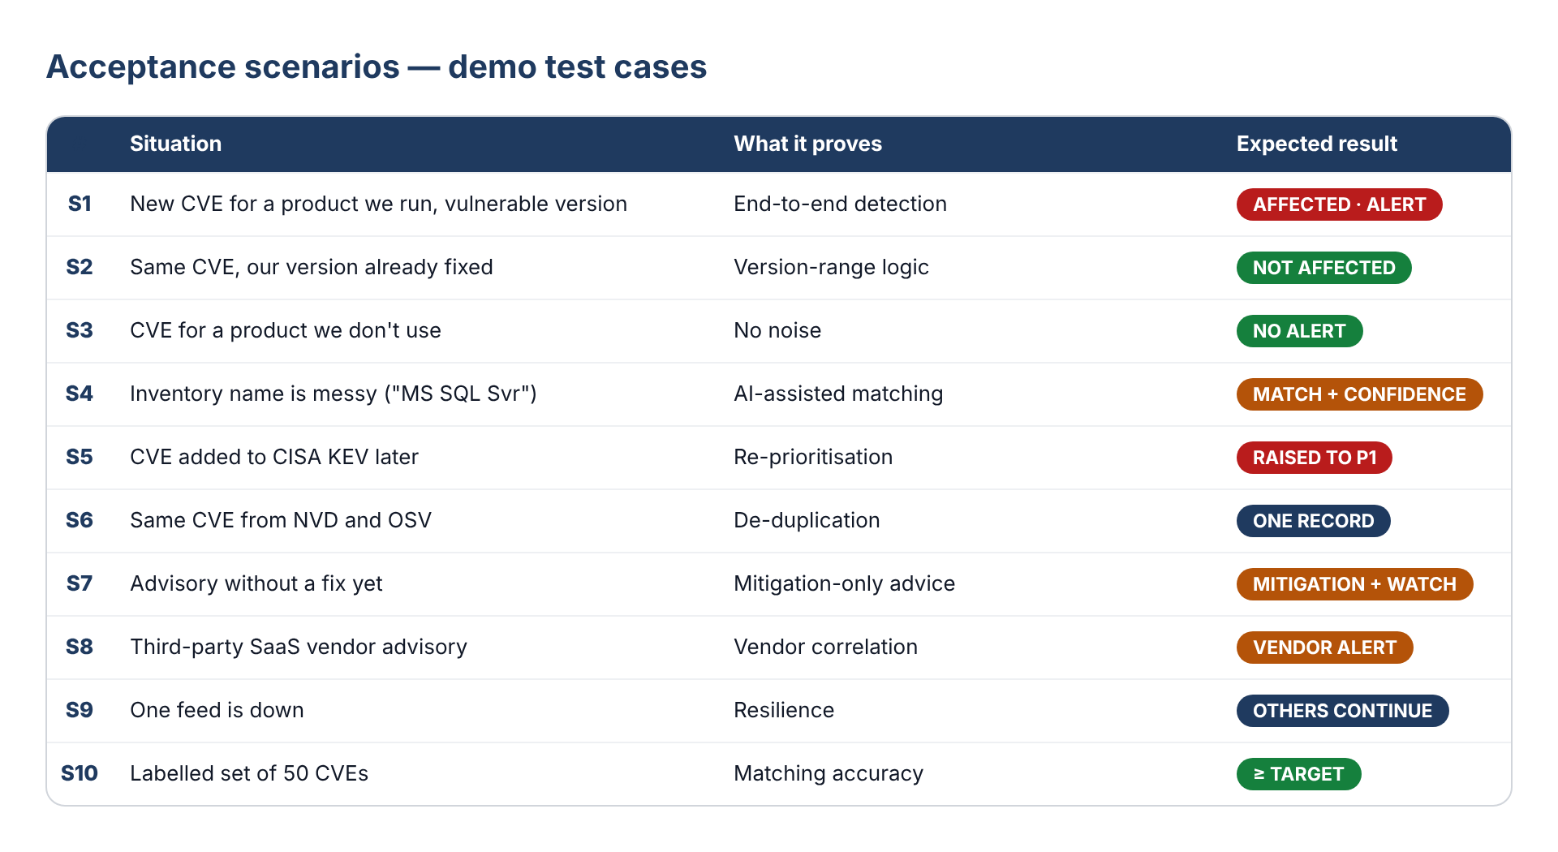
In scope | Out of scope (unless mentor says otherwise)
Public vulnerability feeds + sample inventory | Paid threat-intel feeds, dark-web monitoring
Detection, correlation, prioritisation, advice, alerts | Automatic patching or configuration changes
Prototype dashboard and Teams / email alerts | Production SOC integration (SIEM / SOAR)
Docker-based deployment | Full enterprise CMDB integration

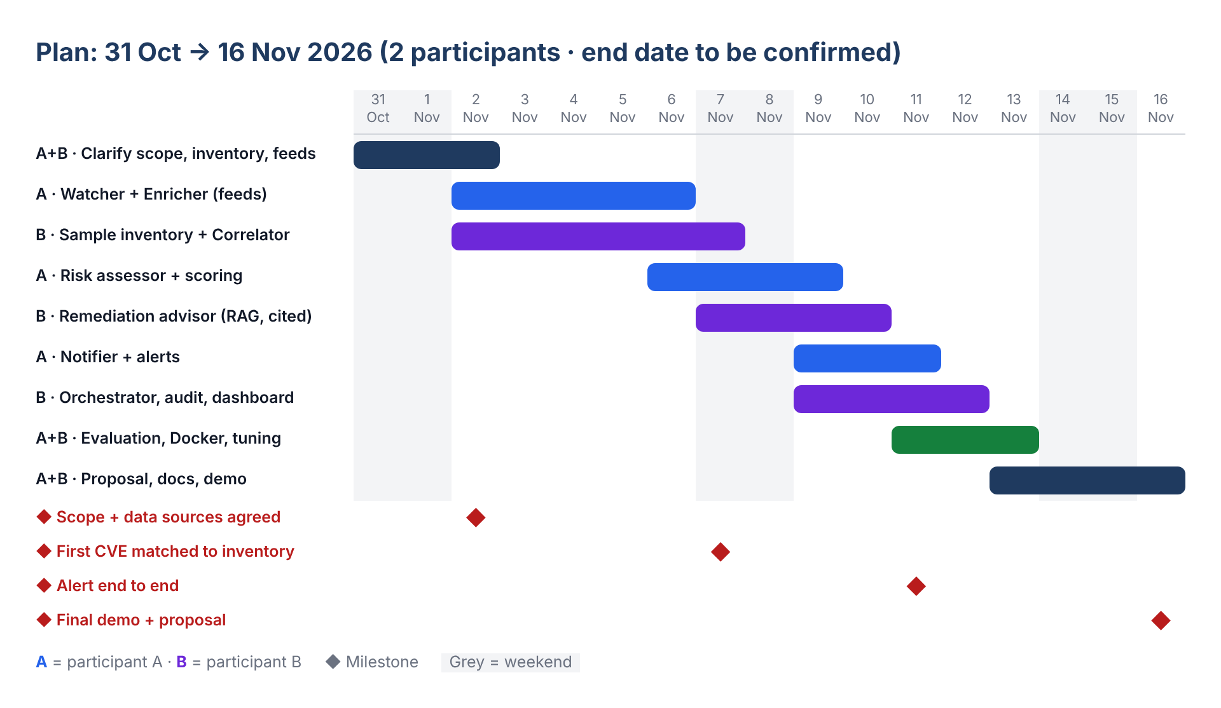

9. Clarifying questions for the mentor
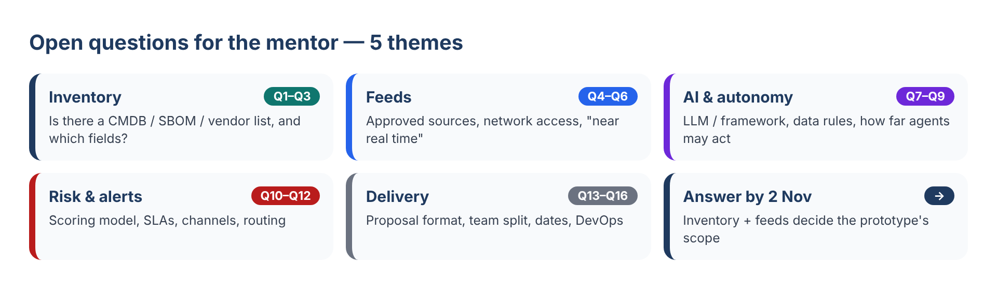
Each question has my default assumption — a quick "yes" or a correction is enough.
Next step: Mentor confirms inventory, feeds and LLM (Q1, Q4, Q7) by 2 Nov → the prototype scope is frozen.
Theme | # | Question | My default assumption
Inventory | Q1 | Is a technology / vendor inventory available (CMDB, SBOM, vendor list)? Can we get a masked sample, or should we create one? | We create a synthetic inventory of ~50 assets
 | Q2 | Which fields can we rely on: product, version, owner, business criticality, internet exposure, data classification? | All six, in the synthetic set
 | Q3 | Should third-party / SaaS vendors be covered, not just software components? | Yes — vendor list with products used
Feeds | Q4 | Which sources are approved: NVD, CISA KEV, EPSS, OSV, GitHub advisories, vendor bulletins, paid threat intel? | Public free sources only
 | Q5 | Can the prototype call external APIs from the network (proxy, API keys)? | Yes, from a dev machine / container
 | Q6 | What does "near real time" mean for you? | Polling every 15 minutes
AI & autonomy | Q7 | Which LLM and agent framework are allowed (Azure OpenAI; LangGraph, CrewAI, other)? | Azure OpenAI + LangGraph
 | Q8 | May inventory details be sent to the LLM, or must they stay local? | Only minimal fields; approved model
 | Q9 | How far may agents act: recommend only, or also open tickets / message owners automatically? | Recommend + alert; no system changes
Risk & alerts | Q10 | Is there an existing risk model, criticality tiers or remediation SLAs we should follow? | Use P1–P4 model in Section 3
 | Q11 | Which alert channels: Teams, email, Jira, ServiceNow? | Teams webhook + email; ticket stretch
 | Q12 | Who receives alerts: security team only, or application owners directly? | App owner + security team for P1 / P2
Delivery | Q13 | What should the "process improvement proposal" contain? Is there current process data to compare against? | As-is vs to-be, metrics, rollout plan
 | Q14 | How should the 2 participants split the work? | A: feeds, risk, alerts · B: inventory, correlation, advice
 | Q15 | Completion date, mentor, and evaluation format? | 16 Nov 2026; live demo + proposal
 | Q16 | DevOps expectations: Docker only, CI pipeline, deployment to a shared environment? | Docker Compose + GitHub Actions CI

