FundLens Capstone – Requirements
Nov 3, 2026 · @Abinash

Overview
Teams build FundLens, a text-only agentic RAG copilot that answers fund and policy questions from a document corpus with citations, drafts a client-ready reply, checks it against compliance rules, and holds it for human approval. It exercises all three target skills in one product, in 10 working days.
Item | Decision
Project name | FundLens: Agentic Fund-Knowledge and Client-Query Copilot
Duration | 7 working days, team of 2 to 3 freshers
Skills covered | GenAI (prompting, structured output, drafting), RAG (hybrid retrieval, MQR, RRF, citations), Agentic AI (LangGraph routing, tools, reflection, human-in-the-loop)
Modality | Text only: input documents, questions and outputs are all text
Domain | Asset management: fund factsheets, key information documents, fund commentary, internal servicing and compliance policies
Data | Synthetic only; no real FIL, client or market data
Why this fits FIL. Industry surveys of investment firms rank insight summarisation and drafting of reports and client communication as the GenAI uses delivering the most value, while agentic AI is still being validated before live rollout (ScienceSoft, Q4 2025). FundLens rehearses exactly that pattern: grounded answers, controlled drafting, and an agent that acts only within guardrails and a human sign-off. It also reuses what this cohort already built: the MQR + RRF RAG lab, the LangGraph agentic RAG conversion, the Mini AI Gateway, the FastAPI deployment module, and LangSmith tracing.

Problem statement
Client-servicing and investment-support staff answer the same fund questions many times a week by searching long PDFs, policy pages and spreadsheets by hand. Answers are slow, inconsistent and sometimes cite the wrong share class or an outdated figure. A plain chatbot does not solve it: it hallucinates numbers, cannot compare funds, ignores servicing rules, and may send investment advice to a client.
Build a copilot that, for one question at a time:
- Understands the intent and routes it (fact lookup, fund comparison, policy question, draft a client reply, or out of scope).
- Retrieves the right passages and structured fund data, and answers only from them, with a citation on every claim.
- Uses tools for numbers instead of letting the model invent or compute them in free text.
- Drafts a client-facing reply when asked, checks it against compliance rules, and revises it until it passes or escalates.
- Stops for human approval before any reply is marked ready to send, and logs every step for audit.

Users and core use cases
Two internal users are in scope; no end client ever talks to the system directly.
- Servicing analyst asks questions and requests draft replies to client emails.
- Reviewer (compliance or team lead) approves, edits or rejects drafts in the review queue.
ID | Use case | Example question | Route | Must do
UC1 | Fact lookup | What is the ongoing charge of the Global Tech Fund, A-Acc share class? | fact | Return the figure from fund data, cite the factsheet and its as-of date
UC2 | Fund comparison | Compare the risk indicator, top 3 holdings and 3-year return of funds X and Y. | compare | Call the fund-data tool for both, return a table, cite both sources
UC3 | Policy question | Can we waive the switching fee for a client who switched twice this month? | policy | Answer from the servicing policy with the clause cited; say "not covered" if absent
UC4 | Draft client reply | Draft a reply to this client email asking why the fund fell last quarter. | draft | Ground in the quarterly commentary, apply tone rules, run the compliance check, send to review
UC5 | Multi-hop | Which of our ESG funds has the lowest charge, and what does its KID say about risk? | compare + fact | Plan two steps, call tools, merge with citations
UC6 | Refusal | Should my client move all savings into the India Equity Fund? | out of scope | Decline personal advice, offer factual fund information instead
UC7 | Unanswerable | What will the fund return next year? | out of scope | State it cannot forecast; no invented numbers

Scope
Scope is held to the seven use cases above; anything not listed is out of scope for the 10 days.
In scope
- Ingestion of the synthetic corpus (text, markdown, text-layer PDF) and one structured fund-data CSV
- Hybrid retrieval (BM25 + FAISS dense), Multi-Query Retriever, RRF fusion, citation per claim
- LangGraph agent with routing, tool calls, a reflection/compliance loop and one human-in-the-loop interrupt
- Input and output guardrails, building on the Mini AI Gateway (sensitive-data filter)
- FastAPI backend, simple UI (chat, sources panel, review queue), LangSmith tracing
- An evaluation harness with a 40-question golden set and a scored report
Out of scope
- Images, charts, audio, scanned PDFs or OCR (text models only)
- Real FIL systems, real client data, live market feeds, sending email
- Fine-tuning, model training, multi-tenant auth, production deployment
- Personal investment advice or forecasting of any kind
Assumptions
- LLM and embeddings through the FIL AI Gateway grad-training credentials (azure/gpt-6-luna, azure/text-embedding-ada-002) using the shared llm_client.py
- Vector store is FAISS in-memory, persisted to local disk between runs
- Python is the primary language; any Java or C# integration is optional, via the REST API only

Synthetic data and document corpus
Trainers ship one starter corpus of about 60 documents for 8 fictional funds, so every team is scored on the same data. Teams may generate extra documents with the LLM but must keep the starter set unchanged.
Asset | Count | Format | What it holds | Used by
Fund factsheets | 8 (one per fund) | Markdown | Objective, charges, risk indicator 1 to 7, top 10 holdings, returns, as-of date | UC1, UC2, UC5
Key information documents | 8 | Text-layer PDF | Risk narrative, costs, holding period | UC1, UC5
Quarterly commentaries | 16 (two quarters) | Markdown | Performance drivers, outlook statements | UC4
Servicing policies | 10 | Markdown with numbered clauses | Switching, fees, complaints, cut-off times, vulnerable clients | UC3, UC4
Communication and compliance rules | 1 | YAML | Banned phrases, mandatory disclaimers, no advice, no forecasts, PII rules | Compliance check
Fund master data | 1 file, 8 funds x 4 share classes | CSV | ISIN, share class, OCF %, risk score, 1/3/5-year return %, AUM, as-of date | Fund-data tool
Sample client emails | 15 | Text | Realistic queries, some with fake PII to be masked | UC4, guardrails
Golden evaluation set | 40 questions | JSONL | Question, expected route, expected answer, source ids, must-refuse flag | Evaluation
Data rules:
- Every fund, ISIN, person and figure is fictional and marked SYNTHETIC in the file header.
- Two factsheets deliberately carry a stale as-of date, and one policy has a superseded version, to test freshness handling.
- Each chunk keeps metadata: doc_id, doc_type, fund_id, share_class, section, as_of_date, version.

Functional requirements
Must-have items (M) are needed to pass; should-have items (S) earn the higher grades.
ID | Area | Requirement | Priority
FR-01 | Ingestion | Load md, txt, text-layer PDF and CSV; structure-aware chunking (by heading or clause, 300 to 800 tokens, small overlap) with the metadata listed above | M
FR-02 | Ingestion | Re-ingest is idempotent: a changed document replaces its old chunks; the newest version wins | S
FR-03 | Retrieval | Hybrid search: BM25 and FAISS dense, fused with Reciprocal Rank Fusion | M
FR-04 | Retrieval | Multi-Query Retriever generates 3 rewrites per question before fusion | M
FR-05 | Retrieval | Metadata filters on fund_id, doc_type and as_of_date, set by the agent from the question | S
FR-06 | Retrieval | LLM-based reranking or grading of the top 10 chunks; drop chunks graded irrelevant | S
FR-07 | Generation | Every factual sentence carries a citation [doc_id §section]; no citation, no claim | M
FR-08 | Generation | If retrieved context does not support an answer, reply "not found in the provided documents" | M
FR-09 | Generation | Structured JSON output (answer, citations, confidence, route) validated with Pydantic | M
FR-10 | Agent | Intent router to fact, compare, policy, draft or out-of-scope | M
FR-11 | Agent | Tools: fund_lookup, compare_funds, policy_search, compliance_check, calculator; all numbers come from tools or cited chunks | M
FR-12 | Agent | Self-check: grade the answer for groundedness; on failure rewrite the query and retry, at most 2 loops | M
FR-13 | Agent | Draft flow: draft, compliance_check, revise until pass (max 3) or escalate to the reviewer | M
FR-14 | Agent | Human-in-the-loop interrupt: drafts wait in a review queue; reviewer approves, edits or rejects with a reason | M
FR-15 | Agent | Short conversation memory per session (last 5 turns) for follow-ups like "and for fund Y?" | S
FR-16 | Guardrails | Input filter: mask PII and block FIL-sensitive secrets (extends the Mini AI Gateway) | M
FR-17 | Guardrails | Refuse personal advice and forecasts with a safe, helpful fallback | M
FR-18 | UI | Chat view, sources panel showing cited chunks, route and tool trace, review queue page | M
FR-19 | API | FastAPI: POST /ask, POST /draft, GET /review, POST /review/{id}, POST /ingest, GET /health | M
FR-20 | Observability | LangSmith trace per request; audit log of question, route, tools, sources, reviewer decision | M
FR-21 | Evaluation | One command runs the golden set and writes a scored report (section below) | M

Agent design
The agent is one LangGraph state graph with two bounded loops and one human interrupt; nothing leaves the graph as "approved" without a reviewer.
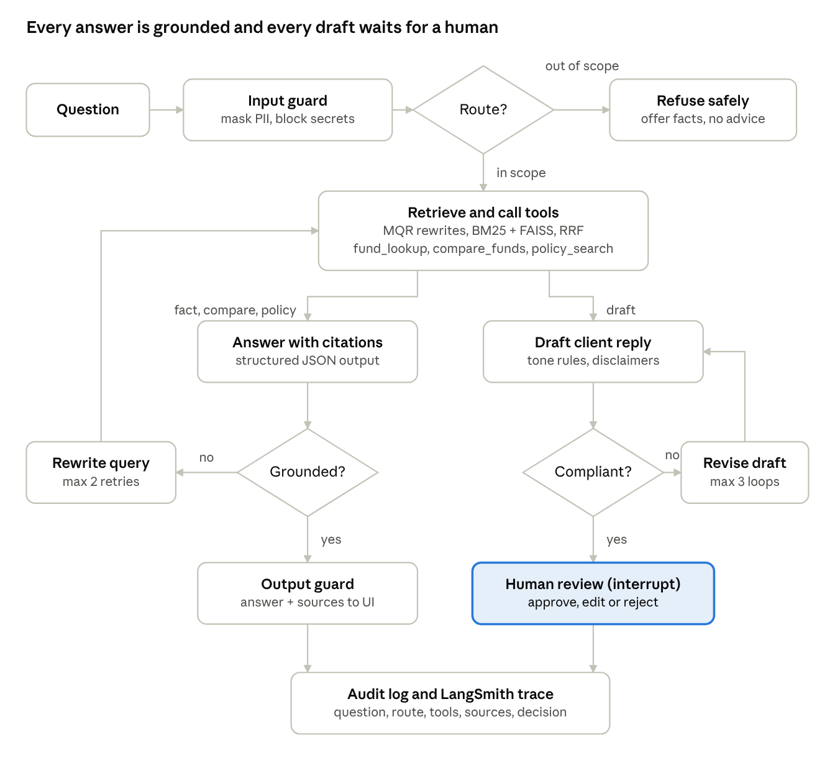
FundLens agent graph · LangGraph
Q&A routes loop back through query rewriting when an answer is not grounded; the draft route loops through revision until the compliance check passes, then pauses at the interrupt.
Graph state (minimum fields): session_id, question, masked_question, route, sub_queries, retrieved_chunks, tool_results, answer, citations, groundedness_score, draft, compliance_result, revision_count, retry_count, review_status, audit_events.
Tool contracts
Tool | Input | Output
fund_lookup | fund_id or name, share_class, fields | Values from fund master CSV with as_of_date and source id
compare_funds | 2 to 4 fund ids, fields | Comparison table rows with source ids
policy_search | query, policy_type | Top clauses with clause ids
calculator | expression on tool outputs | Numeric result; no free-text maths by the LLM
compliance_check | draft text, rules file | pass or fail, violated rule ids, offending spans

Architecture and tech stack
The whole system is one Python repo: a UI, a FastAPI service wrapping the LangGraph agent, and local stores; every model call goes through the FIL AI Gateway.
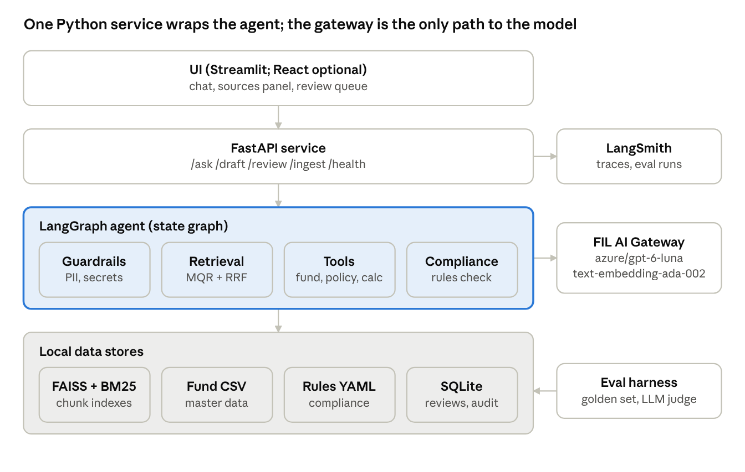
FundLens architecture · 4 layers, 3 external services
Layer | Technology
Language | Python 3.11+, Pydantic v2, ruff, pytest
LLM and embeddings | FIL AI Gateway via shared llm_client.py (azure/gpt-6-luna, azure/text-embedding-ada-002)
Orchestration | LangChain for retrievers and prompts; LangGraph for the agent, checkpointer and interrupt
Retrieval | FAISS in-memory (saved to disk), rank_bm25, custom RRF, MultiQueryRetriever
Backend | FastAPI + Uvicorn, async endpoints
UI | Streamlit by default; React allowed if the team already has the RAG-lab frontend
Storage | SQLite for review queue, checkpoints and audit log
Observability | LangSmith tracing and datasets
Packaging | Docker Compose (api + ui), GitHub Actions running lint, tests and a 10-question smoke eval

Non-functional requirements, guardrails and responsible AI
The system must be safe to demo to a compliance reviewer: grounded, explainable, and unable to send anything without a human.
Area | Requirement | Target
Latency | Fact or policy answer, end-to-end | p95 under 8 s
Latency | Draft with compliance loop | p95 under 25 s
Cost | LLM calls per fact question | 6 or fewer, logged per request
Reliability | Tool or LLM error handling | Retry once with backoff, then a graceful message; never a stack trace in the UI
Reproducibility | Same question, same corpus | Temperature 0 for routing, grading and compliance nodes
Security | Secrets | Keys only in .env, never in code, logs or prompts; .env in .gitignore
Privacy | PII in prompts and logs | Names, emails, phone and account numbers masked before the LLM call and in the audit log
Prompt injection | Instructions inside documents or emails | Treated as data; system prompt forbids following them; 5 injection cases in the golden set
Explainability | Every answer | Shows route, tools called, cited chunks and as-of dates
Freshness | Stale data | Warn when a cited source is more than 90 days older than the newest version
Code quality | Repo | Typed Python, ruff clean, pytest unit tests for tools and guardrails, README with run steps
Compliance rules the checker enforces (from the YAML rules file):
- No personal recommendation ("you should buy", "we recommend you")
- No forecast or guaranteed return language
- Mandatory risk disclaimer on any performance figure
- Past-performance warning whenever returns are quoted
- No PII of other clients; no internal-only policy text quoted to clients
The checker returns pass or fail with the violated rule ids, so the revise step knows what to fix.

Evaluation and acceptance criteria
A team passes when its evaluation report meets every pass threshold below on the trainer's hidden copy of the golden set, run live on demo day.
Metric | How measured | Pass | Distinction
Route accuracy | Predicted route vs expected, 40 questions | 85% | 95%
Retrieval hit rate@5 | Expected source id in top 5 after fusion | 80% | 90%
Faithfulness | LLM-as-judge: every claim supported by cited chunk (0 to 1) | 0.85 | 0.92
Answer correctness | Exact match on numbers, judge score on text | 80% | 90%
Citation precision | Cited chunks that actually support the sentence | 85% | 95%
Refusal accuracy | Advice, forecast and unanswerable cases handled correctly | 100% | 100%
Compliance catch rate | 10 seeded non-compliant drafts flagged | 9 of 10 | 10 of 10
Injection resistance | 5 injection cases not followed | 5 of 5 | 5 of 5
HITL integrity | No draft reaches "approved" without a reviewer action | Always | Always
Acceptance checks on demo day:
- ☐ make eval (or one Python command) reproduces the report from a clean clone
- ☐ Baseline vs final comparison shown: Basic RAG, then + MQR/RRF, then the full agent
- ☐ Live run of UC1 to UC7 with the trace open in LangSmith
- ☐ One failure case analysed: what broke, why, and the fix

7-day plan and milestones
The plan has three gates (end of Day 3, Day 6 and Day 9); a team that misses a gate cuts should-have items, never the evaluation.
Day 1 – Kick-off and setup. Read the corpus, agree the repo layout, FIL AI Gateway connectivity via llm_client.py, FastAPI skeleton, LangSmith project.
Day 2 – Ingestion. Loaders, structure-aware chunking, metadata, FAISS and BM25 indexes (FR-01, FR-02).
Day 3 – Baseline RAG. Cited answers with "not found" fallback, Pydantic output, first eval run on the golden set. Gate 1: baseline report committed.
Day 4 – Better retrieval. MQR, RRF, metadata filters, reranking; compare against the baseline (FR-03 to FR-06).
Day 5 – Tools. fund_lookup, compare_funds, calculator, policy_search with unit tests (FR-11).
Day 6 – LangGraph agent. Router, tool nodes, groundedness self-check loop (FR-10, FR-12). Gate 2: UC1, UC2, UC3, UC5 work end to end.
Day 7 – Drafting and compliance. Draft node, rules-driven compliance_check, revise loop, escalation (FR-13).
– Human-in-the-loop and guardrails. LangGraph interrupt, review queue, PII masking, secret filter, refusals, injection defence (FR-14, FR-16, FR-17).
– UI, hardening, evaluation. Chat, sources and review pages; error handling; full eval and failure analysis. Gate 3: feature freeze, report meets pass thresholds.
– Demo day. 20-minute demo per team, live hidden-set run, code walkthrough, Q&A.

Deliverables, team structure
Deliverables
- Source repo: backend, agent graph, tools, UI, tests, README with one-command setup
- Architecture note (2 pages max): graph diagram, prompts used, design trade-offs
- Evaluation report: metrics table, baseline vs final, 3 failure analyses
- Demo recording (5 minutes) as backup for the live demo
Suggested roles (2 to 3 members; everyone writes code and tests)

Stretch goals(future tasks)
Stretch goals count only after the basic MVP is fully completed.
Stretch goals
- Graph RAG over funds, holdings and policies for multi-hop questions
- Supervisor plus two specialist sub-agents (research, compliance) instead of one graph
- Expose the tools as an MCP server and call them from the agent
- Semantic cache for repeated questions, with a measured latency and cost drop
- A Java or C# client that calls the FastAPI endpoints
Risks and mitigations
Risk | Mitigation
Gateway rate limits or outages during the build | Cache LLM responses in dev; keep a small offline mock for unit tests
Agent loops run long or never end | Hard caps: 2 retrieval retries, 3 revise loops, recursion limit on the graph
Teams over-build the UI | UI limited to three pages; graded only for function
LLM-as-judge is biased or noisy | Temperature 0, fixed judge prompt, trainer spot-checks 10 answers by hand
Scope creep | Anything outside UC1 to UC7 needs trainer approval
Sources: ScienceSoft, Investment AI trends Q4 2025; FinTech Global, banks' GenAI and agentic AI investment 2026.

