**MANGOBD – ONLINE MARKET PLACE FOR BUYING & SELLING MANGOES**

**BY**

**Md. Emamul Murshalin**

**ID: 152-15-6102**

**Md. Nahid Hasan**

**ID: 152-15-5987**

**AND**

**A.K.M. Mohaimin Hossain**

**ID: 152-15-6004**

This Report Presented in Partial Fulfillment of the Requirements for the Degree of Bachelor of Science in Computer Science and Engineering

Supervised By

**Shah Md Tanvir Siddiquee**

Senior Lecturer

Department of CSE

Daffodil International University



**DAFFODIL INTERNATIONAL UNIVERSITY**

**DHAKA, BANGLADESH**

**MAY 2018**

**APPROVAL**

This Project titled **“MANGOBD – ONLINE MARKET PLACE FOR BUYING & SELLING MANGOES**”, submitted by Md. Emamul Murshalin, Md. Nahid Hasan and A.K.M. Mohaimin Hossain to the Department of Computer Science and Engineering, Daffodil International University, has been accepted as satisfactory for the partial fulfillment of the requirements for the degree of B.Sc. in Computer Science and Engineering (BSc) and approved as to its style and contents. The presentation has been held on 25 November 2018.

**BOARD OF EXAMINERS**

**Dr. Syed Akther Hossain**

**Professor and Head**

Department of Computer Science & Engineering

Faculty of Science & Information Technology

Daffodil International University

**Chairman**

**Dr. Sheak Rashed Haider Noori**

**Associate Professor and Associate Head**

Department of Computer Science & Engineering Faculty of Science & Information Technology Daffodil International University

**Internal Examiner**

|  |  |  |  |  |
| --- | --- | --- | --- | --- |
| **Md. Zahid Hasan** | | | | **Internal Examiner** |
| **Assistant Professor** | | | |  |
| Department of Computer Science & Engineering | | | |  |
| Faculty of Science & Information Technology | | | |  |
| Daffodil International University | | | |  |
|  |  |  |  |  |
|  |  |  |  |  |

**Dr. Mohammad Shorif Uddin**

**Prefessor**

Department of Computer Science & Engineering

Jahangirnagar University

**External Examiner**

©Daffodil International University

ii

**DECLARATION**

We hereby declare that, this project has been done by us under the supervision of **Shah Md Tanvir Siddiquee, Senior Lecturer, Department of CSE** Daffodil International University. We also declare that neither this project nor any part of this project has been submitted elsewhere for award of any degree or diploma.

**Supervised by:**

**Shah Md Tanvir Siddiquee**

Senior Lecturer

Department of CSE

Daffodil International University

**Submitted by:**

**Md. Emamul Murshalin**

ID: 152-15-6102

Department of CSE

Daffodil International University

**Md. Nahid Hasan**

ID: 152-15-5987

Department of CSE

Daffodil International University

**A.K.M. Mohaimin Hossain**

ID: 152-15-6004

Department of CSE

Daffodil International University

©Daffodil International University

iii

**ACKNOWLEDGEMENT**

First we express our heartiest thanks and gratefulness to almighty God for His divine blessing makes us possible to complete the final year project successfully.

We really grateful and wish our profound our indebtedness to **Shah Md Tanvir Siddiquee**, **Senior Lecturer**, Department of CSE Daffodil International University, Dhaka. Deep Knowledge & keen interest of our supervisor in the field of “*MangoBD*” to carry out this project. His endless patience ,scholarly guidance ,continual encouragement , constant and energetic supervision, constructive criticism , valuable advice ,reading many inferior draft and correcting them at all stage have made it possible to complete this project.

We would like to express our heartiest gratitude to Dr. Sayed Akhter Hossain, Head**,** Department of CSE, for his kind help to finish our project and also to other faculty member and the staff of CSE department of Daffodil International University.

We would like to thank our entire course mate in Daffodil International University, who took part in this discuss while completing the course work.

Finally, we must acknowledge with due respect the constant support and patients of our parents.

©Daffodil International University

iv

**ABSTRACT**

Our project title “MangoBD- Online market place for buying & selling mangoes” is a web based project. In our country there have many places whose have good reputation of their mangoes. This areas people always trying to produce lot of mangoes and want to sell them at good price. Customers also want to get their pure mangoes without formalin. We are going to build a website where we are the medium of them. Seller can be able to upload their information with mangoes as a vendor then we will verify them. After verify they can publish their mangoes. Then customer can see their mangoes and after checking them they can buy mangoes. When customer buy mangoes then we initially kept the money of customer and after confirm that customer get the mangoes with purity then we will send the money to seller. Finally we want to say that we are going to build a multivendor ecommerce website where people can sell and buy mangoes.

©Daffodil International University

v

|  |  |  |
| --- | --- | --- |
|  | **TABLE OF CONTENTS** |  |
| **CONTENTS** | | **PAGE** |
| Board of examiners | | ii |
| Declaration | | iii |
| Acknowledgements | | iv |
| Abstract |  | V |
| List of Figures | | ix |
| List of Tables | | x |
| **CHAPTER** | |  |
| **CHAPTER 1: INTRODUCTION** | | **1-2** |
| 1.1 Introduction | | 1 |
|  |
| 1.2 | Motivation | 1 |
| 1.3 | Objectives | 1 |
| 1.4 | Expected Outcome | 2 |
| 1.5 | Report Layout | 2 |
| **CHAPTER 2: BACKGROUND** | | **3-7** |
| 2.1 Introduction | | 3 |
| 2.2 | Related Works | 3 |
| 2.3 | Comparative Studies | 6 |
| 2.4 | Scope of the Problem | 7 |

|  |  |
| --- | --- |
| **CHAPTER 3: REQUIREMENT SPECIFICATION** | **8-15** |
| 3.1 Introduction | 8 |
| 3.2 Business Process Modeling | 8 |
| 3.2.1 Waterfall Model | 9 |
| ©Daffodil International University |  |

vi

|  |  |  |  |
| --- | --- | --- | --- |
| 3.3 | Requirement Collection and Analysis | | 10 |
| 3.4 | Use Case Modeling and Description | | 11 |
| 3.5 | Logical Data Model | | 14 |
| 3.6 | Design Requirements | | 15 |
| **CHAPTER 4: DESIGN SPECIFICATION** | | | **17-21** |
| 4.1 | Front-end Design | | 17 |
|  | 4.1.1 My Home Page | | 17 |
|  | 4.1.2 | User Asking Questions | 18 |
|  | 4.1.3 | Doctor Portal | 18 |
|  | 4.1.4 | Admin Portal | 19 |
|  | 4.1.5 | Check Questions | 19 |
|  | 4.1.6 | Saw Doctor List | 20 |
|  | 4.1.7 | Add new Doctor | 20 |
| 4.2 | Interaction Design and UX | | 21 |
| 4.3 | Implementation Requirements | | 21 |
| **CHAPTER 5: IMPLEMENTATION AND TESTING** | | | **22-27** |
| 5.1 | Introduction | | 22 |
| 5.2 | Implementation of Database | | 22 |
|  | 5.2.1 | Database Table | 22 |
|  | 5.2.1.1 Database for Question | | 23 |
|  | 5.2.1.2 Database for Doctor | | 23 |
|  | 5.2.1.3 Database for Search | | 24 |
|  | 5.2.1.4 Database for Admin | | 24 |
| 5.3 | Implementation of Front-end Design | | 25 |
| 5.4 | Implementation of Interactions | | 25 |
| 5.5 | Testing Implementation | | 25 |

©Daffodil International University

vii

|  |  |
| --- | --- |
| 5.6 Testing Result and Report | 27 |

|  |  |
| --- | --- |
| **CHAPTER 6: CONCLUSION AND FUTURE SCOPE** | **28-29** |
| 6.1 Discussion and Conclusion | 28 |
| 6.2 Limitation | 28 |
| 6.3 Scope for Future Development | 29 |
| **REFERENCE** | 30 |
| **PLAGIARISM REPORT** | 31 |

©Daffodil International University

viii

|  |  |
| --- | --- |
| **LIST OF FIGURES** |  |
| **FIGURES** | **PAGES** |
| Figure 2.1: First aid of Bangladesh | 4 |
| Figure 2.2: Mini First aid | 5 |
| Figure 2.3: First aid UK | 5 |
| Figure 2.4: British Red Cross | 6 |
| Figure 3.1: Data flow diagram | 9 |
| Figure 3.2 Waterfall Model | 10 |
| Figure 3.3: Use Case Diagram | 11 |
| Figure 3.4: Logical Data Model | 14 |
| Figure 4.1: Home page | 17 |
| Figure 4.2: User asking question | 18 |
| Figure 4.3: Doctor portal | 18 |
| Figure 4.4: Admin portal | 19 |
| Figure 4.5: Check question | 19 |
| Figure 4.6: Doctor list | 20 |
| Figure 4.7: Add new doctor | 20 |
| Figure 5.1: Database for question | 23 |
| Figure 5.2: Database for Doctor | 23 |
| Figure 5.3: Database for search | 24 |
| Figure 5.4: Database for admin | 24 |

©Daffodil International University

ix

|  |  |  |
| --- | --- | --- |
|  | **LIST OF TABLES** |  |
| **TABLE** | | **PAGES** |
| Table 2.1: Comparison current competition of First aid emergency | | 7 |
| Table 3 | .1: Use case description of Login | 12 |
| Table 3 | .2: Use case description of ask question | 12 |
| Table 3. 3: Use case description of View Information | | 13 |
| Table 3 | .4: Use case description of Control Database | 13 |
| Table 5 | .1: Test Implementation | 26 |

©Daffodil International University

x

**CHAPTER 1**

**INTRODUCTION**

**1.1 Introduction**

In this modern era people don’t like to go to market for buy mangoes because it’s wasting time and terrible and sometimes long distance. But if they go to get this then most of the times they don’t get pure mangoes. Because mainly the mangoes comes from the villages (famous areas like Chapai Nawabganj). Third party vendors brought the mangoes from the village people (actual owner) then they stock them into their firm. City seller bring the mangoes from them and keep mangoes into their shop and sale them to the customers. When a customer get the mangoes already passed many days, so the purity of the mangoes then must be very less.

But if a customer communicate with actual owner and get them within 1-3 days then mangoes purity must be better than previous process. We will make a system to overcome this problem.

Another problem is that our village seller (actual owner) doesn’t get the good price because a third party manage the prices of the mangoes. So, they always get a less price.

So, we decide to make a multivendor ecommerce online store website where we solve all the problems whose I mentioned on the top. We are going to build system where actual owner can upload their mangoes after verifying our process than customer can directly buy the mangoes and within 1-3 days we will deliver the mangoes to the customer’s house.

**1.2 Motivations**

Nowadays, online shopping is a largest and fastest growing sector in Bangladesh. Firstly we choose the project because we see the majority of the village mango sellers don’t get the good prices and customers don’t get pure products but expense more money. We can use this site for business purpose because we are the medium between the customers and sellers. We will take a small percentage when they buy and sale through our website. We often can see village sellers who are suffering a lot to get an enough good price. We want to relieve the sorrows to use this site.

**1.3 Objectives**

* Purchase mango from any areas in Bangladesh.
* Buy mango from the farmer.
* Multivendor site.
* Quality ensure.
* Legal price of mangoes.
* Quality of mangoes.
* Buy online and offline both.
* Blog site.

**1.4 Expected Outcome**

In our country, there are less online shop where we get pure mangoes. Our main focus is that the actual seller is able to get good price and the customer is able to get good mangoes with less price. The customers could not buy easily pure mangoes without formalin. There is no harassment between customers and seller. By using our medium both the seller and buyer get legal prices. Nowadays, the online shopping is popular with people but some online shop don’t give good products. That’s why sometimes people don’t want to believe online shopping. We are trying to make believe the people to online productivity.

©Daffodil International University

1

**1.5 Report Layout**

**Chapter 1: Introduction**

In this chapter, we have discussed about the motivation, objectives and the expected outcome of the project. Later follow by the report layout.

**Chapter 2: Background**

We discuss about the background circumstances of our project. We also talk about the related work, comparison to other candidate systems, the scope of the problem and challenges of the project.

**Chapter 3: Requirement Specification**

This chapter is all about the requirements like business process modeling, the requirement collection and analysis, the use case model of the project and their description, the logical relational database model and the design requirements.

**Chapter 4: Design Specification**

In this chapter, all the designs of the project. Front-end design, back-end design interaction design, UX, and the implementation requirements.

**Chapter 5: Implementation and Testing**

This chapter contains the implementation of database, front-end designs, interactions and the test results of the project.

**Chapter 6: Conclusion and Future Scope**

We discussed about the conclusion and the scope for further developments, which pretty much derive about the project.

©Daffodil International University

2

**CHAPTER 2**

**BACKGROUND**

**2.1 Introduction**

We are designed software which operates in lots of devices over internet. In our country there have many places whose have good reputation of their mangoes. Customers also want to get their pure mangoes without formalin. We are going to build a website where we are the medium of them. Seller can be able to upload their information with mangoes as a vendor then we will verify them. After verify they can publish their mangoes. Then customer can see their mangoes and after checking them they can buy mangoes.

**2.2 Related Work**

There are many online shopping related websites in our country. But unfortunately they don’t focus on mangoes or you don’t find a good source of information individual complete website of mangoBD. From mangoBD, people can buy pure mangoes. Therefore, that is why we become more interested for doing this. Here we have charted a few indexed websites those we have obtained after long inquiring.

1. THE MANGO FUNDRAISER [1]
2. MANGOES MUMBAI [2]
3. MANGOZZ [3]
4. BIG BASKET [4]
5. DEVGAD MANGO [5]
6. AMRAI[6]
7. RAWAAYAT[7]

©Daffodil International University

3

**THE MANGO FUNDRAISER**

They deliver trays of fresh Bowen Special Mangoes directly to the organization or to a nominated address in a metropolitan area. Their Bowen Special Mangoes are hand-picked from our environmentally friendly orchards and packed during the premium mango harvest period. To provide with a full-flavored and nutritious product, they leave the fruit on the tree till it reaches full maturity. The mangoes get a few extra marks but the extra flavor is sensational.

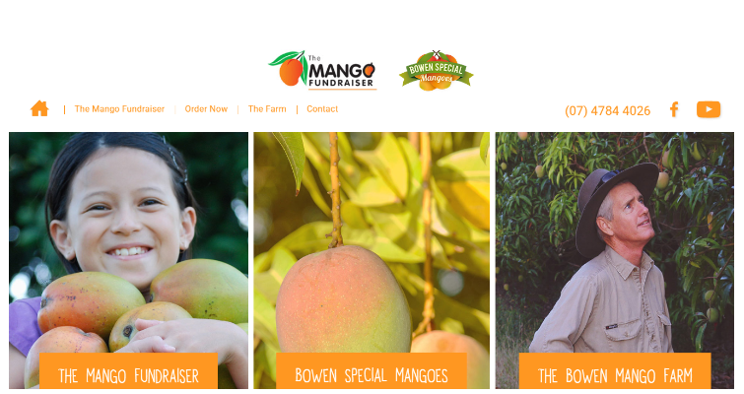

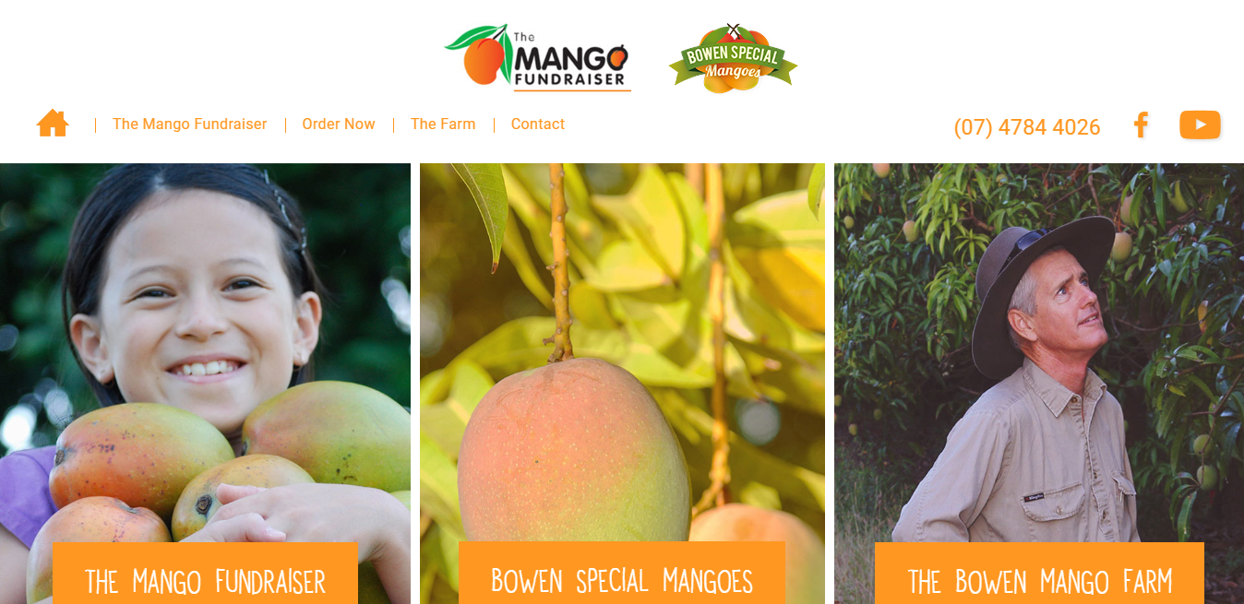

Figure 2.1: Mango Fundraiser

©Daffodil International University

4

**MANGOES MUMBAI**

Mangoes Mumbai brings you Original Ratnagiri Alphonso Mangoes directly from farms to your doorsteps. All our mangoes are 100% Chemical free and Naturally ripened. These mangoes are grown in our family owned farms in Ratnagiri [2].The following figure 2.2 show that.

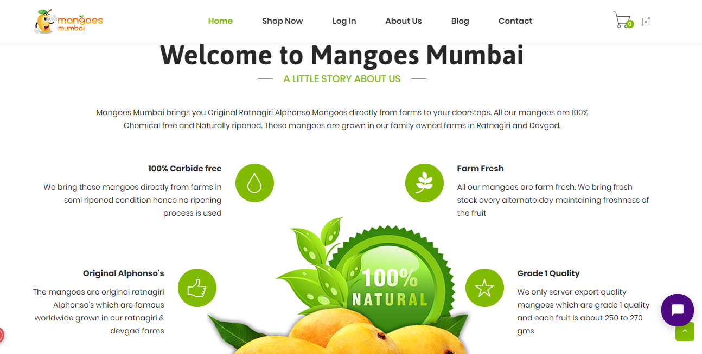

Figure 2.2: Mangoes Mumbai

**MANGOZZ**

Pakistan is amongst the largest producers of the world’s best mango which is liked all over the Globe for its aroma, color and taste. The main types of the Pakistani Mango Rawaayat deals in are Sindhri, Chaunsa, Anwer Ratol and Dosehri. [3]. Figure 2.3 shows Mangozz in Pakistan.

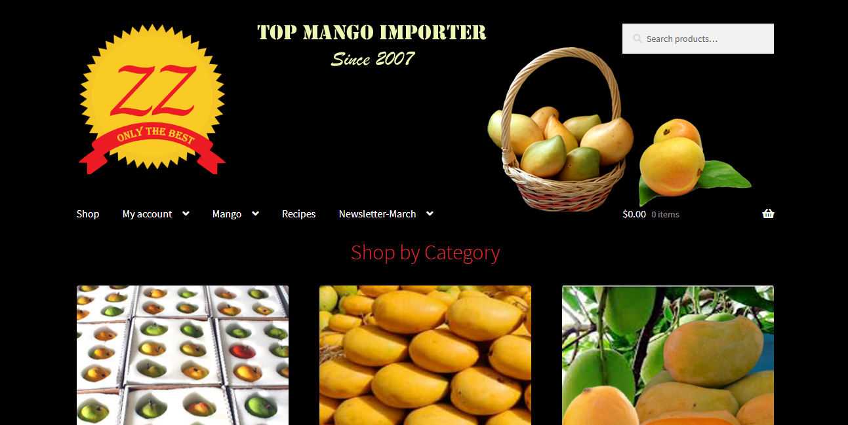

Figure 2.3: Mangozz in Pakistan

©Daffodil International University

5

**BIG BASKET**

Big Basket is same like mangoes Mumbai. They offer online to reduce prices of the mangoes. However, it is not free. In addition, they help refugee [4]. Here in figure 2.4 show the Big Basket.

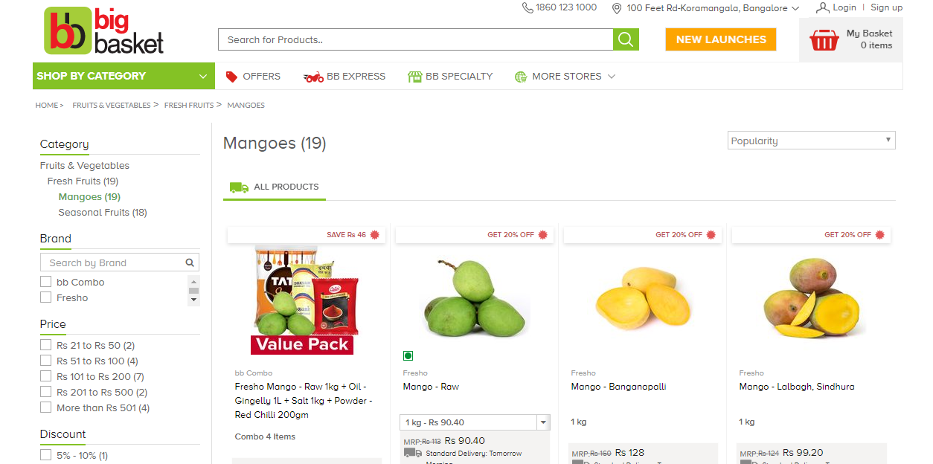

Figure 2.4: Big Basket

**2.3 Comparative Studies**

When we saw online buy and sale mangoes in website then we decide to make this. After that, we started to learn about online mangoes. After some days we realized every online project is similar. However, we think that we will make this project for buyer and seller whose directly connect between them. To make this project we study about online shopping and last php [8]. In our project we use to user portal, seller portal, admin portal, buyer portal. In user, portal user can registration. Admin can update picture, create users, update information, update different kinds of mangoes and admin can control whole system. Therefore, we think it is a complete project for online mangoes. It will be helpful for customer, buyer and seller. Here in table 2.1show that.

©Daffodil International University

6

Table 2.1: Comparison among current competition of First aid emergency

|  |  |  |  |  |  |
| --- | --- | --- | --- | --- | --- |
| Competitors | Can able to provide | Can be able search by | Can give any feature | | |
|  | any | skillet of the user? | of | appointment | |
|  | User search option? |  | system? |  |  |
|  |  |  |  | | |
| Web Portal | Yes | Most of those are not | Most of those are not | | |
|  |  | able | providing | | this |
|  |  |  | feature |  |  |
| Mobile app | Yes | Rare | Most of those are not | | |
|  |  |  | providing this feature | | |
| Social Media | No | No | Yes |  |  |
|  |  |  |  |  |  |

**2.4 Scope of the Problem**

* It is using by internet connect.
* Anyone can use this site for buying mangoes.
* The customer can easily buy using this site.
* The customers get free from mixed with formalin.

**2.5 Challenges**

When we started our project we faced many problems. We are unable to know many things. We had to learn some languages such like HTML, CSS, JAVASCRIPT, BOOTSTRAP, PHP and LARAVEL PHP FRAMEWORK. That was very challenging to learn those kind of languages.

* User friendly design.
* Security.
* Database design.
* Data information.
* Shop page design.
* Connect vendor with customer.

©Daffodil International University

7

**CHAPTER 3**

**REQUIREMENT SPECIFICATION**

**3.1 Introduction**

The purpose of the document is to collect and analyze all assorted ideas that have come up to define the system, its requirements with respect to consumers. Also, we shall predict and sort out how we hope this product will be used in order to gain a better understanding of the project, outline concepts that may be developed later, and document ideas that are being considered, but may be discarded as the product develops. It is to provide a detailed overview of our software product, its parameters and goals. This document describes the project's target audience and its user interface, hardware and software requirements. It defines how our client, team and audience see the product and its functionality.

**3.2 Business Process Modeling**

Business process models play a central role in describing, analyzing, improving, implementing, and monitoring business processes. They can serve as communication medium for professionals with different background and expertise, ranging from business administration, quality management and organizational development to process improvement, systems architectures and software development. The aimof this is toprovide a common understanding and a common language to improve the communication between these professionals during all phases of business process management of projects. This can introduces concepts of business process modeling using the business process Model and Notation industry standard. Participants will learn the elements of process models and their precise meaning [9]. Here figure 3.1 shows that -

©Daffodil International University

8

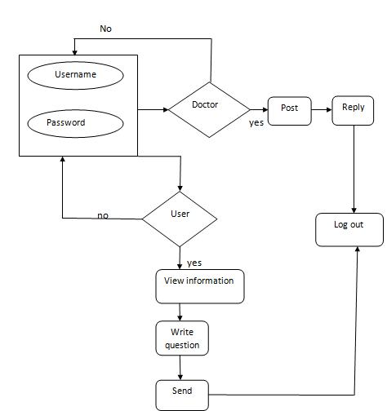

Figure 3.1: Data Flow Diagram of the propose system

**3.2.1 Waterfall Model**

The waterfall model is very important process which is step by step in life cycle. It is flowing such like water because this step is not back to previous step. The phase of requirement gathering, design &development, testing and implementation. Waterfall model figure is given bellow 3.2

©Daffodil International University

9

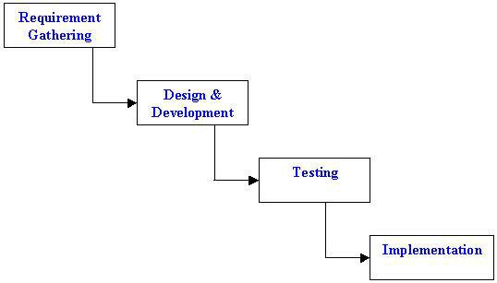

Figure 3.2: Waterfall Model process

**3.3 Requirement Collection and Analysis**

Requirement collection and analysis is one of the primary conditions of application development. For deployment, there are two types of requirements, one is the functional requirement and the other is non-functional requirement. Functional requirements are those activities that are the application software can perform. On the other hand, non-functional requirements define the personality of an application, as if the application is how much efficient, performance issue of the application and many more [10].

**Functional Requirement**

A functional requirement defines a function of a system or its component, where a function is described as a specification of behavior between outputs and inputs. A functional requirements use for login section, registration section. Dashboard contains of portion such as add information, create user, update seller etc

©Daffodil International University

10

**Non-functional Requirement**

Non-functional requirements are very useful for optimize performance. It specifies criteria that can be used to judge the operation of a system, rather than specific behaviors. For using this our application is load quickly very soon. Its UI are user friendly and very attractive user involvement.

**3.4 Use Case Modeling and Description**

Use casemodelling is a useful tool for requirements elicitation. It provides a graphical representation of the software system's requirements. The key elements in a use casemodel are actors, and the use cases themselves. We are using for advancement of a task or complex framework. Use case depictions list the segments of our undertaking slowly. The learner easily found the all data without much of a stretch locate on the undertaking. The model in the figure 3.3 shows that-

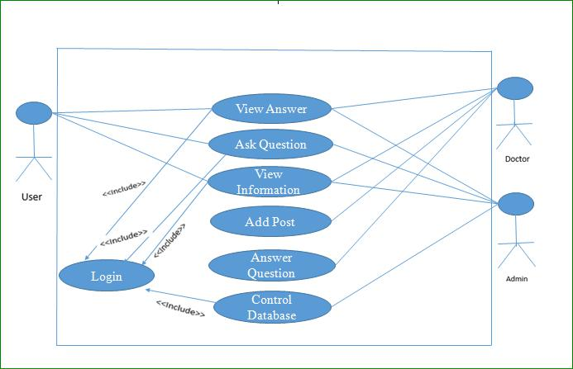

Figure 3.3: Use case diagram

©Daffodil International University

11

**Use Case Description**

A use case is a methodology used in system analysis to identify, clarify and organize system requirement [11]. The use case diagram describes in the table 3.1 to table 3.4.

Table 3.1: Use case description of Login

|  |  |
| --- | --- |
| Use Case | Login |
|  |  |
| Primary Actor | Admin |
|  |  |
| Secondary Actor | Null |
|  |  |
| Pre-Condition | Login |
|  |  |
| Scenario | Valid Username |
|  | Valid password |
|  |  |
| Post Condition | Login Successful or failed |
|  |  |

Table 3.2: Use case description of ask question

|  |  |
| --- | --- |
| Use Case | Ask question |
|  |  |
| Primary Actor | User, Seller, Buyer |
|  |  |
| Secondary Actor | Null |
|  |  |
| Pre-Condition | Login |
|  |  |
| Scenario | Additional information |
|  |  |
| Post Condition | Waiting for reply |
|  | View notification board |
|  |  |

©Daffodil International University

12

Table 3.3: Use case description of view information

|  |  |
| --- | --- |
| Use Case | View information |
|  |  |
| Primary Actor | User, Admin, Seller, Buyer |
|  |  |
| Secondary Actor | Null |
|  |  |
| Pre-Condition | Login |
|  |  |
| Scenario | Additional personal information |
|  |  |
| Post Condition | Information displayed successfully |
|  |  |

Table 3.4: Use case description of Control Database

|  |  |
| --- | --- |
| Use Case | Control database |
|  |  |
| Primary Actor | Admin |
|  |  |
| Secondary Actor | Null |
|  |  |
| Pre-Condition | View information |
|  |  |
| Scenario | Additional personal information |
|  |  |
| Post Condition | Check in Database |
|  |  |

©Daffodil International University

13

**3.5 Logical Data Model**

Logical data model has relational table named admin, seller, user and buyer. The relational model has showed in the following figure 3.4 .

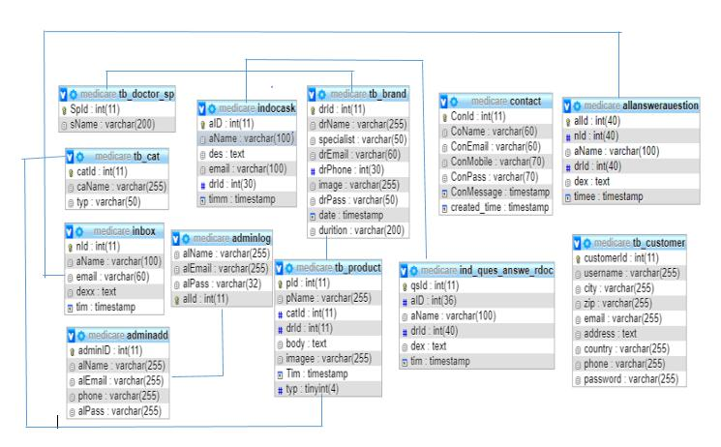

Figure 3.4: Relational Data Model

©Daffodil International University

14

**3.6 Design Requirements**

**Bootstrap**

Bootstrap is a web framework that focuses on simplifying the development of informative web pages. The primary purpose of adding it to a web project is to apply Bootstrap's choices of color, size, font and layout to that project. As such, the primary factor is whether the developers in charge find those choices to their liking. Once added to a project, Bootstrap provides basic style definitions for all [HTML elements](https://en.wikipedia.org/wiki/HTML_element). The end result is a uniform appearance for prose, tables and form elements across [web browsers](https://en.wikipedia.org/wiki/Web_browser) [12].

**JQuery**

JQuery is a fast, small, and feature-rich JavaScript library. It makes things like HTML document traversal and manipulation, event handling, animation, and Ajax much simpler with an easy-to-use API that works across a multitude of browsers. With a combination of versatility and extensibility, jQuery has changed the way that millions of people write JavaScript [13].

**PHP**

The term PHP is an acronym for PHP: Hypertext Preprocessor. PHP is a server-side scripting language designed specifically for web development. PHP can actually do anything related to server-side scripting or more popularly known as the backend of a website. For example, PHP can receive data from forms, generate dynamic page content, can work with databases, create sessions, send and receive cookies, send emails etc. There are also many hash functions available in PHP to encrypt user’s data that makes PHP secure and reliable to be used as a server-side scripting language. So these are some of the abilities of PHP that makes it suitable to be used as server-side scripting language.

©Daffodil International University

15

**PhpMyAdmin**

PhpMyAdmin is one of the most popular applications for MySQL database management. It is a free tool written in PHP. Through this software you can create, alter, drop, delete, import and export MySQL database tables. You can run MySQL queries, optimize, repair and check tables, change collation and execute other database management commands.

* Web interface
* MySQL database management
* Import data from [CSV](https://en.wikipedia.org/wiki/Comma-separated_values) and [SQL](https://en.wikipedia.org/wiki/SQL)
* Administering multiple servers
* Creating PDF graphics of the database layout
* Creating complex queries using query-by-example (QBE)
* Searching globally in a database or a subset.
* Transforming stored data into any format using a set of predefined functions.
* Live charts to monitor MySQL server activity like connections, processes, CPU/memory usage, etc.
* Working with different operating systems.
* Make complex SQL queries easier.

©Daffodil International University

16

**CHAPTER 4**

**DESIGN SPECIFICATION**

**4.1 Front-end Design**

All of those things are front end development (sometimes also called “front end web development”). While web design is the way a website looks, front end development is how that design actually gets implemented on the web. Meanwhile, a front end web developer is the person who does that implementation. Our project is also under of front end.

**4.1.1 My Home page**

The homepage is the main phage of our website. It has beautiful interface and easy to navigate. In the figure 4.1 shows the home page where have home, about, doctor portal, Q & A, ask a question and they have a search button.

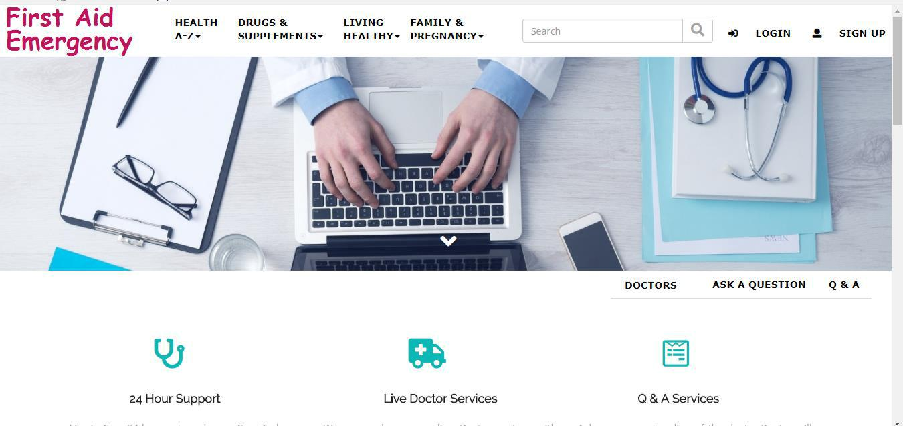

Figure 4.1: Home Page

©Daffodil International University

17

**4.1.2 User asking Question**

In our website user can see all post, all previous question, all information and also ask question .User can easily ask question and get question solve immediately. In the figure 4.2 shows the user-asking question.

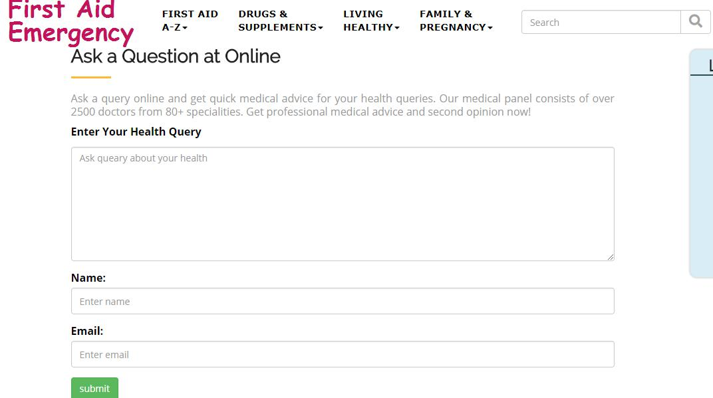

Figure 4.2: User asking Question

4.1.3 Doctor Portal

If the Doctor log in then he can see question. There have three options one is add problem description. Here the doctor can add reply then the doctor looking the question. Then he can answer the question when added then he can logout. In the figure 4.3 shows the doctor portal-

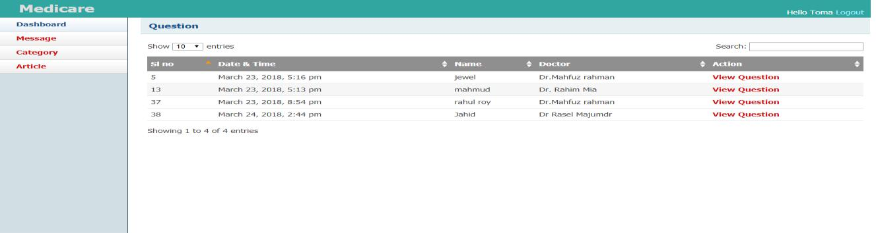

Figure 4.3: Doctor Portal

©Daffodil International University

18

**4.1.4 Admin Portal**

The admin can log in. and he have two options one is show all information it can see the all comments. Another is signup area. Here the admin can sign up for any doctor. In the figure 4.4 shows the admin portal.

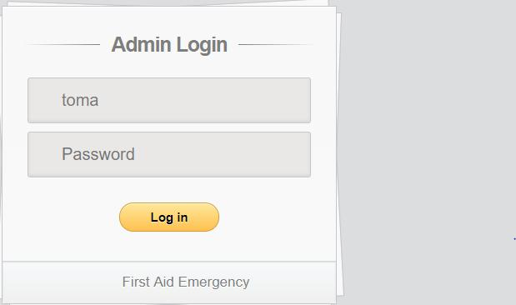

Figure 4.4: Admin Portal

**4.1.5 Check Question**

Here admin and doctor can see all the question .and then doctor can answer user s question.

In the figure 4.5 shows the check question.

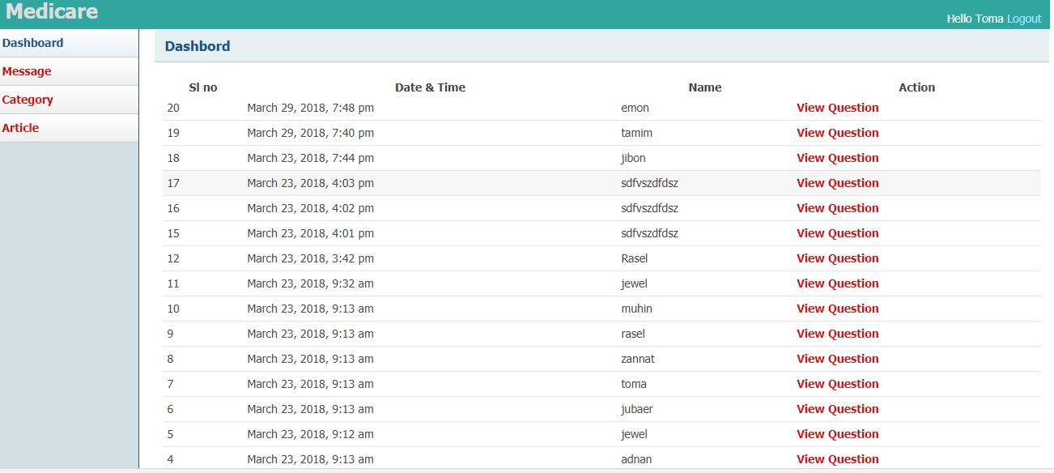

Figure 4.5: Check question page

©Daffodil International University

19

**4.1.6 View Doctor List**

Only admin can see this doctor list. In addition, he can edit or delete. In the figure 4.6 shows the saw doctor list.

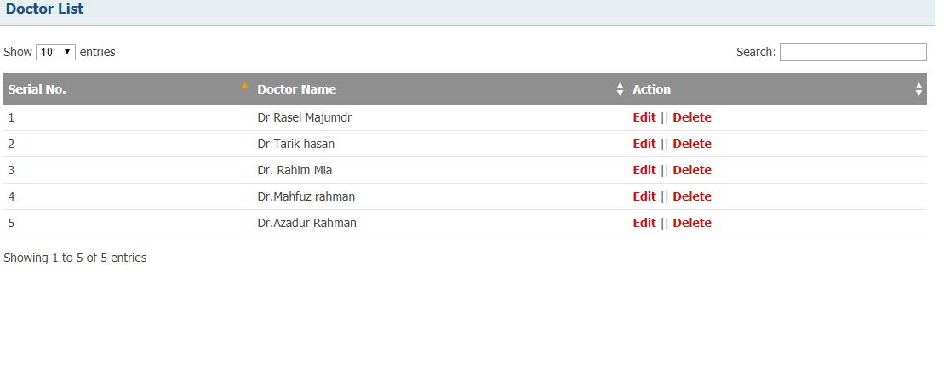

Figure 4.6: Doctor List page

**4.1.7 Add New Doctor**

Only admin can add new doctor in this software. Have to fill name, specialist, email, phone, image, password etc. In the figure 4.7 shows adding new doctor.

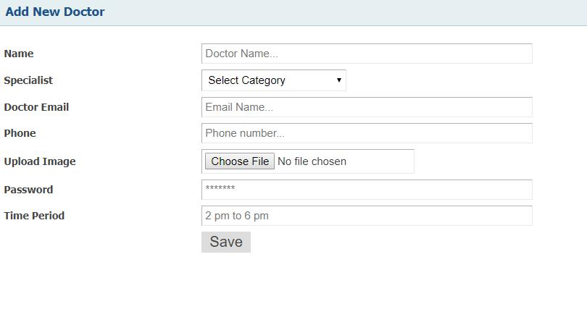

Figure 4.7: Add New Doctor

©Daffodil International University

20

**4.2 Interaction Design and UX**

Interaction design can be understood in simple (but not simplified) terms: it is the design of the interaction between users and products. After all, UX design is about shaping the experience of using a product, and most part of that experience involves some interaction between the user and the product.

**4.3 Implementation Requirements**

To implement this project, we are use software for online treatment system and use different kind of languages as like as HTML, CSS, BOOTSTRAP, JAVASCRIPTS, PHP and MySQL. In this project HTML, CSS, BOOTSTRAP, JAVASCRIPTS for font end and PHP and MySQL use to implementation design. Nonfunctional requirement defines the needs in terms of performance, logical database requirement design contains and reliability availability, security, maintainability and portability to implementation design [14].

©Daffodil International University

21

**CHAPTER 5**

**IMPLEMENTATION AND TESTING**

**5.1 Introduction**

Since the objective of this project is to develop and implement website system with social network flavor where users can buy or add items for trading at the comfort of their homes without barriers of stress, place and geographical location through the internet. Generally, the implementation of a system refers to the transformation of the system specification designed from the originally obtained requirement into program codes [15].

**5.2 Implementation of Database**

A database is a collection of information that is organized so that it can be easily accessed, managed and updated. Many database management tools are available now. There are Adminer, Firebird, SQuirrel SQL, SQLite Database Browser. These are very helpful for ours. High features and we can search many information at an early times.

**5.2.1 Database Table**

All the information are stored on the database table. When we have needed any information, we search and we see the result which comes from database table. The regulator works to control the database and secure from any irrelevant data.

©Daffodil International University

22

**5.2.1.1 Database for Question**

In the figure 5.1 show the question database. If the user creates question, then it can save here and all doctor when they are start to give answer then all question shown from this table

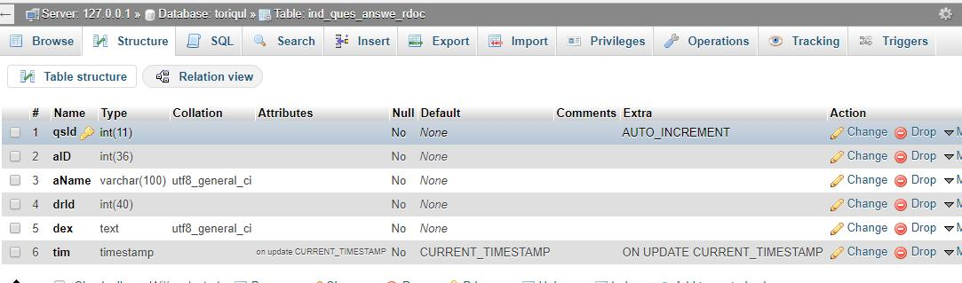

Figure 5.1: Database for question.

**5.2.1.2Database for Doctor**

In the figure 5.2 shows doctor database table. There has some attribute. Here have doctor id, login.

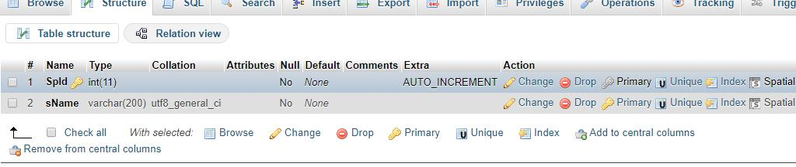

Figure 5.2: Database for Doctor

©Daffodil International University

23

**5.2.1.3 Database for search**

It will show the relevant result from the information. In the figure 5.3 shows the Database for search.

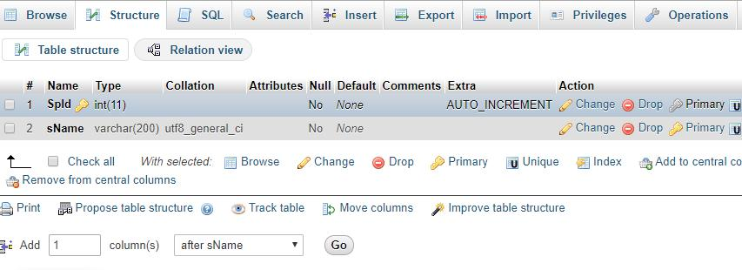

Figure 5.3: Database for search

**5.2.1.4 Database for Admin**

Here all activities related to maintaining a successful database environment. In the figure 5.4 shows the Database for admin.

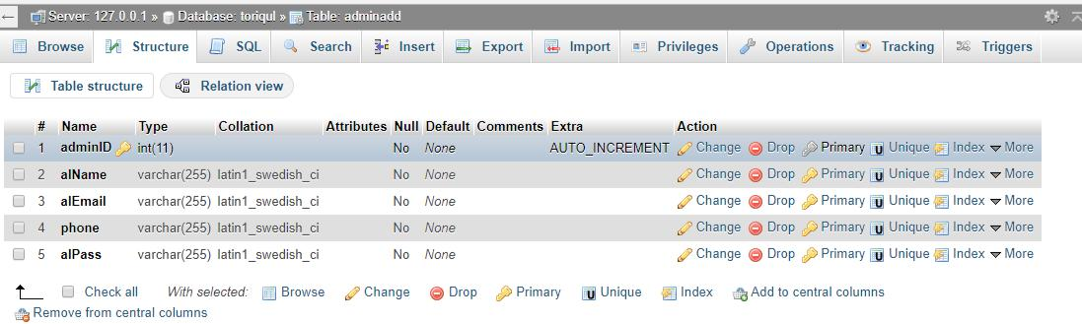

Figure 5.4: Database for Admin

©Daffodil International University

24

**5.3 Implementation of Front-end Design**

Front-end designs the first impression of a user. The first impression people cannot forget easily. That’s why we will try to make front-end design easy, good looking and user affable. We face some problems because every devices display are not same. We fixed our application for responsive every device’s display. Really that was very challenging. We make our application user responsive which is very easy and known to every users. We create this features with the help of HTML, CSS, and JavaScript and jQuery.

Implementation of front-end design are given below :

* + There are some kinds of users like admin, seller, guest and buyer.
  + Seller and buyer must be registered to required information.

**5.4 Implementation of Interactions**

The important part of the project is admin. Admin section control the whole system. In our project, the seller can buy mangoes with directly connect to the buyer. The buyer can get many kinds of mangoes using this website. They can payment money by online. Here is a blog site where people can discuss about mangoes. The buyer and seller have to register for buying and selling. The customer review system is included. The guest user also visit this website. Every part is connect with each other.

**5.5 Test Implementation**

To find errors we design a series of test case. We use software techniques to solve the error.

The test implementation is given below in table 5.1

©Daffodil International University

25

Table 5.1: Test Implementation

|  |  |  |  |  |  |  |  |  |
| --- | --- | --- | --- | --- | --- | --- | --- | --- |
| Test Case | Test Input |  | Expected |  | Actual |  | View | Date |
|  | Output |  | Output |  |
|  |  |  |  |  |  |  |
|  |  |  |  |  |  |  |  |  |
|  | Tested |  |  |  |  |  |  |  |
|  | browsers- |  |  |  |  |  |  |  |
| 1. Display the | Firefox |  | To display the | | Display | the |  |  |
| application | Google |  | pages |  | pages |  | Successful | 19-03-19 |
| pages | Chrome |  | successfully. | | successfully. | |  |  |
|  | Opera |  |  |  |  |  |  |  |
|  | Safari |  |  |  |  |  |  |  |
|  |  |  |  |  |  |  |  |  |
|  |  |  | To warn | that |  |  |  |  |
|  | Blank | or | username | or | Showed |  |  |  |
|  |  |  |  |  |  |  |  |
| 2. Username | incorrect |  | correct |  |  |  | Successful | 22-03-19 |
|  | username |  | username |  | the warning | |  |  |
|  |  |  |  |  |  |  |
|  |  |  | must enter |  |  |  |  |  |
|  |  |  |  |  |  |  |  |  |
|  | Blank | or | To warn | that | Showed | the |  |  |
| 3. Password | incorrect |  | password | or | Successful | 24-03-19 |
|  | warning |  |
|  | password |  | incorrect |  |  |  |  |
|  |  |  |  |  |  |  |
|  |  |  |  |  |  |  |  |  |
| 4.Test Case | Test Input |  | Expected |  | Actual |  | View | Date |
|  | Output |  | Output |  |
|  |  |  |  |  |  |  |
|  |  |  |  |  |  |  |  |  |
|  |  |  |  |  | Show | the |  |  |
| 5. Home | Click on | the | To show | the | homepage | of | Successful | 26-03-19 |
| Home button. | | homepage. |  | first | aid |
|  |  |  |  |
|  |  |  |  |  | successfully. | |  |  |
|  |  |  |  |  |  | |  |  |
|  | Log into |  | To see the |  | Showed the | |  |  |
| 6 Admin Portal | the |  | pending |  | user |  | Successful | 26-03-19 |
|  |  |  |  |  |
|  | admin |  |  |  | pending |  |  |  |
|  | dashboard |  | request |  | request |  |  |  |
|  |  |  |  |  |  |  |
|  |  |  |  |  |  |  |  |  |

©Daffodil International University

26

|  |  |  |  |  |  |  |  |  |
| --- | --- | --- | --- | --- | --- | --- | --- | --- |
|  | Click | on | the | To get |  | Get |  |  |
| 7.Seller Portal | seller | portal | | payment | Successful | 26-03-19 |
| payment |  |
|  | button. |  |  |  | successfully |  |  |
|  |  |  |  |  |  |  |
|  |  |  |  |  |  |  |  |  |
| 8.Test Case | Test Input | |  | Expected |  | Actual | View | Date |
|  | Output |  | Output |
|  |  |  |  |  |  |  |
|  |  | |  |  |  |  |  |  |
|  | Click on | |  |  |  |  |  |  |
|  |  |  |  |  |  | A pop-up |  |  |
|  | the how | |  |  |  |  |  |  |
|  |  |  |  |  |  | window |  |  |
|  | to use the | |  | To see the |  |  |  | 26-03-19 |
| 9.How To use |  |  |  |  |  | opens and | Successful |  |
|  | web |  |  | Instruction |  |  |  |  |
|  |  |  |  |  |  | shows some |  |  |
|  | application | |  |  |  |  |  |  |
|  |  |  |  |  |  | instruction |  |  |
|  | on menu | |  |  |  |  |  |  |
|  |  | |  |  |  |  |  |  |
|  | Click on | |  | To logout |  | Logged out |  |  |
| 10. logout | The Logout | |  | from that |  | Successfully | Successful | 26-03-19 |
|  | Button |  |  | account |  |  |  |  |
|  |  |  |  |  |  |  |  |  |
| 11. Buyer    Portal | Click on the  buyer portal  button | | | Add  To  Cart | | Add to  Cart  Successfully | Successful | 26-03-19 |

**5.6 Testing Result and Report\***

In this website when click doctor portal we can see login page. If doctor uses wrong password or user name, he cannot login. If doctor use correct user name and password then he can login. Only doctor can login in doctor portal. After login user can make question problem wise for doctor. After that user can ask question by. User can see search option. Then he/she can see particular problem, information and solution. User must need to select search and select. Then he /she get question. He/she can also see the recent update.

©Daffodil International University

27

**CHAPTER 6**

**CONCLUTION AND FUTURE SCOPE**

**6.1 Discussion and Conclusion**

The internet has become a major resource in modern business, thus online market has gained significance not only from the entrepreneur’s but also from the customers point of view. For the entrepreneur, online marketing generates a new business opportunities. It should be convenient for the customer to view the contents of their cart and to be able to remove or add mangoes to their cart. The number of features that are designed to make the customer more comfortable. This project helps in understanding the creation of an interactive web page and technologies user to implement it. During the course of the project, we have across the wide variety of problems and difficulties. We have learned the appropriate intricate working behind the dynamic website, how tricky data manipulation can be occurred sometimes but we have done everything. Successfully, the system has been designed in response to the system analysis. All possible error in the program have been eliminated. Necessary validation techniques have been used and normal, abnormal and extremely data was used to test the system.

**6.2 Limitation\***

Our application has some limitation. We will overcome this limitation in future. Some of the main limitations are-

* We implemented this application through local host; it should have a domain to access the website through the internet.
* Only develop for web application.
* Here Chance of missing a diagnosis.

©Daffodil International University

28

**6.3 Scope for Future Developments\***

However, we complete our project work but we have some plan for developed this work

* Our application’s data needs more storage in future, so we will add this with larger database system such as Oracle Database or Microsoft SQL Server
* Video calling with doctor
* We will add auto reply system.
* We will give an option for the user to request for appointment.
* Online training for first aid.

©Daffodil International University

29

**REFERENCES**

1. First Aid Bangladesh, [http://www.firstaid.com.bd/,](http://www.firstaid.com.bd/) last accessed on 26-02-2018 at 8:00am.
2. Mini First Aid, http://www.minifirstaid.co.uk/, last accessed on 16-02-2018 at 9:00am.
3. First Aid Uk, www.firstaid.org.uk,last accessed on 26-02-2018 at 8:00am.
4. Red Cross Org, https://www.redcross.org.uk/first-aid, last accessed on 6-03-2018 at 6:00pm.
5. Mayo Cliniq,https://www.mayoclinic.org/,last accessed on 16-02-2018 at 9:00am
6. Better health, https:,//www.betterhealth.vic.gov.au/,last accessed on 16-02-2018 at 9:00am
7. Medi plus,http://www.mediplus.co.uk/,/,last accessed on 16-02-2018 at 9:00am
8. Learn about php, available at [http://www.theprojectdefinition.com/php-hypertext-preprocessor/,](http://www.theprojectdefinition.com/php-hypertext-preprocessor/) last accessed on 5-03-2018 at 10:00pm
9. Business process model,, <https://open.hpi.de/courses/b93ba381-c3f9-4233-8424-f66eca8d4d8b,last> accessed on 4.4.2018 at 1.00am
10. Implementation requirements, available at [https://www.w3schools.com/,](https://www.w3schools.com/) last accessed on 5-04-

2018 at 1:00pm

1. Use Case diagram, https://en.wikipedia.org/wiki/Use_case, last accessed on 26-03-2018 at 8:00am.
2. Learn about bootstrap, available [athttps://en.wikipedia.org/wiki/Bootstrap_(front-end_framework),](https://en.wikipedia.org/wiki/Bootstrap_(front-end_framework)) last accessed on 25-03-2018 at 12:30pm.
3. Lean about jquery, available at [https://jquery.hackpad.com/,](https://jquery.hackpad.com/) last accessed on 2-03-2018 at 8.00pm
4. Implementation requirements, available at [https://www.w3schools.com/,](https://www.w3schools.com/) last accessed on 2.1.2018 at 8.00am
5. About implementation available <https://www.coursehero.com/file/p6ov0fc/value->interactions-over-Processes-and-tools-Working-software, last accessed on 2-04-2018 at 11:00am.

©Daffodil International University

30

**Plagiarism Report**

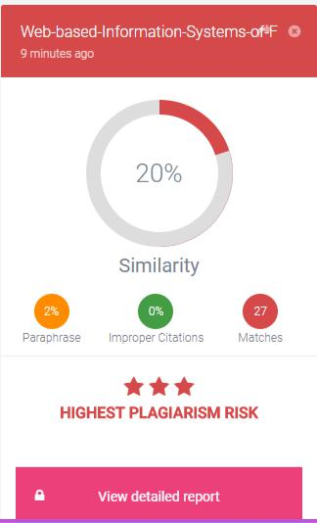

©Daffodil International University

31