**Cmp-SCI-5012**

**Project 2**

Author-Ashwini Malgave

Enterprise Web Development

Project Purpose- Select Math Questions for Offline Reading.

**OUTPUT:**

1. **User Interface:**

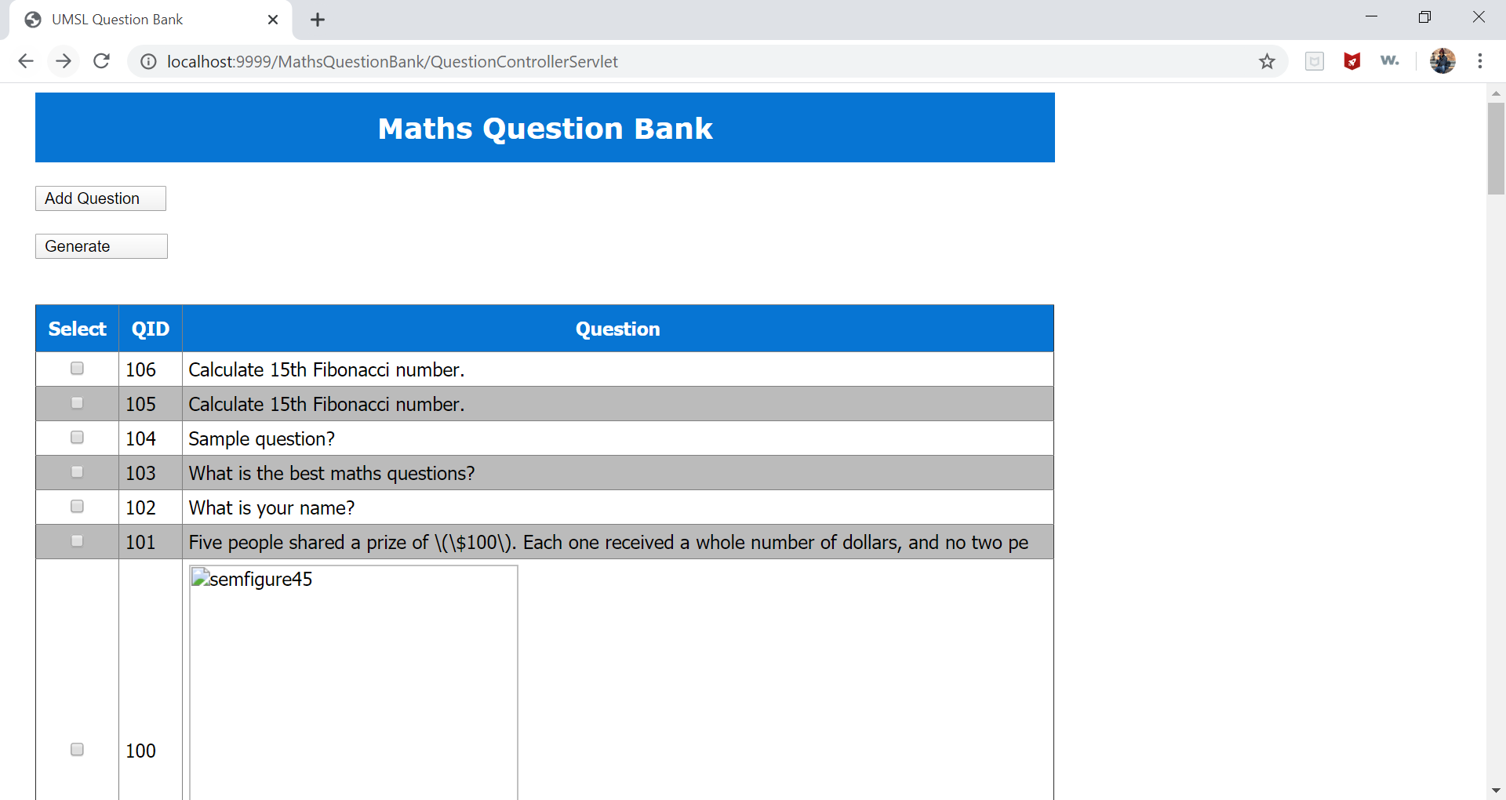

**2)All the questions are displayed in a reverse order and newly added questions will be displayed at top:**



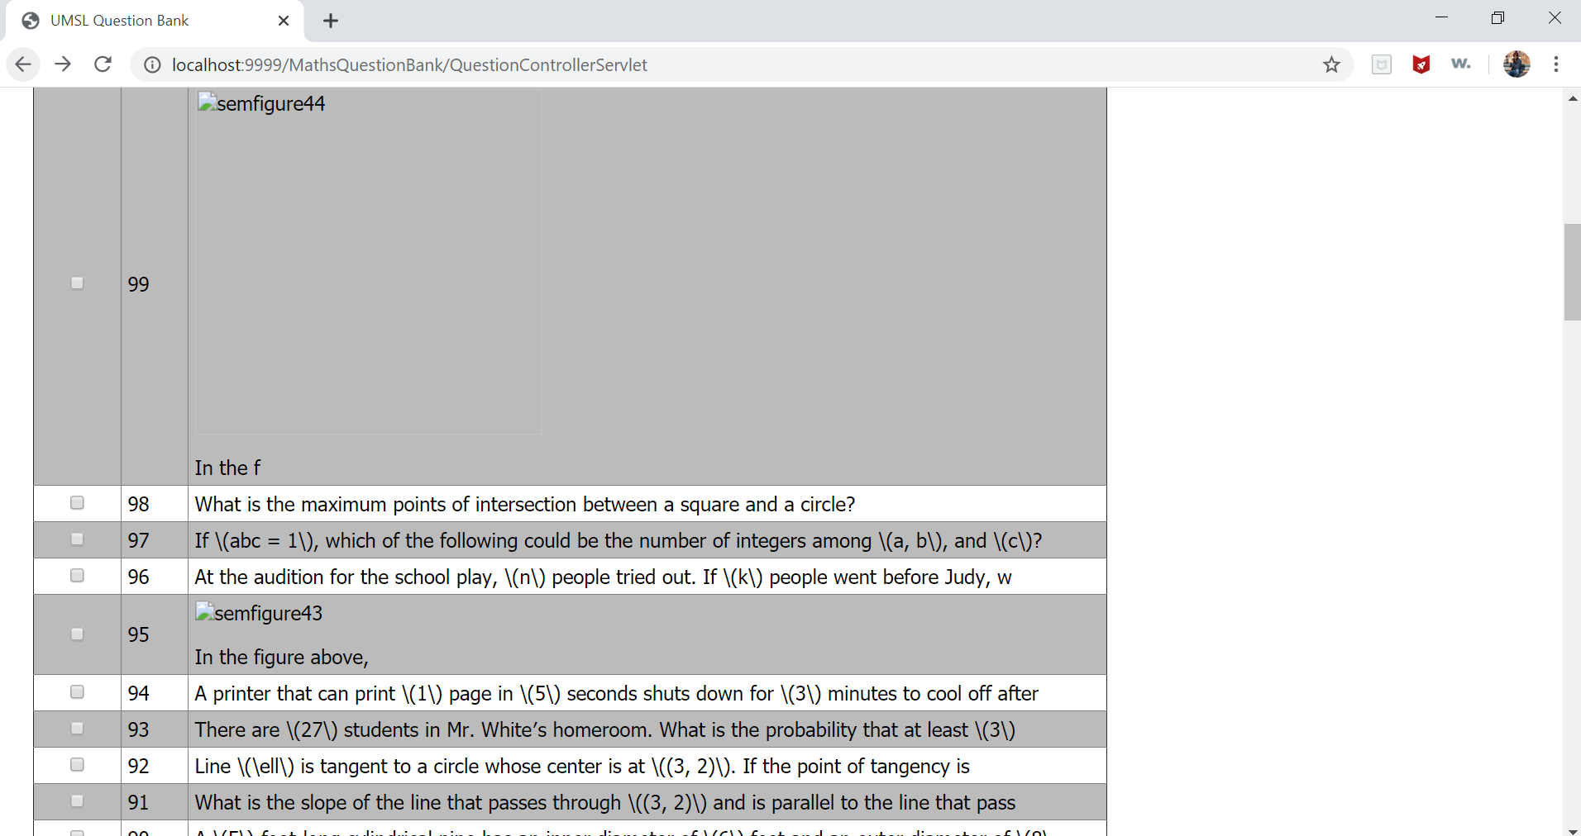

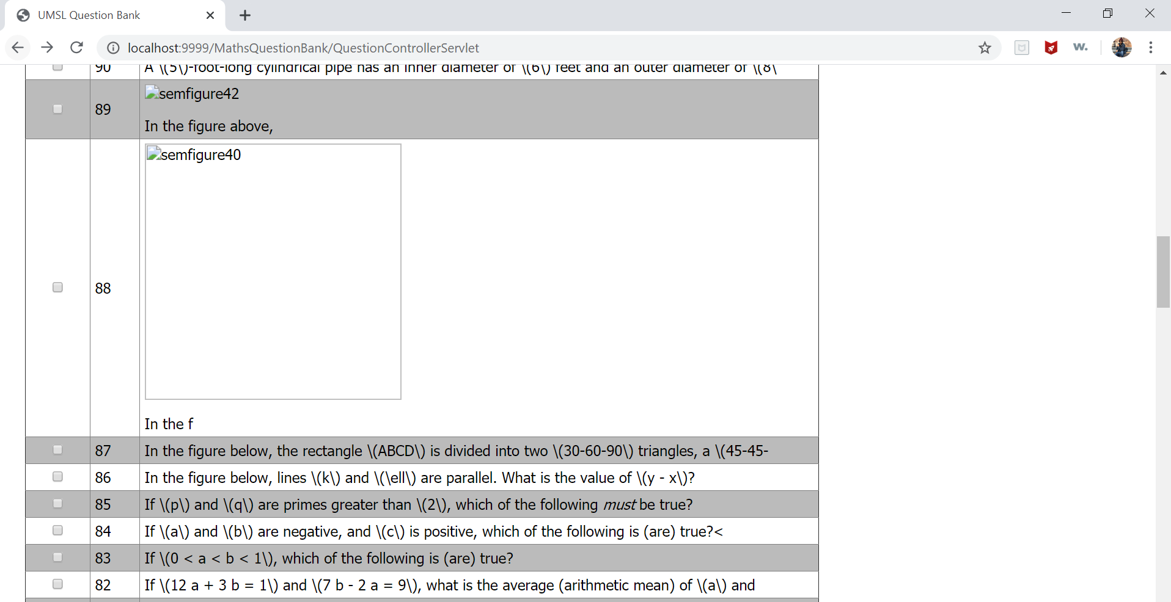

**.Questions continued till question 1……**

**.**

**.**

**.**

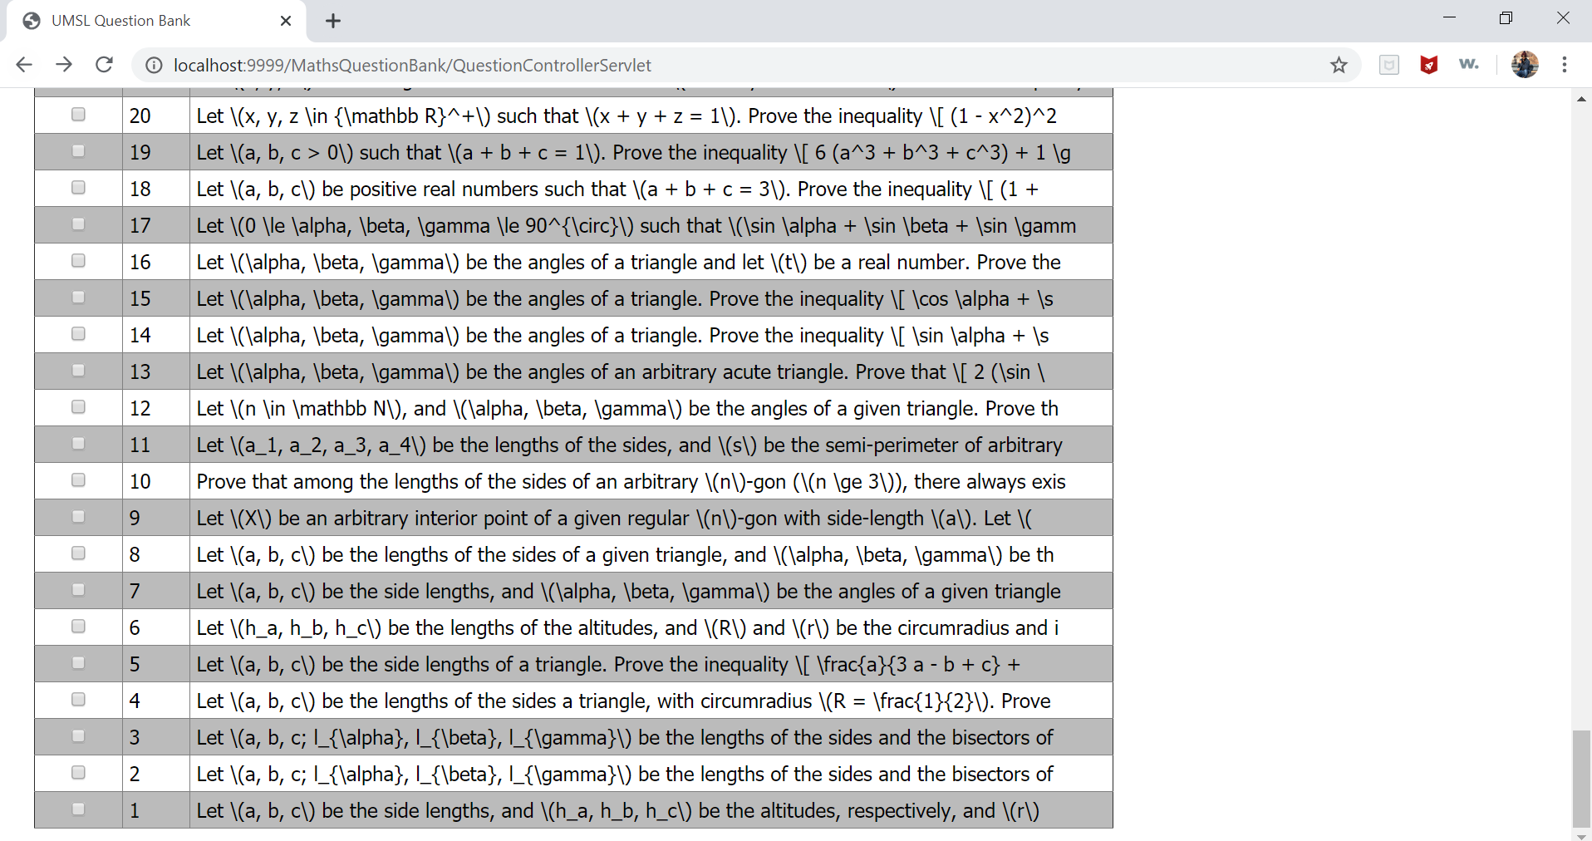

**3)Add new question and Validation**

**After clicking on Add Question button the textarea becomes available for adding new question.**

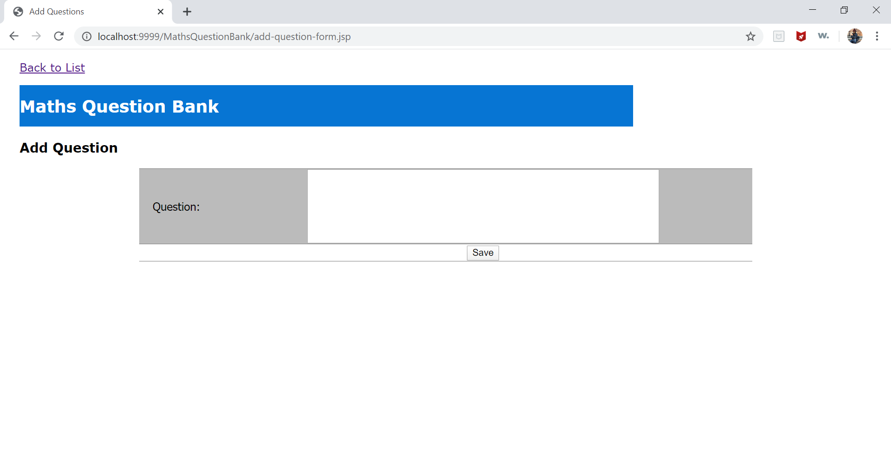

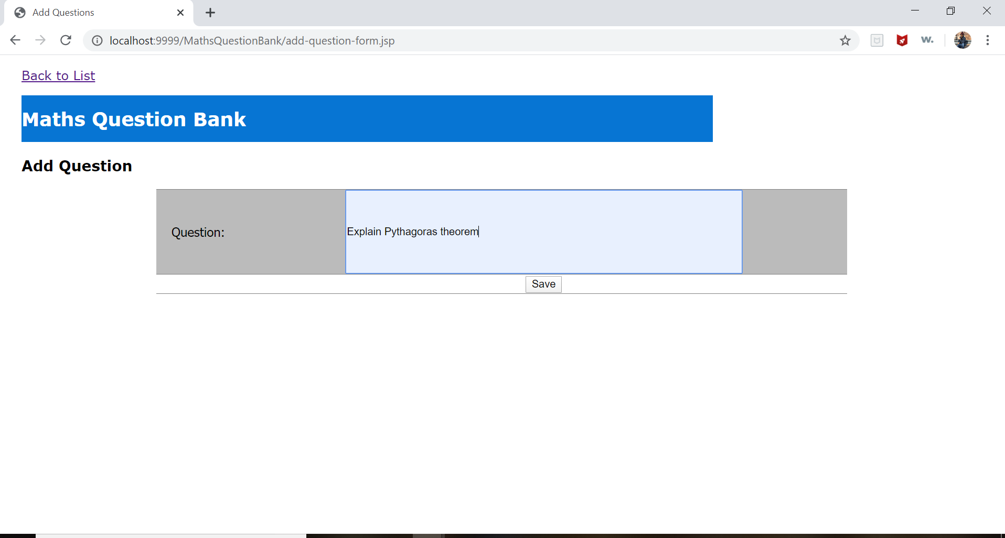

**After clicking on Save ,a question is added into a list and database:**

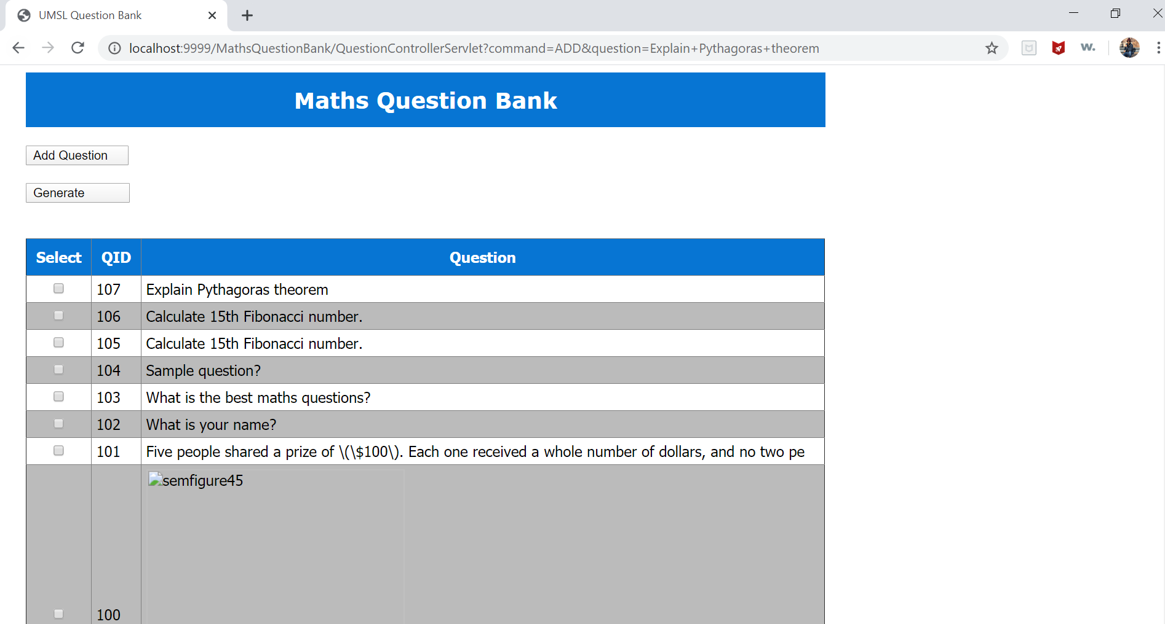

If a Question field is left empty and try to save the question ,it will give error.

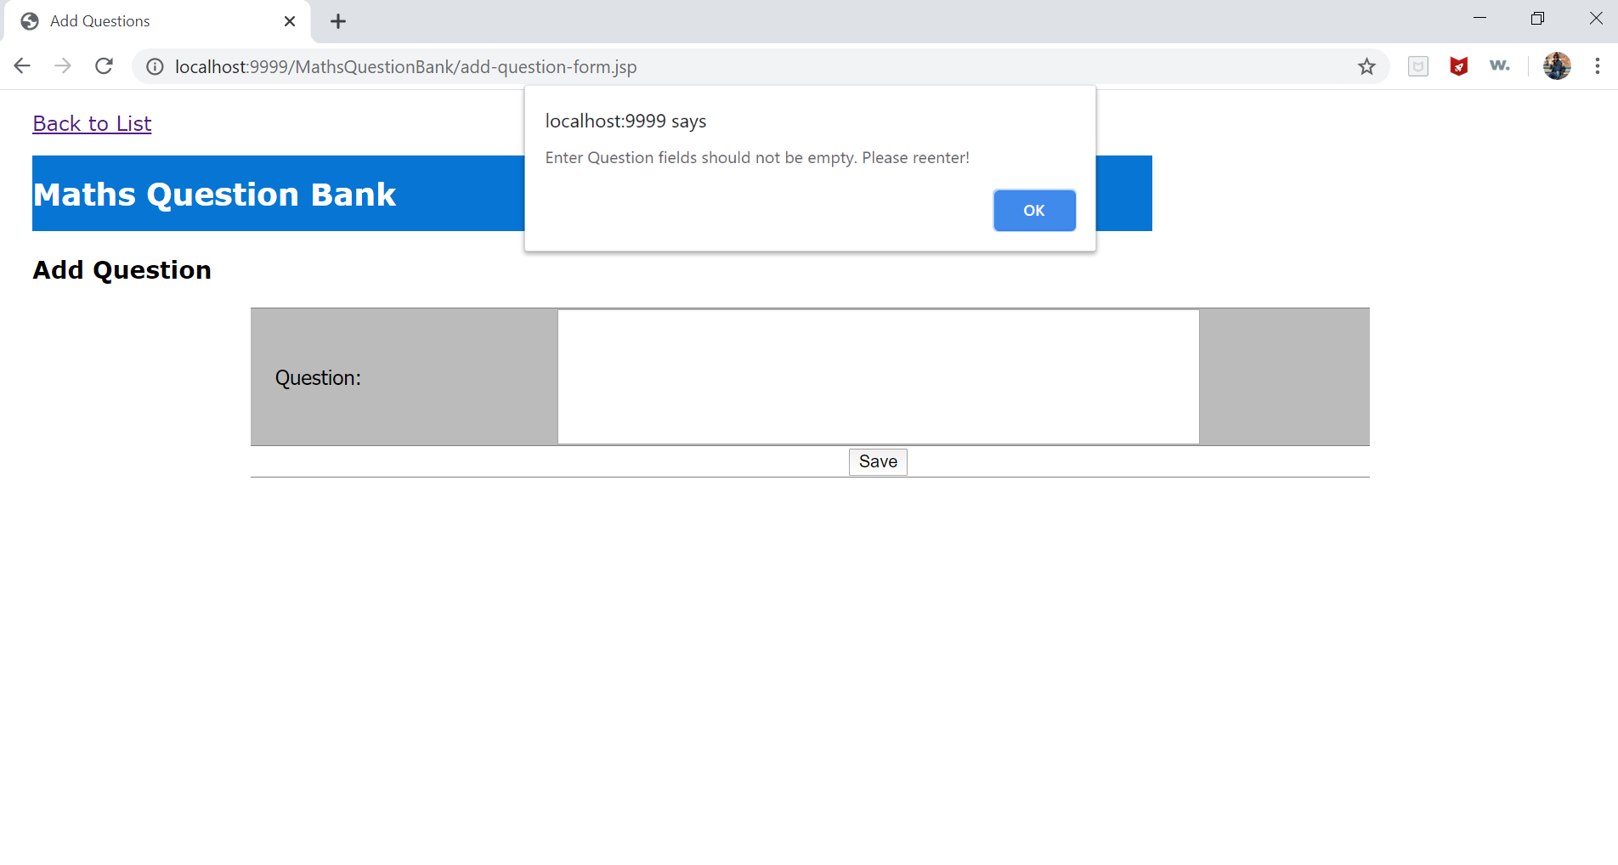

4)Selection

Selected problems: Checkboxes are provided for problems selection. User can deselect the problem by unchecking the checkbox.

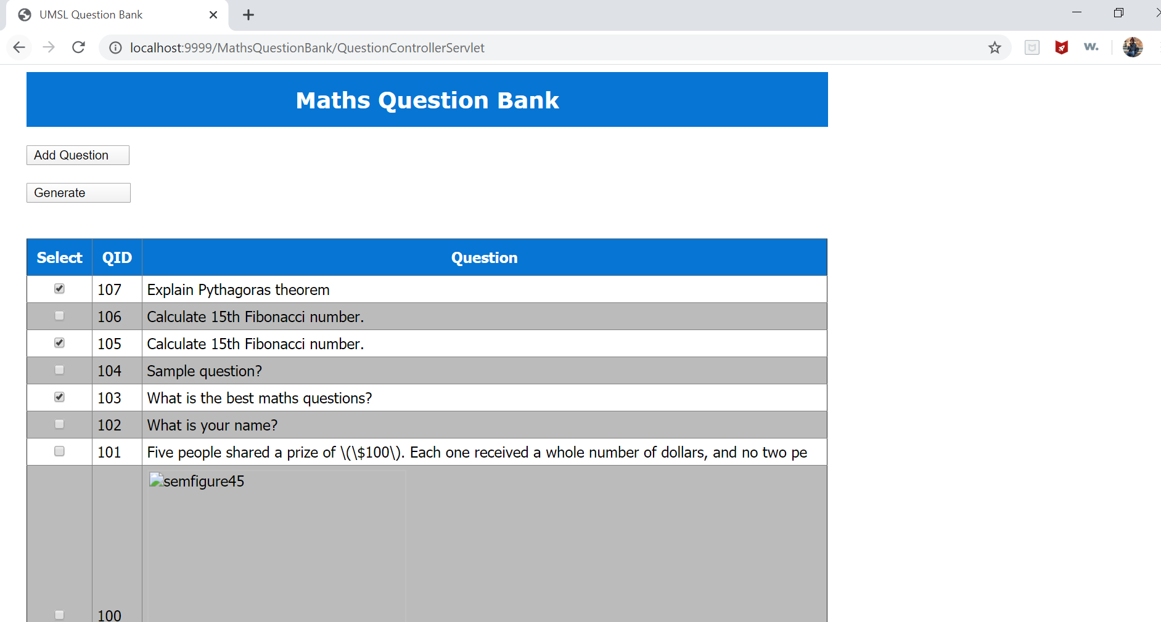

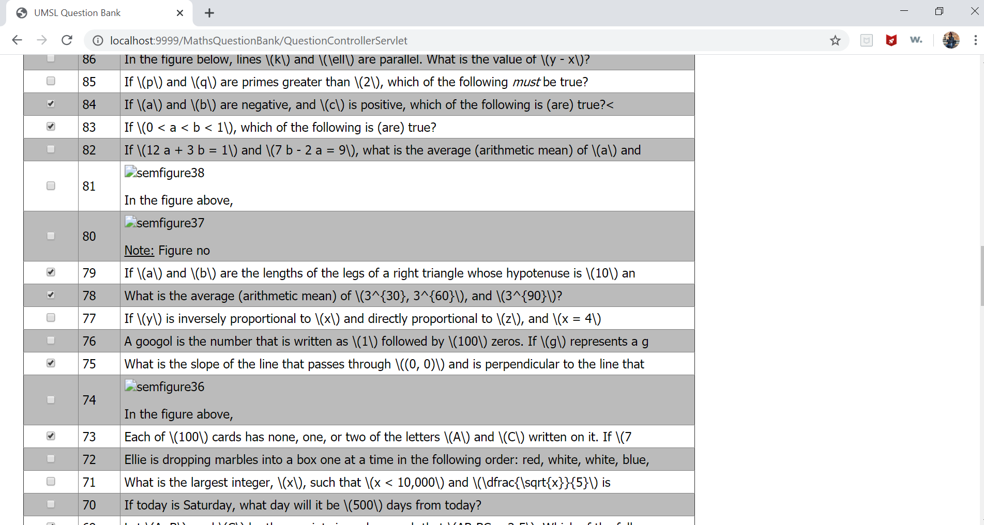

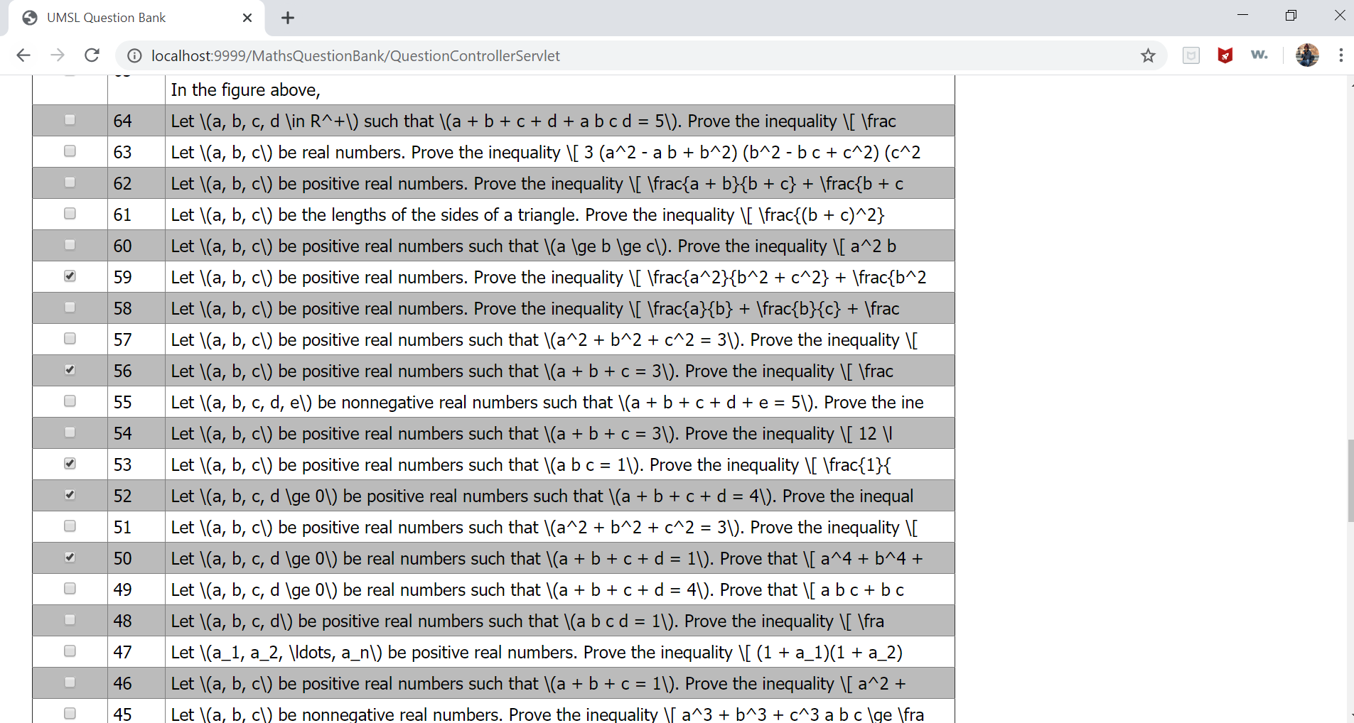

1. **Generate:**

After clicking on **Generate**, Selected questions will be displayed on different Html page.

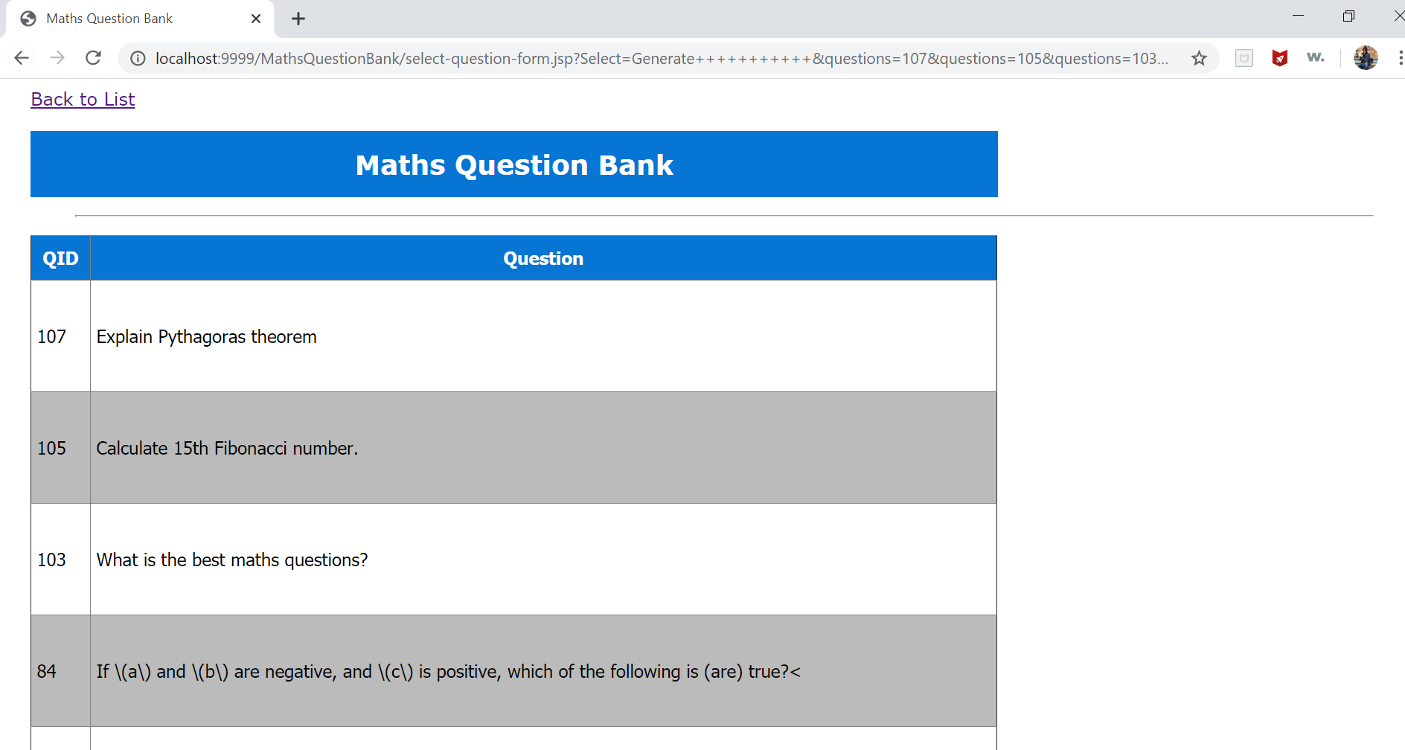

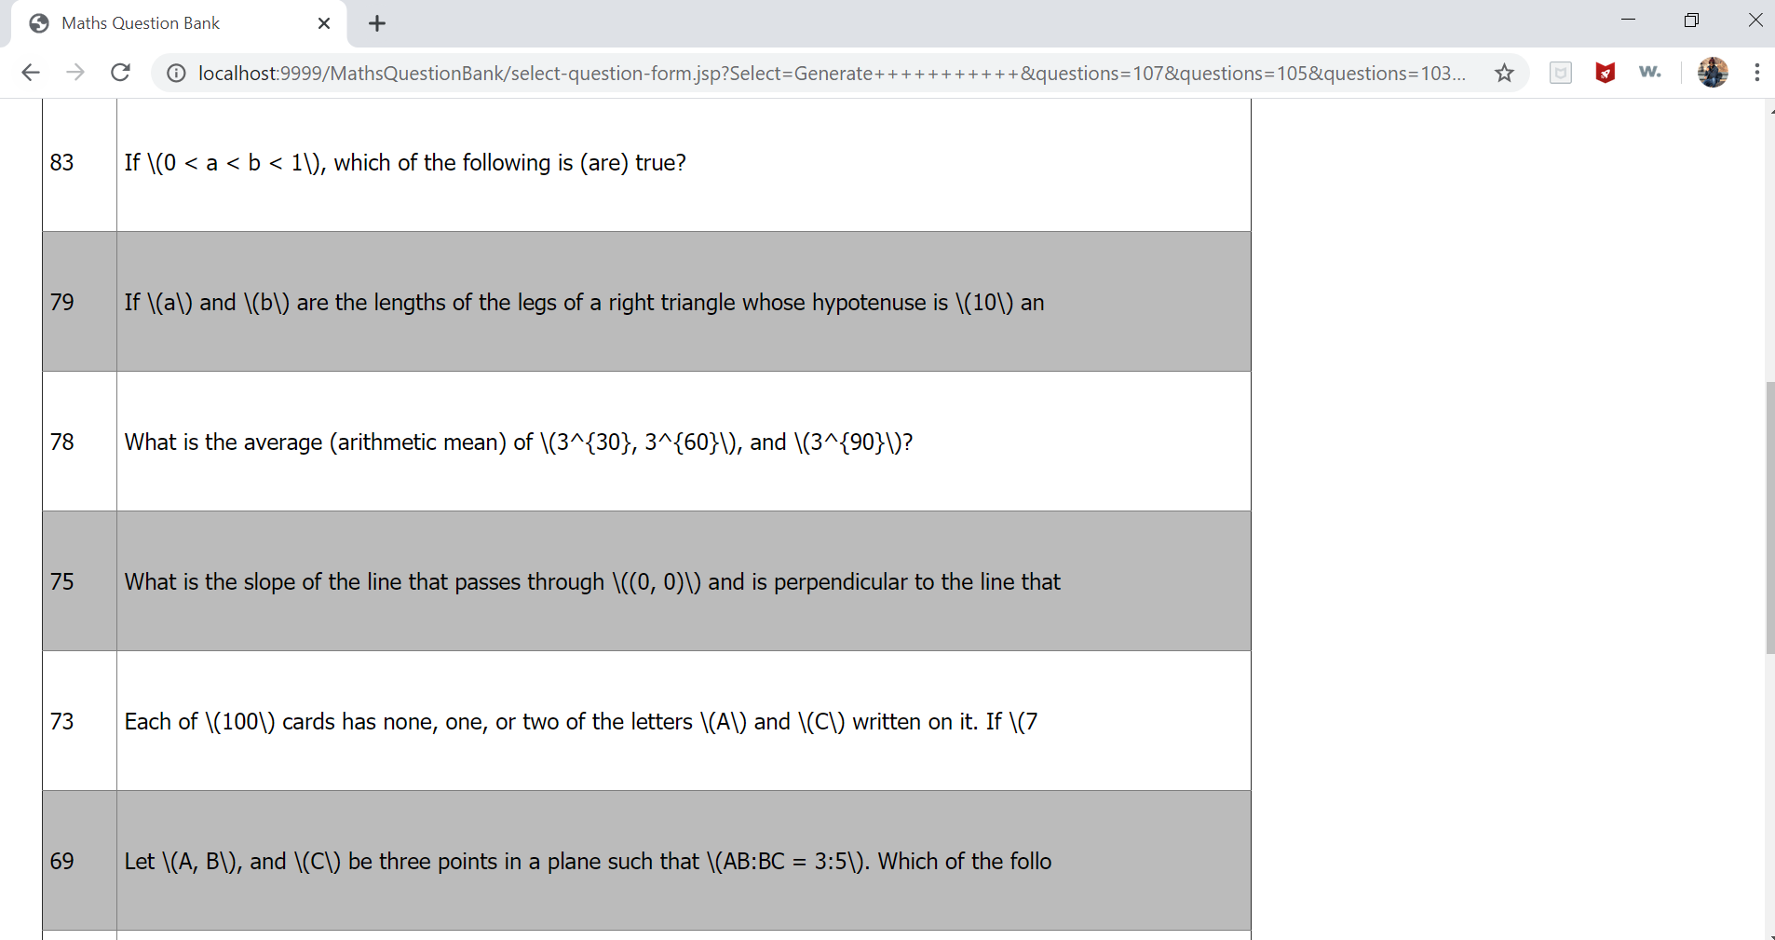

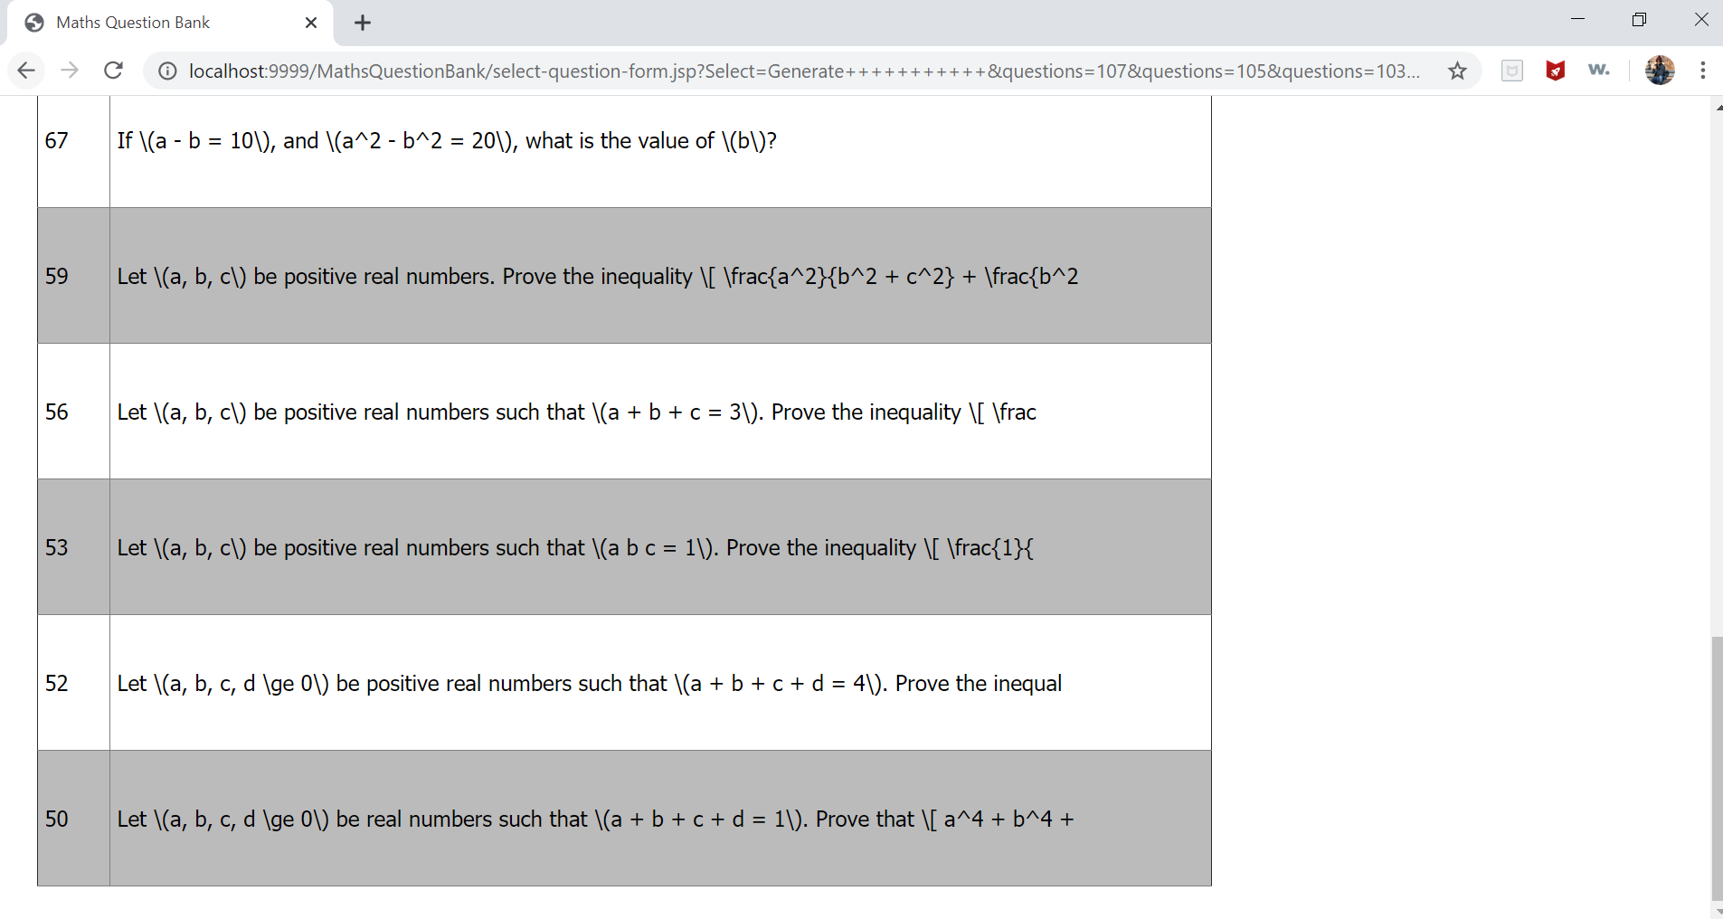

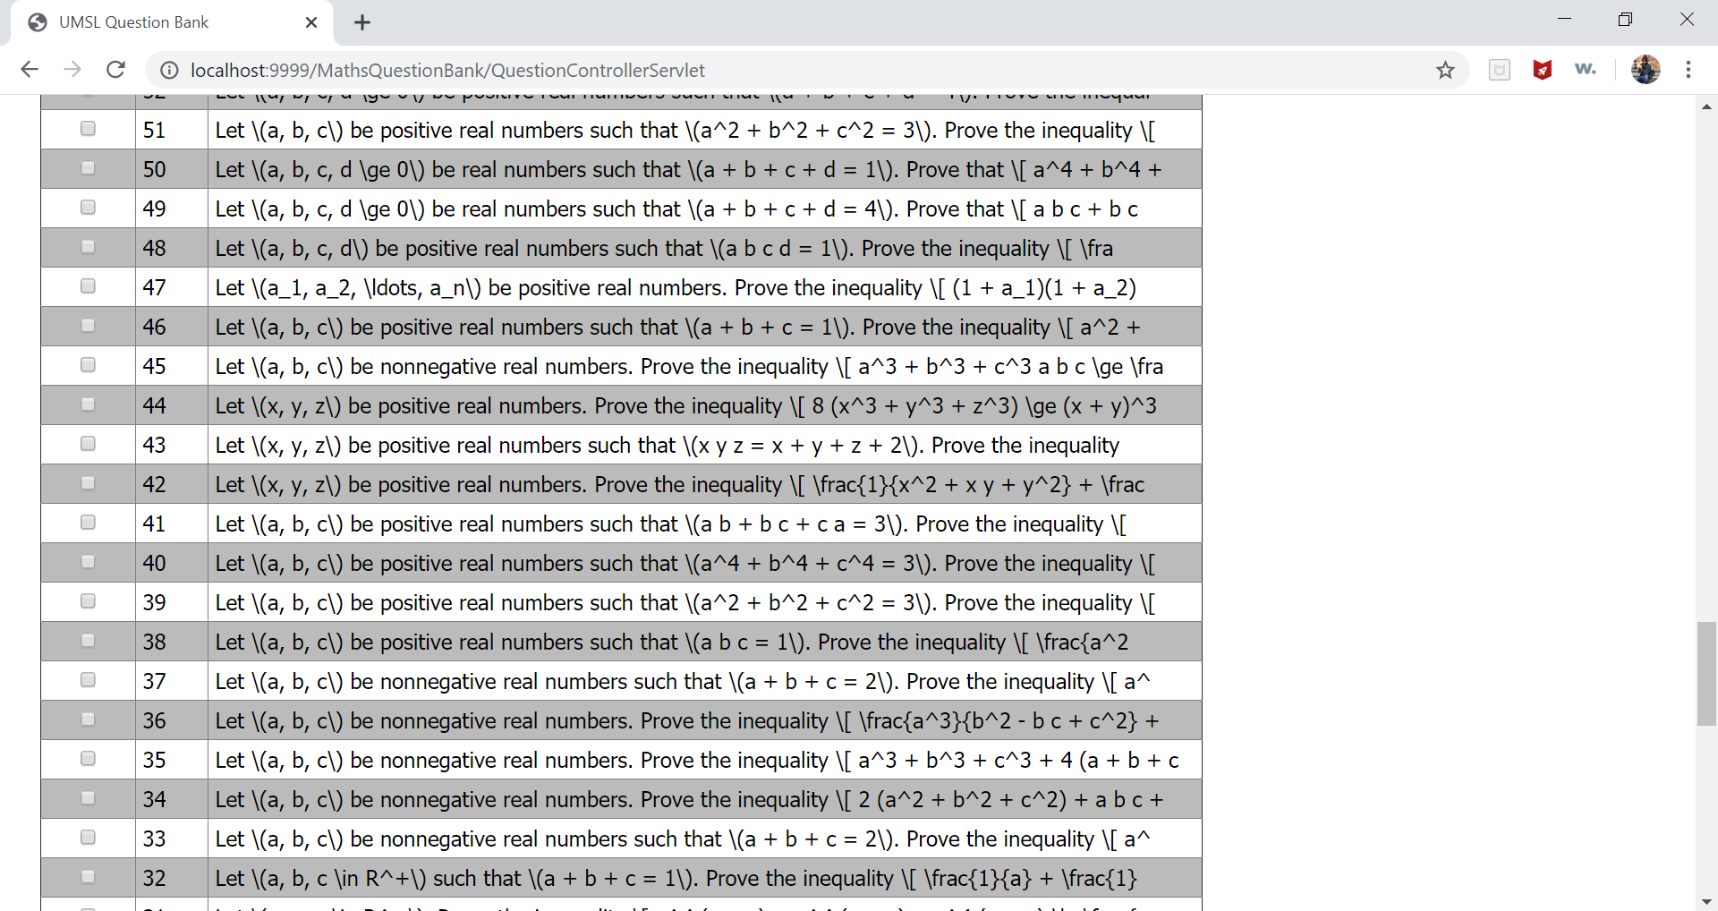

After clicking on Back to List ,main page of Maths Question appears.

Previous selection will get cleared(unchecked).

