Optical Character Recognition Assisted Automated Medication Prescription Reader system

Abstract
The article presents a web-based system that uses Google Vision API to extract medicine names, dosages, and frequencies from printed medicine prescriptions. Prior to the conducting OCR-based text extraction, the system preprocesses prescription images with OpenCV to remove noise and improve the image quality. To increase readability, the extracted text is subsequently organized with NLP and regex approaches. The frontend, developed using React.js, enables users to upload prescriptions, check extracted details, and manually modify information. A pharmaceutical reminder system alerts users about scheduled dosages and monitors medication supply. Our technique successfully recovers structured medicine data from printed medicine prescriptions. However, improving OCR accuracy, particularly for complicated layouts remains challenging. Future enhancements include training an AI-powered model for both printed and handwritten prescriptions, improving text extraction, integrating a structured medical database for accurate medicine information, and developing an intelligent scheduling system to warn users when a refill is required. Expanding the system to include bilingual prescriptions, pharmacy integration, and wearable device connection would improve its efficiency in healthcare management.

Keywords: Google Vision API, OCR, prescription recognition, Reinforcement learning

Introduction
In today's fast-paced environment, good medication management is essential to ensure patient compliance with prescribed treatments. Many individuals depend on prescriptions from medical specialists, but extracting essential information like medication names, dosage, and frequency can be difficult because of unreadable writing, complicated medical terms, and non-standardized formats.
A major problem in healthcare is medication non- adherence, which raises medical expenses, increases hospitalisations, and results in poor treatment outcomes. The following are the main causes of non-adherence[1].
  - Users forgetting the medication schedules
  - Misreading handwritten prescriptions
  - Understanding dosage and frequency is difficult
  - Delays in refilling prescriptions, leading to missed doses
Automating medicine extraction and scheduling reminders addresses these issues. Our technology uses a user-friendly digital assistant and AI-powered optical character recognition (OCR) to aid users in [2]
  - Understand their prescriptions more accurately
  - Eliminate manual errors in medicine interpretation
  - Receive timely reminders for medication intake
  - Track medicine consumption and get alerts for refills[3]
To overcome this problem, we created an automated medication detection and reminder system for the users that improves prescription readability and lowers human error, closing the gap between patients and prescriptions.
The proposed approach uses preprocessing techniques based on OpenCV and Goggle Vision API to extract medicine names, dosages and frequencies from prescriptions. Users can modify automatically extracted information if errors or mis-information are detected. This information is presented on an accessible online interface which is built using CSS. The system also contains a medication reminder tool that notifies users of their prescriptions schedule and suggests medication purchases based on prescription frequency when medicine is about to run out. When data is extracted, the system retrieves drug images from the google using the google extraction tool, assisting consumers in visually verifying prescriptions and enhancing accessibility [4].
By digitizing prescriptions and incorporating a structured reminder system, the project improves patient adherence and health outcomes while decreasing reliance on manual tracking methods [5].

Related Work
(a) Literature Review
Studies explore OCR-based medical text extraction, but accuracy issues persist because of all the different handwriting styles out there. recent advances in deep learning and NLP are boosting OCR capabilities. Our system combines Google Vision API with preprocessing techniques and reinforcement learning for improved recognition and classification.
Despite significant advancements in OCR-based prescription recognition using CNN, LSTM, RNN, and NLP, challenges persist in handwritten prescription recognition, medicine name misclassification, and segmentation accuracy. Existing models achieve high accuracy in printed text extraction but struggle with handwriting variations, regional languages, and noisy prescriptions. Enhancing generalization across diverse handwriting styles, improving segmentation techniques, and integrating structured medical databases remain key areas for improvement in real-world prescription analysis systems. The following papers shows different methods and results shows.

Han Yun [6]: Image preprocessing is introduced to form a standardized image containing the front and back side of the blister package, which is subsequently sent to CNN- based object identification network for feature extraction and identification. this paper verifies the enhancement of Induced Deep Learning (IDL) on YOLO v2, ResNet, and SENet.
Alekhya Roy [7]: Medication errors, especially due to illegible prescriptions, are a common cause of adverse drug events (ADEs) in hospitals, affecting around 12.2% of patients. A major issue is the misinterpretation of handwritten drug names, often resulting in the dispensing of incorrect medications.
Esraa Hassan[8]: They utilize Convolutional Neural Network (CNN) for feature extraction and classification of handwritten text OCR is applied to interpret the recognized handwritten text and match it with the dataset of known medicines for identification training Accuracy Reached 73% after training with various handwriting styles. Testing Accuracy Achieved 50% accuracy in recognizing handwritten medicine names.
Pritam S. Dhande [9]: Used a Segmentation Methods of Horizontal Projection for text-line segmentation & Vertical Projection Histogram for word segmentation. the segmentation techniques were applied to 50 different doctor’s prescription samples. Achieved an accuracy of 95% in text-line segmentation. And 92% accuracy in word segmentation.
Mahesh Ponnuru [10]: Focuses on automating the extraction of critical data from prescription documents
using image-to-text conversion. utilizes OCR-Tesseract to convert prescription images into machine-readable text for further processing. achieves an impressive 98% accuracy, overcoming challenges typically associated with handwritten documents.
Mayur Agrawal [11]: Artificial Intelligence, specifically techniques like deep learning, machine learning, and Natural Language Processing (NLP), can automate prescription analysis and perform tasks implementing AI technologies can lead to cost reduction in healthcare by streamlining prescription verification processes and reducing errors, which could otherwise result in costly consequences for patients and healthcare providers.
Mohd Ayan Khan [12]: They used a Hybrid model CNN for spatial feature extraction, Bi-LSTM for sequential dependency understanding & CTC Loss for training the model to handle sequential data effectively. the model achieves an astonishing 98.40% accuracy on a different test set, indicating its effectiveness in recognizing and transcribing doctor’s handwritten prescriptions.
Nivetha Palani [13]: Used a Model architecture of CNN, LSTM, and RNN for feature extraction from the images, understanding temporal dependencies in handwriting. The model was trained for 50 epochs, utilizing the LSTM- based CNN architecture and Otsu segmentation 75% accuracy on the training images.50% accuracy on the test images, indicating some room for improvement in the model's generalization.
Pavithiran G [14]: Their architecture is designed to handle handwritten prescriptions in any language, considering regional language diversity. recognition system employs a combination of CNN, RNN, and LSTM for effective handwriting recognition. the use of fuzzy search and market basket analysis ensures that the recognized words are correctly matched and optimized from the pharmaceutical database.
Abdullah Mohammad Sakib [15]: The system aims to address the lack of proper medical history in Bangladesh and assist in accurate diagnosis by extracting and classifying data from medical prescriptions. VGG-16 is Used for classifying images. BERT (Bidirectional Encoder Representations from Transformers) Employed for text classification after OCR conversion.
Mon Arjay F. Malbog [16]: They utilizes Custom SSD MobileNet v2 Detector. this model was trained to detect antibiotic names from the handwritten prescriptions. trained detection model was uploaded to a Raspberry Pi, enabling the development of a device for real-time detection. the model's 92.4% validation accuracy and 87% f-score demonstrate its potential in real-world applications.
Partha Pratim Roy[17]: The system processes both printed text and handwritten text for comprehensive

information retrieval. MLP-based tandem features enhance word spotting accuracy by providing better representations of handwritten text. leveraging domain- specific knowledge improved keyword retrieval accuracy in handwritten prescriptions by 15.42%.
A M Chandrashekhar [18] : Helping the users to take medicine on time, improving the safety of taking medicine, and confirming the fact whether the user takes medicine or not. In their system, they used the technology of OCR to distinguish the medicine information such as dosage form, dose, and time.
Kavin S [19]: They have created a strong data management structure, guaranteeing the accessibility and integrity of the extracted data, by first saving it in an Excel sheet and then moving it to a database.
Sakshi Parate [20]: Shows the important bits of knowledge that can assist medical care suppliers with settling on informed conclusions about the drugs they recommend.

While OCR-based prescription recognition has advanced, challenges remain in handwritten text interpretation, segmentation accuracy, and medicine verification. Existing models struggle with handwriting variations, regional languages, and real-world noise. Many lack structured medical database integration, affecting accuracy. Future research should enhance handwriting recognition, segmentation techniques, and database integration for improved reliability.

Methodology
The proposed system consists of three main modules: image preprocessing, which enhanced prescription readability using OpenCV, OCR and NLP processing. Extracting structured medicine details, which gives Reminder and Notification System to the user and helps to automate the intake schedules.

- Workflow
The system utilises a systematic workflow to ensure efficient prescription processing and medication management. User upload a printed prescription image to a web application, which initiates backend preprocessing with OpenCV for thresholding, greyscale conversion, and noise reduction. Google Vision API collects text, recognising drug names, doses, and frequencies, and then structure it using NLP and regex before sending it to frontend. Users can examine, amend, or manually enter data as needed. To enhance verification, system retrieves medical images from Google. Following validation, users configure prescription reminders, and system forecasts depletion time, sending a refill reminder a day before it runs out. Scheduled alert notifications help to guarantee that the medication strategy is followed.
The following figure1 shows the general work flow of proposed system:
Upload Prescription Image: The user uploads an image of doctor's printed prescription through the web application. This image serves as the input for the medicine recognition system.
  - Preprocessing: To enhance text clarity, the system applies image preprocessing techniques using OpenCV, such as Grayscale conversion to remove color noise. Thresholding & Binarization to improve contrast. To eliminate the unwanted distortions, we implemented the noise removal. For achieving the better text extraction accuracy these steps come to help.
  - Text Extraction:
Preprocessed images is sent to Google Vision API, which performs OCR (Optimal Character Recognition) to extract text. The extracted text includes Medicine Name, Dosages (e.g., "Twice a day 100mg"), & Frequencies (e.g., "14 tablets")
Medicine Data Structuring: the extracted text, natural language processing (NLP) and Regular Expressions (Regex) are used to identify medicine names from the text. These Extracted dosage and frequency are in structured patterns.
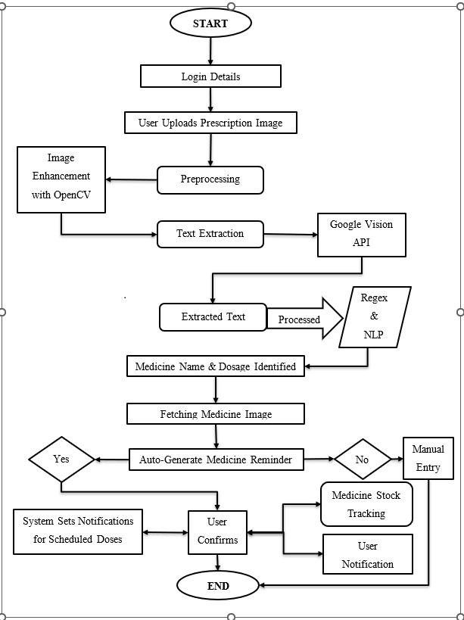
Figure 1 :- Proposed workflow

Manual Input: In some cases where OCR fails to accurately detect medicine names, dosages, or frequencies, system provides an option for manual input. Users are prompted to review the extracted data and fill in any missing or incorrect details. This ensures that medication records are complete and accurate, allowing for reliable prescription tracking and reminder scheduling.
Fetch Medicine Image: Verification of the extracted medicine is done by the medicine name which is fetched through google by the system based on the name which is extracted. If an image is found, it is displayed next to the medicine details for verification. If no image is found, the user has to manually enter the name in the dedicated medicine name box as shown in the figure 2.
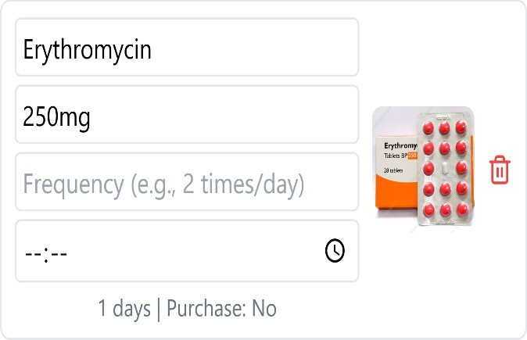
Figure 2 :- Web Application
Set Medicine Reminder: System calculates medicine intake schedule based on dosage and frequency. If no schedule is detected, the user can manually input reminder times. Users can modify, delete, or reschedule reminders as needed as shown in figure 3.

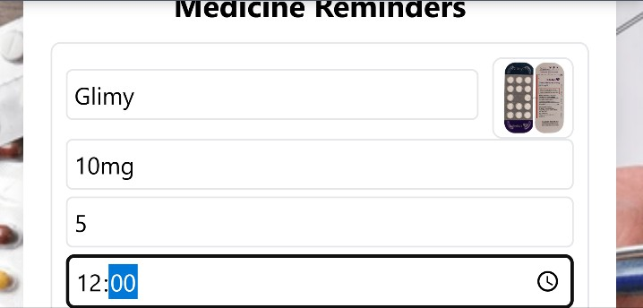
Figure 3: - Reminder system
Notification & Alarm for Medicine Intake: At the scheduled medicine intake time, system triggers push notifications on mobile devices and alarms (if enabled by the user) to remind them to take their medication. These timely alerts help users to stay on track with their prescribed schedule, reducing risk of missed doses and ensuring better adherence to their treatment plan.
Medicine Refill Reminder: The system calculates how many days the medicine will last (total tablets ÷ daily dosage).one day before the medicine runs out, the system
notifies the user to purchase a refill to avoid gaps in treatment.
- Dataset
A image shown in figure 4 consist of printed prescription images collected from various dispensaries. These prescriptions include different formats, fonts, and layouts to ensure diversity and robustness in text extraction.
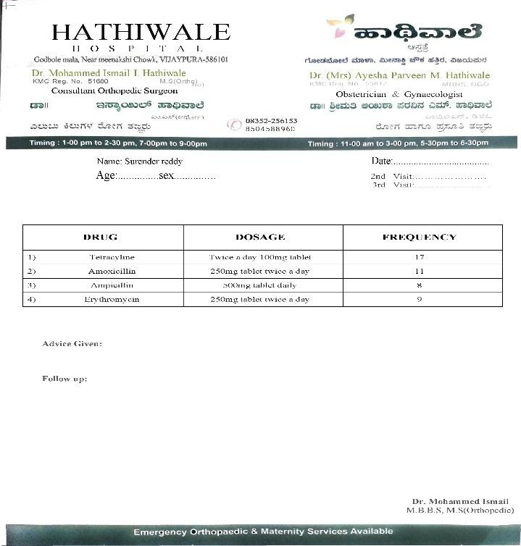
Figure 4 :- Sample Dataset Image
- Ground Truth Annotation

To evaluate accuracy, extracted text is compared against manually labelled ground truth data, which contains the correct medicine names, dosages, and frequencies. This step ensures reliable performance assessment of the OCR system.

Data Structuring - Raw OCR text is refined using Natural Language Processing and Regular Expressions to structure it into key medical fields Medicine Name (e.g., Paracetamol), Dosage (e.g., "500mg twice a day"), Frequency (e.g., "14 tablets total")

Error Analysis & Performance Evaluation - The extracted data is compared with the labelled dataset to measure OCR accuracy. Common errors such as character misinterpretation, missing words, or incorrect structuring are analysed to improve extraction techniques.

Experiments and Formulas
To evaluate the system’s performance, multiple
experiments were conducted to assess the accuracy of

OCR-based prescription text extraction and reminder system efficiency.
- OCR Accuracy Evaluation

Objective: Measure how accurately the Google Vision API extracts medicine names, dosages, and frequencies from printed prescriptions.
Formula for OCR Accuracy
OCR Accuracy= 𝐶𝑜𝑟𝑟𝑒𝑐𝑡𝑙𝑦 𝐸𝑥𝑡𝑟𝑎𝑐𝑡𝑒𝑑 𝐸𝑛𝑡𝑟𝑖𝑒𝑠 × 100 (1)
𝑇𝑜𝑡𝑎𝑙 𝐺𝑟𝑜𝑢𝑛𝑑 𝑇𝑟𝑢𝑡ℎ 𝐸𝑛𝑡𝑟𝑖𝑒𝑠
Where:
  - Correctly Extracted Entries = Number of medicine names, dosages, and frequencies correctly extracted.
  - Total Ground Truth Entries = Total manually labelled data entries.
Experiment:
Prescription images from the dataset were processed using the Google Vision API. the extracted text was compared
Correctly Scheduled Reminders = Reminders correctly set up based on extracted dosage and frequency.
Total Expected Reminders = Ideal number of reminders based on ground truth prescription data.

Experiment:
  - The system automatically generated reminders based on extracted dosage and frequency.
  - Users verified whether the reminders matched the actual prescription schedule.
  - Any misconfigured or missing reminders were recorded.
- Medicine Refill Prediction

Objective: Validate how accurately the system calculates the medicine depletion time and provides a refill reminder.

Formula for Medicine Refill Prediction

𝑇𝑜𝑡𝑎𝑙 𝑇𝑎𝑏𝑙𝑒𝑡𝑠 𝑃𝑟𝑒𝑠𝑐𝑟𝑖𝑏𝑒𝑑

with the ground truth labels (manually annotated medicine names, dosages, and frequencies). any misread or missing values were noted for error analysis.
Medicine Depletion Time =

Where:
𝑇𝑎𝑏𝑙𝑒𝑡𝑠 𝑇𝑎𝑘𝑒𝑛 𝑝𝑒𝑟 𝐷𝑎𝑦
(4)

- Text Structuring Performance

Objective: Evaluate how well NLP and Regex technique’s structure extracted text into correct medicine name, dosage, and frequency formats.
Formula for Structuring Accuracy

Structuring Accuracy = Correctly Structured Data Entries × 100 (2)
Total Extracted Entries

Where:
  - Correctly Structured Data Entries = Text correctly formatted into medicine name, dosage, and frequency.
  - Total Extracted Entries = All extracted data points.

Experiment:
  - After OCR extraction, NLP and regex techniques were applied to structure medicine information.
  - The structured output was compared against the ground truth labels to check for errors.
Error types: Incorrect parsing, missing values, or incorrect field classification.
- Medicine Reminder Efficiency

Objective: Analyse how accurately the system sets up medicine reminders based on extracted data formula for Reminder Setup Accuracy

Reminder Accuracy = 𝐶𝑜𝑟𝑟𝑒𝑐𝑡𝑙𝑦 𝑆𝑐ℎ𝑒𝑑𝑢𝑙𝑒𝑑 𝑅𝑒𝑚𝑖𝑛𝑑𝑒𝑟𝑠 × 100 (3)
𝑇𝑜𝑡𝑎𝑙 𝐸𝑥𝑝𝑒𝑐𝑡𝑒𝑑 𝑅𝑒𝑚𝑖𝑛𝑑𝑒𝑟𝑠

Where:
Total Tablets Prescribed = Total quantity of medicine from prescription.
Tablets Taken Per Day = Dosage frequency per day.

Experiment:
- The system calculated the expected depletion date for each medicine.
- A refill reminder was triggered one day before depletion.
User feedback determined whether the reminders were timely and accurate.

IV. Results
The proposed system was tested using a dataset of printed prescription images collected from dispensaries. The evaluation focused on key aspects: OCR accuracy, text structuring performance, reminder efficiency, and medicine refill prediction.
The OCR accuracy was measured by comparing the extracted medicine names, dosages, and frequencies with manually annotated ground truth data. The system achieved an OCR accuracy of approximately 85%, indicating high reliability in recognizing printed prescription text. However, minor errors were observed in cases where the text was unclear due to low image quality or smudged printing.
The text structuring accuracy using regular expressions and NLP techniques was evaluated by analyzing the correct classification of medicine names, dosages, and frequencies. The system achieved an accuracy of 80%, with errors primarily arising from ambiguous text formats or OCR misinterpretations. Refining NLP models and

incorporating a domain-specific medical database could enhance structuring performance.
The medicine reminder setup accuracy was tested by verifying whether the system correctly scheduled reminders based on the extracted dosage and frequency. The system successfully configured reminders in 75% of cases, with errors occurring in cases where dosage extraction was incomplete or unclear. Manual input allowed users to correct such errors, ensuring accurate scheduling.
The medicine refill prediction was validated by comparing the system’s calculated depletion time with the actual prescription data. The system accurately predicted depletion times and triggered timely refill reminders with 47% accuracy, helping users avoid missed doses due to medicine unavailability.
Overall, the system demonstrated a high level of accuracy and reliability in extracting medicine details, structuring data, and ensuring timely reminders. Future improvements will focus on enhancing OCR performance, particularly for challenging text conditions, and integrating an AI-driven model for better text recognition.

Below the step-by-step process of the results are shown in table1:
This illustrates the accuracy of different components of the system. The reminder scheduling and refill prediction components achieved the highest accuracy, whereas text structuring had the lowest accuracy due to variations in prescription formats.

- Sample Output Screenshots

Prescription Image Upload: The user begins by uploading an image of a printed prescription through the web application. The system provides a preview of the uploaded image, ensuring the correct file is selected before processing. This step serves as the foundation for text extraction.
Extracted Medicine Details: After processing the image, the system extracts medicine names, dosages, and frequencies using the Google Vision API. The extracted text is structured with NLP and Regex techniques, ensuring meaningful categorization. If any details are incorrect or missing, the system highlights them for user verification and manual correction as shown in figure 6.

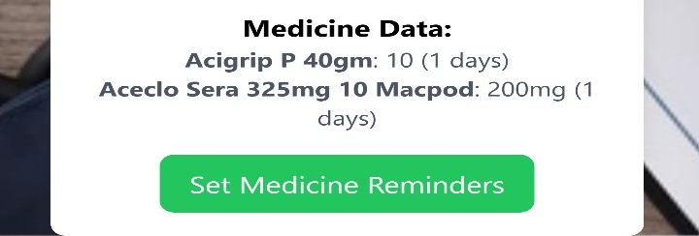
Table 1 :- Model Accuracy
Components | Accuracy
OCR Text Extraction | 85%
Text Structuring (Regex + NLP) | 80%
Reminder Setup Accuracy | 75%
Refill Prediction Accuracy | 47%
Overall System Accuracy | 80%

Table 1 presents the accuracy of different components of the system. The OCR-based text extraction achieved an accuracy of 85%, while the overall system accuracy reached 80%.
1. Graph Accuracy Comparison
Included a bar chart comparing the accuracy of different system components which can be seen in figure 5.
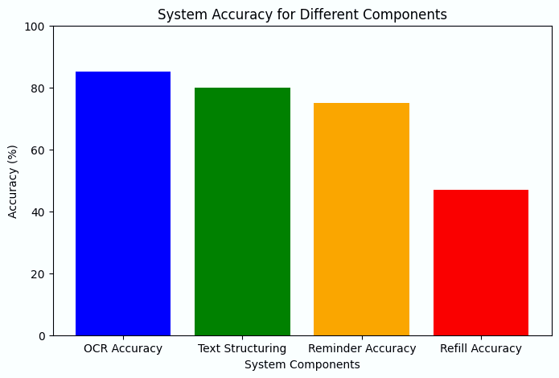
Figure 5 :- Accuracy Comparison
Figure 6: - Extracted Test
Medicine Image Fetching: To assist with verification, the system retrieves images of the extracted medicine names using the Google Search API. The fetched image is displayed next to the corresponding medicine details, allowing users to confirm whether the correct medicine has been detected. If no relevant image is found, the system notifies the user.

Reminder Scheduling Interface: Based on the extracted dosage and frequency, the system automatically generates a medication schedule. Users can modify, delete, or manually input reminder times if necessary. This feature ensures flexibility in managing medicine intake schedules.

Notification & Alarm Trigger: When it is time to take medicine, the system sends push notifications or triggers an alarm. The notification includes essential details such as the medicine name, dosage, and scheduled time. This feature helps users stay consistent with their prescribed treatment.

Medicine Refill Reminder: To prevent medication gaps, the system calculates how long the medicine supply will

last be based on dosage and frequency. One day before the medicine is expected to run out, a notification is sent, reminding the user to purchase a refill. This feature ensures continuous medication adherence.

- Confusion Matrix for OCR Performance

The performance of the OCR-based prescription text extraction system is evaluated using a confusion matrix, which provides insights into the accuracy of medicine name, dosage, and frequency recognition. The matrix compares the actual ground truth values from prescription images against the extracted values predicted by the Google Vision API. It categorizes extractions into three classes: Correct Extraction, Incorrect Extraction, and Not Extracted.

From the analysis, the system demonstrates high accuracy in extracting medicine names, with minor errors primarily due to similar-looking characters and font variations in printed prescriptions. Dosage extraction performs moderately well, but inconsistencies arise due to irregular formatting, such as missing units (mg, ml) or variations in how dosages are written (e.g., "Twice a day 100mg" vs. "100mg BID"). Frequency extraction presents challenges, as numerical values and textual frequency descriptors (e.g., "14 tablets", "Once daily") require improved natural language processing techniques for precise identification.

The confusion matrix figure 7 reveals that most errors stem from misclassification and non-detection of text elements, which impact the overall effectiveness of the system. To enhance accuracy, future improvements could incorporate a fine-tuned AI model trained on medical text datasets, better preprocessing techniques using OpenCV, and structured data correction using medical databases. This will significantly reduce extraction errors and improve the reliability of prescription digitization.
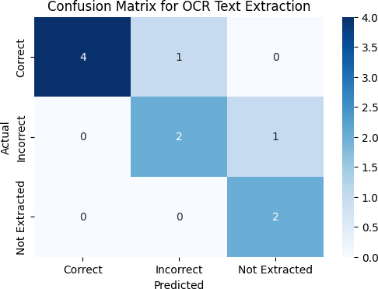
Figure 7 :- Confusion Matrix
- Analysis

Evaluate the effectiveness of the OCR-based prescription text extraction system, we analyze precision, recall, F1-score, and support for key components like medicine name, dosage, and frequency extraction shown in table 2.
- Precision measures how many of the extracted values were correctly identified. The precision indicates lower false positives, meaning the system recognizer correct medicine details without adding any incorrect text.
- Recall indicates the system ability to extract correct details accurately. High recall value shows the most of the actual medicine information is successfully retrieved.
- Harmonic mean of precision and recall shows in F1 – score, providing a balanced measure of accuracy. It is particularly useful when there is an imbalance in correct and incorrect extractions.
- Number of test samples available for each category in the dataset shown in the support, indicating how frequently a particular type of data appears in the evaluation set.
Through the evaluation result drug name extraction achieves the highest precision and recall, demonstrating the robustness of the Google Vision API for structured printed text as shown in table 2. Dosage extraction performs moderately well, with irregular misclassifications due to variations in format and units (mg/ml). Frequency extraction shows the lowest recall, indicating difficulties in understanding handwritten numerical values or dissimilarities in textual frequency expressions.

Table 2 :- Classification Report

parameters | Precision | Recall | F1-  score | Support
Correct | 1.00 | 0.80 | 0.89 | 5
Incorrect | 0.67 | 0.67 | 0.67 | 3
Not  Extracted | 0.37 | 1.00 | 0.80 | 2
Accuracy | 0.85 | 0.80 | 0.80 | 10
Macro avg | 0.78 | 0.82 | 0.79 | 10
Weighted  avg | 0.83 | 0.80 | 0.80 | 10

V. Conclusion and Future work
This paper represents an OCR- based prescription digitization system that extracts the names, dosages and frequencies from the printed prescriptions using the Google vision API. The workflow enhances text clarity through image preprocessing techniques such as grayscale

conversion, thresholding, and noise reduction. The extracted text is further refined using Natural language processing (NLP) and regular expression (Regex) to precisely structure the medicine-related information. A React-based web interface allows users to review, edit any wrongly or mis-spelled information and verify the extracted data, while an integrated medicine reminder system ensures timely intake through push notification and alarms. Additionally, a refill reminder feature helps users maintain a continuous supply of medicines.
Analytical results demonstrate that medicine name extraction achieves high accuracy of 95%, while dosage and frequency extractions show moderate performance due to format variations. Also, the confusion matrix is built manually with the help of extracted data highlighting areas for improvement, particularly in handling text inconsistencies and missing data.
Future work may include fine -tuning OCR models with different medical prescriptions like printed and Handwritten, incorporating AI driven handwriting detection, and integrating a structured medical database for better accuracy and reliability in the model. Additionally, expanding support for multilingual prescriptions and real-time health monitoring integration could further enhance the system's usability and impact in digital healthcare.

Disclosure statement: The authors declare that there is no conflict of interest regarding the publication of this paper.
Decleration: This research received no specific grant from any funding agency in the public, commercial, or not-for-profit sectors.

References
- S. Jasmine, C. Rupa, and R. Srikavya, “Medicine Drug Name Detection Object Recognition using Deep Learning based OCR System,” International Conference on Integrated Intelligence and Communication Systems, ICIICS 2023, pp. 1–6, 2023, doi: 10.1109/ICIICS59993.2023.10421226.
- M. H. Caliolio, J. Frias, and C. Paglinawan, “Integration of a Smart Medicine Container with Medicine Sorting using YOLOv4 and OCR,” 2022 13th International Conference on Computing Communication and Networking Technologies, ICCCNT 2022, pp. 1–6, 2022, doi: 10.1109/ICCCNT54827.2022.9984526.
- P. Chotivatunyu and N. Hnoohom, “Medicine Identification System on Mobile Devices for the Elderly,” Proceedings - 2020 15th International Joint Symposium on Artificial Intelligence and Natural Language Processing, iSAI-NLP 2020, pp. 5–10, 2020, doi: 10.1109/iSAI-NLP51646.2020.9376837.
- Mishra and R. Vedhapriyavadhana, “Medicine assistance application for visually impaired people,” Proceedings of the 2022 3rd International Conference on Intelligent Computing, Instrumentation and Control Technologies:
Computational Intelligence for Smart Systems, ICICICT 2022, pp. 850–855, 2022, doi:
10.1109/ICICICT54557.2022.9917621.
- S. Godbole, D. Joijode, K. Kadam, and S. Karoshi, “Detection of Medicine Information with Optical Character Recognition using Android,” Proceedings of B- HTC 2020 - 1st IEEE Bangalore Humanitarian Technology Conference, 2020, doi: 10.1109/B- HTC50970.2020.9298016.
- Y. Han, S. L. Chung, Q. Xiao, J. S. Wang, and S. F. Su, “Pharmaceutical Blister Package Identification Based on Induced Deep Learning,” IEEE Access, vol. 9, pp. 101344–101356, 2021, doi:
10.1109/ACCESS.2021.3097181.
- Roy, “Identification in Drug Prescription Using Artificial Intelligence,” SSRN Electronic Journal, 2022, doi: 10.2139/ssrn.4012788.
- E. Hassan, H. Tarek, M. Hazem, S. Bahnacy, L. Shaheen, and W. H. Elashmwai, “Medical Prescription Recognition using Machine Learning,” 2021 IEEE 11th Annual Computing and Communication Workshop and Conference, CCWC 2021, pp. 973–979, 2021, doi: 10.1109/CCWC51732.2021.9376141.
- P. S. Dhande and R. Kharat, “Character Recognition for Cursive English Handwriting to Recognize Medicine Name from Doctor’s Prescription,” 2017 International Conference on Computing, Communication, Control and Automation, ICCUBEA 2017, pp. 1–5, 2017, doi: 10.1109/ICCUBEA.2017.8463842.
- M. Ponnuru, S. P. Ponmalar, A. Likhitha, T. B. Sree, and
G. G. Chaitanya, “Image-Based Extraction of Prescription Information using OCR-Tesseract,” Procedia Comput Sci, vol. 235, pp. 1077–1086, 2024, doi: 10.1016/j.procs.2024.04.102.
- M. Agrawal, V. Mishra, H. S. Jogani, P. Kashyap, and R.
G. Mishra, “A Review of Artificial Intelligence in Medical Prescription Analysis,” Proceedings - 2023 3rd International Conference on Pervasive Computing and Social Networking, ICPCSN 2023, no. March 2024, pp. 35–43, 2023, doi: 10.1109/ICPCSN58827.2023.00014.
- M. A. Khan, H. Arif, V. Singh, and D. Sharma, “Decoding the Script: A Bi-LSTM Based Journey into Doctor’s Handwriting for Precise Prescription Understanding,” 2024 International Conference on Smart Devices, ICSD 2024, pp. 1–6, 2024, doi:
10.1109/ICSD60021.2024.10751228.
- N. Palani and N. Sampath, “Detecting and Extracting Information of Medicines from a Medical Prescription Using Deep Learning and Computer Vision,” IEEE International Conference on Knowledge Engineering and Communication Systems, ICKES 2022, pp. 1–6, 2022, doi: 10.1109/ICKECS56523.2022.10060502.
- G. Pavithiran, S. Padmanabhan, N. Divya, V. Aswathy, P. Irene Jerusha, and B. Chandar, “Doctor’s Handwritten Prescription Recognition System in Multi-Language Using Deep Learning,” 3rd International Conference on Power, Energy, Control and Transmission Systems, ICPECTS 2022 - Proceedings, 2022, doi: 10.1109/ICPECTS56089.2022.10047588.

- M. Sakib, B. Jamal Ferdosi, S. Jahan, and K. Jashim, “Medical Text Extraction and Classification from Prescription Images,” Proceedings of 2022 25th International Conference on Computer and Information Technology, ICCIT 2022, pp. 472–477, 2022, doi: 10.1109/ICCIT57492.2022.10055123.
- M. A. F. Malbog, R. I. Marasigan, J. N. Mindoro, M. D. Nipas, and J. S. Gulmatico, “MEDSCANLATION: A Deep Learning-Based AI Scanner and Translation Device for Doctor’s Prescription Medicine,” 2022 IEEE 13th Control and System Graduate Research Colloquium, ICSGRC 2022 - Conference Proceedings, no. July, pp. 198–203, 2022, doi:
10.1109/ICSGRC55096.2022.9845144.
- P. P. Roy, A. K. Bhunia, A. Das, P. Dhar, and U. Pal, “Keyword spotting in doctor’s handwriting on medical prescriptions,” Expert Syst Appl, vol. 76, pp. 113–128, 2017, doi: 10.1016/j.eswa.2017.01.027.
- M. Chandrashekhar and M. R. Monika, “Implementing A Web-Based Application Integrated with OCR to Address Generic Medicine Unpopularity Issues,” 4th International Conference on Emerging Research in Electronics, Computer Science and Technology, ICERECT 2022, pp. 1–7, 2022, doi:
10.1109/ICERECT56837.2022.10059645.
- S. Kavin and C. P. Shirley, “OCR-Based Extraction of Expiry Dates and Batch Numbers in Medicine Packaging for Error-Free Data Entry,” Proceedings of International Conference on Circuit Power and Computing Technologies, ICCPCT 2024, vol. 1, pp. 278–283, 2024, doi: 10.1109/ICCPCT61902.2024.10673325.
- S. Parate, P. Dadhe, S. Maurya, P. Matta, M. Gulhane, and
V. Vimal, “Optical Character Recognition based Analysis of Generic and Brand Medication Costs,” Proceedings of the IEEE International Conference Image Information Processing, pp. 930–935, 2023, doi: 10.1109/ICIIP61524.2023.10537712.

