Identification and Classification of Pneumonia medical condition using U-Net algorithm
Kalaigar Abdul Muqeet¹, Kiran MC^{2*}, Vasanthakumar GU³
Dept. of Mechanical Engineering, M. Tech Robotics & AI, Nitte Meenakshi Institute of Technology, NITTE University, Bengaluru,INDIA¹ Dept. of Robotics and Artificial Intelligence, Jawaharlal Nehru New College of Engineering, Shivamogga, INDIA²
Dept. of Computer Science Engineering, Nitte Meenakshi Institute of Technology, NITTE University, Bengaluru, INDIA³ am586288@gmail.com, 20.kiranmc@gmail.com, vasanth.gu@nmit.ac.in

Abstract
Pneumonia remains leading cause of death worldwide, which poses significant challenges to healthcare systems. This respiratory illness, caused by various viruses and bacteria, leads to breathing difficulties and chest pain due to fluid accumulation and inflammation in the alveoli. Chest imaging techniques such as X-ray, CT and MRI provide detailed visualization of the lungs, with chest X-rays commonly used by radiologists to detect pneumonia based on radiographic patterns. The U-Net model in conjunction with deep learning algorithm to automate the classification and segmentation of diseased lung sections from x-ray images. Model is trained for pixel-wise segmentation, generating masks that accurately delineate lung regions affected by pneumonia. Performance of the model is checked using metrics such as the dice coefficient (0.76), Intersection Over Union (IOU 0.62), and overall accuracy 62.5%. Additional calculation is done by using confusion matrix and classification data indicates a precision of 67% for normal cases and 60% for pneumonia patients. These findings show U-Net's potential to enhance automated diagnostic processes, thereby lowering radiologist’s workload and enabling faster, more accurate assessments in clinical environments.
Keywords: Deep learning, Image segmentation, U-Net architecture, Pixel-wise segmentation

I. Introduction
Pneumonia is the cause of nearly 15% of all deaths in children under 5 years old, or almost 80,000 deaths every year (WHO). Therefore, the utilization of automated image segmentation has received attention for interpreting X-Ray and CT images to increase the accuracy of these diagnoses. Inconsistencies and problems arise when thresholding and edge detection methods are deployed due to image quality and varying contrast. In medical imaging, depth learning methods based on CNN, have demonstrated strong results with excelled outcomes. However, challenges to higher performance persist in regard to computational expenses of training the model, and large annotated datasets.
proposed a pneumonia segmentation method that is a unique approach utilizing U-Net architecture in addition to CNN based classifiers to improve accuracy and efficiency. The model is trained and validated against publicly available Kaggle datasets with normal X-Ray images and pneumonia X-Ray images, comparing its performance against analogous methods in the literature such as U-Net, ResNet and DenseNet. In addition, this paper presents aspects of significance relevant to the research:
- Implemented an Optimized U-Net architecture for better segmentation of disease effected lung regions from X-ray images.
- Integration of VGG16 for feature extraction which is pretrained as feature extractor to enhance pneumonia classification performance.
- Addressed a dataset imbalance by applying pneumonia cases
- Evaluated with multiple matrixes like Dice Coefficient and IoU.

Digital image processing refers to a set of techniques used to modify and analyze digital images. An image is a two-dimensional signal denoted by the function f(x, y), where x and y are spatial coordinates, and the amplitude of corresponds to intensity or grey level. If the intensity values are constant, the region of the image would appear to be uniformly gray. In the digital world, however, these values are discrete and have a limited number of scopes. In relation to diagnosing pneumonia, U-Net is used to segment the lung regions in chest X-rays and highlight the areas of infection. The main segmentation process can not only display the regions in the X-ray that show signs of pneumonia, but it will also generate masks that pinpoint exactly where the areas of the lungs are abnormal. [1].
These networks are highly accurate for segmentation and
classification tasks because they handle complex, high dimensional medical images [2]. Other studies using the CNN or ResNet models have achieved excellent accuracy as well as very high overlaps (IoU) with disease localization. Due to advancements in AI, ML, and DL, these models have developed into indispensable techniques for pneumonia detection. CNNs are also widely applied in the classification of chest x-rays, separating normal lungs from pneumonia affected lungs. ResNet or DenseNet models are often further enhanced using transfer learning, where a model that has been pre-trained is retrained or fine-tuned to improve classification of pneumonia, especially if there is limited data. In this study, CNN is used to classify chest x-rays into normal or pneumonia categories after it has been trained to learn the respective features based on labelled datasets. Upon being fully trained, this model can then accurately predict pneumonia in images it has not previously seen [3].
Additionally, the model used was U-Net, which serves to segment lung regions and provide an image of the affected
area of the lung to assess how severe the infection is. This offers an additional visual tool to assist with medical diagnosis.
II. Literature Review
Segmentation is extremely important for diagnosing pneumonia and diseases affecting the lungs. Various researchers have worked on improving segmentation and classification with CNN architectures like ResNet and DenseNet, which are utilized in medical imaging. In [4], a computer-aided diagnosis (CAD) system was proposed that combined lung segmentation plus classification for pneumonia using U-Net segmentation. Still other researchers built off that paper and investigated Sobel edge detection, CLAHE contrast enhancement and Gaussian filtering for chest X-ray analysis in order to create a more efficient analysis method (P. Meenakshi et
al., [5]). Harsh Agrawal et al. [6] used transfer learning along with image augmentation and feature enhancement
and was able to classify pneumonia with 96.00% accuracy
and 97.44% recall. Then, Md. Jahid Hasan et al. [7] proposed the use of an online attention module in conjunction with a 3D CNN after achieving 92% segmentation with a 99.2% classification accuracy. Bhavye Gupta et al. [8] trained a CNN on more than 17,000 chest X-rays and achieved an accuracy of 88.62%. Jaile Sebes et al. [9] applied a U-Net model that was fine-tuned with the RSNA Pneumonia Detection Challenge dataset to optimize guide for segmentation and detection. In summary, we can see the early positive results of U-Net or similar CNN models to segment and classify pneumonia in CT and MRI images; however, there are still some challenges such as noise, low contrast, and variability that need exploring. Future improvements of a U-Net type model will investigate overfitting and dimension-reducing outputs.

III. Materials and Methods
- U-Net Model Architecture
The U-Net architecture structure as shown in Figure 1 is an example of an encoder-decoder structure. The blue boxes in the figure represent multi-channel feature maps with a number of channels above and width and height below. The arrows designate operations. U-Net was developed for biomedical image segmentation, which entails SIDS a probability value of either 0 or 1 for each pixel to indicate areas of background or targeted regions. U-Net is capable of performing segmentation on 512×512 images in seconds and created a path for numerous improved architectures. Localization is important for medical image segmentation. Skip connections in U-Net link corresponding encoder and decoder layers, so that spatial and contextual information are preserved, and achieve high accuracy even with limited labelled data. In the final layer of the U-Net architecture a 1×1 convolutional operation is used to classify each pixel into a specific class, thus creating a segmentation map which classifies every pixel in the image as the appropriate class. Figure 2 describes the overall workflow for pneumonia detection with this type of approach.

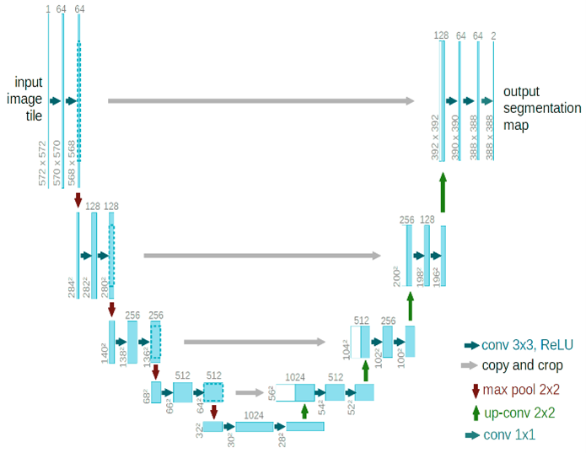
Figure 1 U-Net architecture showing encoder–decoder structure with convolution, pooling, up sampling, and skip connections for Proposed pneumonia segmentation.
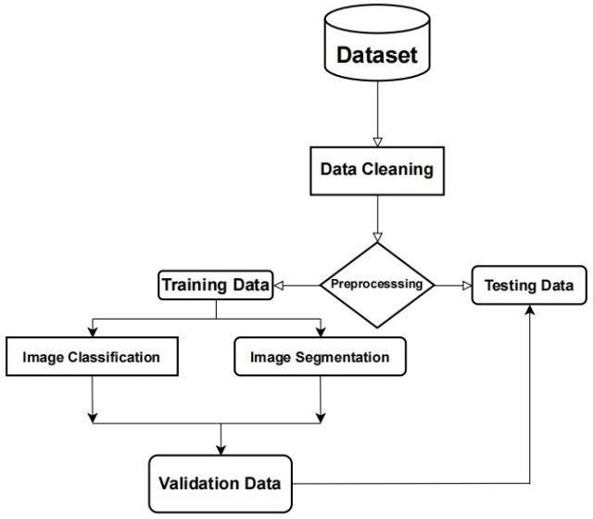
Figure 2 Workflow of the proposed system illustrating dataset preparation, preprocessing, segmentation, classification, and validation steps.
- Exploratory Data Analysis

The training dataset maintains a balanced distribution of "normal" and "pneumonia" images to allow the model to learn and distinguish between the features of both classes. The dataset consists of 1,341 normal and 3,875 pneumonia X-ray images downloaded from the Kaggle repository with each image having a corresponding mask precisely annotating the regions of pneumonia that enables training with pixel-wise classification. The statistics validating the dataset, are provided in Figure 4.
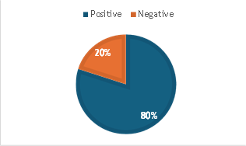

Figure 3 Dataset Validation of used X-Ray Images

- Data Augmentation
By generating new images from existing images to increase a dataset and thereby improving model performance while reducing overfitting to the data, data augmentation is beneficial. For example, to compute the new pixel coordinates from an image that has been rotated, a trigonometric formula is used
𝑥′ = 𝑥𝑐𝑜𝑠(𝜃) − 𝑦𝑠𝑖𝑛(𝜃), 𝑦′ = 𝑥𝑠𝑖𝑛(𝜃) + 𝑦𝑐𝑜𝑠(𝜃) (1)
- The Dice Coefficient
In image segmentation tasks, the Dice coefficient which is also called Dice similarity coefficient (DSC) is a frequently used assessment statistic. The Dice coefficient is calculated using (5):
Dice = $\frac{2\sum{(M_{true} * M_{pred}}}{\sum{M_{true} + M_{pred} } }$ (5)

The Dice coefficient is for measuring segmentation accuracy and higher dice values indicate better segmentation performance. The Loss of Binary Cross-Entropy (BCE) used in equation (6) as the loss function to compare ground truth and expected masks during U-Net training. For binary classification tasks, such as segmentation tasks, where each pixel is categorised as either an area infected with pneumonia or one that is not, this pixel wise loss function is frequently utilised. The formula for (BCE) loss is given below:
$L_{BCE}= -\frac{1}{N}\sum_{i=1}^{N}{[M_{true,i}\log{{(M}_{pred,i})}+(1- M_{true,i})\log{(1-M_{pred, i})}]}y$ (6)
- Combined Loss Function (Dice + BCE)
The loss functions used during U-Net training combine (BCE) loss and Dice loss to improve segmentation accuracy. by penalizing incorrect predictions and guiding the model to generate better masks. This Balances pixel-wise accuracy (via BCE) and segmentation quality via Dice. Ensures better mask generation.
$L=α⋅L_{BCE}​+(1-α)⋅(1-Dice)$ (7)

This Softmax layer ensures that the model provides clear, probabilistic outputs for whether a chest X-ray image belongs to which class. A popular loss function for classification assignments when differentiating between 0 two classes is the aim is the Binary Cross Entropy Loss for Classification. where the classification's BCE loss is computed as:
$L_{BCE}= -\frac{1}{N} \sum_{i=1}^{N}{[y_{i}\log\left(\hat{y_{i}}\right)+\left(1-y_{i}\right)\log\left(1-\hat{y_{i}}\right)] }$(9)
IV. Results
The results show the of combining segmentation and classification in medical imaging. Dice and IoU scores confirmed precise pneumonia region segmentation, which improved CNN-based classification performance, achieving accuracy, precision, recall, and F1-score, demonstrating reliable results on unseen test data.
step-by-step process of the results are shown:
Up sampling is applied to balance the dataset of 3,875 pneumonia and 1,341 normal X-rays, increasing the total to 7,750 images with equal representation of both classes.
The graph shows the accuracy for training and validation with training in blue and validation in red, over time (in epochs). While the validation accuracy fluctuated while the training accuracy increased rapidly, reaching a value of 0.93 after 10 epochs for training accuracy. For both training and validation loss to decrease, and level off at 0.18 means it is performing well on unknown data and successfully learning.
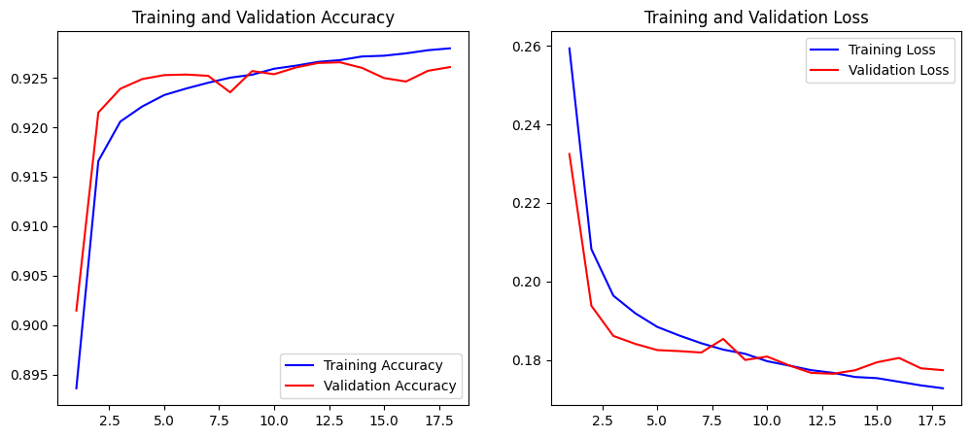
Figure 4 Test & Validation graph of Pneumonia Segmentation
- Test Loss and Accuracy

Figure 7 illustrates how the labels on the test set deviate
from the predicted labels. A low loss value, like 0.1235, shows that the model minimises prediction errors and works well with data that hasn't been seen before. The accuracy is the percentage of true predictions made by the model on the test set. An accuracy of 95.83% means that out of every 100 test images, about 96 were correctly classified as either normal or pneumonia.

Figure 5 Accuracy and loss values of classification

- Dice Coefficient
In binary segmentation tasks, the overlap between the true and anticipated masks is computed using the Dice Coefficient, sometimes referred to as the F1 score. A number of 1 denotes more overlap and segmentation accuracy; the range is 0 to 1. A score of 0.7658 in this case means that almost 76.6% of the predicted segmentation coincides with the actual segmentation, demonstrating a good.
- Intersection Over Union
An additional frequently used statistic for assessing segmentation accuracy is the IoU. It is calculated by dividing the intersection area of the true and predicted masks by the union of the two masks. Similar to the Dice Coefficient, it has a value between 0 and 62.1% of the predicted and real masks overlap, according to a result of 0.6205, meaning that the model still has to be improved in certain segmentation zones as shown in the fig 6.

Figure 6 Dice and IoU Results of Segmentation

- Confusion Matrix
This matrix model shows fig 9 the normal and pneumonia images showing that true positive is predicted pneumonia correctly in 3 cases and true negative model classified 2 normal cases for false positive and negative 2 normal cases were wrongly classified as pneumonia and 1 pneumonia case were wrongly classified as normal.

S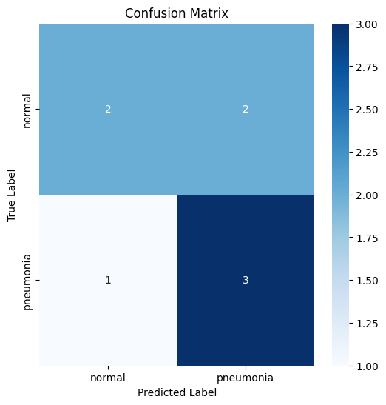
Figure 7 Confusion Matrix of the Extracted Results

V. Conclusion
A deep learning model for pneumonia segmentation and classification from chest X-ray images that is built on the U-Net architecture. The model successfully segmented areas of the lung infected by pneumonia (i.e., the disease). The model had a Dice coefficient of 0.7658, IoU score of 0.6205, and accuracy of 62.5 percent. Improvements to specificity and recall for normal and pneumonia cases were further improved by layering a CNN classifier on top of the U-Net in essence using it as a feature extractor. Overall, the study indicates that a U-Net could serve as a reliable-supportive tool for a radiologist, decreasing diagnostic time and burden on radiologists.
Despite the promising results, moderate accuracy may have been attributed to the imbalance of the data and variability in image quality. Our future work will address this with larger backend data repositories and more diverse datasets, coupled with better augmentation and hybrid deep learning models to improve generalization. Overall, this study provides insight into a U-Net architectures ultimate potential to be a reliable supportive and clinical-useable diagnostic tool for rapid diagnosis that is scalable.
References
- Daniel J. Mollura, Matthew P. Lungren, Radiology in Global Health, Springer New York, NY, DOI https://doi.org/10.1007/978-1-4614-0604-4
- Bharath K, U-Net Architecture for Image Segmentation, 2021, DigitalOcean
- Abhishek Sharma; Daniel Raju, “Detection of pneumonia clouds in chest X-ray using image processing approach”, 2017 Nirma University International Conference on (NUiCONE), 29 March 2018, DOI: 10.1109/NUICONE.2017.8325607
- K. Passera et al., "A Fuzzy-C-Means Cluster ing Algorithm for a Volumetr ic Analysis of Paranasal Sinus and Nasal Cavity Cancer s," 2006 International Conference of the IEEE Engineering in Medicine and Biology Society, New York, NY, USA, 2006, pp. 3078- 3081, doi: 10.1109/IEMBS.2006.260334.
- Sanskruti Dhore; Deepa Abin, “Chest X-ray Segmentation Using Watershed and Super Pixel Segmentation Technique”, 2021 International Conference on (ICCICT), 12 August 2021, DOI: 10.1109/ICCICT50803.2021.9510078
- Meenakshi, P., Bhavana, K., & Nair, A. K. (2022). “Pneumonia Detection using X-ray Image Analysis with Image Processing Techniques”. 2022 7th International Conference on Communication and Electronics Systems (ICCES).
https://doi.org/10.1109/icces54183.2022.9835798
- Agrawal, H. (2021). “Pneumonia detection using image processing and deep learning .Pneumonia”. https://doi.org/10.1109/icais50930.2021.9395895

