MetaComic Client User Manual

February 2011

Contents

1 Contents 2
2 Introduction 3
3 Introduction to MetaComic Client. 4
4 Main User Interface. 5
4.1 Main Menu Explained 6
5 MetaComic Archiver 9
5.1 Tagging Comic Strips Explained 10
6 MetaComic Comic Collector 11
7 MetaComic Options 12
8 MetaComic Plug-ins 14
9 Troubleshooting MetaComic 15
10 Developing Plug-ins for MetaComic 19
11 MetaComic FAQ 20
12 Help and Support 21

Introduction
This manual contains the details need to use the MetaComic: RSS/XML Daily Comic Strip Viewer & Archiver. Please go through each section to understand the functionality of the MetaComic application.

Introduction to MetaComic Client.

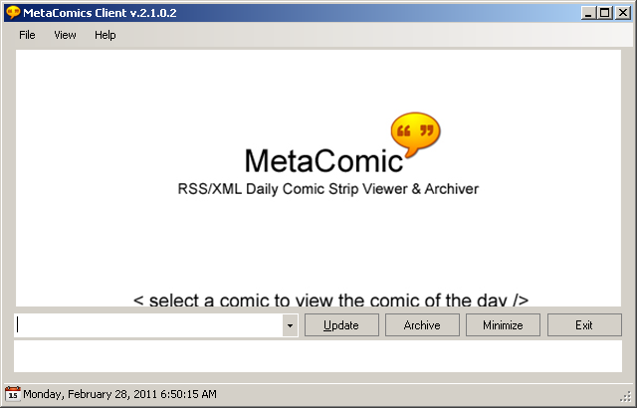

The MetaComic client is Windows desktop based comic strip retrieval and archiving utility used to fetch comic strips from various publicly available RSS/XML feeds on the Internet. It can be used to update your daily comic strips for viewing at ease of your Windows desktop. The application maintains a folder based comic strip database in which you can store and manage your favorite comic strips. It can be used to convert comic strip images in your comic strip database to CBZ (comic book archive) format or PDF format for archiving.

With MetaComic you can tag your favorite comic strips with keywords as you wish. It allows you to bookmark your favorite comic strips.

MetaComic contains a number of comic feeds that you can use to get stared with. Select the comic strips you wish to view from the Plug-in list of Comic strip and click the Update button from the MetaComic client and you can view your favorite daily comic strips.

Setup and Installation

Main User Interface.

The main user interface is as shown below

Buttons

Update: Click the Update Button to update your favorite daily comic strips. Messages will be displayed in the display area below as each comic strip is being updated.

Archive: Click the Archive Button to open the MetaComic Archive Viewer.

Minimize: Click the Minimize Button to minimize MetaComic to the Windows System Tray.

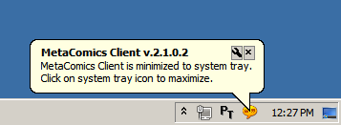

Exit: Click the Exit Button to terminate the MetaComic Application.

The status bar of the MetaComic application displays the current date and time.

Main Menu Explained

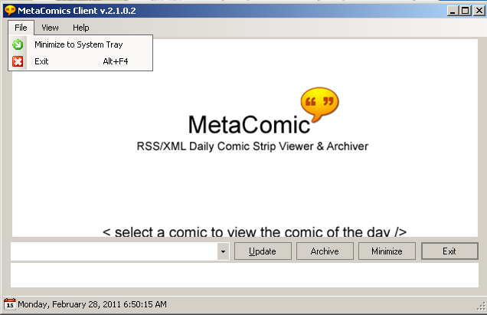

Minimize to System Tray: Select the Minimize to System Tray Option to minimize MetaComic to the Windows System Tray.

Exit: Select the Exit Option to terminate the MetaComic Application.
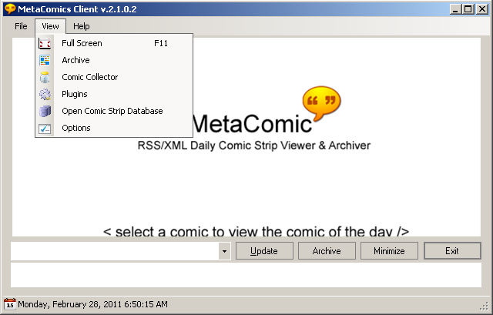

Full Screen: Select the Full Screen option to switch the MetaComic Application to full screen mode.

Archive: Select the Archive option to open the MetaComic Archiver

Comic Collector: Select the Comic Collector option to open the MetaComic Comic Collector

Plugins: Select the Plugins option to open the Plugins and select the comic strip plugins you wish to enable

Open Comic Strip Database: Select the Open Comic Strip Database option to open the Comic Strip Database Folder.

Options: Select the Options to set the MetaComic Application options.

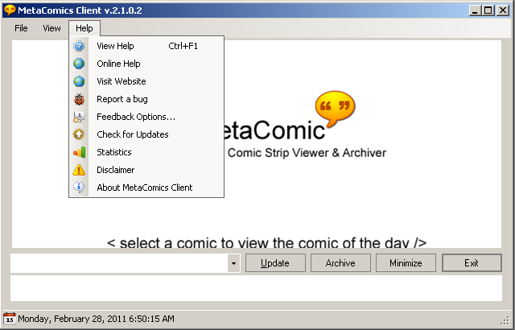

View Help: Click the View Help option to view the offline help for the MetaComic Application.

Online Help: Click the Online Help option to visit the online help (internet connection needed)

Visit Website: Click the Visit Website option to visit the MetaComic Website on CodePlex

Report a bug: Click the Report a bug option to visit the MetaComic bug/issue tracker website

Feedback Options…: Click the Feedback option to visit the MetaComic feedback/discussion website.

Check for Updates: Click the Check for updates option check for new updates/releases online.

Statistics: Click the statistics option to let MetaComic analyze and give statistics of your comic strip database.

Disclaimer: Click the Disclaimer to agree to the MetaComic disclaimer.

About MetaComic Client: Click to view information about MetaComic Application

MetaComic Archiver

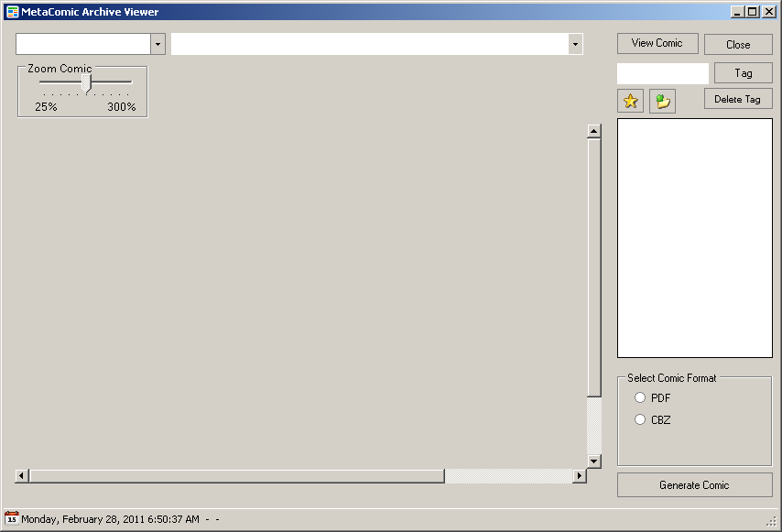

View Comic
Close
Tag
Delete Tag
Select Comic Format
PDF
CBZ
Generate Comic
Zoom Comic
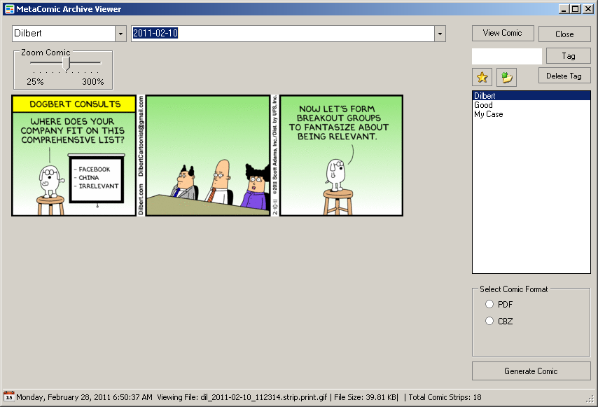

Tagging Comic Strips Explained

MetaComic Comic Collector

MetaComic Options
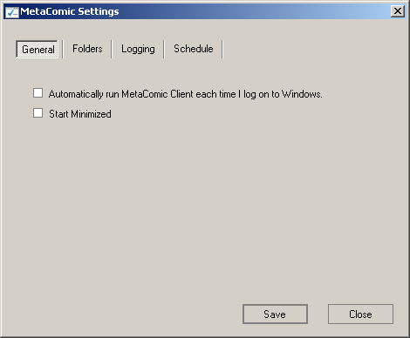

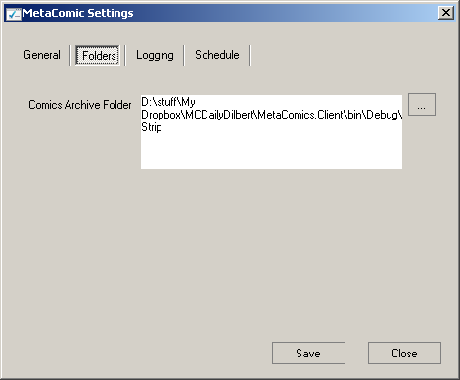

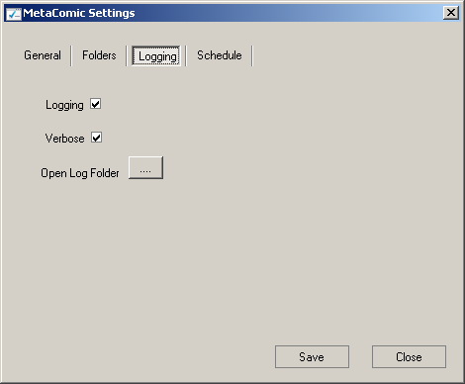

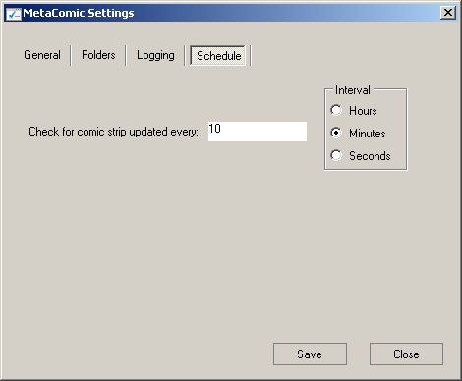

MetaComic Plug-ins
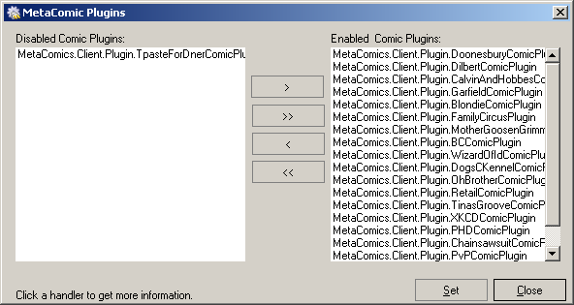

Troubleshooting MetaComic

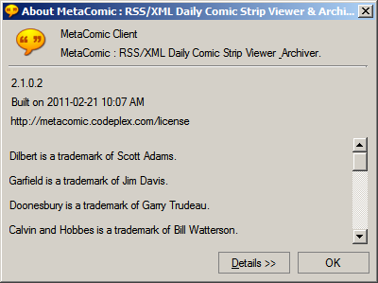

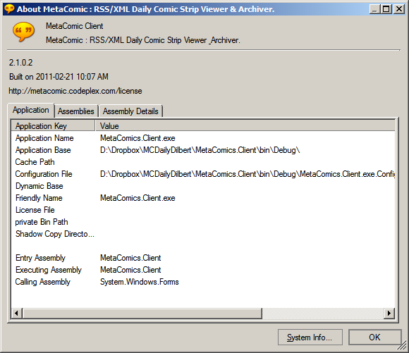
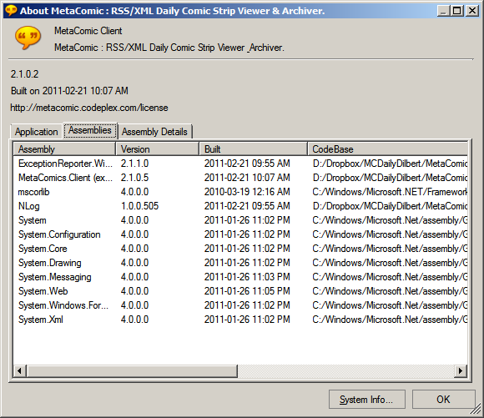
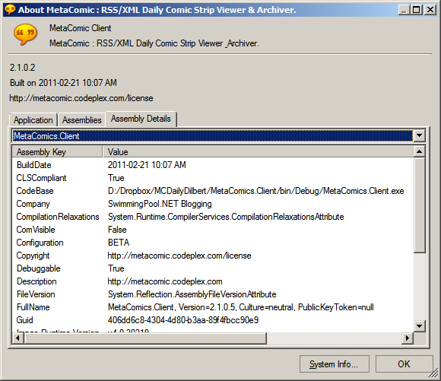

Developing Plug-ins for MetaComic

MetaComic FAQ
What is MetaComic Client used for?
What programming does MetaComic use?
Wa
Help and Support

Report a bug/feedback: You can always report your feedbacks and bugs you find at the MetaComic
Discussions found at the url : http://metacomic.codeplex.com/discussions

You can submit your bugs and issues at the url: http://metacomic.codeplex.com/workitem/list/basic

For better support it is advisable to mention your PC Configuration details like Operating System(OS).

Note: You may have to Register at the MetaComic Discussions by signing up (you can use your Microsoft Windows Live ID to sign up) before you post your feedbacks and bugs.

