Data Analytics Case Study Report

Executive Summary
A retailer that grew from one London store to a national estate in a single year supplied a 693-row trading extract known to contain recording errors. Following the Data Analytics Life Cycle, the data was profiled, cleaned to 680 validated stores, analysed in Python, and delivered as a twelve-panel interactive Tableau dashboard plus a linear regression model predicting sales from marketing budget.
Key findings: the chain earned £7.06bn sales and £5.14bn profit (72.9% margin), but six stores made losses driven by headcount-led overheads; staffing shows no relationship with sales and a negative one with profit (r = −0.22); Home electronics and Mobile phones dominate demand; neither store size nor city population predicts performance once the London outlier is excluded; and a £5.40bn Q3 spike requires investigation before it informs planning. The regression (R² = 0.945) predicts monthly sales of £35.3m to £94.2m at budgets of £20k to £50k, extrapolations to be read as upper bounds. Recommendations (Section 6) centre on staffing correction, incremental marketing scale-up and data governance.

Contents

List of Figures
Figure 1: Analytical workflow. Figure 2: Top and bottom ten stores by sales. Figure 3: The six loss-making stores. Figure 4: Headcount vs sales and profit. Figure 5: Category performance. Figure 6: Store size vs profit. Figure 7: Quarterly sales trajectory. Figure 8: Final Tableau dashboard. Figure 9: OLS regression with predictions. Figure 10: Residuals vs fitted values.

List of Tables
Table 1: Data cleaning log. Table 2: DALC vs CRISP-DM. Table 3: Correlation matrix (679 non-London stores). Table 4: Model performance metrics. Table 5: Predicted sales at requested budgets. Table 6: Prioritised recommendations.

1. Overview: Why Data Integrity Matters
In one year the company grew from a single London store to 680 stores, but record-keeping has not kept pace: the supplied dataset contained duplicated entries and inconsistent naming. Data integrity, meaning accuracy, consistency and completeness across the data life cycle, underpins every decision: analysis of flawed inputs produces flawed conclusions regardless of tooling ("garbage in, garbage out") [1]. Here the consequences were measurable: thirteen duplicated records inflated apparent sales by over £78 million, and Norwich, entered six times, would have appeared to be a region in itself. Poor data quality carries documented enterprise costs [16], estimated by Gartner at $12.9 million per organisation annually [2].
Once integrity is established, analysis and visualisation deliver three benefits. They compress scale: a well-designed chart exposes outliers and patterns in 680 rows that no reader could absorb directly, and Anscombe showed identical summary statistics can conceal radically different structures that only visualisation reveals [3]. They replace intuition with evidence: the assumption that more staff means more sales is contradicted by the data (Section 3). And they enable forward planning: the regression in Section 5 converts marketing history into budget-specific forecasts, while the dashboard lets non-technical stakeholders filter and drill down without an analyst [4].

2. Methodology: The Data Analytics Life Cycle
The project followed the Data Analytics Life Cycle (DALC), moving from business objective through data understanding and preparation to analysis, visualisation and communication [5]. Figure 1 shows the workflow as executed, including the feedback loop refitting the model as new data arrives. The main alternative, CRISP-DM [14], was rejected for the reasons in Table 2: its deployment emphasis suits machine-learning products, whereas this brief requires decision support.
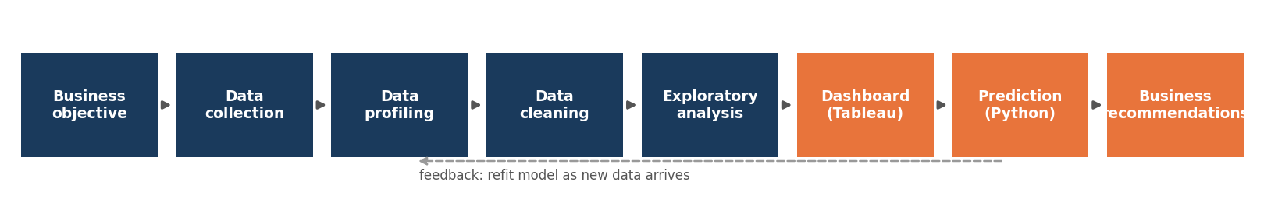
Figure 1: Analytical workflow followed in this project (DALC phases with model-refit feedback loop).
Table 2: DALC vs CRISP-DM methodology selection
Aspect | DALC (selected) | CRISP-DM (rejected)
Primary aim | Decision support and insight | Deployed predictive modelling
Final phases | Visualisation and communication | Evaluation and deployment
Fit to this brief | Maps directly onto the required outputs (clean data, dashboard, one interpretable model) | Deployment focus exceeds the brief; no deployed system is required

2.1 Phase 1: Defining the Objective
The objective, framed from the brief before touching the data, was to transform the raw first-year records into (a) a cleaned, trustworthy dataset, (b) an interactive Tableau dashboard answering the key commercial questions of store performance, staffing, product mix, store size, quarterly growth and geography, and (c) a Python model predicting sales at specified marketing budgets.

2.2 Phase 2: Understanding the Data
The main dataset held 693 rows and 25 columns covering store identity, geography, operating characteristics, cost structure and performance; a second dataset held 24 months of London marketing budget and sales plus an embedded "TOTAL" row. Profiling in pandas was assessed against the six recognised data-quality dimensions [15], [20]: uniqueness failed (13 exact duplicates); consistency failed (one category under several labels); validity was compromised by whitespace defects; completeness passed (no missing values); accuracy could not be externally verified but internal reconciliation gave no cause for doubt; and timeliness is weak, as a static snapshot ages immediately. Reconciliation checks confirmed the four quarterly columns sum exactly to total sales, and profit equals sales minus overhead, for every row, so cleaning could focus on de-duplication and standardisation rather than reconstructing corrupted figures.

2.3 Phase 3: Data Cleaning
Cleaning was scripted in Python (pandas) so every step is repeatable and auditable, unlike manual spreadsheet edits. Table 1 logs each issue, evidence and action. After cleaning, 680 unique stores remained with six standardised categories, exported as the single source of truth for Tableau. The pipeline is reproducible: the script (Appendix A) automates every check and figure, and embedded validation halts the pipeline if reconciliation fails [17].
Table 1: Data cleaning log
Issue identified | Evidence | Action taken
Duplicate records | 13 duplicated rows: Norwich (Store 18) entered 6 times; Stores 300–307 each entered twice | drop_duplicates(): 693 rows reduced to 680 unique stores
Inconsistent naming | "tablet" vs "Tablets"; "TV'S"; trailing spaces in "Home electronics " and "Audio equipment " | Trimming plus a mapping to one canonical label per category
Whitespace in headers | Column "Opening Hours " carried a trailing space, breaking programmatic references | All column names stripped of whitespace
Summary row in data | Marketing dataset contained a "TOTAL" row that would distort any fitted model | Row removed before regression (n = 24 months retained)
Validation of derived fields | Q1–Q4 columns vs Total sales; Sales − Overhead vs Total profit | Both reconcile exactly for every row (max difference £0)

3. Exploratory Analysis: Answering the Business Questions
Unless stated otherwise, correlations exclude the London flagship, an extreme outlier on almost every variable; Section 3.4 shows why this decision is itself part of the findings.

3.1 Which stores made the most and least sales and profit?
London leads decisively: £38.8m sales and £32.8m profit, more than double the next store. A cluster of mid-sized towns, Kirkham (£17.8m), Nairn (£17.7m) and West Wickham (£17.6m), outperforms many large cities, while Pemberton, Littlemore and Pont-y-pŵl recorded the lowest sales (£3.1–3.2m). Six stores made losses: Dewsbury (−£1.46m), Acton (−£0.84m), Islington (−£0.82m), Stockport (−£0.75m), Sutton in Ashfield (−£0.39m) and Macclesfield (−£0.21m).
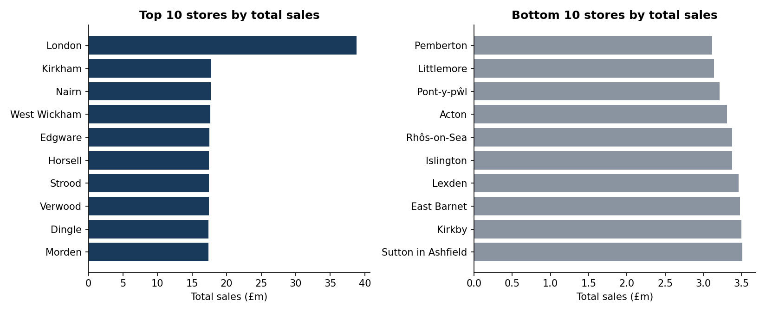
Figure 2: Top and bottom ten stores by total annual sales.
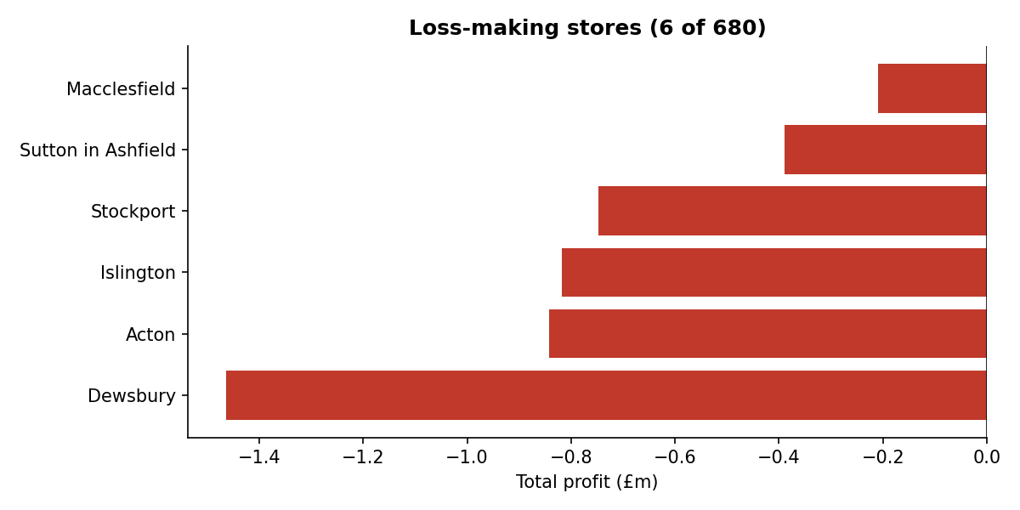
Figure 3: The six loss-making stores, high overheads on low revenue.
Critical evaluation. The loss-makers share low sales with overheads sized for busier stores, but rankings cannot establish why sales are low, as competition, demographics and site quality are unrecorded. The ranking identifies where to investigate, not what to conclude; closing a store whose losses stem from a fixable cost structure would destroy recoverable value.

3.2 Did the number of employees influence sales and profit?
No. Across the 679 non-London stores, headcount is uncorrelated with sales (r = −0.02) and clearly negatively correlated with profit (r = −0.22): staffing dominates overhead, and additional employees do not generate the revenue to cover their cost. Loss-making Stockport carries 130 employees on £3.8m of sales; profitable Bradford generates £11.0m with 67.
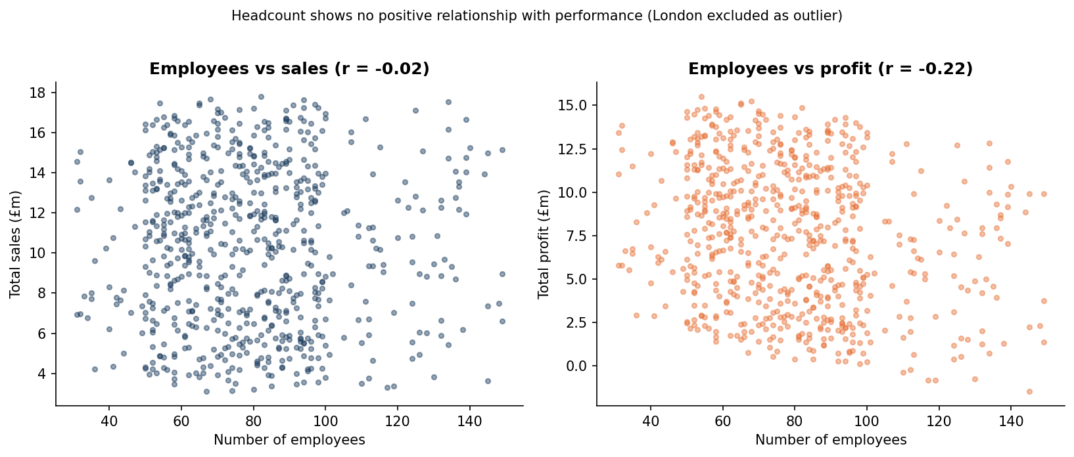
Figure 4: Scatter plots show no positive headcount–performance relationship.
Critical evaluation. Correlation is not causation: struggling stores could conceivably have been given extra staff. However, Table 3 shows headcount and overhead are perfectly collinear (r = 1.00), supporting the cost-side mechanism that staff costs effectively are the overhead. A controlled trial adjusting headcount at matched store pairs should precede chain-wide change.

3.3 Which products were the best selling?
Home electronics leads in the most stores (150 of 680) and sold the most units (533k), narrowly ahead of Mobile phones (147 stores, 520k units), which edged ahead on revenue (£1.54bn vs £1.53bn). Cameras (130 stores) are a strong third; TVs are weakest (71 stores, 242k units).
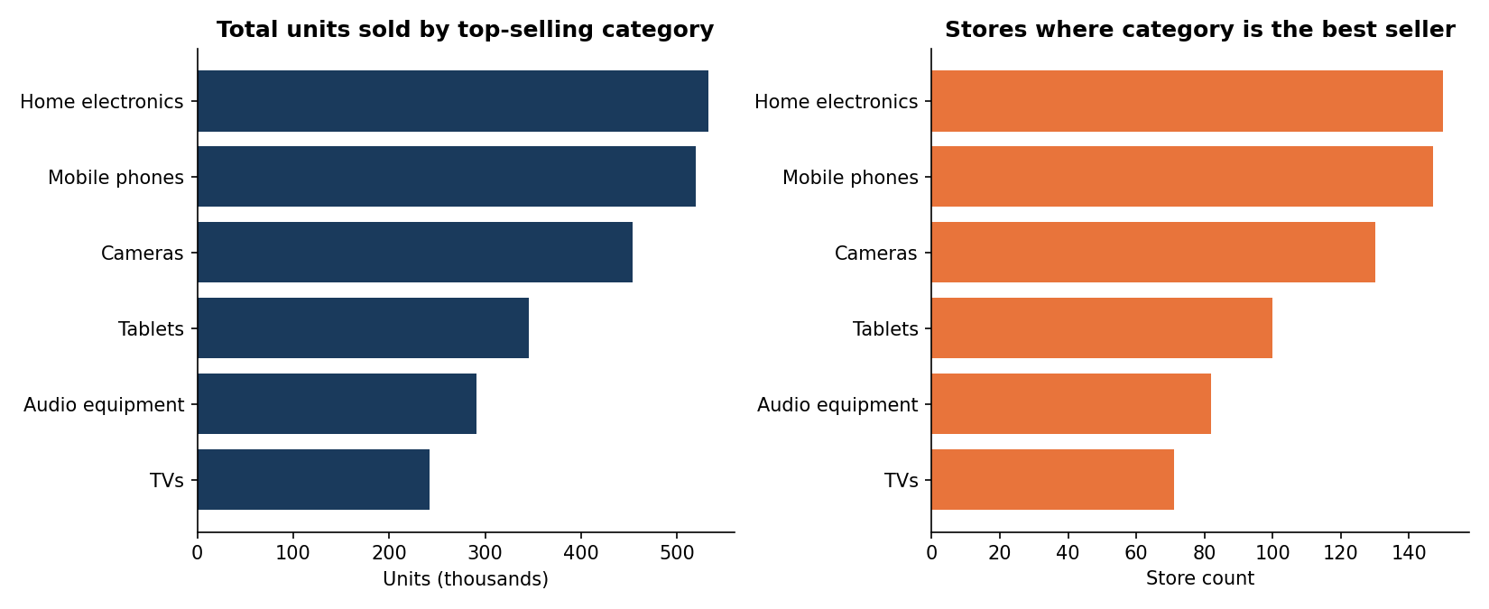
Figure 5: Category performance by units sold and by store count.
Critical evaluation. The dataset records only each store's top category, so "best selling" means "most frequently the local leader": a strong second everywhere would be invisible. Pre-cleaning, the "tablet"/"Tablets" split would have fragmented the Tablets figure, the consistency dimension directly altering a business conclusion.

3.4 Did a bigger store influence profit?
Not meaningfully. With London included, size appears mildly related to profit (r ≈ 0.11) and population appears the strongest sales predictor (r ≈ 0.27). Excluding London, both largely vanish: size–profit r = 0.04, population–sales r = 0.07. One extreme store, the largest, in the biggest city, with the highest sales, manufactured most of the apparent effect. Compact Leicester (85 m²) delivers £14.0m sales and £10.8m profit, outperforming far larger sites.
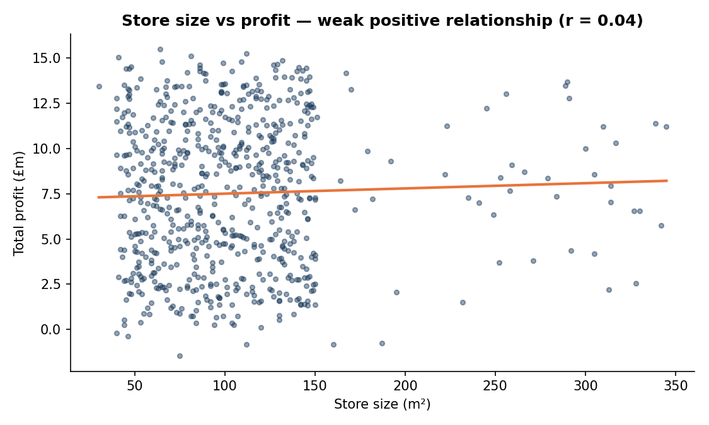
Figure 6: Store size vs profit, negligible relationship with wide scatter (London excluded).
Critical evaluation. A naive full-dataset correlation would have advised prioritising large stores in populous cities on the strength of one observation, echoing Anscombe's warning against statistics without visual and sensitivity checks [3]. Profitability plausibly depends on demographics, competition, rents and pricing, none captured here.

3.5 Did any store significantly increase from Q1 to Q4?
Growth was dramatic but non-linear: company-wide sales rose from £0.24bn (Q1) to £0.38bn (Q2), spiked to £5.40bn in Q3, then fell to £1.04bn in Q4, still over four times Q1. Store-level Q1-to-Q4 comparisons stay strongly positive: London grew 3,297% (£750k to £25.5m), with Royton (+898%), Stocksbridge (+863%) and Hove (+855%) steepest among the expansion stores.
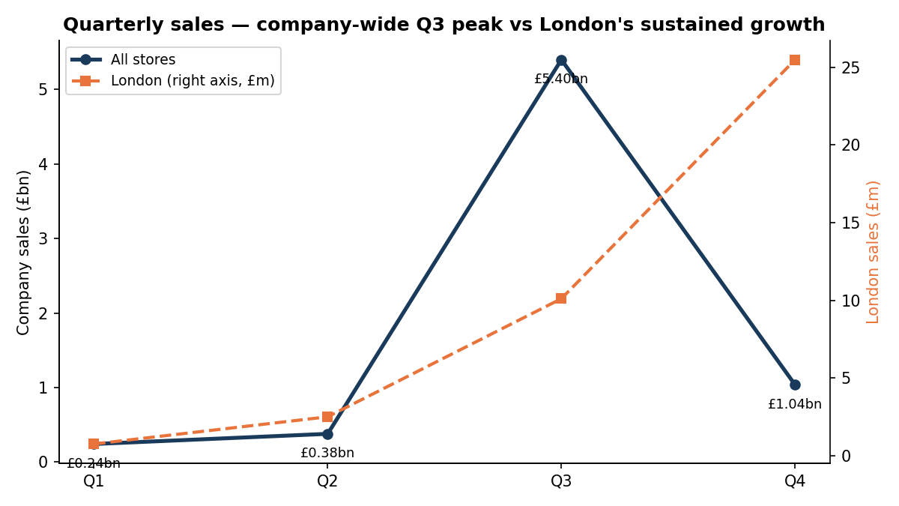
Figure 7: Company-wide Q3 peak vs London's sustained quarter-on-quarter growth.
Critical evaluation. The Q3 spike cannot be explained from within the dataset: no seasonal, promotional or recording-date metadata exists to distinguish a genuine surge from a revenue-recognition timing effect. The interpretations imply opposite actions, replicate a campaign versus fix a reporting defect, so establishing the cause must precede planning that relies on Q3.

3.6 Which city store sold the most of each product?
Category champions by units: Mobile phones, London (5,620); Home electronics, Wembley (4,992); Tablets, Wandsworth (4,991); Cameras, Hereford (4,988); TVs, Royal Leamington Spa (4,876); Audio equipment, Quedgeley (4,939). These are natural pilot sites: trialling a promotion where a category already leads isolates the intervention's effect from baseline demand.

3.7 Correlation matrix
Table 3 consolidates pairwise Pearson correlations for the 679 non-London stores. Pearson was chosen because the variables are continuous and the relationships of interest are linear; Spearman's rank alternative is preferable when relationships are non-linear or outliers dominate, a risk addressed here instead by excluding London [11].
Table 3: Correlation matrix of key store variables (679 non-London stores)
 | Sales | Profit | Employees | Size | Population | Overhead
Sales | 1.00 | 0.98 | −0.02 | 0.08 | 0.07 | −0.02
Profit | 0.98 | 1.00 | −0.22 | 0.04 | 0.02 | −0.22
Employees | −0.02 | −0.22 | 1.00 | 0.18 | 0.24 | 1.00
Size | 0.08 | 0.04 | 0.18 | 1.00 | 0.35 | 0.18
Population | 0.07 | 0.02 | 0.24 | 0.35 | 1.00 | 0.24
Overhead | −0.02 | −0.22 | 1.00 | 0.18 | 0.24 | 1.00

Three relationships stand out. Sales–profit (r = 0.98) confirms revenue, not cost variation, drives most profit differences. Employees–overhead (r = 1.00) shows overhead is an almost perfect function of headcount, mechanically explaining why headcount hurts profit (r = −0.22) while adding nothing to sales. And the variables intuition says should matter, size and population, show the weakest relationships (0.02–0.08), reinforcing Section 3.4.

4. Dashboard Design and Justification
The dashboard was built in Tableau from the cleaned export: twelve worksheets on a 1600×900 canvas, with five KPI cards along the top, the map on the left, four analytical panels centre-right and the quarterly trend along the bottom (Figure 8). Panel placement matches visual prominence to task importance [13]. Each design choice below states the rationale and the rejected alternative.
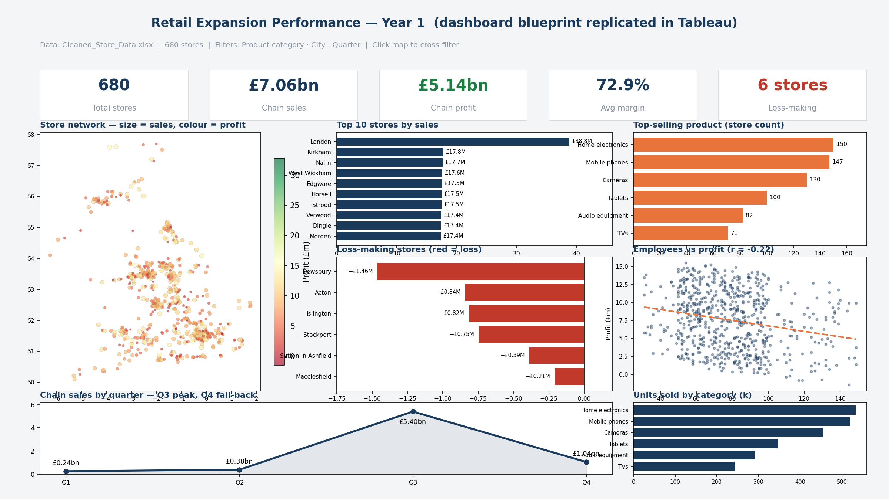
Figure 8: Final dashboard: five KPI cards, network map, ranked and category bars, loss panel, staffing scatter, quarterly trend, interactive filters.
- KPI band. Five cards (680 stores; £7.06bn sales; £5.14bn profit; 72.9% margin; 6 loss-makers via a calculated field) give the state of the business in seconds, placed top per the F-scanning pattern [6]. Gauges were rejected as space-hungry decoration [4].
- Symbol map. Latitude and longitude make a map the natural encoding; size encodes sales, a red–green diverging scale encodes profit, processed pre-attentively so losses are spotted without searching [7]. A choropleth was rejected: stores are points, and region shading misattributes performance.
- Ranked bars (top 10). Bars use aligned position and length, the most accurately judged channels [8]; horizontal orientation keeps city names legible. A figures table (lookup, not comparison) and a treemap (less accurate area judgements) were rejected.
- Category bars. Two complementary bar panels (stores led per category; units sold). Pies were rejected: with six similar categories, angle comparison is unreliable where bar length is readable [8].
- Loss panel. A dedicated red bar chart isolates the six negative-profit stores as a pre-attentive alarm [7], preventing exceptions drowning in a 680-store ranking.
- Staffing scatter. A scatter with trend line puts the counter-intuitive r = −0.22 finding on the dashboard itself; binned grouped bars were rejected because binning discards variation [8].
- Quarterly line. Lines are the standard time encoding [4] and the Q3 peak is instantly legible; stacked areas were rejected as four periods gain nothing from stacking [10].
- Interactivity and consistency. Global product, city and quarter filters act on every panel and map clicks cross-highlight stores: "overview first, zoom and filter, details-on-demand" [9]. A restrained navy/orange palette with red reserved for losses maximises data-ink [10]; visual scanning principles guide the reading order [19].

4.1 Ethics and governance
The data is aggregated at store level with no personal data, so GDPR is not directly engaged; however, headcount and staff-cost fields underpin recommendations affecting employees, and store-level figures must be treated as decision inputs, not individual performance judgements. Internal publication requires access controls, as store profitability is commercially sensitive. The model is deliberately transparent, a stated linear equation with published assumptions and extrapolation limits, consistent with responsible-analytics practice [17].

5. Predictive Analysis in Python: Marketing Budget vs Sales
After removing the embedded TOTAL row, 24 monthly observations remain and the budget–sales correlation is r = 0.972, making ordinary least squares regression the appropriate first model [11]. Alternatives were rejected on principle: polynomial regression risks overfitting 24 points and behaves erratically beyond the data, exactly where answers are needed; ridge regression addresses multicollinearity, absent with one predictor; and tree-based models are flat outside their training range, structurally incapable of the requested extrapolations [11], [17].
The fitted equation is Sales = 1,963.98 × Budget − 4,005,987: each additional £1 of monthly marketing spend was associated with roughly £1,964 of additional monthly sales within the observed range. Table 4 summarises performance; Figure 9 shows the fit and the four requested scenarios.
Table 4: Model performance metrics
Metric | Value
Observations (months) | 24
Pearson r | 0.972
R² | 0.945
MAE | £1.71 million
RMSE | £1.98 million
Shapiro–Wilk (residuals) | p = 0.874, normality not rejected

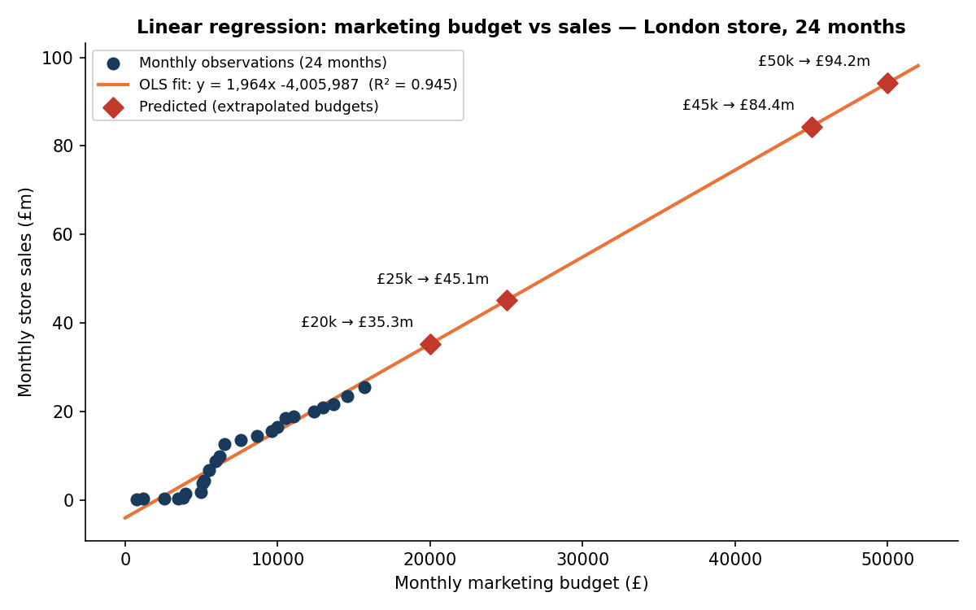
Figure 9: OLS regression with the four requested budget scenarios plotted as predictions.
Diagnostics. Residuals (Figure 10) are approximately randomly distributed around zero with no pronounced funnel shape, indicating no major heteroscedasticity; a Shapiro–Wilk test does not reject residual normality (p = 0.874); and with monthly observations, serial dependence cannot be ruled out but shows no visible pattern. Minor curvature at higher budgets suggests some non-linearity, reinforcing the caution against large extrapolations.
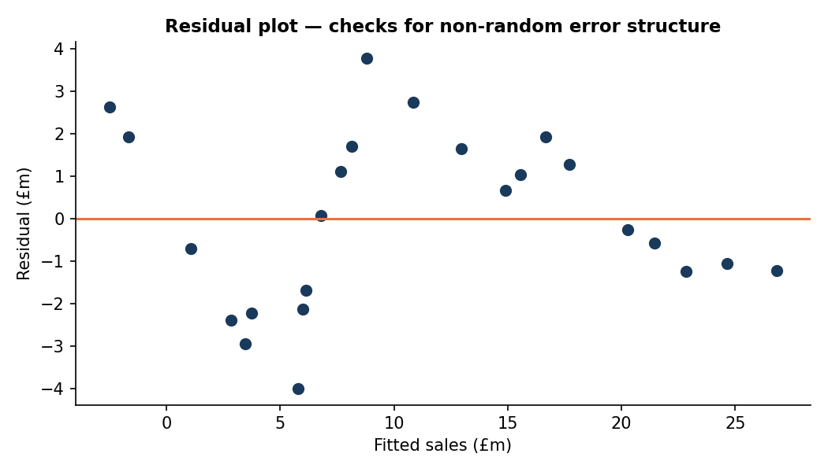
Figure 10: Residuals vs fitted values, no severe violation of linearity or homoscedasticity.
Table 5: Predicted monthly sales at the requested budget levels
Marketing budget (£/month) | Predicted monthly sales (£) | Note
20,000 | 35,273,665 | Extrapolated ~27% beyond data
25,000 | 45,093,578 | Extrapolated
45,000 | 84,373,229 | Far extrapolation, indicative only
50,000 | 94,193,142 | Far extrapolation, indicative only

A material caveat applies: observed budgets span £763–£15,698 per month, so all four scenarios extrapolate, the top two by over three times the maximum. Linear extrapolation assumes the £1,964-per-£1 return persists, whereas marketing typically shows diminishing returns [12], and the negative intercept warns against interpretation near zero. The predictions are upper bounds; the prudent path is incremental increase with measurement and refitting, the DALC as its intended continuous loop.

6. Business Recommendations
Table 6 converts the findings into measurable, prioritised actions.
Table 6: Prioritised recommendations
Priority | Recommendation (measurable) | Timeframe
Immediate | Reduce staffing costs by 10–15% at the six loss-making stores (employees–overhead r = 1.00 identifies headcount as the recoverable cost) and monitor profitability for one quarter before wider rollout. | 1 month
Immediate | Investigate the Q3 revenue spike with finance to establish whether it is trading or a recording-timing effect. | 1 month
High | Introduce entry-point validation: unique store keys, controlled category vocabularies, automated duplicate detection on load [20]. | 3 months
Medium | Raise London marketing spend from ~£16,000 to £20,000/month for three months, compare realised sales with model predictions, and refit before further increases. | 6 months
Medium | Prioritise Home electronics and Mobile phones in stock and promotion; commission a TV range review; pilot category promotions at the champion stores in Section 3.6. | 6 months
Long-term | Base site selection on profiled characteristics of over-performing mid-town stores (Kirkham, Nairn, West Wickham), not floorspace or population; connect the dashboard to a live source. | 12 months

7. Limitations
Dataset. One trading year permits no year-on-year comparison or seasonality estimate; four quarterly values per store are too few for time-series methods. No demographics, competitor, rent or price data exist, so performance drivers are only partially examined and omitted variables cannot be excluded. Figures are nominal, and only each store's top category is recorded.
Model. The regression assumes linearity and constant returns; every requested prediction extrapolates beyond the observed range, where those assumptions are untested [12]. With 24 observations from one store, variables that co-moved with budget may inflate the apparent effect: the slope is an association, not a causal return on spend.
Dashboard. The dashboard is static and historical with no live refresh, forecasting resides in Python rather than Tableau, and dense urban areas suffer some overplotting. Acceptable for an annual review, these would need addressing for operational use (Section 9).

8. Conclusion
The Data Analytics Life Cycle transformed an unreliable 693-row export into 680 validated stores, a twelve-panel interactive dashboard, and a quantified prediction model, meeting every Phase 1 objective. The process proved the opening argument: without cleaning, sales would have been overstated by £78m, Tablets undercounted, and one outlier would have manufactured a spurious case for large-format stores.
The findings carry direct commercial weight: a successful expansion (£7.06bn sales, £5.14bn profit, 72.9% margin) with six loss-makers whose cause is mechanical, headcount-driven overheads misaligned with revenue; demand concentrated in Home electronics and Mobile phones; no evidence that size or population predicts performance; a Q3 spike requiring explanation; and an interpretable marketing model with stated limits. Next steps are prioritised in Table 6, anchored by governance measures that let next year's analysis start from trustworthy records rather than repair work.

9. Future Work
With monthly multi-year data, time-series forecasting (exponential smoothing, ARIMA) could model seasonality and test whether the Q3 pattern recurs [18]. Demographic and competitor data would enable multiple regression or supervised machine learning on store performance, while customer segmentation would target product and promotion decisions. A live data connection would convert the dashboard into an operational monitoring tool with quality alerts at ingestion. Every extension depends on governance: richer analytics amplify good and bad data alike.

References
[1] R. Kitchin, The Data Revolution: Big Data, Open Data, Data Infrastructures and Their Consequences. London: SAGE Publications, 2014.
[2] Gartner, "How to Improve Your Data Quality," Gartner Insights, 2021. [Online]. Available: https://www.gartner.com/smarterwithgartner/how-to-improve-your-data-quality (accessed 27 Jul. 2026).
[3] F. J. Anscombe, "Graphs in Statistical Analysis," The American Statistician, vol. 27, no. 1, pp. 17–21, 1973.
[4] S. Few, Information Dashboard Design: Displaying Data for At-a-Glance Monitoring, 2nd ed. Burlingame, CA: Analytics Press, 2013.
[5] EMC Education Services, Data Science and Big Data Analytics: Discovering, Analyzing, Visualizing and Presenting Data. Indianapolis, IN: John Wiley & Sons, 2015.
[6] J. Nielsen, "F-Shaped Pattern for Reading Web Content," Nielsen Norman Group, 2006. [Online]. Available: https://www.nngroup.com/articles/f-shaped-pattern-reading-web-content/ (accessed 27 Jul. 2026).
[7] C. Ware, Information Visualization: Perception for Design, 4th ed. Cambridge, MA: Morgan Kaufmann, 2020.
[8] W. S. Cleveland and R. McGill, "Graphical Perception: Theory, Experimentation, and Application to the Development of Graphical Methods," Journal of the American Statistical Association, vol. 79, no. 387, pp. 531–554, 1984.
[9] B. Shneiderman, "The Eyes Have It: A Task by Data Type Taxonomy for Information Visualizations," in Proc. IEEE Symposium on Visual Languages, 1996, pp. 336–343.
[10] E. R. Tufte, The Visual Display of Quantitative Information, 2nd ed. Cheshire, CT: Graphics Press, 2001.
[11] G. James, D. Witten, T. Hastie, and R. Tibshirani, An Introduction to Statistical Learning: with Applications in R, 2nd ed. New York: Springer, 2021.
[12] G. J. Tellis, Effective Advertising: Understanding When, How, and Why Advertising Works. Thousand Oaks, CA: SAGE Publications, 2004.
[13] T. Munzner, Visualization Analysis and Design. Boca Raton, FL: CRC Press, 2014.
[14] R. Wirth and J. Hipp, "CRISP-DM: Towards a Standard Process Model for Data Mining," in Proc. 4th Int. Conf. on the Practical Applications of Knowledge Discovery and Data Mining, 2000, pp. 29–39.
[15] ISO 8000-8:2015, Data Quality Part 8: Information and Data Quality: Concepts and Measuring. Geneva: International Organization for Standardization, 2015.
[16] T. C. Redman, "The Impact of Poor Data Quality on the Typical Enterprise," Communications of the ACM, vol. 41, no. 2, pp. 79–82, 1998.
[17] F. Provost and T. Fawcett, Data Science for Business: What You Need to Know about Data Mining and Data-Analytic Thinking. Sebastopol, CA: O'Reilly Media, 2013.
[18] R. J. Hyndman and G. Athanasopoulos, Forecasting: Principles and Practice, 3rd ed. Melbourne: OTexts, 2021.
[19] S. Few, Now You See It: Simple Visualization Techniques for Quantitative Analysis. Oakland, CA: Analytics Press, 2009.
[20] DAMA International, DAMA-DMBOK: Data Management Body of Knowledge, 2nd ed. Basking Ridge, NJ: Technics Publications, 2017.

Appendices
- Appendix A: analysis_and_prediction.py, the Python script covering profiling, cleaning, exploratory analysis, correlation matrix and the regression, with console output evidencing each phase.
- Appendix B: Cleaned_Store_Data.xlsx, the validated 680-store dataset (plus long-format quarterly sheet) used as the Tableau source.
- Appendix C: Retail_Performance_Dashboard.twb, the Tableau workbook with the twelve worksheets, calculated Loss Flag field, dashboard layout and global filters.
- Appendix D: Cleaning-log evidence, Table 1 cross-referenced against the script's printed profiling output.
- Appendix E: All analytical charts (Figures 2–10) are regenerated by the Appendix A script, demonstrating end-to-end reproducibility from the raw files.

