Sprint #1

Sprint Backlog

|  |  |  |  |
| --- | --- | --- | --- |
| Story ID | Story/Task | Estimated Hours | Actual Hours |
| 01 | ListView | 30m | 1h |
|  |  |  |  |
|  |  |  |  |

Review

The simple version of ListView was successfully created.

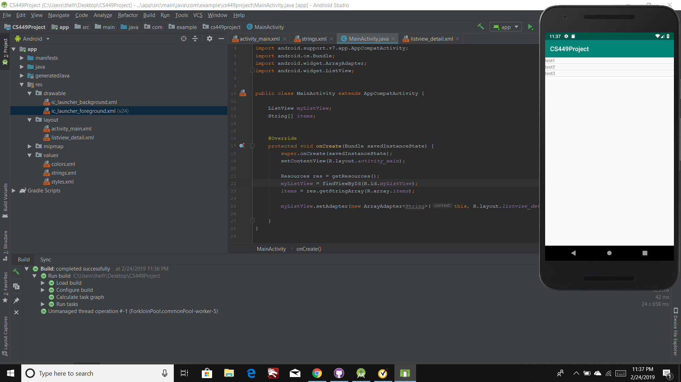

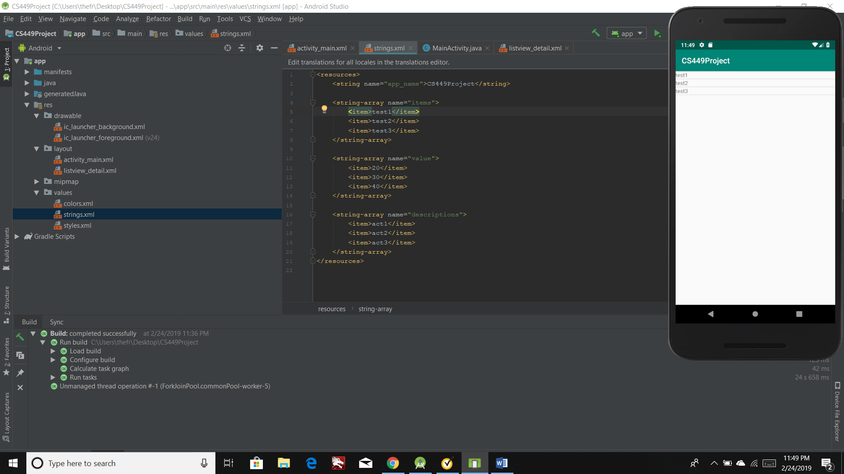

Retrospective

It took me a while to learn to how access Res file and make a list through string-array variables.

In the next sprint, I am going to extend the elements of each item(descriptions, value, etc,…)