Sprint #2

Sprint Backlog

|  |  |  |  |
| --- | --- | --- | --- |
| Story ID | Story/Task | Estimated Hours | Actual Hours |
| 02 | EditText | 10m | 30m |
| 03 | SavingFiles | 1h | 1h30m |
|  |  |  |  |

Review

EditText window  
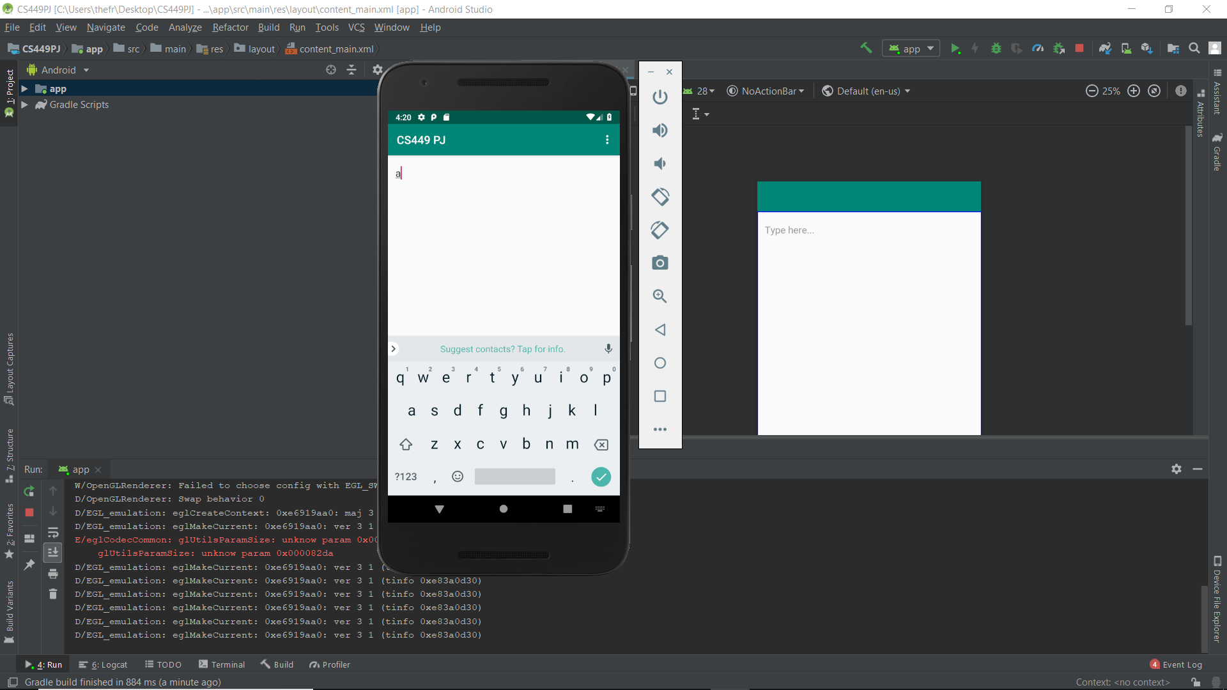

Saving Files

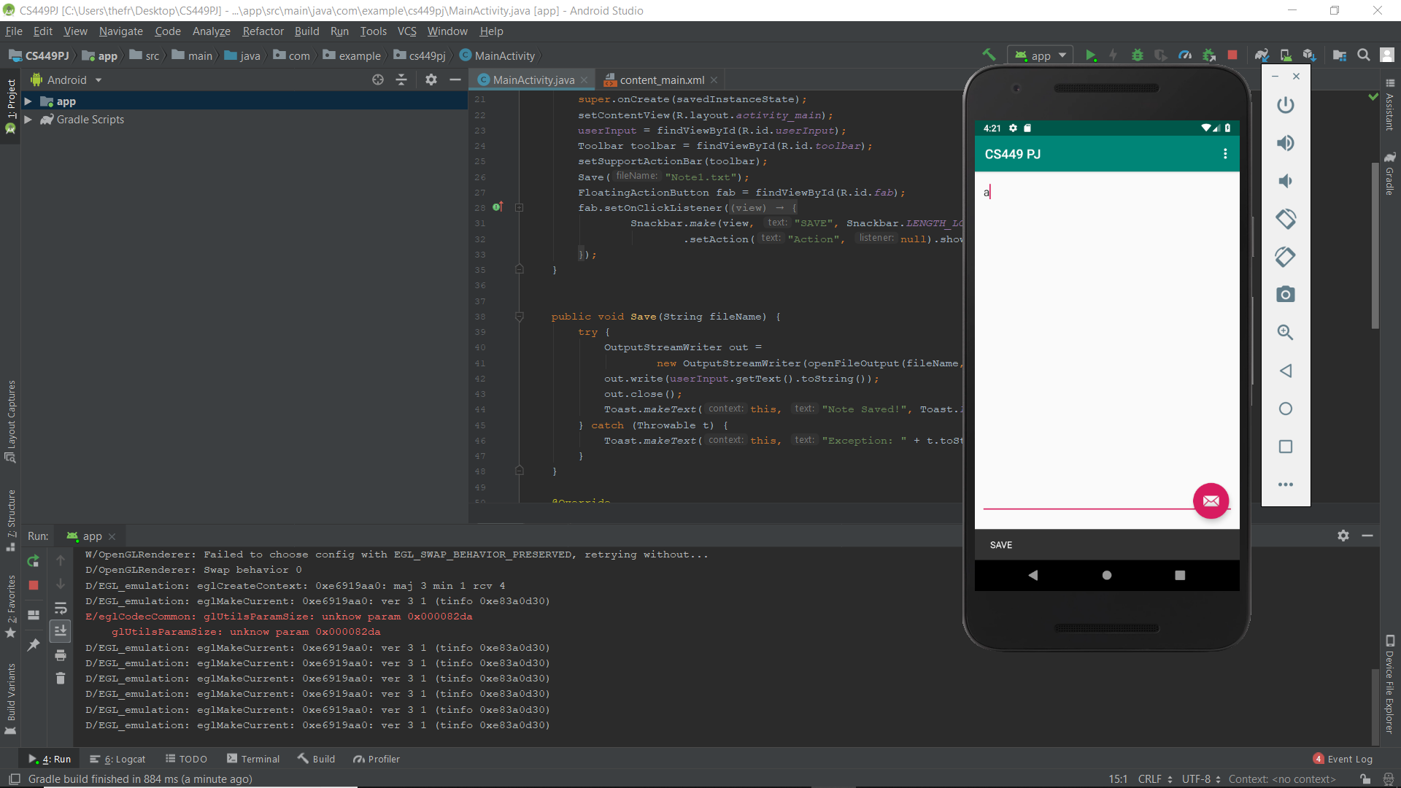

Retrospective

I got some trouble when I was trying to reset the frozen emulator

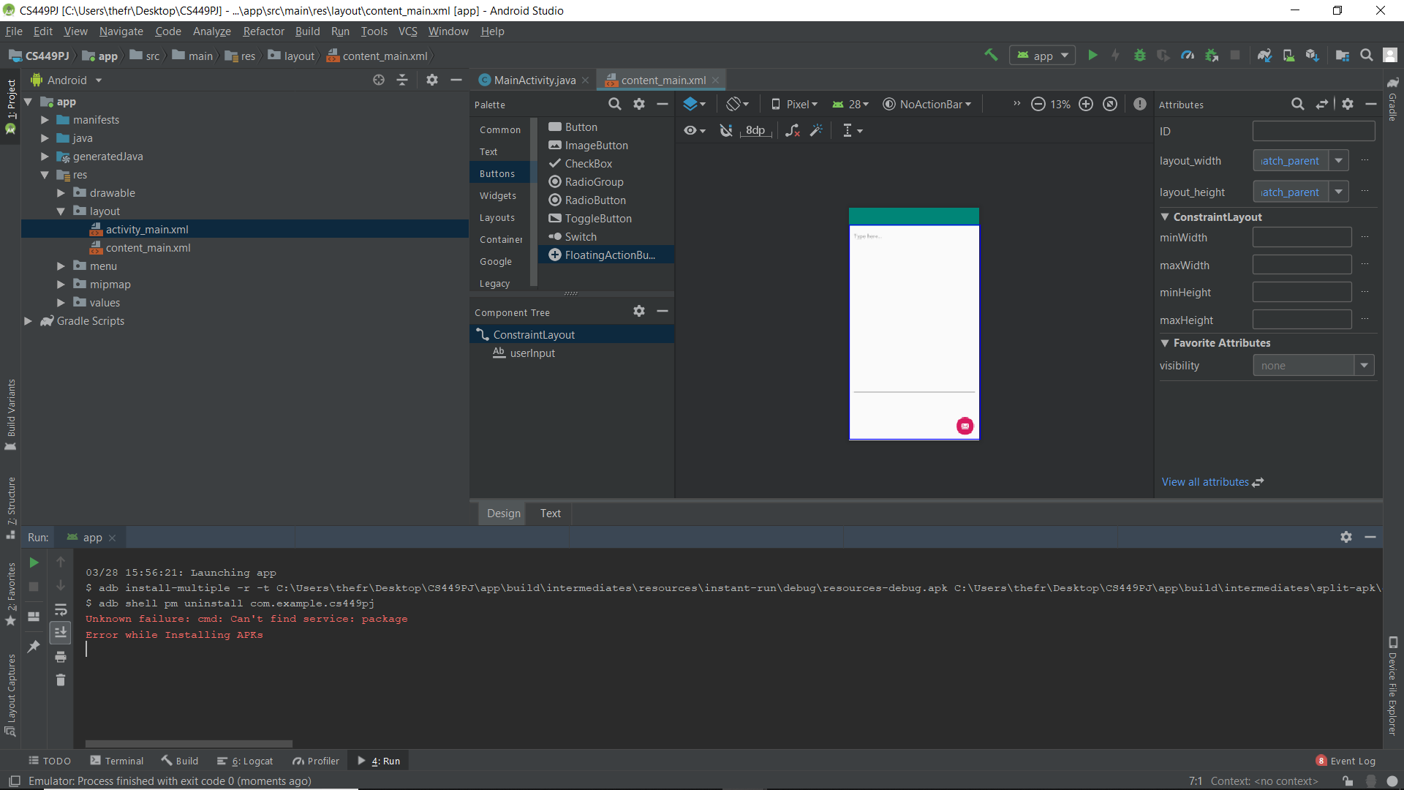

As a result, I have to wipe out all the data of the emulator

For the next sprint, I will work on loading method.