Sprint #3

Sprint Backlog

|  |  |  |  |
| --- | --- | --- | --- |
| Story ID | Story/Task | Estimated Hours | Actual Hours |
| 03 | FileCheck | 20m | 30m |
| 04 | OpenMethod | 30m | 50m |
|  |  |  |  |

Review

File checking is used to find whether there is a file exists to load

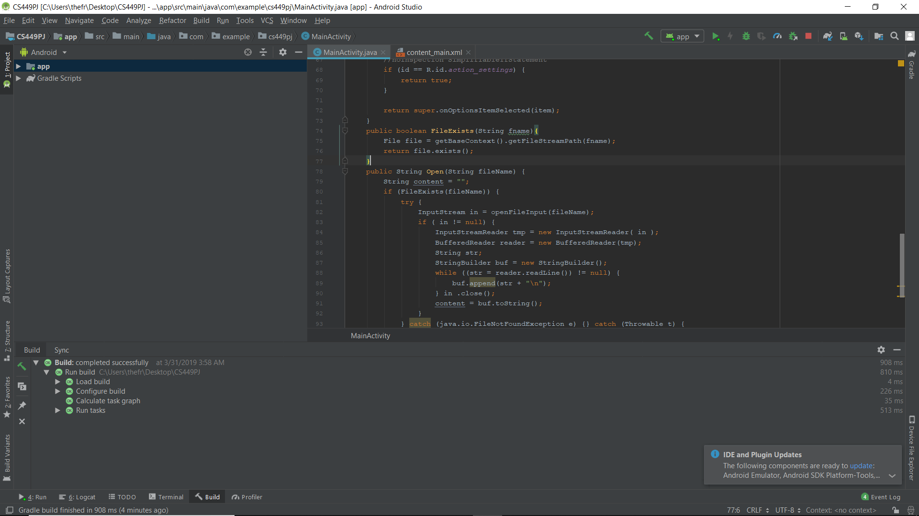

If there is a file that exists, open method passes the file name string that we want to open. When the users saved a file, it will be loaded whenever they open the app again instead of the app showing a blank page.  
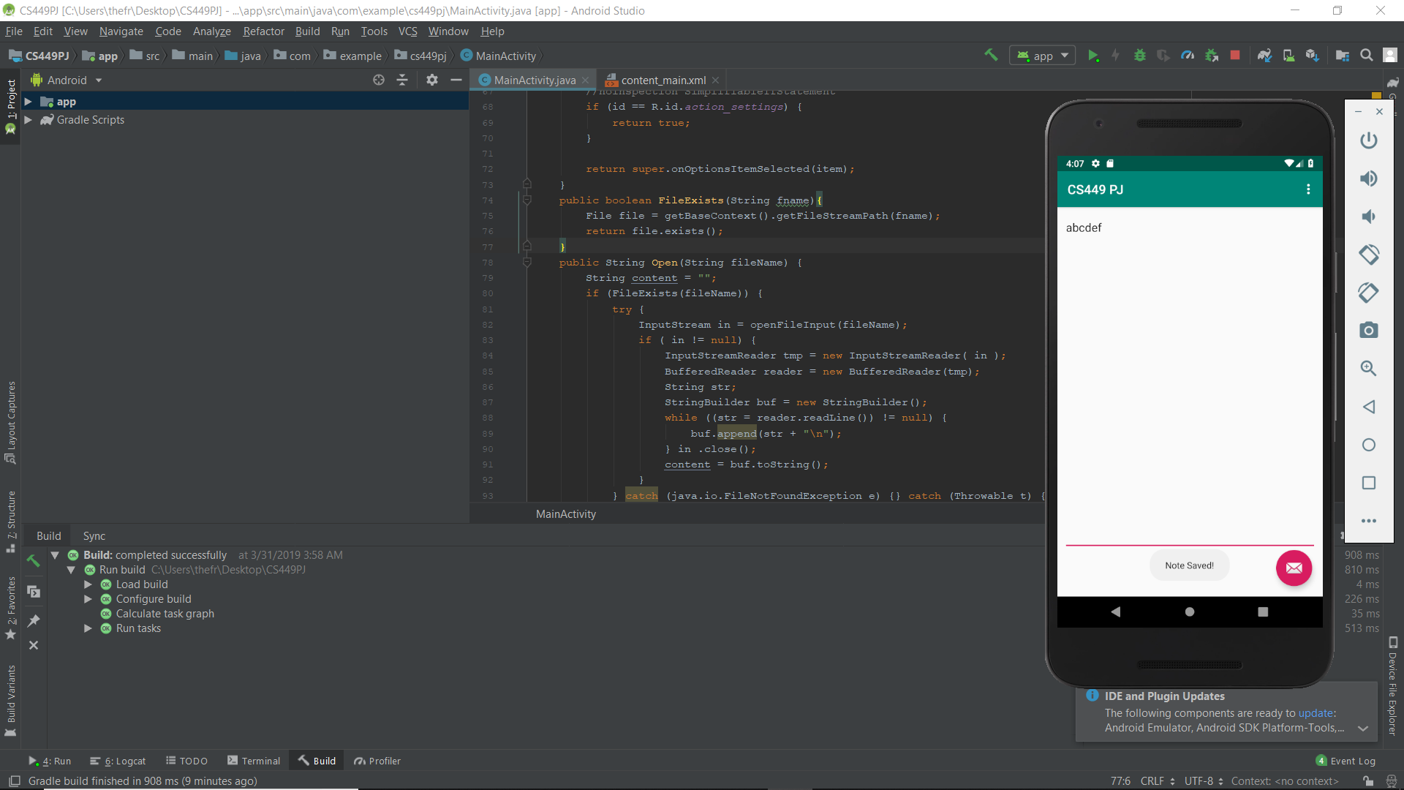

Retrospective

It took extra time for me to practice new methods and apply them to the app.  
For the next sprint, I will try to implement the feature where users can save more than one note.