Sprint #4

Sprint Backlog

|  |  |  |  |
| --- | --- | --- | --- |
| Story ID | Story/Task | Estimated Hours | Actual Hours |
| 05 | NoteSelectLayout | 30m | 40m |
| 04 | NoteBuilder | 30m | 30m |
|  |  |  |  |

Review

Note select layour sample, using a recycler view in order to display notes. The view can be select straight.  
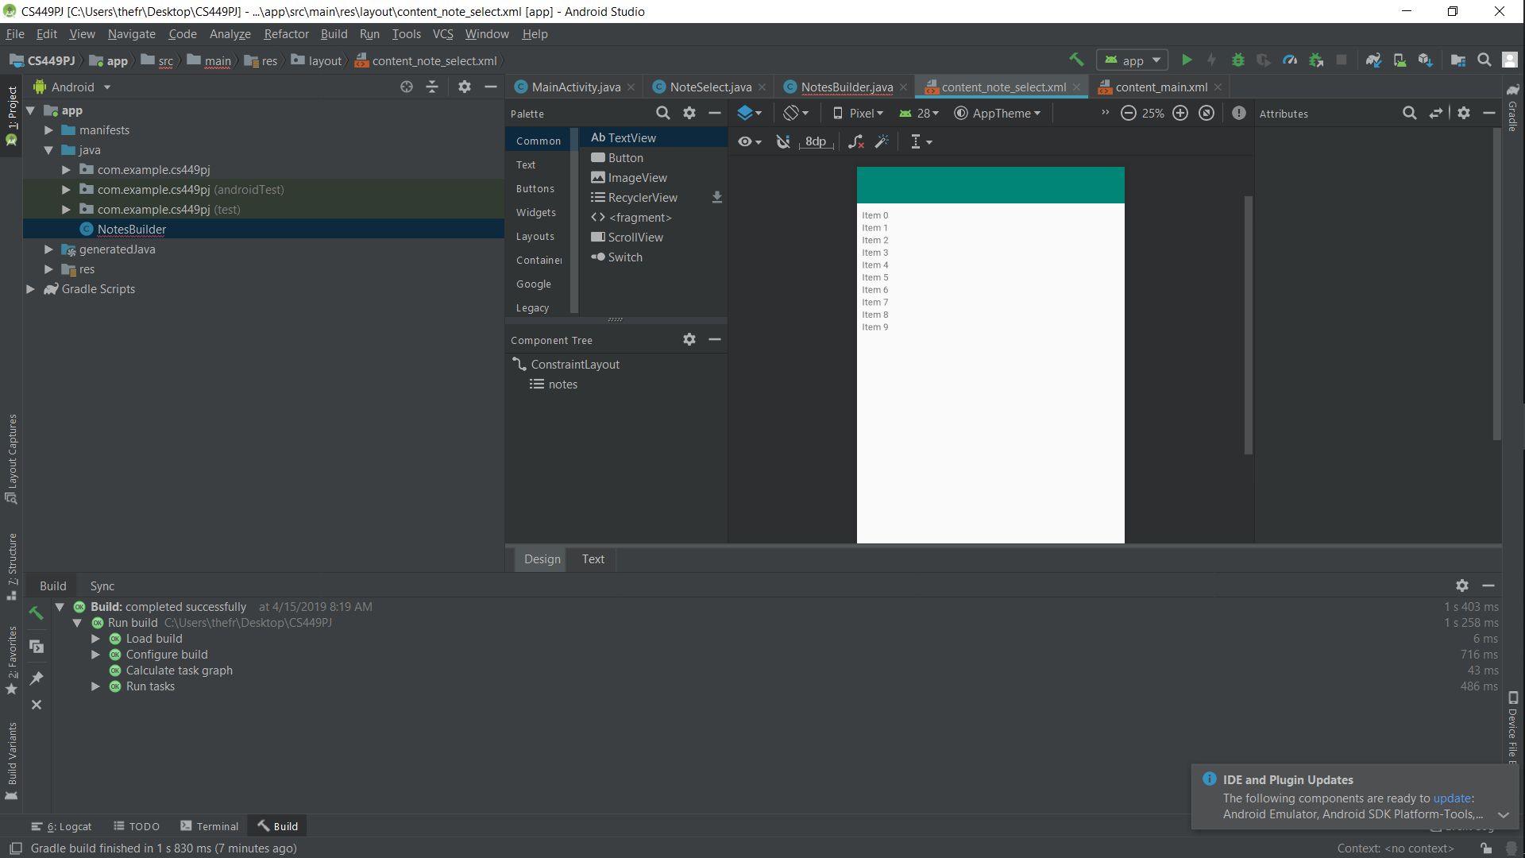

This Java class build the note objects.

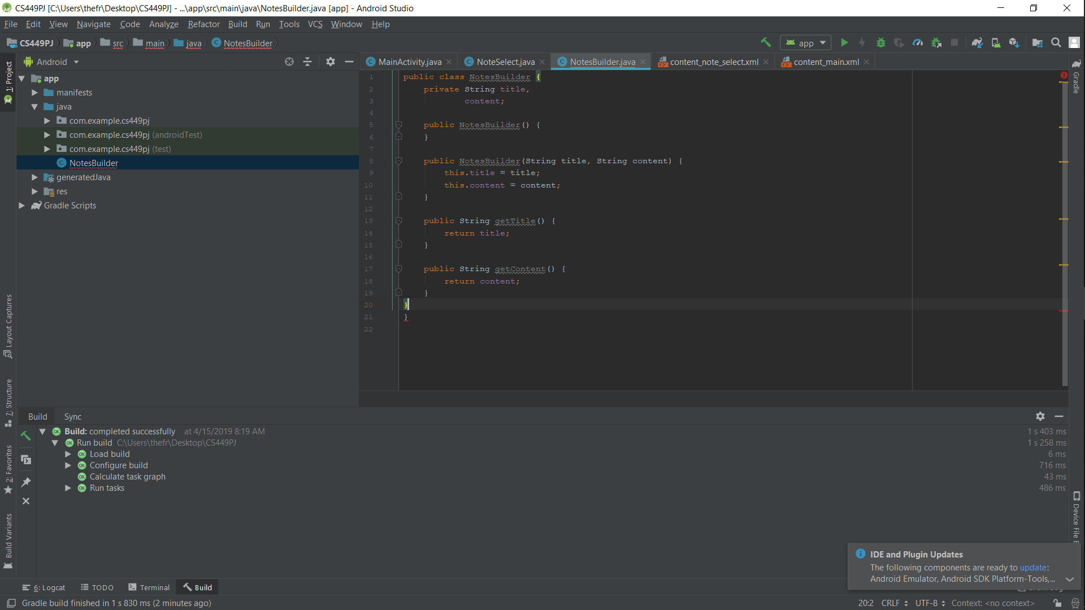

Retrospective

I got some issues when I was trying to make the new layout. Some of the class and packages were unresolved.

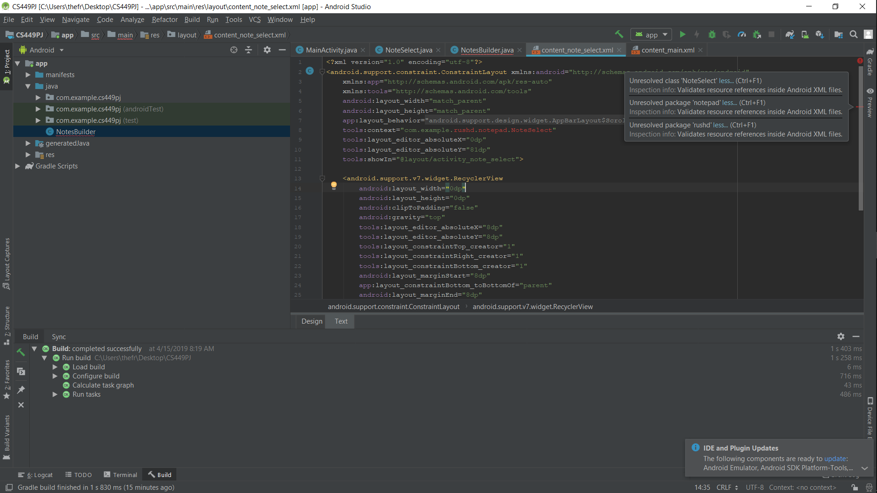

For the next sprint, I will work on NoteAdapter