Sprint #5

Sprint Backlog

|  |  |  |  |
| --- | --- | --- | --- |
| Story ID | Story/Task | Estimated Hours | Actual Hours |
| 07 | RelativeLayout | 20m | 20m |
| 08 | NotesAdapter | 40m | 1h |
|  |  |  |  |

Review

With recycle view, the relative layout can include images and all kind of other views in each row.

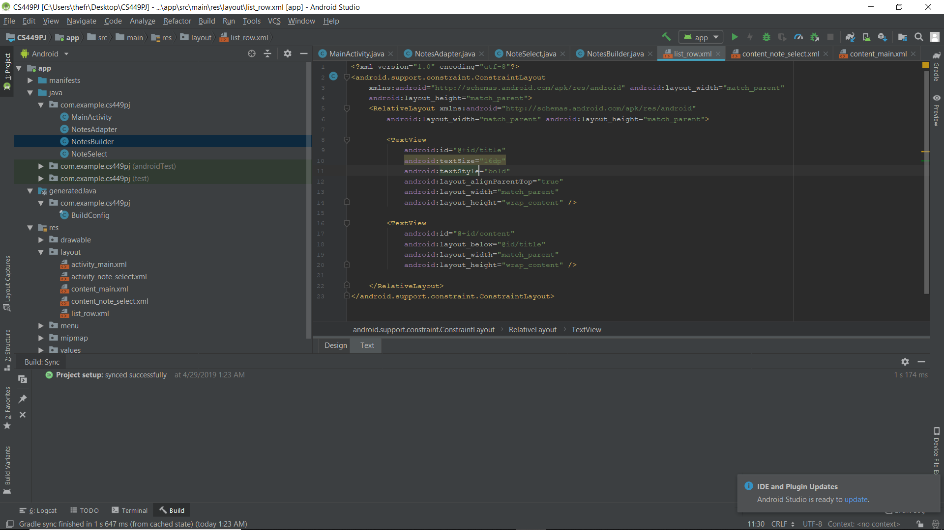

NotesAdapter class takes a data set and attaches it to the recycle view.

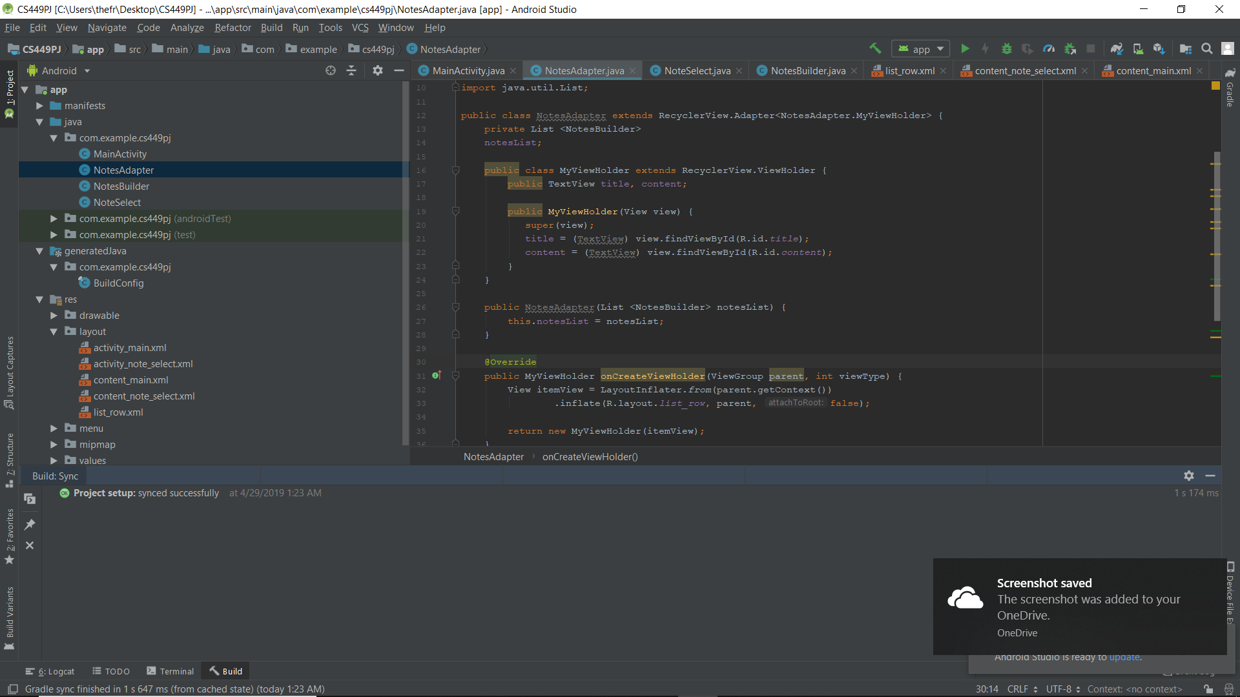

Retrospective

I got a little trouble when I was trying to create a new class but did not know how to locate it to the right place

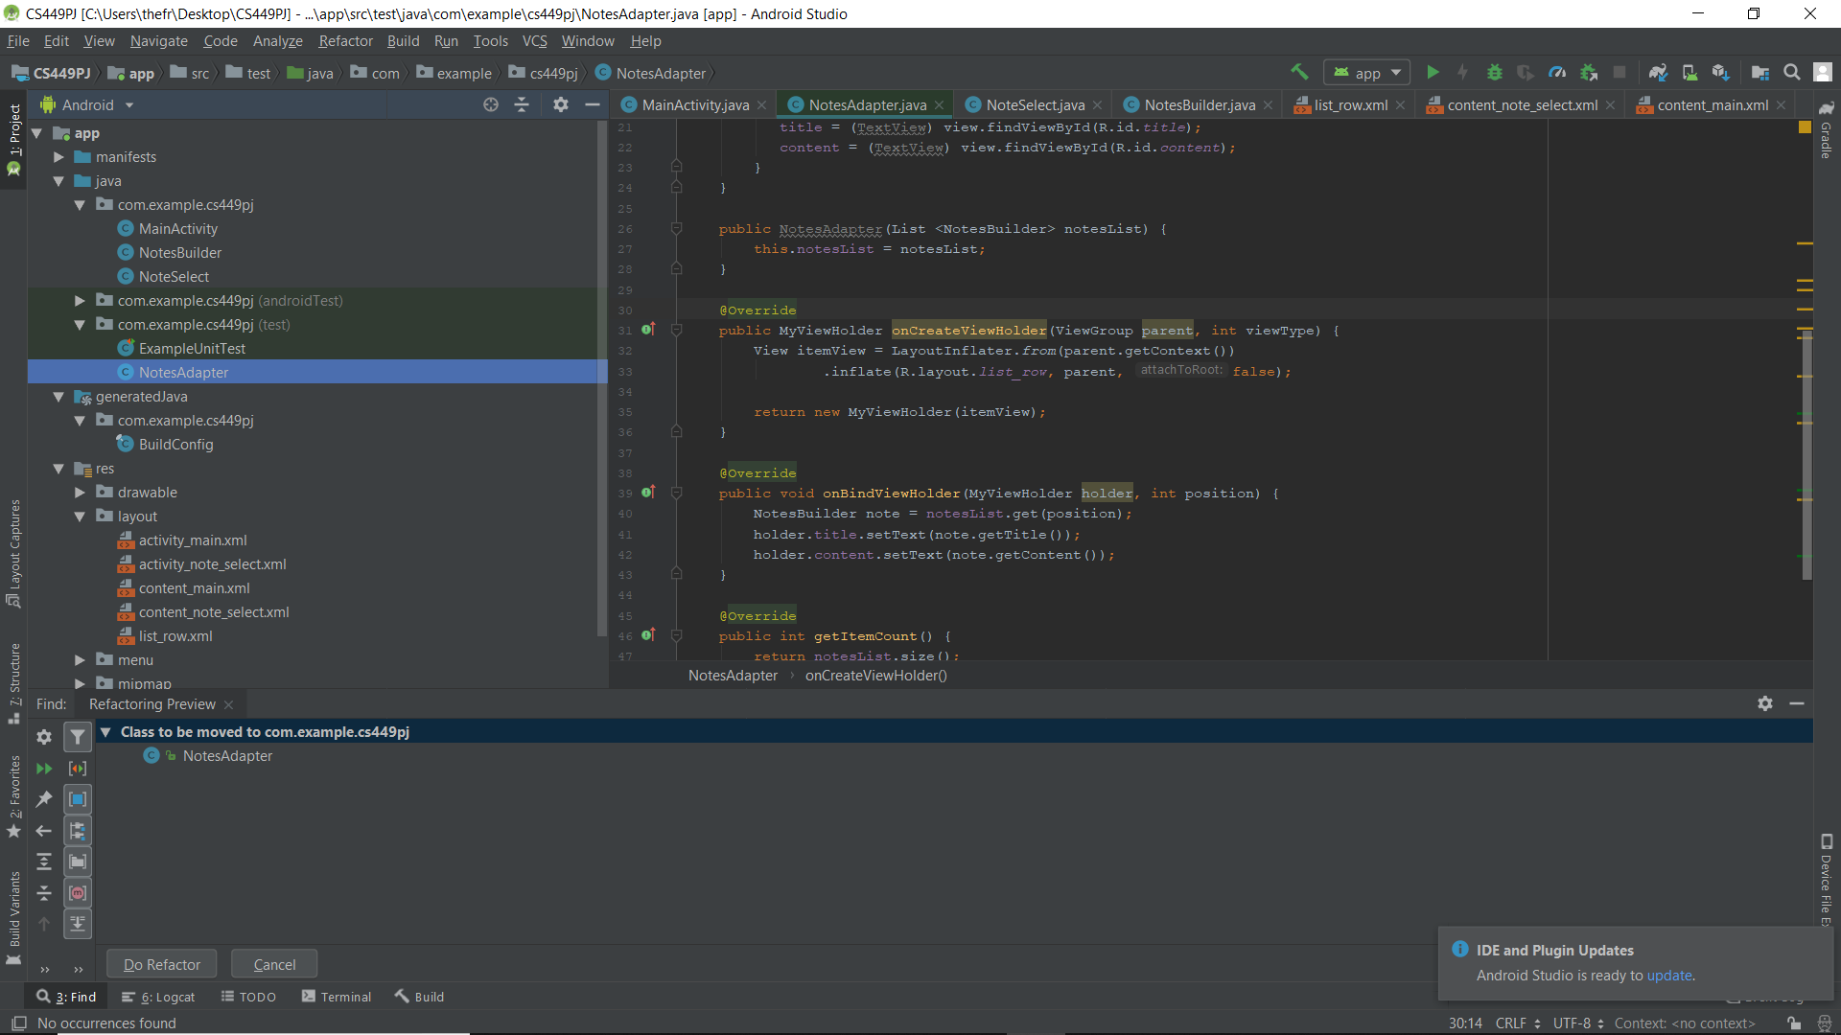

For the next sprint, I will finish the last part of the project, which is the NoteSelect class of the app.