Sprint #6

Sprint Backlog

|  |  |  |  |
| --- | --- | --- | --- |
| Story ID | Story/Task | Estimated Hours | Actual Hours |
| 09 | NoteSelect | 50m | 1h20m |
|  |  |  |  |
|  |  |  |  |

Review

Using LinearLayoutManager, RecycleView is populated using the adapter so that it shows the notes. prepareNote is where this happens.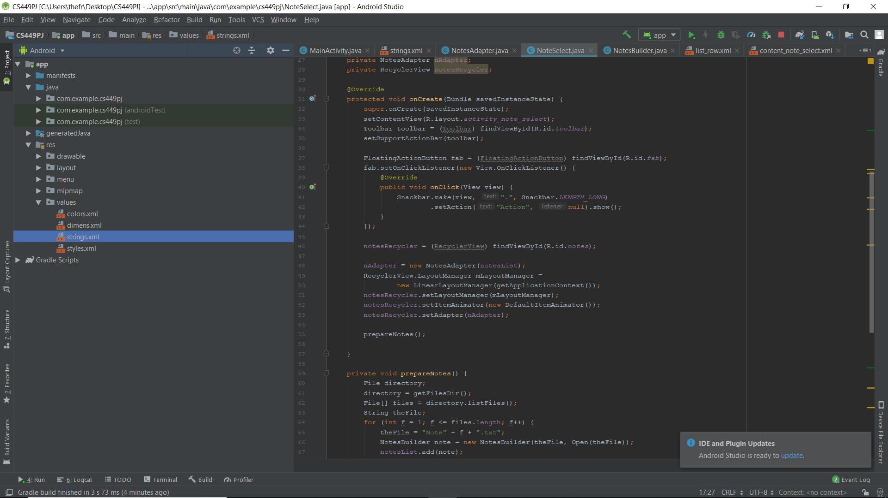

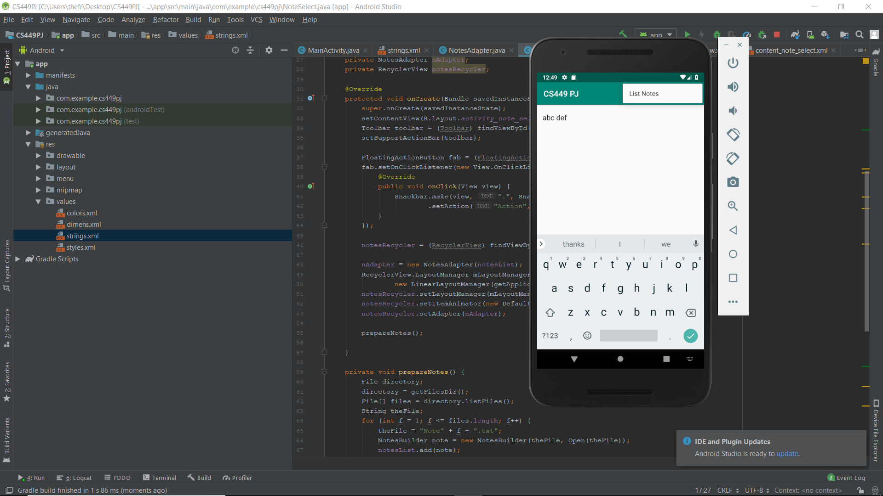

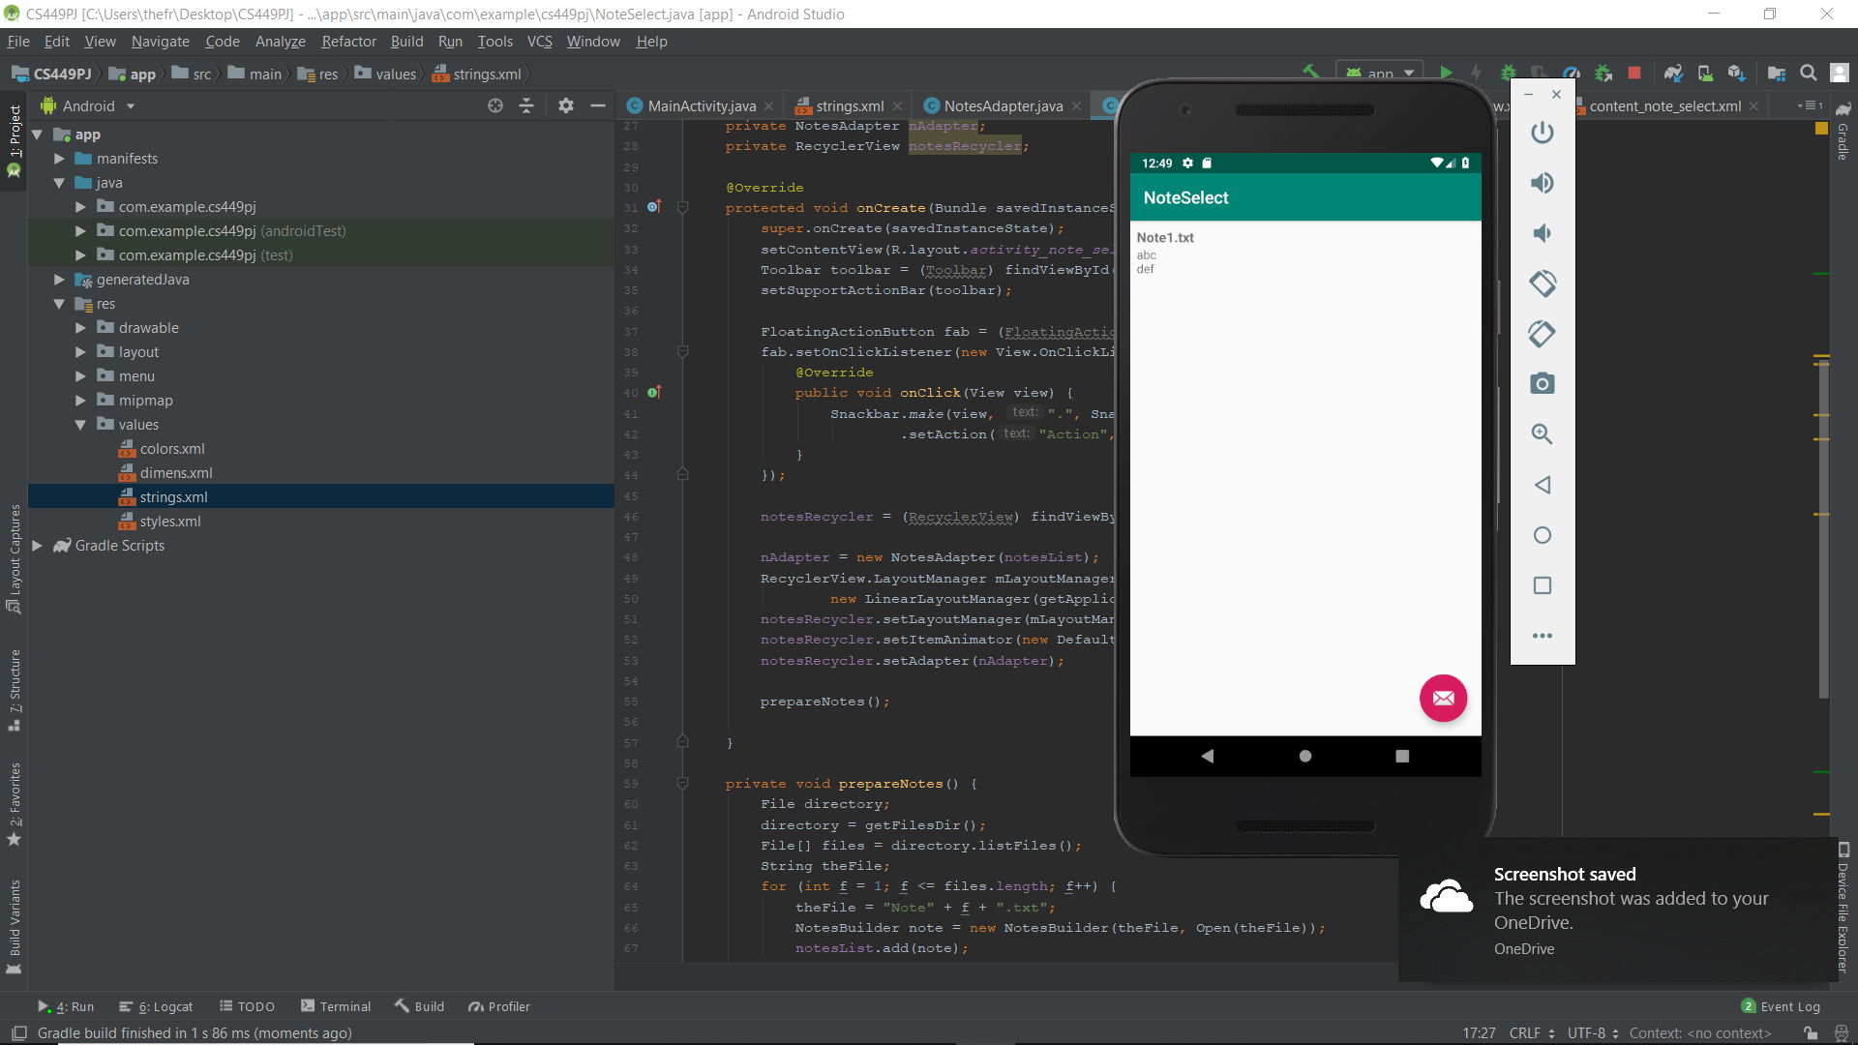

Retrospective

This is my very first Android project that I put effort to study a new programming language. I find this is quite challenging and interesting at the same time for this semester.