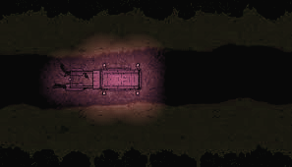It’s night time, the dark and deep blue sky was looking peaceful. You wake up drowsy in the tent of a wagon. Your body is still tied up and the metal chain was still there. Where are they taking you now? You feel the bumpiness as the wagon slowly moved on the cold hard road. It’s a familiar feeling…it’s not the first time that you’ve been sold. Around you were other illegal goods of the land, human life was just another commodity to them. You look out the small gap at the entrance of the wagon. The corners of the covering cloth are softly lit by lamps outside the wagon. Maybe the next place would be nicer. Looking out of the window, you wonder if one day you will be free.

Then, there was a flash of light and followed slowly was silence as the wagon stopped. You wonder, “What happened? “. A soft rumbling sound followed shortly was, you hear the driver running away form the wagon and hear his muffled scream. You began to get extremely anxious, the wagon began to shake more and more violently. And you try to look outside but was tied to the wagon by a metal chain.

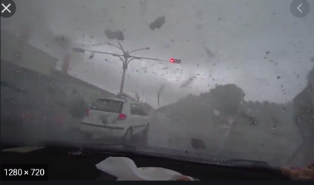Then **it** **hit**, an insanely large cloud of wind and dust struck the wagon. Propelling you violently with it. Everything in the back was flying around, you scream for help. You don’t want to die. You’re crying. The hood of the wagon blew off against the wind. Around you see trees and rocks all in the air. Were you in the middle of a tornado? As you were processing all these overwhelming emotions, something in you in the head and you pass out.

You’re first encounter with money girl, you see her struggling with some guards, she yells at you EH WAIT SHES MY FRIEND, … Guard says miss do you know this person, the games first menu pop ups > NO > Alright shes gets taken away comedicallys… I’ll get you for thiss…….

As you adventure you meet people who could be part of your party, each one having their own quirky unique characteristics. You’re not really sure what waits for you all but enjoy partying with them.

**Money girl** likes money, she is a passionate magician from her hometown but unfortunately one of the worst wizards. She is bright and cheery and gets easily excited, especially when it comes to money. Some times she has trouble balancing her friendship with people and money, but really is a good person inside. When our next quest was at her hometown, she seemed quite reluctant to go, are there things she doesn’t want us or them to know? Why does she like money so much? What are her motivations?

**Ideas to explore**

**Instead of kingdom separated by race, maybe separate by some weird thing like height, some kingdoms are just really tall elves+humans+orcs.**

**Maybe a very globalized fantasy world. Majority elf but some humans/orcs in each kingdom**

**Characcter ideas.**

A character that is an absolute chunni, convinced he is something like a (demonlord serial killer) and acts like it even though he really isn’t. Instances where he struggles to play his persona because he really isn’t that

**Storyies I liked**

**Nogame no life**

**Sheleter**

**Undertale**

**Trails of mana**

**Wizard of oz;**