# Accessible PowerPoint Presentations

Creating a presentation using an accessibly principles will not only help you better utilize PowerPoint’s built-in tools for structure, but it will also ensure that all of your content is available to all students regardless of how it might be consumed.

It should be understood that a presentation, alone, is often not an instructional recommendation. It is the presentation, in conjunction with a lecture or activities that enhance the learning experience.

## Live PowerPoint Presentations

Be aware that some students may not be able to **see** well, **hear** well, or **understand information** presented in some ways. In seated classes, following a few presentation guidelines will ensure as many students understand the presentation as possible:

* Speak clearly
* Use simple language
* Reference all displayed text
* Describe pertinent parts of graphics, videos, and other visuals
* Describe other visual information. For example, when asking a question that requires a response of raising a hand, report how many students responded.

## Creating an Accessible PowerPoint Presentation

If a presentation is to be emailed, uploaded to Blackboard, or digitally shared with a student in any way, it will need to be structured accessibly. It is easier to accomplish this while creating the presentation; however, these guidelines are applicable to existing presentations.

1. Use slide **Layouts** to arrange information on all slides. Layouts help build the structural backbone of a presentation. Many layout options are available and this is the most significant thing you can do to ensure accessibility.  
   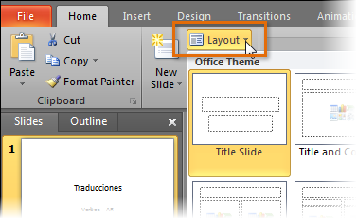
2. Use a **unique** **title** for each slide. The title can be simple, and it should reflect the slide’s content.   
   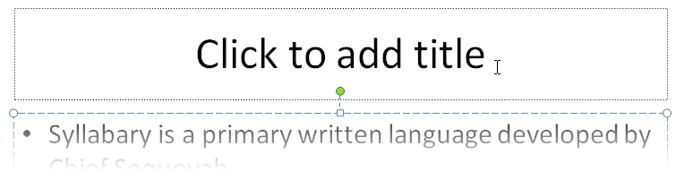
3. Utilize **built-in bulleted and numbered lists**. Slides should not contain paragraphs of information. Break the information into bite-sized chunks and let the slide be a supplement to your lecture.  
   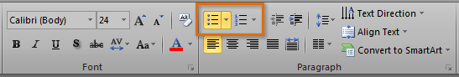
4. View the presentation in **Outline View** to confirm that the content on individual slides is logically sequenced.  
   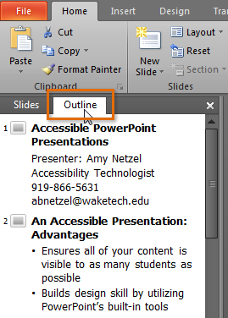
5. Use **good color contrast** (especially when considering themes). Light and dark color combinations usually work well.
   * Avoid using color alone as emphasis. Use bold and/or italics, as well.
   * Note that a succession of underlined words is often misinterpreted as a hyperlink.
6. Compose alternative text for all images with the purpose of informing the student of their function. Right-click the **image** and select **Format Picture**.   
   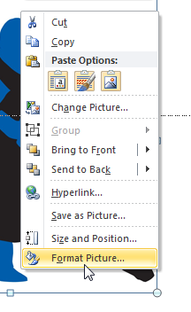
   * When using images as decoration, you may write the word *Decorative* as the alternative text
   * If the image needs a longer description, provide the description on the slide (or in the Notes area).
7. Tables should be created natively using PowerPoint's **Insert Table** command. Do not give the table an alternative text; doing so will make the content unavailable to assistive technology.  
   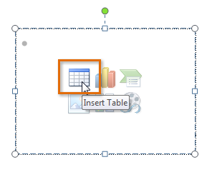
8. Create accessible hyperlinks and provide a direct link. The **hyperlink text should answer three questions**:
   * To which website does the link go? (name of website)
   * What will be viewed? (specific content)
   * What happens when the link is clicked? (opens in a new window)
9. **Avoid automatic slide transitions and text animations**. Simple **on-click** slide transitions are OK.
10. Evaluate your presentation with the **Accessibility Checker**.  
    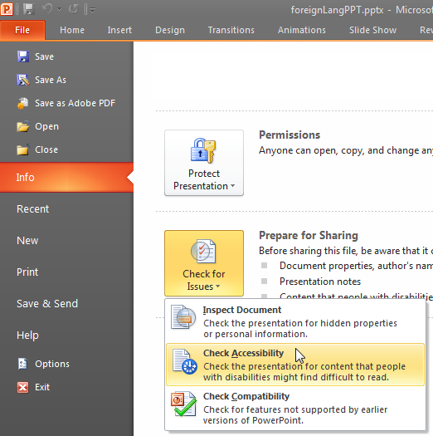

## Equivalent Access Options

Contact Amy (abnetzel@waketech.edu) or Darrin (daevans3@waketech.edu) if you’d like training or a refresher on any of these options:

* Use Camtasia to create a video of your PowerPoint presentation. A video can be uploaded to YouTube and easily captioned. A transcript should also be provided. eLearning Support can assist with captioning, as well (email Amy).
* Type your accompanying lecture, accessibly, in Word. Make sure to let the reader know which slide(s) you are referencing.
* Audio record the live lecture and upload it with the accessible presentation and a transcript of the recording. Make sure to let the reader know which slide(s) you are referencing.

## More Information

* [W3C’s How to Make Presentations Accessible to All (opens in a new window)](http://www.w3.org/WAI/training/accessible)  
  Direct link: http://www.w3.org/WAI/training/accessible
* [WebAIM’s PowerPoint Accessibility (opens in a new window)](http://webaim.org/techniques/powerpoint/)  
  Direct link: http://webaim.org/techniques/powerpoint/