# Creating Accessible Content in SoftChalk

SoftChalk is a great resource for developing and posting lesson content in Blackboard. Its versatile nature gives faculty members the ability to type material as well as embed media and develop activities for students. As lessons are created, following a few accessible design tips will help ensure the content is available to all students.

## Tip 1: Accessible Color, Contrast, and Themes

Selecting a font and background color that have strong color contrast will ensure the text stands out from the background. Generally, dark and light color combinations work well, for example black or dark blue text on a white background, or yellow text on a black background.

### Combinations to avoid

With almost 10% of male students (and about 1% of female students)[1] experiencing some form of color vision deficiency, it is important to make sure that color alone is not used for emphasis or to convey information. Use an additional indicator, such as bold or italics to emphasize textual information or use symbols when conveying graphical information. Additionally, the combinations of red and black as well as green and black should be avoided.

### Creating a Theme

You may wish to design a theme that automatically formats the text and background color of each new lesson page.

* Click **Tools** and select then select **StyleBuilder**.  
  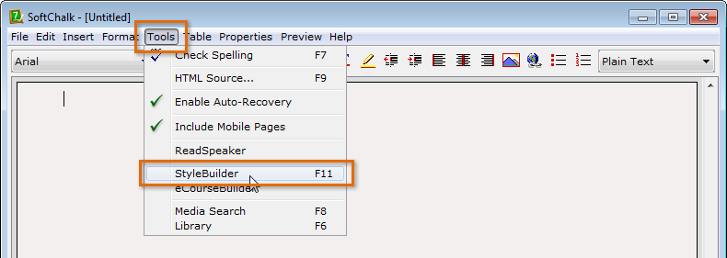

### Loading a Customized Theme

Your department may already have a SoftChalk design template. If so, you’ll need to load it.

1. Click **Properties** and then select **Style Properties** from the menu that appears.  
   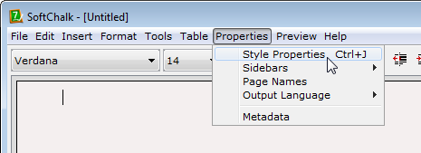
2. The Style Properties dialog box appears. Click the **Install & Restore** tab and then **Install Custom Style**.  
   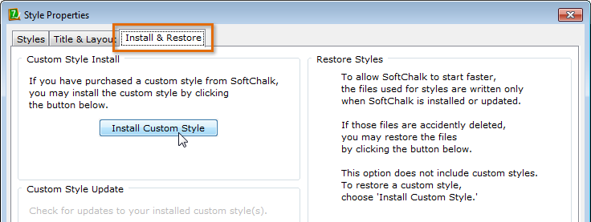

## Tip 2: Creating Structured Content

Content that is well-structured is easier to navigate. Two tools for creating structure are SoftChalk’s heading styles and list commands.

Note: The font style and color of these tools can be saved in a theme.

### To Add a Heading Style

Remember to use the heading styles in order. Generally, there should only be one Heading 1 per page and Headings 2 and 3 should be used for subheadings.

1. Highlight the text you wish to format.  
   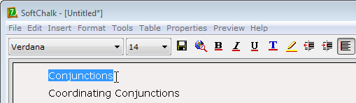
2. Click the **Plain Text** drop-down menu and select the desired heading. In the example below, Heading 1 has been selected because this is the subject of the page.  
   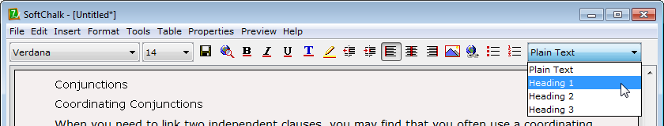
3. The heading style will be applied.  
   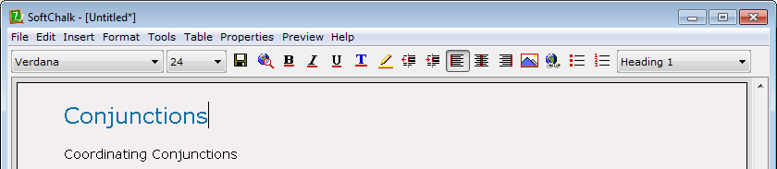

### To Create a List

1. Place the insertion point on a blank line.
2. Click the **Toggle Bullet List** or **Toggle Number List** command.  
   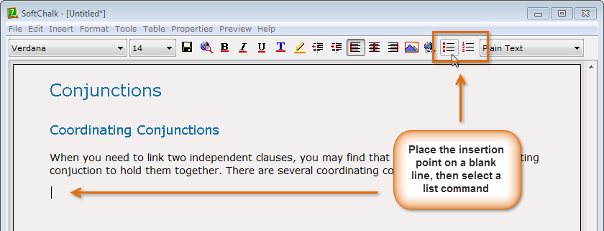
3. A bullet (or number) will appear. Type the first item of the list. Press **Enter** to move to the next line.  
   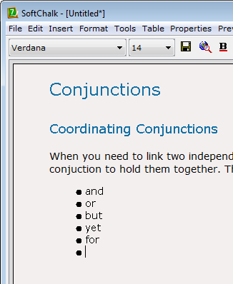
4. To create a sub-list, click the **Increase Indent** command.  
   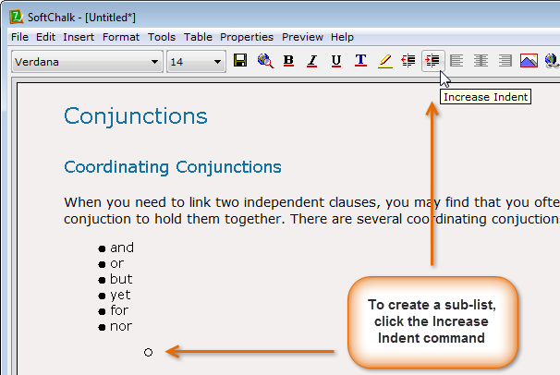
5. When you are done typing new items, press **Enter twice** to exit the list.

## Tip 3: Accessible Images

SoftChalk allows you to insert images to help supplement content. Each image will need text representation (an alternative text) so that its content is available to those who are unable to see it.

### To Insert an Accessible Image

1. Right-click on the location you want to insert an image and select **Image**.  
   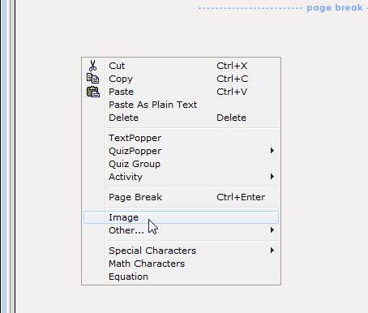
2. The Insert Image dialog box appears. Click **Select Image** and locate the image.
3. In the **Alternative text** field, type a short alternative text for the image. Click **OK**.  
   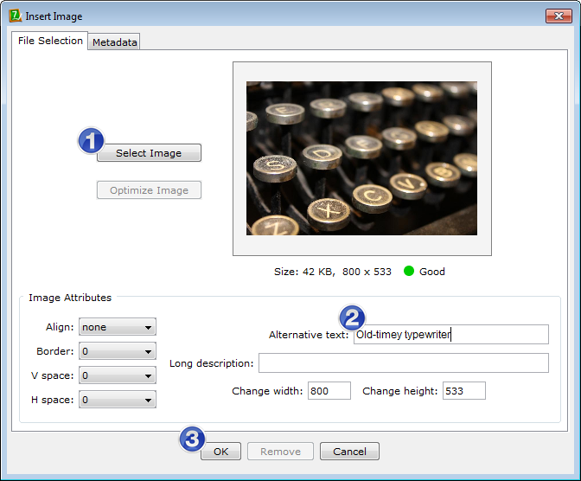

Note: If a **longer description** is necessary, type it as a **paragraph**, either above or below the image **in the lesson**. Consider adding a longer description when an image is a complex graphic or if it contains important content. When a long description is necessary, all students will benefit from it.

## Tip 4: Accessible Hyperlinks

Screen reading software allows students, with sight disabilities, to access all of a page’s hyperlinks as a list; the links will be presented out of context, meaning the list will not contain other content from the page. For this reason, it’s important to provide some important information in the hyperlink text:

1. **Where is the link going?** If the destination is a website, type the name of the site.
2. **What will be viewed (or why is the link provided)?** Often, this might be a particular page within the website you’ve chosen, but if there is something in particular that you want to draw students’ attention to, communicate that in the hyperlink text.
3. **What happens when the link is clicked?** If you choose to have the link open in a new window, informing students of what to expect (i.e., a new window opening) will help them be ready to navigate the new environment.

### Sample Hyperlinks

* [eLearning WTCC’s YouTube video on Accessible Hyperlinks (opens in a new window)](http://youtu.be/aJ9Admz15D8?list=PLcACEST_xBAH6riKYtenS2Wpx6T9KEhpm)  
  [http://youtu.be/aJ9Admz15D8?list=PLcACEST_xBAH6riKYtenS2Wpx6T9KEhpm]
* Accessible Hyperlinks Video Transcript (text document) Note: this hyperlink is formatted for illustrative purposes only.

### To Insert a Hyperlink

You will work with your web browser and SoftChalk.

1. In your web browser, locate the webpage you wish to use. Copy the page’s **address** (URL).  
   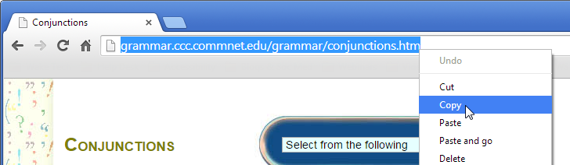
2. In SoftChalk, highlight the **text** you want to use as the hyperlink. Right-click, select **Other** and then **Hyperlink**.  
   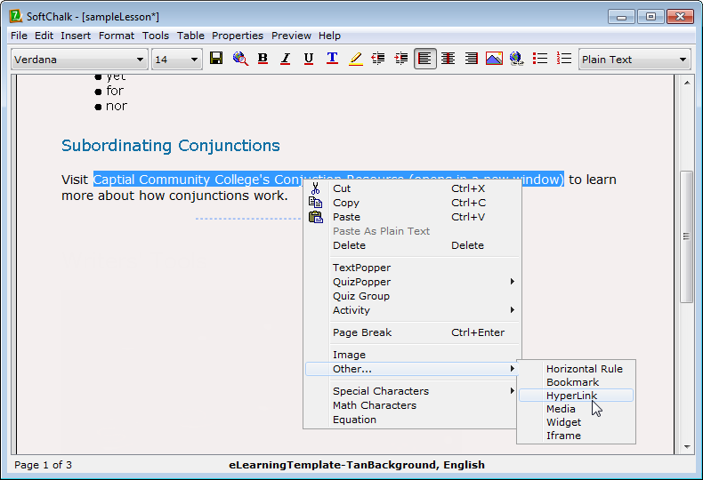
3. A dialog box appears. In the **URL or Selected File** field, paste the webpage’s address. If the page is located outside of the Blackboard environment, place a check next to **Open the link in a new window**. Click **OK**.  
   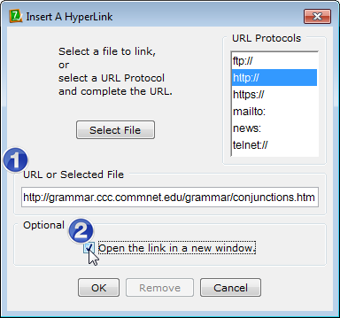
4. The text will be hyperlinked. As a courtesy, include a directly to the webpage by pasting it near the hyperlink.  
   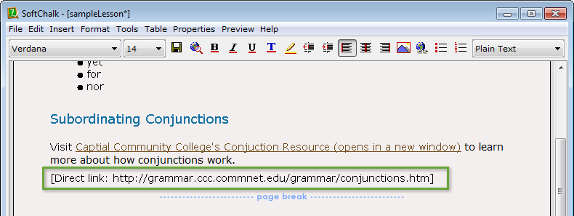

## Tip 5: Adding a Video Widget

When you need to add a video to a lesson, use SoftChalk’s **video widget** tool to embed the video right into the page. The widget’s controls are keyboard accessible and when a **captioned video** is selected and a **transcript** included near the video, an accessible media experience is created.

### To Create a Video Widget

You will work with your web browser and SoftChalk.

1. In your web browser, locate the captioned YouTube video you wish to use. Copy the video’s **address** (URL).  
   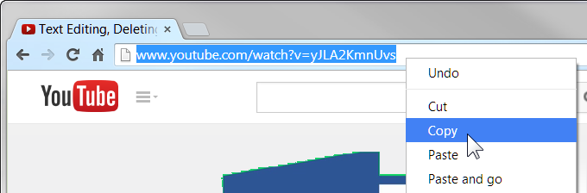
2. In SoftChalk, right-click the **location** where you want to place the video widget. Select **Other** and then **Widget**.  
   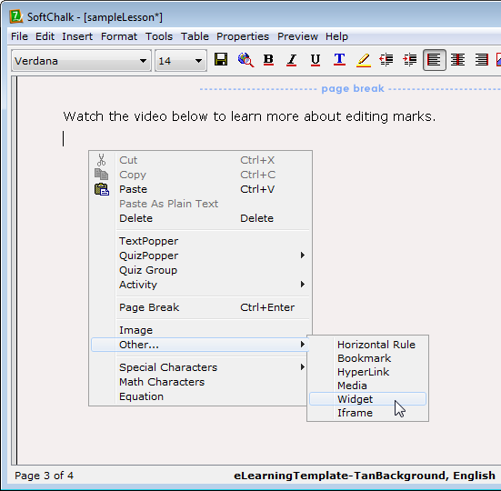
3. A dialog box appears. In the **Name** field, type the video’s title as it appears in YouTube. In the **Description** field, paste the video’s address.  
   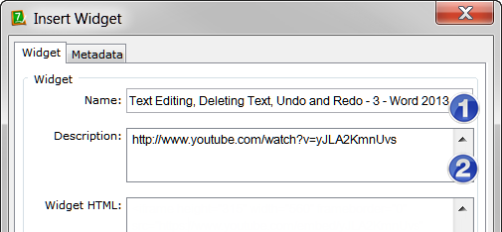
4. In your web browser, click the video’s **Share** button and then select the **Embed** tab.  
   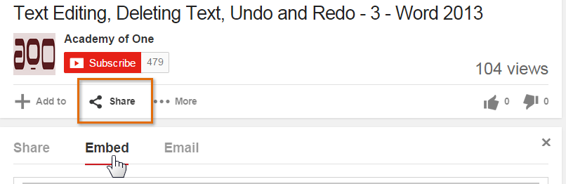
5. The video’s embed code appears. Copy the **code**.  
   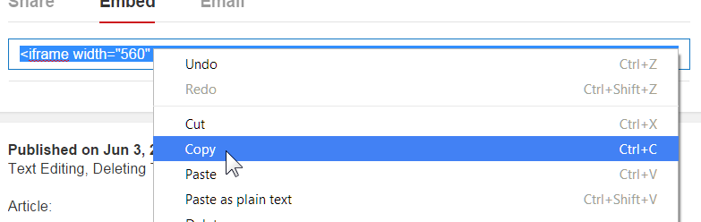
6. In SoftChalk, locate the **Widget HTML** field. Paste the embed code in the Widget HTML.
7. In the embed code, type *https:* before *//www.*, so the code appears as:  
   src=”**https:**//www.youtube....

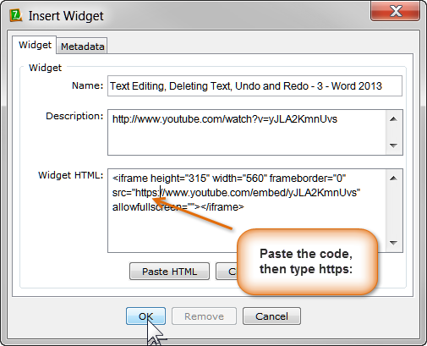

1. Click **OK**.
2. The video widget appears in the lesson. For now, it will say Widget Placeholder. To check the widget, preview the lesson by clicking **Preview** and then **View in Browser**.  
   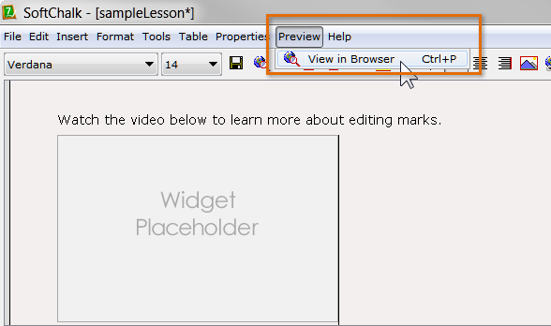

Note: To search for a captioned YouTube video, type the topic you want to search for into the Search field followed by a comma and then cc (for closed captioned)  
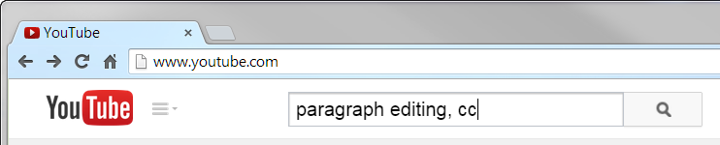

## Tip 6: Accessible SoftChalk Activities

SoftChalk has a number of built-in, accessible interactives that can be used to assess student knowledge, review information, or serve as a simple break from reading content:

* DragNDrop
* Ordering
* Flash Card
* Hot Spot
* Labeling
* Sorting

To learn more about how to use these SoftChalk activities, download the [SoftChalk user guide (opens in a new window)](http://support.softchalk.com/ics/support/DLSplash.asp) for your version of the software.  
  
[Direct link: http://support.softchalk.com/ics/support/DLSplash.asp]

1. Source: Color Blind Awareness. http://www.colourblindawareness.org/