|  |
| --- |
| CUNY SPS |
| Data-based Determinants of Steam Sales |
| MSDS 698 - Capstone Project |

|  |
| --- |
| Taha Ahmad  5-14-2024 |

# Table of Contents

Table of Contents 1

Abstract 2

Keywords 2

Author Introduction 2

Problem Statement 2

Literature Review 3

Methodology 6

Experimentation & Results 7

Data Collection and Preprocessing 7

Data Processing and Exploration 12

Summary and Conclusion 18

Works Cited 19

Appendix 21

# Abstract

In this research paper, we present a methodological approach aimed at extracting and analyzing data from various APIs to gather comprehensive insights into video games released within the past decade. Emphasis was placed on extracting modifiable information relevant to developers, while disregarding static factors such as temporal context. The acquired data underwent rigorous processing through API integration to enhance historical sales records and extract additional features from textual descriptions. Subsequently, predictive models were constructed and systematically compared. Although the most compelling model of an OLS exhibits moderate accuracy with a high RMSE of $56,250 in predicting game sales, it offers valuable guidance for developers seeking to optimize their sales strategies. Key insights include the efficacy of features such as HDR support, juxtaposed with the potential deterrent effect of numeric-heavy game descriptions.

# Keywords

Market Research, Machine Learning, Video Games, Interpretability, Logistic Regression

# Author Introduction

This research project was conducted by Taha Ahmad, a graduate student at CUNY SPS’s Master of Data Science program. He has previous experience in the cybersecurity field working as a cybersecurity analyst and then engineer. Working with log data and alerting has given him an appreciation for what goes into the specifics of machine learning models working into the backend. While a lifelong hobby has led to this project basing itself on machine learnings in the sector of video games.

# Problem Statement

The gaming industry is a sleeping tiger in regards to profit potential for investors and businesses alike. In 2023, the global market for games reached 184 billion USD in revenue (Wijman, 2024). This can be directly compared to the global box office revenue for movies in 2023 hitting $33.9B (Mitchell, 2024) or the global music market revenue hitting $28.6B the same year (IFPI, 2024). This difference of about six times more revenue than these well-established giants of entertainment, showcases the potential for profitability within the video game industry.

The video game industry is made up of multiple sectors though, and we specifically want to focus on the $38.4B slice of the market that is attributed to games sold for use on computers. As this is the fastest growing portion of the industry with +5.3% year over year growth last year. Broken down further there are multiple different platforms that sell games on PC, but the largest by far is Valve’s Steam marketplace with $8.8B in 2023 revenue and 132M monthly active users that will only have grown since the last count in 2021 (Steamworks Development, 2022). Those are 132 million potential customers to sell to, but every new game that comes out is competing with the 108k and counting other games on the storefront (SteamDB, 2024). Large game development companies are able to compete on the marketplace through having existing loyal customers and large marketing budgets. However, independent developers and smaller companies cannot feel confident in their new releases selling even if they are certain in the quality of the product.

Therein lies the crux of the problem we want to tackle: How can a small developer release a game on Steam and stand out amongst the multitude of competitors? We want to take a data driven approach to solving this problem by gathering data available through Steam and third-party APIs to extract features for previously released games. With the data we aim to build a predictive model that is able to accurately assess which features get games by small developers in the hands of the most Steam users as possible. Ideally this research will be able to be used by developers to improve their sales with minimal changes to the vision of the product that they want to release.

The issue at hand hinges on the fact that small game developers have many disadvantages selling their games on Steam mainly owing to a lower marketing budget, less insight into the market, and mostly non-existent customer recognition. Yet, there is still the occasional success story of a small developer creating the latest hit game that's taken the Internet by storm. In theory, these games that are ending up much more successful should be doing something tangibly different. Taking a data-driven approach, relying on game information provided by Steam, to resolve this problem allows us to distill our research question down to:

What developer actions and game features can small game developers listing their game on Steam utilize to achieve the most sales?

# Literature Review

Our literature review starts off with us taking a look at those studies which have a similar goal to ours. Right off the bat, we are able to find *Game Data Analytics using Descriptive and Predictive Mining* with the same goal to help developers sell their games better. The authors tackle this by iterating on a clustering algorithm for a large number of games and features extracted from Steam APIs. The clusters that they build essentially segment games into those that sold better and those that sold worse based on characteristics like player average playtime and user review rating (Prathama, Asmara, & Barakbah, 2020). It is good information for us to keep in mind that average playtime and user review ratings are important predictors for how well a game sells. This is a sentiment that is echoed in other literature as well along with the affect that having a certain publisher or genre can have on a game (Sacranie, 2010; Cox, 2013). However, we won’t be using the playtime and quality predictors as they are not necessarily something that the developer themselves is able to change when releasing a game on the Steam storefront. A developer can attempt to make their game as good as possible, but that doesn’t necessitate a good review from most players or players contributing more time into their game. We want to focus on those variables that the developer is quickly able to change without compromising their vision.

Following that line of thought we move on to find studies where we can locate these variables that are easily changed but also contribute to sales. *Value Creation in the Video Game Industry* is a review paper that attempts to tackle making a broad economic overview of the industry and highlighting what marketing and research in the industry has found to lead to higher profits. We’re not terribly interested in the generic overview of the industry. However, deeper insights into phenomenon that lead to increased sales such as direct network effects which consist of large positive feedback loops in sales is something that we’re keeping a watch out for in our data when creating our models. More importantly for us there is discussion regarding social media marketing and sentiment positively affecting sales (Marchand & Hennig-Thurau, 2013). YouTube is also showcased as another avenue for having positive effects on sales when looking at other research (Adigüzel, 2021). In theory, we should be able to mine for social media information regarding the developers or publishers of the game to see if they have been engaging in social media marketing along with evaluating the response sentiment. Both of these would become powerful parts of our model if achieved.

Text mining information can be a powerful tool even if it isn’t applied to social media. After looking into the previous avenue of data mining, we headed towards looking for information on how to optimize mining data from product descriptions. Each game on the Steam store has a large product description in order to inform the potential consumer what exactly the game is about, and more importantly attempt to sell the game to them. Description mining for games was a very sparse research topic when looked into, but general information about product descriptions was much more forgiving. The Association for Computing Machinery put out research on utilizing models to extract the features from the description of a product semi-automatically. The process involves manually creating a set of common variables from within the descriptions that could be extracted by searching upon it (Acher, Cleve, Perrouin, Heymans, & Vanbeneden, 2012). Mining common information from the description for our project will follow suit in a similar manner, where we manually outline what common variables we want to extract from our descriptions.

A multitude of other features for the games that we are analyzing will be extracted directly through the Steam page. Which is why the next related topic regarding our research has to do with finding out what features that a game have would generally seem to appeal to different gamers. This research is based on directly surveying gamers about their preferences and classifying them into different clusters of play style while the features of games are different clusters of game styles. It is found that there are demographic features that correlate with what types of video games a player likes (Tondello & Nacke, 2019). Additional information is also found that the most common demographic of gamers is currently younger males, a group with a preference for action, racing, and sports games (GilPress, 2024). Our research can assume that the likely outcome is for a game being listed as one of those genres will increase sales. Thus, we should make sure to put variables for the genre in our model.

So far, our research has mainly focused on features for our model. We now move on to looking into potential models themselves. Our first instinct for modeling game sales data in order to maximize interpretability of the model is to utilize an ordinary least squares regression model. As with OLS, coefficients will be easily available to measure the effect of each change in variable. However, with our Steam data we could potentially have more than a hundred variables from features, genres, and tags. Simen Gaure provides an alternate form of OLS that has been made available through an R package after his research. It is optimized for data with a high number of categorical variables such as ours. In essence, Gaure changes the matrix multiplication method for finding the coefficients through generalizing the formula to be estimating instead of calculating (Gaure, 2013). We may require this method of calculating OLS if we end up having too many variables.

Even if we are able to fit an OLS model just fine, we want to have other models to compare it to and interpret if they beat the OLS. *Explaining machine learning models in sales predictions* helps us better understand how importance can be extracted from models that are not traditionally very interpretable. The main example utilized in the study is the EXPLAIN explanation model for random forests, where the explanation model allows for quantifying both the negative and positive affect each feature has on the outcome (Bohanec, Kljajić Borštnar, & Robnik-Šikonja, 2017). Ideally, we would be able to extend this method for other black-box predictive models that we use. XGBoost is a forerunner for another potential model to use, although it was not applied within the paper, we would like to attempt this ourselves if XGBoost is the optimal model for accuracy.

No matter what type of model we use, there was a very specific concern that we had regarding historical sales data, which required in-depth research on how to deal with it. Sales data that is tied to time in some way, shape, or form can be vaguely considered a type of time series data. However, our model is not purely a time series model nor could it be construed as one. As despite having many data points for some days, there would be wide gaps in between many other dates due to game releases happening in seasons of sorts. Thus, we wanted to look into removing the effect of time from regression-based models. One paper tackles this by utilizing locally weighted robust regression to minimize trend that is found within the regression data (CB, PS, & CC, 2003). Unfortunately, we do not seem to have the amount of data points per date to be able to recreate detrending through the lowess regression method.

Looking into other sources, we find a textbook regarding econometrics data and analysis which will have similar time affected data in the field. The textbook espouses that it is possible to control for time that will have a similar affect across entities within our data utilizing the model of Yit=β0+β1Xit+δ2B2t+⋯+δTBTt+uit. This can be extended to include fixed effects that are not time based at the same time which might be useful information if we implement region information into our data as well (Hanck, Arnold, Gerber, & Schmelzer, 2024). However, the application of this fixed affect model once again seems to hinge on having multiple historical data points for each type of categorical variable. Having multiple historical data points for our games would do us no favors when we are only interested in how well a game has sold at a fixed point after the game has released.

Since we are unable to find a satisfying way to deal with the effect of time in our model completely, we decide to look into how to detect the presence of time affecting our model. Once more we delve into the field of econometrics by looking at lectures for Econometrics 2 at Montana State University. The lecture that we find relevant to the current problem gives us an overview of how time might affect regression models that are based on least squares. We will need to look at our resultant models to see if errors end up correlating with each other in a pattern that has to do with time, see if some games selling well might lead to others in the genre selling better too due to increasing exposure, or data that seems to be related but the actual reasoning for correlation is based on time trends (Stoddard, 2016).

# Methodology

            The main process we will attempt to answer our research question:

What developer actions and game features can small game developers listing their game on Steam utilize to achieve the most sales?

Will be through predictive model building in Python through an ipython notebook. Our initial data was planned to be collected mainly through a third-party API called SteamSpy that scrapes the relatively undocumented Steam API. Through this we would have been able to collect data for every game on Steam, and create a model trained on the features of all the games that were released ever since SteamSpy started collecting data, ten years ago. Our target variable was going to be the approximated unit sales for games, one month after they have released, found through SteamSpy’s historical data.

Unfortunately, after paying for a pro subscription to SteamSpy which boasted access to historical pricing data, we found out that historical data was not provided through the API and instead through JavaScript tables in a painfully slow loading website where authentication headers did not properly return historical data due to issues syncing the pro account benefits. This made SteamSpy unfeasible as a source if we were to use historical data. Instead, we pivoted to utilizing the Gamalytic API to collect historical sales data from. The Gamalytic API is very similar in concept to SteamSpy in that it partially contains sales data scraped from the Steam API but also partially has models which estimate sales data at certain points in time. Sales data being partially model driven is a concern for the validity of our response variable. However, Gamalytic claims that “77% of estimates were within 30% margin of error” (Gamalytic, 2024). Additionally, the models which output sales data do not utilize any of the variables that we are going to use, so we will not fall prey to unwittingly including an explanatory variable that is part of what the response is directly derived from.

Meanwhile the explanatory variable set will include a wide variety of descriptors pertaining to information that is available on the Steam product page such as price, genre, multiplayer capability, controller support, description, and more. Additionally, we will need to gather description data from an official Steam app details API with no official documentation (Valve, 2024). Thankfully unofficial documentation uploaded to a wiki site by user “RJackson” was available and used to guide our efforts (RJackson, 2020). We also made precursory attempts to collect data on social media actions that the developers have taken on platforms such as X or Reddit, however those were unsuccessful.

            After data collection, we split the data into training and test, then move on to data processing and exploration the data will be cleaned of any errors, outliers, or missing values. We will need to adjust the historical sales data to approximate sales for thirty days. Additionally, variables will be created from the description and names which will be text mined to obtain the maximum amount of usable information from our data. A large number of variables will be pulled from arrays that make up the tags, genres, and features of each game and selected for the most popular ones. Feature selection will take place afterwards seeing if we can narrow our features to those with high correlation to historical sales, or at least does that are not overly collinear. Throughout this step we will be analyzing the relationship between the different variables and each other or the sales data.

Once our data is initially processed, we will begin building models. We will start out with iterating upon an ordinary least squares model to get the best form of a valid model that we can. While a decision tree model will be attempted as well for having the highest amount of interpretability. Finally, we will build an XGBoost model to use as a benchmark for regression accuracy to compare our other models to.

Finally, the performance of the various models will be evaluated using a mix of minimizing the root mean square error and maximizing interpretability to select the best one. We will then answer our research question by using the variable importance from this model as a guide.

# Experimentation & Results

## Data Collection and Preprocessing

We begin our data collection by using the Requests Python package which allows us to easily query the APIs that we will be gathering the data from. We'll also be using the time module so we can wait a bit before querying the API repeatedly, this allows us to collect data politely by following the API guidelines and not overloading servers. The JSON package is used in combination with the google.colab package are to save the json formatted data that is queried to google drive. Which provides a cloud backup in case of an error when querying the API and will not have to retry from scratch

From the Gamalytic API we have created a function using requests and json to page through the paged API response and get some information on all of the the games released after 2014. We choose 2014 as the cutoff due to Gamalytic having full historical sales data since release for only games that were released after that year. We also set a price minimum of $1 for any games queried, as our project's goal involves seeing what encourages consumers to decide to use their time and money towards a game. If a game is free the friction to try is much lower. Thus, we want to remove that potential confounding variable from within our dataset. In order to be polite, we do limit ourselves to one api call per second here.

For each page retrieved we add the json information to an array and save it once the function is done. Error handling is also set up in case of any timeouts or other exceptions. Initially our functions saved the API information to Google Drive after mounting our Google Drive account. However, once we were able to download the information, we moved it to GitHub for easier reproducibility and convenience, to both the reader and us, and download the data again from there. Afterwards, we import pandas as the package will be crucial for working with our data in a reasonable manner. Reading our uploaded json file as a dataframe allows us to preview the data we have collected so far.

We now have the data for the 58004 paid Steam Games that were released in the past 10 years. Our data includes features such as the Steam ID of a game, which will be used as a unique identifier throughout the project; the total copies sold which we'll not be using as a response variable, since those that were out longer would simply have time to sell more as a confounding variable; and a multitude of other tags that we will either process or go over later.

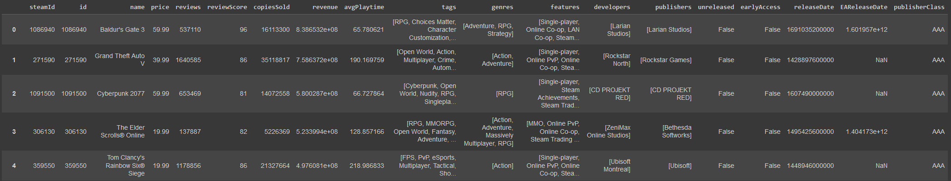

Before we move on to more API calls to join our data together, we subset our data by only including games that do not have an early access release date. A game having an early access release date means that the game was released in an unfinished state which is still actively being built upon by the developers. These games will not have actually been out for approximately 30 days from their real release date when collecting the historical data that we want. Since early access games can be out for many years before they hit their official release date. Thus, it is only proper to remove them from the dataset lest our response variable not be valid. We do this bit of processing earlier on because there are about 13,000 games with early access release dates. So, leaving these games in our dataset before making additional singular API calls would have us making 13,000 more calls than necessary. An unpolite way to utilize the free APIs.

In order to gather the data regarding game descriptions, we'll need to utilize another API, the Steam app details API. This will require querying on the individual steamIds of the games that we currently have from our previous collection. We take the ids from the dataframe of the 45,065 games that we have gathered and convert it into a list to be used further down the line.

Additionally, we import the BeautifulSoup package in order to parse any HTML remnants that are common within descriptions that are retrieved from the Steam API. However, some of the HTML might be a good indicator for sales such as the number of images or links contained in the description. So, we make sure to count those in our parsing function.

An example of a singular parse result is shown below to be compared to the raw data. It's not perfect with some artifacts still making it through the parse such as a double backslash for the “10\10” remark. Yet, we are still left with new info to use for model building and text that could be processed further for more variables.

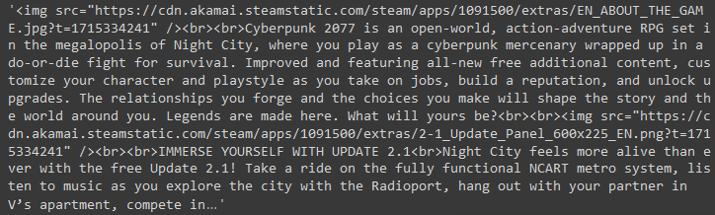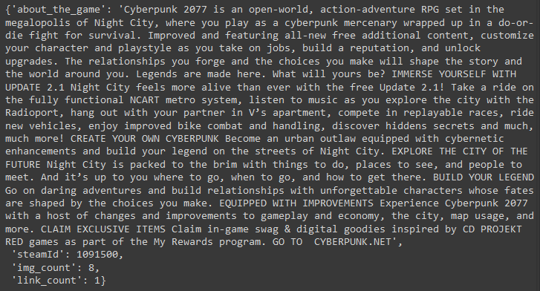

We also want to attempt to take into account the fact that some games will be selling more just from the fact that they've been out longer. Finding an alternate response variable of historical unit sales from around 30 days after release will allow us to mitigate the advantage older games get just from existing longer. To do this we call another Gamalytic API which gives us historical data over multiple different unix timestamps. We find the first unix time stamp that is greater than a month older than the release date (the range here is usually 1-1.5 months after release) and use that as the historical price indicator. Afterwards, we put together our parsing and processing functions inside another function which calls both the Steam and Gamalytic APIs every second after processing has completed. It retains features from the previous function such as being able to save on error and saving upon completion.

The historical data and description retrieval function takes multiple revisions in order to get to a state that allows for smooth and consistent processing of the potential 45,000 API requests. Such as: Saving the partial dump files to have a consistent name for recombining down the line and ensuring the files are properly dumped, and having an extended retry attempt when the occasional time out does occur.

Due to our iterative function writing process accidental missing entries from the description table were detected after one of the first runs, and a new function had to be created to query these again only from the Steam API.

Unfortunately, after 10,811 entries of historical Gamalytic data and Steam descriptions being collected we end up being IP forbidden from accessing the Steam API. We have taken into account the only condition of accessing the API which is being limited to 100,000 requests per day, and also have been taking waiting time between requests. Thus, we end up unsure of the true reason we are being forbidden from the API. However, to take data collection further after being restricted access to the API would not be misuse of a public API that Valve is providing us access to. So, we end our data collection for the extended data with only 10,811 entries of the 45065 we were initially hoping for. Still, this is a good sample of about 2/9ths of the population, games that have been fully released on Steam within the past 10 years, that we are working with.

The next step is consolidating the data from the partial json files that were generated by the function. We have created a function to search upon the naming convention of our dump files which classifies a json dump as either a historical sales data file with a suffix of "_1" or a description file with a suffix of "_2".We load both combined query result files into pandas dataframes and preview what they look like. We see below that df1 has a decent amount of excess information like rank, followers, revenue, players, score, and reviews which we'll want to trim later on. This is because our problem is focused on analyzing the variables that a developer can change before or at release. Unfortunately, a developer cannot simply set their games score, the proportion of positive Steam reviews out of a hundred, to be 100.

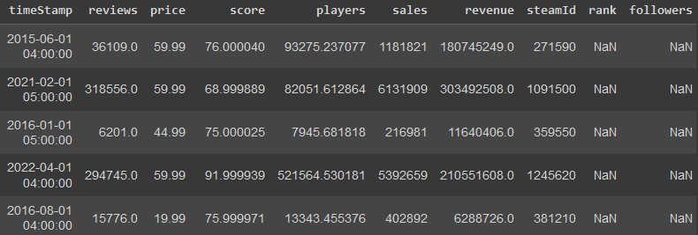 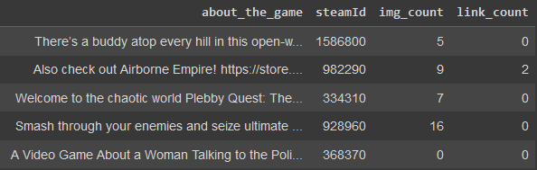

We also notice that the historical sold data is four rows shorter than the data in the description data. We can figure out which games exactly are missing through an anti-join on the description dataframe and then request those four from the Gamalytic API. A surprising result ends up being returned with only two IDs not being shared between the two dataframes. This could possibly be a result of duplicates during the collection process with overlap between some files, so we check for any duplicated rows. We see that there are eight duplicates within the description data and six duplicates within the historical data. After taking out these duplicates it leaves the historical data only missing the two Steam IDs which were previously detected. We call the Gamalytic API for these two missing IDs and utilize the previously created function for finding historical data that is closest to a month after release. Then, we are able to concatenate these two rows of data to our historical dataframe and see that our two dataframes are now equal in length and have all the same games contained within them.

The next step, that we had planned originally was to find the social media accounts from the developers and publishers’ columns of our original Gamalytic dataframe. Previously getting this information could have been done freely and easily through the Twitter and Reddit APIs (Grantham-Philips, 2023). Unfortunately, within the past year both of these companies have made their APIs paid in a way that would require a large budget to gather this social media information (Weatherbed, 2023). For this reason, we regretfully must drop the idea of gathering social media posting information for our games.

Still, we want to reiterate the importance of developers utilizing social media from our previous research: social media is known to be a very powerful force for advertising any sort of product these days. If something gets shared through social media there is the ever so slight chance of the product going viral, but also there will more consistently be discussion generated about said product. Since more people will be seeing the product in a format that allows for discussion like being able to comment on a developer mentioning that their new game is going to come out. For something that can be done for free, it should be a tool utilized by developers.

The last part of data collection is getting rid of fields that we will not use and merging together our three different API collections to get a singular dataframe which we will process further for model building. The fields that we end up keeping are:

1. SteamID: which is the unique identifier for each game on the Steam store itself. This will not be used as an explanatory variable within our model, but it is good to keep in case we need additional information for a row.
2. Name: which is self-explanatorily the name of the game, in theory this is something that could influence if a new game is sold more or less based on a few different factors that could be extracted through text mining.
3. Tags: are keywords that can possibly apply to a game which are added to store pages by Steam users, the lower on the array index a tag is the more users will have applied that tag. Thus, even though some user tags might not be accurate, the top few tags are likely to be apt descriptors of a game due to having large amounts of votes.
4. Genres: are keywords that the developers or publishers themselves apply to the Steam game page which will be even more accurate descriptors of a game. Typical game genres can include action games, RPG or role-playing games, adventure games, and many more.
5. Features: are keywords that the developers or publishers themselves apply to the Steam game page and regard features that a game has such as if it is playable online with others, is playable offline alone, has support for controllers, and more.
6. ReleaseDate: is the day a game is released to the public on Steam in unix time. This will be converted to a date and further processed to isolate the effect of each year passing, but include the effect that releasing at a certain time within a year will have.
7. PublisherClass: is an ordered categorical feature that classifies the size of the developer. Since, there are going to be differences in the amount of exposure and advertising a smaller company is going to be able to put forth, this variable will almost certainly have an effect on which variables matter the most to increase copies sold. In fact, it might be a good idea to make a different model for each type of variable here if the data allows it. The Gamalytic's API info page provides these four possible values from smallest to largest (Gamalytic, 2024):
   1. Hobbyist (AKA basement dwellers): Any publisher who made less than $10k lifetime on Steam.
   2. Indie: Publishers who made more than $10k and less than $50m lifetime on Steam.
   3. AA: Publishers who published at least 2 games, made more than $50m and less than $500m lifetime on Steam.
   4. AAA: Publishers who published at least 2 games, made more than $500m lifetime on Steam and have at least $10m average revenue per game.
8. Timestamp: is the date and time where our price and sales variables were recorded. We will utilize this variable to determine the amount of time after the release date our sales record happened to normalize sales based on exactly 30 days.
9. Price: is how much the game costed at the time of the timestamp. Price may be one of the largest influencers for our response variable due to the importance of money for every type of consumer.
10. Sales: is our response variable which is the number of units sold at the time of the timestamp. Note that this number can also include preorders and is only an estimate provided by Gamalytic, albeit an educated estimate that tends to have high accuracy. We will be adjusting this number since right now the records will not all be taking place 30 days after release date.
11. About_the_game: is the main description provided on the Steam product page for a game with any html inside of it extracted by our previous processing. We still want to attempt more NLP on the description to see how it may affect sales.
12. Img_count: is the number of images that are contained within the description of a Steam game. The prevailing theory from general discussions with small developers is that the higher the image count within the description, the better the sales.
13. Link_count: is the amount of non-image links that are contained within the description of a Steam game. We're unsure of exactly what effect having regular links might have, if any.

## Data Processing and Exploration

Data processing and exploration involves creating new features from collected data, modifying existing features, removing certain rows, and more. We begin this process by reading in our previously created csv as a pandas dataframe. Now we proceed with splitting our dataframe into a training set and a testing set. Keeping these two as separate before processing the data will prevent any data leakage from the training data into our evaluation set. Less data leakage means that there is a better chance our data can be applied to data which is external to our data set. We go with a generally accepted split of twenty percent of testing data compared to eighty percent of training data to ensure that the amount of data used for training is on the higher end.

To get an overview of our data we are utilizing the skim function from the skimpy package, pictured below is a skim from it. This package is based off of the SkimR library from R where the intent is to give a quick overview and jumpstart into data exploration for the data that you have. We can get some interesting insights right off the bat with our numerical variables such as price and sales having incredibly high values at the hundredth percentile. A possible indicator of erroneous outliers within the data.

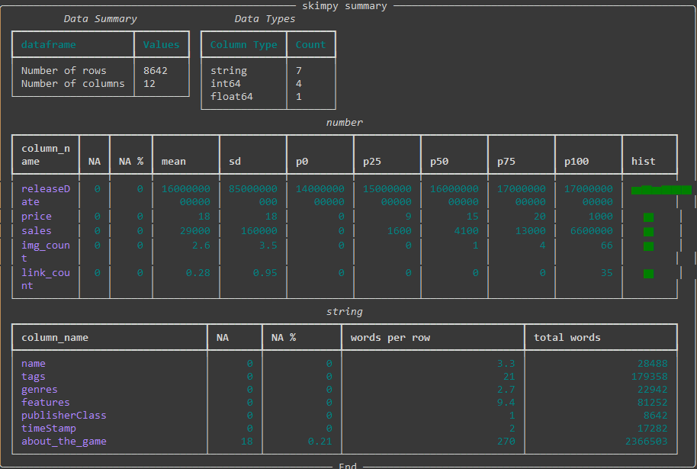

One of the things to note in our skim table is that the timestamp and release date columns are not in a proper format for analysis. The release date is currently stored in unix datetime format down to the millisecond. While the timestamp string is found to be contained in three different formats: unix datetime millisecond, year-month-day with time to the second, and year-month-day with time down to the millisecond.

We have to convert these values to proper datetime variables in order to make processing and analyzing the data easier. This conversion is done through the to_datetime function provided by Pandas. We also remove the time from these dates, as our calculations will not be needing such specificity. With these two columns in datetime format we are able to create the new time after release column. This is how long after the release date the historical sales data was actually recorded. As previously mentioned, we are aiming for a month’s worth of sales data after release. However, historical data records do not necessarily match up to exactly thirty days or even approximately close to thirty days. Thus, we need to account for this discrepancy in our data by normalizing the historical sales records by adjusting the value to match a time after of release which was actually thirty days.

Before that, we want to make sure that the time after release is not too large for some titles which might have sparse historical data collection from Gamalytic in order to increase the validity of our adjustment. We utilize sixty days as the threshold for being too far from a month after release to adjust, this number is based on analysis of when new game sales tend to exponentially decay (Birkett, 2018). While we utilize fourteen days as the floor based on Gamalytic taking at least two weeks for estimates to be able to reliably level out (Gamalytic, 2024).

Taking a look at some of these games that fall under the threshold to understand what may have gone wrong: We are able to see that in some cases Gamalytic has the wrong release date which is the case of Naruto to Boruto: Shinobi Striker below. This is concerning for the rest of our data, but manually sampling through it we are able to see that every other game sampled had the correct release date. For games that we see where the timestamp is taken more than sixty days from the release date, such as with Woodle Tree 2: Worlds, it is simply a case of the historical sales date not being updated frequently. In general, more popular and larger name games seem to get their data updated more frequently from the Gamalytic API data. With convincing explanations of why we have deltas that vastly exceed our thresholds we are comfortable with simply dropping the rows containing these timestamps. As 512 rows from our 8643-row training dataset is substantial, but the data is erroneous.

After dropping the degenerate rows, we apply our adjustment formula to the rest of the samples. Our adjustment formula is a fairly simple approach that does assume a fairly linear increase in sales past the two weeks mark up until the two-month mark. We create an adjustment factor that is the percent of thirty days that the historical data was actually recorded. Then this adjustment factor is multiplied by sales and rounded to the nearest whole number as we cannot have a decimal amount of a sale. We additionally extract the year, month, and day from the release date in order to use these to fix in place any date-based trends that might be affecting sales. Finally, we apply a sanity check to our adjusted sales values by taking a look at the highest ones after the conversion.

What we are able to find is that the top sales adjusted entries are extremely well selling games. Using Elden Ring as an example, there was an official announcement for 12 million sales on all platforms within two weeks (Orland, 2022). If anything, 4.5 million sales in a month might be an underestimate even if it's only for the copies sold on Steam. Still, looking at other games in a similar fashion our adjusted sales variable seems to be reasonable data for copies sold.

We also observe the distribution of adjusted sales in both logarithmic and non-logarithmic scales through a boxplot and histogram. Our histograms, showcased below, tells us that despite having a slightly leftward skewed modal peak, the sales data is distributed well enough to a normal distribution once adjusted logarithmically. We consider log transforming to have our response variable more closely approximate a normal distribution, but this is only necessary if the distribution of the residuals is not normal. Thus, we will hold off until later if it is needed (Ford, 2018).

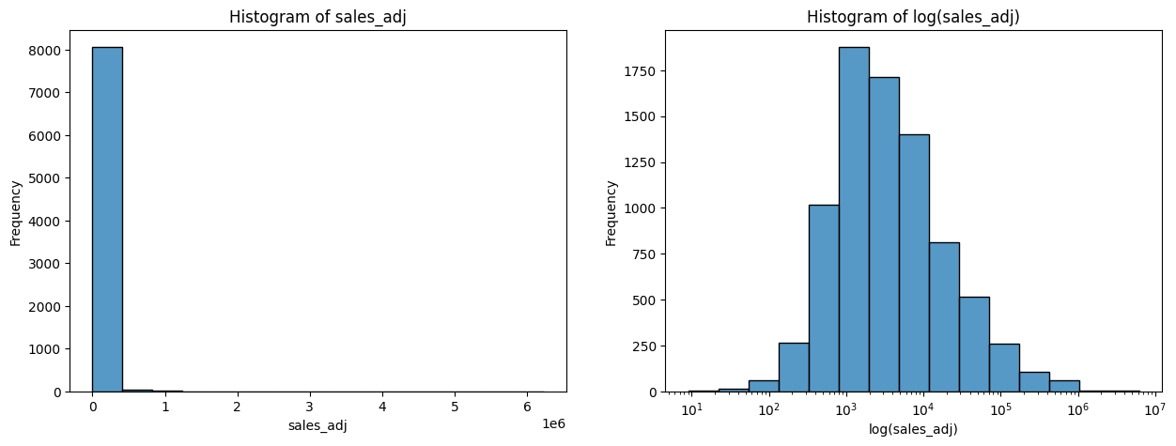

Our boxplot showcases that there are many "outliers" within this distribution which slightly reduces the normalcy of this variable. However, we will not be removing any "outliers" for our response variable of sales due to the reason that these games that do particularly well or particularly bad are a part of real data. Some games simply trend and go viral while others never find an audience. Our model hopefully will give better insight and reasoning to both of these occurrences.

Next, we move on to price. Every consumer is price conscious, there doesn't need to be any higher reason besides the fact that money is a limited resource. So those games with lower prices will likely sell well, but this is also discounting the effect of perceived value on items that are priced too low. Someone may see a game of their favorite genre that is price $10, but buy one that is priced $30 assuming that the $30 game will be better.

What we mainly want to achieve by processing and exploring price is the pruning of any outliers or erroneous data. We begin this process by taking a look at the general boxplot, shown below with the boxplot after removing outliers, and histogram of price to find absolutely disproportionately priced games on the higher end going up to $1,000. The current accepted high-end price of a game is $69.99, so these points need to be looked into further.

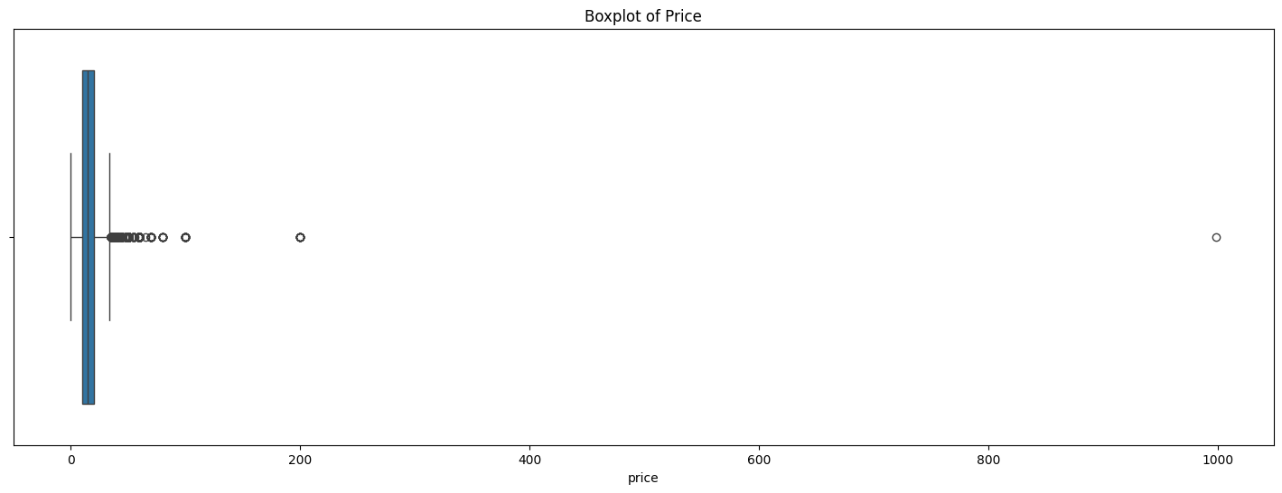

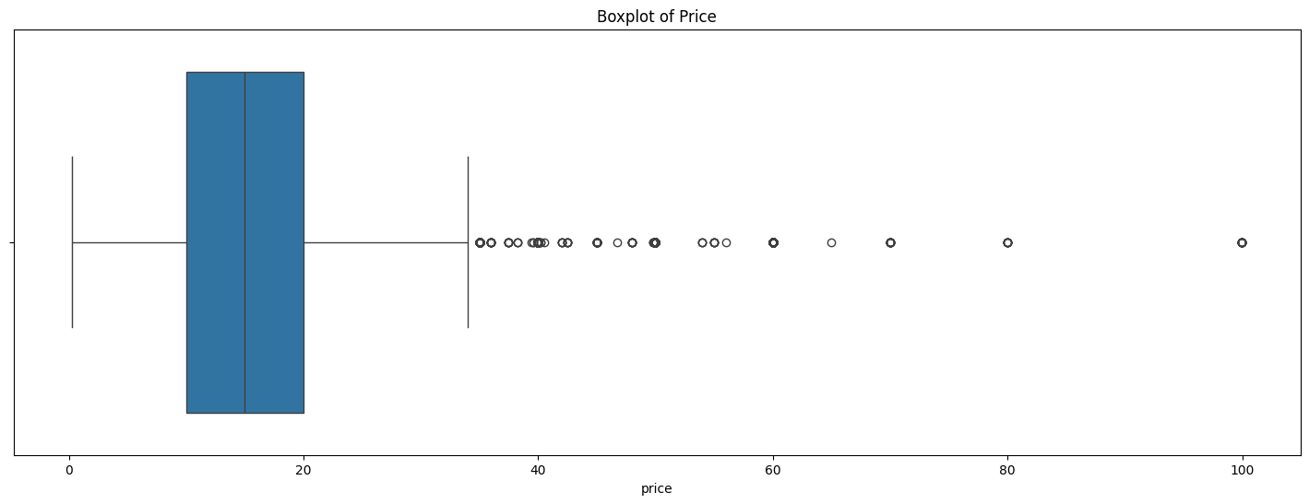

Manually looking through those games that are priced lower than $1 and greater than $70, we are able to see that the collected historical data once again has errors within it. Any free to play games that are priced at $0 should have been excluded from our api queries in the first place, but it seems like occasionally the historical data would bring back an incorrect price on the Gamalytic end. Which means it would show a paid game incorrectly as costing nothing. An example of this is shown below with the game Yakuza 0, a full priced title, shown as costing $0. For the higher priced titles, these involve the correct pricing data, but those that exceed $150 are egregious outliers completely separated from our pricing distribution. The worst example is Ascent Free-Roaming VR Experience which is priced at $999.99, however the game does not have any qualities that would demand such a price differential from other games on the Steam store.

Thus, we remove any points of data that are above $150 or are free. In total this is only a removal of 37 rows from our training data. Removal of the high outliers leaves our data rightward skewed and not normally distributed. Interestingly enough, even the price of $60 which is the standard price point for big game releases is considered an outlier here. This is due to the fact that there are many less big game releases compared to indie game releases on Steam. Still, we keep these points in as they are realistic indicators of possible price points for a game. Despite our assertion at the start of this section, it does not seem that there is a high direct correlation between the price of a game and the number of sales, rather variation of sales tends to increase as price does from our scatterplot below.

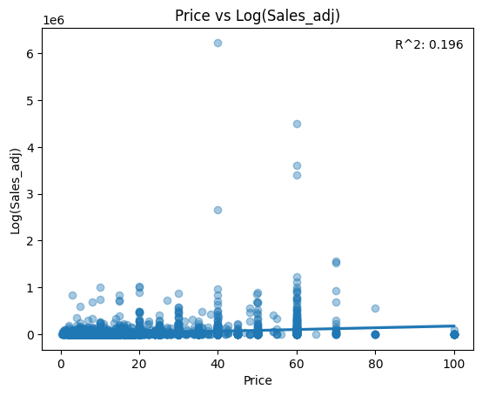

Moving on to the number of images and links in your Steam description, which when properly placed greatly affects your game sales is commonplace "knowledge" shared among independent game developers. Thus, we had previously extracted these features for our model building.

Taking a look at boxplots generated for these two features we can see that the number of images and links embedded within a Steam description overwhelmingly tends towards the low side. The median link count in a description is none at all, while the median image count is just one. Looking at the histograms we are able to see that these features mimic a Poisson distribution which should be appropriate for model building without transformation. Unfortunately taking a look at scatterplots, shown below, with a line of best fit, we see that there is close to no correlation between sales and image count for either of these features. The relationship is likely complex and would require analyzing the positioning of the image links within the description to sales, which is unfortunately not something that we are equipped to be able to do. Still, combined with other variables in a model there may be surprises with the significance of these variables.

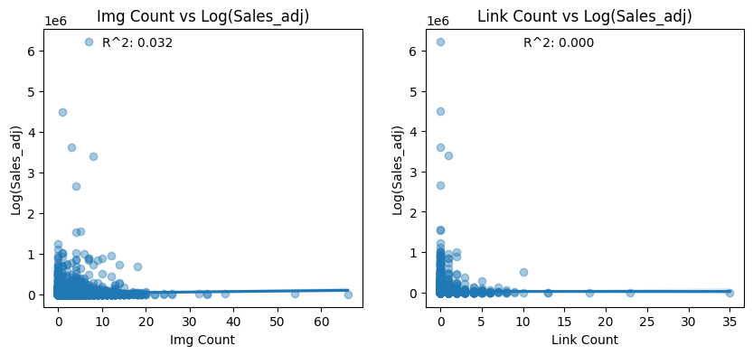

With name and description processing, the name is going to be the first thing that someone coming to your Steam page sees. Thus, it would make sense if different features about the name caused an increase or decrease towards sales. If someone wants to dig deeper into your game because they are intrigued, then they would be looking at the description. Which in theory will also have features that lead to the potential customer deciding to either buy the gamer or not. We want to extract these potential features utilizing some simple string processing.

From our name field we will extract five different features:

1. The length of the name which could increase sales when it is shorter due to being able to read and recommend more easily.
2. The capital letter ratio which may draw increased attention if it is larger.
3. The digit to letter ratio which may decrease sales if it is larger due to having more numbers leading to a more complex name.
4. The special symbol to letter ratio which may decrease sales if it is larger due to having more symbols leading to a more complex name.
5. The word count in the name could increase sales when it is shorter due to being able to read and recommend more easily like the total length.

We then take a look at how applicable these new variables might be to our model by correlating them with adjusted sales in the heatmap below. Unfortunately, once more, we have extremely weak correlation in each case against sales_adj. One thing to note is that the length of the name in total seems to have slightly more of an effect on adjusted sales while being highly colinear to the word count of a name. Thus, we will drop the word count of the name variable.

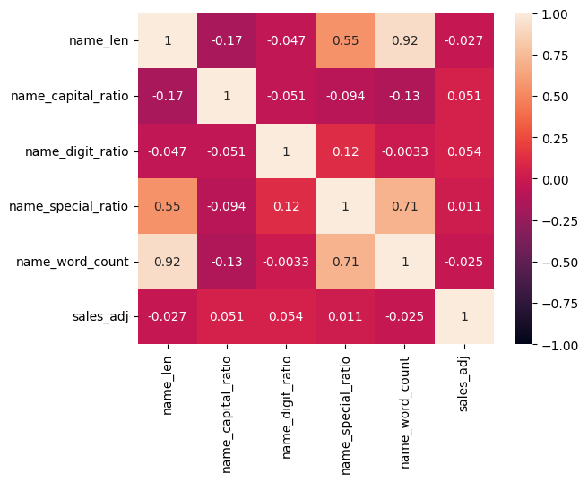

Before we begin feature extraction from the description column, we have noticed from previous skimming of our data that there are NA values present within the descriptions. We want to inspect these NA values to determine if they provide us with information or not. Such as if they are games that don't actually have a description which would also provide us insight as a feature to model with, determining if that has an impact on sales.

Manually sorting through the descriptions, we are able to determine that the games which do not have an entry under the about_the_game field are not games without a description on their Steam page. As a direct example, the game Aokana - Four Rhythms Across the Blue, has no description information when retrieved from the Steam API, but does have a description on the game page itself. These games have their description uploaded as images instead, which is why img_count which was extracted from the description html is still available. Unfortunately, we are limited in our capabilities to extract these images and analyze the text on them. Thus, we will delete the few samples that have an image-based description.

After removing the missing values from within the descriptions we begin to further process the descriptions into the following fields:

1. The length of the description which could increase sales when it is larger due to having more information provided about the game.
2. The capital letter ratio which may draw increased attention if it is larger.
3. The digit to letter ratio which may increase sales if it is larger due to having more numbers such as the amount of playtime or number of characters leading to more information that a potential customer would want to see.
4. The special symbol to letter ratio which may decrease sales if it is larger due to having more symbols leading to a harder time for the user reading the description.
5. The word count in the name could increase sales when it is larger due to having more information provided about the game like the total length.
6. The stop word ratio could increase sales when it is smaller due to having more information provided in the description per word.
7. The average word length could increase sales when it is smaller due to having more information provided in the description per word like the stop word ratio.

The correlation between sales and the description features seems to be extremely low even compared to the correlation between the name features and adjusted sales when observed in the correlation heatmap below. The highest correlation is just 0.047 between adjusted sales and the capital ratio of the description. Since the data contained within the description can be processed an extreme number of ways, it makes sense that our simple processing doesn't have high correlation out of the gate. Since our model will take advantage of the combination of features, these might still be useful. The one exception is description word count which has an almost perfect colinear relationship with description length at 0.99, but since it has lower correlation with adjusted sales, we drop the variable.

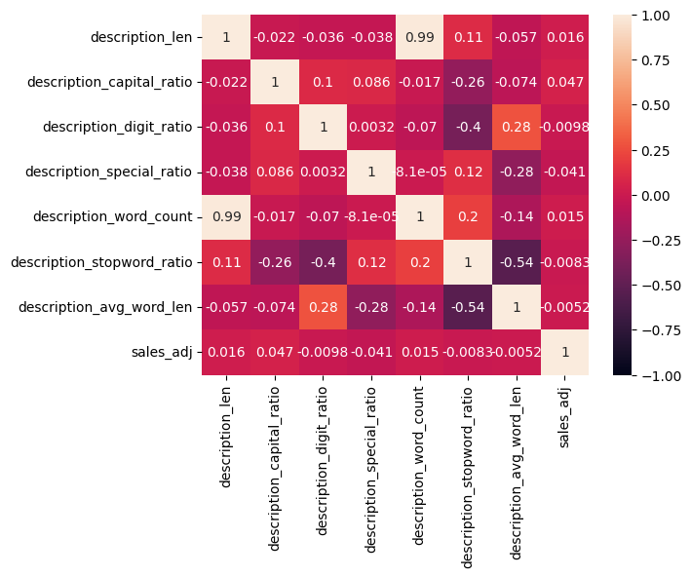

The class of publisher is a variable that will likely have a high effect on game sales. As consumer trust and awareness of developers grow as their publisher class does as well. A consumer will be more likely to purchase something from someone that they have either heard of or played a game from before. We believe this variable will be best used to fix effects of class into place, since changing your publisher class is not something a developer can simply due. However, the effects should be accounted for in the model.

First, we find the amount of each type of publisher class within our data to ensure that each class has sufficient samples to build a model against. The hobbyist segment of the publisher class surprisingly is the smallest value with only thirty examples within our training data. This is less than half a percent of the total sample size. Thus, this class is degenerate and not usable for modeling. So, we drop the samples from the hobbyist class. Next, we take a look at a boxplot, shown below, of publisher class against adjusted sales to determine how exactly the publisher class may influences sales. Like we had suggested before, the higher the class of publisher, the greater both the median sales and each percentile range. While independent and AA publishers may have occasional big hits, they are considered as outliers by going beyond 1.5*IQR. Ideally, integrating publisher class into our model may tell us what leads to those outliers to have sales shift higher for independent developers. Finally, we change the publisher class to a categorical variable so it is able to be fit into a model.

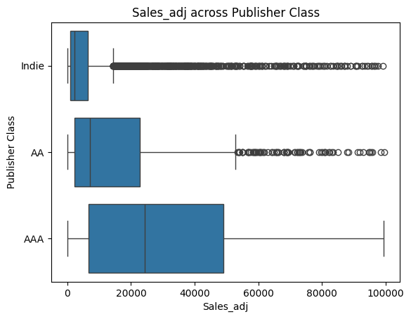

Our final step of processing and exploring the data will focus on array variables that will be converted to dummy variables. These include the user-applied tags on a game, the developer-applied genres, and the developer-applied features.

The first part involves turning these variables from strings to arrays by evaluating them as python objects. Then we take only the first five of the tags and genres to limit the dummy variables for these to the most important and relevant ones. The features are not limited as they are not assigned in any order of importance. The next step to process these arrays is extracting only those of each variable which appear at least ten times throughout their column and are within the top 30 most popular of their columns. By having a threshold of at least ten counts, we ensure that a feature or tag that only a few games might have does not skew the importance of the variable. We keep only 30 of each variable to maintain some semblance of parsimony for interpretation of the model down the line. Less variables will also mean less processing power required for model building. Finally, we create dummy variables for each of these array variables that will indicate the presence of a certain genre, tag, or feature for a game. This leaves us with 96 different variables total.

With all of our columns processed and new columns added, we want to remove columns that are no longer needed for model building. This includes intermediary columns that had data which we processed out such the array columns or the description. Additionally, automatically adding dummy variable names had introduced some spaces and special characters into our column names. Typically, these don't interact the best with model building, thus we remove them.

We take one last skim, a partial version shown below, of our final training dataframe to make sure we did not miss anything or some of our changes did not apply. Everything ends up looking as expected.

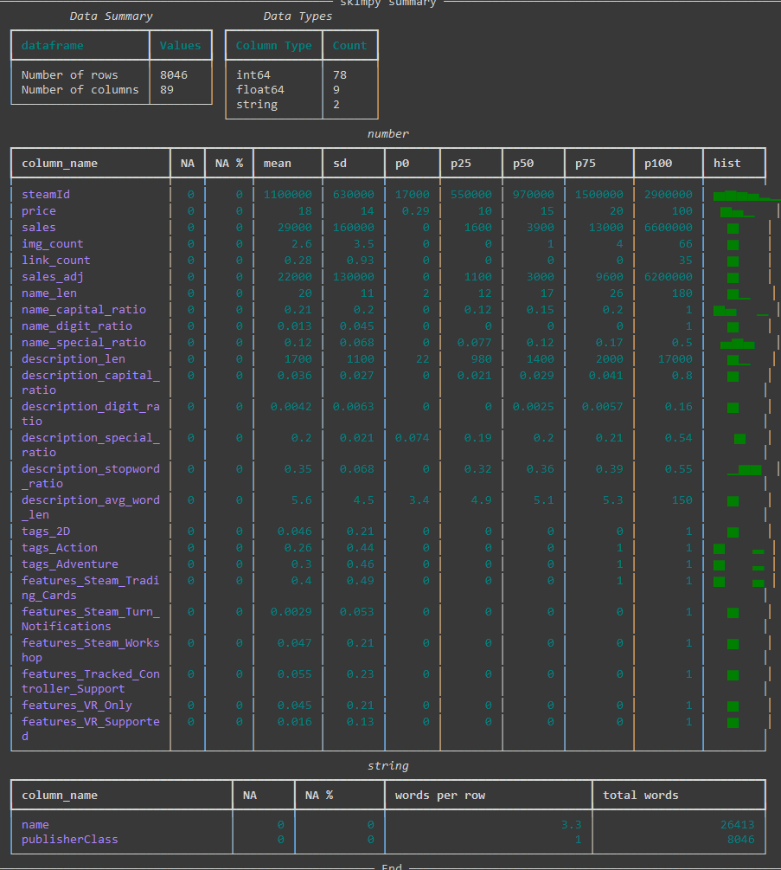

## Model Building and Selection

We begin our model building journey with a quick and dirty ordinary least squares model to see where we are right out of the gate without any additional variable manipulation. It turns out, that with an adjusted R^2 of 0.157, we're far off from a model that we'd like to see, as you can see below on the left. Looking through the significance of the coefficients within the model, we see that only about 1/4 of our features provide any significant information.

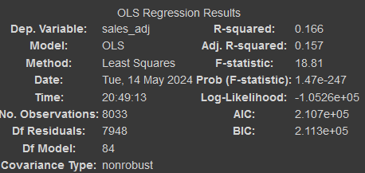 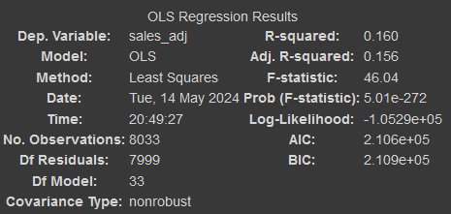

Thus, the next logical step to improve the OLS model is commencing stepwise feature selection. We create a function that iterates upon a model with no features and only selects features that have a p-value of greater than 0.05, our threshold indicator for a significant feature. Unfortunately, even with a restricted number of features that are all significant on their own, we end up with a model with 32 variables but a decrease in the R^2 by 0.001, shown above on the right. Since our variables did decrease by 51, this is an improvement on the previous model, but we want to make our model a good fit.

In order to see what we can do to improve our OLS model; we take a look at the diagnostic graphs for residuals that are shown below. Looking at a residual’s vs fitted graph allows us to see that there seems to be heavy heteroskedasticity in the model. Our QQ plot distribution also looks nothing close to normal. This indicates that our current model is not appropriately extracting all the information it can from our data. Taking a look at partial residual plots for each variable also shows us that for most of the categories, our residuals are evenly distributed but heteroskedastic.

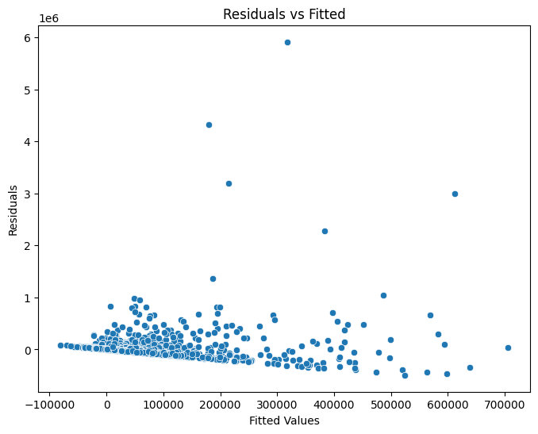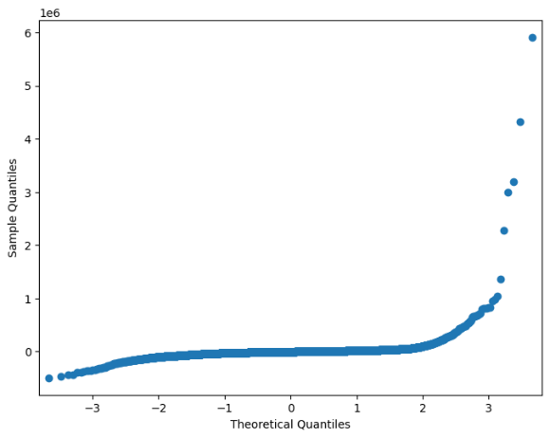

One way of decreasing heteroskedasticity is by transforming variables to be closer to a normal distribution. As we're aware of our response variable being non-normal, we begin with transforming it through a log transform. This leads to our adjusted R-squared almost doubling, as shown on the left below, an excellent change. We utilize stepwise feature selection once more to make the number of coefficients we are utilizing more manageable. This time we end up with an adjusted R^2 decrease of 0.02 and only 31 less variables, shown below on the right. The slight decrease in R^2 is worth the increase in parsimony that is achieved here.

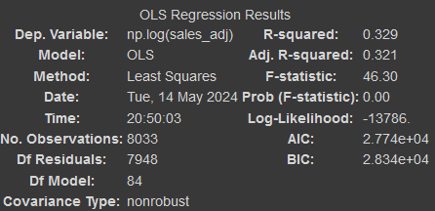 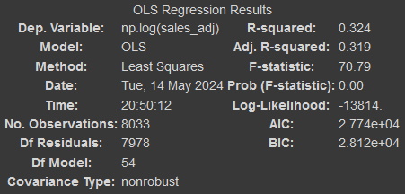

Going through and plotting our residual diagnostic plots once more shows us that we have gotten much closer to a viable model with the residual’s vs fitted graph looking much more random and the QQ plot much closer to normal. However, our standardized residuals that are below -5 seem to be following a pattern. We want to look further into that before we decide if this model is truly viable. After looking into it we see that something very interesting has been caught by our diagnostic plots here. Out of these games which were predicted to have much more sales than they "actually" do, 11 out of the 13 are recorded as having no sales. This is another error in the data which we didn't catch before. As the author, personally owns two of these games, and there are reviews from paid customers on the other games we know that they do have sales. With another error from our data collection, we will go ahead and drop these before retraining the model.

By dropping just, the erroneous data we gain a whole point in our adjusted R^2, and more importantly from our diagnostic plot we see that the model can be considered to meet the assumptions of a linear regression model with the errors being close enough to linear, homoscedastic, normal, and independent. Below is a visualized form of the coefficients and the extent to which they effect sales.

We also attempt to reduce our variables utilizing elastic net regression; however, we do not get much an improvement in our model our reduction in the variable used from our simple OLS with stepwise.

We create a decision tree model to attempt to create a model that can provide interpretability in a visual form. We are required to restrict the depth and max nodes of the decision tree, or else it would perfectly fit itself to the training data. We get an R^2 of 0.82 which is very good, but since decision trees have a tendency to overfit combined with the fact that they are worse at being regressors, we may need to watch this closely. We provide a visual representation of our decision tree below. The split values seem to be chosen quite arbitrarily looking at their extremely large squared errors which are in the billions of dollars squared. This tree example likely is not a good fit for our purposes. Below is the variable importance for the decision tree model visualed in graph form. This is not directional like the ordinary least squares regression unfortunately.

The final model that we want to build is an XGBoost model. This is simply for the fact that an XGBoost model tends to be very accurate, and we want to attempt to use it as a benchmark for how well our two other models are faring in evaluation. Looking at the R^2 of our XGBoost model we get 0.860 which does end up beating the decision tree model and the linear regression model. However, we want to see how it fares in actual evaluation later on. We’re able to see the most important variables for the XGBoost model in absolute terms, but we don't know if in app purchases being part of a game increase or decrease sales.

## Model Evaluation

With our regression models built, we want to see which one has the best performance for our purposes. We are evaluating the models that we have built on a combination of interpretability and the lowest RMSE on the test data to measure accuracy. With the interpretability being given to the OLS model purely for having readable coefficients while decision tree comes in second from being viewable directly. In a very interesting upset our OLS model starts with the worst training root mean squared error, however it seems to adjust to the data which we held out the best with the lowest test RMSE. The OLS model is the only one that showed improvement from the training RMSE. Still, 56,250 is a large average difference between actual and predicted sales. However, it is overall the best model we get and we can consider the parameters from this to be a good guiding direction on what may influence game sales within the first month. To close out our results section we take a look at the variables within the OLS model again. We see that there are multiple features that can be implemented to increase sales, however some features may also tend to decrease sales.

# Summary and Conclusion

We started this investigation with a simple question:

What developer actions and game features can small game developers listing their game on Steam utilize to achieve the most sales?

Our actions focused on retrieving data from different APIs to scrounge up as much information as we could in games made within the past 10 years. We focused on information that a developer would be able to change rather than things that were not under their control such as what year it was. We processed the data that was acquired through API to adjust our historical sales and get more features from text fields. Finally, we built models and compared them to each other head-to-head. The model most interesting to us is not super accurate or a good fit to game sales data, but it is sufficient to provide us with guiding information on what features a game developer should try to utilize for increasing their game sales such as providing support for HDR, while avoiding having many numbers in the description of the game.

There are many things that we wish we could have improved on and would like to see in future works such as:

* Finding a data source for historical sales that did not have as many errors as we were seeing while going through the data processing. Additionally, a data source which had historical data for exactly 30 days after release would provide our model better results.

* Spreading out our queries under even more time to gather data for the entirety of the games that were released within the past 10 years rather than being ip banned after retrieving just a portion.

* A method to collect data on how developers and publishers were posting about their games on social media or utilizing marketing through ads and influencers to push for game sales.

* A method to utilize the day and month information within our date that could account for periods of times that games are more or less likely to sell. This would lead to better guidance for possible release dates for developers. Additionally, the method would take into account possible games that are releasing at the same time and creating competition making a game a harder sell.

* An indicator of data for if the game was released at a discounted sale or not.

* A better method for processing the name and description strings. Perhaps utilizing sentiment analysis for the description and accounting for where images are placed.

* Perhaps there are models better suited to our data which also carry high interpretability for our data.

* Extending this model for use by actual developers to input information about their game and getting recommendations for what steps they should do next to increase revenue would be the ultimate goal for taking the project all the way to the end.

# Video Presentation

https://www.youtube.com/watch?v=0QDxB-v_QAw

# Works Cited

Acher, M., Cleve, A., Perrouin, G., Heymans, P., & Vanbeneden, C. (2012, January 25). On extracting feature models from product descriptions. *VaMoS '12: Proceedings of the 6th International Workshop on Variability Modeling of Software-Intensive Systems*, 45-54. doi:10.1145/2110147.2110153

Adigüzel, F. (2021). The Effect of YouTube Reviews on Video Game Sales. *Journal of Business Research - Turk*, 2096-2109.

Birkett, J. (2018, March 26). *Can week-one Steam sales predict first year sales?* Retrieved from Game Developer: https://www.gamedeveloper.com/business/can-week-one-steam-sales-predict-first-year-sales-

Bohanec, M., Kljajić Borštnar, M., & Robnik-Šikonja, M. (2017). Explaining machine learning models in sales predictions. *Expert Systems with Applications, 71*, 416–428. doi:10.1016/j.eswa.2016.11.010

CB, B., PS, A., & CC, A. (2003, May 15). Using lowess to remove systematic trends over time in predictor variables prior to logistic regression with quantile categories. *Stat Med, 22*(9), 1477-93. doi:10.1002/sim.1507

Cox, J. (2013, April 15). What Makes a Blockbuster Video Game? An Empirical Analysis of US Sales Data. *Managerial and Decision Economics*, 189-198. Retrieved from https://onlinelibrary.wiley.com/doi/abs/10.1002/mde.2608

Ford, C. (2018, August 17). Interpreting Log Transformations in a Linear Model. Charlottesville, Virginia, USA.

Gamalytic. (2024). *Api Reference*. Retrieved from Gamalytic: https://gamalytic.com/api-reference.txt

Gaure, S. (2013, October). OLS with multiple high dimensional category variables. *Computational Statistics & Data Analysis, 66*, 8-18. doi:10.1016/j.csda.2013.03.024

GilPress. (2024, January 31). *How Many Gamers Are There? (2024 Statistics)*. Retrieved from What's The Big Data: https://whatsthebigdata.com/number-of-gamers/

Grantham-Philips, W. (2023, June 16). *The Reddit blackout, explained: Why thousands of subreddits are protesting third-party app charges*. Retrieved from AP News: https://apnews.com/article/reddit-blackout-api-91f60aaec2eaf7cd0e3751e2fb3dd653

Hanck, C., Arnold, M., Gerber, A., & Schmelzer, M. (2024). *Introduction to Econometrics with R.* Essen, Germany: University of Duisburg-Essen . Retrieved from https://www.econometrics-with-r.org/10.4-regression-with-time-fixed-effects.html

IFPI. (2024). *State of the Industry.* IFPI. Retrieved from https://globalmusicreport.ifpi.org

Marchand, A., & Hennig-Thurau, T. (2013). Value Creation in the Video Game Industry: Industry Economics, Consumer Benefits, and Research Opportunities. *Journal of Interactive Marketing, 27*(3), 141–157. doi:10.1016/j.intmar.2013.05.001

Mitchell, R. (2024, January 4). *Gower Street Analytics estimates 2023 Global box office hit $33.9 billion*. Retrieved from Gower Street: https://gower.st/articles/gower-street-analytics-estimates-2023-global-box-office-hit-33-9-billion/

Orland, K. (2022, March 16). *Putting Elden Ring’s 12 million sales in context*. Retrieved from ArsTechnica: https://arstechnica.com/gaming/2022/03/putting-elden-rings-12-million-sales-in-context/

Prathama, N. Y., Asmara, R., & Barakbah, A. R. (2020). Game Data Analytics using Descriptive and Predictive Mining. *2020 International Electronics Symposium (IES)*. doi:10.1109/ies50839.2020.9231949

RJackson. (2020, September 1). *Storefront API*. Retrieved from Team Fortress Wiki: https://wiki.teamfortress.com/wiki/User:RJackson/StorefrontAPI

Sacranie, J. (2010). Consumer Perceptions & Video Game Sales: A Meeting of the Minds. *Honors Projects*(108). Retrieved from https://digitalcommons.iwu.edu/econ_honproj/108

SteamDB. (2024). *Instant Search.* Retrieved May 9, 2024, from SteamDB: https://steamdb.info/instantsearch/?refinementList[appType][0]=Game

Steamworks Development. (2022, March 8). *Steam - 2021 Year in Review.* Retrieved from Steam: https://store.steampowered.com/news/group/4145017/view/3133946090937137590

Stoddard, C. (2016). Autocorrelation. *Econometrics 2.* Bozeman: Montana State University. Retrieved from https://www.montana.edu/cstoddard/562/Autocorrelation.pdf

Tondello, G. F., & Nacke, L. E. (2019, October 17). Player Characteristics and Video Game Preferences. *CHI PLAY '19: Proceedings of the Annual Symposium on Computer-Human Interaction in Play*, 365–378. doi:10.1145/3311350.3347185

Valve. (2024). *App Details API*. Retrieved from Steam: https://store.steampowered.com/api/appdetails

Weatherbed, J. (2023, February 2). *Twitter replaces its free API with a paid tier in quest to make more money*. Retrieved from The Verge: https://www.theverge.com/2023/2/2/23582615/twitter-removing-free-api-developer-apps-price-announcement

Wijman, T. (2024, February 8). *Newzoo’s games market revenue estimates and forecasts by region and segment for 2023*. Retrieved from Newzoo: https://newzoo.com/resources/blog/games-market-estimates-and-forecasts-2023

# Appendix

!pip install pandas

!pip install requests

!pip install beautifulsoup4

#!pip install google.colab

!pip install skimpy

!pip install numpy

!pip install seaborn

!pip install matplotlib

!pip install scikit-learn

!pip install nltk

!pip install statsmodels

!pip install graphviz

!pip install xgboost

import requests

import time

import json

import pandas as pd

from bs4 import BeautifulSoup

import os

from skimpy import skim

import numpy as np

import seaborn as sns

import matplotlib.pyplot as plt

from sklearn.model_selection import train_test_split

import nltk

from nltk.corpus import stopwords

nltk.download('stopwords')

import statsmodels.api as sm

import statsmodels.formula.api as smf

from sklearn import tree

from graphviz import Source

import xgboost as xgb

from statsmodels.tools.eval_measures import rmse

def paged_requests(url = 'https://api.gamalytic.com/steam-games/list', payload = {"price_min": 1, 'date_min': 1420070399999, "limit" : 100, "page": 0}, maxpage = "no", timeout = 10):

  request_list = []

  start = payload['page']

  r = requests.get(url, params=payload)

  if isinstance(maxpage, int):

    maxpage = min(maxpage, r.json()['pages'])

  else:

    maxpage = r.json()['pages']

  for page in range(payload['page'], maxpage):

    if page == start:

      request_list.extend(r.json()['result'])

      time.sleep(1)

    else:

      payload['page'] = page

      try:

        r = requests.get(url, params=payload, timeout = timeout)

      except requests.exceptions.Timeout:

        print(f"Timed out on page {page}")

        with open(f'{drive}/erroratpage{page}.json', 'w') as f:

          f.write(json.dumps(request_list))

        return request_list

      request_list.extend(r.json()['result'])

      time.sleep(1)

  with open(f'{drive}/completedpagedquery.json', 'w') as f:

    f.write(json.dumps(request_list))

  return request_list

# Set drive to wherever you want to save your data if calling the APIs

drive = "/content/drive/MyDrive/Colab Notebooks"

'''

from google.colab import drive

drive.mount('/content/drive')

gamalytic_list = paged_requests()

'''

!wget https://github.com/abnormalPotassium/SteamSalesModeling/raw/main/completedpagedquery.zip && unzip completedpagedquery.zip

df = pd.read_json("completedpagedquery.json")

df

df = df[df['EAReleaseDate'].isna()]

len(df)

id_list = list(df["steamId"])

def getdesc(description, id):

  description = {k: description[str(id)]['data'][k] for k in ('steam_appid', 'about_the_game')}

  description["steamId"] = description.pop('steam_appid')

  soup = BeautifulSoup(description['about_the_game'], 'html.parser')

  description['about_the_game'] = soup.get_text(separator=" ").strip()

  description["img_count"] = len(soup.find_all('img'))

  description["link_count"] = len(soup.find_all('a'))

  return description

url2 = "https://store.steampowered.com/api/appdetails"

game = id_list[2]

payload2 = {"filters": "basic", "appids": game}

timeout = 10

r2 = requests.get(url2, params=payload2, timeout = timeout)

description = r2.json()

r2.json()[str(game)]['data']['about_the_game']

getdesc(description, game)

def findmonth(timestamps):

  if abs(timestamps['history'][-1]['timeStamp'] - timestamps['releaseDate']) <= 2629743000:

    hist_price = timestamps['history'][-1]

    hist_price["steamId"] = int(timestamps["steamId"])

    return hist_price

  for i in range(1,len(timestamps['history'])):

    if abs(timestamps['history'][0]['timeStamp'] - timestamps['history'][i]['timeStamp']) >= 2629743000:

      hist_price = timestamps['history'][i]

      hist_price["steamId"] = int(timestamps["steamId"])

      return hist_price

def dual_requests(id_list = id_list, timeout = 10, start = 0):

  url2 = "https://store.steampowered.com/api/appdetails"

  payload2 = {"filters": "basic"}

  temp = start

  request_list1 = []

  request_list2 = []

  for i, game in enumerate(id_list[start:]):

    url1 = f'https://api.gamalytic.com/game/{game}'

    payload2["appids"] = game

    try:

      r1 = requests.get(url1, timeout = timeout)

      r2 = requests.get(url2, params=payload2, timeout = timeout)

    except requests.exceptions.Timeout:

      print(f"Timed out on id index {temp+i}")

      with open(f'{drive}/partialquery{temp}to{temp+i}_1.json', 'w') as f:

        f.write(json.dumps(request_list1))

      with open(f'{drive}/partialquery{temp}to{temp+i}_2.json', 'w') as f:

        f.write(json.dumps(request_list2))

      return request_list1, request_list2

    request_list1.append(findmonth(r1.json()))

    request_list2.append(getdesc(r2.json(), game))

    if ((i > 0) & (i%100 == 0)):

      with open(f'{drive}/partialquery{temp}to{temp+100}_1.json', 'w') as f:

        f.write(json.dumps(request_list1))

      request_list1 = []

      with open(f'{drive}/partialquery{temp}to{temp+100}_2.json', 'w') as f:

        f.write(json.dumps(request_list2))

      request_list2 = []

      temp += 100

    time.sleep(1)

  with open(f'{drive}/partialquery{temp}to{temp+100}_1.json', 'w') as f:

    f.write(json.dumps(request_list1))

  with open(f'{drive}/partialquery{temp}to{temp+100}_2.json', 'w') as f:

    f.write(json.dumps(request_list2))

  return request_list1, request_list2

def single_requests(id_list = id_list, timeout = 10, start = 0, end = 1558):

  url2 = "https://store.steampowered.com/api/appdetails"

  payload2 = {"filters": "basic"}

  temp = start

  request_list2 = []

  for i, game in enumerate(id_list[start:(end+1)]):

    payload2["appids"] = game

    try:

      r2 = requests.get(url2, params=payload2, timeout = timeout)

    except requests.exceptions.Timeout:

      print(f"Timed out on id index {temp+i}")

      with open(f'{drive}/partialquery{temp}to{temp+i}_2.json', 'w') as f:

        f.write(json.dumps(request_list2))

      return request_list2

    request_list2.append(getdesc(r2.json(), game))

    if ((i > 0) & (i%100 == 0)):

      with open(f'{drive}/partialquery{temp}to{temp+100}_2.json', 'w') as f:

        f.write(json.dumps(request_list2))

      request_list2 = []

      temp += 100

    time.sleep(2)

  with open(f'{drive}/partialquery{temp}to{temp+100}_2.json', 'w') as f:

    f.write(json.dumps(request_list2))

  return request_list2

descriptions = single_requests(start = 0, end = 1558)

while True:

  start = 0

  try:

    timestamps,descriptions = dual_requests(id_list = id_list, start = start)

  except:

    time.sleep(10)

    files = [f for f in os.listdir(drive) if f.startswith("partialquery")]

    numbers = [int(f.split("to")[1].split("_")[0]) for f in files]

    start = max(numbers)

  else:

    print("Finally finished")

    break

def combine_json_files(directory, suffix):

  combined_data = []

  for filename in os.listdir(directory):

    if filename.startswith("partialquery") and filename.endswith(suffix + ".json"):

      with open(os.path.join(directory, filename), 'r') as f:

        data = json.load(f)

        combined_data.extend(data)

  with open(f'{directory}/combined_data{suffix}.json', 'w') as f:

    json.dump(combined_data, f)

combine_json_files(drive, "_1")

combine_json_files(drive, "_2")

df1 = pd.read_json(drive + "/combined_data_1.json")

df2 = pd.read_json(drive + "/combined_data_2.json")

df1

df2

missingid = list(df2[~df2['steamId'].isin(df1['steamId'])]['steamId'])

print(missingid)

print(f'duplicates in description data: {df2.duplicated().sum()} \nduplicates in historical data: {df1.duplicated().sum()}')

df1 = df1.drop_duplicates(subset='steamId', keep='last')

df2 = df2.drop_duplicates(subset='steamId', keep='last')

print(f'duplicates in description data: {df2.duplicated().sum()} \nduplicates in historical data: {df1.duplicated().sum()}')

missingarr = []

for i, game in enumerate(missingid):

  url1 = f'https://api.gamalytic.com/game/{game}'

  r1 = requests.get(url1, timeout = 10)

  missingarr.append(findmonth(r1.json()))

  time.sleep(1)

missing_df = pd.DataFrame(missingarr)

df1 = pd.concat([df1,missing_df], ignore_index=True)

print(f'Are df1 and df2 are now the same length?: {len(df1) == len(df2)}')

df3 = pd.merge(df[["steamId","name","tags","genres","features","releaseDate","publisherClass"]], df1[["steamId","timeStamp","price","sales"]], on='steamId')

df3 = pd.merge(df3, df2, on='steamId')

df3

"""

dfa = [[df, "GamalyticA"],[df1, "GamalyticB"],[df2, "SteamDesc"], [df3, "SteamComplete"]]

for x,y in dfa:

  x.to_csv(f'{drive}/{y}.csv')

"""

df = pd.read_csv("https://raw.githubusercontent.com/abnormalPotassium/SteamSalesModeling/main/Data/SteamComplete.csv", index_col=0)

df_train, df_test = train_test_split(df, test_size=0.2, random_state=1337)

print(f'df_train shape: {df_train.shape}')

print(f'df_test shape: {df_test.shape}')

skim(df_train.drop('steamId', axis = 1))

tcol = df_train.columns.get_loc('timeStamp')

for i,x in enumerate(df_train['timeStamp']):

  try:

    df_train.iloc[i, tcol] = pd.to_datetime(x, format='%Y-%m-%d %H:%M:%S')

  except ValueError:

    try:

      df_train.iloc[i, tcol] = pd.to_datetime(x, format='%Y-%m-%d %H:%M:%S.%f')

    except ValueError:

      df_train.iloc[i, tcol] = pd.to_datetime(int(x), unit='ms')

tcol = df_test.columns.get_loc('timeStamp')

for i,x in enumerate(df_test['timeStamp']):

  try:

    df_test.iloc[i, tcol] = pd.to_datetime(x, format='%Y-%m-%d %H:%M:%S')

  except ValueError:

    try:

      df_test.iloc[i, tcol] = pd.to_datetime(x, format='%Y-%m-%d %H:%M:%S.%f')

    except ValueError:

      df_test.iloc[i, tcol] = pd.to_datetime(int(x), unit='ms')

df_train['timeStamp'] = pd.to_datetime(df_train['timeStamp']).dt.floor('D')

df_test['timeStamp'] = pd.to_datetime(df_test['timeStamp']).dt.floor('D')

df_train['releaseDate'] = pd.to_datetime(df_train['releaseDate'], unit='ms').dt.floor('D')

df_test['releaseDate'] = pd.to_datetime(df_test['releaseDate'], unit='ms').dt.floor('D')

df_train['timeAfterRelease'] = df_train['timeStamp'] - df_train['releaseDate']

df_test['timeAfterRelease'] = df_test['timeStamp'] - df_test['releaseDate']

df_train[(pd.Timedelta(days = 14) > df_train['timeAfterRelease']) | (pd.Timedelta(days = 61) < df_train['timeAfterRelease'])]['timeAfterRelease']

df_train.loc[199]

df_train.loc[10754]

df_train = df_train.drop(df_train[(pd.Timedelta(days = 14) > df_train['timeAfterRelease']) | (pd.Timedelta(days = 61) < df_train['timeAfterRelease'])].index)

df_test = df_test.drop(df_test[(pd.Timedelta(days = 14) > df_test['timeAfterRelease']) | (pd.Timedelta(days = 61) < df_test['timeAfterRelease'])].index)

df_train['sales_adj'] = round(df_train['sales'] / (df_train['timeAfterRelease']/pd.Timedelta(days=30)), 0).apply(lambda x: int(x))

df_test['sales_adj'] = round(df_test['sales'] / (df_test['timeAfterRelease']/pd.Timedelta(days=30)), 0).apply(lambda x: int(x))

df_train['sales_adj'] += 1

df_test['sales_adj'] += 1

df_train['releaseYear']  = df_train['releaseDate'].dt.year

df_train['releaseMonth']  = df_train['releaseDate'].dt.month

df_train['releaseDay']  = df_train['releaseDate'].dt.day

df_test['releaseYear']  = df_test['releaseDate'].dt.year

df_test['releaseMonth']  = df_test['releaseDate'].dt.month

df_test['releaseDay']  = df_test['releaseDate'].dt.day

df_train.sort_values(by=['sales_adj'], ascending=False).head(5)

fig, axes = plt.subplots(1, 2, figsize=(18, 6))

sns.boxplot(x=df_train["sales_adj"], ax=axes[0])

axes[0].set_title("Boxplot of Sales_adj")

axes[1].set_title("Boxplot of Log(Sales_adj)")

sns.boxplot(x=np.log(df_train["sales_adj"]), ax=axes[1])

axes[0].set_xlabel("Sales_adj")

axes[1].set_xlabel("Log(Sales_adj)")

plt.show()

fig, axes = plt.subplots(1, 2, figsize=(15, 5))

sns.histplot(data=df_train["sales_adj"], bins=15, ax=axes[0])

axes[0].set_title("Histogram of sales_adj")

axes[0].set_xlabel("sales_adj")

axes[0].set_ylabel("Frequency")

sns.histplot(data=df_train["sales_adj"], bins=15, log_scale=True, ax=axes[1])

axes[1].set_title("Histogram of log(sales_adj)")

axes[1].set_xlabel("log(sales_adj)")

axes[1].set_ylabel("Frequency")

plt.show()

fig, axes = plt.subplots(figsize=(18, 6))

sns.boxplot(x=df_train["price"], ax=axes)

axes.set_title("Boxplot of Price")

plt.show()

fig, axes = plt.subplots(figsize=(15, 5))

sns.histplot(data=df_train["price"], bins=25, ax=axes)

axes.set_title("Histogram of Price")

axes.set_xlabel("price")

axes.set_ylabel("Frequency")

plt.show()

df_train[(1 > df_train['price']) |( 70 < df_train['price'])]

df_train.loc[228]

df_train.loc[4603]

len(df_train[( 150 < df_train['price'])])

df_train = df_train.drop(df_train[(0 == df_train['price']) |( 150 < df_train['price'])].index)

df_test = df_test.drop(df_test[(0 == df_test['price']) |( 150 < df_test['price'])].index)

fig, axes = plt.subplots(figsize=(18, 6))

sns.boxplot(x=df_train["price"], ax=axes)

axes.set_title("Boxplot of Price")

plt.show()

fig, axes = plt.subplots(figsize=(15, 5))

sns.histplot(data=df_train["price"], bins=25, ax=axes)

axes.set_title("Histogram of Price")

axes.set_xlabel("price")

axes.set_ylabel("Frequency")

plt.show()

sns.regplot(x="price", y="sales_adj", data=df_train, logx=False, scatter_kws={'alpha': 0.4})

plt.title('Price vs Log(Sales_adj)')

plt.xlabel('Price')

plt.ylabel('Log(Sales_adj)')

r = df_train['price'].corr(df_train['sales_adj'])

plt.text(85, 6100000, f'R^2: {r:.3f}', fontsize=10)

plt.show()

fig, axes = plt.subplots(1, 2, figsize=(18, 6))

sns.boxplot(x=df_train["img_count"], ax=axes[0])

axes[0].set_title("Boxplot of img_count")

axes[1].set_title("Boxplot of link_count")

sns.boxplot(x=np.log(df_train["link_count"]), ax=axes[1])

axes[0].set_xlabel("img_count")

axes[1].set_xlabel("link_count")

plt.show()

fig, axes = plt.subplots(1, 2, figsize=(15, 5))

sns.histplot(data=df_train["img_count"], bins=15, ax=axes[0])

axes[0].set_title("Histogram of img_count")

axes[0].set_xlabel("img_count")

axes[0].set_ylabel("Frequency")

sns.histplot(data=df_train["link_count"], bins=15, ax=axes[1])

axes[1].set_title("Histogram of link_count")

axes[1].set_xlabel("link_count")

axes[1].set_ylabel("Frequency")

plt.show()

fig, axes = plt.subplots(1, 2, figsize=(10, 4))

sns.regplot(x="img_count", y="sales_adj", data=df_train, ax=axes[0], logx=False, scatter_kws={'alpha': 0.4})

axes[0].set_title('Img Count vs Log(Sales_adj)')

axes[0].set_xlabel('Img Count')

axes[0].set_ylabel('Log(Sales_adj)')

r1 = df_train['img_count'].corr(df_train['sales_adj'])

axes[0].text(10, 6100000, f'R^2: {r1:.3f}', fontsize=10)

sns.regplot(x="link_count", y="sales_adj", data=df_train, ax=axes[1], logx=False, scatter_kws={'alpha': 0.4})

axes[1].set_title('Link Count vs Log(Sales_adj)')

axes[1].set_xlabel('Link Count')

axes[1].set_ylabel('Log(Sales_adj)')

r2 = df_train['link_count'].corr(df_train['sales_adj'])

axes[1].text(10, 6100000, f'R^2: {r2:.3f}', fontsize=10)

plt.show()

df_train['name_len'] = df_train['name'].apply(lambda x: len(x))

df_train['name_capital_ratio'] = df_train['name'].apply(lambda x: sum(1 for c in x if c.isupper()) / len(x))

df_train['name_digit_ratio'] = df_train['name'].apply(lambda x: sum(1 for c in x if c.isdigit()) / len(x))

df_train['name_special_ratio'] = df_train['name'].apply(lambda x: sum(1 for c in x if not c.isalnum()) / len(x))

df_train['name_word_count'] = df_train['name'].apply(lambda x: len(x.split()))

df_test['name_len'] = df_test['name'].apply(lambda x: len(x))

df_test['name_capital_ratio'] = df_test['name'].apply(lambda x: sum(1 for c in x if c.isupper()) / len(x))

df_test['name_digit_ratio'] = df_test['name'].apply(lambda x: sum(1 for c in x if c.isdigit()) / len(x))

df_test['name_special_ratio'] = df_test['name'].apply(lambda x: sum(1 for c in x if not c.isalnum()) / len(x))

df_test['name_word_count'] = df_test['name'].apply(lambda x: len(x.split()))

df_train_corr = df_train[['name_len', 'name_capital_ratio', 'name_digit_ratio', 'name_special_ratio', 'name_word_count', 'sales_adj']]

corr_matrix = df_train_corr.corr()

heatmap = sns.heatmap(corr_matrix, vmin=-1, vmax=1, annot=True)

plt.show()

df_train = df_train.drop('name_word_count', axis=1)

df_test = df_test.drop('name_word_count', axis=1)

len(df_train[df_train['about_the_game'].isna()])

df_train.loc[1034]

df_train = df_train.drop(df_train[df_train['about_the_game'].isna()].index)

df_test = df_test.drop(df_test[df_test['about_the_game'].isna()].index)

df_train['description_len'] = df_train['about_the_game'].apply(lambda x: len(x))

df_train['description_capital_ratio'] = df_train['about_the_game'].apply(lambda x: sum(1 for c in x if c.isupper()) / len(x))

df_train['description_digit_ratio'] = df_train['about_the_game'].apply(lambda x: sum(1 for c in x if c.isdigit()) / len(x))

df_train['description_special_ratio'] = df_train['about_the_game'].apply(lambda x: sum(1 for c in x if not c.isalnum()) / len(x))

df_train['description_word_count'] = df_train['about_the_game'].apply(lambda x: len(x.split()))

df_train['description_stopword_ratio'] = df_train['about_the_game'].apply(lambda x: len([word for word in x.split() if word in stopwords.words('english')]) / len(x.split()))

df_train['description_avg_word_len'] = df_train['about_the_game'].apply(lambda x: np.mean([len(word) for word in x.split()]))

df_test['description_len'] = df_test['about_the_game'].apply(lambda x: len(x))

df_test['description_capital_ratio'] = df_test['about_the_game'].apply(lambda x: sum(1 for c in x if c.isupper()) / len(x))

df_test['description_digit_ratio'] = df_test['about_the_game'].apply(lambda x: sum(1 for c in x if c.isdigit()) / len(x))

df_test['description_special_ratio'] = df_test['about_the_game'].apply(lambda x: sum(1 for c in x if not c.isalnum()) / len(x))

df_test['description_word_count'] = df_test['about_the_game'].apply(lambda x: len(x.split()))

df_test['description_stopword_ratio'] = df_test['about_the_game'].apply(lambda x: len([word for word in x.split() if word in stopwords.words('english')]) / len(x.split()))

df_test['description_avg_word_len'] = df_test['about_the_game'].apply(lambda x: np.mean([len(word) for word in x.split()]))

df_train_corr = df_train[['description_len', 'description_capital_ratio', 'description_digit_ratio', 'description_special_ratio', 'description_word_count', 'description_stopword_ratio','description_avg_word_len','sales_adj']]

corr_matrix = df_train_corr.corr()

heatmap = sns.heatmap(corr_matrix, vmin=-1, vmax=1, annot=True)

plt.show()

df_train = df_train.drop('description_word_count', axis=1)

df_test = df_test.drop('description_word_count', axis=1)

df_train.groupby('publisherClass')['publisherClass'].count()

df_train = df_train.drop(df_train[df_train['publisherClass'] == 'Hobbyist'].index)

df_test = df_test.drop(df_test[df_test['publisherClass'] == 'Hobbyist'].index)

df_train

sns.boxplot(x = df_train[df_train['sales_adj']<100000]['sales_adj'], y=df_train[df_train['sales_adj']<100000]['publisherClass'], orient="h")

plt.title('Sales_adj across Publisher Class')

plt.xlabel('Sales_adj')

plt.ylabel('Publisher Class')

plt.show()

df_test['publisherClass'] = df_train['publisherClass'].astype('category')

df_test['publisherClass'] = df_test['publisherClass'].astype('category')

df_train['tags'] = df_train['tags'].apply(lambda x: eval(x)).apply(lambda x: x[:5])

df_test['tags'] = df_test['tags'].apply(lambda x: eval(x)).apply(lambda x: x[:5])

df_train['genres'] = df_train['genres'].apply(lambda x: eval(x)).apply(lambda x: x[:5])

df_test['genres'] = df_test['genres'].apply(lambda x: eval(x)).apply(lambda x: x[:5])

df_train['features'] = df_train['features'].apply(lambda x: eval(x))

df_test['features'] = df_test['features'].apply(lambda x: eval(x))

tag_counts = {}

for tags_list in df_train['tags']:

    for tag in tags_list:

        if tag not in tag_counts:

            tag_counts[tag] = 1

        else:

            tag_counts[tag] += 1

sorted_tag_counts = sorted(tag_counts.items(), key=lambda item: item[1], reverse=True)

top_30_tags = [tag for tag, count in sorted_tag_counts[:30] if count > 10]

df_train['tags'] = df_train['tags'].apply(lambda tags_list: [tag for tag in tags_list if tag in top_30_tags])

df_test['tags'] = df_test['tags'].apply(lambda tags_list: [tag for tag in tags_list if tag in top_30_tags])

genre_counts = {}

for genre_list in df_train['genres']:

    for genre in genre_list:

        if genre not in genre_counts:

            genre_counts[genre] = 1

        else:

            genre_counts[genre] += 1

sorted_genre_counts = sorted(genre_counts.items(), key=lambda item: item[1], reverse=True)

top_30_genres = [genre for genre, count in sorted_genre_counts[:30] if count > 10]

df_train['genres'] = df_train['genres'].apply(lambda genre_list: [genre for genre in genre_list if genre in top_30_genres])

df_test['genres'] = df_test['genres'].apply(lambda genre_list: [genre for genre in genre_list if genre in top_30_genres])

feature_counts = {}

for feature_list in df_train['features']:

    for feature in feature_list:

        if feature not in feature_counts:

            feature_counts[feature] = 1

        else:

            feature_counts[feature] += 1

sorted_feature_counts = sorted(feature_counts.items(), key=lambda item: item[1], reverse=True)

top_30_features = [feature for feature, count in sorted_feature_counts[:30] if count > 10]

df_train['features'] = df_train['features'].apply(lambda feature_list: [feature for feature in feature_list if feature in top_30_features])

df_test['features'] = df_test['features'].apply(lambda feature_list: [feature for feature in feature_list if feature in top_30_features])

for x in ['tags','genres','features']:

  df = pd.get_dummies(df_train[x].explode(), prefix = x).groupby(level=0).sum()

  df_train = pd.merge(left = df_train, right = df, left_index = True, right_index = True)

for x in ['tags','genres','features']:

  df = pd.get_dummies(df_test[x].explode(), prefix = x).groupby(level=0).sum()

  df_test = pd.merge(left = df_test, right = df, left_index = True, right_index = True)

df_train.shape

remove = ['tags','genres','features','releaseDate','timeStamp','about_the_game','timeAfterRelease']

df_train = df_train.drop(remove, axis = 1)

df_train.columns = df_train.columns.str.replace('&', '').str.replace(' ', '_').str.replace('/', '').str.replace('-', '')

df_test = df_test.drop(remove, axis = 1)

df_test.columns = df_test.columns.str.replace('&', '').str.replace(' ', '_').str.replace('/', '').str.replace('-', '')

skim(df_train)

#Saving midpoint

df_train.to_csv(f'{drive}/dftrain.csv')

df_test.to_csv(f'{drive}/dftest.csv')

#Loading midpoint

df_train = pd.read_csv(f'{drive}/dftrain.csv')

df_test = pd.read_csv(f'{drive}/dftest.csv')

mcols = list(df_train.drop(['sales','sales_adj','name','steamId','publisherClass'], axis = 1).columns)

mcols_str = " + ".join(mcols)

results = smf.ols(f'sales_adj ~ {mcols_str}', data=df_train).fit()

results.summary()

pvalues = results.pvalues.loc[results.pvalues < 0.05].sort_values()

coefficients = results.params.loc[results.pvalues < 0.05]

features = pvalues.index.tolist()

for i in range(len(features)):

    print(f"Feature: {features[i]}, Coefficient: {coefficients[i]}, p-value: {pvalues[i]}")

def stepwise_selection(X, y):

    selected_features = []

    for feature in X.columns:

        if feature not in selected_features:

            new_features = selected_features + [feature]

            model = smf.ols(f'y ~ {" + ".join(new_features)}', data=df_train).fit()

            pvalue = model.pvalues[feature]

            if pvalue < 0.05:

                selected_features.append(feature)

    return pd.DataFrame({'feature': selected_features, 'pvalue': model.pvalues[selected_features]})

selected_features = stepwise_selection(df_train[mcols], df_train['sales_adj'])

print(selected_features)

mcols = list(selected_features['feature'])

mcols_str = " + ".join(mcols)

results = smf.ols(f'sales_adj ~ {mcols_str}', data=df_train).fit()

results.summary()

plt.rc("figure", figsize=(8,6))

sns.scatterplot(x=results.fittedvalues, y=results.resid)

plt.title('Residuals vs Fitted')

plt.ylabel('Residuals')

plt.xlabel('Fitted Values')

plt.show()

sm.qqplot(results.resid)

plt.show()

plt.rc("figure", figsize=(32,32))

sm.graphics.plot_partregress_grid(results)

plt.show()

mcols = list(df_train.drop(['sales','sales_adj','name','steamId','publisherClass'], axis = 1).columns)

mcols_str = " + ".join(mcols)

results = smf.ols(f'np.log(sales_adj) ~ {mcols_str}', data=df_train).fit()

results.summary()

selected_features = stepwise_selection(df_train[mcols], np.log(df_train['sales_adj']))

mcols = list(selected_features['feature'])

mcols_str = " + ".join(mcols)

results = smf.ols(f'np.log(sales_adj) ~ {mcols_str}', data=df_train).fit()

results.summary()

plt.rc("figure", figsize=(10,6))

sns.scatterplot(x=results.fittedvalues, y=results.resid)

plt.title('Residuals vs Fitted')

plt.ylabel('Residuals')

plt.xlabel('Fitted Values')

plt.show()

sm.qqplot(results.resid)

plt.show()

df_train.loc[results.resid[results.resid < -5].index]

df_train = df_train.drop(df_train.loc[results.resid[results.resid < -5].index].index)

selected_features = stepwise_selection(df_train[mcols], np.log(df_train['sales_adj']))

mcols = list(selected_features['feature'])

mcols_str = " + ".join(mcols)

results = smf.ols(f'np.log(sales_adj) ~ {mcols_str}', data=df_train).fit()

results.summary()

plt.rc("figure", figsize=(10,6))

sns.scatterplot(x=results.fittedvalues, y=results.resid)

plt.title('Residuals vs Fitted')

plt.ylabel('Residuals')

plt.xlabel('Fitted Values')

plt.show()

sm.qqplot(results.resid)

plt.show()

plt.rc("figure", figsize=(16,12))

importances = results.params[1:]

features = results.params[1:].index.tolist()

df_imp = pd.DataFrame({'feature': features, 'importance': importances})

df_imp = df_imp.sort_values('importance', ascending=False)

plt.tick_params(axis='y', labelsize=10)

sns.barplot(x='importance', y='feature', data=df_imp)

plt.title('Variable Importance for OLS Model')

plt.show()

mcols = list(df_train.drop(['sales','sales_adj','name','steamId','publisherClass'], axis = 1).columns)

mcols_str = " + ".join(mcols)

results_las = smf.ols(f'np.log(sales_adj) ~ {mcols_str}', data=df_train).fit_regularized(alpha=0.02, L1_wt=0.01, refit= True)

results_las.summary()

clf = tree.DecisionTreeRegressor(max_depth = 10, max_leaf_nodes=25, random_state=1337)

clf = clf.fit(df_train.drop(['sales','sales_adj','name','steamId','publisherClass'], axis = 1), df_train['sales_adj'])

clf.score(df_train.drop(['sales','sales_adj','name','steamId','publisherClass'], axis = 1), df_train['sales_adj'])

Source(tree.export_graphviz(clf, out_file=None, feature_names=df_train.drop(['sales','sales_adj','name','steamId','publisherClass'], axis = 1).columns))

importances = clf.feature_importances_

indices = np.argsort(importances)[::-1]

features = df_train.drop(['sales','sales_adj','name','steamId','publisherClass'], axis = 1).columns

plt.rc("figure", figsize=(10,6))

sns.barplot(x=importances[indices][:10], y=features[indices][:10], orient='h')

plt.ylabel("feature")

plt.title('Variable Importance for Decision Tree Model')

plt.show()

model = xgb.XGBRegressor(objective="reg:squarederror", n_estimators=10, seed=1337)

model.fit(df_train.drop(['sales','sales_adj','name','steamId','publisherClass'], axis = 1), df_train['sales_adj'])

model.score(df_train.drop(['sales','sales_adj','name','steamId','publisherClass'], axis = 1), df_train['sales_adj'])

importances = model.feature_importances_

indices = np.argsort(importances)[::-1]

features = df_train.drop(['sales','sales_adj','name','steamId','publisherClass'], axis = 1).columns

plt.figure(figsize=(10,6))

sns.barplot(x=importances[indices][:10], y=features[indices][:10], orient='h')

plt.ylabel("feature")

plt.title('Variable Importance for XGBoost Model')

plt.show()

ypred_train = np.exp(results.predict(df_train.drop(['sales','sales_adj','name','steamId','publisherClass'], axis = 1)))

ypred_test = np.exp(results.predict(df_test.drop(['sales','sales_adj','name','steamId','publisherClass'], axis = 1)))

rmse_train_res = rmse(df_train['sales_adj'], ypred_train)

rmse_test_res = rmse(df_test['sales_adj'], ypred_test)

ypred_train = clf.predict(df_train.drop(['sales','sales_adj','name','steamId','publisherClass'], axis = 1))

ypred_test = clf.predict(df_test.drop(['sales','sales_adj','name','steamId','publisherClass'], axis = 1))

rmse_train_clf = rmse(df_train['sales_adj'], ypred_train)

rmse_test_clf = rmse(df_test['sales_adj'], ypred_test)

ypred_train = model.predict(df_train.drop(['sales','sales_adj','name','steamId','publisherClass'], axis = 1))

ypred_test = model.predict(df_test.drop(['sales','sales_adj','name','steamId','publisherClass'], axis = 1))

rmse_train_model = rmse(df_train['sales_adj'], ypred_train)

rmse_test_model = rmse(df_test['sales_adj'], ypred_test)

df = pd.DataFrame({

    'Model': ['OLS', 'Decision Tree', 'XGBoost'],

    'RMSE Train': [rmse_train_res, rmse_train_clf, rmse_train_model],

    'RMSE Test': [rmse_test_res, rmse_test_clf, rmse_test_model]

})

print(df.to_string())

df_sorted = df.sort_values(by='RMSE Test', ascending=False)

df_sorted.plot.bar(x='Model', y=['RMSE Train', 'RMSE Test'])

plt.xlabel('Model')

plt.ylabel('RMSE')

plt.title('Model Comparison')

plt.show()

importances = results.params[1:]

features = results.params[1:].index.tolist()

df_imp = pd.DataFrame({'feature': features, 'importance': importances})

df_imp = df_imp.sort_values('importance', ascending=False)

colors = ['orange' if importance < 0 else 'lightblue' for importance in df_imp['importance']]

plt.rc("figure", figsize=(16,12))

plt.tick_params(axis='y', labelsize=10)

sns.barplot(x='importance', y='feature', data=df_imp, palette=colors)

plt.title('Variable Importance for OLS Model')

for i, bar in enumerate(plt.gca().patches):

    plt.gca().text(bar.get_x() + bar.get_width() / 2, bar.get_y() + bar.get_height() / 2,

                   '{:.3f}'.format(df_imp['importance'][i]), ha='center', va='center', color='black')

plt.show()