Lab Assignment 2 :

15. Write a function triplets that takes a number n as argument and returns a list of triplets

Such that sum of first two elements of the triplet equals the third element using numbers

below n. Please note that (a,b, c) and (b, a, c) represent same triplet.

Sol.

def triplet(n):

l =[]

for i in range(1,n-3):

for j in range(i+1,n-2):

for k in range(j+1,n-1):

if i+j == k :

l.append([i,j,k])

print(l)

a = input();

triplet(a)

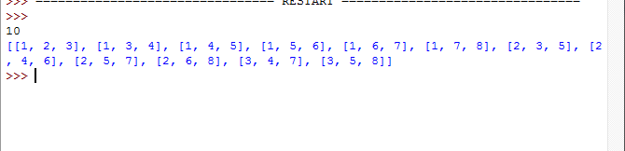

16. Write a python function parse_csv to parse csv (comma separated values) files.

Sol.