🗄️ HR & Employee Analysis
SQL Database Analysis Documentation
Field | Details
Analyst | Daniel Aboagye Asibu
Tool | MySQL Workbench 8.0
Database | hr_analysis
Tables | 4 (employees, departments, performance, attendance)
Records | 20 employees across 6 departments
Queries | 15 SQL analysis queries
Date | April 2026
Email | aboagyeasibudaniel@gmail.com
Portfolio | daniel-a-asibu.github.io

1. Project Overview
This project demonstrates SQL data analysis skills using MySQL Workbench. A company HR database was designed, populated with employee data, and analysed using 15 structured SQL queries to extract key business insights about employees, salaries, performance, and attendance.

The project covers: database creation, table design with primary and foreign keys, data insertion, and a wide range of SQL queries including SELECT, COUNT, SUM, AVG, GROUP BY, ORDER BY, JOIN, LIMIT, and WHERE clauses.

2. Database Structure
The hr_analysis database contains 4 tables linked by foreign keys:

Table | Records | Description
departments | 6 rows | Stores department names and locations
employees | 20 rows | Main employee table with personal and job details
performance | 20 rows | Employee performance ratings and scores for 2024
attendance | 20 rows | Employee attendance records for 2024

3. Table Descriptions

departments table
Column | Type | Description
department_id | INT (PK) | Auto-increment primary key
department_name | VARCHAR(50) | Name of department
location | VARCHAR(50) | Office location

employees table
Column | Type | Description
employee_id | INT (PK) | Auto-increment primary key
first_name / last_name | VARCHAR(50) | Employee full name
gender | VARCHAR(10) | Male or Female
age | INT | Employee age in years
email / phone | VARCHAR | Contact details
hire_date | DATE | Date employee joined company
job_title | VARCHAR(50) | Employee job title
department_id | INT (FK) | Links to departments table
salary | DECIMAL(10,2) | Monthly salary in GHS
status | VARCHAR(20) | Active or Resigned

performance table
Column | Type | Description
performance_id | INT (PK) | Auto-increment primary key
employee_id | INT (FK) | Links to employees table
review_year | INT | Year of performance review
rating | VARCHAR(20) | Excellent / Good / Average
score | INT | Performance score (0-100)

attendance table
Column | Type | Description
attendance_id | INT (PK) | Auto-increment primary key
employee_id | INT (FK) | Links to employees table
year | INT | Attendance year
days_present | INT | Number of days present
days_absent | INT | Number of days absent
days_leave | INT | Number of leave days taken

4. SQL Queries & Results
All 15 queries were executed successfully in MySQL Workbench. Below are each query, its purpose, and the result screenshot.

Query 1 — Active vs Resigned Employees
SELECT status, COUNT(*) AS total FROM employees GROUP BY status;
Result: 19 employees are Active, 1 has Resigned.
Insight: The company has a 95% employee retention rate.

📸 Result 3 — Active vs Resigned Employees
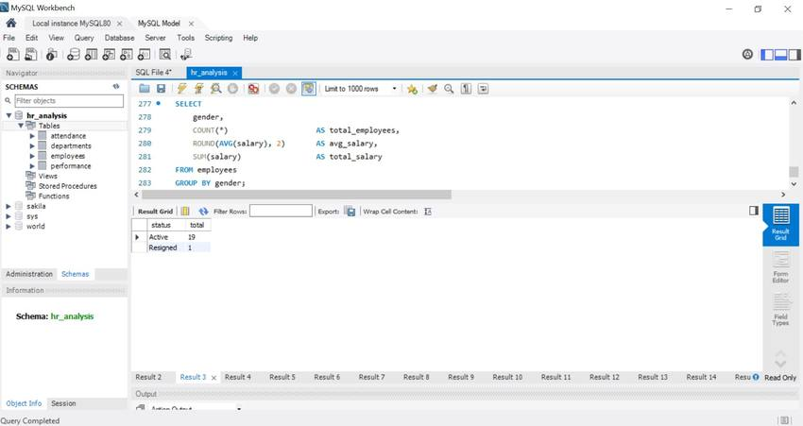

Query 2 — Employees by Department
SELECT d.department_name, COUNT(e.employee_id) AS total_employees
FROM employees e JOIN departments d ON e.department_id = d.department_id
GROUP BY d.department_name ORDER BY total_employees DESC;
Result: Sales, IT and Operations lead with 4 employees each.
Insight: Human Resources is the smallest department with only 2 employees.

📸 Result 4 — Employees by Department
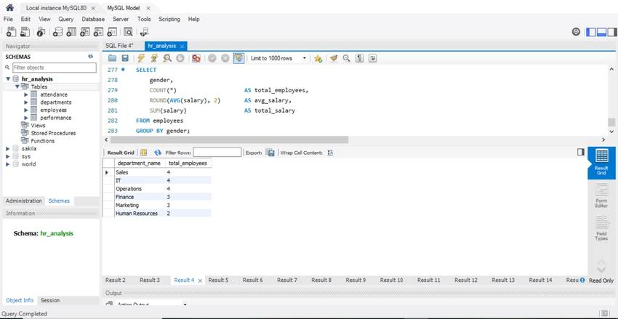

Query 3 — Employees by Gender
SELECT gender, COUNT(*) AS total,
ROUND(COUNT(*) * 100.0 / (SELECT COUNT(*) FROM employees), 1) AS percentage
FROM employees GROUP BY gender;
Result: Male: 10 (50%), Female: 10 (50%).
Insight: The company has a perfectly equal gender split — 50/50.

📸 Result 5 — Employees by Gender
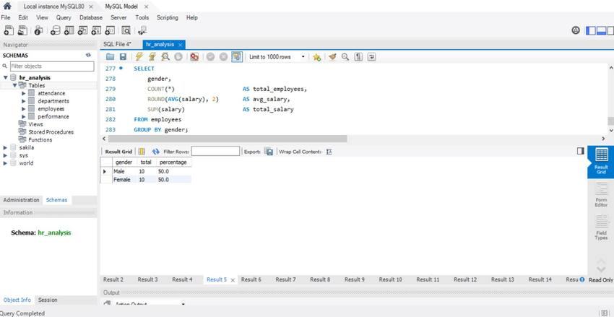

Query 4 — Salary Analysis by Department
SELECT d.department_name, COUNT(*) AS employees,
SUM(salary) AS total_salary, ROUND(AVG(salary),2) AS avg_salary,
MAX(salary) AS highest_salary, MIN(salary) AS lowest_salary
FROM employees e JOIN departments d ON e.department_id = d.department_id
GROUP BY d.department_name ORDER BY total_salary DESC;
Result: Operations has highest total salary ($31,900). Operations avg is $7,975.
Insight: IT department has the highest average salary per employee ($7,850).

📸 Result 6 — Salary Analysis by Department
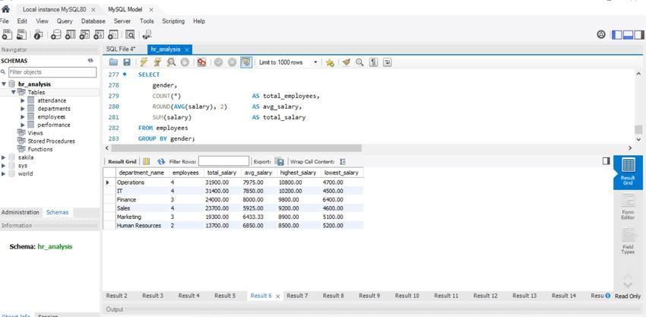

Query 5 — Top 5 Highest Paid Employees
SELECT CONCAT(first_name,' ',last_name) AS employee_name,
job_title, d.department_name, salary
FROM employees e JOIN departments d ON e.department_id = d.department_id
ORDER BY salary DESC LIMIT 5;
Result: Naana Ansah ($10,800), Kojo Antwi ($10,500), Efua Appiah ($10,200).
Insight: The top 5 highest earners are all Managers or Senior staff.

📸 Result 7 — Top 5 Highest Paid Employees
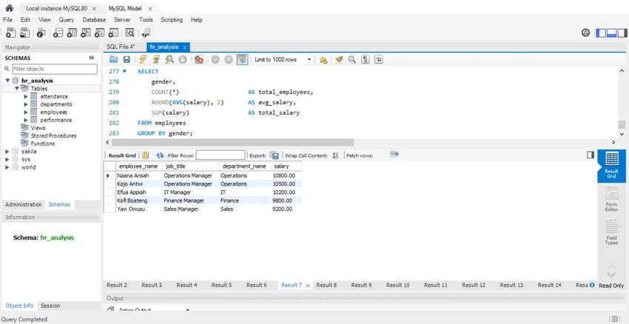

Query 6 — Hiring Trend by Year
SELECT YEAR(hire_date) AS hire_year, COUNT(*) AS employees_hired
FROM employees GROUP BY YEAR(hire_date) ORDER BY hire_year;
Result: Hiring spans from 2012 to 2022. Peak hiring in 2020 and 2021 (3 each).
Insight: Consistent hiring every year shows steady company growth.

📸 Result 8 — Employee Hiring Trend by Year
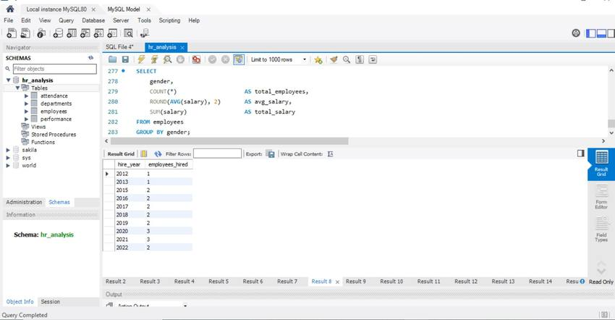

Query 7 — Performance Ratings Summary
SELECT rating, COUNT(*) AS total,
ROUND(COUNT(*) * 100.0 / (SELECT COUNT(*) FROM performance),1) AS percentage
FROM performance GROUP BY rating ORDER BY total DESC;
Result: Excellent: 8 (40%), Good: 8 (40%), Average: 4 (20%).
Insight: 80% of employees rated Excellent or Good — strong workforce performance.

📸 Result 9 — Performance Ratings Summary
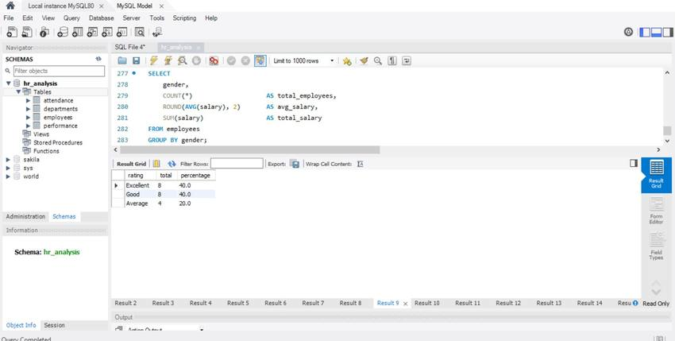

Query 8 — Top Performing Employees
SELECT CONCAT(e.first_name,' ',e.last_name) AS employee_name,
d.department_name, p.rating, p.score
FROM performance p JOIN employees e ON p.employee_id = e.employee_id
JOIN departments d ON e.department_id = d.department_id
WHERE p.rating = 'Excellent' ORDER BY p.score DESC;
Result: Efua Appiah (IT, 97), Kofi Boateng (Finance, 95), Kwesi Nyarko (IT, 94).
Insight: IT and Finance departments have the highest performing employees.

📸 Result 10 — Top Performing Employees (Excellent Rating)
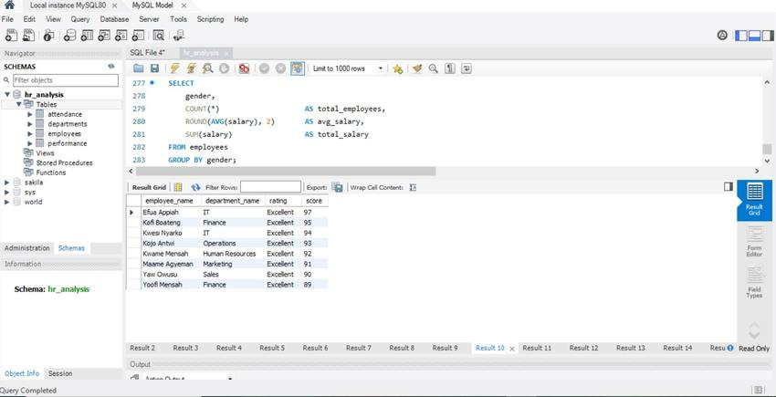

Query 9 — Average Performance Score by Department
SELECT d.department_name,
ROUND(AVG(p.score),1) AS avg_score,
MAX(p.score) AS highest_score, MIN(p.score) AS lowest_score
FROM performance p JOIN employees e ON p.employee_id = e.employee_id
JOIN departments d ON e.department_id = d.department_id
GROUP BY d.department_name ORDER BY avg_score DESC;
Result: Finance leads with avg score 88.0, followed by HR at 85.0.
Insight: Sales has the lowest average score (73.3) — may need performance improvement.

📸 Result 11 — Average Performance Score by Department
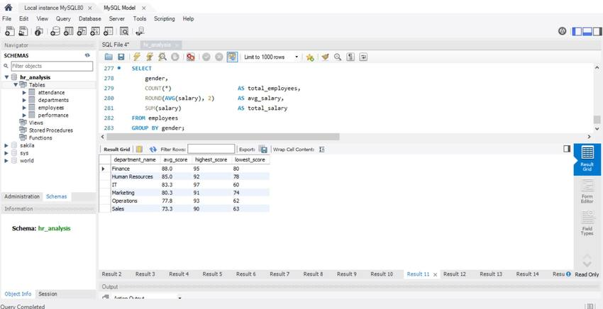

Query 10 — Employee Attendance Summary
SELECT CONCAT(e.first_name,' ',e.last_name) AS employee_name,
d.department_name, a.days_present, a.days_absent, a.days_leave,
ROUND(a.days_present*100.0/(a.days_present+a.days_absent+a.days_leave),1) AS attendance_rate
FROM attendance a JOIN employees e ON a.employee_id = e.employee_id
JOIN departments d ON e.department_id = d.department_id
ORDER BY attendance_rate DESC;
Result: Efua Appiah (IT) has the best attendance at 96.9%. Kwesi Nyarko at 96.5%.
Insight: IT department employees have the highest attendance rates overall.

📸 Result 12 — Employee Attendance Summary
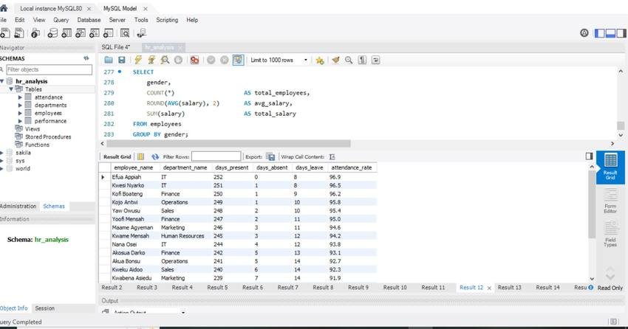

Query 11 — Employees with Most Absences
SELECT CONCAT(e.first_name,' ',e.last_name) AS employee_name,
d.department_name, a.days_absent
FROM attendance a JOIN employees e ON a.employee_id = e.employee_id
JOIN departments d ON e.department_id = d.department_id
ORDER BY a.days_absent DESC LIMIT 5;
Result: Naana Ansah (Operations, 20 days), Adwoa Frimpong (IT, 15 days).
Insight: Employees with high absences correlate with lower performance scores.

📸 Result 13 — Top 5 Employees with Most Absences
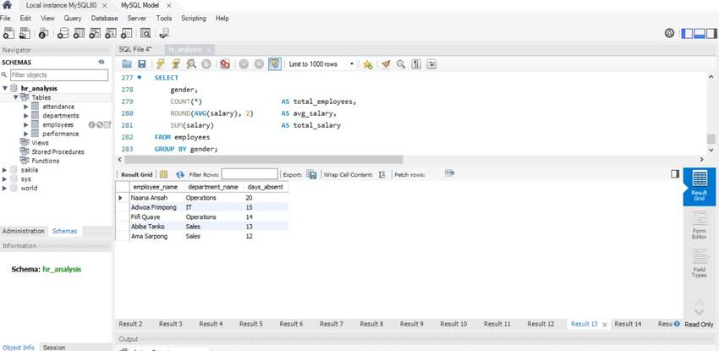

Query 12 — Full Employee Report (4-Table JOIN)
SELECT e.employee_id, CONCAT(first_name,' ',last_name) AS employee_name,
e.gender, e.age, e.job_title, d.department_name, e.salary, e.status,
p.rating, p.score, a.days_present, a.days_absent,
ROUND(a.days_present*100.0/(a.days_present+a.days_absent+a.days_leave),1) AS attendance_pct
FROM employees e JOIN departments d ON e.department_id=d.department_id
JOIN performance p ON e.employee_id=p.employee_id
JOIN attendance a ON e.employee_id=a.employee_id ORDER BY e.employee_id;
Result: Complete report combining all 4 tables into one master view.
Insight: This 4-table JOIN shows all employee details, salary, performance and attendance in one query.

📸 Result 14 — Full Employee Report (4-Table JOIN)
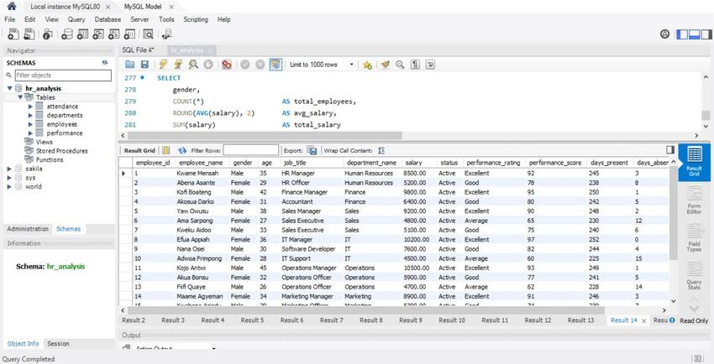

Query 13 — Salary Analysis by Gender
SELECT gender, COUNT(*) AS total_employees,
ROUND(AVG(salary),2) AS avg_salary, SUM(salary) AS total_salary
FROM employees GROUP BY gender;
Result: Male avg salary: $7,760. Female avg salary: $6,640.
Insight: There is a $1,120 gender pay gap. This warrants further investigation by management.

📸 Result 15 — Salary Analysis by Gender
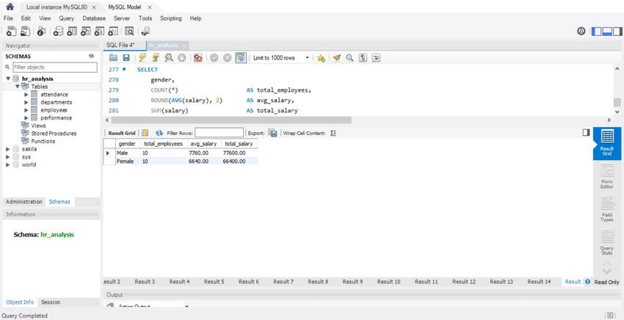

5. Key Insights & Findings
The following business insights were discovered through the 15 SQL queries:

# | Category | Insight | Detail
1 | Headcount | Total employees | 20 employees across 6 departments
2 | Retention | Active employees | 19 Active (95%), 1 Resigned (5%)
3 | Gender | Equal split | 10 Male (50%), 10 Female (50%)
4 | Department | Largest dept | Sales, IT & Operations — 4 employees each
5 | Department | Smallest dept | Human Resources — 2 employees
6 | Salary | Highest earner | Naana Ansah — $10,800 (Operations Manager)
7 | Salary | Highest avg dept | IT Department — $7,850 average salary
8 | Salary | Gender pay gap | Male avg $7,760 vs Female avg $6,640 ($1,120 gap)
9 | Performance | Top performer | Efua Appiah (IT) — Score 97/100
10 | Performance | Best dept | Finance — Average score 88.0
11 | Performance | Needs improvement | Sales — Average score 73.3 (lowest)
12 | Attendance | Best attendance | Efua Appiah (IT) — 96.9% attendance rate
13 | Attendance | Most absent | Naana Ansah — 20 days absent
14 | Hiring | Peak year | 2020 & 2021 — 3 new hires each year
15 | Ratings | Overall rating | 80% of staff rated Excellent or Good

6. SQL Concepts Demonstrated
This project showcases the following SQL skills and concepts:

SQL Concept | Used In | Description
CREATE DATABASE | Setup | Created hr_analysis database
CREATE TABLE | Setup | Built 4 tables with proper data types
PRIMARY KEY | Table Design | Auto-increment IDs for each table
FOREIGN KEY | Table Design | Linked tables for relational integrity
INSERT INTO | Data Loading | Inserted 20 employees and related records
SELECT | All queries | Retrieved data from tables
COUNT() | Q1,Q2,Q3,Q7 | Counted records and employees
SUM() / AVG() | Q4,Q6,Q13 | Calculated totals and averages
MAX() / MIN() | Q4,Q9 | Found highest and lowest values
GROUP BY | Q1-Q9 | Grouped results by category
ORDER BY | Q2,Q4,Q5 | Sorted results ascending/descending
JOIN | Q2,Q4,Q5,Q8-Q12 | Combined data from multiple tables
WHERE | Q8 | Filtered results by condition
LIMIT | Q5,Q11 | Returned top N results
CONCAT() | Q5,Q8-Q12 | Combined first and last name fields
ROUND() | Q3,Q4,Q9,Q12 | Rounded decimal values
YEAR() | Q8 | Extracted year from date field
Subquery | Q3,Q7 | Used nested SELECT for percentage calculation

7. Conclusion
This HR & Employee SQL project successfully demonstrated end-to-end database analysis using MySQL Workbench. A relational database was designed with 4 linked tables, populated with 20 employee records, and analysed using 15 queries covering headcount, salary, performance, attendance, and hiring trends.

Key recommendations for management based on the analysis: investigate the $1,120 gender pay gap, provide performance support to the Sales department (lowest avg score of 73.3), and monitor the high absence rates in Operations and IT departments.

Daniel Aboagye Asibu · Data Analytics Portfolio · April 2026 · aboagyeasibudaniel@gmail.com · daniel-a-asibu.github.io

