🏥 Hospital Patient Data
Data Cleaning, Analysis & Dashboard Documentation
Field | Details
Analyst | Daniel Aboagye Asibu
Tool | Microsoft Excel
Dataset | hospital_analysis.xlsx
Records | 500 patient records
Columns | 15 columns
Period | January – December 2024
Date | April 2026
Email | aboagyeasibudaniel@gmail.com
Portfolio | daniel-a-asibu.github.io

1. Project Overview
This document presents the complete data analysis workflow performed on a Hospital Patient dataset using Microsoft Excel. The workflow covers data cleaning, pivot table analysis, chart creation, and dashboard design.

The goal was to extract meaningful insights about patient admissions, departmental revenue, doctor performance, and insurance patterns to support data-driven hospital management decisions.

2. Dataset Description
The dataset contains 500 hospital patient records for the year 2024 across 5 departments, 6 doctors and 4 insurance types.

Column | Data Type | Description
Patient_ID | Text | Unique patient identifier (PAT-0001 to PAT-0500)
Admit_Date | Date | Date patient was admitted to hospital
Discharge_Date | Date | Date patient was discharged
Month | Text | Month of admission (January to December)
Gender | Text | Patient gender — Male or Female
Age | Number | Patient age in years (1 to 85)
Department | Text | Hospital department (5 departments)
Diagnosis | Text | Medical diagnosis assigned to patient
Doctor | Text | Name of attending doctor (6 doctors)
Length_of_Stay | Number | Number of days spent in hospital
Status | Text | Patient status — Admitted, Discharged, Critical, Under Observation
Insurance | Text | Insurance type — NHIS, Private, Self-Pay, Corporate
Total_Bill | Currency | Total amount billed to patient ($)
Amount_Paid | Currency | Amount paid by patient ($)
Outstanding | Currency | Remaining unpaid balance ($)

3. Raw Data Preview
Before cleaning, the raw dataset was inspected to understand its structure, column names, data types, and overall quality.

📸 Raw Dataset — Initial State Before Any Cleaning
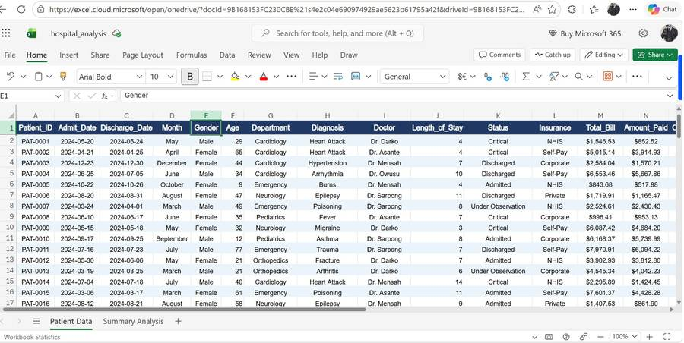

4. Data Cleaning Process
A systematic 4-step data cleaning process was performed to ensure the dataset is accurate, complete, consistent, and ready for analysis.

Step 1 — Remove Duplicate Records
Duplicate records can cause incorrect totals and misleading analysis. Excel's Remove Duplicates function was used to check all 15 columns for repeated rows.
Process: Data tab → Remove Duplicates → Select All Columns → OK
Result: No duplicate records were found. All 500 records are unique.
Action Taken: No rows removed. Dataset remains at 500 records.

📸 Remove Duplicates — All 15 Columns Selected
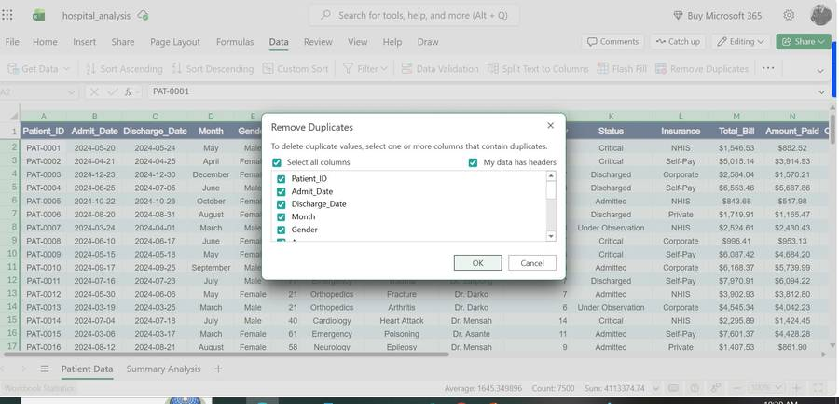
📸 Result — 500 Records Confirmed, No Duplicates Found
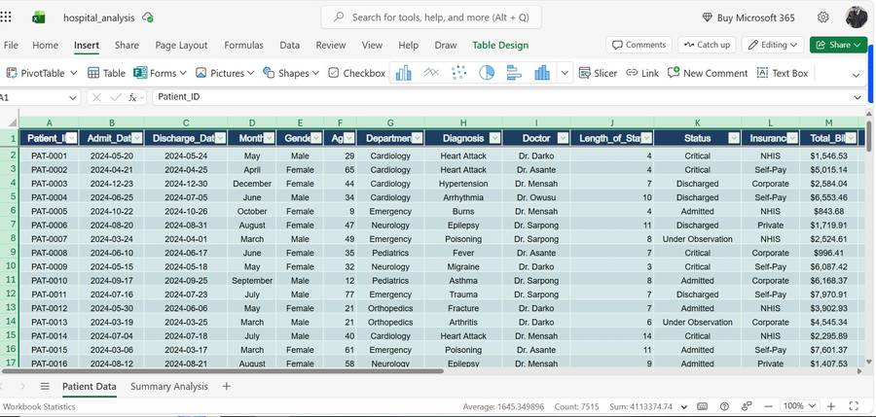

Step 2 — Check for Missing / Blank Values
Missing values can cause errors in calculations and pivot tables. Excel's Find & Replace with empty search criteria was used to detect any blank cells.
Process: Ctrl+F → Leave search box empty → Match Entire Cell Contents → Find All
Result: No blank or missing values found across all 500 rows and 15 columns.
Action Taken: No changes required. Dataset is 100% complete.

Step 3 — Spelling Check Using Column Filters
Filters were applied to all categorical columns to visually inspect each unique value for spelling errors, inconsistencies, or unexpected entries.
Process: Data tab → Filter → Click dropdown on each column → Review all unique values

Column | Unique Values Found | Count | Status
Department | Cardiology, Emergency, Neurology, Orthopedics, Pediatrics | 5 | ✅ All Correct
Gender | Male, Female | 2 | ✅ All Correct
Status | Admitted, Critical, Discharged, Under Observation | 4 | ✅ All Correct
Doctor | Dr. Asante, Dr. Boateng, Dr. Darko, Dr. Mensah, Dr. Owusu, Dr. Sarpong | 6 | ✅ All Correct
Insurance | Corporate, NHIS, Private, Self-Pay | 4 | ✅ All Correct

📸 Department Filter — 5 Departments Verified
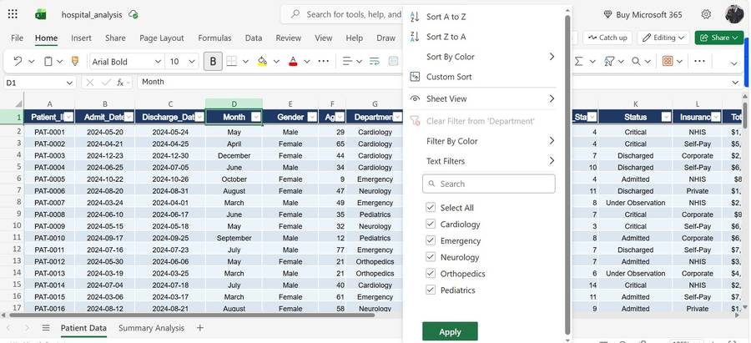
📸 Gender Filter — Male and Female Only
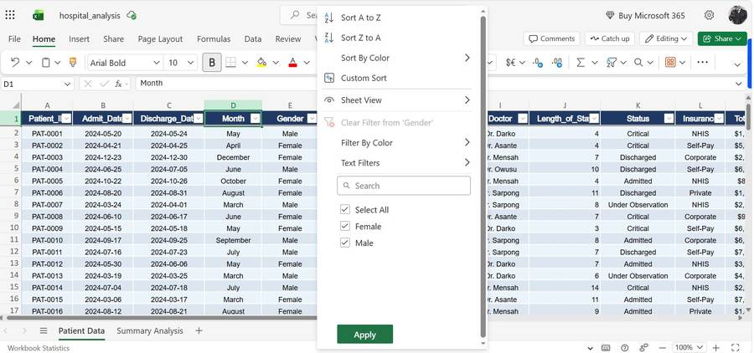
📸 Status Filter — 4 Status Values Verified
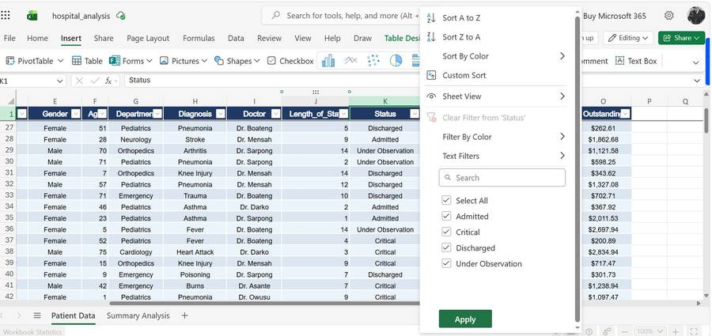
📸 Doctor Filter — All 6 Doctors Verified
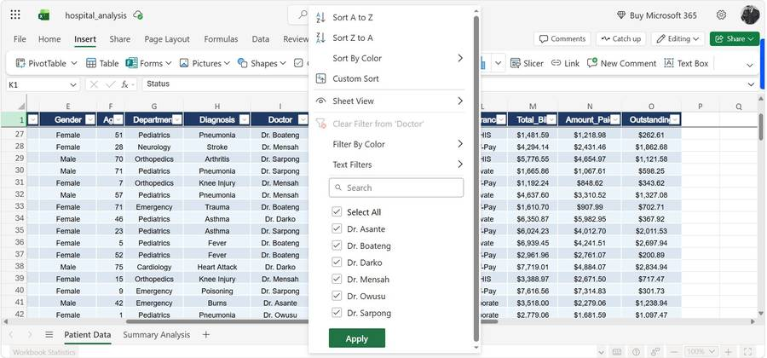

Step 4 — Verify Data Types
Each column was checked to confirm that Excel had assigned the correct data type for accurate sorting, filtering, and calculations.

Column | Expected Type | Actual Type | Status
Admit_Date / Discharge_Date | Date | Date | ✅ Correct
Total_Bill / Amount_Paid / Outstanding | Currency | Currency ($) | ✅ Correct
Age / Length_of_Stay | Number | Number | ✅ Correct
Department / Diagnosis / Doctor | Text | Text | ✅ Correct
Patient_ID / Gender / Status | Text | Text | ✅ Correct

5. Data Cleaning Summary
All 4 cleaning steps were completed successfully. The dataset is clean, complete, and ready for analysis.

# | Cleaning Step | Finding | Action Taken | Status
1 | Duplicate Records | No duplicates found | No action needed | ✅ Pass
2 | Missing Values | No blank cells | No action needed | ✅ Pass
3 | Department Spelling | 5 values — correct | No action needed | ✅ Pass
4 | Gender Spelling | 2 values — correct | No action needed | ✅ Pass
5 | Status Spelling | 4 values — correct | No action needed | ✅ Pass
6 | Doctor Spelling | 6 names — correct | No action needed | ✅ Pass
7 | Insurance Spelling | 4 values — correct | No action needed | ✅ Pass
8 | Data Types | All correct | No action needed | ✅ Pass

6. Pivot Table Analysis
Four pivot tables were created from the cleaned dataset to extract key business insights across departments, insurance types, doctors, and monthly trends.

Pivot Table 1 — Analysis by Department
Shows patient count, total bill, amount paid and outstanding balance broken down by each of the 5 hospital departments.
Key Finding: Neurology has the most patients (106) and highest revenue ($466K). Orthopedics has the fewest patients (92).

📸 Pivot Table 1 — Patients & Revenue by Department
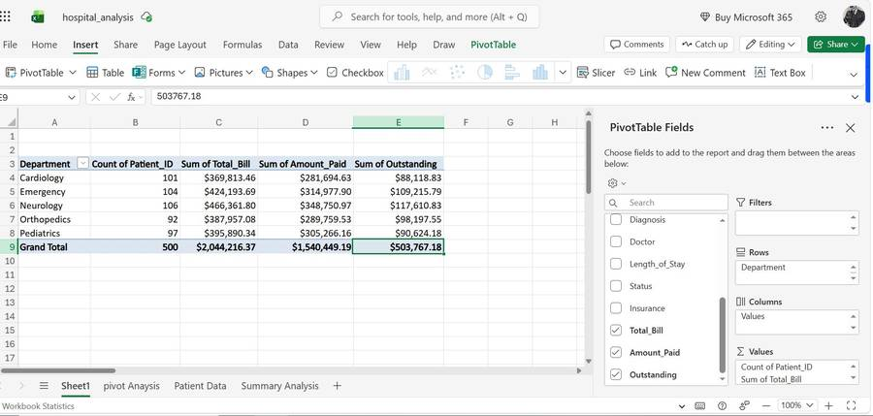

Pivot Table 2 — Analysis by Insurance Type
Shows how patients and revenue are distributed across the 4 insurance types — Corporate, NHIS, Private, and Self-Pay.
Key Finding: Corporate has the most patients (140) and highest revenue ($612K). Self-Pay has the highest outstanding balance ($130K).

📸 Pivot Table 2 — Patients & Revenue by Insurance Type
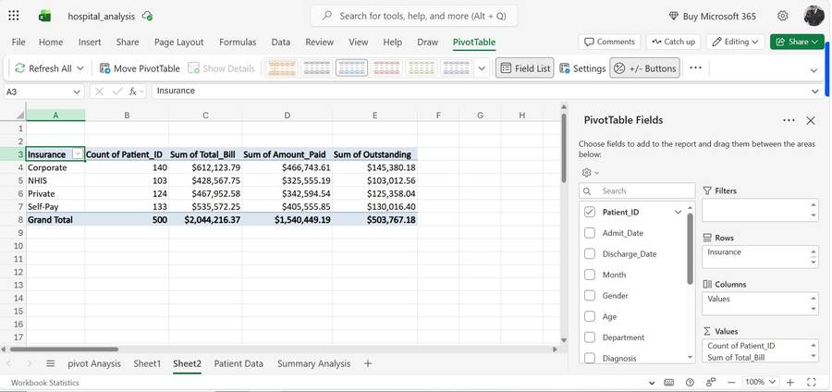

Pivot Table 3 — Analysis by Doctor
Shows each doctor's patient count, average length of stay, and total revenue generated throughout 2024.
Key Finding: Dr. Owusu has the most patients (92) and highest revenue ($393K). Average length of stay is 7.4 days across all doctors.

📸 Pivot Table 3 — Doctor Performance Analysis
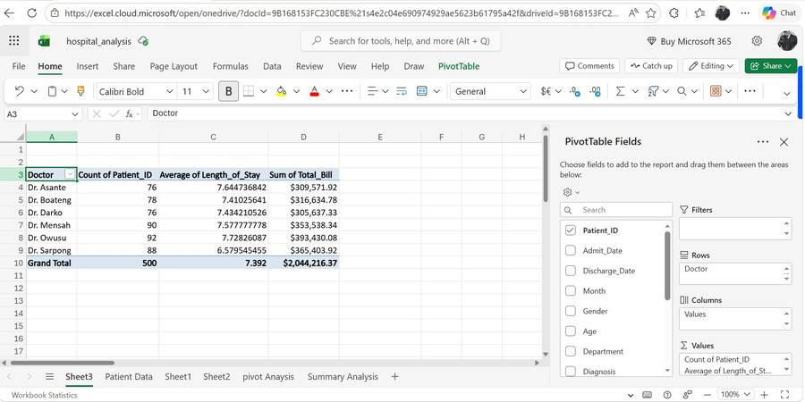

Pivot Table 4 — Monthly Patient Admissions
Shows how patient admissions and total revenue varied across all 12 months of 2024 to identify seasonal trends.
Key Finding: July is the peak month with 59 admissions and $255K revenue. June is the slowest with only 31 admissions and $122K revenue.

📸 Pivot Table 4 — Monthly Admissions & Revenue Trend
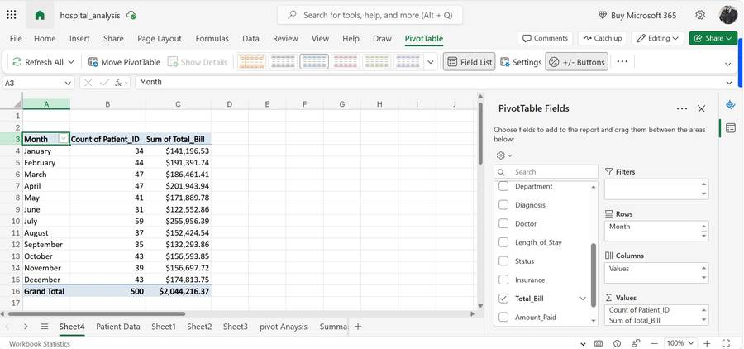

7. Data Visualisation — PivotCharts
Four PivotCharts were created directly from the pivot tables to present the findings visually in a clear and professional manner.

Chart 1 — Patients by Department (Clustered Bar Chart)
Insight: Neurology leads in both patient count and revenue. All departments have comparable outstanding balances.

📸 Chart 1 — Patients & Revenue by Department
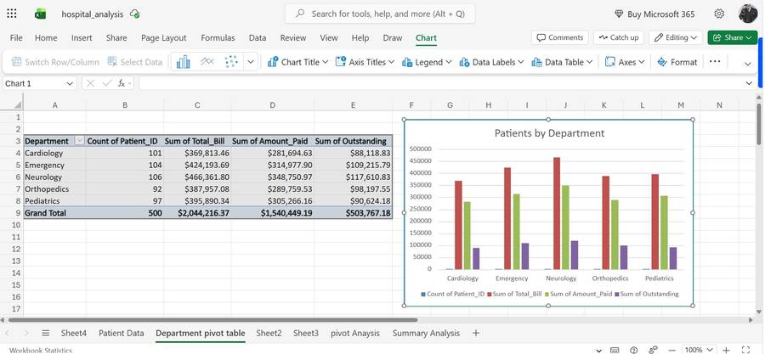

Chart 2 — Revenue by Insurance Type (Pie Chart)
Insight: Revenue is fairly evenly distributed — Corporate 28%, Self-Pay 27%, Private 25%, NHIS 20%.

📸 Chart 2 — Revenue by Insurance Type
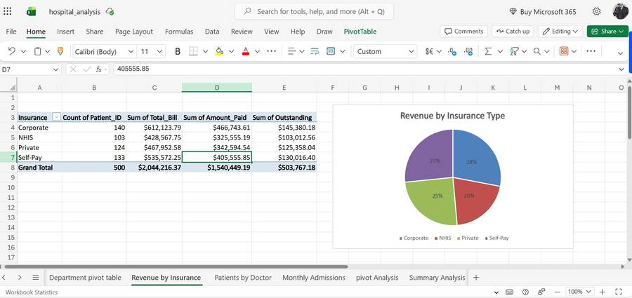

Chart 3 — Patients by Doctor (Bar Chart)
Insight: Dr. Owusu generates the highest revenue ($393K). All doctors have a similar average length of stay around 7 days.

📸 Chart 3 — Revenue & Patients by Doctor
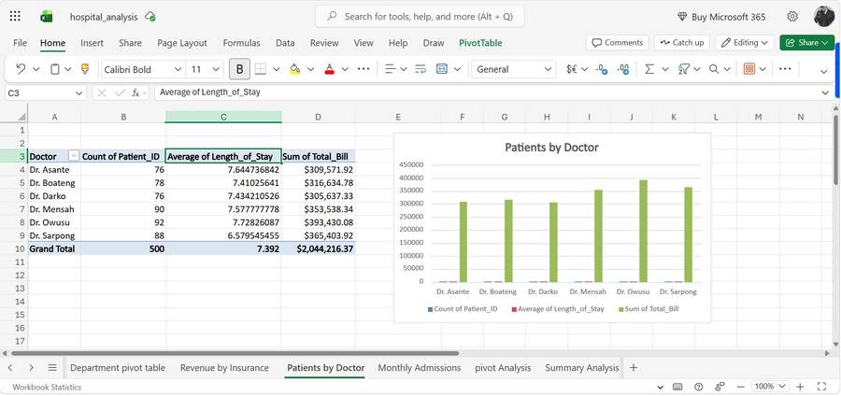

Chart 4 — Monthly Patient Admissions (Line Chart)
Insight: July is the peak month. June is the slowest. Revenue trends closely follow patient admission numbers.

📸 Chart 4 — Monthly Patient Admissions & Revenue Trend
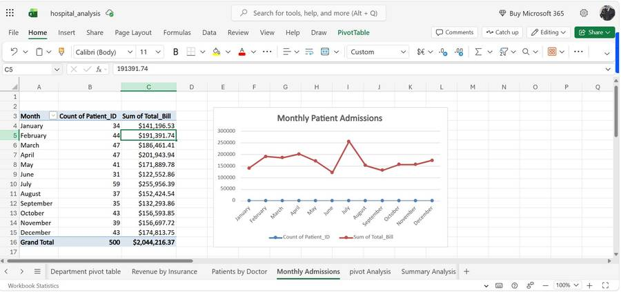

8. Excel Dashboard
A professional interactive dashboard was built in Excel combining all KPI metrics and charts into a single, visually appealing view. The dashboard uses a clean white background with coloured KPI cards and 4 embedded PivotCharts.

Dashboard Element | Description
Title Bar | Dark navy header with dashboard title and analyst details
KPI Card 1 — Total Patients | 500 patients across all departments
KPI Card 2 — Total Revenue | $2,044,216 billed in 2024
KPI Card 3 — Outstanding | $503,767 (24.6%) still unpaid
KPI Card 4 — Avg Length of Stay | 7.4 days per patient
Chart 1 — Monthly Revenue Trend | Line chart showing revenue and admissions Jan–Dec
Chart 2 — Revenue by Insurance | Pie chart showing insurance distribution
Chart 3 — Revenue by Department | Horizontal bar chart by department
Chart 4 — Revenue by Doctor | Horizontal bar chart by doctor

📸 Final Excel Dashboard — Hospital Patient Analysis 2024
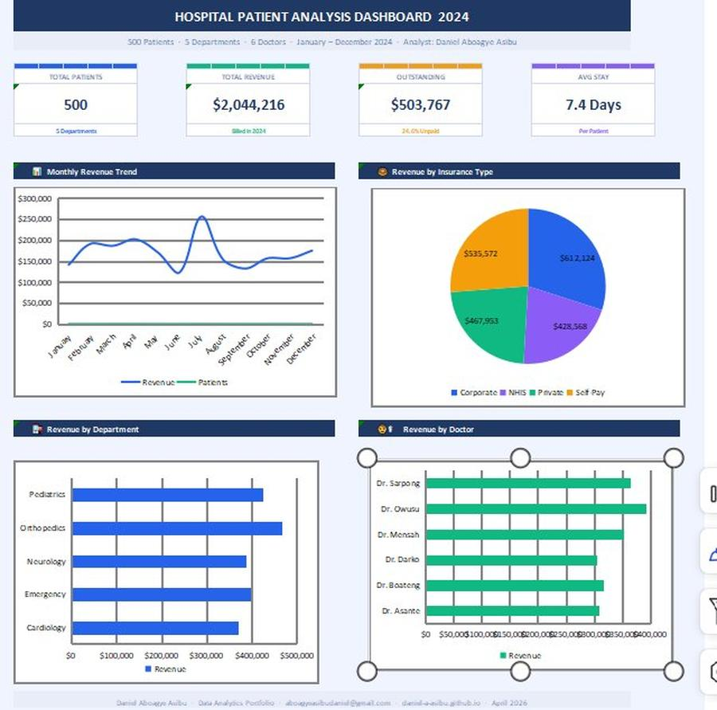

9. Key Insights & Findings
The following key business insights were discovered through the pivot table and chart analysis:

# | Category | Insight | Detail
1 | Department | Top performer | Neurology — 106 patients, $466K revenue
2 | Department | Lowest performer | Orthopedics — 92 patients, $387K revenue
3 | Insurance | Largest group | Corporate — 140 patients, $612K billed
4 | Insurance | Highest debt | Self-Pay — $130K outstanding balance
5 | Doctor | Top earner | Dr. Owusu — 92 patients, $393K revenue
6 | Doctor | Avg stay | 7.4 days average across all doctors
7 | Monthly | Peak month | July — 59 patients, $255K revenue
8 | Monthly | Slowest month | June — 31 patients, $122K revenue
9 | Financial | Total billed | $2,044,216 across all 500 patients
10 | Financial | Total outstanding | $503,767 (24.6%) remains unpaid

10. Conclusion
The Hospital Patient dataset was successfully cleaned, analysed, visualised, and presented through a professional Excel dashboard. The data was found to be clean with no duplicates or missing values across all 500 records.

Key findings show that Neurology is the highest-performing department, Corporate insurance covers the most patients, Dr. Owusu is the top-earning doctor, and July has the highest patient admissions. The $503,767 outstanding balance across Self-Pay and other insurance types highlights a critical area for revenue collection improvement.

These insights can help hospital management make better decisions about resource allocation, doctor workload, department investment, and revenue collection strategy.

Daniel Aboagye Asibu · Data Analytics Portfolio · April 2026 · aboagyeasibudaniel@gmail.com · daniel-a-asibu.github.io

