IT353 - System Analysis and Design
Student Activities Management System (SAMS)
Task 2 - Prototyping

Student Name | Hussain Ali Al Hatielah
Student ID | S230052323
Project | Student Activities Management System

Task 2
Select ONE prototyping approach (Evolutionary Prototyping or Throwaway Prototyping). Develop low-fidelity prototypes for 3 main screens of the system and justify why your chosen approach is more appropriate for this project. [2 marks]

Selected Approach
I selected evolutionary prototyping for the Student Activities Management System.
Evolutionary prototyping starts with a simple working version of the system and improves it gradually after receiving user feedback. The prototype is refined over time instead of being discarded.
This approach is suitable for SAMS because the system has different users with different requirements. Students need simple searching and registration functions, activity organizers need participant management tools, and Student Affairs needs approval and reporting functions. Some requirements may become clearer only after these users interact with the early prototype.
Evolutionary prototyping is more suitable than throwaway prototyping because the early screens and functions can be reused and improved. This saves development time and allows the system to grow gradually.
Screen 1: Student Home and Activity Search
The first screen allows students to search for activities and filter them by category, campus, or date.
Main elements include:
- Search bar
- Category filter
- Campus filter
- Date filter
- List of upcoming activities
- Available-seat information
- Activity history summary
- Navigation to certificates and notifications
The student can select an activity to view more details.
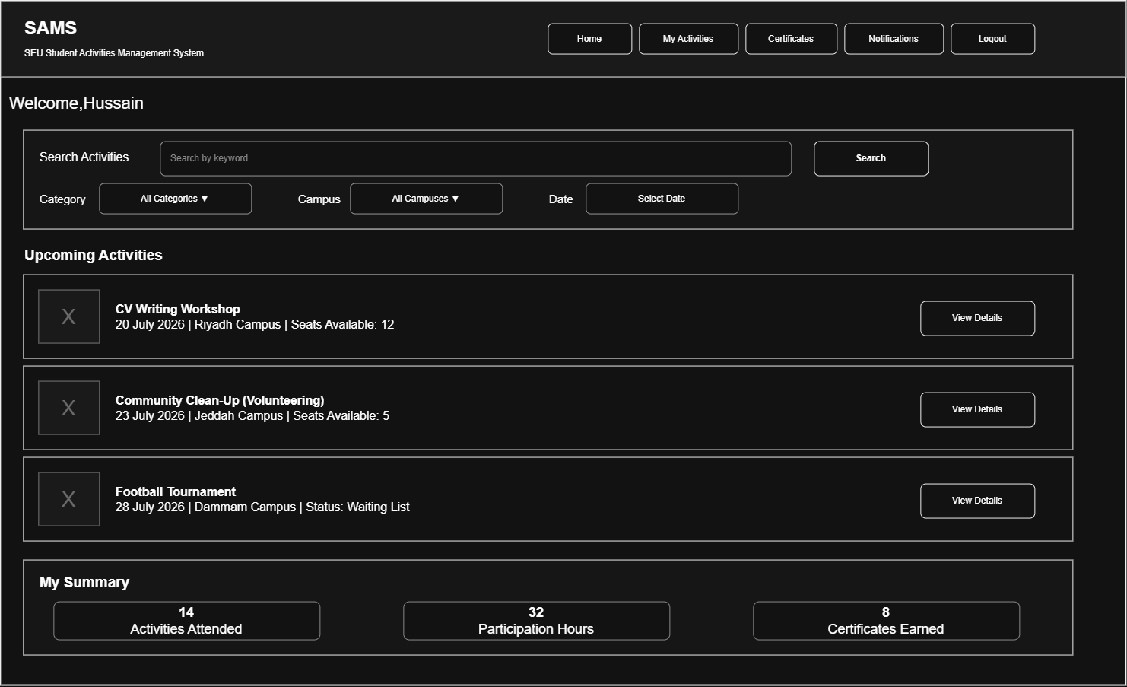
Figure 1: Student Home and Activity Search Low-Fidelity Prototype

Screen 2: Activity Details and Registration
This screen displays complete information about one selected activity and provides the appropriate registration action based on seat availability and the student’s registration status.
Main elements include:
- Activity title and category
- Organizer, date, time, and location
- Activity description and eligibility conditions
- Registration period and available seats
- Attendance method
- Reserve a Seat button
- Join Waiting List button when the activity is full
- Cancel Reservation button after registration
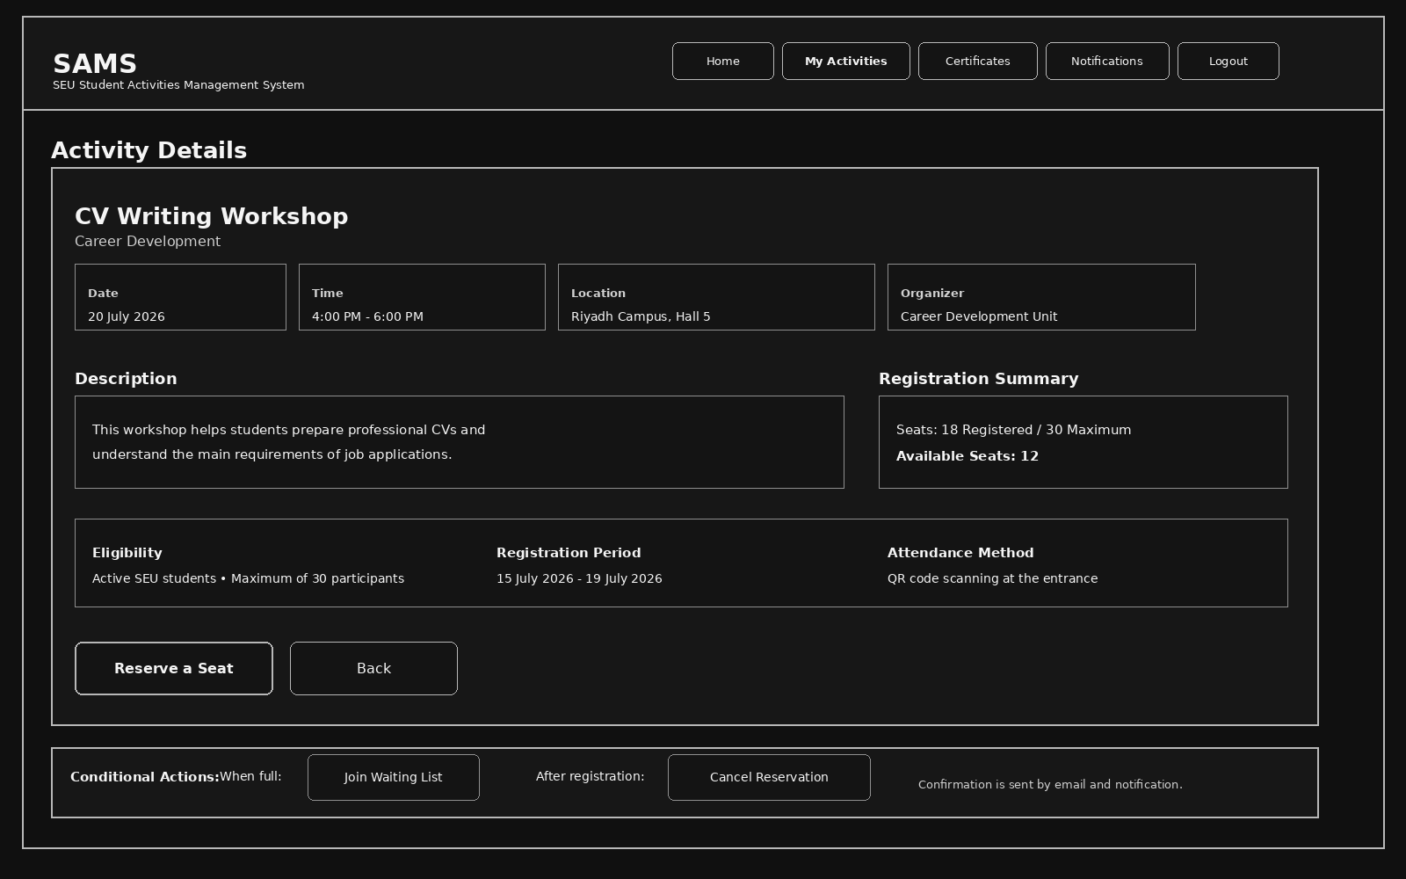
Figure 2: Activity Details and Registration Low-Fidelity Prototype

Screen 3: Organizer Management Dashboard
This screen allows the activity organizer to manage activities and participants, monitor registration and attendance statistics, and complete the main operational actions for each activity.
Main elements include:
- Create New Activity
- Edit, publish, and cancel activities
- View participant lists and approve registrations
- Generate QR code and record attendance
- Issue certificates and generate activity reports
- Display registered, waiting-list, and attendance totals
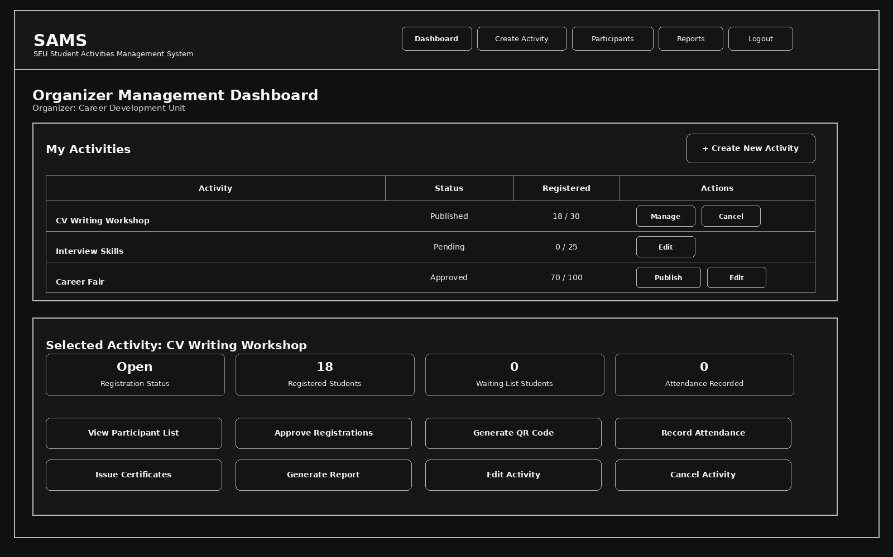
Figure 3: Organizer Management Dashboard Low-Fidelity Prototype

