JavaScript:

What is e.preventDefault(); ?

Asynchronous programming:

Instead of waiting for a call to a method that doesn’t affect the whole process, we pass a call back function that executes a block of code when that call returns.

APIs of Asynchronous programming in JavaScript:
- XMLHttpRequest & Fetch
- Jquery ajax, axios and other HTTP libraries.
- Node.js fs (file system) module.

Methods of handling asynchronous code:

- Callbacks
- Promises
- Async/await

Ajax is not a framework or library: it is a set of web technologies to send and receive data between the client and server, asynchronously.

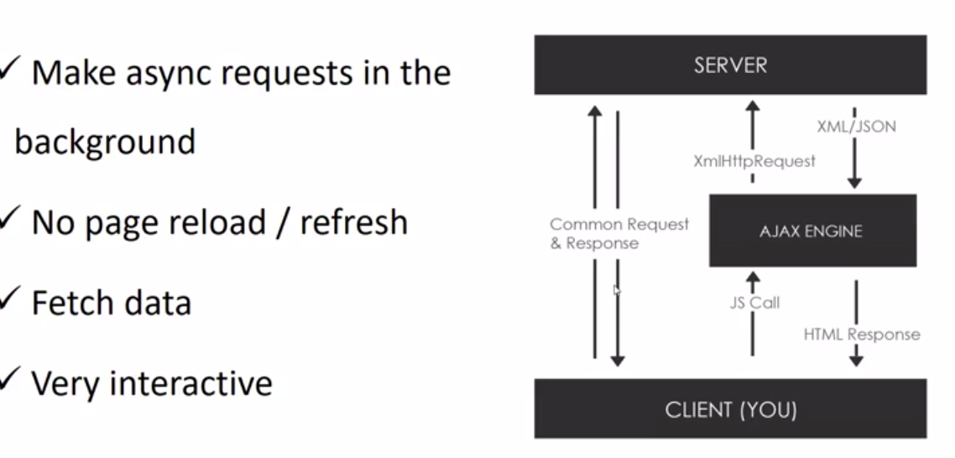

XHR (XML HTTP Request):

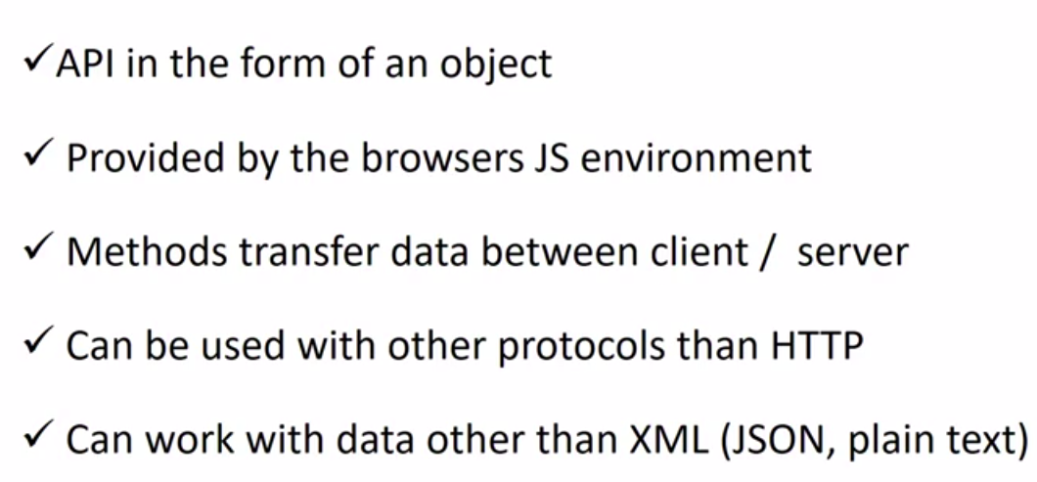

XHR methods:

const xhr = new XMLHttpRequest();

xhr.open(method: string, url: string, async: boolean, username?: string, password?: string) → establish a connection to server, changing xhr.readyState to 1

xhr.readyState values

// readyState Values
// 0: request not initialized
// 1: server connection established
// 2: request received
// 3: processing request
// 4: request finished and response is ready

XMLHttpRequest.onload = callback; → do something when ready state becomes = 4
is the function called when an XMLHttpRequest transaction completes successfully.
callback is the function to be executed when the request completes successfully.

xhr.onprogress(this: XMLHttpRequest) → do something when ready state = 3 (for spinners /loaders)

JSON.parse(“response json string”) → convert to a valid javascript object

API:

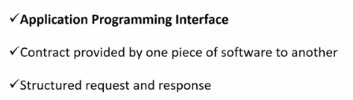

REST API:

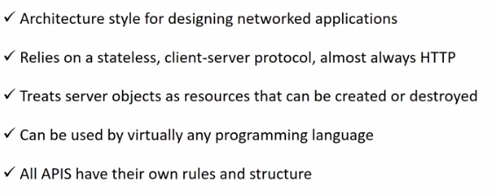
server objects like blog post or user

HTTP requests:

GET – POST – DELETE – PUT

and
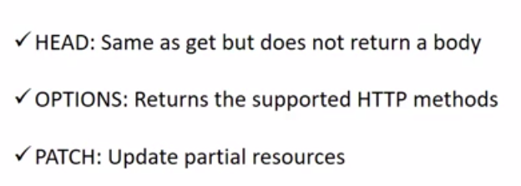

Callback functions:

A function that is passed as a parameter to another function and is ran in the function body.

easyhttp example, video 63

------------------------------------------------------------------------------------------------------------------------

Promises:

Alternative to callback. Alternative way of handling asynchronous operations.

While they are handling asynchronous operations, they can promise to do something when that operation is finished.

We handle a promise response with a .then. This block of code will run when the promise is complete.

return new Promise(function(resolve, reject){// body });

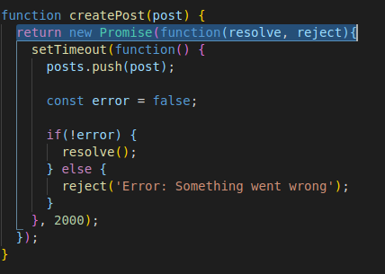

Calling:

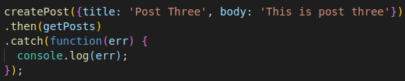

Fetch API is the new standard for handling HTTP requests, and is based on Promises. It is a part of window object.

fetch.(url).then(function(res: Promise) { // return res.json()}).then(function(data) { // code after processing}).catch(function(err) {// handling err});

Error handling with fetch is a bit different than with something like Axios or jQuery.
If there is an http error, it will not fire off .catch automatically.
You have to check the response and throw an error yourself.
Here is an example

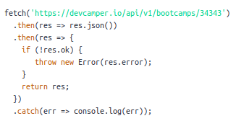

I would suggest creating a separate function for error handling

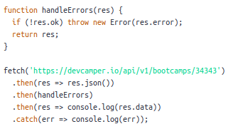

Study the scope of (this) in arrow functions.

Study Promises vs Callbacks

Explain clearly why some functions have to return promise (asynchronous)

------------------------------------------------------------------------------------------------------------------------

Async/Await: ES7

putting async before a function makes it return a promise

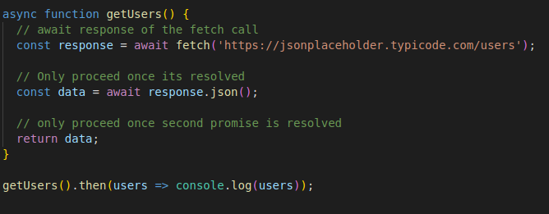

Study errors type in JavaScript

------------------------------------------------------------------------------------------------------------------------

ES6 new features

Iterators and generators:

Iterators: Advanced loops that can be paused.

Generators: Functions that can be paused and return multiple values

Very good example is video 88 – ProfileScroller

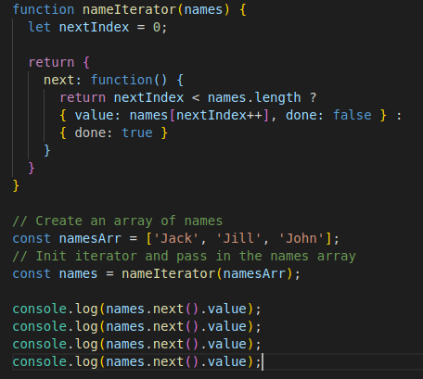

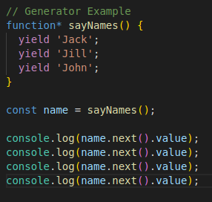

------------------------------------------------------------------------------------------------------------------------

Symbols:

Every single symbol is completely unique, making them very valuable in terms of things like object property identifiers.

const symbol = Symbol(); // not new Symbol(), as it is primitive not object

const symbol = Symbol(‘sym’);

Symbol(‘123’) === Symbol(‘123’) // returns false, it is unique !!

Cannot be wrapped in String template, so a workaround is needed

console.log(`Hello ${sym}`); // cannot convert symbol to string

console.log(`Hello ${String(sym)}`); // correct

console.log(`Hello ${sym.toString()}`); // correct

Symbols are not enumerable in for … in

Symbols are ignored in Json.stringify

Study real cases of Symbols

------------------------------------------------------------------------------------------------------------------------

De-Structuring:

Gives as an easy way to assign variables and extract variables from arrays and objects.

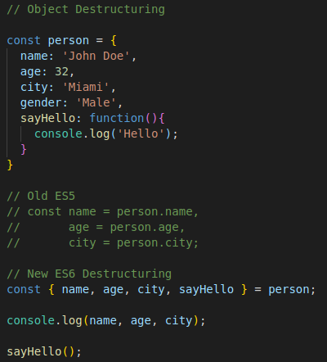

------------------------------------------------------------------------------------------------------------------------

Maps:

possible types of keys:

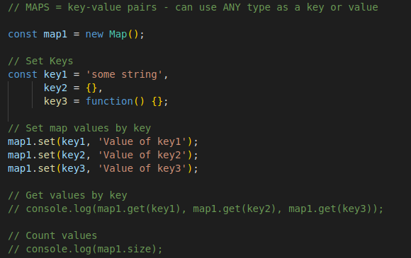
Operations:

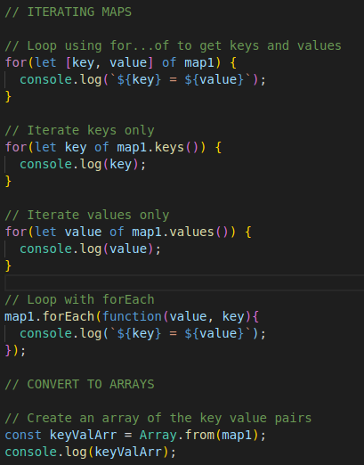

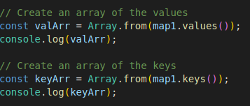

Sets are in video 92 – no new to screenshot !!

JavaScript patterns:

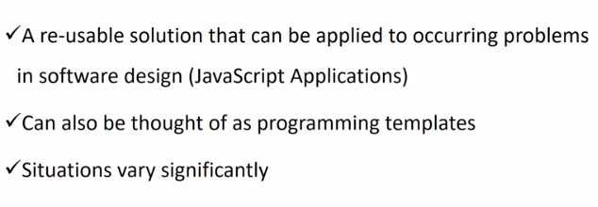
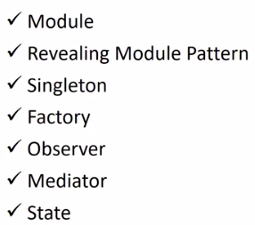

ES6 introduced modules, meaning that we can separate files to export which are just custom pieces of code and import them into a new file.

This is not supported by browsers, we have to use a compiler like babel with a module loader like web pack.

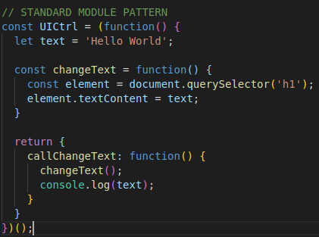

UICtrl.callChangeText();

Revealing Module Pattern:

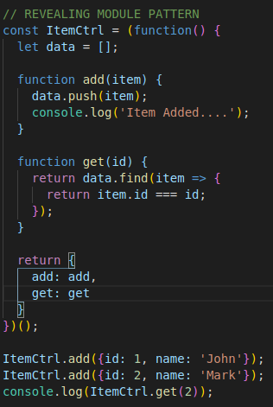

Note the difference between Standard and revealing → in revealing, you call the function as it is.
In standard, you can call something + the private function

Singletone:

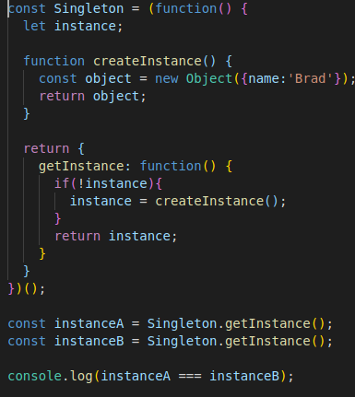

Factory:

A way of creating an interface for creating objects, but we can let subclasses define which classes to instantiate.

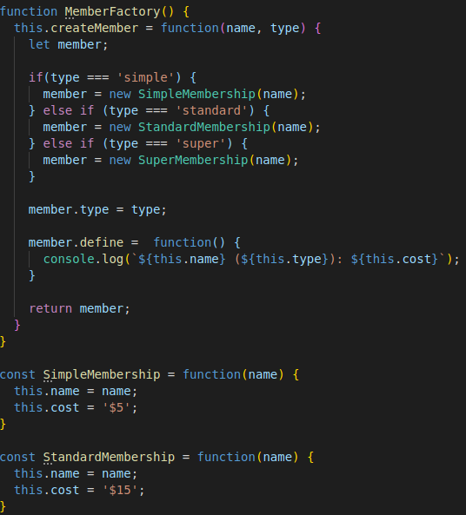

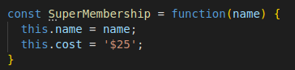

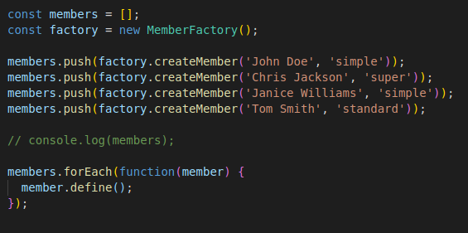

Observer pattern:

Can be used to notify the DOM of certain elements to be updated. Angular relies on this pattern through event management.

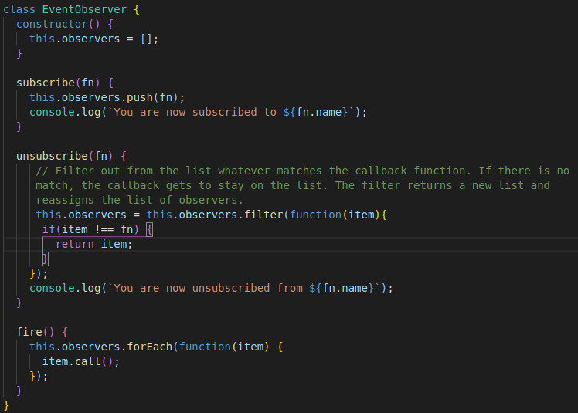

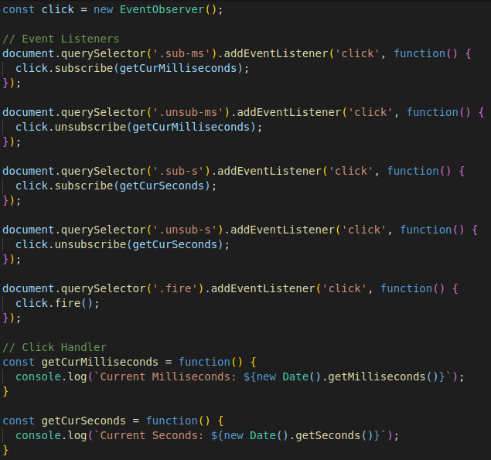

Mediator → Chatroom – study

------------------------------------------------------------------------------------------------------------------------

OOP in java script:

ES5 constructor

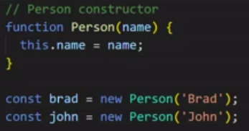

console.log(this) in the global prints window object

What is the difference between a normal function and constructor syntax?

A method is function inside an object.

Person constructor with method inside:

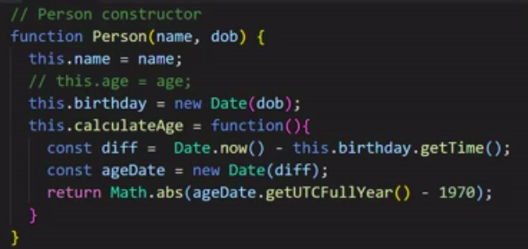

The following prints no because the triple operator === compares type and value – and the created string is of type object, not string primitive:

name1 is of type string
name2 is of type object
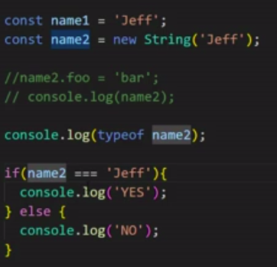

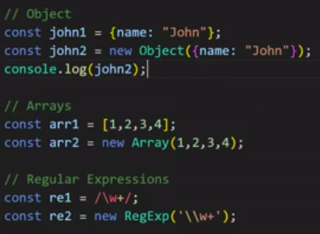

Creating primitives with the way of the object slows things down. It is recommended to create the the primitive way.

Prototype:

Each object in JS has a prototype and a prototype is an object itself.

All objects inherit their properties and methods from their prototype.

In computer science, a literal is a notation for representing a fixed value in source code.

We cannot access prototype as a property.

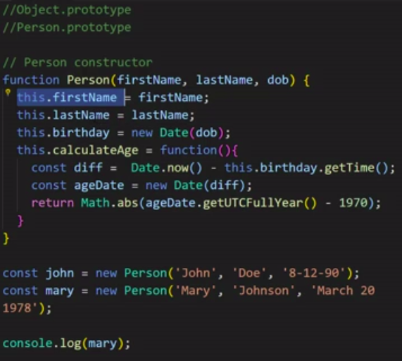

In the above example, each object should have its own first,last name and birthday. But the method calculate age is the same to all objects. So we should put in inside the prototype, not inside the object itself as it is unique per class, not object.

Try to print an object and investigate in prototype properties in console.

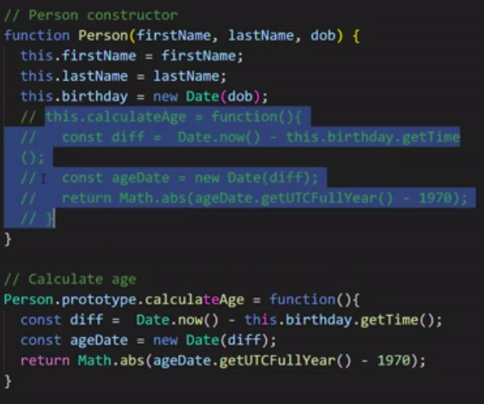

Prototypical inheritance:

Call is a function that allows us another function from somewhere else in the current context

In the below example, Customer inherits properties from Person but not the methods in prototype.

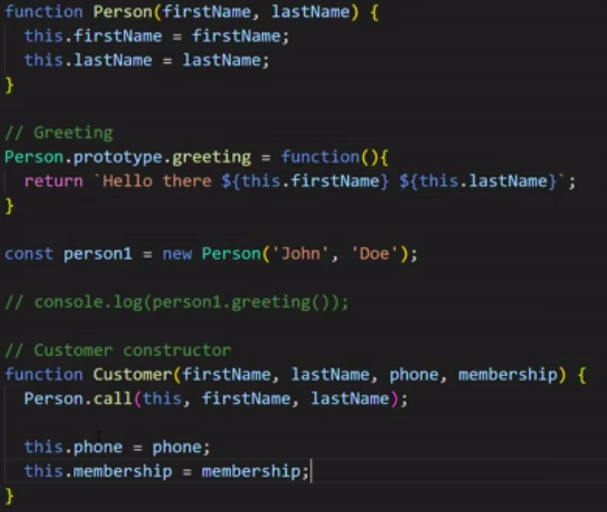

To inherit prototype:

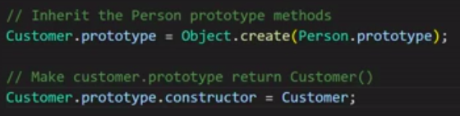

We can overwrite Person prototype methods in Customer.

Object.create:

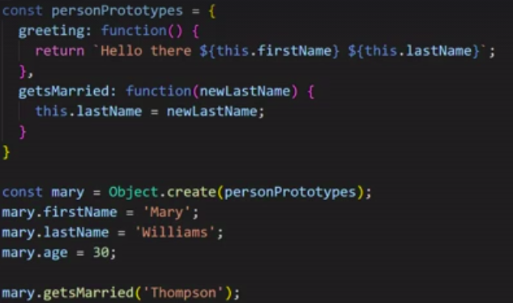
Another way:

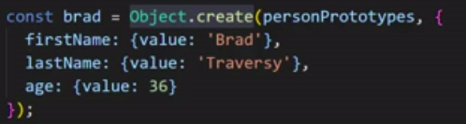

Object.create vs using prototype directly

In ES6 classes, every method declared in the class is created in Prototype object

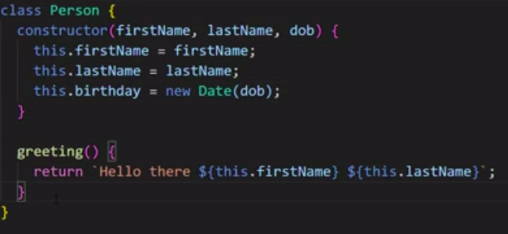

static methods

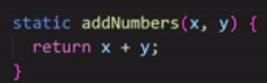

Babel is used to transpile ES6 code to regular ES5 code that browsers can compile, especially in modules.
Webpack gives us a nice workflow.

Invest some time to learn this tools and how they work.

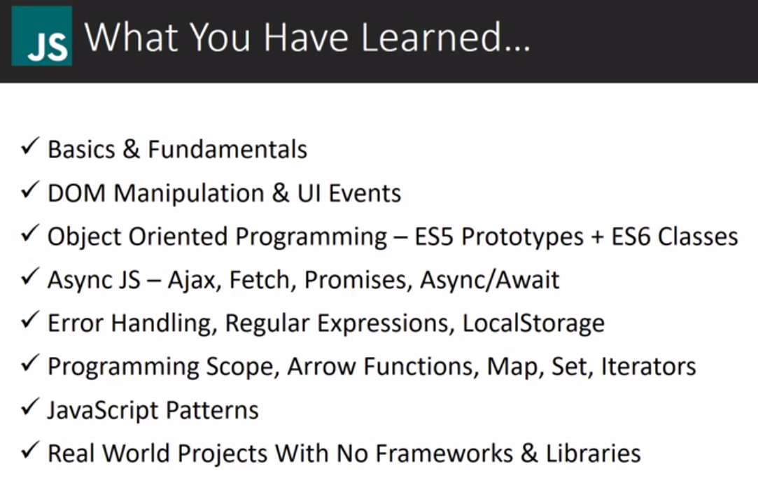

This is what you should test yourself and build your knowledge map and story. Try to make an explanation so that you can make short videos with your own way.

Null vs undefined:

- null is an assigned value. It means nothing.
- undefined typically means a variable has been declared but not defined yet.
- null and undefined are falsy values.
- null and undefined are both primitives. However an error shows that typeof null = object.
- null !== undefined but null == undefined.

https://codeburst.io/javascript-null-vs-undefined-20f955215a2

