MASTER PROJECT
KNOWLEDGE BASE
CoralGuard-X / Coral Reef Detection, Classification & Video Intelligence
Project evolution from the original box-only scope to the current accuracy-first architecture.
Document Version: 1.0
Reconstruction Date: 03 September 2026
Source of Truth: this project conversation and the project artifacts created/shared inside it

Document Purpose:
This document reconstructs and preserves the complete technical, operational, architectural, and troubleshooting knowledge accumulated throughout the project conversation.
Preservation Rule
Where the conversation contains superseded designs, this document preserves both the historical decision and the current replacement. Unknown or unverified details are explicitly marked Confirmed, Inferred, Unclear, Deprecated, or Pending.

Table of Contents
1. Project Overview and Reconstruction
2. Project Timeline
3. Full Architecture Documentation
4. Data Architecture
5. Complete Workflow Extraction
6. Business Rules
7. Problems & Troubleshooting Knowledge Base
8. Decisions Log
9. Code Knowledge Extraction
10. Naming & Terminology Dictionary
11. UI / UX Documentation
12. Roles & Permissions
13. Automation & Triggers
14. Reports / Search / Dashboards
15. Calculations & Formulas
16. Testing History & Regression Checklist
17. What We Learned Building This System
18. Current State Snapshot
19. Missing / Unclear Information
20. AI Handover Context
Appendix A. Metrics History
Appendix B. Project Artifact Inventory
Appendix C. Mermaid Reference Diagrams

1. Project Overview and Reconstruction
Project name. CoralGuard-X is the latest name used for the integrated coral AI system. Earlier documentation also refers to the work generically as Coral Reef AI / Coral Detection & Classification.
Problem statement. The system must locate corals in underwater images/video, isolate each coral instance sufficiently well to reduce background contamination and overlap, classify the coral into the operational species labels available in the dataset, reject uncertain/non-coral candidates pragmatically, and produce stable annotated video suitable for research demonstration and eventual real-time use.
The scope evolved substantially. The original explicit requirement was Detection → Crop → Classification → Video → Real-Time, with segmentation explicitly excluded. After real video deployment exposed overlapping bounding boxes, background contamination, ambiguous colonies, and false labels on dead-looking/non-coral structures, instance segmentation was introduced as a practical refinement layer. The project then evolved through a Teacher→Student segmentation experiment and finally to an accuracy-first architecture that uses CoralSCOP directly as the primary mask refiner.
Requirement Type | Requirement / Constraint | Status
Core functional | Detect coral candidates in underwater images/video. | Confirmed
Core functional | Classify detected coral into six operational labels. | Confirmed
Core functional | Produce annotated video with stable IDs/species. | Confirmed
Quality | Handle small, crowded and overlapping colonies better than early baselines. | Confirmed
Quality | Reduce background/rock inside ROI before classification. | Confirmed
OOD/validity | Allow Unknown/Non-Coral rejection instead of forced six-class prediction. | Implemented pragmatically; not true open-set
Performance | Use local RTX A6000 and optimize long-running notebook stages. | Confirmed
Evaluation | Do not use held-out detector test for iterative tuning/model selection. | Confirmed
Taxonomy | Do not invent biological certainty where labels are ambiguous/typo-prone. | Confirmed
Deployment | Near-term requirement: generate a presentable first video quickly for academic review. | Current priority

Target users / stakeholders. No formal product user model was implemented. The conversation identifies the user as the research/development operator and an academic “doctor” as a review/demo stakeholder. There is no implemented web application, customer portal, or enterprise user management layer.
Operational class labels (as audited in the annotation set):
- Euphflfiaancora
- Favosites
- Platygyra
- Sarcophyton
- Sinularia
- WavingHand
Taxonomy caution
Platygyra, Sarcophyton and Sinularia are genus-level names. Euphflfiaancora may correspond to Fimbriaphyllia ancora; Favosites may be a typo for Favites; WavingHand is a common-name style label. The conversation explicitly required not overstating taxonomic certainty.

2. Project Timeline
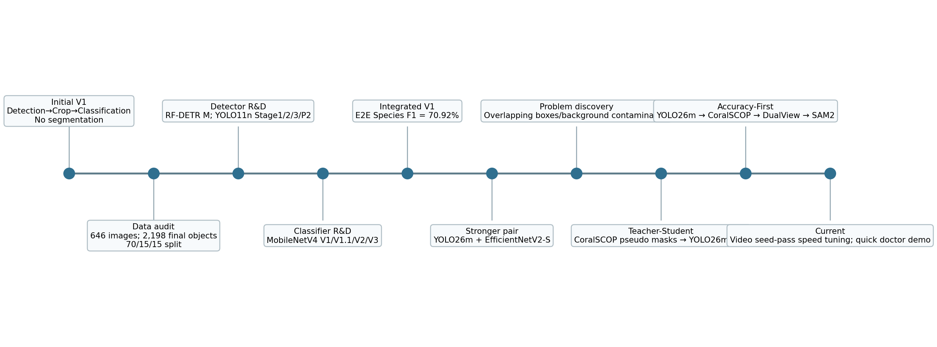
Logical project timeline. Dates are not assigned where the conversation did not provide an explicit date.
ID | Milestone | What changed | Status
T01 | Initial V1 scope | Detection → bounding box → ROI crop → species classification → annotated video → real-time. Segmentation explicitly excluded. | Deprecated scope constraint
T02 | Dataset audit and canonicalization | 646 image/JSON pairs audited; one duplicate object removed; EXIF orientation normalized; leakage-safe split established. | Final data foundation
T03 | RF-DETR Medium baseline | 10-epoch detector reached strong validation performance; demonstrated that the dataset could support much stronger localization than tiny YOLO baseline. | Historical benchmark
T04 | YOLO11n baseline + Stage 2 | YOLO11n 10-epoch baseline followed by 832px underwater-focused fine-tuning. | Superseded detector path
T05 | YOLO11n Stage 3 | Targeted small/crowded sliced fine-tuning at 960px; became the lightweight detection baseline. SAHI inference later failed to help. | Historical baseline
T06 | YOLO11n P2 Stage 4 | P2/P3/P4/P5 experiment tried to improve small objects; transfer mismatch and short training left it under-converged. | Not adopted
T07 | MobileNetV4 classifier evolution | V1 → V1.1 → V2 Sarcophyton-targeted → V3 288px +10% context + hard mining. | Historical classifier baseline
T08 | Integrated Stage3 + MobileNetV4 V3 | Validation E2E Species F1 = 70.92%; failure attribution showed detector/localization dominated errors. | Important benchmark
T09 | Video stabilization | BoT-SORT, bbox EMA, gap hold, classifier probability EMA; FFmpeg H.264 replaced low-quality mp4v. | Retained concepts
T10 | Stronger model pair | YOLO26m + EfficientNetV2-S became the stronger deployment pair; local Windows/A6000 migration followed. | Pre-segmentation baseline
T11 | Real-video failure discovery | Overlapping boxes, background inside ROIs, Unknown/incorrect predictions, dead-looking/algae-like structures exposed limitations of box-only crop classification. | Architecture pivot trigger
T12 | CoralGuard-X hybrid | YOLO26m candidate detection + CoralSCOP box-prompted masks + classifier + SAM2 proposed. | Superseded by Teacher→Student then accuracy-first
T13 | Teacher→Student V2 | CoralSCOP generated pseudo instance masks; YOLO26m-SEG student trained for 150 epochs. | Completed experiment
T14 | Student evaluation | Pseudo-mask mAP50:95 0.5905; original-GT box operating F1 0.7311. Student segmentation useful, detector behavior weaker than old YOLO26m. | Decision point
T15 | Final accuracy-first architecture | Old YOLO26m kept as primary detector; CoralSCOP used directly on detector candidates; Dual-View classifier + OOD gate + SAM2.1. | Current final architecture
T16 | Runtime optimization | Dual-view data build, classifier training, and video seed pass were optimized. Refresh stride moved from 1 to 5 for speed; quick one-video demo path requested. | Current work

3. Full Architecture Documentation
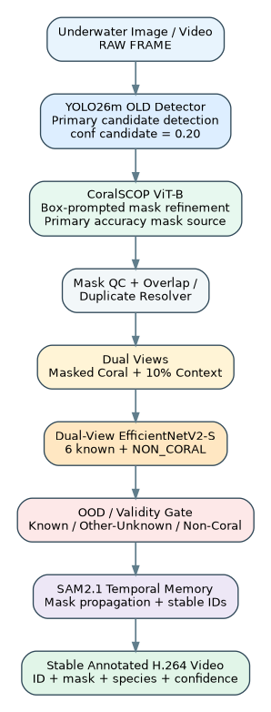
Figure 3-1. Final accuracy-first system architecture.
This is a research/ML notebook system rather than a conventional web application. Therefore “frontend”, “backend”, “database”, and “permissions” are mapped to their functional equivalents below rather than invented as nonexistent services.
Component | Purpose | Inputs | Outputs | Dependencies
Notebook Control Layer | VS Code Jupyter notebooks on Windows; exposes config cells, training/evaluation cells, progress output and artifact paths. | Config variables, file paths, checkpoints | Models, manifests, reports, videos | Python/PyTorch/Ultralytics/timm/OpenCV
File-System Data Layer | Local workspace stores datasets, masks, manifests, model checkpoints, caches and outputs. | COCO/CSV/JPEG/PNG/JSON/ZIP | Derived datasets/checkpoints | D:\Coral_Local_Workspace
YOLO26m Detector | Primary candidate detector in current architecture. | RGB image/frame | Candidate bounding boxes + confidence | Ultralytics 8.4.117; old verified checkpoint
CoralSCOP | Accuracy-first instance mask refiner using YOLO boxes as prompts. | RGB frame + box prompt | Precise binary mask + score | CoralSCOP ViT-B checkpoint, segment_anything-style API
Mask QC / Duplicate Resolver | Chooses/filters masks and suppresses duplicate overlapping hypotheses. | Masks, detector boxes, scores | Clean instance list | IoU, containment, mask quality logic
Dual-View EfficientNetV2-S | Shared backbone classifier over masked coral and +10% context view. | Two 300×300 views | 7-way logits/embedding | Old EfficientNetV2-S transfer weights + new fusion/head
OOD / Validity Gate | Prevents forced known-species assignment when confidence/margin/embedding is weak or NON_CORAL is strong. | Probabilities + embedding | Known / Other-Unknown / Non-Coral | Validation-derived prototypes/thresholds
SAM2.1 Temporal Memory | Propagates masks and stabilizes object identity between refresh frames. | Seed masks + video frames | Per-frame masks + IDs | facebook/sam2.1-hiera-large
FFmpeg Output Layer | Creates high-quality H.264 MP4, optionally preserving audio. | Annotated raw frames + source audio | Final MP4 | libx264; CRF/preset configurable

Current inference sequence:
RAW FRAME
→ YOLO26m old detector (candidate boxes)
→ CoralSCOP on each candidate box
→ mask quality + duplicate/overlap resolution
→ masked coral view + 10% context view
→ Dual-View EfficientNetV2-S
→ known / Other-Unknown / Non-Coral gate
→ SAM2.1 temporal memory and stable IDs
→ H.264 annotated video
Deprecated / alternate architecture: YOLO26m-SEG Student as primary segmenter. This remains a useful fast/backup model but is no longer the accuracy-first primary spatial path because its original-GT detection operating point was weaker than the old YOLO26m detector.
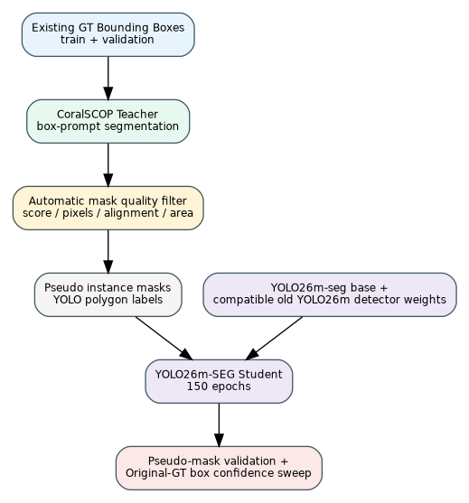
Figure 3-2. Teacher→Student training architecture retained as a completed experiment and possible fast-mode model.
Mermaid representation of the current architecture:
flowchart TD
A[RAW underwater frame] --> B[YOLO26m old detector]
B --> C[Candidate boxes]
C --> D[CoralSCOP box-prompt masks]
D --> E[Mask QC + overlap/duplicate resolver]
E --> F1[Masked coral view]
E --> F2[+10% context view]
F1 --> G[Dual-View EfficientNetV2-S]
F2 --> G
G --> H[OOD / validity gate]
H --> I[SAM2.1 temporal memory]
I --> J[Stable annotated H.264 video]

4. Data Architecture
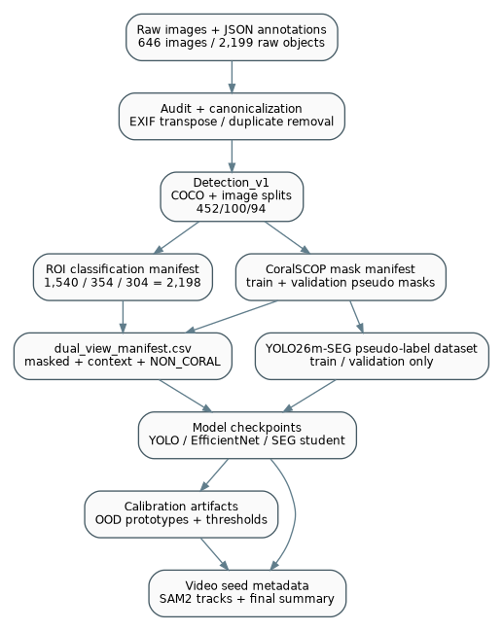
Figure 4-1. Dataset and artifact data flow.
The project uses a file-based data architecture: COCO JSON, CSV manifests, image folders, PNG mask files, YAML dataset configs, PyTorch checkpoints and JSON/CSV reports. No relational database was implemented.

4.1 Canonical dataset inventory
Dataset layer | Train | Validation | Test | Total / Notes
Detection images | 452 | 100 | 94 | 646 images
Detection boxes | 1,540 | 354 | 304 | 2,198 final objects
Classification ROIs | 1,540 | 354 | 304 | 2,198 ROIs; same split lineage
CoralSCOP teacher masks | train generated | validation generated | NOT generated for tuning | Pseudo masks, not human GT
Seg student validation | - | 100 images / 352 pseudo-mask instances | test untouched | 2 validation objects filtered/absent from pseudo-mask dataset

Raw audit history: 2,199 raw objects were found; one duplicate annotation was removed, leaving 2,198 final ground-truth objects. Forty images required EXIF orientation normalization during canonicalization.

4.2 Core entities / files and Data Dictionary

COCO Detection JSON
Field | Type | Purpose | Source | Validation / Relationships
images[].id | integer (observed) | Image identifier | Dataset audit/canonicalization | Unique within split; referenced by annotations
images[].file_name | string (observed) | Image filename/path | Canonical image folder | Must resolve to an image file
annotations[].id | integer (observed) | Annotation identifier | Annotation conversion | Used to name/associate pseudo masks
annotations[].image_id | integer (observed) | Parent image reference | COCO JSON | FK-like reference to images.id
annotations[].category_id | integer (observed) | Detector category | Canonicalization | Single detector class: target_coral
annotations[].bbox | [x,y,w,h] numeric | Ground-truth rectangle | Raw annotation conversion | Converted to xyxy for many internal calculations

classification_roi_manifest_split.csv
Field | Type | Purpose | Source | Validation / Relationships
roi_id | string | Unique ROI record | ROI dataset builder | Used to name context/masked images
image_stem | string | Source image key | Source image filename | Used for CoralSCOP mask mapping
raw_detection_label | string | Operational species label | Original annotations | One of six audited labels
x1_px/y1_px/x2_px/y2_px | numeric | ROI box in pixels | Canonical annotation | Used for crop and mask matching
split | string | train/validation/test | Leakage-safe split | Must preserve source-image split

coralscop_mask_manifest.csv
Field | Type | Purpose | Source | Validation / Relationships
split | string | Data split | Mask generation loop | train/validation only during tuning
ann_id | integer | Source annotation ID | COCO annotation | Links pseudo mask to prompt object
image_id | integer | Source image ID | COCO image | Parent reference
image_path / image_stem | string | Source image locator/key | Canonical dataset | Used by dual-view mapping
mask_path | string | PNG mask location | CoralSCOP generation | Must exist and decode to 2D boolean mask
mask_score | float | Teacher mask score | CoralSCOP predictor | Minimum quality gate typically 0.35
area/alignment metrics | float where present | Pseudo-mask audit | mask quality logic | Teacher agreement indicators, not independent GT accuracy

dual_view_manifest.csv
Field | Type | Purpose | Source | Validation / Relationships
split | string | train/validation | ROI split | No detector test used for training
label | string | 6 species + NON_CORAL | ROI label or generated negative | Classifier target
context_path | string | +10% context JPEG | Dual-view builder | JPEG quality 95
masked_path | string | Foreground-focused JPEG | CoralSCOP mask/proxy mask | JPEG quality 95
source | string | Provenance marker | Builder | e.g., CORALSCOP_CORAL / BACKGROUND_NEGATIVE

student_operating_config.json
Field | Type | Purpose | Source | Validation / Relationships
best_seg_conf_original_gt | float | Best validation operating confidence | Original-GT confidence sweep | Observed result 0.40
model/checkpoint refs | string | Student checkpoint metadata | Cell 9 | Promoted to models/best_yolo26m_seg_student.pt

ood_calibration.json + ood_prototypes.npz
Field | Type | Purpose | Source | Validation / Relationships
known_classes | list | Known species classes | Classifier metadata | Six known species
similarity_thresholds | mapping | Per-class cosine threshold | Known validation embeddings | 3rd percentile scheme
known_conf_threshold | float | Minimum known-class confidence | Calibration config | 0.50 in current design
known_margin_threshold | float | Top1-top2 margin gate | Calibration config | 0.08
non_coral_threshold | float | NON_CORAL rejection gate | Calibration config | 0.45
proto__<class> | vector | Class embedding prototype | Train embeddings | Stored in NPZ

video seed_metadata.json / summary.json
Field | Type | Purpose | Source | Validation / Relationships
track_id | integer | Temporal object ID | Refresh-frame association | May fragment if association is weak
frame_idx | integer | Conditioning frame index | Video seed pass | Depends on refresh_stride
mask_path | string | Saved conditioning mask | CoralSCOP seed pass | PNG; compression optimized during speed work
box | numeric list | Object rectangle | Mask bbox | Used for association/overlay
det_conf | float | YOLO detection confidence | Detector | Candidate threshold currently 0.20
label / cls_conf | string/float | Classifier result at seed | Dual-view classifier | May be smoothed later
refresh_stride | integer | Keyframe cadence | Runtime config | Notebook default 3; experiments 1 and 5; quick-demo tuning pending
output | string | Final video path | FFmpeg render | Accuracy-first final MP4

Figure 4-2. ERD-style relationship model for the file-based project entities.
Data provenance rule
Mask mAP against CoralSCOP pseudo masks measures agreement with the teacher, not independent segmentation truth. The detector held-out test remains reserved for final selection/evaluation.

5. Complete Workflow Extraction
Workflow | Trigger / Input | Processing & Validation | Output
WF-01 Dataset Audit & Canonicalization | Raw image + JSON folders | Inventory pairs; validate annotations; remove duplicate; EXIF transpose; convert to canonical RGB JPEG; split by image 70/15/15; write COCO/split artifacts. | 646 valid pairs, 2,198 final GT boxes. Test split isolated.
WF-02 Detector Training | Canonical Detection_v1 | Train baseline or fine-tune chosen YOLO/RF-DETR model on train; validate only on validation; checkpoint best weights; tune confidence on validation. | Detector checkpoint + metrics + confidence operating point.
WF-03 Classification ROI Training | ROI manifest + GT boxes | Crop/pad ROI; preserve split lineage; train classifier; hard-mine/target confusions without touching test for model selection. | Classifier checkpoint + class metrics.
WF-04 CoralSCOP Pseudo-Mask Generation | Train/validation images + GT boxes | Set image once; prompt each GT box; choose best mask; normalize to 2D; quality filter; save PNG + manifest. | Teacher pseudo masks.
WF-05 YOLO26m-SEG Student | Pseudo masks + YOLO26m-seg + old detector weights | Convert masks to YOLO polygons; train 150 epochs; validate pseudo masks; sweep confidence against original GT boxes. | Student segmenter; currently backup/fast mode.
WF-06 Dual-View Dataset | ROI manifest + CoralSCOP masks | Map ROI↔mask by image key + box IoU; save +10% context and masked foreground; create conservative NON_CORAL negatives. | dual_view_manifest.csv.
WF-07 Dual-View Classifier | Dual-view pairs + old EfficientNetV2-S weights | Shared EfficientNetV2-S backbone; fuse context/masked embeddings; train up to 150 epochs; select by validation Macro-F1. | Best dual-view checkpoint.
WF-08 OOD Calibration | Train/validation embeddings | Compute normalized embeddings; class prototypes; per-class similarity thresholds; set confidence/margin/NON_CORAL gates. | OOD calibration artifacts.
WF-09 Accuracy-First Image Inference | Image/frame | YOLO candidates → CoralSCOP each box → mask QC/duplicate resolver → dual-view classifier → OOD gate. | Instance masks + species/validity labels.
WF-10 Video Seed Pass | Video + accuracy-first spatial stack | Extract frames; process refresh frames; associate tracks; save CoralSCOP masks as SAM2 conditioning records. | seed_metadata.json and seed masks.
WF-11 SAM2 Final Video | Frame folder + seed masks + classifier | Load SAM2.1; add mask prompts; propagate; classify periodically; EMA probabilities; render overlays; encode H.264. | Final MP4 + JSON/CSV summary.

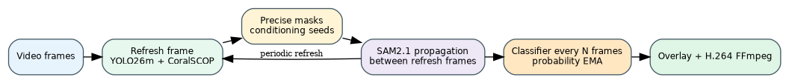
Figure 5-1. Final video runtime workflow.

5.1 Error scenarios common to workflows
- Missing checkpoint/path: fail fast with FileNotFoundError rather than silently downloading/retraining the wrong model.
- Mask dimensionality mismatch: normalize/squeeze to a strict 2D boolean mask before indexing RGB arrays.
- Mask/image resolution mismatch: nearest-neighbor resize mask to source image dimensions.
- Pseudo mask missing/failed: record failure reason and exclude rather than invent a polygon.
- Validation/test leakage risk: test must not participate in threshold tuning or pseudo-label model selection.
- Unknown taxonomy/background: use pragmatic rejection label rather than assigning a known species with unsupported certainty.
- Video tracking fragmentation: currently observed as many track IDs; needs stronger association/pruning before final runtime benchmark.

6. Business Rules / Technical Governance Rules
Rule ID | Rule | Where Applied | Reason | Current Status
BR-001 | Detector is single-class target_coral; species classification occurs downstream. | Detection dataset/model | Separates localization from taxonomy | Final
BR-002 | Split by source image; expected detection split = 452/100/94 images. | All model training | Prevent leakage | Final
BR-003 | Do not use held-out detector test during iterative training/model selection. | Detector/segmentation | Preserve independent evaluation | Final
BR-004 | Old classifier test was historically exposed; do not reuse it for future model selection. | Classification | Avoid optimistic bias | Final caution
BR-005 | Use +10% context around coral crop for classification. | Classifier | V3 improved robustness while retaining morphology | Final
BR-006 | Avoid blur/downscale/heavy JPEG/noise for texture-sensitive classifier training. | Classifier augmentation | Coral morphology/texture are discriminative | Final
BR-007 | CoralSCOP pseudo masks are teacher labels, not human GT. | Segmentation evaluation | Scientific validity | Final
BR-008 | No explicit Dead Coral or Algae class exists; do not invent these labels. | Classifier/output | Annotation truth constraint | Final
BR-009 | Unknown is pragmatic rejection, not proven open-set recognition. | OOD gate | No explicit unseen-species validation set | Final
BR-010 | Candidate detection confidence in accuracy-first runtime is intentionally low (0.20). | Video/image inference | Favor recall; downstream mask/classifier can reject | Current
BR-011 | CoralSCOP mask score minimum typically 0.35; minimum mask pixels 40. | Mask QC | Reject empty/weak masks | Current
BR-012 | Duplicate masks suppressed around mask IoU 0.65 / containment 0.85 with box-overlap support. | Duplicate resolver | Avoid multiple labels on same colony | Current
BR-013 | SAM2 classification is periodic and probabilities are EMA-smoothed (alpha 0.25). | Video | Reduce label flicker | Current
BR-014 | Final H.264 quality mode used CRF 12 / slow; quick-demo mode may use CRF 16 / veryfast. | Video export | Trade quality vs urgent demo speed | Current/temporary
BR-015 | REFRESH_STRIDE is a performance/accuracy lever. Notebook default 3; user tested 1 then 5; faster demo settings are allowed. | Video seed pass | CoralSCOP is the dominant refresh cost | Current runtime tuning

7. Problems & Troubleshooting Knowledge Base
Issue ID | Component | Problem / Symptoms | Root Cause | Final Fix | Lesson Learned | Status
ISS-001 | Data audit | One duplicated object annotation existed. | Object count mismatch / duplicate GT. | Duplicate detected during audit; removed. | Canonical final object count fixed at 2,198. | Resolved
ISS-002 | Image orientation | 40 images changed orientation under EXIF transpose. | Raw file pixels did not reflect display orientation consistently. | Canonical RGB images generated after EXIF transpose. | Use EXIF-aware loading before annotation geometry is finalized. | Resolved
ISS-003 | Taxonomy | Several labels are typo/common-name/uncertain taxonomy. | Dataset operational labels are not all clean scientific names. | Preserve original label vocabulary; document candidate taxonomic corrections only. | Do not silently rename biological classes. | Open documentation issue
ISS-004 | YOLO11 Stage2 | Small and crowded recall remained weak. | P3-only small-object limitations plus scene crowding/localization. | Targeted small/crowded sliced training at 960px. | Stage3 improved small/crowded metrics. | Resolved/benchmark
ISS-005 | Stage3 slicing | Original positive-slice selection did not guarantee small GT inclusion. | Random positive slices could miss the target small object. | Stage4 fixed selection logic to prioritize actual small objects. | Selection semantics matter as much as slice count. | Resolved in later experiment
ISS-006 | SAHI | SAHI inference performed badly despite the small-object motivation. | Sliced inference/merge behavior did not fit this dataset/model setup. | Evaluated then rejected. | Do not keep SAHI in final runtime just because it is theoretically relevant. | Rejected
ISS-007 | YOLO11 P2 Stage4 | P2 model severely underperformed Stage3 after 15 epochs. | Architecture/head changed and only partial transfer occurred; run was under-converged. | Do not interpret as proof P2 is inherently bad; experiment not promoted. | Architecture changes may need longer recovery training. | Not adopted
ISS-008 | Classifier | Sarcophyton was a weaker class. | Class-specific confusion/visual similarity. | Targeted V2 fine-tune, then V3 288px + context + hard mining. | Class-targeted hard mining can outperform generic augmentation. | Resolved to V3 baseline
ISS-009 | Video V1 | Boxes/species flickered frame-to-frame. | Independent frame predictions and unstable detector boxes/probabilities. | BoT-SORT + bbox EMA + gap hold + probability EMA. | Temporal smoothing mitigates but does not mathematically eliminate flicker. | Resolved conceptually
ISS-010 | Video quality | OpenCV mp4v output looked visibly degraded. | Codec/encoding quality. | Switch to FFmpeg H.264, high-quality CRF 10/12. | Encoding layer matters independently of model accuracy. | Resolved
ISS-011 | Closed-set classifier | Non-coral/unseen structures were forced into known labels. | Six-class softmax has no native unknown class. | Confidence/margin rejection, later NON_CORAL training + embedding OOD gate. | Unknown remains pragmatic without an explicit unknown benchmark. | Partially resolved
ISS-012 | Deployment | Bounding boxes included rock/background and overlapped colonies. | Box-only localization cannot isolate irregular adjacent coral shapes. | Architecture pivot to instance segmentation via CoralSCOP. | Real-video failure modes should drive architecture, not only validation mAP. | Resolved architecturally
ISS-013 | Initial CoralGuard hybrid | CoralSCOP only refined masks at inference; YOLO itself was not retrained for masks. | User wanted the segmenter to learn from teacher masks, not only call teacher at runtime. | Teacher→Student pseudo-label architecture created. | Clarify whether “teacher-student” means pseudo-label supervision vs logit distillation. | Superseded
ISS-014 | Cell 5 | defaultdict missing import. | Notebook cell dependency oversight. | Add from collections import defaultdict. | Standalone/restart-safe cells must own their imports. | Resolved
ISS-015 | Cell 5 | coralscop_predictor undefined after restart/out-of-order execution. | Runtime state from Cell 4 was lost. | Run CoralSCOP load cell / use restart recovery cell. | Notebook state must be recoverable from disk artifacts. | Resolved
ISS-016 | Mask helper | mask_bbox raised “too many values to unpack”. | Stored/read mask sometimes had singleton/channel dimension. | normalize_mask_2d using squeeze and channel handling before np.where. | Never assume PNG mask loads as H×W. | Resolved
ISS-017 | Student dataset Cell 6 | KeyError: score in mask audit. | Empty-mask branch returned incomplete dictionary. | mask_quality always returns score/area_ratio/bbox_iou/pixels/reason. | All error branches must honor the same schema. | Resolved
ISS-018 | Student evaluation | YOLO26m-SEG was good on pseudo masks but weaker as detector on original GT. | Training objective optimized teacher-mask agreement, not necessarily old box operating behavior. | Keep old YOLO26m as primary detector; use CoralSCOP directly for accuracy path; SEG student becomes backup/fast mode. | Evaluate each component on the ground truth relevant to its intended job. | Final decision
ISS-019 | Windows restart | Variables/models disappeared after device restart. | Notebook in-memory state is ephemeral. | Recovery cell reloads checkpoints, configs, mask manifest, helper functions. | Persist every important artifact and make restarts first-class. | Resolved
ISS-020 | Dual-view Cell 7 | IndexError boolean index did not match RGB channel axis. | local_mask had shape H×W×1 while context was H×W×3. | Robust mask normalization/squeeze; resize nearest-neighbor if needed; index with strict H×W bool mask. | Shape assertions belong immediately before boolean image indexing. | Resolved
ISS-021 | Dual-view build speed | Building 1,894 ROI pairs was slow. | Repeatedly opening same source image and JPEG I/O. | Turbo grouped processing by source image; resume skip; fast OpenCV read; high-quality JPEG retained. | Group work by shared expensive input. | Resolved
ISS-022 | Classifier training speed | Dual-view EfficientNetV2-S was very slow. | Two image views, repeated JPEG decode/resize, two separate backbone forwards. | RAM cache resized images; one concatenated backbone forward; AMP; channels_last; TF32; fused AdamW; resume checkpoints. | Optimize input pipeline and GPU utilization before reducing model/image quality. | Optimization supplied; final speed not yet reported
ISS-023 | Jupyter warning | TqdmWarning: IProgress not found. | ipywidgets notebook progress integration missing. | Ignored as non-functional warning. | Do not treat UI progress warning as training failure. | Benign
ISS-024 | Video seed pass speed | REFRESH_STRIDE=1 caused ~1.5–2.1 s per refresh and very long runs. | YOLO + CoralSCOP were executed on every frame. | Increase REFRESH_STRIDE to 5; CoralSCOP only on refresh frames and SAM2 handles temporal propagation. | A “seconds/frame” log can actually mean seconds/refresh; interpret denominator correctly. | Improved but still being tuned
ISS-025 | Video track count | Track IDs grew to ~67–69 in sample seed pass. | Association fragmentation / new IDs accumulating. | Track-pruning/stronger association identified as next fix; quick demo proposed top 25 stable tracks. | Uncontrolled ID growth can make SAM2 the next bottleneck. | Pending
ISS-026 | Urgent demo | Need first video for doctor quickly rather than all five. | Batch pipeline prioritized completeness over near-term demo. | Process first completed seed metadata only; keep top 25 stable tracks; classifier stride 5; FFmpeg veryfast CRF16. | Production workflow should support demo/fast mode separately. | Temporary demo mode

7.1 Screenshots preserved from troubleshooting
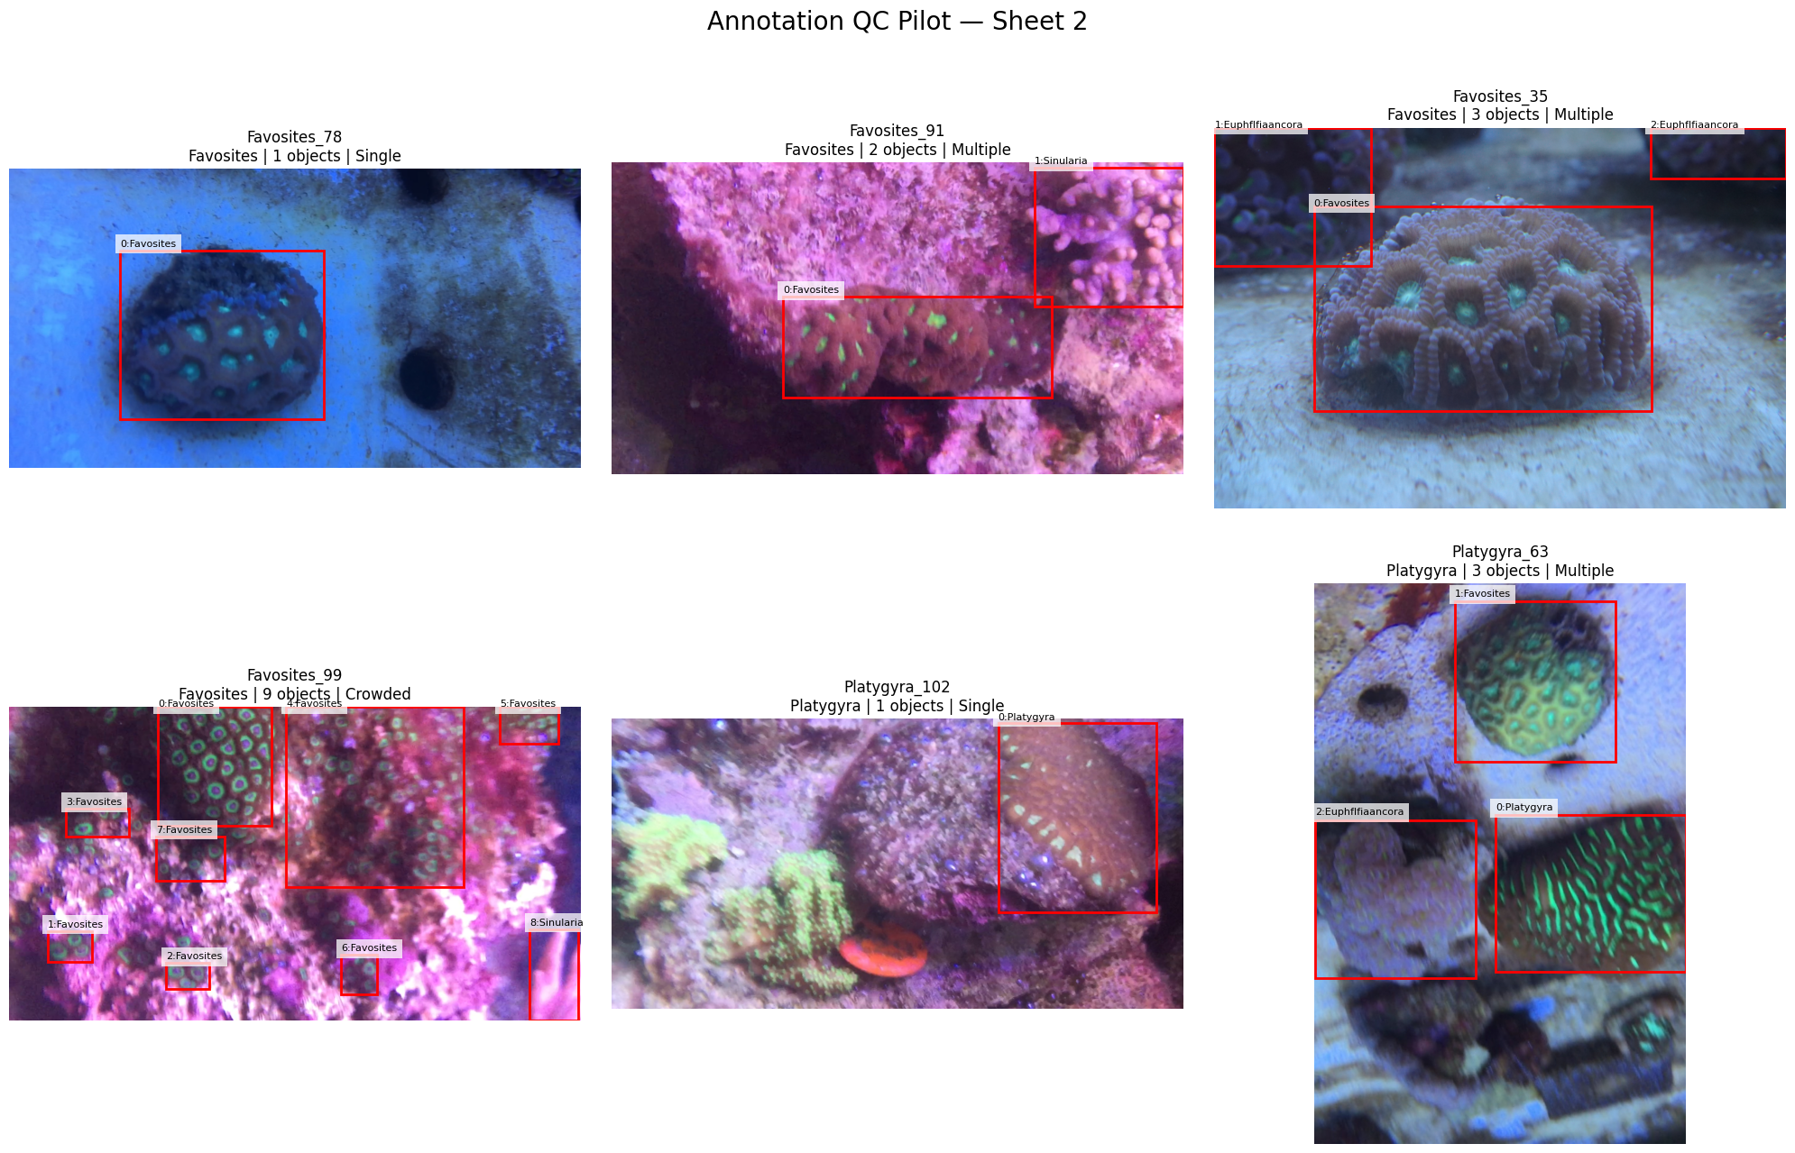
Annotation QC example showing single, multiple and crowded coral boxes. This context motivated explicit small/crowded analysis.
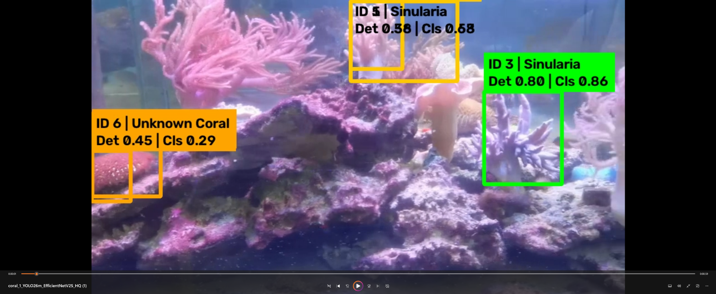
Real-video deployment screenshot showing overlapping detections and an “Unknown Coral” prediction. This was a key trigger for the segmentation pivot.
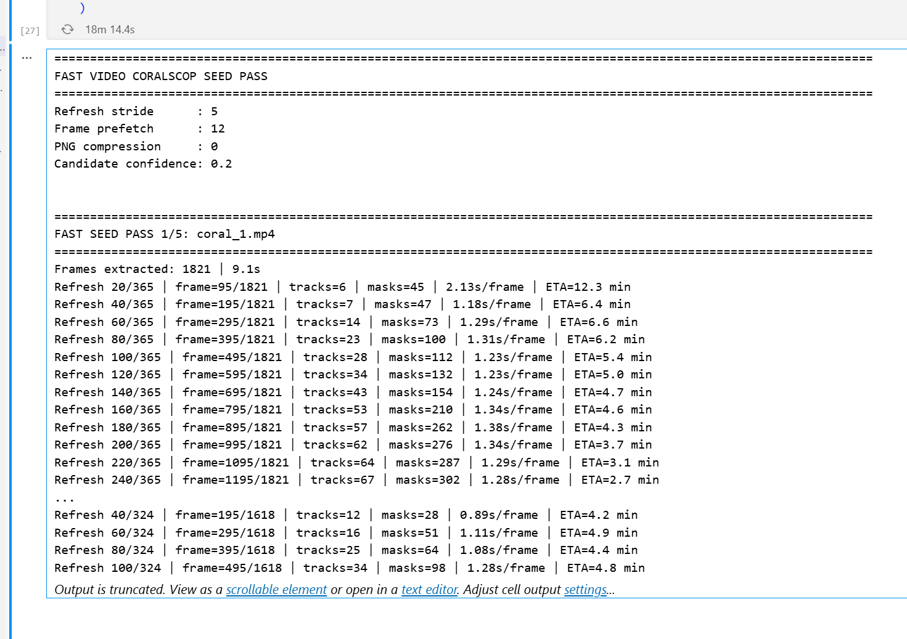
Current video seed-pass tuning with REFRESH_STRIDE=5. The output shows fewer refresh operations but continued CoralSCOP cost and rapid growth in track IDs.

8. Decisions Log
Decision ID | Decision | Alternatives | Reason | Consequence | Status
DEC-001 | Start with detection + ROI classification; no segmentation. | Segmentation-first pipeline | Simpler original scope and available box annotations. | Built strong box/classification baseline. | Deprecated
DEC-002 | Single-class detector target_coral, species classifier downstream. | 6-class detector | Separates localization and species learning; supports dedicated classifier. | Two-stage pipeline. | Final
DEC-003 | Use validation for threshold tuning; preserve detector test. | Tune on test | Scientific evaluation hygiene. | Independent test remains available. | Final
DEC-004 | Stage3 YOLO11n as lightweight baseline rather than SAHI/P2. | SAHI / P2 Stage4 | Measured results and deployment simplicity. | Stage3 retained for historical comparison. | Historical final for YOLO11 path
DEC-005 | MobileNetV4 V3 as lightweight classifier baseline. | Earlier V1/V1.1/V2 | V3 best test/validation balance with context/hard mining. | Historical classifier benchmark. | Historical
DEC-006 | Move to YOLO26m + EfficientNetV2-S for stronger pair. | Keep only tiny models / RF-DETR deployment | Stronger practical capacity and integrated local pipeline. | New pre-seg baseline. | Superseded by final spatial design but detector retained
DEC-007 | Introduce instance segmentation after real-video evidence. | Continue box-only tuning | Boxes could not isolate irregular overlapping corals. | Scope expanded beyond original “no segmentation” rule. | Final architectural pivot
DEC-008 | Use CoralSCOP as domain-specific mask teacher. | Generic semantic segmentation | Box-prompted coral-specific segmentation useful without manual mask GT. | Pseudo masks and direct runtime masks. | Final
DEC-009 | Train YOLO26m-SEG Student from CoralSCOP pseudo masks. | Teacher-only inference | Wanted a learned fast instance segmenter. | Completed 150-epoch student experiment. | Completed but not primary runtime
DEC-010 | Do not promote SEG student as primary detector. | Student-only detector/segmenter | Original-GT operating F1 weaker than old YOLO26m. | Old YOLO26m remains candidate detector. | Final
DEC-011 | Accuracy-first path uses CoralSCOP directly on YOLO candidates. | Student mask primary + CoralSCOP fallback | Accuracy prioritized over raw speed; teacher likely stronger than imitation student. | CoralSCOP becomes primary mask source. | Current final
DEC-012 | Use SAM2.1 for temporal memory instead of running full spatial stack every frame. | Independent-frame inference only | Reduce flicker/cost and propagate precise masks. | Keyframe/refresh architecture. | Final
DEC-013 | Train Dual-View classifier with masked + context images and NON_CORAL proxy negatives. | Single crop only | Preserve species texture/context while giving clean foreground view and validity signal. | 7-way classifier + OOD gate. | Current
DEC-014 | Keep segmentation student as Fast/Backup mode. | Discard student | 150-epoch work remains valuable for speed/recovery. | Potential quality vs speed operating modes. | Final secondary
DEC-015 | Runtime tuning uses refresh stride rather than raising detector confidence. | Raise DET_CANDIDATE_CONF | Higher confidence risks missing small corals; stride directly attacks CoralSCOP cost. | DET candidate remains 0.20 during tuning. | Current

9. Code Knowledge Extraction
Current / final code is distributed primarily across two notebooks: the completed Teacher→Student notebook and the later Accuracy-First notebook. Several fixes and speed patches were supplied after the latest notebook was generated; those patches are documented here because they are not guaranteed to be integrated into the saved notebook file.

9.1 Current notebook modules
Notebook | Important Cells / Functions | Status
CoralGuard_X_V2_FINAL_Teacher_Student_LOCAL_Windows.ipynb | Cells 1–17: environment, paths, CoralSCOP pseudo masks, SEG dataset, student training/validation, dual-view classifier, OOD, SAM2 video. | Completed experiment notebook; primary runtime superseded
CoralGuard_X_ACCURACY_FIRST_YOLO_CoralSCOP_DualView_SAM2_LOCAL.ipynb | Cells 1–17: accuracy-first config, old detector, CoralSCOP direct masks, dual-view classifier, OOD, image smoke test, video seed pass, SAM2 render. | Current main notebook
Coral_Video_V2_BoTSORT_Stable_Boxes_Large_Text.ipynb | BoT-SORT + bbox smoothing + species EMA. | Historical temporal design; concepts reused
Coral_End_to_End_Stage3_MobileNetV4_V3_Validation.ipynb | Integrated detector/classifier validation and error attribution. | Historical E2E benchmark

9.2 Critical mask normalization fix
def normalize_mask_2d(mask):
mask = np.asarray(mask)
mask = np.squeeze(mask)
if mask.ndim == 3:
if mask.shape[-1] in (1, 3, 4):
mask = mask[..., 0]
elif mask.shape[0] in (1, 3, 4):
mask = mask[0]
if mask.ndim != 2:
raise ValueError(f"Expected 2D mask, got {mask.shape}")
return (mask > 0).astype(bool)
Purpose: normalize CoralSCOP/PNG masks before np.where, ROI slicing, or RGB boolean indexing. This fix resolved both mask_bbox dimensionality errors and the Dual-View Cell 7 H×W×1 vs H×W×3 boolean-index failure.

9.3 Student training configuration (completed)
SEG_EPOCHS = 150
SEG_IMGSZ = 1024
batch = 16 # actual completed run
optimizer = AdamW
lr0 = 1e-4
lrf = 0.02
weight_decay = 5e-4
cos_lr = True
patience = 40
mosaic = 0.15
copy_paste = 0.10
multi_scale = 0.10
max_det = 500
The completed run took 232.61 minutes and produced best.pt and last.pt. best.pt is the model-selection checkpoint.

9.4 Dual-View speed patch
# Instead of two separate backbone calls:
# f_context = backbone(context)
# f_masked = backbone(masked)
x = torch.cat([context, masked], dim=0)
features = backbone(x)
B = context.shape[0]
f_context = features[:B]
f_masked = features[B:]
embedding = fusion(torch.cat([f_context, f_masked], dim=1))
Additional supplied optimizations: preload resized 300×300 dual-view JPEGs into RAM; AMP FP16; channels_last; cuDNN benchmark; TF32; fused AdamW; resume from last checkpoint. Final speedup was not yet reported in the conversation.

9.5 Current runtime configuration and quick-demo patch
# Accuracy-first candidate behavior
DET_CANDIDATE_CONF = 0.20
CORALSCOP_MIN_SCORE = 0.35
CORALSCOP_MIN_PIXELS = 40
# Notebook default was 3; user tested 1, then moved to 5 for speed.
REFRESH_STRIDE = 5
# Quick doctor demo recommendations (temporary):
video_paths = video_paths[:1]
KEEP_TRACKS = 25
CLS_STRIDE = 5
# FFmpeg: preset=veryfast, CRF=16
Not yet integrated warning
The quick-demo/top-25-track and accelerated EfficientNet cells were supplied as replacement cells after the main notebook was created. Treat them as current patch knowledge, not automatically present in the saved notebook unless manually pasted.

10. Naming & Terminology Dictionary
Term | Meaning | Used In
target_coral | The detector’s single object class. | Detection
ROI | Region of Interest crop corresponding to one coral box/mask. | Classification
Stage 1 / Stage 2 / Stage 3 | YOLO11n baseline, enhanced underwater fine-tune, targeted small/crowded fine-tune. | Historical detector R&D
Stage 4 P2 | YOLO11n architecture with P2/P3/P4/P5 output strides 4/8/16/32. | Historical detector experiment
CoralSCOP | Coral-specialized box-prompt segmentation model used as mask teacher/refiner. | Segmentation
Teacher mask / pseudo mask | Mask generated by CoralSCOP from an existing GT box; not manual mask GT. | Teacher→Student
YOLO26m-SEG Student | Instance segmentation model trained from CoralSCOP pseudo masks. | Fast/backup segmenter
Dual-View | Classifier input consisting of masked foreground plus +10% context crop. | Classifier
NON_CORAL | Proxy negative class generated from conservative background crops. | Validity/classifier
Other/Unknown Coral | Pragmatic rejection label for uncertain known-class predictions. | OOD
OOD | Out-of-distribution / open-set style rejection logic; pragmatic here. | Classifier calibration
Prototype | Normalized mean embedding of a known class used for cosine similarity. | OOD calibration
EMA | Exponential moving average for species probabilities / historically box smoothing. | Video stability
Refresh frame | Frame where the full YOLO + CoralSCOP spatial stack is rerun. | Video
REFRESH_STRIDE | Number of source frames between refreshes. | Runtime speed/accuracy control
Seed record | CoralSCOP mask/box/track record used to condition SAM2. | Video
SAM2.1 | Temporal mask memory/propagation model used for multi-object video masks. | Video
BEST_SEG_CONF | Validation-tuned operating confidence for SEG student against original GT boxes; observed 0.40. | SEG evaluation

11. UI / UX Documentation
There is no formal graphical frontend. The current user interface is the VS Code/Jupyter notebook plus generated annotated video. UI/UX requirements therefore concern cell organization, progress reporting, configuration visibility, restart safety and video overlay readability.
Screen / Surface | User | Purpose / Actions | Key Fields | Validation / Behavior | Connected Backend
Environment / Config Cells | Research operator | Verify GPU, paths, versions; adjust batch/thresholds/strides. | Workspace paths, model paths, DET_CANDIDATE_CONF, REFRESH_STRIDE, batch sizes. | Fail fast if CUDA/path/checkpoint missing. | Local filesystem + PyTorch/Ultralytics
Training Cells | Research operator | Start/resume training and observe epoch metrics. | Epochs, batch, optimizer, augmentations. | Checkpoint best/last; early stopping. | Model output folders
Validation / Calibration Cells | Research operator | Review mAP/F1/confidence and promote checkpoints. | Validation split, thresholds. | Test isolation; schema checks. | CSV/JSON reports
Video Seed Pass | Research operator | Observe refresh progress, tracks, masks, ETA. | Video list, refresh stride. | Resume artifacts and track cap/pruning. | Frame cache + seed metadata
Final Video Overlay | Researcher / academic reviewer | See object ID, mask, species/Unknown and confidence. | SAM2 masks + classifier state. | Avoid clutter/duplicate instances. | FFmpeg MP4

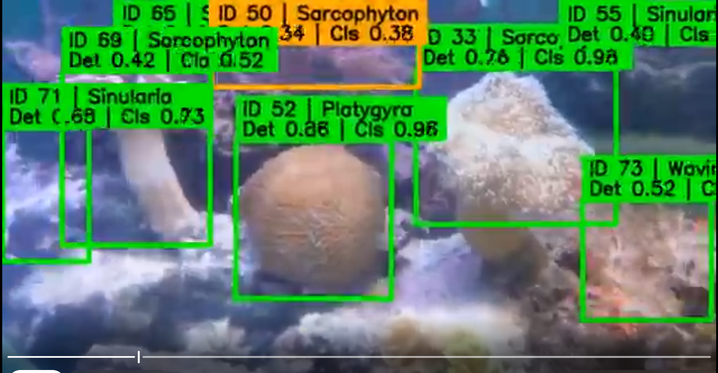
Historical stable-video overlay example: tracked IDs, species labels and detector/classifier confidence. New architecture intends to replace box-only emphasis with mask overlays.

12. Roles & Permissions
No software RBAC or authentication layer exists in the project. The roles below are operational roles inferred from the workflow, not implemented application permissions.
Role | Responsibilities | Screens / Artifacts | Editable | Viewable | Approval Authority / Restrictions
Research/Development Operator | Run notebooks; edit configs; train/evaluate; inspect outputs. | All notebooks, datasets and output folders. | Local code/configs/artifacts. | All project artifacts. | Responsible for not touching held-out test during tuning.
Academic Reviewer (“doctor”) | Review demonstration results and project progress. | Final videos, diagrams, metrics/presentations. | None implemented. | Exported deliverables. | No software approval workflow implemented.
Future Dataset/Annotation Reviewer | Manual mask/taxonomy QA would improve scientific validity. | QC images/manifests. | Not implemented. | Potential future review artifacts. | Pending role, no permissions system.

13. Automation & Triggers
Automation | Trigger | Conditions | Action | Source | Destination | Failure Behavior
AUTO-01 | Notebook cell execution | Dataset/model checks pass | Generate derived manifests/crops/masks | Source files | Output folders | Fail fast exception; many stages resume-safe
AUTO-02 | During model training | Validation Macro-F1 or mAP improves | Save best checkpoint; always maintain last checkpoint where supported | Training batches | weights/*.pt or .pth | Early stopping via patience
AUTO-03 | SEG validation | Confidence sweep over validation predictions | Select BEST_SEG_CONF and write operating config | Original validation GT | student_operating_config.json | Does not touch test
AUTO-04 | Dual-view OOD calibration | Classifier/embedding evaluation completes | Compute prototypes and similarity thresholds | Train/validation embeddings | ood_calibration.json + NPZ | Pragmatic OOD only
AUTO-05 | Video refresh frame | frame_idx % REFRESH_STRIDE == 0 | YOLO candidate detection + CoralSCOP masks + association | Video frame | Seed records/masks | Dominant runtime cost
AUTO-06 | Video classification frame | frame_idx % CLS_STRIDE == 0 | Classify SAM2 masks and update EMA probabilities | Propagated masks | Track classifier state | Reduces redundant classifier calls
AUTO-07 | Final render | SAM2 frame output available | Draw overlays and pipe BGR frames to FFmpeg | Annotated frame stream + source audio | H.264 MP4 | Raise on FFmpeg failure

14. Reports / Search / Dashboards
Report / Artifact | Purpose | Source | Notes
Coral_Project_Stage3_MobileNetV4_Evaluation_Matrix.png | Historical combined detector/classifier/E2E dashboard. | Stage3 audit + MobileNetV4 V3 + integrated validation. | Key comparison artifact.
training_history*.csv | Epoch history for classifier/detector experiments. | Training loops. | Used to inspect plateau/best epoch.
teacher_mask_quality_audit.csv | Pseudo-mask pass/failure reasons and metrics. | CoralSCOP mask filtering. | Troubleshooting pseudo-label quality.
student_confidence_sweep_original_GT.csv | SEG student precision/recall/F1 across confidence. | Original validation GT. | Fair operating-point tuning for student boxes.
final_validation_classification_report.csv | Per-class classifier precision/recall/F1. | Dual-view validation. | Final classifier analysis.
final_validation_confusion_matrix.csv | Confusion matrix. | Dual-view validation. | Class error analysis.
accuracy_first_video_summary.csv | Per-video runtime/stability summary. | Final video render. | No ground-truth video accuracy claimed.
ACCURACY_FIRST_FINAL_PROJECT_SUMMARY.json | Final configuration and scientific limitations. | Final notebook summary cell. | Machine-readable handover.

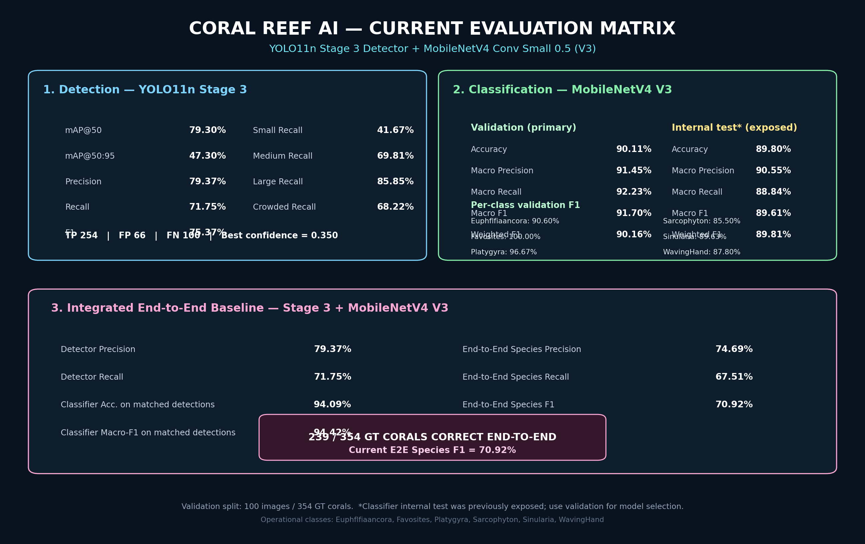
Historical integrated evaluation matrix retained as the primary Stage3 + MobileNetV4 V3 baseline snapshot.

15. Calculations & Formulas
Calculation | Formula / Logic | Applied To | Notes
Intersection over Union (box) | IoU = area(intersection) / area(union) | Box matching, mask-bbox alignment, duplicate resolution. | Guard denominator with epsilon.
F1 | 2 × Precision × Recall / (Precision + Recall) | Detector operating point and species E2E. | Do not confuse correct-count fraction with F1.
Mask IoU | pixels(A ∩ B) / pixels(A ∪ B) | Duplicate suppression and track association. | Masks normalized to 2D boolean first.
Mask containment | pixels(A ∩ B) / min(pixels(A), pixels(B)) | Detect nearly contained duplicate masks. | Current duplicate threshold around 0.85.
+10% context | Expand box width/height by 10% on each dimension and clip to image. | Classifier context view. | Preserves local environment without full-scene contamination.
CoralSCOP candidate mask quality | Weighted combination of teacher score, box alignment and reasonable area behavior. | Choose one mask from multimask output. | Exact weighting varied by notebook version; current generated notebook used 0.55/0.30/0.15.
OOD cosine similarity | normalized embedding dot class prototype. | Known-class validity gate. | Per-class threshold derived from known validation embeddings.
Species probability EMA | p_smooth = α·p_current + (1−α)·p_previous | Video label stability. | Current α = 0.25.
Refresh count | ceil(number_of_frames / REFRESH_STRIDE) | Seed-pass workload estimate. | 1821 frames at stride 5 ≈ 365 refreshes.
Track association score | Weighted mask IoU + box IoU + center proximity. | Refresh-frame ID association. | Current notebook family uses mask/box/center terms; fragmentation remains pending.

16. Testing History & Regression Checklist
Test ID | Scenario | Input | Expected | Actual | Fix / Consequence | Status
TEST-001 | Raw audit | 646 images + 646 JSON; 2,199 objects before dedupe. | Detect malformed/missing pairs. | Valid; one duplicate found. | Duplicate removal + canonicalization. | Pass
TEST-002 | Split audit | 452/100/94 images and 1,540/354/304 boxes. | Leakage-safe image-level split. | Expected counts achieved. | Locked split. | Pass
TEST-003 | RF-DETR baseline validation | 10 epochs. | Strong reference detector. | Epoch10 mAP50:95 .5231; best regular .5373. | Retained benchmark. | Pass
TEST-004 | YOLO11 Stage3 validation audit | conf ~.35. | Small/crowded improvement. | F1 .7537; small recall .4167; crowded .6822. | Retained baseline. | Pass
TEST-005 | SAHI validation | Stage3 + SAHI640. | Improve small/crowded inference. | Failed badly relative to standard path. | Rejected SAHI. | Fail / rejected
TEST-006 | MobileNetV4 V3 validation/test | 288px + context + hard mining. | Classifier generalization. | Test Acc .8980; MacroF1 .8961. | Historical classifier final. | Pass; test historically exposed
TEST-007 | Integrated Stage3 + MobileNetV4 V3 | 100 val images / 354 GT. | End-to-end species performance. | E2E Species F1 70.92%. | Failure attribution drove detector focus. | Pass
TEST-008 | YOLO26m + EfficientNetV2-S integrated | 100 val images / 354 GT. | Stronger pair. | E2E Species F1 .708978. | Pre-seg benchmark. | Pass
TEST-009 | SEG student pseudo-mask validation | 100 images / 352 instances. | Teacher agreement. | Mask mAP50:95 .590519; box mAP50:95 .641117. | Useful segmenter. | Pass with pseudo-GT caveat
TEST-010 | SEG student original-GT confidence sweep | Original 354 GT boxes. | Fair detection operating point. | conf .40; P .7857; R .6836; F1 .7311. | Old YOLO26m kept as primary detector. | Pass / decision
TEST-011 | Dual-view first epoch | Epoch 1/150. | Check classifier starts correctly. | Acc .8921; MacroF1 .8699. | Training later optimized for speed. | Partial; final best not reported
TEST-012 | Accuracy-first video seed pass | 5 videos; first 1821 frames. | Runtime/track behavior. | At stride 5 ~1.2–1.4 s/refresh later; tracks grew to ~67. | Speed improved; track fragmentation pending. | In progress

16.1 Regression testing checklist
- Environment: correct .venv, CUDA available, RTX A6000 visible, package versions printed.
- Paths: detector, classifier, CoralSCOP, SAM2, manifests and video ZIP/folder resolve without fallback surprises.
- Dataset counts: 452/100/94 images and 1,540/354/304 objects remain unchanged.
- ROI mapping: 1,894 train+validation positive ROIs map to CoralSCOP masks; no missing class/split.
- Mask robustness: all loaded masks normalize to H×W boolean; resized with nearest-neighbor only.
- Dual-view outputs: context/masked files exist, no duplicate manifest rows, all seven labels represented as expected.
- Classifier: checkpoint class_to_idx exactly matches runtime mapping; validation Macro-F1 reported before promotion.
- OOD: calibration files correspond to the same classifier checkpoint and class order.
- Detector: candidate threshold change is recorded; do not silently reuse old .375 threshold for the new architecture.
- Video: first smoke-test image is visually inspected for masks/duplicates before long batch run.
- Tracking: monitor unique/active track count; fail or prune if IDs grow implausibly.
- Final video: verify frame count, source FPS, audio preservation (if expected), readable overlay and no encoding artifacts.
- Scientific: held-out detector test remains untouched until final architecture is frozen.

17. What We Learned Building This System
Domain | Project-specific lesson
Architecture | A box-only pipeline can score well yet fail visually when irregular overlapping objects contaminate ROI crops. Real deployment screenshots exposed this earlier than aggregate mAP did.
Evaluation | Pseudo-label validation and original human box validation answer different questions. High teacher agreement cannot be marketed as independent segmentation accuracy.
Component responsibility | The best segmenter does not need to be the best detector. Keeping old YOLO26m for candidates and CoralSCOP for masks is more defensible than forcing YOLO26m-SEG to own both jobs.
Data engineering | Image-level split lineage must flow into every derived ROI/mask dataset; otherwise a clean detector split can become a leaky classifier split.
Small/crowded objects | Target selection logic matters. Random slicing that does not guarantee the intended small object can waste training volume.
Model experimentation | A theoretically attractive method (SAHI or P2) should not survive solely because it matches the problem description; measured behavior decides promotion.
Classifier design | Coral texture/morphology is sensitive to destructive augmentations. Context helped, but blur/downscale/heavy JPEG/noise were intentionally avoided in the stronger classifier path.
OOD | Softmax confidence alone is insufficient for unknown/background rejection. Combining NON_CORAL, confidence, margin and embedding similarity is more practical, while still requiring honest open-set caveats.
Notebook engineering | Restart-safe, schema-consistent cells are critical. Missing imports, implicit globals and inconsistent error-branch dictionaries caused avoidable failures.
Mask handling | Always normalize mask dimensionality immediately after reading/inference. H×W, H×W×1 and singleton-channel tensor forms must be handled explicitly.
Performance | The dominant bottleneck can move: disk I/O → duplicate backbone forwards → CoralSCOP refresh cost → SAM2 track count. Optimize measured bottlenecks one layer at a time.
Video systems | Tracking stability and runtime are architectural, not cosmetic. Refresh cadence, track association, ID pruning and classifier cadence materially determine whether the final system is usable.
Communication | The project needs both Accuracy Mode and Demo/Fast Mode. A research presentation may prioritize obtaining one high-quality representative video quickly instead of processing an entire batch.

18. Current State Snapshot
Category | Current State
Working | Canonical detection/classification dataset and split; historical detector/classifier baselines; CoralSCOP pseudo-mask generation; YOLO26m-SEG student training/validation; accuracy-first YOLO→CoralSCOP image path; dual-view dataset build; local RTX A6000 environment; video frame extraction and CoralSCOP seed-pass logic.
Partially Working / In Progress | Dual-View EfficientNetV2-S final training metrics are not fully reported; accelerated replacement cell was supplied. Video seed pass is running with stride tuning. SAM2 final end-to-end video output has not yet been confirmed in conversation.
Pending | Track fragmentation fix/pruning; first quick doctor-demo video; final SAM2 render verification; final E2E metric suite on frozen architecture; held-out detector test; explicit unknown/non-coral benchmark; human mask QA if independent segmentation metrics are desired.
Known Issues | Track IDs can grow to ~67–69 on sample video; CoralSCOP refresh remains expensive; NON_CORAL negatives may contain unlabeled coral if annotations are not exhaustive; Unknown is pragmatic only; taxonomy remains partly ambiguous.
Removed / Deprecated | Original “no segmentation” constraint; SAHI inference; YOLO11 P2 Stage4 as final detector; SEG student as primary detector/segmenter; always-run CoralSCOP on every frame (stride=1) for practical demo runtime.
Current Final Architecture | YOLO26m old detector → CoralSCOP direct mask → overlap/duplicate resolver → masked + context Dual-View EfficientNetV2-S → OOD/validity gate → SAM2.1 temporal memory → H.264 video.

18.1 Current local environment / paths
Item | Value
Workspace | D:\Coral_Local_Workspace
Python | 3.12.0 in .venv
PyTorch | 2.11.0+cu128
CUDA runtime | 12.8
GPU | NVIDIA RTX A6000, ~48 GB VRAM
Ultralytics | 8.4.117
timm | 1.0.22
OpenCV | 5.0.0 recorded
FFmpeg | C:\Users\sayed.abdo\AppData\Local\Microsoft\WinGet\Packages\Gyan.FFmpeg_Microsoft.Winget.Source_8wekyb3d8bbwe\ffmpeg-9.0-full_build\bin\ffmpeg.EXE
Detection data | D:\Coral_Local_Workspace\data\Coral_Reef_AI_Project\01_Data\Final\Detection_v1
ROI manifest | D:\Coral_Local_Workspace\data\Coral_Reef_AI_Project\04_Dataset_Splits\classification_roi_manifest_split.csv
Current final notebook | CoralGuard_X_ACCURACY_FIRST_YOLO_CoralSCOP_DualView_SAM2_LOCAL.ipynb
Expected final video root | D:\Coral_Local_Workspace\outputs\CoralGuard_X_ACCURACY_FIRST\06_Final_Videos

18.2 Immediate next steps
- Finish / confirm one Dual-View classifier best checkpoint and record its final validation Macro-F1, per-class report and confusion matrix.
- Use the already completed first-video seed metadata if available; do not rerun all five videos for the urgent academic demo.
- For quick demo: limit to first video, retain top ~25 stable seed tracks, classify every ~5 frames, encode with FFmpeg veryfast/CRF16.
- Inspect the first SAM2 output visually for ID fragmentation, duplicate masks and label stability before processing more videos.
- Then improve refresh-frame association / stale-track pruning so the active ID count reflects actual simultaneous colonies rather than accumulated historical IDs.
- Freeze architecture and thresholds; only then use held-out detector test and report final E2E metrics without further tuning.

19. Missing / Unclear Information
Gap ID | Missing / Unclear Item | What is known
GAP-001 | Final Dual-View EfficientNetV2-S best epoch/metrics after the speed-optimized cell. | The conversation only explicitly shows Epoch 1: Acc .8921, MacroF1 .8699 before later optimization.
GAP-002 | Whether the final accuracy-first SAM2 MP4 was successfully generated. | The conversation currently shows seed-pass progress, not final output verification.
GAP-003 | Independent mask ground truth. | No human instance-mask GT is available; pseudo-mask metrics are teacher agreement.
GAP-004 | True open-set test data. | No explicit unseen coral species benchmark; Unknown remains rejection logic.
GAP-005 | Formal labels for dead coral/algae. | Not present in the audited six-label dataset.
GAP-006 | Exhaustiveness of coral annotations for background-negative generation. | NON_CORAL may be contaminated by unlabeled coral if annotation coverage is incomplete.
GAP-007 | Final track association thresholds after fragmentation optimization. | Current association produces many IDs on example videos; final pruning logic is pending.
GAP-008 | CoralSCOP commercial licensing clearance. | Conversation recorded CC BY-NC-SA 4.0/non-commercial restrictions; verify legal terms before any commercial product use.
GAP-009 | Final real-time FPS. | Never established for the final accuracy-first pipeline; do not invent.
GAP-010 | Final held-out test performance for frozen architecture. | Intentionally pending until model/threshold selection is complete.

20. AI Handover Context
The following block is designed to be copied into a new ChatGPT conversation as a self-contained project handover. It intentionally prioritizes current decisions plus critical historical constraints.
You are continuing a Computer Vision project called CoralGuard-X / Coral Reef AI. Treat this context as the project source of truth unless I explicitly provide newer results.
PROJECT PURPOSE
Build an underwater coral system that detects coral instances, isolates them accurately enough for species classification, rejects uncertain/non-coral candidates pragmatically, and produces stable annotated video. Original scope was Detection → Crop → Classification → Video → Real-Time with no segmentation, but real-video failures forced an instance-segmentation pivot.
DATA
Canonical detection dataset: 646 images, 2,198 final GT boxes after removing one duplicate. Image-level split: train 452 images/1,540 boxes; validation 100/354; test 94/304. Detector is single-class target_coral. Classification ROIs use the same lineage: 1,540/354/304. Six operational species labels: Euphflfiaancora, Favosites, Platygyra, Sarcophyton, Sinularia, WavingHand. Taxonomy is partly ambiguous; do not silently “correct” labels. Held-out detector test must not be used for tuning. The old classifier test was historically exposed and must not be reused for model selection.
HISTORICAL BASELINES
RF-DETR Medium 10 epoch final validation: mAP50:95 .5231, mAP50 .8271, mAP75 .5767, mAR@500 .7288, F1 .7808, P .8030, R .7599; best regular mAP ~.537313.
YOLO11n Stage3 standard audit at conf .35: P .7937, R .7175, F1 .7537, small recall .4167, medium .6981, large .8585, crowded .6822; mAP50 ~.793, mAP50:95 ~.473. SAHI was rejected. Stage4 P2 was under-converged and not promoted.
MobileNetV4 V3: 288px +10% context + train-only hard mining; test Acc .8980, MacroF1 .8961, Sarcophyton test F1 .8539.
Stage3+MobileNet V3 integrated validation: 100 images/354 GT; 254 matched detections; 239 correct detection+species; E2E Species P .7469, R .6751, F1 .7092. Failure attribution: 68 detector misses, 32 localization errors, 15 classification errors.
Stronger pre-seg pair: YOLO26m validation mAP50:95 .507131, mAP50 .806921, P .836268, R .714689. EfficientNetV2-S validation Acc .889831, MacroF1 .883817. Integrated E2E F1 .708978 at detector conf .375.
SEGMENTATION PIVOT
Real video showed overlapping boxes, excess rock/background inside ROIs, uncertain/Unknown predictions and dead-looking/algae-like structures. Instance segmentation was introduced. CoralSCOP is used as a coral-specific box-prompt teacher/refiner. There is no explicit Dead Coral or Algae class.
TEACHER→STUDENT EXPERIMENT
Existing GT boxes → CoralSCOP pseudo instance masks → mask quality filter → YOLO26m-SEG student. Student trained 150 epochs at imgsz1024; completed in 232.61 minutes. Pseudo-mask validation: box mAP50:95 .641117, box mAP50 .811005, box mAP75 .687784, mask mAP50:95 .590519, mask mAP50 .787498, mask mAP75 .630761. On original validation GT boxes, best confidence .40: TP242 FP66 FN112, P .785714, R .683616, F1 .731118. Therefore the SEG student is useful as fast/backup segmentation but is NOT the primary detector in the accuracy-first architecture.
CURRENT FINAL ARCHITECTURE
RAW FRAME → OLD YOLO26m DETECTOR → candidate boxes → CoralSCOP directly on each candidate → precise instance masks → mask QC/overlap/duplicate resolver → masked coral view +10% context view → Dual-View EfficientNetV2-S → known species / Other-Unknown Coral / Non-Coral validity logic → SAM2.1 temporal mask memory → stable ID+mask+species annotated H.264 video.
Use old YOLO26m as the primary detector because its original-GT operating behavior was stronger than the SEG student. CoralSCOP is primary accuracy mask source. YOLO26m-SEG student is a fast/backup mode.
CURRENT RUNTIME / OOD RULES
Accuracy-first candidate confidence = .20. CoralSCOP min score ~.35, min pixels 40. Duplicate mask IoU ~.65, containment ~.85. Dual-view context padding 10%. Classifier has six known species + NON_CORAL proxy class. OOD thresholds in design: known confidence .50, top1-top2 margin .08, NON_CORAL .45, plus per-class prototype cosine similarity. Unknown is pragmatic rejection only because no true unseen-species validation set exists. SAM2 model: facebook/sam2.1-hiera-large. Species EMA alpha .25.
VIDEO SPEED STATE
Running CoralSCOP every frame (REFRESH_STRIDE=1) was too slow (~1.5–2 s per refresh). The user moved to REFRESH_STRIDE=5; first video has 1821 frames → about 365 refreshes and later speed around ~1.2–1.4 s/refresh. Track IDs grew to ~67–69, indicating fragmentation; track pruning/stronger association is pending. Immediate priority is one video quickly for an academic doctor. Quick-demo recommendation: process only first video, reuse completed seed metadata, keep top ~25 stable tracks, CLS_STRIDE=5, FFmpeg preset veryfast / CRF16. Do not rerun all 5 videos unnecessarily.
LOCAL ENVIRONMENT
Windows workspace D:\Coral_Local_Workspace. Python 3.12.0, torch 2.11.0+cu128, CUDA 12.8, NVIDIA RTX A6000 ~48GB, ultralytics 8.4.117, timm 1.0.22. Main detection data: D:\Coral_Local_Workspace\data\Coral_Reef_AI_Project\01_Data\Final\Detection_v1. ROI manifest: ...\04_Dataset_Splits\classification_roi_manifest_split.csv. CoralSCOP checkpoint: D:\Coral_Local_Workspace\models\vit_b_coralscop.pth. Main current notebook: CoralGuard_X_ACCURACY_FIRST_YOLO_CoralSCOP_DualView_SAM2_LOCAL.ipynb. Expected final video root: D:\Coral_Local_Workspace\outputs\CoralGuard_X_ACCURACY_FIRST\06_Final_Videos.
CRITICAL TROUBLESHOOTING
- Normalize every mask to strict H×W boolean before np.where/indexing; this fixed both mask_bbox and H×W×1 boolean-index errors.
- Cell 6 student mask audit previously had KeyError 'score'; every branch must return the same audit schema.
- After restart, reload checkpoint/config/manifest state; do not retrain completed models.
- Dual-view data build was accelerated by grouping ROIs by source image and skipping existing outputs.
- Dual-view classifier speed patch: cache resized 300×300 images in RAM; single concatenated backbone forward for context+masked; AMP; channels_last; TF32; fused AdamW; resume checkpoint.
- Do not interpret pseudo-mask mAP as human segmentation GT accuracy.
- Do not claim final FPS, flicker or final video accuracy unless actually measured.
CURRENT STATUS / NEXT STEPS
Final dual-view best metrics after the speed-optimized training cell are not yet recorded in the conversation. Accuracy-first video seed pass is in progress; final SAM2 MP4 is not yet confirmed. Next: obtain first doctor-demo video, inspect track fragmentation/duplicates, then improve association/pruning, freeze architecture, and only then run held-out final evaluation.

Appendix A. Metrics History
Model / Stage | Metric | Value | Interpretation
RF-DETR Medium, epoch 10 | Val mAP50:95 | 0.5231 | Historical strong baseline
RF-DETR Medium, best regular | Val mAP50:95 | 0.537313 | Epoch 8 recorded
RF-DETR Medium, epoch 10 | mAP50 / mAP75 | 0.8271 / 0.5767 | P .8030 / R .7599 / F1 .7808
YOLO11n 10ep | mAP50:95 / mAP50 | 0.436 / 0.697 | P .719 / R .593
YOLO11n Stage2 | mAP50:95 / mAP50 | 0.4439 / 0.7727 | P .7576 / R .6864
YOLO11n Stage3 | mAP50:95 / mAP50 | ~0.473 / ~0.793 | Custom F1 .7537 @ conf .35
YOLO11n Stage3 | small / crowded recall | 0.4167 / 0.6822 | Main targeted groups
YOLO11n P2 Stage4 | mAP50:95 / mAP50 | 0.265 / 0.596 | Under-converged; not promoted
MobileNetV4 V3 | Test Accuracy / MacroF1 | 0.8980 / 0.8961 | Historical test exposed
Stage3 + MobileNet V3 | E2E Species F1 | 0.7092 | 239/354 correct E2E; do not confuse .6751 recall with F1
YOLO26m | Val mAP50:95 / mAP50 | 0.507131 / 0.806921 | P .836268 / R .714689
EfficientNetV2-S | Val Acc / MacroF1 | 0.889831 / 0.883817 | Pre-seg single-view strong model
YOLO26m + EffNetV2-S | E2E Species F1 | 0.708978 | conf .375; 229 correct detection+species
YOLO26m-SEG Student | Pseudo box mAP50:95 | 0.641117 | Teacher-mask dataset
YOLO26m-SEG Student | Pseudo mask mAP50:95 | 0.590519 | Teacher agreement, not human mask GT
YOLO26m-SEG Student | Original-GT P/R/F1 | 0.785714 / 0.683616 / 0.731118 | Best conf .40; TP242 FP66 FN112
Dual-View EffNetV2-S | Epoch 1 Acc / MacroF1 | 0.8921 / 0.8699 | Only explicit current training epoch result recorded

Appendix B. Project Artifact Inventory
Artifact | Purpose
YOLO11n_Coral_Detection_10Epochs.ipynb | YOLO11n detection baseline.
YOLO11n_Validation_Error_Audit.ipynb | Validation error/size/crowding audit.
YOLO11n_Stage3_Targeted_Sliced_Finetune_SAHI.ipynb | Stage3 targeted training + rejected SAHI evaluation.
YOLO11n_Stage3_1_SmallHardPriority_Localization_Finetune.ipynb | Stage3.1 small/hard-priority localization fine-tuning.
YOLO11n_P2_Stage4_SmallPriority_Coral.ipynb | P2 small-priority experiment.
YOLO11n_P2_Stage4_1_HybridRecovery_Standalone.ipynb | Stage4 recovery experiment notebook.
Coral_Classification_MobileNetV4_Small050.ipynb | MobileNetV4 classification pipeline.
Coral_End_to_End_Stage3_MobileNetV4_V3_Validation.ipynb | Historical E2E integrated evaluation.
Coral_Video_Inference_Stage3_MobileNetV4_V3.ipynb | Initial video inference.
Coral_Video_V2_BoTSORT_Stable_Boxes_Large_Text.ipynb | Tracking/stabilization video version.
RFDETR_Large_ConvNeXtSmall_Full_Coral_Pipeline.ipynb | Alternative RF-DETR/ConvNeXt full pipeline.
YOLO26m_EfficientNetV2S_Full_Coral_Pipeline.ipynb | Stronger pre-seg YOLO26m + EfficientNetV2-S pipeline.
YOLO26m_Continue_50ep_From_Best_Colab.ipynb | Continuation experiment.
YOLO26m_EfficientNetV2S_PLUS150_EACH_Colab.ipynb | Planned +150 each continuation notebook.
YOLO26m_EfficientNetV2S_Colab_Resume_VIDEO_ONLY.ipynb | Video-only resume path.
CoralGuard_X_FINAL_Hybrid_Coral_Pipeline_LOCAL_Windows.ipynb | Initial CoralSCOP inference-refinement hybrid.
CoralGuard_X_V2_FINAL_Teacher_Student_LOCAL_Windows.ipynb | Teacher→Student segmentation architecture.
CoralGuard_X_ACCURACY_FIRST_YOLO_CoralSCOP_DualView_SAM2_LOCAL.ipynb | Current final accuracy-first notebook.
Coral_Project_Stage3_MobileNetV4_Evaluation_Matrix.png | Historical metric dashboard.
plan full.png | Early project plan / roadmap visual.
coral_video.zip | Video test input archive.

Excluded unrelated material
A RECOVERY-X2 log containing B4_RMSE, SAM, PSNR, SSIM and DC was identified as unrelated to the coral project and is intentionally not merged into coral metrics.

Appendix C. Mermaid Reference Diagrams

C.1 Teacher→Student training
flowchart TD
A[Existing GT Boxes] --> B[CoralSCOP Teacher]
B --> C[Pseudo Instance Masks]
C --> D[Mask Quality Filter]
D --> E[YOLO Polygon Segmentation Labels]
F[YOLO26m-seg Base] --> G[YOLO26m-SEG Student]
H[Old YOLO26m compatible weights] --> G
E --> G
G --> I[Pseudo-mask Validation]
G --> J[Original-GT Box Confidence Sweep]

C.2 Video runtime
flowchart LR
V[Video Frames] --> K[Refresh Frame]
K --> Y[YOLO26m Detector]
Y --> C[CoralSCOP Masks]
C --> S[SAM2.1 Conditioning]
S --> P[Mask Propagation]
P --> Q{Classification frame?}
Q -- yes --> E[Dual-View EfficientNetV2-S + EMA]
Q -- no --> R[Reuse smoothed state]
E --> O[Overlay / H.264]
R --> O
P --> K
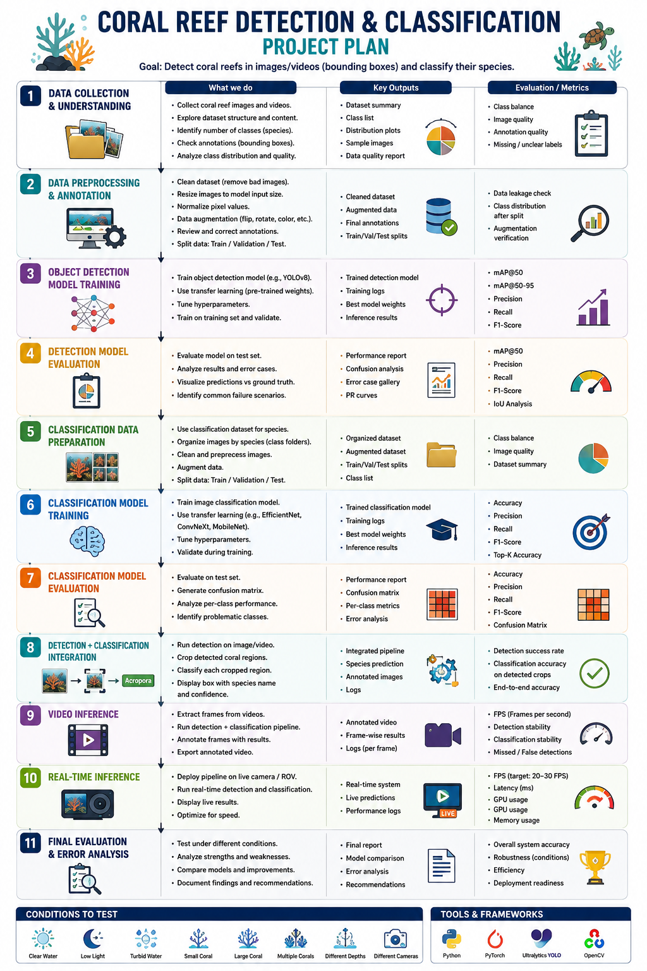
Early project plan visual preserved as historical planning evidence.
End of document.
This reconstruction preserves current decisions, superseded designs, measured metrics, troubleshooting fixes, known gaps and next actions as of the last project message available on 03 September 2026.

