Assignment Main Flow UI Review
Living review record for sandbox-first, functionality-preserving UI refinement
Status: Living review - collaborative step review pending
Baseline branch: codex/assignment-workflow-ui-polish
Baseline commit: 23e86f0f
Captured: 13 July 2026
Scope: Main assignment flow; visual and copy refinement only

Working direction: The flow is stable and coherent. The main opportunity is to reduce repeated reassurance, completion messaging, and nested surfaces so each step feels lighter without changing behavior.

Purpose and working agreement
- Review one workflow step at a time in the live sandbox.
- Use browser annotations to capture hard-to-describe visual concerns.
- Do not change workflow functionality during this polish pass.
- Record accepted decisions in this document before final review and CI.
- Keep Support details unchanged unless it becomes a separate future topic.

Overall assessment
- Accessibility: 3/4 - clear labels and non-color-only progress states; keyboard and contrast checks remain pending.
- Performance: 3/4 - no visible responsiveness problems; runtime profiling was outside the visual pass.
- Responsive structure: 3/4 - structurally sound; the captured evidence is desktop only.
- Theming consistency: 4/4 - calm palette and consistent component vocabulary.
- UI anti-patterns: 3/4 - repeated reassurance and nested bordered surfaces are the main weakness.

Cross-flow opportunities
- Remove duplicated notices and overlapping completion messages.
- Compress completed setup areas so the current task becomes the visual anchor.
- Clarify actions that repeat work after a step is already complete.
- Normalize transcript typography, metadata presentation, and date locale.
- Preserve the current navigation model and all workflow behavior.

Decisions already locked
- Advanced actions appears only after successful sharing on Review & share.
- Advanced actions is a separate card below the main-flow footer and Start another assignment.
- Support details remains independent and unchanged for now.

Step 1. Student
Initial verdict: The step is understandable, but completed setup choices occupy more space than the actual student-selection task.
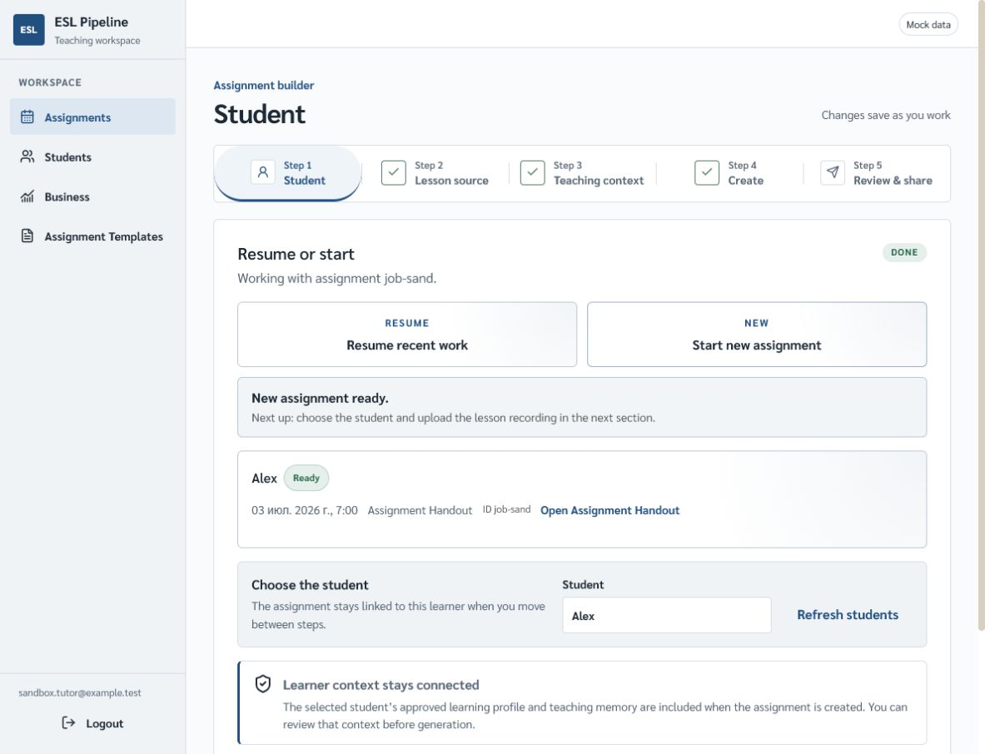
Current sandbox baseline - Step 1: Student

Initial findings
- Resume or start remains visually dominant after the user has already selected a path.
- New assignment readiness, previous assignment information, and learner-context reassurance create several consecutive status surfaces.
- The student chooser should be the strongest visual anchor once setup is resolved.
- The displayed date uses a locale inconsistent with the English interface.

Questions for collaborative review
- How much of Resume or start should remain visible after choosing New or Resume?
- Which readiness message is genuinely useful before the learner is selected?
- Should recent assignment context remain expanded or become a compact summary?

Acceptance checks
- Starting and resuming assignments still behave exactly as before.
- The selected learner remains obvious and editable.
- Dates use a consistent English locale.
- No useful recovery or context information is removed.
Review status: queued for collaborative review

Step 2. Lesson source
Initial verdict: The source choice is clear. Most improvement can come from removing duplicated copy and making transcript content feel less technical.
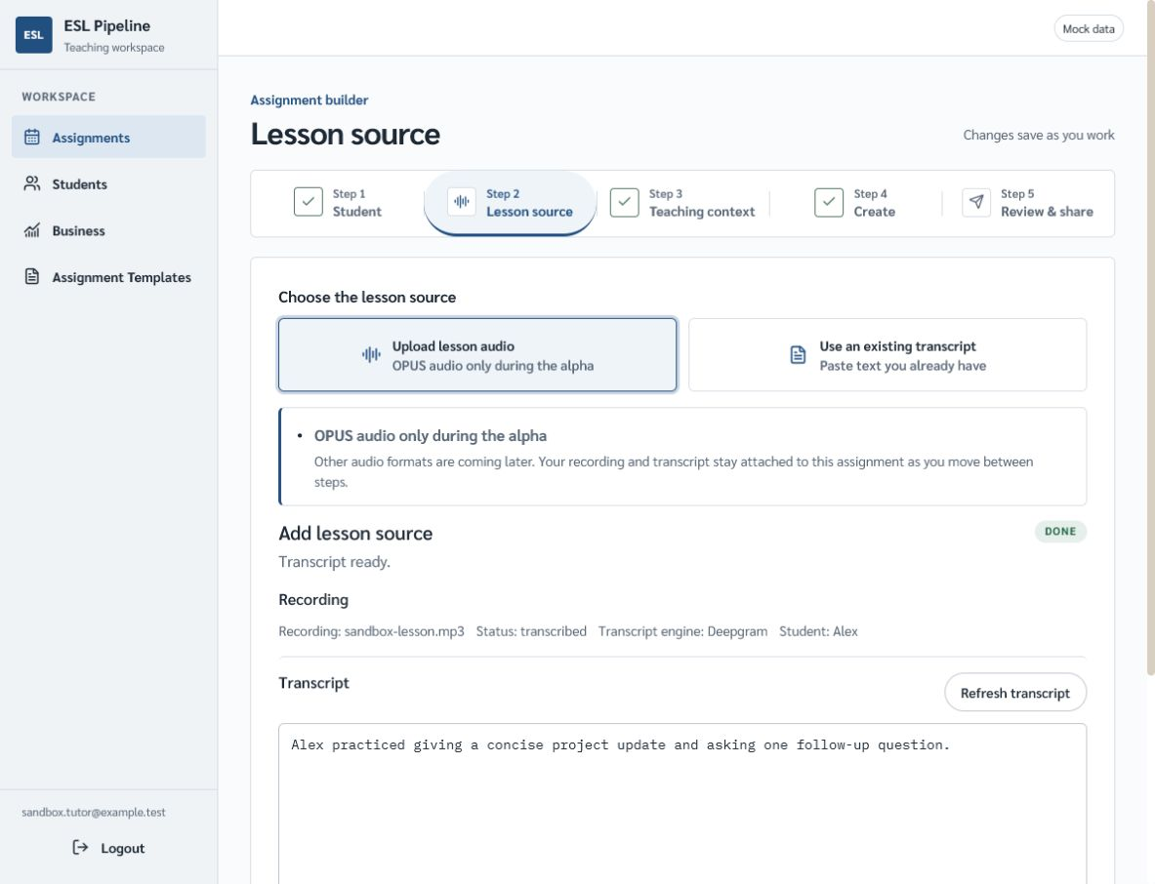
Current sandbox baseline - Step 2: Lesson source

Initial findings
- OPUS audio only during the alpha appears in both the selected source option and a separate notice.
- Transcript ready, the Done badge, and readiness copy communicate the same state several times.
- Recording metadata reads as one low-contrast sentence instead of a scan-friendly summary.
- The transcript uses monospace even though it is ordinary prose rather than code or Markdown.

Questions for collaborative review
- Which single location should carry the alpha-format limitation?
- What recording metadata does a teacher actually need at this point?
- Should transcript readiness be represented by the badge, heading copy, or both?

Acceptance checks
- Upload, transcript refresh, and source switching remain unchanged.
- The alpha audio limitation remains discoverable.
- Transcript prose is comfortable to read and edit.
- Metadata stays available without dominating the step.
Review status: queued for collaborative review

Step 3. Teaching context
Initial verdict: The information is useful, but the reference profile dominates the viewport while the teacher's active input sits below it.
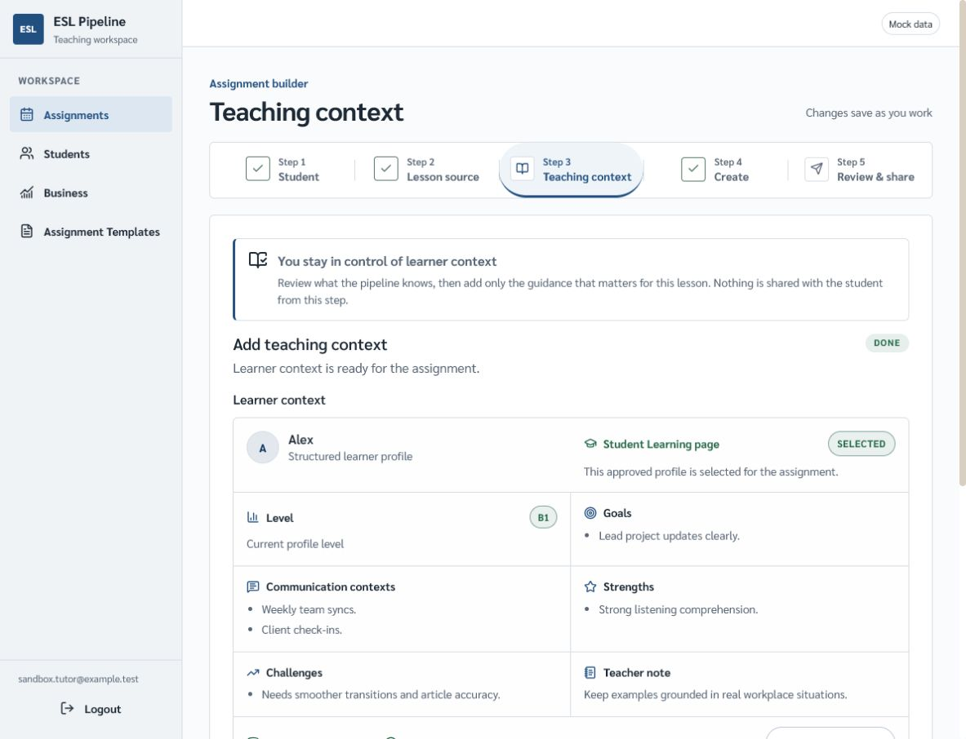
Current sandbox baseline - Step 3: Teaching context

Initial findings
- The learner profile grid consumes most of the first viewport.
- Teacher notes, the active task on this step, appear below detailed reference information.
- Selected, approved profile, and learner context ready overlap semantically.
- The introductory reassurance card adds another large surface before the working controls.

Questions for collaborative review
- Should teacher notes come before the detailed learner profile?
- Which learner facts must remain visible without expansion?
- Can the profile become a compact summary while preserving trust and inspectability?

Acceptance checks
- All learner context remains accessible and unchanged in meaning.
- Teacher notes become visible earlier in the step.
- The selected learner and profile provenance remain clear.
- No automatic navigation or save behavior changes.
Review status: queued for collaborative review

Step 4. Create
Initial verdict: The editor is clear and appropriately technical. The main ambiguity is whether Generate means first generation or regeneration once content already exists.
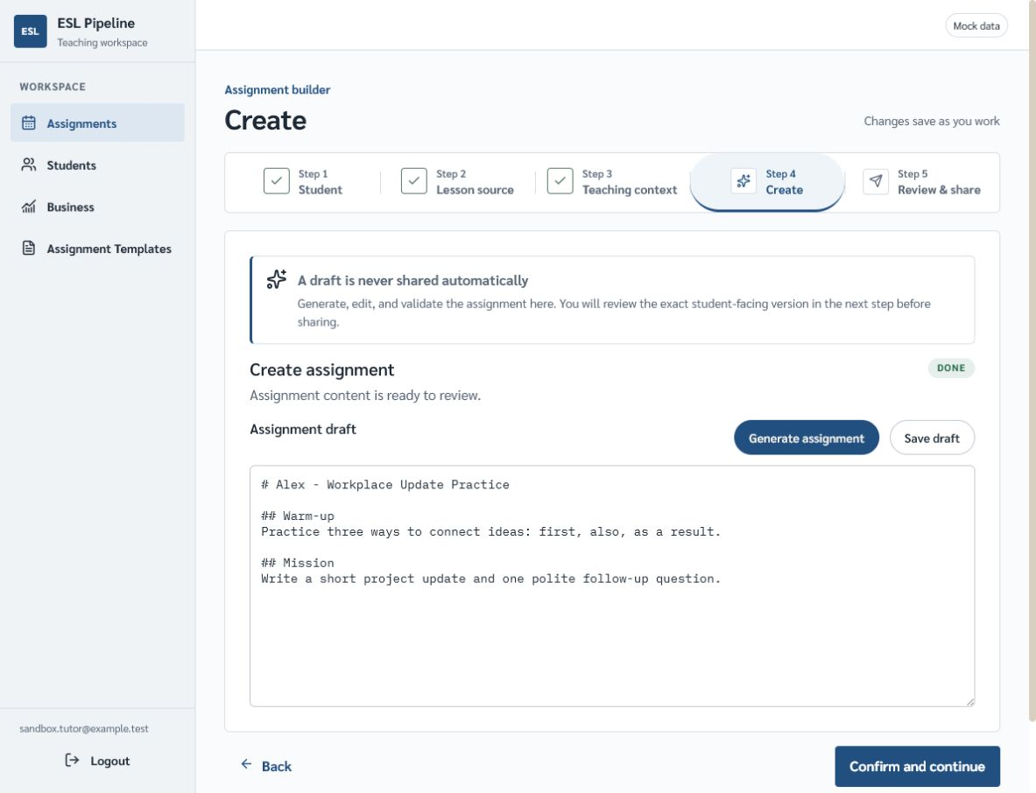
Current sandbox baseline - Step 4: Create

Initial findings
- Generate assignment remains a strong primary action after assignment content is already ready.
- The generation action competes visually with Confirm and continue.
- Assignment content is ready to review and the Done badge repeat the completed state.
- Monospace is appropriate here because the draft exposes Markdown structure.

Questions for collaborative review
- Should the completed-state label become Regenerate assignment?
- Which action should have primary visual weight after a draft exists?
- How much readiness copy is necessary before review?

Acceptance checks
- Generate, regenerate, save, and continue behavior remains unchanged.
- The next recommended action is visually unambiguous.
- Markdown remains readable and editable.
- The user is never led to believe the draft shares automatically.
Review status: queued for collaborative review

Step 5. Review & share
Initial verdict: The main flow and post-share area now have the right structure. Remaining work is largely completed-state hierarchy and copy economy.
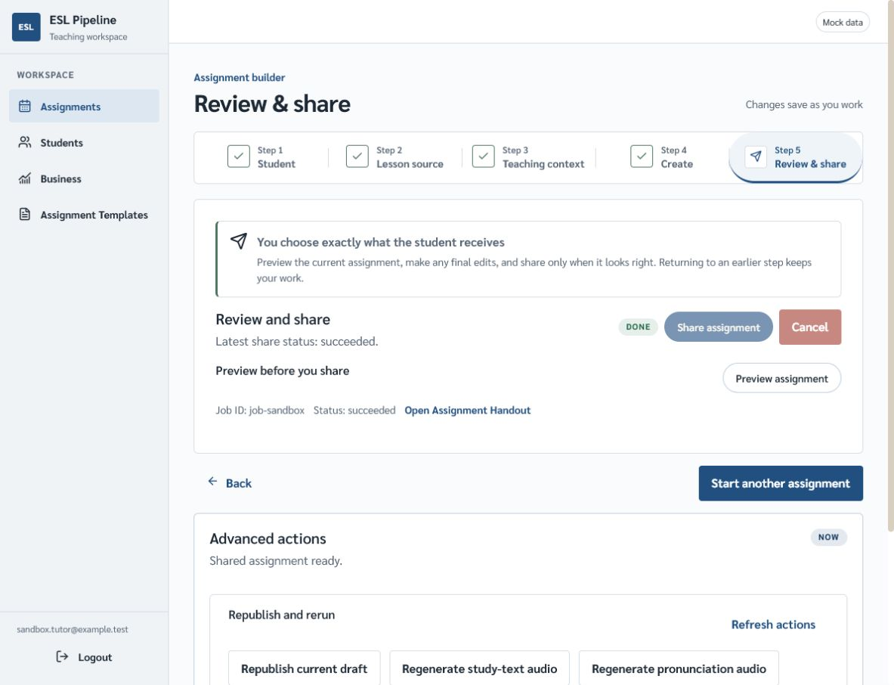
Current sandbox baseline - Step 5: Review & share

Initial findings
- Disabled Share assignment and Cancel controls remain visually prominent after successful sharing.
- Share status, handout access, preview, Job ID, and raw status are spread across several lines.
- Technical job metadata competes with teacher-facing actions.
- Start another assignment is now correctly separated from Advanced actions.

Questions for collaborative review
- What is the most important action immediately after successful sharing?
- How much technical status information belongs in the main card?
- Should completed share controls remain visible, or only become quieter?

Acceptance checks
- Preview, handout access, sharing, cancellation, and reset behavior remains unchanged.
- Successful sharing is unmistakable.
- Start another assignment remains the primary post-completion action.
- Advanced actions never appears on Steps 1 through 4.
Review status: queued for collaborative review

Step 5 continued: Advanced actions
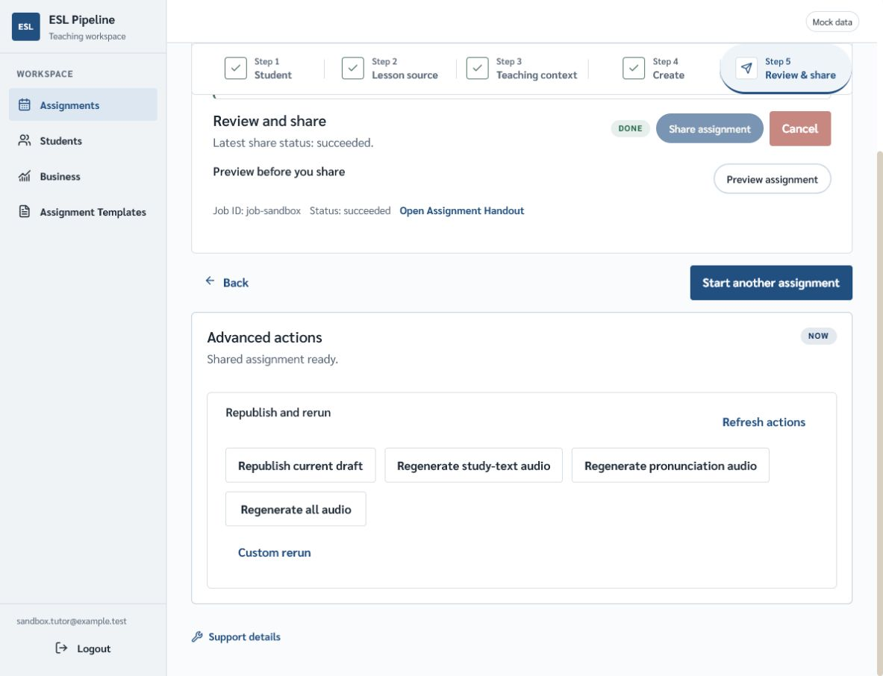
Current sandbox baseline - Advanced actions after successful sharing

Initial findings
- The separate bordered card and spacing now establish the intended boundary from the main flow.
- The Now badge has no clear meaning and reads as decorative status noise.
- Advanced actions, Shared assignment ready, Republish and rerun, and Republish current draft overlap in meaning.
- All rerun controls have similar visual weight even though their scope and consequence differ.

Acceptance checks
- The card stays below Start another assignment and outside the main step card.
- Every existing rerun, republish, refresh, and custom-rerun action remains available.
- The border remains complete and visible at every expansion state.
- Support details stays independent below the card.

Decision log
How to use this section: After each collaborative step review, record the accepted visual changes, explicit non-changes, and evidence used to approve the result.

Step 1: Student
- Accepted changes: pending
- Explicit non-changes: pending
- Validation evidence: pending

Step 2: Lesson source
- Accepted changes: pending
- Explicit non-changes: pending
- Validation evidence: pending

Step 3: Teaching context
- Accepted changes: pending
- Explicit non-changes: pending
- Validation evidence: pending

Step 4: Create
- Accepted changes: pending
- Explicit non-changes: pending
- Validation evidence: pending

Step 5: Review & share
- Accepted changes: pending
- Explicit non-changes: pending
- Validation evidence: pending

Evidence limits
- Screenshots show the desktop mock-data sandbox on 13 July 2026.
- Keyboard navigation, screen-reader output, contrast measurements, and narrow viewport behavior were not exercised in the initial audit.
- The document records design review evidence, not implementation authority or runtime contracts.

