Bash Script for Blocking Domains using iptables

This report describes a Bash script used to block a domain using iptables on a Linux system. The script resolves a domain to its IP address and blocks all traffic to and from the IP, including ICMP (ping).

# Terminal Commands:

### **1-Open the script in Nano editor:**

nano fbash.sh

**Description:**  
Opens the Bash script file in the terminal-based text editor nano to write or edit the firewall script.

### **2. Make the script executable:**

chmod +x fbash.sh

**Description:**  
Gives execute permission to the script so it can be run directly from the terminal.

### **3. Execute the script with a domain**

sudo ./fbash.sh google.com

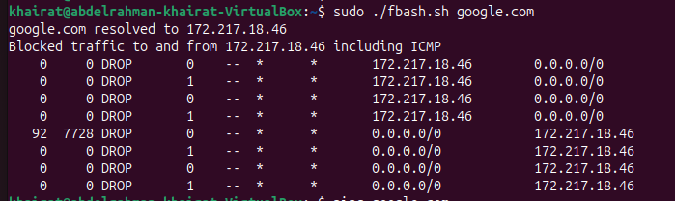**Description:**  
Runs the script with root privileges and passes google.com as the target domain to block.

**4. Test if the domain is blocked using ping**

ping google.com

**Description:**  
Sends ICMP requests to google.com to test connectivity.

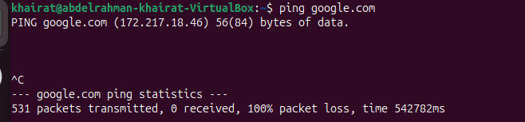

### **5. Check iptables rules by IP address**

sudo iptables -L -n --line-numbers | grep "172.217.18.46"

**Description:**  
Filters the iptables firewall rules to show entries specifically targeting the resolved IP of google.com.

# 

### **6. Bash Script :**